Group 2: Alex Medellin and Nick Rummel

CSC463

Dr. Girard

November 20, 2017

**Genetic Algorithm Lab**

1. Four reflective opto sensors were used for this lab. Two were placed on the front of the robot. One on the right side and one on the left side of the front of the robot. The two other sensors were placed on the sides of the robot. One sensor on each side. These were placed where they were so that walls could be detected on each side and allow the robot to turn the correct direction.
2. In the initial iteration, only two of the six (33.3%) life forms received a non-zero score. While this is a low percentage, those odds are decent considering that our sample size was so small. The paper we read in the class had generated a population of 500 individuals with 200 to 300 generations.
3. From observation, the robot appeared to work better when the generated algorithm was shorter. A limit on the number of levels generated in the tree could be implemented. The program could also keep track of algorithms that worked based on user input. The code would create a “baseline” tree over time to use as model when generating or mutating a tree.
4. 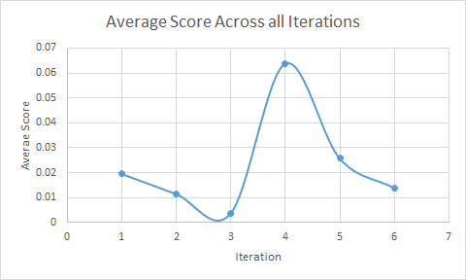
5. 1. 4 tiles in 10 seconds = 0.4
   2. 1 tile in 1 second = 1
   3. 8 tiles in 20 seconds = 0.4
6. Given our current scoring system, the same score is obtained by going twice the distance in twice the amount of time. The trial that made it farther should get a higher score since it made it farther. This could be fixed by scaling the scores somehow by increasing the score based off of how far the robot got.