|  |  |
| --- | --- |
| Identification:  Document Revision |  |
| Date: |  |
| Cage Code: |  |

|  |
| --- |
| **Customer: N/A** |
|  |
| **Cooling Subsystem – System/Susbsystem Specifications**  **VCCS (MG BoK v2 Sample)** |
|  |
|  |

|  |  |
| --- | --- |
| **No. pagine /**  **Nr. of pages** | **Classificazione / Classification** |
|  | NON CLASSIFICATO / UNCLASSIFIED |
|  | NON CLASSIFICATO CONTROLLATO / UNCLASSIFIED CONTROLLED |
|  | RISERVATO / RESTRICTED |
|  | RISERVATISSIMO / CONFIDENTIAL |
|  | SEGRETO / SECRET |
|  | **No. totale delle pagine / Total nr. of pages** |

**Document Authority**

|  |  |
| --- | --- |
|  |  |
|  |  |
|  |  |
|  |  |

**Point of Contact**

|  |  |
| --- | --- |
|  |  |

**REVISION RECORD**

|  |  |  |  |  |
| --- | --- | --- | --- | --- |
| **Rev.** | **Modification No.** | **Date** | **Description** | **Author/s** |
|  |  |  |  |  |
|  |  |  |  |  |

Sommario

1 Introduction 1

1.1 Purpose 1

1.2 Scope 1

1.3 Overview 1

2 Cooling System Solution Domain 2

2.1 1 Subsystem Requirements 2

2.1.1 1 Subsystem Requirements Metrics 2

2.1.2 SSR-1 SRS for Cooling System 2

2.2 2 Subsystem Structure 3

2.2.1 1 Logical Interfaces 3

2.2.2 2 Exchange Items 3

2.2.3 3 Logical Components 3

2.3 3 Subsystem Behavior 3

2.4 4 Subsystem Parameters 3

2.5 5 Traceability 3

3 2.2 CP System Solution Domain 3

3.1 2 Subsystem Structure 3

3.1.1 1 Logical Interfaces 3

3.1.2 2 Exchange Items 3

3.1.3 3 Logical Subsystems 3

3.2 3 Subsystem Behavior 3

4 3 Configuration Domain 3

4.1 2 System Structure 3

4.2 3 System Behavior 3

4.3 4 System Parameters 3

4.3.1 1 Parameter Values 3

4.4 5 Traceability 3

5 4 Implementation Domain 3

5.1 1 Implementation Requirements 4

5.1.1 PR-1 Implementation Requirements Specification for Cooling System 4

5.2 2 Traceability 4

5.3 4

6 Appendix A: Diagram 5

6.1 BB Functions To Context 5

6.2 Cool Down Cabin Air 5

6.3 Cool Down Cabin Air 6

6.4 Cooling System Logical Components 6

6.5 Cooling System States 7

6.6 Cooling System Structure 8

6.7 CP System States 9

6.8 CP System Structure 10

6.9 Evaluate Status 11

6.10 Evaluate Status 11

6.11 Exchange Items 12

6.12 Exchange Items 12

6.13 From SNs to SRS 13

6.14 From Stakeholder Needs to Physical Requirements 13

6.15 From Stakeholder Needs to Subsystem Requirements 13

6.16 Implementation Requirements for Cooling System 14

6.17 Implementation Requirements to Subsystem Requirements and LSSA 14

6.18 Index 14

6.19 Initialize Other Subsystems 15

6.20 Initialize Other Subsystems 15

6.21 Integrated System Behavior 16

6.22 Logical Architecture of VCCS 16

6.23 Logical Architecture of VCCS without Interfaces 17

6.24 LSA to Problem Domain 17

6.25 LSA to System Requirements 18

6.26 LSSA to Subsystem Requirements 19

6.27 Measures of Effectiveness 20

6.28 MoEs for Subsystems 20

6.29 New System Requirements 21

6.30 Perform System Check 21

6.31 Perform System Check 22

6.32 Processing Subsystem Interfaces 23

6.33 Provide Comfortable Temperature 24

6.34 Provide Comfortable Temperature 25

6.35 Reach Desired Temperature 26

6.36 Refined Stakeholder Needs 26

6.37 Refined Stakeholder Needs 27

6.38 Refrigerant Conditions 29

6.39 Satisfied Subsystem Requirements 29

6.40 Satisfied System Requirements 29

6.41 Scope for Auto-completion and Type Selection 29

6.42 Scope for System Configuration 29

6.43 Scope for Type Selection 30

6.44 Stakeholder Needs 30

6.45 Subsystem Parameters for Total Energy Consumption for Cooling 31

6.46 Subsystem Requirements 31

6.47 Subsystem Requirements Formalized 32

6.48 Subsystem Requirements to System Requirements and LSA 32

6.49 Subsystems Communication in VCCS 32

6.50 System Configuration to System Requirements 33

6.51 System Parameters for Total Energy Consumption 34

6.52 System Requirements 35

6.53 System Requirements Formalized 35

6.54 System Requirements to Problem Domain 35

6.55 System Requirements to Stakeholder Needs 36

6.56 Total Energy Consumption for Cooling 36

6.57 Total Energy Consumption of VCCS 37

6.58 Total Energy Consumption Values 37

6.59 Total Energy Consumption Values 37

6.60 Use Cases of Vehicle In Use SC 38

6.61 VCCS Configuration Energy Consumption 38

6.62 VCCS Configuration Structure 39

6.63 VCCS Configuration Structure 39

6.64 VCCU Conceptual Subsystems Communication 39

6.65 VCCU ICD Whitebox 40

6.66 VCCU Interfaces 40

6.67 Vehicle In Use 41

6.68 WB Functions To Conceptual Subsystems 41

**Executive Summary**

VCCS System Specification.

# Introduction

## Purpose

<This document provides requirements with their properties including requirement id, requirement name, requirement text and the dependencies.>

## Scope

<Provide a short description of the system being specified and its purpose, including relevant benefits, objectives, and goals.>

## Overview

<Describe what the document contains and explain how the document is organized>

# Cooling System Solution Domain

## 1 Subsystem Requirements

### 1 Subsystem Requirements Metrics

### SSR-1 SRS for Cooling System

#### SSR-1.1 Cooling Approach

The Cooling System shall be able to compress, condense, and evaporate the refrigerant.

##### 

##### SSR-1.1.1 Air for Cooling

The Cooling System shall be able to draw the air out of the cabin and blow back the cooled air.

##### 

##### SSR-1.1.2 Hot Air Removal

The hot air shall be transferred to the outside of the Cooling System.

##### 

##### SSR-1.1.3 Waste Removal

The waste generated during the cooling process shall be removed from the Cooling System.

#### 

#### SSR-1.2 Cooling System Working States

The main working states of the Cooling System shall be Off and On. Being in the On state, the Cooling System shall visit the Initializing, Idling, and Operating sub-states.

##### 

##### SSR-1.2.1 Internal Communication

The Cooling System shall get control signals from the Central Processing (CP) System send back the response.

##### SSR-1.2.2 Initialization

The Cooling System shall be initialized by the CP System. If the initialization succeeds, the Cooling System shall transit to the Idling state and wait there for the signal to start cooling.

##### 

##### SSR-1.2.3 Idling

The Cooling System shall go to the Idling state either after the successful initialization or when the CP System requires it to stop cooling.

##### 

##### SSR-1.2.4 Operating

While working the Cooling System shall cool down the cabin air until the CP System requires to stop.

#### 

#### SSR-1.3 Max Energy Consumption for Cooling

The Cooling System shall consume maximum 1.2 kWh.

## 2 Subsystem Structure

### 1 Logical Interfaces

### 2 Exchange Items

### 3 Logical Components

## 3 Subsystem Behavior

## 4 Subsystem Parameters

## 5 Traceability

# 2.2 CP System Solution Domain

## 2 Subsystem Structure

### 1 Logical Interfaces

### 2 Exchange Items

### 3 Logical Subsystems

## 3 Subsystem Behavior

# 3 Configuration Domain

## 2 System Structure

## 3 System Behavior

## 4 System Parameters

### 1 Parameter Values

## 5 Traceability

# 4 Implementation Domain

## 1 Implementation Requirements

### PR-1 Implementation Requirements Specification for Cooling System

#### PR-1.1 Electronics & Electric

##### PR-1.1.1 Electric Relays

For accepting electric impulses, a general purpose electromagnetic relay, 11-pins, 3PDT contact type, available for the common coil voltages of 12 V DC, shall be used.

#### PR-1.2 Mechanics

##### PR-1.2.1 Refrigerant Pipe

Refrigerant pipes shall be of copper, with smooth bend elbows.

###### PR-1.2.1.1 Pipe Diameter

The diameter of the pipe shall be 19.5 mm.

###### PR-1.2.1.2 Line Capacity

The liquid line capacity shall be at minimum 22 kW. The gas line capacity shall be at minimum 2 kW.

#### PR-1.3 Fluids

##### PR-1.3.1 Refrigerant

Refrigerant liquid shall be R-1234yf HFO.

#### PR-1.4 Generic Characteristics

##### PR-1.4.1 Max Energy Consumption by Components

Each component shall consume no more than 0.2 kWh of energy.

## 2 Traceability

## 

# Appendix A: Diagram

## BB Functions To Context

NA

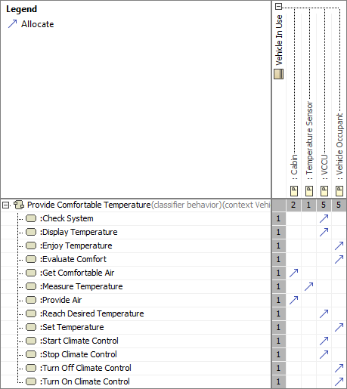

1. BB Functions To Context

## Cool Down Cabin Air

NA

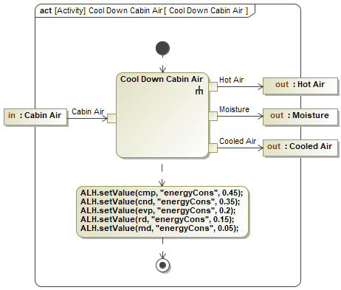

1. Cool Down Cabin Air

## Cool Down Cabin Air

NA

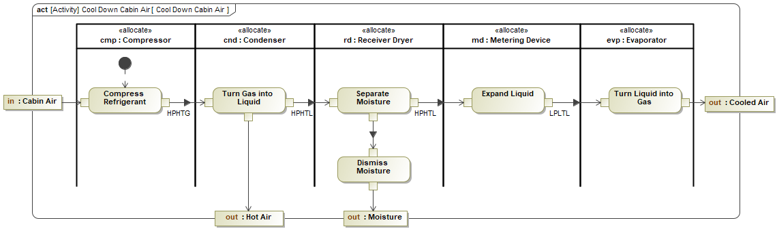

1. Cool Down Cabin Air

## Cooling System Logical Components

NA

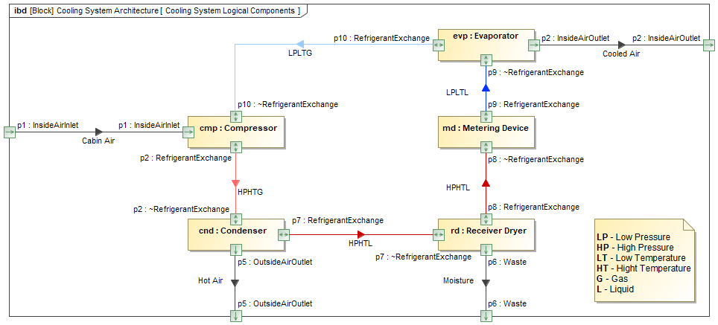

1. Cooling System Logical Components

## Cooling System States

NA

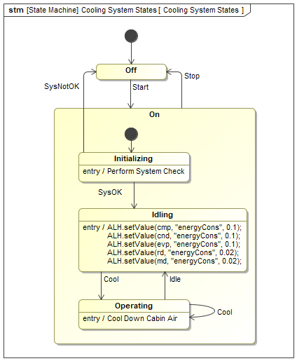

1. Cooling System States

## Cooling System Structure

NA

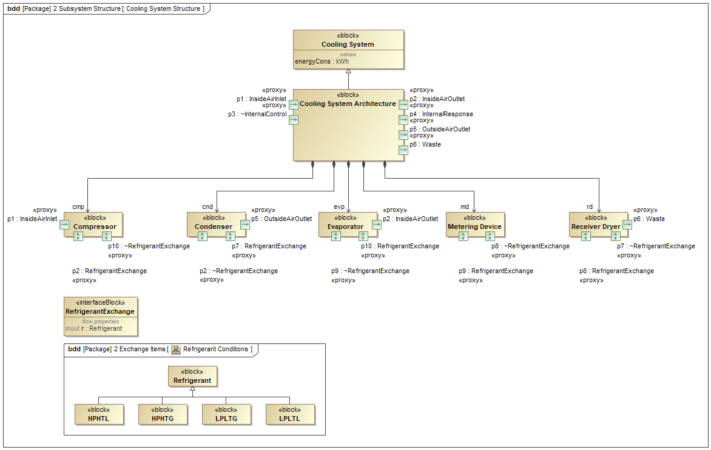

1. Cooling System Structure

## CP System States

NA

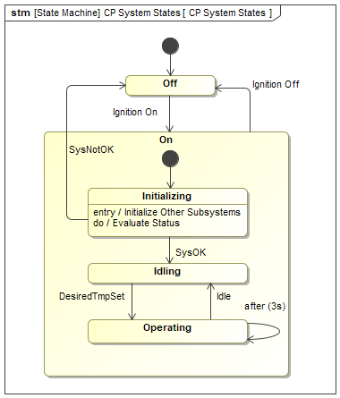

1. CP System States

## CP System Structure

NA

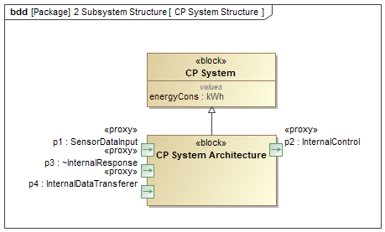

1. CP System Structure

## Evaluate Status

NA

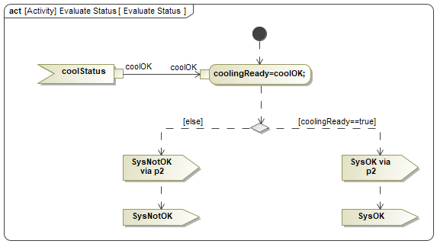

1. Evaluate Status

## Evaluate Status

NA

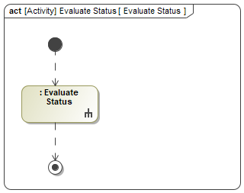

1. Evaluate Status

## Exchange Items

NA

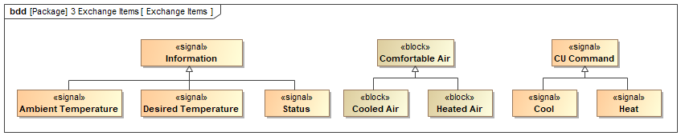

1. Exchange Items

## Exchange Items

NA

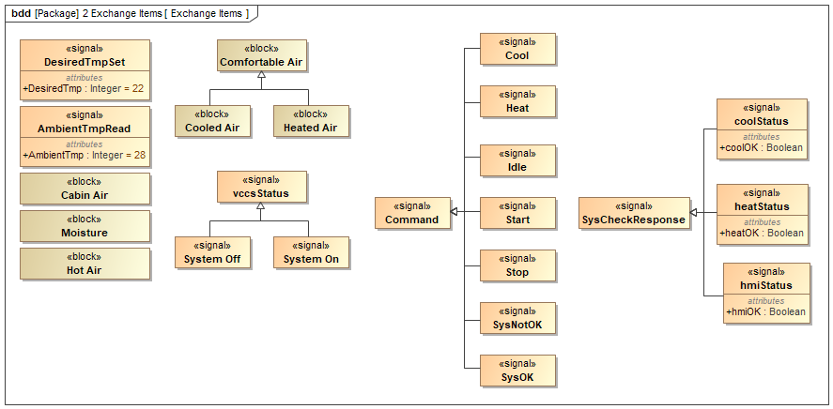

1. Exchange Items

## From SNs to SRS

NA

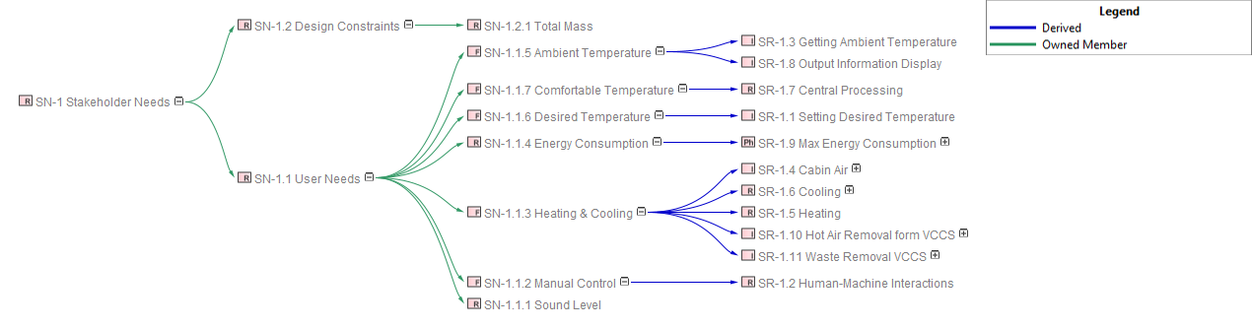

1. From SNs to SRS

## From Stakeholder Needs to Physical Requirements

NA

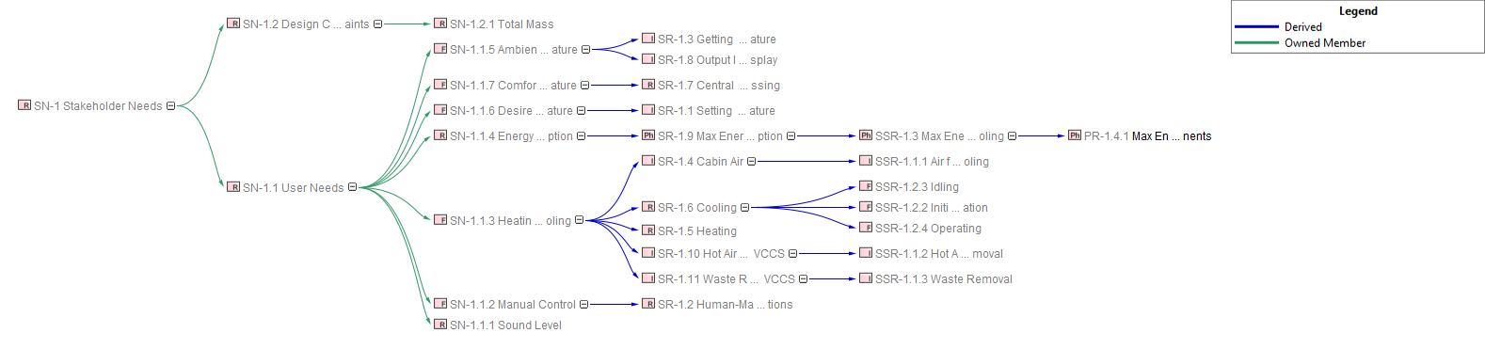

1. From Stakeholder Needs to Physical Requirements

## From Stakeholder Needs to Subsystem Requirements

NA

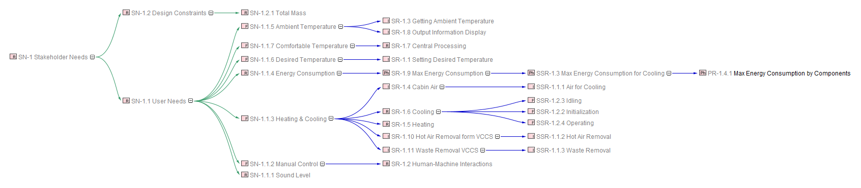

1. From Stakeholder Needs to Subsystem Requirements

## Implementation Requirements for Cooling System

NA

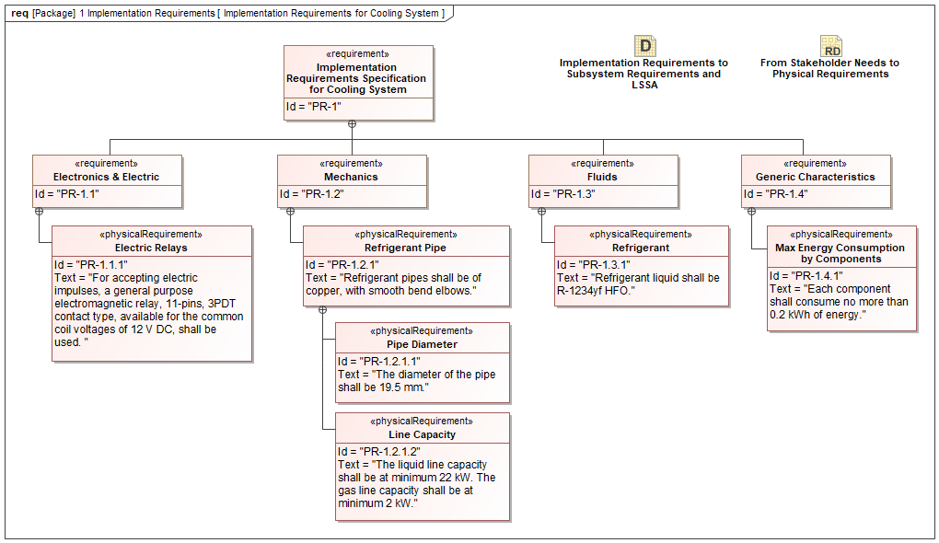

1. Implementation Requirements for Cooling System

## Implementation Requirements to Subsystem Requirements and LSSA

NA

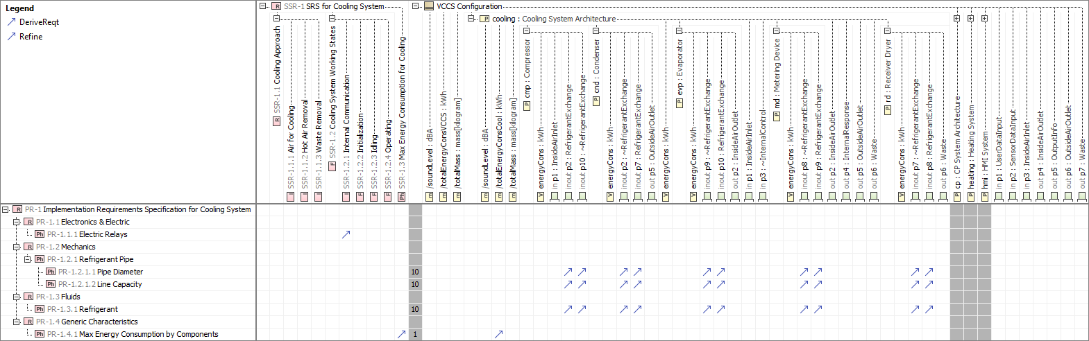

1. Implementation Requirements to Subsystem Requirements and LSSA

## Index

NA

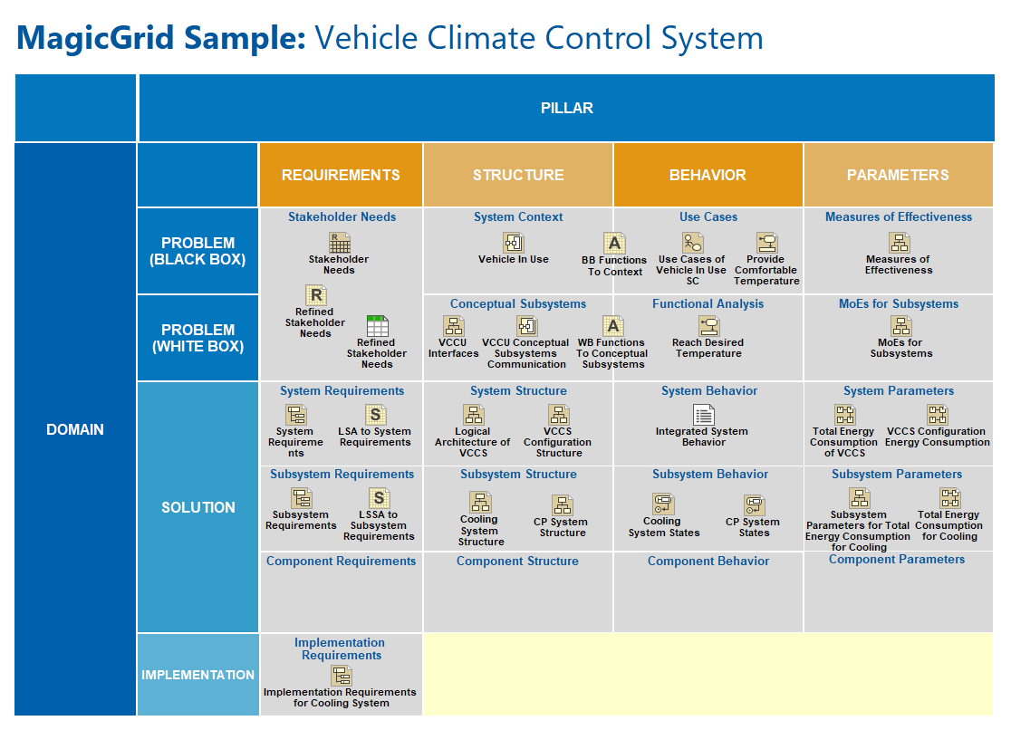

1. Index

## Initialize Other Subsystems

NA

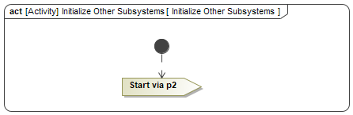

1. Initialize Other Subsystems

## Initialize Other Subsystems

NA

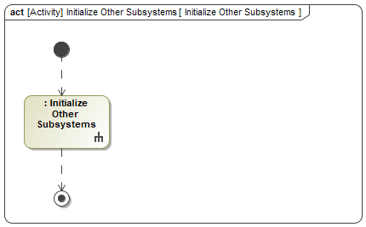

1. Initialize Other Subsystems

## Integrated System Behavior

NA

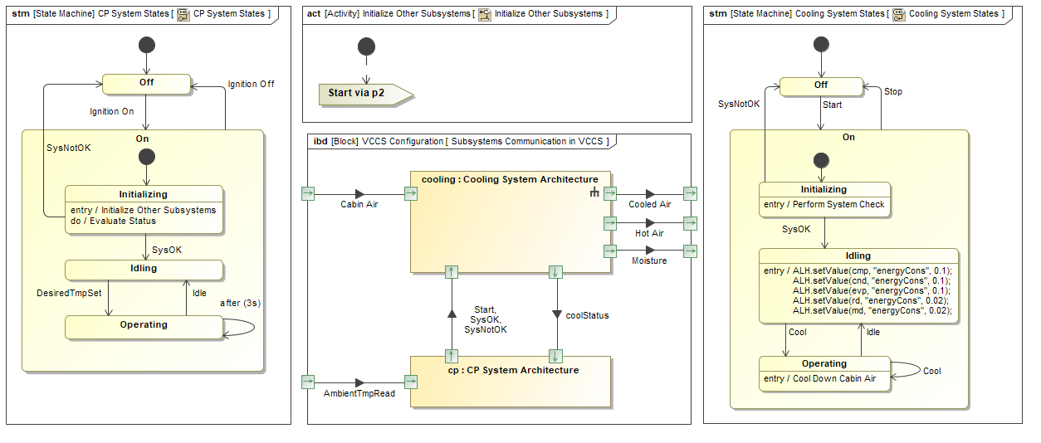

1. Integrated System Behavior

## Logical Architecture of VCCS

NA

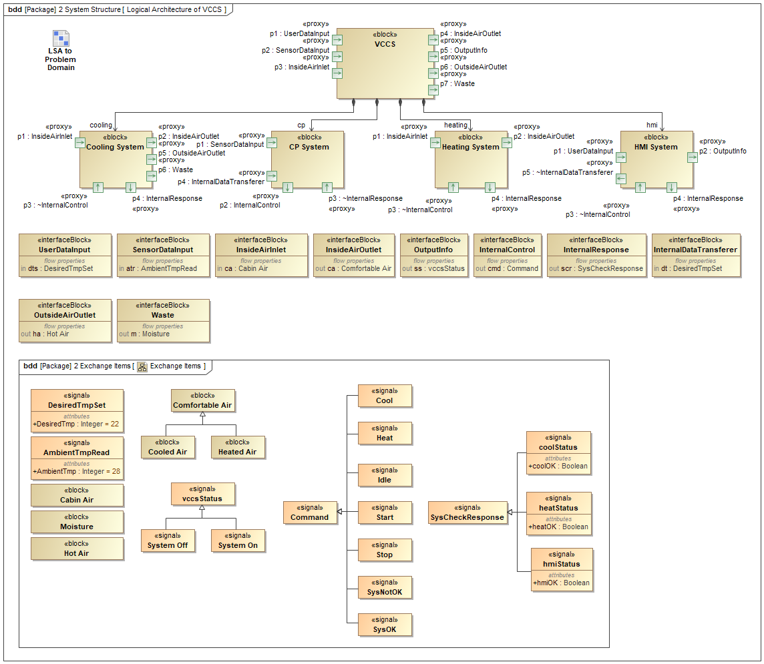

1. Logical Architecture of VCCS

## Logical Architecture of VCCS without Interfaces

NA

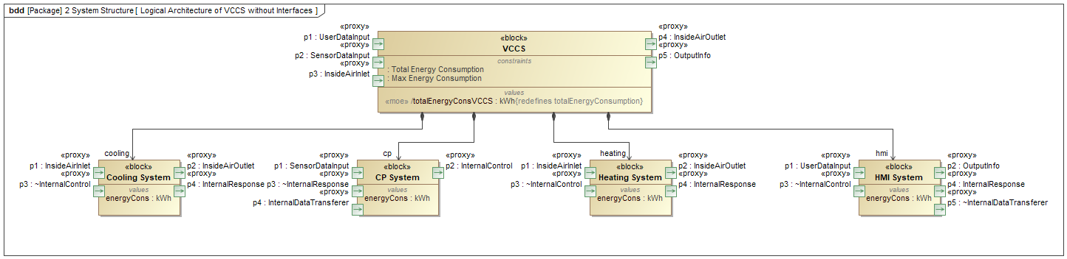

1. Logical Architecture of VCCS without Interfaces

## LSA to Problem Domain

NA

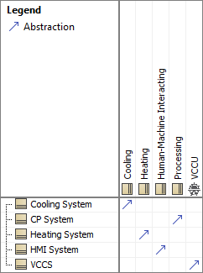

1. LSA to Problem Domain

## LSA to System Requirements

NA

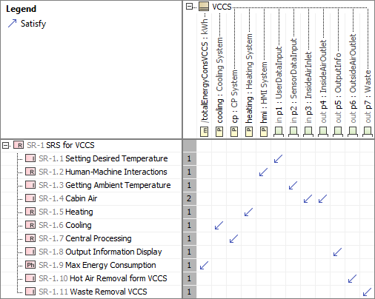

1. LSA to System Requirements

## LSSA to Subsystem Requirements

NA

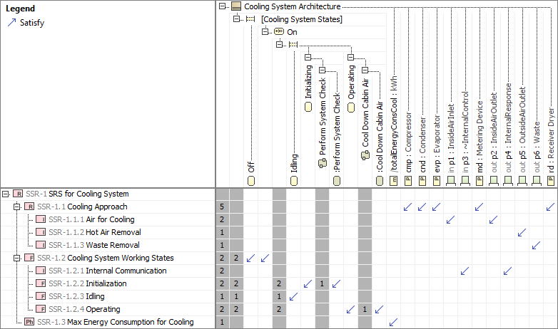

1. LSSA to Subsystem Requirements

## Measures of Effectiveness

NA

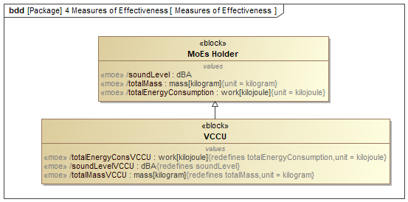

1. Measures of Effectiveness

## MoEs for Subsystems

NA

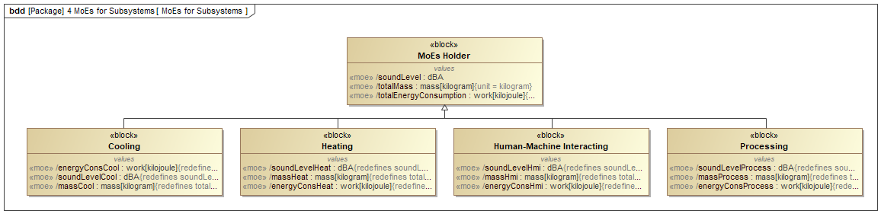

1. MoEs for Subsystems

## New System Requirements

NA

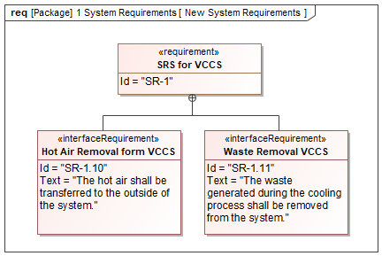

1. New System Requirements

## Perform System Check

NA

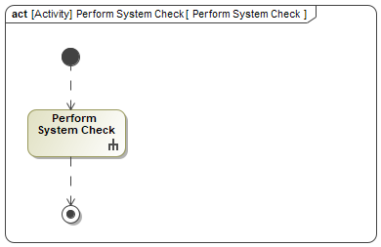

1. Perform System Check

## Perform System Check

NA

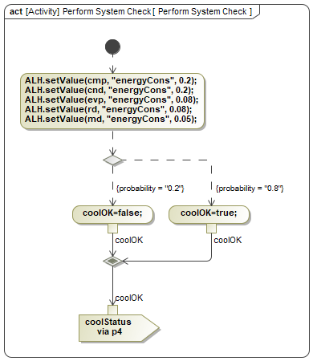

1. Perform System Check

## Processing Subsystem Interfaces

NA

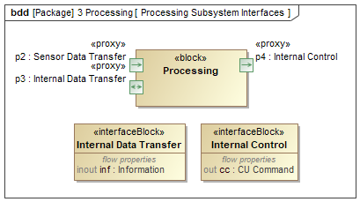

1. Processing Subsystem Interfaces

## Provide Comfortable Temperature

NA

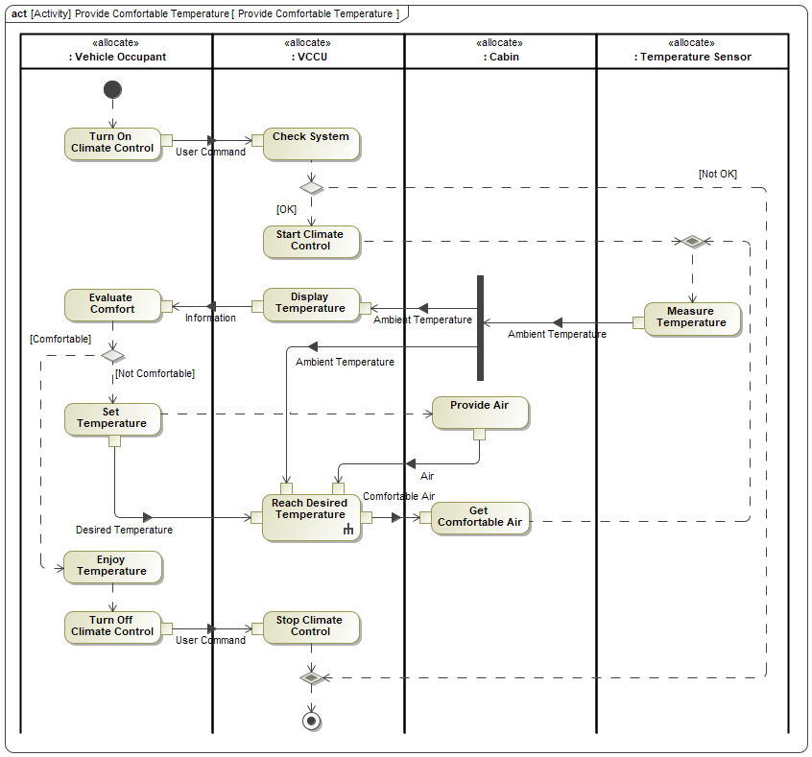

1. Provide Comfortable Temperature

## Provide Comfortable Temperature

NA

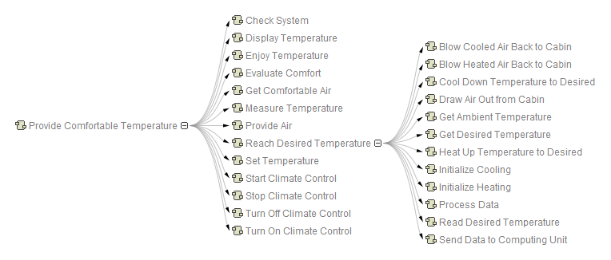

1. Provide Comfortable Temperature

## Reach Desired Temperature

NA

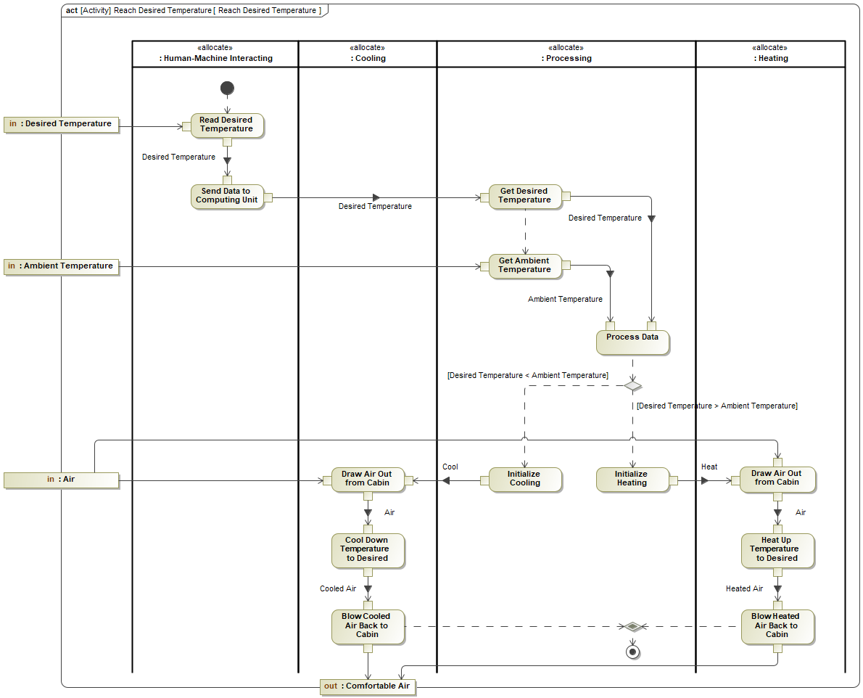

1. Reach Desired Temperature

## Refined Stakeholder Needs

NA

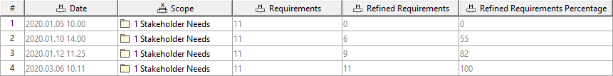

1. Refined Stakeholder Needs

## Refined Stakeholder Needs

NA

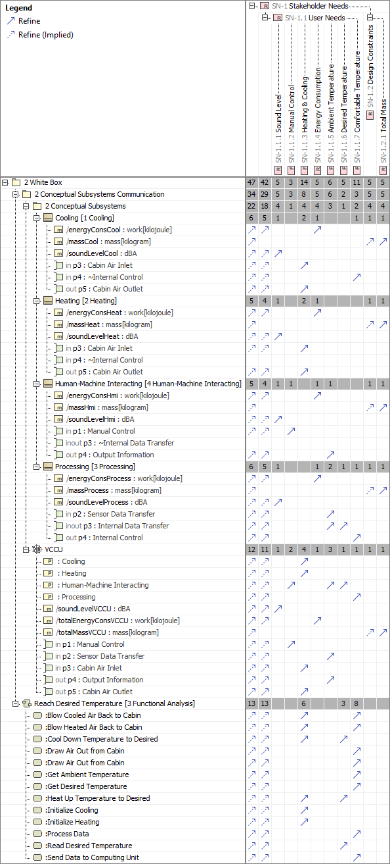

1. Refined Stakeholder Needs

## Refrigerant Conditions

NA

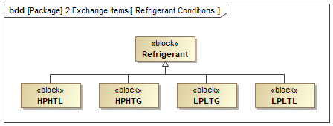

1. Refrigerant Conditions

## Satisfied Subsystem Requirements

NA



1. Satisfied Subsystem Requirements

## Satisfied System Requirements

NA



1. Satisfied System Requirements

## Scope for Auto-completion and Type Selection

NA

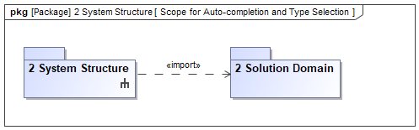

1. Scope for Auto-completion and Type Selection

## Scope for System Configuration

NA

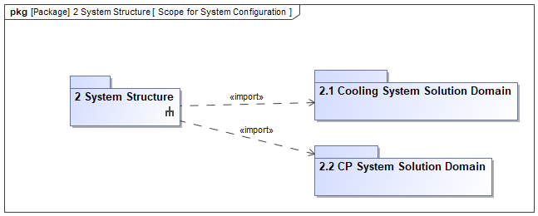

1. Scope for System Configuration

## Scope for Type Selection

NA

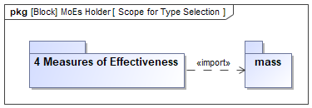

1. Scope for Type Selection

## Stakeholder Needs

NA

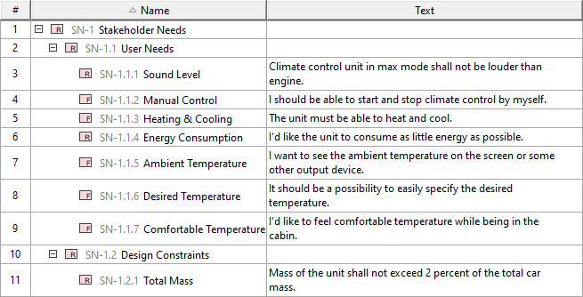

1. Stakeholder Needs

## Subsystem Parameters for Total Energy Consumption for Cooling

NA

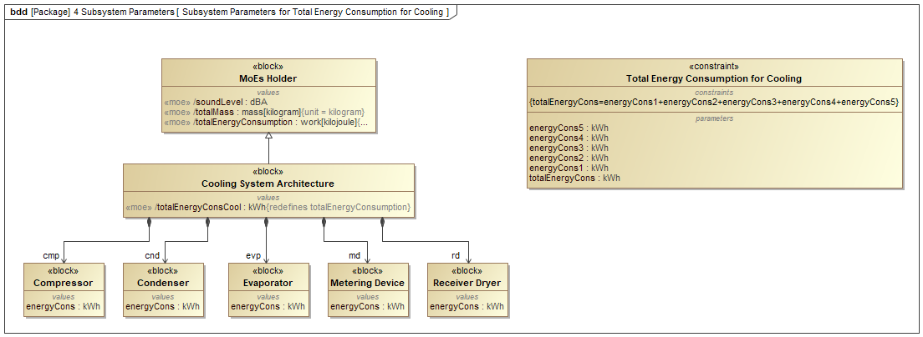

1. Subsystem Parameters for Total Energy Consumption for Cooling

## Subsystem Requirements

NA

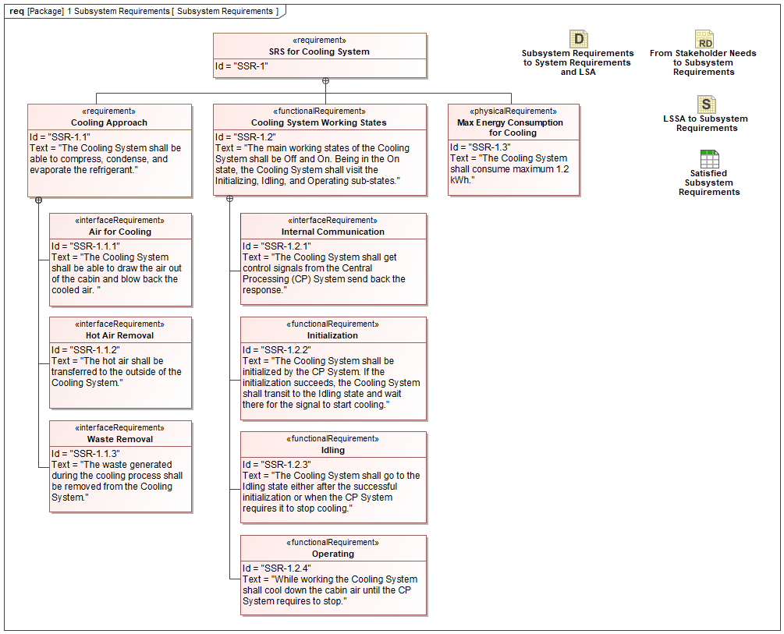

1. Subsystem Requirements

## Subsystem Requirements Formalized

NA

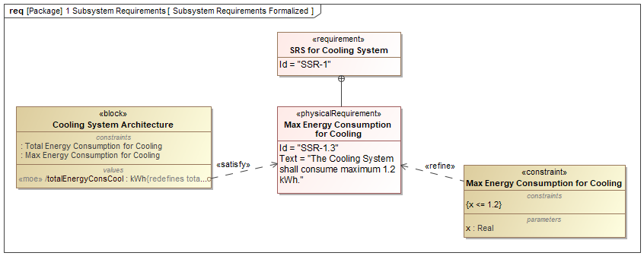

1. Subsystem Requirements Formalized

## Subsystem Requirements to System Requirements and LSA

NA

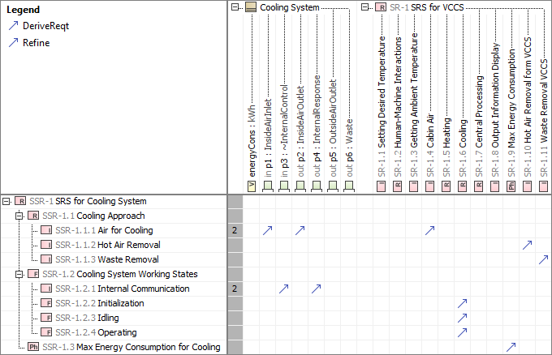

1. Subsystem Requirements to System Requirements and LSA

## Subsystems Communication in VCCS

NA

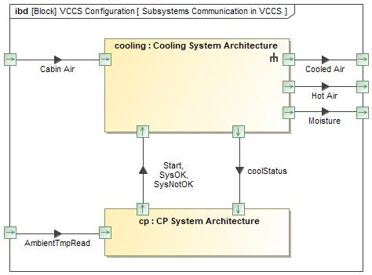

1. Subsystems Communication in VCCS

## System Configuration to System Requirements

NA

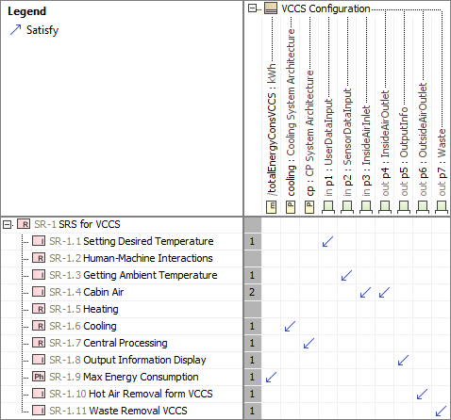

1. System Configuration to System Requirements

## System Parameters for Total Energy Consumption

NA

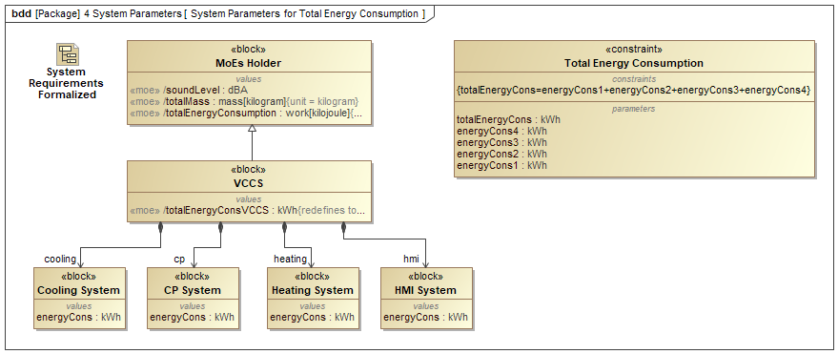

1. System Parameters for Total Energy Consumption

## System Requirements

NA

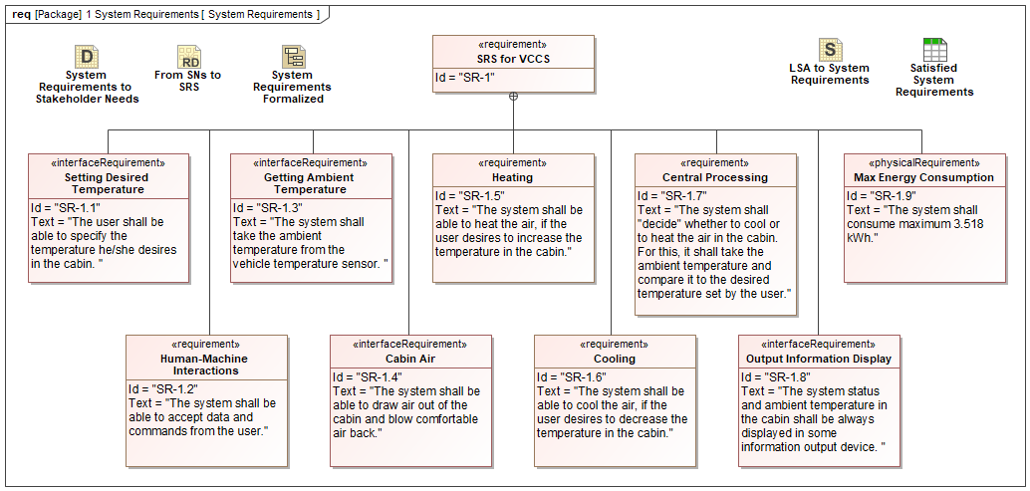

1. System Requirements

## System Requirements Formalized

NA

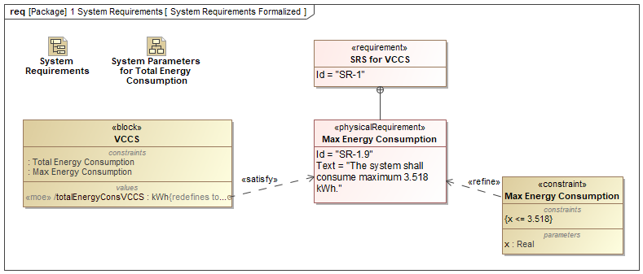

1. System Requirements Formalized

## System Requirements to Problem Domain

NA

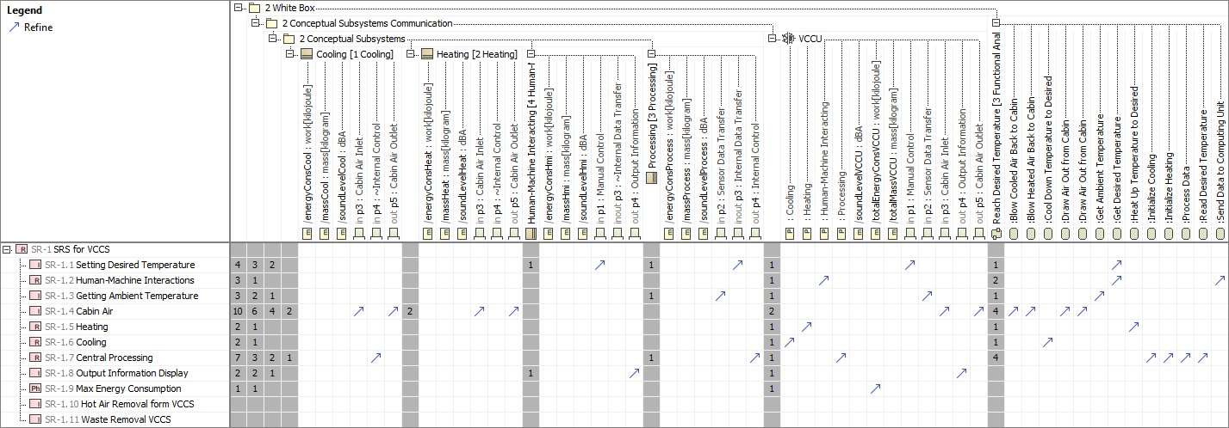

1. System Requirements to Problem Domain

## System Requirements to Stakeholder Needs

NA

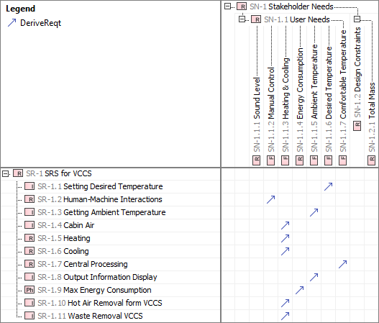

1. System Requirements to Stakeholder Needs

## Total Energy Consumption for Cooling

NA

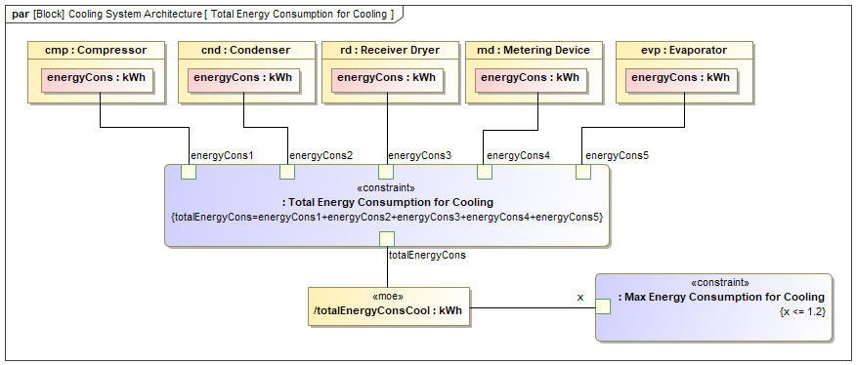

1. Total Energy Consumption for Cooling

## Total Energy Consumption of VCCS

NA

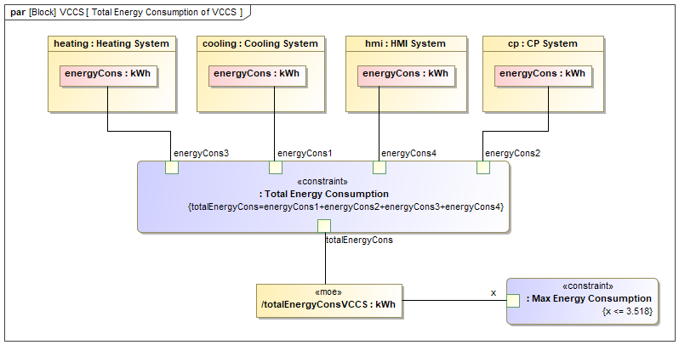

1. Total Energy Consumption of VCCS

## Total Energy Consumption Values

NA

846899283.png

1. Total Energy Consumption Values

## Total Energy Consumption Values

NA

-1690319122.png

1. Total Energy Consumption Values

## Use Cases of Vehicle In Use SC

NA

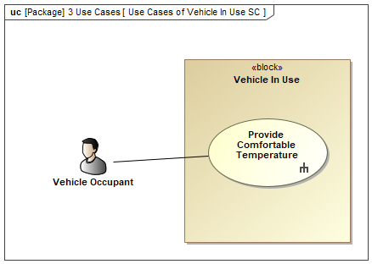

1. Use Cases of Vehicle In Use SC

## VCCS Configuration Energy Consumption

NA

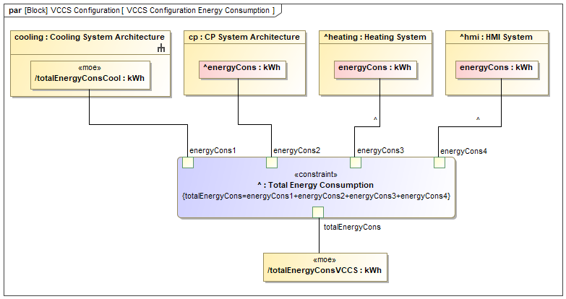

1. VCCS Configuration Energy Consumption

## VCCS Configuration Structure

NA

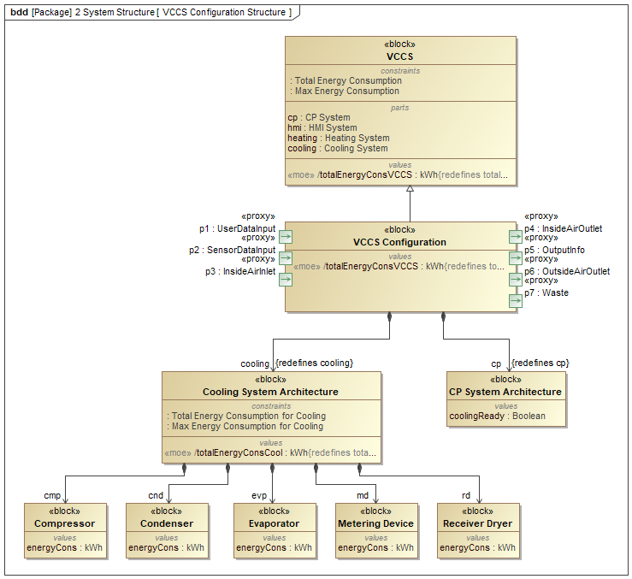

1. VCCS Configuration Structure

## VCCS Configuration Structure

NA

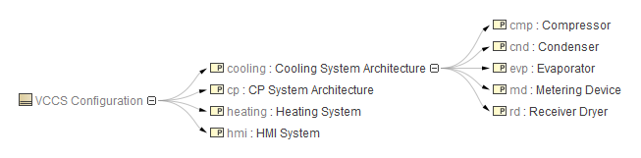

1. VCCS Configuration Structure

## VCCU Conceptual Subsystems Communication

NA

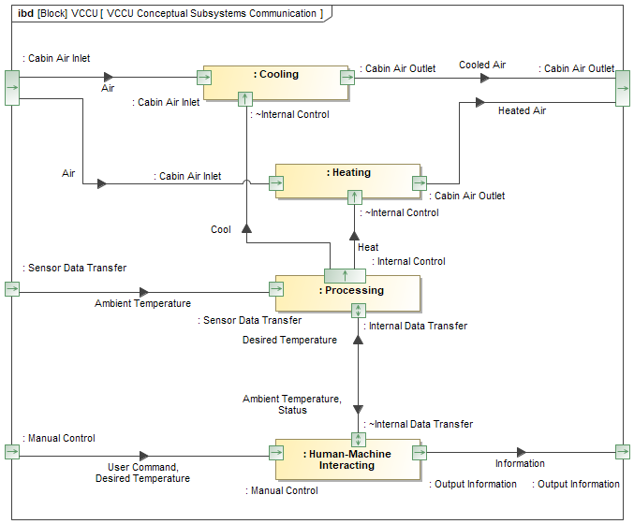

1. VCCU Conceptual Subsystems Communication

## VCCU ICD Whitebox

NA

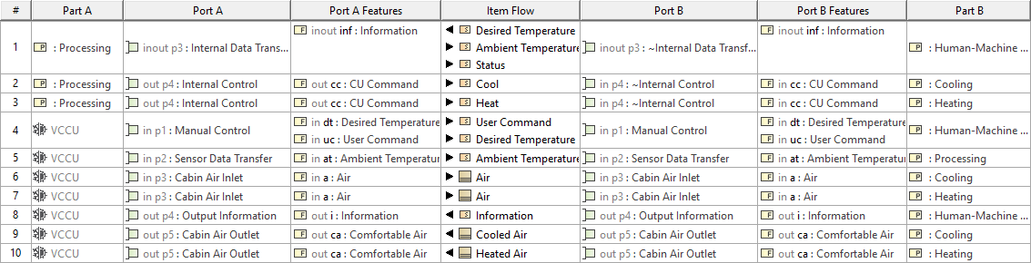

1. VCCU ICD Whitebox

## VCCU Interfaces

NA

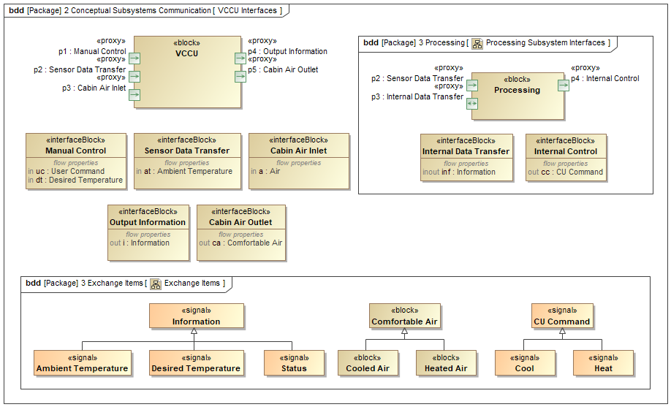

1. VCCU Interfaces

## Vehicle In Use

NA

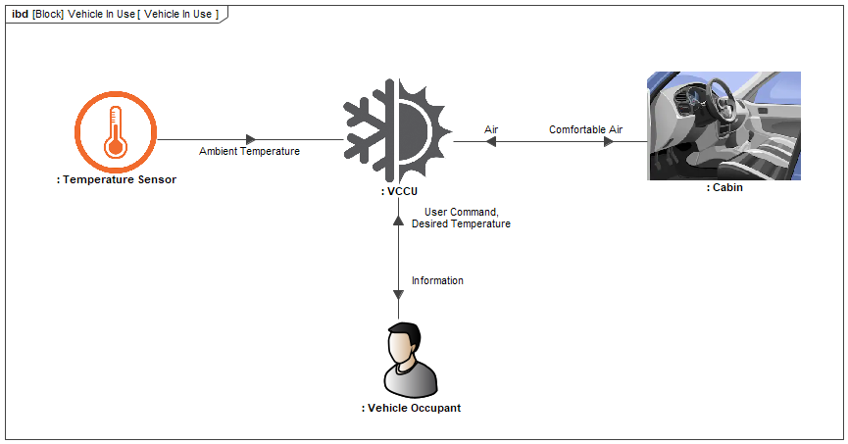

1. Vehicle In Use

## WB Functions To Conceptual Subsystems

NA

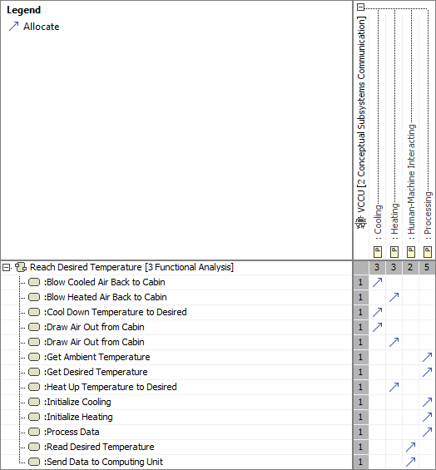

1. WB Functions To Conceptual Subsystems