|  |  |
| --- | --- |
| Identification:  Document Revision |  |
| Date: |  |
| Cage Code: |  |

|  |
| --- |
| **Customer: N/A** |
|  |
| **User/Stakeholder Requirements**  **VCCS (MG BoK v2 Sample)** |
|  |
|  |

|  |  |
| --- | --- |
| **No. pagine /**  **Nr. of pages** | **Classificazione / Classification** |
| 23 | NON CLASSIFICATO / UNCLASSIFIED |
|  | NON CLASSIFICATO CONTROLLATO / UNCLASSIFIED CONTROLLED |
|  | RISERVATO / RESTRICTED |
|  | RISERVATISSIMO / CONFIDENTIAL |
|  | SEGRETO / SECRET |
| **23** | **No. totale delle pagine / Total nr. of pages** |

**Document Authority**

|  |  |
| --- | --- |
|  |  |
|  |  |
|  |  |
|  |  |

**Point of Contact**

|  |  |
| --- | --- |
|  |  |

**REVISION RECORD**

|  |  |  |  |  |
| --- | --- | --- | --- | --- |
| **Rev.** | **Modification No.** | **Date** | **Description** | **Author/s** |
|  |  |  |  |  |
|  |  |  |  |  |

Sommario

1 Introduction 1

1.1 Purpose 1

1.2 Scope 1

1.3 Overview 1

2 1Problem Domain 2

2.1 1 Black Box 2

2.1.1 1 Stakeholder Needs 2

2.1.2 2 System Context 3

2.1.3 3 Use Cases 3

2.1.4 4 Measures of Effectiveness 3

2.2 3

2.3 Measures of Effectiveness 4

2.4 Provide Comfortable Temperature 4

2.5 Scope for Type Selection 5

2.6 Stakeholder Needs 6

2.7 Subsystem Parameters for Total Energy Consumption for Cooling 6

2.8 Use Cases of Vehicle In Use SC 6

2.9 VCCS Configuration Energy Consumption 7

2.10 Vehicle In Use 8

**Executive Summary**

User/Stakeholder Requirements

# Introduction

## Purpose

<This document provides requirements with their properties including requirement id, requirement name, requirement text and the dependencies.>

## Scope

<Provide a short description of the system being specified and its purpose, including relevant benefits, objectives, and goals.>

## Overview

<Describe what the document contains and explain how the document is organized>

# 1Problem Domain

## 1 Black Box

### 1 Stakeholder Needs

#### 1 Stakeholder Needs Metrics1

#### SN-1 Stakeholder Needs

##### SN-1.1 User Needs

###### SN-1.1.1 Sound Level

Climate control unit in max mode shall not be louder than engine.

###### SN-1.1.2 Manual Control

I should be able to start and stop climate control by myself.

###### SN-1.1.3 Heating & Cooling

The unit must be able to heat and cool.

###### SN-1.1.4 Energy Consumption

I'd like the unit to consume as little energy as possible.

###### SN-1.1.5 Ambient Temperature

I want to see the ambient temperature on the screen or some other output device.

###### SN-1.1.6 Desired Temperature

It should be a possibility to easily specify the desired temperature.

###### SN-1.1.7 Comfortable Temperature

I'd like to feel comfortable temperature while being in the cabin.

##### 

##### SN-1.2 Design Constraints

###### SN-1.2.1 Total Mass

Mass of the unit shall not exceed 2 percent of the total car mass.

|  |  |
| --- | --- |
|  |  |
|  |  |

### 2 System Context

#### 1 Users & Other Systems

### 3 Use Cases

### 4 Measures of Effectiveness

## 

1. Index

## Measures of Effectiveness

NA

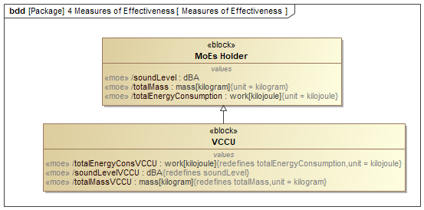

1. Measures of Effectiveness

## Provide Comfortable Temperature

NA

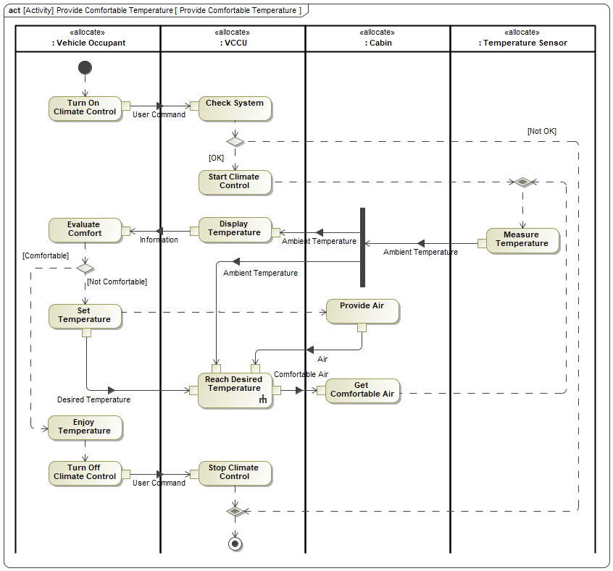

## Scope for Type Selection

NA

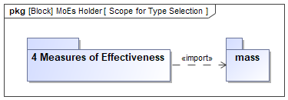

1. Scope for Type Selection

## Stakeholder Needs

NA

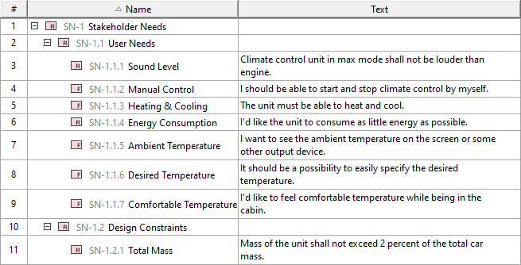

1. Stakeholder Needs

## Subsystem Parameters for Total Energy Consumption for Cooling

NA

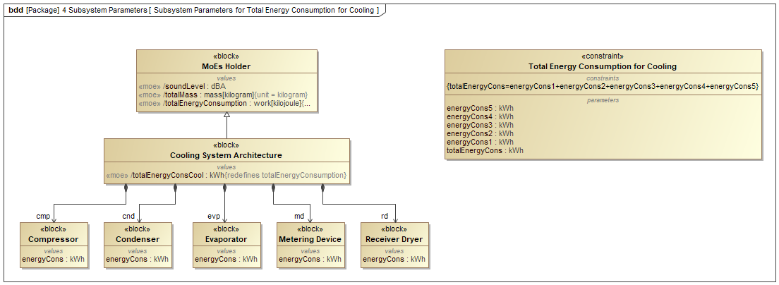

1. Subsystem Parameters for Total Energy Consumption for Cooling

## Use Cases of Vehicle In Use SC

NA

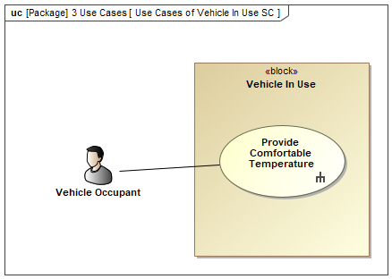

1. Use Cases of Vehicle In Use SC

## VCCS Configuration Energy Consumption

NA

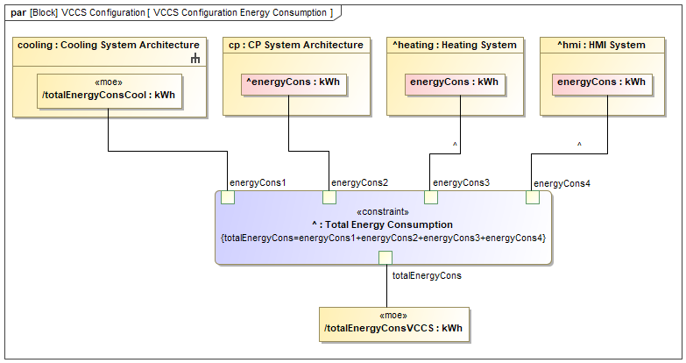

1. VCCS Configuration Energy Consumption

## Vehicle In Use

NA

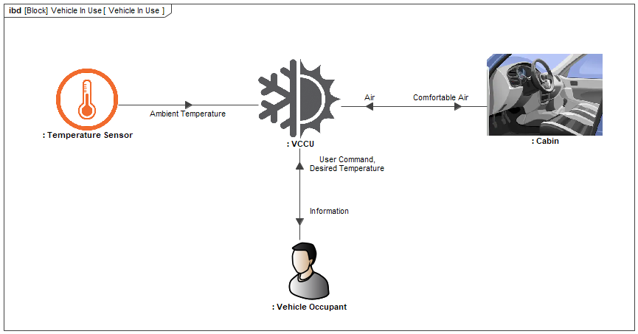

1. Vehicle In Use