**Course Description**

In this two morning or one day course we will show you how to prepare and conduct spatial analysis on a variety of spatial data in R, including a range of spatial overlays and data processing techniques. We will also cover how to use GeoDa to perform exploratory spatial data analysis, including making use of linked displays and measures of spatial autocorrelation and clustering.

This course is ideal for anyone who wishes to build on their existing spatial data and GIS knowledge or R scripting knowledge. It gives you the skills to answer questions using your data, and understand the advantages and limitations of this type of spatial data analysis.

*This course can follow-on from the ‘Introduction to Spatial Data & Using R as a GIS’ course, or be run independently if participants have some previous knowledge of R / RStudio and spatial data.*

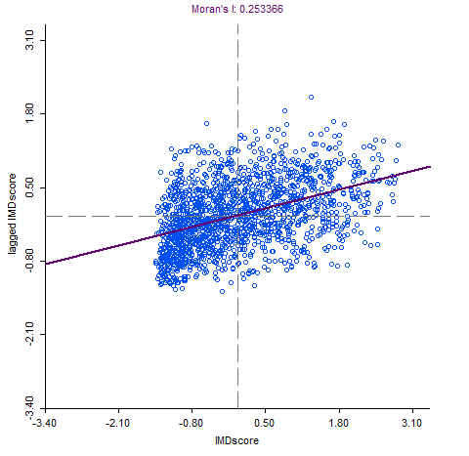

**Learning Outcomes**

* Understand linked displays in GeoDa
* Be able to interpret Spatial Autocorrelation
* Perform Local Indicators of Spatial Autocorrelation
* Calculate Moran’s I and LISA in R
* Perform Point in Polygon analysis
* Know how to reorder data
* Know how to use buffers within R
* Pros and cons of using point or polygon data

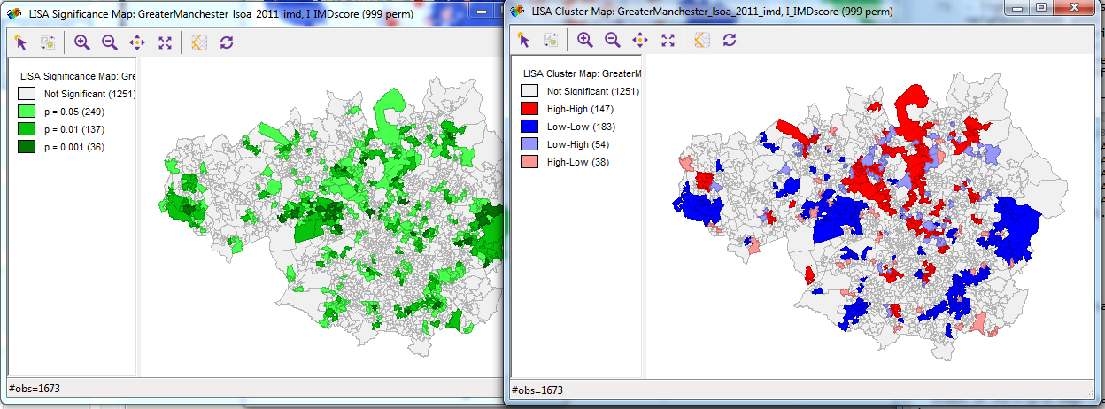**Outline: Day 1**

* 10:00am – 10:30am – Spatial data and EDA
* 10:30am – 11:00am – Spatial statistics
* 11:15am – 11:30am – Location and regression
* 12:00pm – 1:00pm – Spatial decision making

**Outline: Day 2**

* 10:00am – 10:20am – Recap
* 10:20am – 11:30am – Spatial decision making
* 11:45am – 1:00pm – Bring your own data

*“The materials were good. Nick did a good job as trainer. Just enough details in the notes and lots of help if needed.”*

- Advanced R Course, Liverpool

Have a look at [www.nickbearman.com](http://www.nickbearman.com) or contact me for more details

Dr Nick Bearman | +44 (0) 7717 745715 | [nick@nickbearman.com](mailto:nick@nickbearman.com)