**Course Description**

In this two half day or one day introductory course we will give you an overview on how GIS works, and what we can and can’t do with spatial data. We assume no prior knowledge of GIS and will explain how to get data into the GIS as well as how to produce maps using your own data.

This course is ideal for anyone who wishes to use spatial data in their role, including researchers, students and anyone who has data with some spatial information (e.g. address, postcode, etc.) which they wish to show on a map. It is also suitable for those who wish to have an overview of what GIS and spatial data can be used for.

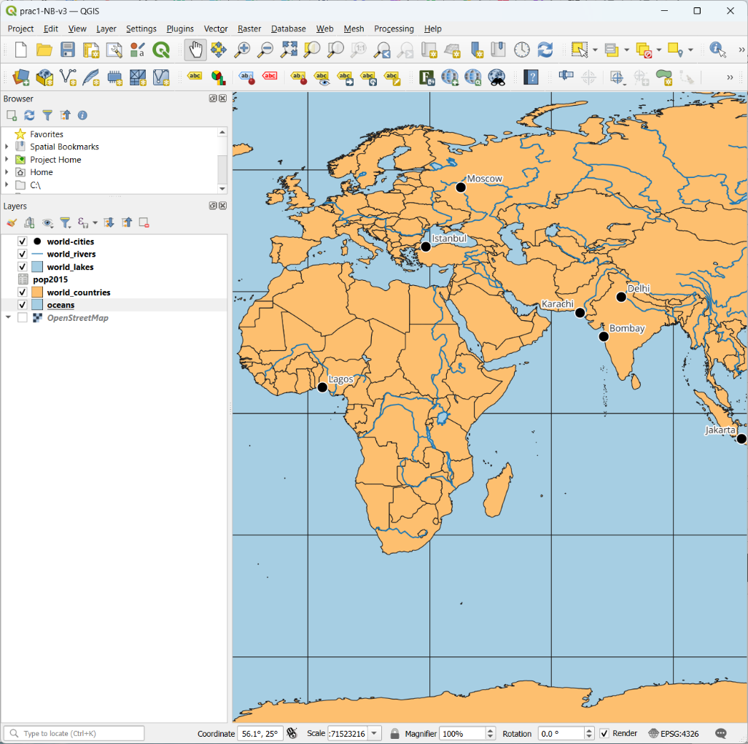

This course requires no prior knowledge of GIS or spatial data. A level of basic computer experience is required.

**Learning Outcomes**

* Be able to open QGIS and add data
* Understand how to add data with latitude & longitude coordinates
* Join tabular data to spatial data
* Be able to undertake calculations
* 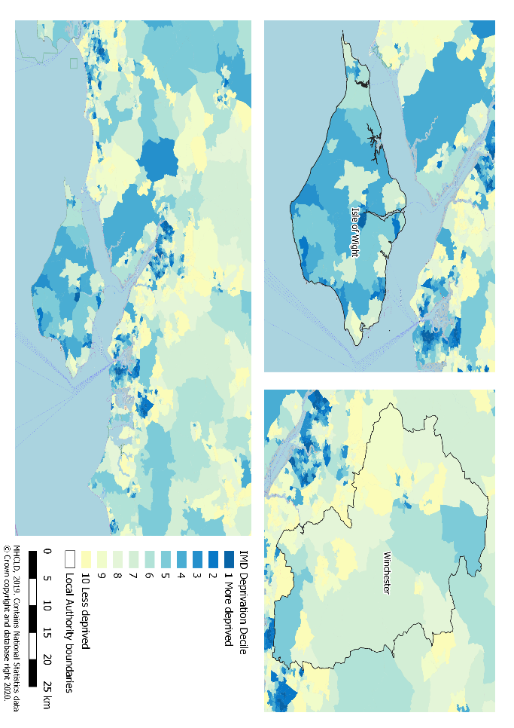Understand how to classify data for a choropleth map
* Designing and producing a publication-ready map in QGIS

**Outline: Day 1**

* 10:00am – 10:45am – What is GIS?
* 10:45am – 11:30am – Intro to QGIS
* 11:45am – 12:15pm – Classification
* 11:45am – 12:30pm – Intro to QGIS

**Outline: Day 2**

* 10:00am – 10:20am – Map design
* 10:20pm – 11:30am – IMD map
* 11:45am – 12:20pm – Creating data
* 12:20pm - 1:00pm – Your own data

 *“I love having a workbook to go through, it’s how I learn best.   
Also, perfect balance between presentation and practical work.”*   
Harriet Ann Patrick, PhD Researcher, University of Sheffield

Have a look at [www.nickbearman.com](http://www.nickbearman.com) or contact me for more details

Dr Nick Bearman | +44 (0) 7717 745715 | [nick@nickbearman.com](mailto:nick@nickbearman.com)