**Course Description**

In this two half day or one day course we will explore how to use R to import, manage and process spatial data. We will also cover the process of making choropleth maps, as well as some basic spatial analysis. Finally, we will cover the use of loops to make multiple maps quickly and easily, one of the major benefits of using a scripting language to make maps, rather than traditional graphic point-and-click interface.

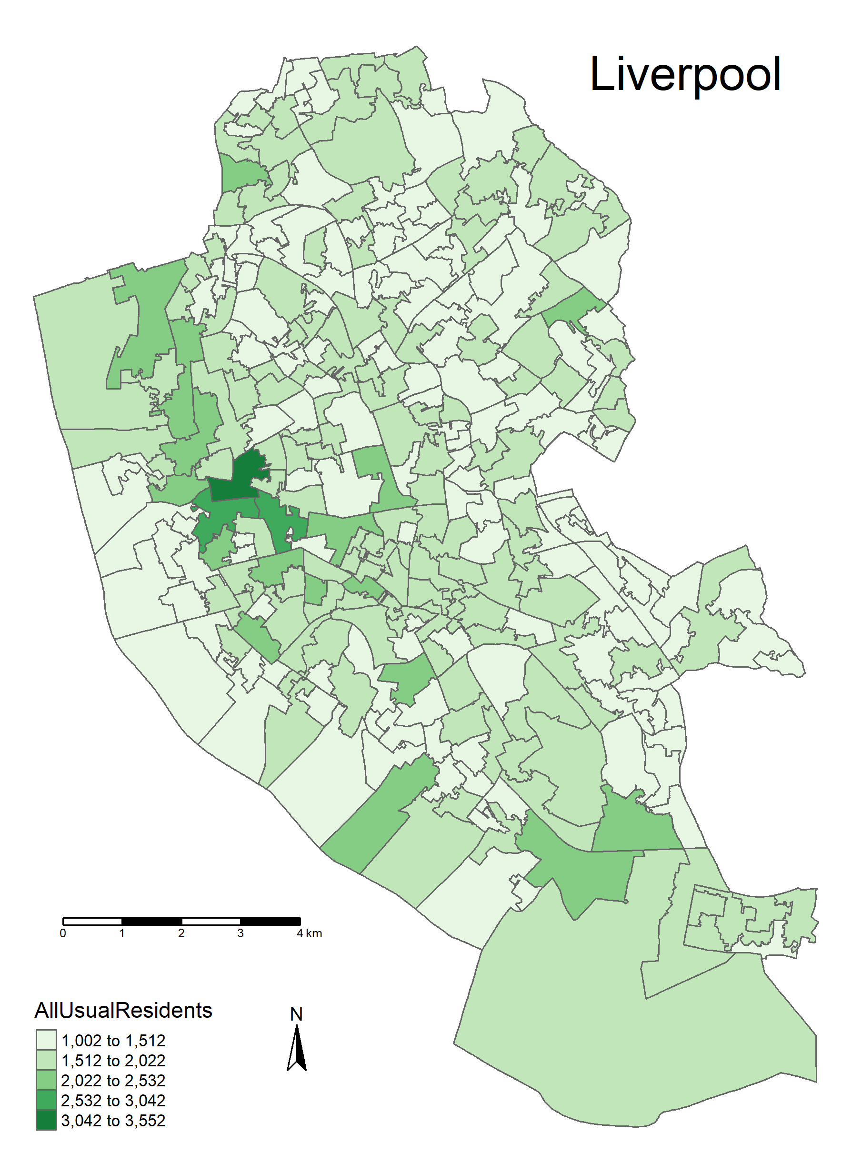This course is ideal for anyone who wishes to use spatial data in their role, including researchers, students and anyone who has data with some spatial information (e.g. address, postcode, etc.) which they wish to show on a map. It is also suitable for those who wish to have an overview of what GIS and spatial data can be used for.

*No previous experience of coding is required, although participants would benefit from some experience of using spatial data (e.g. Google Maps).*

**Learning Outcomes**

* Use R to read in CSV data & spatial data
* Know how to plot spatial data using R
* Join spatial data to attribute data
* Customize colour and classification methods
* Understand how to use loops to make multiple maps
* Know how to reproject spatial data
* Be able to perform point in polygon operations
* Know how to write shape files
* Know how create a 'heat-map' using point data

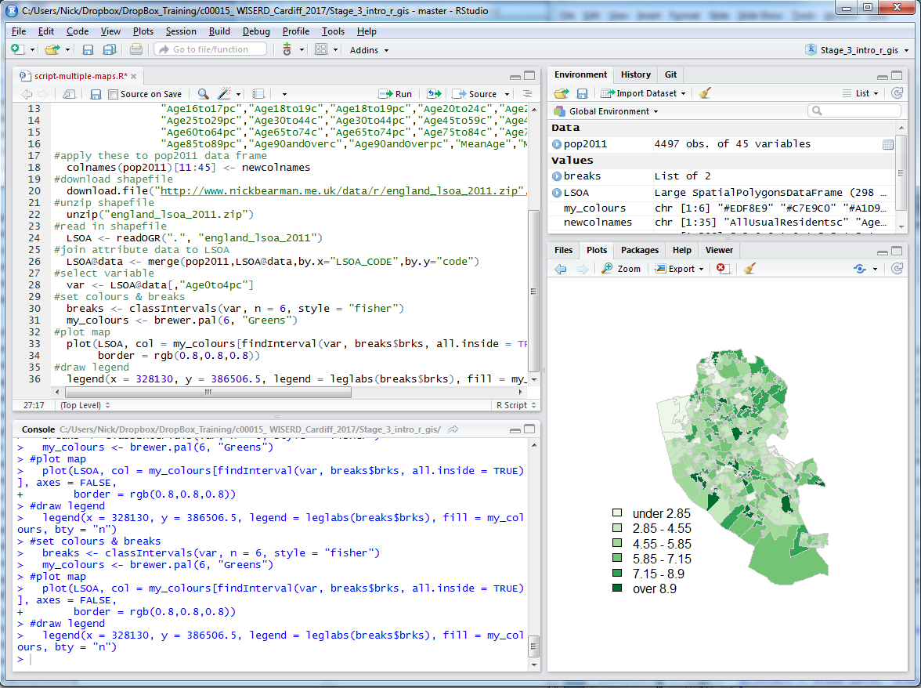

**Outline: Day 1**

* 10:00am – 10:45am – What is GIS & R?
* 10:45am - 11:30am – Intro to GIS & R
* 11:30am – 11:50am – Classification
* 11:50am – 1:00pm – Making a Map

**Outline: Day 2**

* 10:00am – 10:20am – Making Maps
* 10:20am – 11:30am – Clustering of Points
* 11:45am – 1:00pm – Bring your own data

 *“I was hugely impressed with the session Nick had put together. I came to the course with very little experience with either spatial analysis or using R, nevertheless,   
Nick’s course works for a genuinely mixed ability audience. I have returned to the office with a much higher skill level and a confidence to get stuck in. Thanks Nick!”*– Lois Aspinall, Using R for Spatial Analysis, London

Have a look at [www.nickbearman.com](http://www.nickbearman.com) or contact me for more details

Dr Nick Bearman | +44 (0) 7717 745715 | [nick@nickbearman.com](mailto:nick@nickbearman.com)