**Evaluating the Use of Sound to Help Representation of Distance in a Landscape Visualisation Setting**

Nick Bearman1 (now 2), Andrew Lovett1

1School of Environmental Sciences, University of East Anglia, Norwich, NR4 7TJ

Tel: +44 (0)7717 745715 Fax: +44(0)1603 591327

2European Centre for Environment and Human Health, Peninsula College of Medicine and Dentistry, Knowledge Spa, Royal Cornwall Hospital, Truro, Cornwall, TR1 3HD

Email: n.bearman@uea.ac.uk, a.lovett@uea.ac.uk, www.nickbearman.me.uk

**Summary:** This work evaluates the use of piano notes and bird calls to help represent distance to wind turbines in a landscape visualisation. Visualisations were shown to a variety of Geographic Information professionals (n = 45). Using sound and vision together was significantly more successful than vision alone (p < 0.001) and piano notes were generally more successful than bird calls. A binary logistic regression analysis showed that participants who pay attention to sounds and number of attempts were significant factors for most of the methods.

**KEYWORDS:** sonification, landscape visualisation, distance perception, Geographic Information professionals

**1. Introduction**

The representation of distance in landscape visualisation is often difficult to understand and use of sound may help users. This work forms the third case study of the authors PhD, following the first two case studies which were also presented at GISRUK evaluating the use of sound to represent uncertainty in ArcGIS (Bearman & Lovett, 2010) and Google Maps (Bearman & Appleton, 2011).

**2. Literature Review**

Landscape visualisation is increasingly used in planning to assess the potential visual impact of a development (Appleton & Lovett, 2005). In recent years the use of computer based landscape visualisation has come to the forefront, providing many advantages (and some limitations) over traditional physical models and photomontages (Lange, 2011). Perception of landscape visualisations varies due to many characteristics (Appleton & Lovett, 2003) and distance is important interpret correctly. Visual methods of representing distance may detract from and/or obscure parts of the visualisation, whereas sound does not.

Sonification refers to the presentation of information using non-speech audio and covers many fields (Dubus 2011) but is relatively new to GIS. It is a way of representing complex data sets for analysis in a different way to visual methods and also a way of reinforcing data shown visually, resulting in better performance from users (Harrower, 2007). Sonification prototypes of spatial data have been created (Fisher, 1994; MacVeigh & Jacobson, 2007) but with limited user testing.

**3. Method**

Wind turbines were placed at distances between 800 and 3000m on a series of generated landscape visualisations using Visual Nature Studio 2.85 (3D Nature, 2011), based on literature data (Bishop, 2002) expert advice and a pilot study. All the turbines were 100m tall, based on a turbine located in Swaffham, Norfolk (Ecotricity, 2011) and a field of view of 60 degrees was used, standard for a wide angle lens (Sevenant & Antrop, 2011). For each visualisation (n = 18), participants were asked to estimate how many turbines were within 2000m. Table 1 lists the different types of visualisations and sounds used.

Evaluation sessions were run in small groups (2 to 8) with participants recruited from UEA, Ordnance Survey, UK Climate Impacts Programme, the Broads Authority and planners from Norfolk County Council (n = 45). A series of questions and visualisations shown on a projector, followed by a group discussion session. Answers were collected using an audience response system (TurningPoint, Reivo 2011) consisting of slides integrated into Microsoft PowerPoint and handheld keypads.

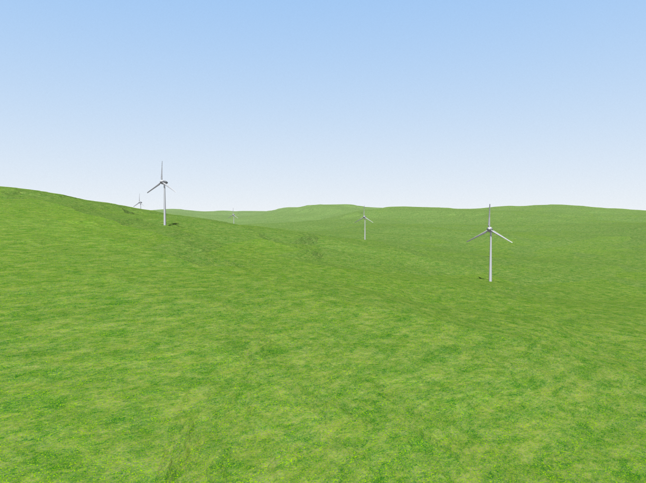

**Figure 1.** An example of one of the visualisations with five wind turbines.

**Table 1.** The different methods used and order they were shown in the evaluation. *As shown in Figure 1. #Demonstration of the sound available at http://www.nickbearman.me.uk/academic/ bearman_lovett_2012_gisruk/evaluation_demo.pptx (28MB).

|  |  |  |
| --- | --- | --- |
| **Method Name** | **Visual Element** | **Sonic Element** |
| Vision Only | Turbine visualisation* | (none) |
| Vision & Sound (Piano) | Turbine visualisation* | Note for each turbine played in sequence# |
| Sound Only (Piano) | (none) | Note for each turbine played in sequence# |
| Vision & Sound (Bird Call) | Turbine visualisation* | Note for each turbine played in sequence# |
| Sound Only (Bird Call) | (none) | Note for each turbine played in sequence# |
| Vision with Scale | Turbine visualisation, with turbine at distance of 1000m marked | (none) |

**4. Results & Analysis**

The number of turbines the participants thought were within 2000m was compared to the correct answer for each visualisation, with a value of 0 being correct, a negative value being an underestimation and a positive value being an overestimation.



**Figure 2.** The mean score for each method, with 0 being a perfect score, with error bars (± 2 standard errors). Sound Only (Piano) was the most successful and Vision Only the least successful.

Figure 2 shows the scores for each method for all participants. The most effective method was Sound Only (Piano), significantly better than any other methods (p<0.001) and Vision Only was the worst performer. These results are consistent with the discussion session, with Piano being rated as a more useful sound than Bird Calls.

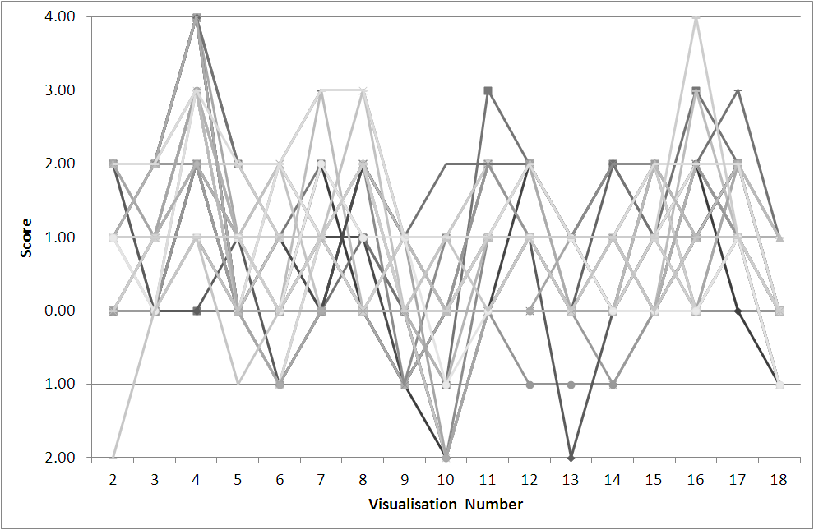

**Figure 3.** Graph of all responses in the evaluation. The visualisations are in the order completed, where 2-4 = Vision Only, 5-8 = Vision & Sound (Piano), 9-10 = Sound Only (Piano), 11-14 = Vision & Sound (Bird), 15-16 = Sound Only (Bird), 17-18 = Vision with Scale. Some methods overestimate (Sound Only [Bird]) and some underestimate (Sound Only [Piano]).

Figure 3 shows how the individual respondents’ answers vary over 18 visualisations, with the majority of answers between +2 and -1 (94.9%). There is a general trend of improvement within each group, particularly Vision & Sound (Bird). Participants were likely to overestimate the number of turbines. There were no significant differences between participants from different organisations or different levels of GIS knowledge.

A logistic regression model was created for each method, to predict if the user would select the correct number of turbines. For all methods using sound, the learning style question ‘You pay attention to the sounds of various things’ had a significant impact, with people who do pay attention performing less well. Attempt number also had an impact on the bird call methods, with later attempts being more successful than earlier ones. While the pattern seen with attempt number is unsurprising, the ‘Pay attention to sounds’ pattern is unexpected. An explanation for this is may be that people who do pay attention to sounds were concentrating on the sounds played to them rather than the task, so scored lower. However it is not an obvious finding to interpret and needs further research.

**5. Conclusion**

Overall the best performing method was Sound Only (Piano) with a mean score of -0.02, and using sound and vision combined was also very successful. Participants with higher GIS knowledge performed better, but this was a non significant. The regression analysis showed that the ability to listen to sounds and attempt number have an impact on the ability to use the sonification. Further research is required to refine the influence of subject knowledge and learning style.

Adding a second labelled turbine at 3000m to the Visual Only method would make the data more comparable to the other methods. The visualisations were not photo-realistic because of time restraints, but a truly photo-realistic visualisation does not necessarily result in better understanding of the landscape. Resources should be focused in the specific areas of the visualisation which have the most impact (Appleton & Lovett, 2003).

This work provides a contribution to the literature as an evaluation of sonification in an area where few have been completed, and shows that Piano notes are more effective than Bird Calls at representing this data. Sonification has wider applications in spatial data representation, where it is useful to present large or complex data sets that cannot be shown visually, and it may be more appropriate for some users than complex visual methods.

**Acknowledgements**

This research has been conducted as part of ESRC/NERC PhD Studentship No. ES/F012454/1 with additional financial support from Ordnance Survey.

**Biography**

Nick Bearman is studying for a PhD at UEA in Environmental Science, researching different methods of representing uncertainty using sound in a variety of spatial data environments. As well as the work on using sound in a landscape visualisation setting, the research has also included use of sound to represent uncertainty in address point data and future climate prediction data. He submitted his PhD thesis in January 2012 and has now started a post-doctoral research position at the European Centre for Environment and Human Health (ECEHH, Peninsula College of Medicine & Dentistry, Universities of Exeter & Plymouth).

**References**

3D Nature, 2011. What Is Visual Nature Studio? Available at: http://3dnature.com/vnsinfo.html [Accessed 08/11/11].

Appleton, K. & Lovett, A., 2003. GIS-based visualisation of rural landscapes: defining `sufficient’ realism for environmental decision-making. *Landscape and Urban Planning*, 65(3), pp.117-131.

Appleton, K. & Lovett, A., 2005. GIS-based visualisation of development proposals: reactions from planning and related professionals. *Computers, Environment and Urban Systems*, 29, pp.321-339.

Bearman, N. & Appleton, K., 2011. Using Google Maps to collect spatial responses in a survey environment. In GISRUK 2011. University of Portsmouth, UK.

Bearman, N. & Lovett, A., 2010. Using Sound to Represent Uncertainty in Address Locations. In GISRUK 2010. UCL, London, UK.

Bishop, I.D., 2002. Determination of thresholds of visual impact: The case of wind turbines. *Environment and Planning B: Planning and Design*, 29(5), pp.707-718.

Dubus, G. & Bresin, R., 2011. Sonification of physical quantities throughout history: a meta-study of previous mapping strategies. In *Proceedings of the 17th International Conference on Auditory Display*. International Conference of Auditory Display. Budapest, Hungary.

Ecotricity, 2011. Ecotech Centre, Norfolk - Our Green Energy - Ecotricity. Available at: http://www.ecotricity.co.uk/our-green-energy/our-green-electricity/from-the-wind/wind-parks-gallery/ecotech-centre-norfolk [Accessed 25/11/11].

Fisher, P.F., 1994. Animation and Sound for the Visualisation of Uncertain Spatial Information. In *Visualisation in Geographic Information Science*. Chichester, UK: Wiley.

Harrower, M., 2007. The Cognitive Limits of Animated Maps. *Cartographica: The International Journal for Geographic Information and Geovisualization*, 42(4), pp.349-357.

Lange, E., 2011. 99 volumes later: We can visualise. Now what? *Landscape and Urban Planning*, 100(4), pp.403-406.

MacVeigh, R. & Jacobson, R.D., 2007. Increasing the dimensionality of a Geographic Information System (GIS) Using Auditory Display. In *Proceedings of the 13th International Conference on Auditory Display*. Montréal, Canada, pp. 530-535. Available at: http://www.music.mcgill.ca/icad2007/proceedings.php [Accessed 25/05/08].

Reivo, 2011. TurningPoint. Available at: http://www.turningtechnologies.co.uk/ [Accessed 05/11/11].

Sevenant, M. & Antrop, M., 2011. Landscape Representation Validity: A Comparison between On-site Observations and Photographs with Different Angles of View. *Landscape Research*, 36(3), pp.363-385.