

Using the OnePractice Mail Manager

# Introduction

The HubOne OnePractice Mail Manager is an Outlook add-in that facilitates rapid saving of emails and attachments to individual client’s folders in SharePoint directly from the email itself. It allows the user to assign meta-data to the email before it is filed and allows the user to file in the root or subfolders beneath a client’s directory in SharePoint.

# Setting up your software

On first run you will be presented with the “Connect to Document Center” fly out window. Enter your OnePractice Document Center URL which will be in a format similar to <https://yourcompany.sharepoint.com/documentcenter> and your Office365 login details. Now click the Connect button to connect to SharePoint. This will run a once off synchronization process to retrieve your SharePoint lists including your clients list. Once the software has run its initial synchronization each subsequent access should be faster as the software caches your list information on your own PC. **Please note:** For this reason when you add new clients to your clients list or if you add new folders or subfolders to SharePoint you will need to resynch the software (detailed later in the document).

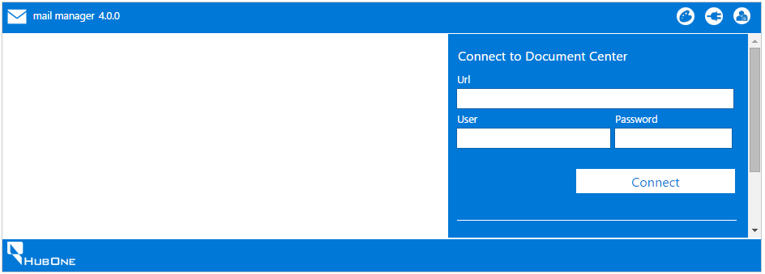

# Using the OnePractice Mail Manager

The Mail Manager is accessed from your email body in Outlook Desktop client or Outlook Web Access (OWA) from your browser by clicking the OnePractice Mail tab at the top of the email read window.

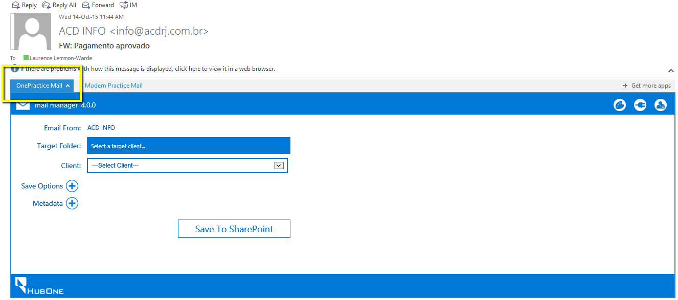

## The Controls Bar



From left to right:

1.  **Update Theme Button**. Click this button to synchronize the application theme with your Office 365 theme.
2.  **Refresh Clients & Folders Button**. Click this button to synchronize the application with any changes to your clients list or your folder structure in SharePoint.
3.  **Connect to One Practice Button**. Click this button to enter your Office 365 credentials and your OnePractice Document Center site address.
4.  **Settings Button**. Click this button to view your fixed settings in SharePoint.

## Saving emails to client folders

### Basic saving

At its most basic the application is used to save emails to client’s folders in SharePoint. Select the desired client target from the drop down list and click “Save to SharePoint”. This will save the email directly to the root folder of the client selected in “.msg” file format. The application will then show a small cloud image in the bottom right of the window indicating that this email has been saved. This cloud image will appear every subsequent time this email is accessed through the Mail Man the application so you will know it’s most recent save history. Click the cloud to view the save date and the folder location link.

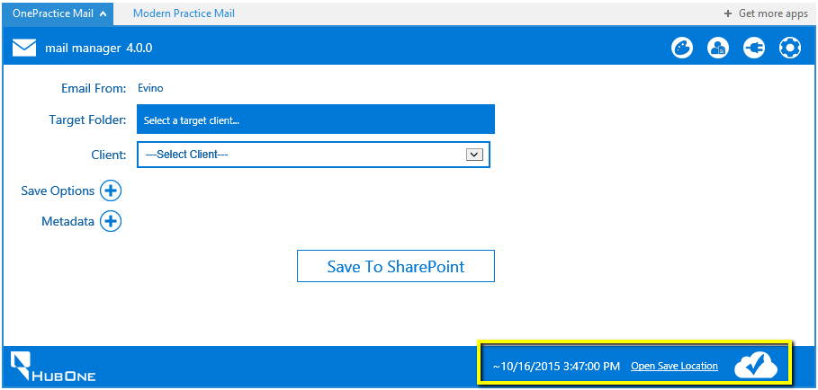

### Explaining the interface

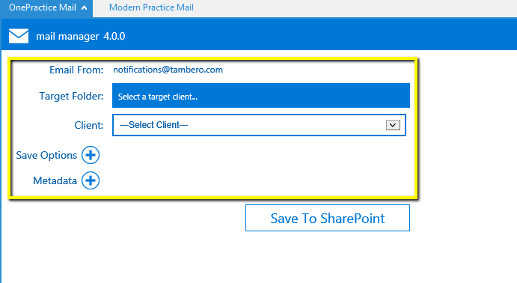

**Email From:** This shows the email sender

**Target Folder:** The selected client will show here and if you select a subfolder, this will show. This indicates the location in SharePoint where the email will be saved.

**Client:** The client folder you wish to save the email to.

**Save Options:** Click to expose various extra save options.

**Metadata:** Click to expose any custom metadata columns you may have added to your Documents Library in the OnePractice Portal Document Center (more on this later in the document).

### Saving to subfolders

On selecting a client target that has subfolders under its root directory in SharePoint these folders will appear next to the drop down list. You can choose to save to a subfolder under the client at this point.

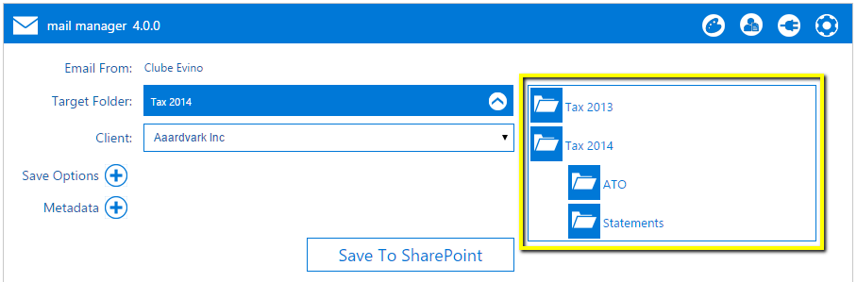

The selected folder will appear in the Target Folder box. To navigate back up to the top click the up arrow icon as shown below.

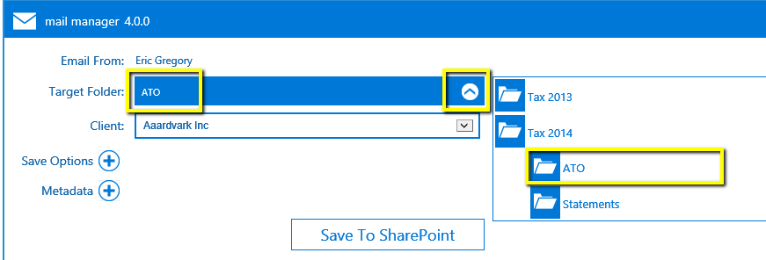

### Save Options – Saving Attachments

If your email has attachment files and you wish to save to these separately to the client folder as well, you can open the Save Options panel and select the Save Attachments checkbox. All non-embedded attachments (*an embedded attachment is e.g. your company logo embedded in the email body*) will be saved to your target folder as individual files. If you don’t save the actual attachment files, the saved email item (.msg) will still have access to these files if you open the email in Outlook.

**Why would I save attachments as separate files outside the email?** One reason could be that you wish to use any of the attachments as an attachment for another email created through the Mail Template Manager software or if you wish to edit the attachment file.

### Save Options – Add Sender as Contact

If you wish to add the email sender as a Contact in Xero Practice Manager for the Client you have selected, select this option. The software will check the existing Contacts for the Xero Practice Manager client and if this email does not match any existing one, a new contact will be created for the client.

### Save Options – Rename File

If you wish to change the name of the email being saved to your client’s folder, enter a new name in the Rename File textbox. If this is blank, the email will be saved using the subject line as name.

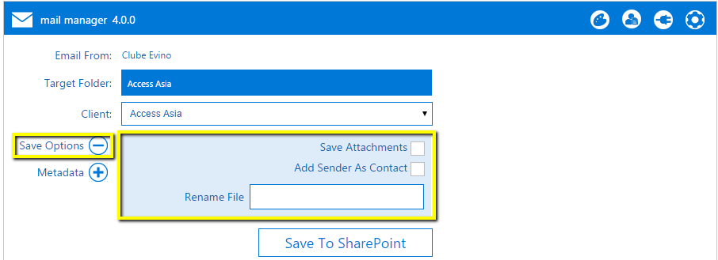

# Adding custom metadata to your document

Metadata is extra data used to describe your document. When we talk about metadata in the context of our email documents we are talking about adding extra fields/columns to SharePoint to store more data against a particular document when it is saved. These extra data columns are not included in a SharePoint by default so we will have to create them ourselves.

**Note:** Metadata is useful in describing documents and could be used for categorizing and grouping documents foregoing the need for a complicated folder structure in your Client folder in SharePoint.

**Examples** of extra data columns you may want to save against a document could include Tax Year, Document Type (such as Correspondence, Admin, ASIC, Tax) and more.

The Mail Manager allows you to add information to these custom fields for your email before you save it into SharePoint. This way this additional data can be used to more accurately define your saved email, facilitate easier categorization or grouping, increase searchability and append other useful information.

### Creating your own custom data columns in SharePoint

To create metadata columns for your emails in SharePoint you will need to perform the following simple tasks:

There are two ways to add custom columns, the first being the quickest.

**Directly from the Document Library**

1. Navigate to the Document Center in SharePoint



1. Navigate to the Document Library by clicking the “Documents” link.

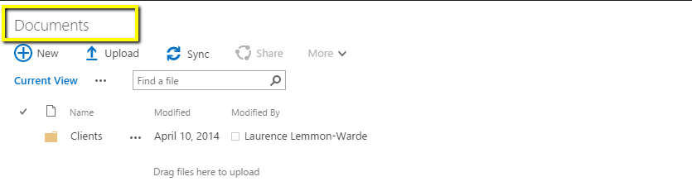

1. Click the LIBRARY Tab and then select Create Column

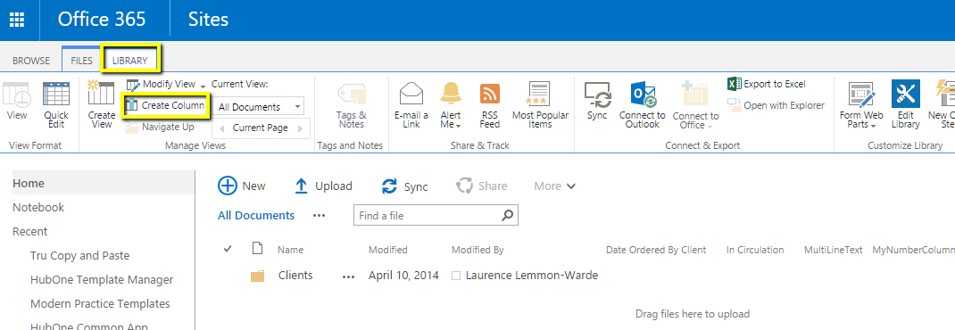

1. Enter a column name and then select the type of metadata column you wish to append to your documents. Template Manager currently only caters for Text, Multiline Text, Choice, Number, Date and Yes/No column types. Examples of custom columns could include Tax Year, Priority, Filed at ATO or similar.
2. The column will automatically appear in your default view.

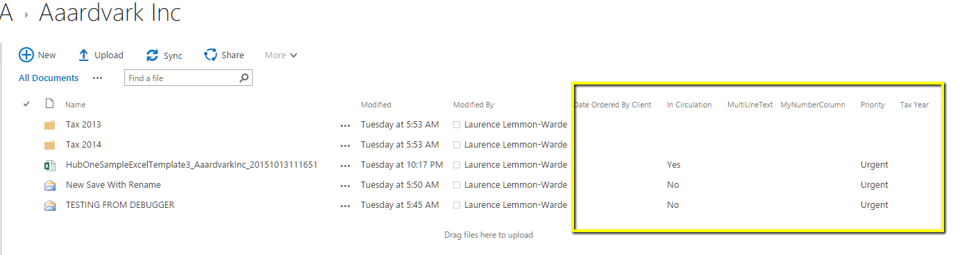

**From Site Contents**

1. Navigate to your Site Contents in your OnePractice Portal Document Center in SharePoint by clicking the cog icon at the top right of your browser window.

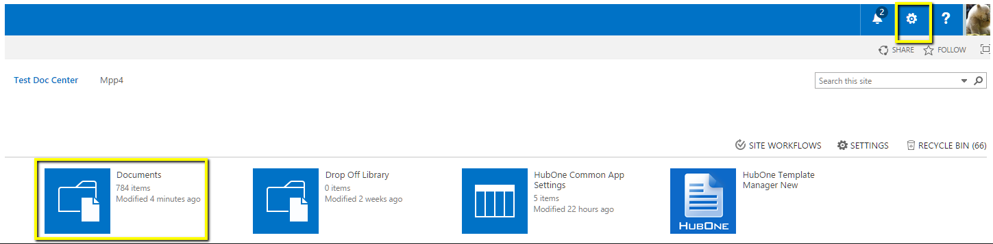

1. Select the Documents Library
2. Select the Library Tab and then click Library Settings

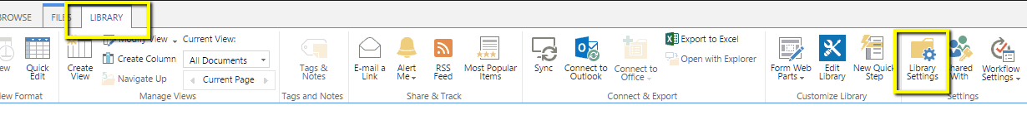

1. Under the Columns heading select Create column
2. Enter a column name and then select the type of metadata column you wish to append to your documents. Template Manager currently only caters for Text, Multiline Text, Choice, Number, Date and Yes/No column types. Examples of custom columns could include Tax Year, Priority, Filed at ATO or similar.

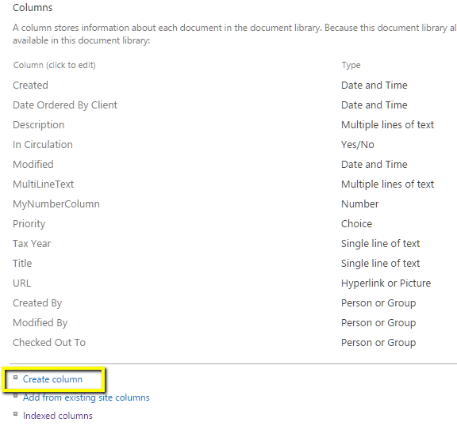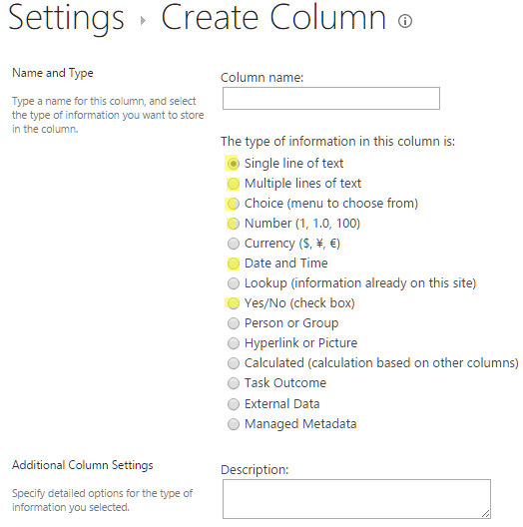

1. These custom columns will now appear in the Mail Manager after you hit the refresh button () in the Controls Bar.
2. Now, before you save the email, if you wish to add this extra data, click the Metadata button to display all your custom fields.
3. Enter your custom data and this data will be filed against your document.

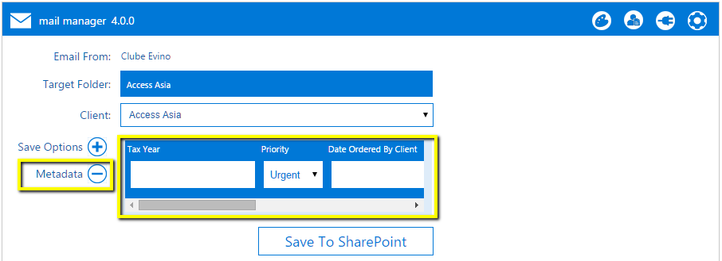

1. To view your new custom columns in SharePoint you will need to add them to your default view in SharePoint.
2. To do this navigate back to Site Contents and select the Library Tab. Now select Modify View and add the newly created columns to your default view.
3. Refresh your page and the new columns will appear as in the image below

