

Using the OnePractice Mail Template Manager

# Introduction

The HubOne OnePractice **Mail** **Template** Manager (*not to be confused with the HubOne OnePractice Template Manager*) is an Outlook add-in that allows you to use predefined email templates stored in SharePoint while composing emails in Outlook Desktop Client or Outlook Web access (OWA). The application facilitates pre-populating these templates with client or job data and attachments before sending the email.

# Using the OnePractice Mail Template Manager

The Mail Template Manager is accessed from Outlook Desktop client or Outlook Web Access (OWA) from your browser by clicking the “New Email” button and then selecting **Add Ins > OnePractice Mail** for OWA or **Apps For Office > OnePractice Mail** for Outlook Desktop.

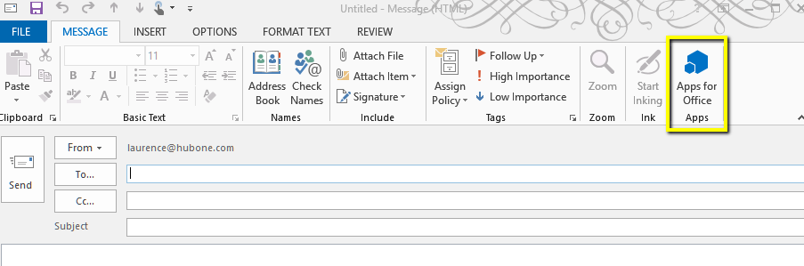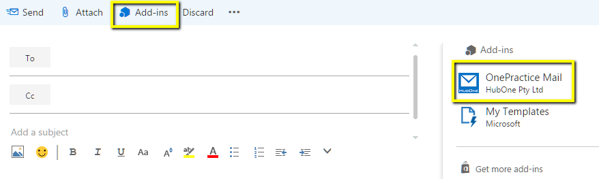

On first run you will be presented with the “Connect to Document Center” fly out window. Enter your OnePractice Document Center URL which will be in a format similar to [https://xxx.sharepoint.com/ documentcenter](https://xxx.sharepoint.com/%20documentcenter) and your Office365 login details. Now click the Connect button to connect to SharePoint. This will run a once off synchronization process to retrieve your SharePoint templates including your clients list. Once the software has run its initial synchronization each subsequent access should be faster as the software caches your list information on your own PC. **Please note:** For this reason when you add new clients to your clients list or if you add new folders or subfolders to SharePoint you will need to resynch the software (detailed later in the document).

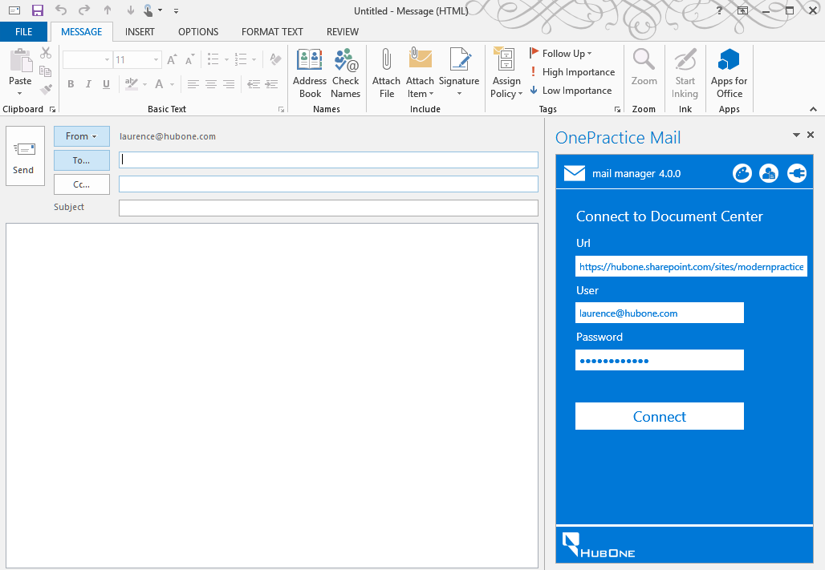

## The Controls Bar



From left to right:

1. **Update Theme Button**. Click this button to synchronize the application theme with your Office 365 theme.
2. **Refresh Clients & Folders Button**. Click this button to synchronize the application with any changes to your clients list or templates in your Modern Practice Email Templates folder.
3. **Connect to One Practice Button**. Click this button to enter your Office 365 credentials and your OnePractice Document Center site address.

## Creating email templates

### Manual Creation through Outlook

Email templates are stored in the same SharePoint Document Library as are templates used in the OnePractice Template Manager application. To navigate to this library login to your SharePoint OnePractice Document Center, click the Settings Cog > Site Contents > Modern Practice Templates.

In this folder, any “.msg” file you save will be presented by the Email Template Manager as a candidate to be used in the composition of a new email.

To create a new email template directly from Outlook:

1. Select “New Email” and create your template email content including adding any attachments you want to be included in the template.
2. Be sure to correctly apply the Template Field format rules as laid out later in the document. **NB: You can use the Template Manager Field Builder to correctly create template fields. This is located in the Template Manager software on your OnePractice Document Center in SharePoint.**
3. Click the FILE Tab and select “Save As…”
4. Select the default save option and save to your local machine (Outlook Message Format – Unicode).

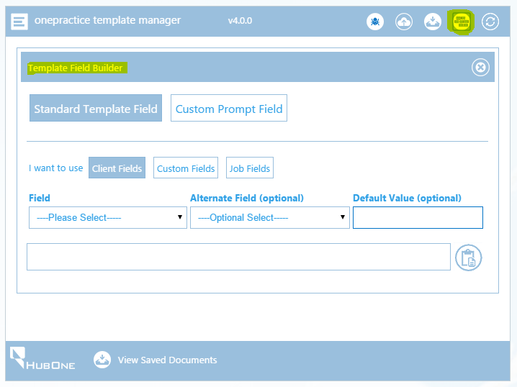

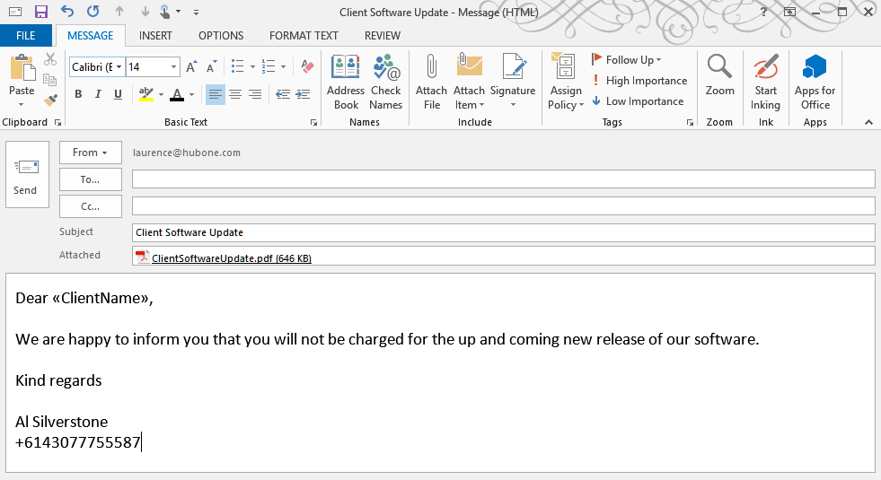

1. Drag and drop the file into your Modern Practice Template Document Library.
2. The file will now be available in the Template Explorer panel once you have refreshed its contents.

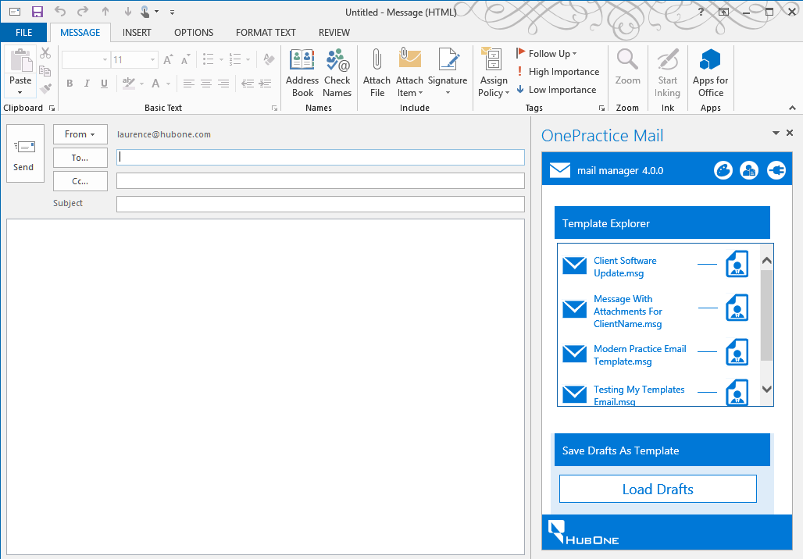

### Using the Mail Template Manager to Create Templates

1. Select “New Email” in Outlook and create your template email content including adding any attachments you want to be included in the template.
2. Be sure to correctly apply the Template Field format rules as laid out later in the document. **NB: You can use the Template Manager Field Builder to correctly create template fields. This is located in the Template Manager software on your OnePractice Document Center in SharePoint.**
3. Allow Outlook to save the mail as a Draft to your Drafts folder. You can do this simply by closing the email window – Outlook will notify you that the item has been saved to your Drafts Folder.
4. To save as a draft in OWA, click the ellipsis (…) in the top menu ribbon and select “Save draft”
5. Click the **Load Drafts** button on the Email Template Manager software to load up all your Draft Emails.
6. Select the draft you wish to save as a template and rename it if you like.
7. Click **Save as Template** to save it to SharePoint.

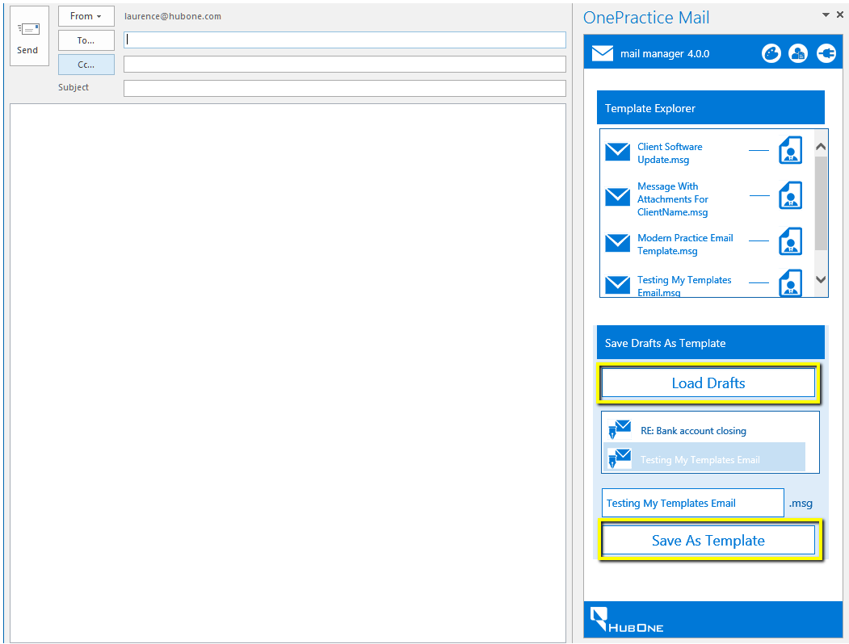

## Merging client data with template & sending

1. Once you have selected the email template you wish to use, click the Merge with Client Icon next to the template name.
2. Now you select the client whose data you wish to populate the email template. The primary contact email address.

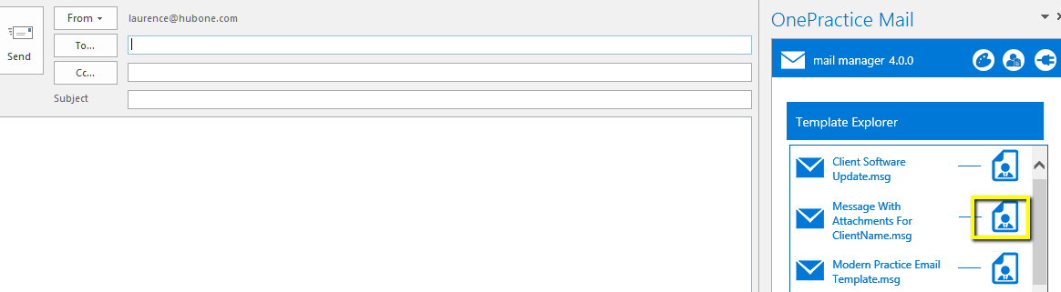

1. The primary contact email address of that client will be displayed and automatically used as the default email address of the email.
2. You can add extra recipients for the email in the Outlook Recipients boxes.
3. If you do not wish to edit the email body or add additional attachments, you can now click the Send Email button.

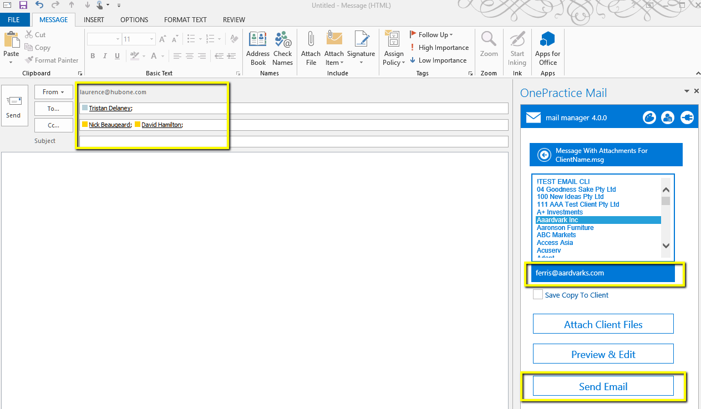

## Merging client data with templates, editing and then sending

1. Once you have selected the email template as in the process above you can click the Preview & Edit button.
2. This will allow you to manually edit the email before sending it directly from Outlook.
3. **NB: Once you click the Preview & Edit button please be patient, the software can take up to 15 seconds to process the request.**

## 

## Adding client files as extra attachments

Once you have selected a client from the list, you can choose to add extra attachments to your email from that client before you send.

1. Click the Attach Client Files button
2. This will return the most recent 50 documents in that client’s folder in SharePoint.
3. If you wish to retrieve another document not listed you can enter in a search term and click the Search icon. This will search all the documents under this client and return the relevant matches.
4. Select one or many attachments by clicking the attachment name. The size of the combined attachments will be displayed as you pick and choose.
5. To deselect just re-click the document

