

Using the OnePractice Scanned Document Manager

# Introduction

The HubOne OnePractice Scanned Document Manager is a useful tool providing the means to greatly reduce the time spent by your staff filing scans into SharePoint. The application combines state-of-the-art technologies to intelligently read, categorize and file scans from your scanner and organize them in SharePoint according to options you have configured.

# Setting up your Software

After installing the application and running it you will be required to enter a number of configuration settings fields before being able to let the application monitor your scanner directory. You will be warned that settings are not yet valid.

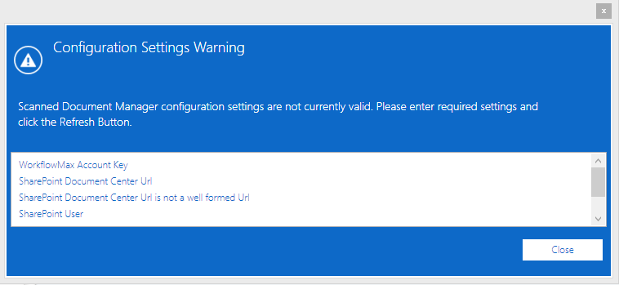

Close the warning window and now we must configure settings.

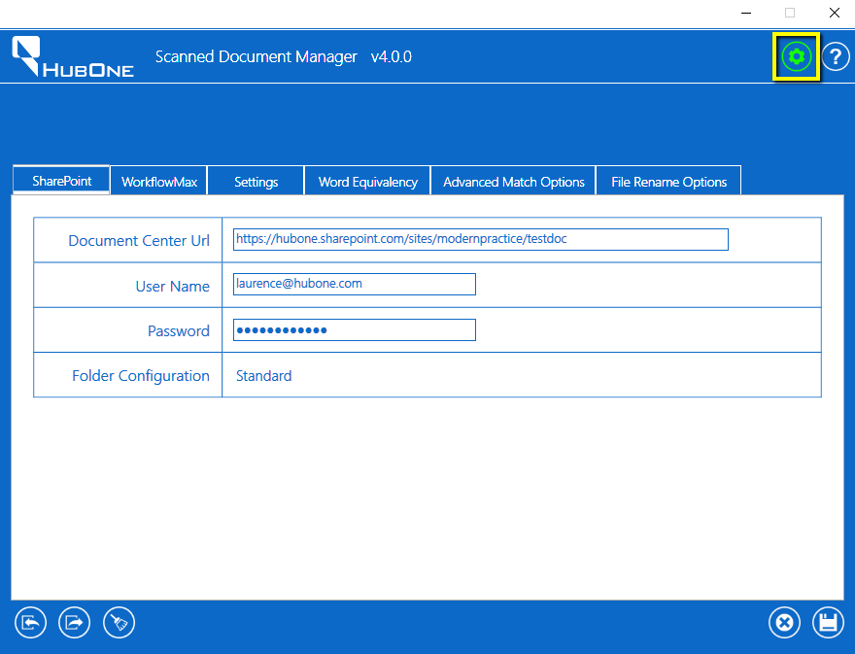

Click the Configuration Cog icon at the top right to get started. You will see the configurations tab control.

## SharePoint Tab

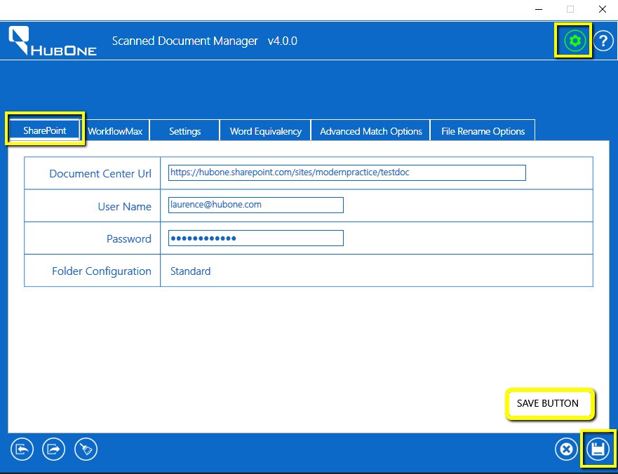

On the SharePoint Tab you are prompted to enter the URL of your Modern Practice Portal Document Center, your SharePoint User Name and Password.

The Folder Configuration label indicates which folder structure you have for filing clients. This can be Alphanumeric or Standard according to how your Modern Practice was configured during set-up.

Click the Save Button on the bottom right to save your settings.

## WorkflowMax Tab

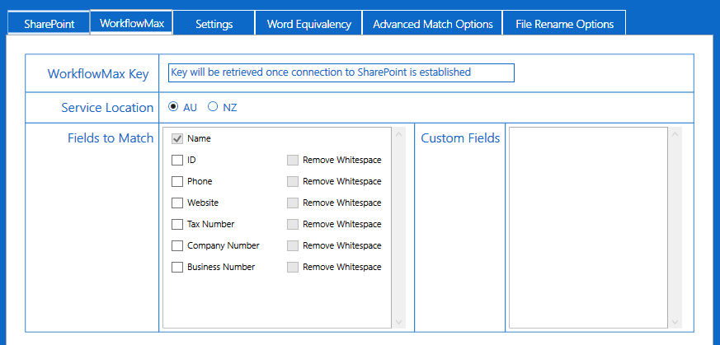

Here you are prompted to enter your WorkflowMax Account Key which HubOne will supply. Email us at [support@hubone.com](mailto:support@hubone.com) to request this key.

You must also select your location Service Location – the default is Australia but if you are located in New Zealand you must change the Service Location setting.

Client fields to match: These are the fields the application will look to match within your scanned document. Name is selected as mandatory. E.g. If your scanned document contains the name of one of your WorkflowMax clients, the application will file the scan under the correct Client folder in your Document Center’s Clients folder. If Name is not matched the software will attempt to match on any of the other fields you have selected.

The same goes for any Custom Fields you may have set up in WorkflowMax. These will only appear after you have saved all your required settings and have connected the application to WorkflowMax.

Click the Save Button on the bottom right to save your settings.

## Settings Tab

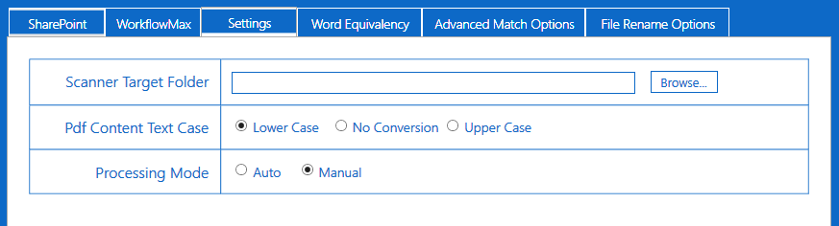

Here you are prompted to enter the folder where your scanner saves its output pdf files. This is the folder the software will monitor and to which your scanner must send its pdf output files.

You can also select to convert the entire pdf content to a different case to aid in locating keywords. E.g. If your scanned document contains the Client Name “Dobson **and** Sons” and your WorkflowMax clients name is “Dobson **And** Sons” it may be a good idea to convert to lowercase to match.

Processing Mode tells the software to either quietly process the documents without requesting manual input in Auto mode or to request manual confirmation of each scan before it is filed. Manual mode is set as default while you configure your file match settings. Once you are happy that the software is running as you need it to, you can switch to Auto Mode. We will go into more detail on this later.

Click the Save Button on the bottom right to save your settings.

## Word Equivalency Tab

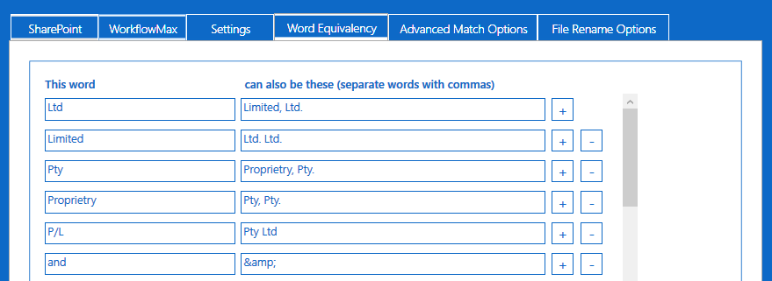

Here you are able to enter as many Word Equivalents as you please. The software checks the client’s name for any of the words on the left and if found it will scan the document contents for any variation you enter on the right.

E.g. If your client’s name is “HubOne Pty **Ltd**” but your document content contains the name “HubOne Pty **Limited**” – the first rule in the image above would locate this name in the document and file this document in the HubOne Pty Ltd folder in SharePoint.

The software comes pre-loaded with several rules which you can keep or remove as you need.

Click the Save Button on the bottom right to save your settings.

## Advanced Match Options Tab

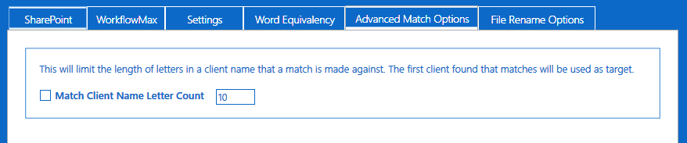

Enter the number of characters in a Client Name with which to make a match against. The first client found that matches will be used as the target.

E.g. If you have two clients “Aardvark and Sons Group” and “Aardvark and Sons Pty Ltd” in WorkflowMax and you have the Letter Count Match set to 8. It will find “Aardvark and Sons Group” first alphabetically and file against this client if it finds the word “Aardvark” anywhere in the scanned document.

Click the Save Button on the bottom right to save your settings.

## File Rename Options Tab

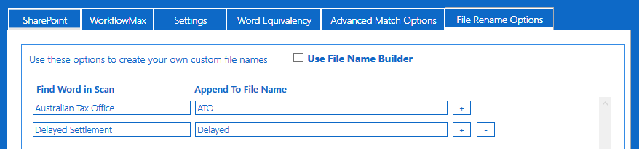

This panel gives you the option to add file renaming rules.

You can add as many “Find Word in Scan” rules as you please. If the software locates any of these words in the document it will append your chosen word to the file name. **Be careful as you have a limit of 255 characters for your file name.**

### Using the File Name Builder Tool

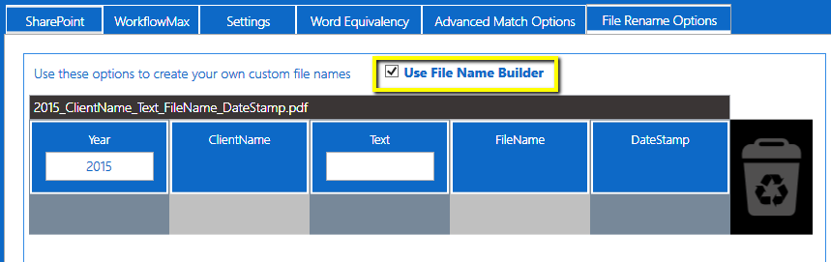

Access the handy File Name Builder tool by checking the box as in the image above. This will expose the interactive drag & drop panel from which you can create a complex file renaming rule easily.

To explain how to use this powerful feature we will give a couple of real-world examples.

### Example 1

Let’s say for example we want to have a renaming rule that prepends the Tax Year to the start of the file name, appends the actual FileName and finishes off by placing a DateStamp for the exact time and date the scan was filed.

**Desired Result**: “2015_FilingForJanVanRiebeekPartners_12233434122015.pdf”

To create this rule on the File Name Builder we would

1. Simply drag and drop the 2 non-required panels into the garbage panel on the right

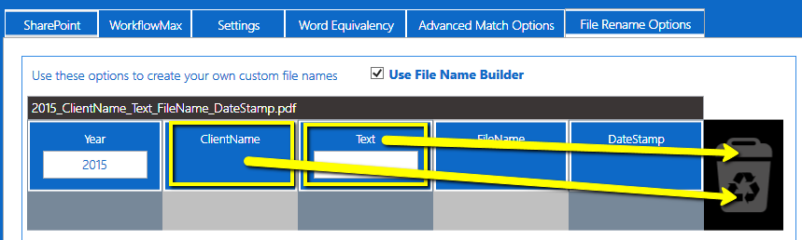

1. This would leave us with the correct rule shown as below

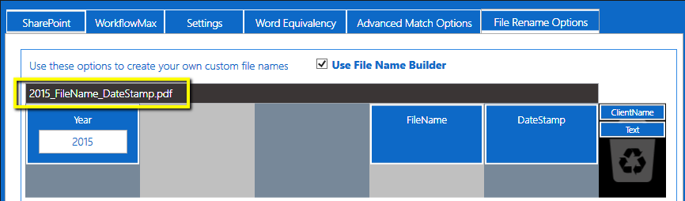

### Example 2

What if we wanted to add the custom text “Archive” to the front of each of a particular batch of scans and append the ClientName after the FileName to the document before it is filed? Easy…

**Desired Result**: “Archive_Scan000004_AardvarkSurveying.pdf”

To create this rule on the File Name Builder we would

1. Simply drag and drop the non-required panels to the garbage and then re-order the desired ones.
2. Enter your custom text in the textbox provided
3. Note: items can be dragged out of the garbage just as easily.

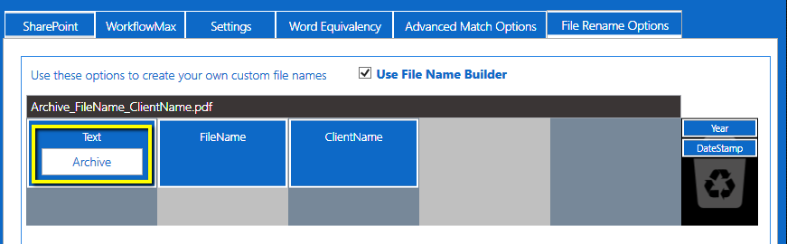

Click the Save Button on the bottom right to save your settings.

## The Settings are ready!

Once all settings are valid and the Save Button on the bottom right is clicked the Refresh Button will appear. The software will prompt you to click the Refresh button to synchronize your software with your clients list and with SharePoint.

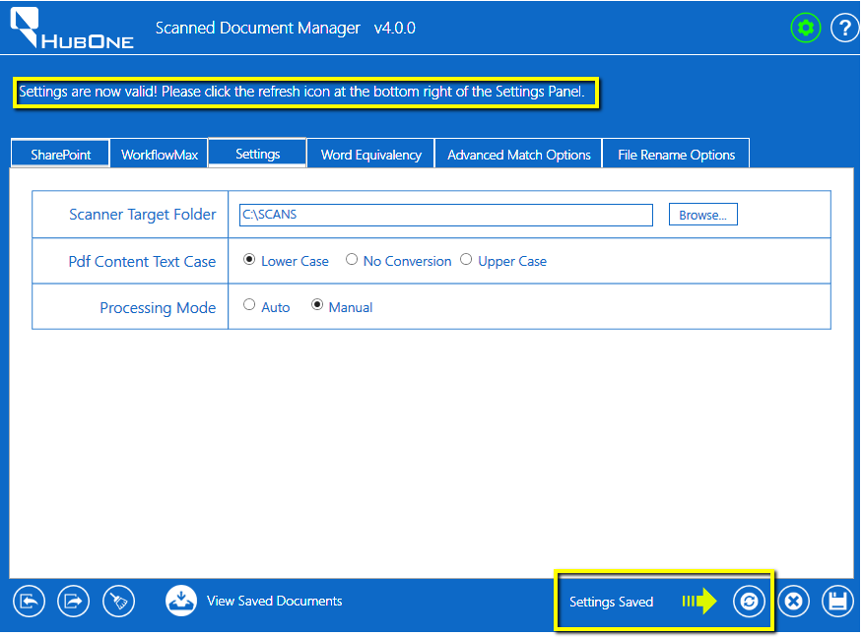

The Scanned Document Manager will indicate how many clients are in your clients list and will theme itself according to your selected SharePoint theme.

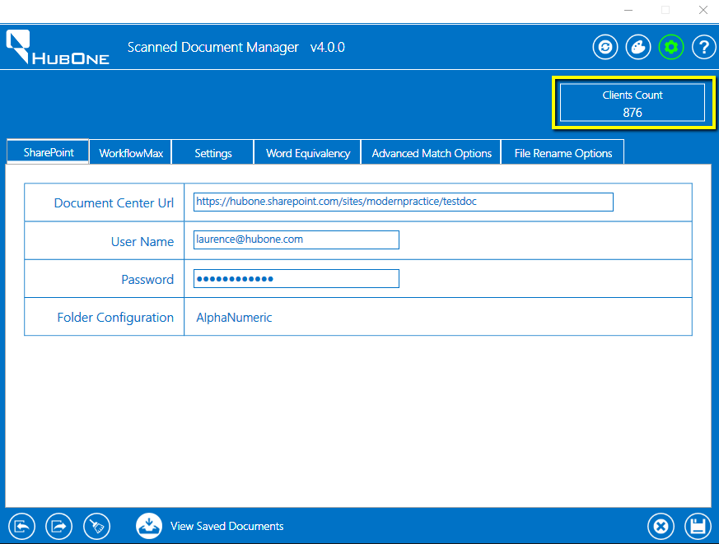

# Importing and Exporting Settings

Once your settings are complete and valid you can Export them to allow others to use the same settings on their machines. Click the middle Export Settings button on the bottom left and select a location to save your settings file.

To Import saved settings click the Import Settings button on the far left and select the relevant .xml file to import. NB: username and password for SharePoint are not saved.

Click the broom button to clear all your settings.



# Using the Software

Once your settings are complete and valid and you have clicked the Refresh Button on the bottom right of the application window the system will connect to SharePoint and WorkflowMax and synchronize your clients list. Click the green Settings Button at the top right to close the Settings feature. The software is now ready to use and will start monitoring the folder you have selected in settings. A notification box will appear in the top right hand corner indicating your WorkflowMax client tally.

NB: If a new client is added to WorkflowMax it is a good idea to resynchronize the software with WorkflowMax so it will have the updated list cached. You can do this by clicking the Reload Button in the header bar.

## 

## Manual Mode Processing

If you have selected Manual Mode in the settings the software will load a prompt window for each document it finds in the Scans Target Folder.

The software will attempt to match one of your clients against the scanned document utilizing all your rules and settings. It will show you which client it then believes to be the match and let you know what it matched on. The example above found the Client Name in the document.

You can preview the document to be saved before saving.

If you wish to discard the document click Do Not Process. This will remove the document from the Scan Target Folder and file it in an Errors Folder where it can be retrieved at a later stage if needs be.

If a match is not found or you don’t agree with the match you can select your own Client or simply file to the DropOff Library.

## File Logs

The directory you have selected to scan will contain 2 folders. These are “UploadCompleted” which will contain all files that have been successfully uploaded to SharePoint and “UploadErrors” which will contain files that have not been uploaded due to some issue. The FileUploadLog.csv file will contain a history of all files processed including the original file name and its subsequent renamed file and location in SharePoint.

