

Using the OnePractice Template Manager

# Introduction

The Modern Practice Template Manager facilitates powerful and easy integration between Microsoft Office Word or Excel template documents and Client and Job lists data. It provides a window to your central template store in SharePoint (Modern Practice Templates). The software allows you to populate pre-defined templates with Client or Job data on demand as well as prompt users to input real time data before filing to a Clients folder in SharePoint. Template Manager appears as default on your OnePractice Document Center and incorporates seamless automatic updating so you will always have the latest version when it is released.

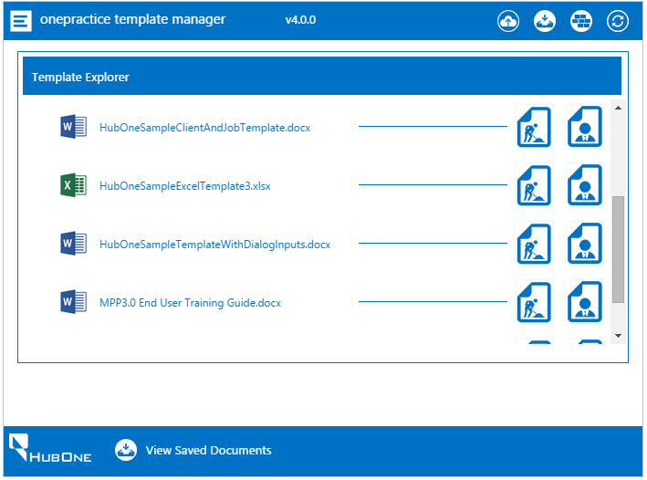

# The Software

Template Manager is installed as default on the home page of your OnePractice Document Center. It appears showing a list of your Word and Excel Template files which are stored in the Modern Practice Template Library in your Document Center. These can be accessed directly in SharePoint by clicking the Settings Cog > Site Contents > Modern Practice Templates. Any MS Word or Excel document placed in this directory will appear in the Template Manager File Explorer (after clicking refresh in the controls bar of the Template Manager software).

## Initial Run

On first run, the application will load your Clients and Jobs lists and store them locally in your browser for quick access later on. Please be patient, as this can take up to a minute if your Clients and or Jobs list is long. Once this process completes the application will notify you if there are no templates in your templates directory.

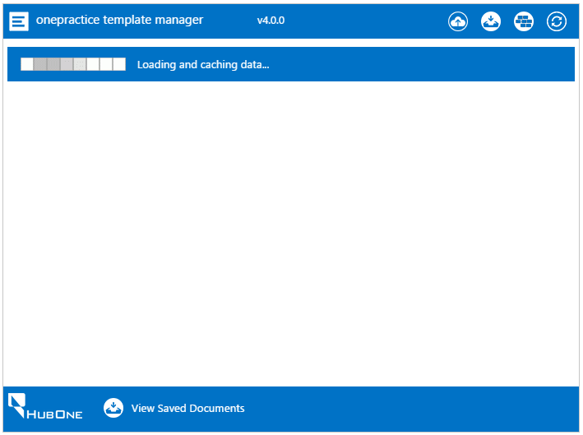

## The Controls Bar



Each of the features shown by the Controls Bar will be explained in more detail later in this document.

From Left to Right:

1.  **Drag & Drop Button**. Click this button to view the Drag & Drop window where you can conveniently drag Word or Excel templates onto the Template Manager and it will file the templates to the Modern Practice Templates library for you.
2.  **View Saved Documents Button**. Click this button to view recently saved documents. This view gives you a link to the actual document and a link to the folder it was saved to in your client’s library.
3.  **Template Field Builder Button**. Click this button to view the Template Field Builder tool. This will assist you in creating Standard or Custom Prompt fields and allow you to copy to your clipboard for easy pasting into your Microsoft Office Template File. It will display all the available Client, Job and Custom fields you have available to add to templates as well as assist you in building the often complex Custom Prompt fields which prompt a user to enter information in real time when merging the template with Client or Job data.
4.  **Refresh Button**. Click this button to refresh all your Template and Client/Jobs data from the server. As the Template Manager caches data locally in your internet browser to reduce network traffic and greatly speed up its functionality it needs to be refreshed from time to time to pick up changes in your Client/Job data and to locate newly added Templates.

# Creating & Saving Template Documents

1. Open a new or existing Word or Excel document (.docx, .xlsx) and style as desired.
2. To add Template Fields you can manually type in the field making sure to maintain its format exactly as specified in the example below

Below are examples of template fields you can add. Please note the angle brackets must match these exactly so it is best to either copy from this document or use the powerful Template Field Builder control accessed via the Controls Bar.

## Standard Template Fields

Standard Template fields are used to merge Xero Practice Manager Client or Job data with your template. Each of these fields will be populated by data from the selected Client or Job in Xero Practice Manager when the document merge is processed. Alternative field and Default Text options are available as in the examples below.

|  |
| --- |
| Example 1. A simple Standard Field to show the Xero Practice Manager client name in the template  «ClientName» |
| Example 2. A simple Standard Field to show the Xero Practice Manager Job Name in the template  «JobName» |
| Example 3. A complex Standard Field to show the Xero Practice Manager “Client Postal Address” and if this has no data show the alternative field Client Address and if this has no data show the default text “No Data Available”. Note the pipe-character separators “|” between each field.  «ClientPostalAddress|ClientAddress|No Data Available» |
| Example 4. A complex Standard Field to show the Xero Practice Manager Job Due Date and if this has no data show the default text “No Due Date Available”. Note the pipe-character separators “|” between each field including the blank in the middle. When using alternative options three (3) pipe characters are required always in the form Field | Alternative Field | Default Text.  «JobDueDate| |No Due Date Available» |

## Custom Prompt Template Fields

These fields are used to prompt the user for information before the merge is completed. Several types of prompt controls are available of which a few are detailed below.

|  |
| --- |
| Example 1. A “Text” Custom Prompt Field to request the user to input some text before the merge is processed. This will prompt the user to enter some text information. Note the special characters used to separate the fields.  ##Please enter Tax Year?~~Text## |
| Example 2. A “Number Range” Custom Prompt Field to request the age of the client. This will prompt the user to enter his/her age within a number range from 18 to 85. Note the special characters used to separate the fields.  ##How old are you?~~NumberRange~~18|80## |
| Example 3. A “Yes or No” Custom Prompt Field to request the tax status of a client. This will prompt the user to select either a Yes or No answer. Note the special characters used to separate the fields and that the Yes or No text is also customizable.  ##Are you registered with the ATO?~~Boolean~~Yes|No## |
| Example 4. A “Choice” Custom Prompt Field to request the client to choose from a list of options.  ##Where did you hear about us?~~Choice~~Bing|Google|Other## |
| Example 5. A “Date” Custom Prompt Field to request the user to enter a date. This will display a calendar control or allow the user to enter a date in text format.  ##What date did you lodge your tax return?~~Date## |

# Using the Template Field Builder

All of the above fields can be constructed using the handy Template Field Builder tool.

Access this tool by clicking the “bricks” icon in the Control Bar. The tool will display defaulted to create a Standard Template Field.

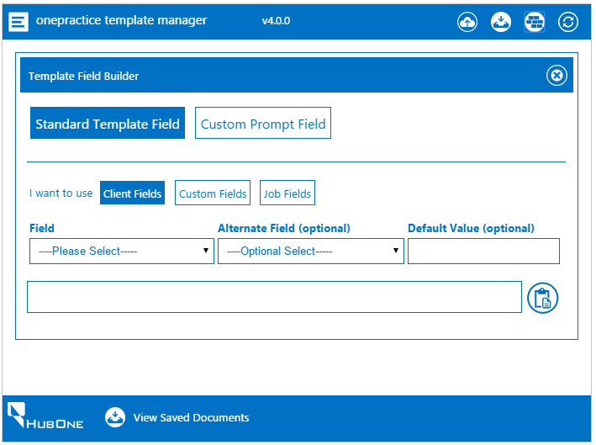

## Standard Template Fields

1. Select the type of field you want to use from the 3 buttons. Xero Practice ManagerClient Fields/Job Fields/Custom Fields. This will populate the drop down lists with all the relevant available fields for making templates.
2. Select the initial field – this is mandatory and the other fields will not function without this.
3. If you wish to add an alternative field in case the first field contains no data, select the alternative and add default text if you wish.
4. You will see the field being constructed for you in real time in the bottom textbox.
5. Once you are happy click the Clipboard button to copy the created field and allow you to paste it (Ctrl + V) into the template you are busy creating.

## Custom Prompt Fields

1. Select the Custom Prompt Field button to show the relevant controls
2. Select the Field Type
3. Enter the text you wish to appear in the prompt and any extra data that may be required according to the field type selected.
4. Once you are happy click the Clipboard button to copy the created field and allow you to paste it (Ctrl + V) into the template you are busy creating.

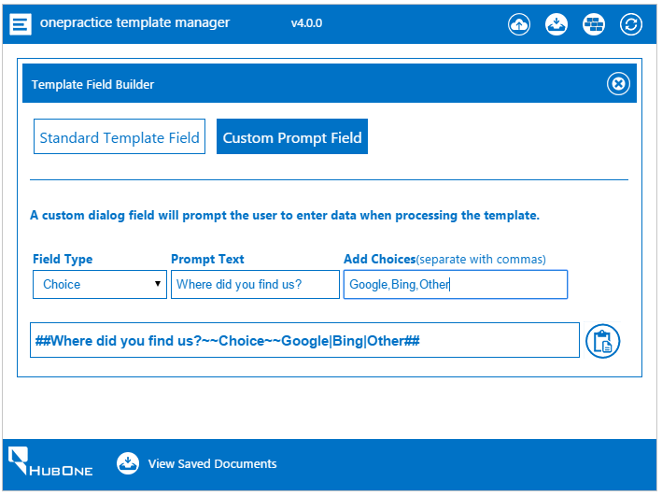

## Saving Your Template

Once your template is ready it needs to be saved to the **Modern Practice Templates** Document Library in your OnePractice Document Center. To navigate to this folder and save your template manually go to your OnePractice Portal Document Center in SharePoint > Site Contents > Modern Practice Templates. Or, if you do not need to save the template to a specific subfolder you can simply save it to the root folder of this library by dragging and dropping the template onto the Drag Drop Window of the Template Manager that will automatically upload it to the correct location for you.

## Using Drag & Drop

Once you are ready to save your newly created template, you can simply drag and drop it onto the Template Manager software “Drag & Drop” window. Access this by clicking on the “Cloud Upload” button in the Control Bar. Now simply drag and drop your Excel or Word template onto the window and it will upload to the root folder for you. If you need to add the template to a more complex folder structure, do this through SharePoint directly.

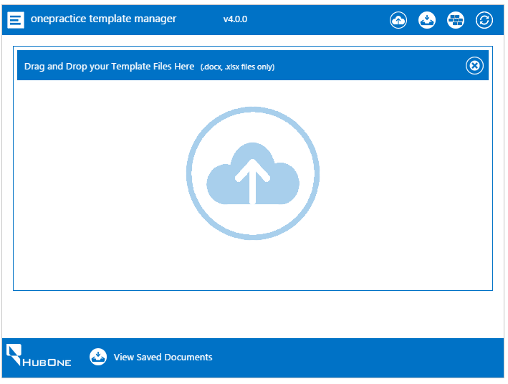

# Merging Template with Clients or Jobs Data

The main purpose of the software is to allow the user to merge Client or Job data with a predefined template file.

1. From the Main Explorer window select the template you wish to use by clicking either the Client or the Job logo to the right of the document in order to merge with the relevant data.

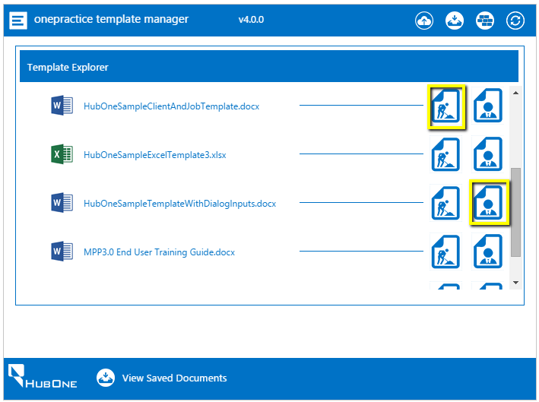

1. This will show the list of Clients or Jobs available to merge with.
2. Select the Client/Job or multiple Clients/Jobs and click the Download or Save Button.

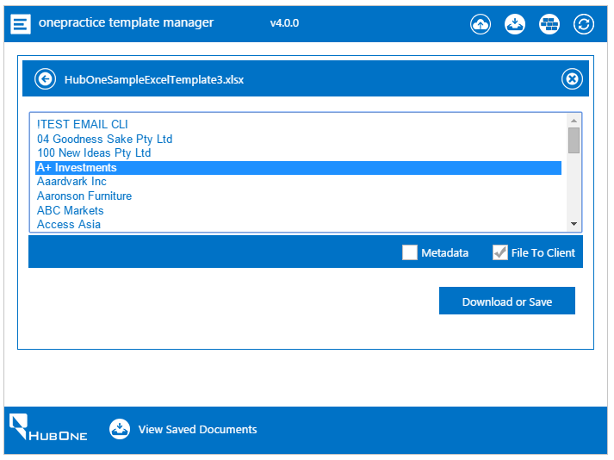

1. You can select to Download the documents to your PC rather than file them to SharePoint by selecting or deselecting the “File to Client” checkbox.
2. If the template has Custom Prompt Fields these will require input before processing is completed.

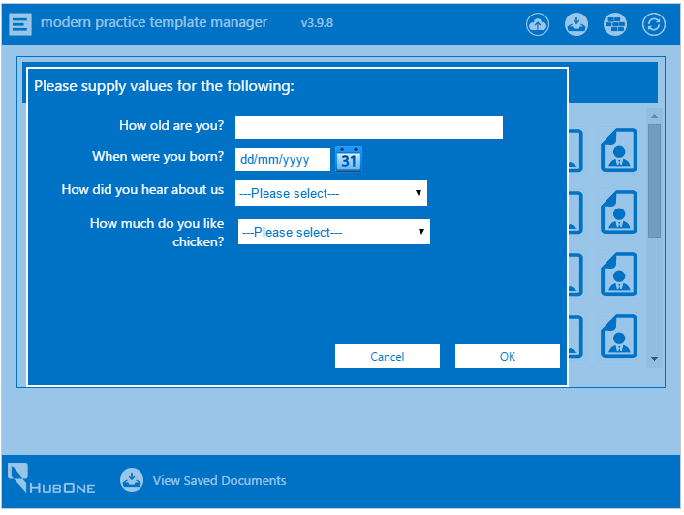

1. Once the document (s) have been processed they will appear in the “View Saved Documents” window accessible from the “View Saved Documents” link in the footer or from the “Downloads” icon in the Control Bar. Here you will be able to view the actual saved document or navigate to the folder it was saved into in SharePoint by clicking the Client link. **NB:** If clicking the link in this view does not open a new window to the target location you need to make sure your Popup Blocker setting in your browser is disabled.

**For Internet Explorer**: <http://windows.microsoft.com/en-us/internet-explorer/ie-security-privacy-settings#ie=ie-11>

**For Chrome:** <https://support.google.com/chrome/answer/95472?hl=en>

**For Firefox:** <https://support.mozilla.org/en-US/kb/pop-blocker-settings-exceptions-troubleshooting>

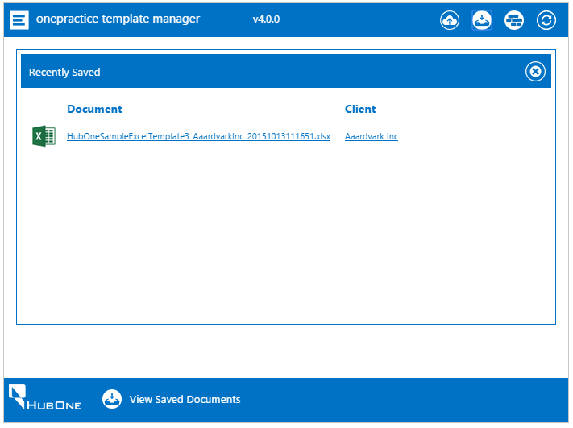

# Adding custom metadata to your document

The Template Manager allows you to add custom metadata to your document before you save it into SharePoint. This data can be used to more accurately define a document, facilitate easier categorization or grouping, increase searchability and append other useful information. Examples of metadata could include “Period End” e.g. June 2015 or “Assignment” e.g. a choice between Tax/GST/Super/Correspondence

To create metadata columns for your documents in SharePoint you will need to perform the following simple tasks:

1. Navigate to your Site Contents in SharePoint by clicking the cog icon at the top right of your browser window.

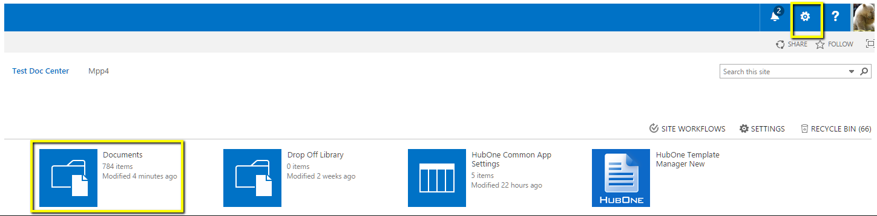

1. Select the Documents Library
2. Select the Library Tab and then click Library Settings

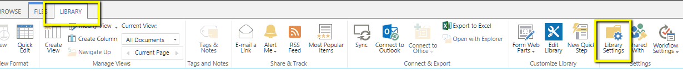

1. Under the Columns heading select Create column
2. Enter a column name and then select the type of metadata column you wish to append to your documents. Template Manager currently only caters for Text, Multiline Text, Choice, Number, Date and Yes/No column types. Examples of custom columns could include Tax Year, Priority, Filed at ATO or similar.

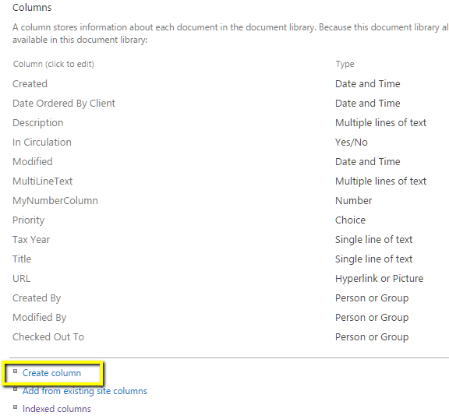 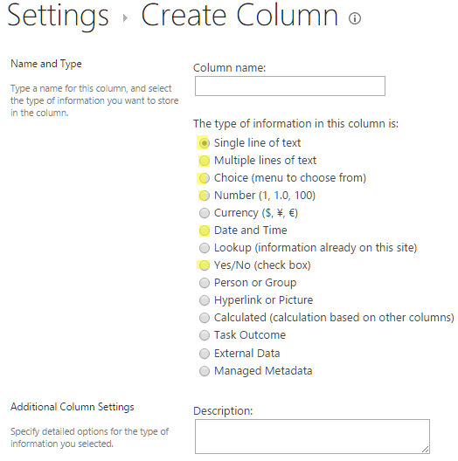

1. These custom columns will now appear in the Template Manager after you hit the refresh button.
2. Enter your custom data and this data will be filed against your document.
3. To view your new Custom columns you will need to add them to your default view in SharePoint.
4. To do this navigate back to Site Contents and select the Library Tab. Now select Modify View and add the newly created columns to your default view.

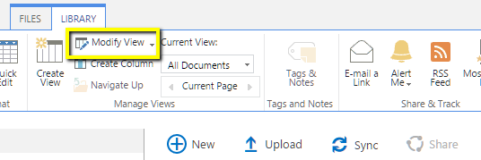

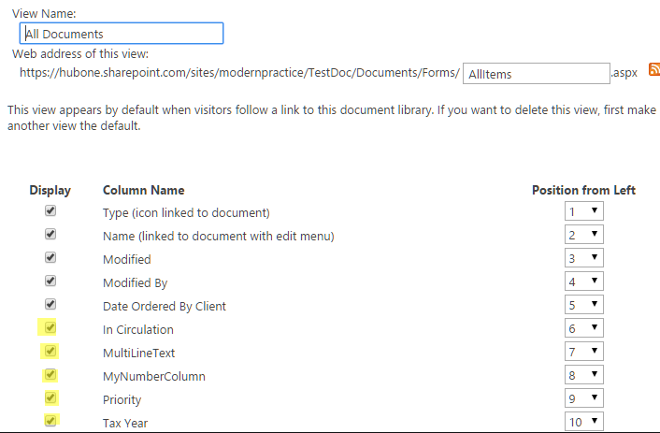

1. Now you are ready to add metadata to your merge documents.
2. Select the Metadata Checkbox and the custom columns you entered will appear as in the image below. If they do not appear you need to click the REFRESH button in the controls bar to re-synchronize your software with SharePoint.
3. Fill in your values and once you save your document these new columns will be populated for the document.

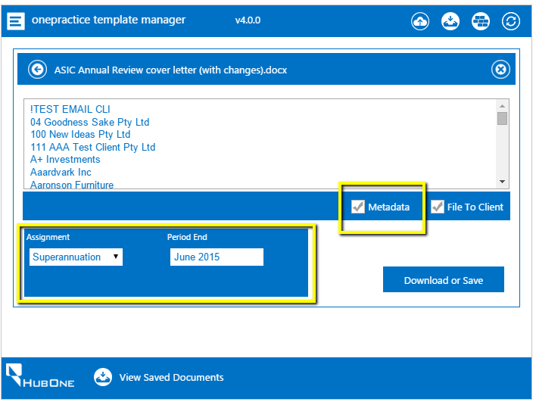

# Themes

The Template Manager is SharePoint Theme enabled. If you change your theme in Office365 SharePoint it will reflect in the Template Manager software.

1. From the Settings Cog select Change the Look.
2. Select a template you like and select Try It Out
3. If you like the template select Apply
4. Template Manager will be modified to reflect your changes.

