x*y | x **and** y = 1 when both x and y = 1

x+y | x **or** y = 1 when either x or y or both = 1

x (with line over it) | **not x** = 1 when x = 0

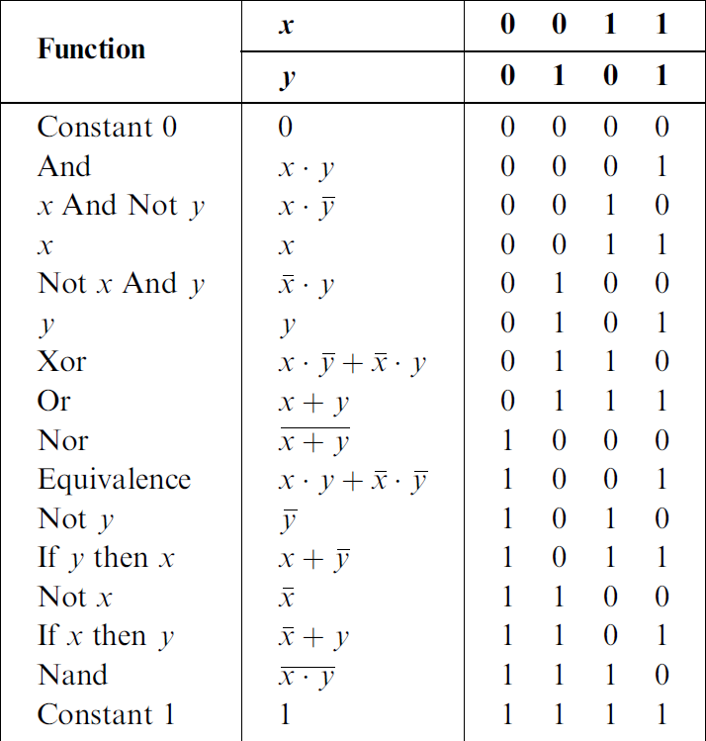

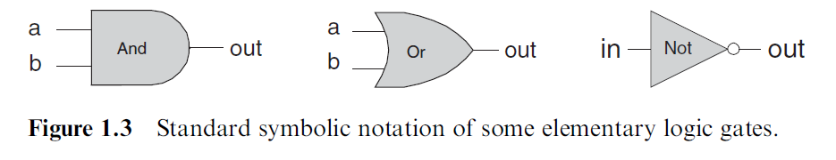

The Nand function (as well as the Nor function) has an interesting theoretical

property: Each one of the operations And, Or, and Not can be constructed from it,

and it alone (e.g., x Or y ¼ ðx Nand xÞ Nand ðy Nand yÞ. And since every Boolean

function can be constructed from And, Or, and Not operations using the canonical

representation method, it follows that every Boolean function can be constructed

from Nand operations alone.