Table 1. Life history parameter values used in the Gulf of Mexico Gray Triggerfish population model simulation. The “Estimated” column denotes whether a parameter was estimated or fixed within the assessment models (Yes = Y, No = N).

|  |  |  |  |  |
| --- | --- | --- | --- | --- |
| **Parameter** | **Symbol** | **Estimated** | **Value** | **Source** |
| Natural mortality reference | *Mref* | Y | 0.3016 | SEDAR (2015)* |
| Lorenzen *c* for natural mortality | *c* | N | 1.776 | SEDAR (2015)* |
| Start age | *a0* | N | 0 | SEDAR (2015) |
| Reference age | *a3* | N | 0.5 | SEDAR (2015) |
| Plus group age | *A* | N | 10 | SEDAR (2015) |
| Length at *a0* (cm) | *L0* | N | 28.3 | SEDAR (2015) |
| Length at *a+* (cm) | *L∞* | N | 58.97 | SEDAR (2015) |
| Growth rate (year-1) | *K* | N | 0.14 | SEDAR (2015) |
| Length-weight scaling (kg cm-3) | α | N | 2.16e-5 | SEDAR (2015) |
| Allometric factor | β | N | 3.007 | SEDAR (2015) |
| Maturity slope (cm-1) | Ω1 | N | -0.065 | SEDAR (2015) |
| Length at 50% maturity (cm) | Ω2 | N | 31 | SEDAR (2015) |
| Log mean virgin recruitment | *ln(R0)* | Y | 9.7608 | SEDAR (2015) |
| Steepness | *h* | N | 0.4593 | SEDAR (2015) |
| Recruitment SD | σr | Y | 0.3582 | SEDAR (2015) |
| Selectivity parameter B1 | B1 | Y | 4.375 | SEDAR (2015)* |
| Selectivity parameter B2 | B2 | Y | -3 | SEDAR (2015)* |
| Selectivity parameter B3 | B3 | Y | 1.124 | SEDAR (2015)* |
| Selectivity parameter B4 | B4 | Y | 1.582 | SEDAR (2015)* |
| Annual fully selected fishing mortality |  | Y | Figure X | SEDAR (2015) |
| Catchability of fishery index | *q* | Y | 0.0001 | Arbitrary |

*Approximated from the stock assessment (SEDAR 2015)

Table 2. Population model equations. These apply to both simulator and estimator.

|  |  |
| --- | --- |
| Description | Equation |
| Length at age |  |
| Weight at age | = α |
| Natural Mortality at age |  |
| Maturity at age |  |
| Fecundity at age |  |
| Selectivity |  |
| Fishing mortality |  |
| Total mortality |  |
| Recruitment |  |
| Spawning biomass |  |
| Unfished survivorship |  |
| Initial abundance at age* |  |
| Abundance at age |  |
| **Predicted Data** |  |
| Predicted catch |  |
| Predicted composition with ageing error |  |
| Predicted index |  |

*Note simulator starts in year 1 and estimator in year 26 (when fishing begins)

Table 3. Convergence Table.

|  |  |  |
| --- | --- | --- |
| SM | EM | Convergence Percentage |
| No Ageing Error | No Ageing Error | 100 |
| Constant bias at age | 77 |
| Linear bias with age | 41 |
| Curvilinear bias with age | 75 |
| Constant bias at age | No Ageing Error | 99 |
| Constant bias at age | 100 |
| Linear bias with age | 14 |
| Curvilinear bias with age | 95 |
| Linear bias with age | No Ageing Error | 90 |
| Constant bias at age | 93 |
| Linear bias with age | 91 |
| Curvilinear bias with age | 74 |
| Curvilinear bias with age | No Ageing Error | 97 |
| Constant bias at age | 99 |
| Linear bias with age | 19 |
| Curvilinear bias with age | 95 |

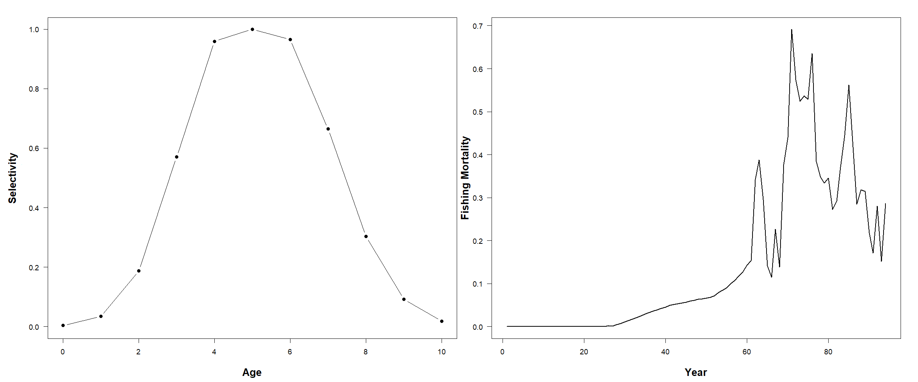

Figure 1. Left Panel – Fishery Selectivity used in the population operating model. Right Panel - Time series of Fishing mortality for Gulf of Mexico Gray Triggerfish (minus shrimp fishery) used in the operating model.

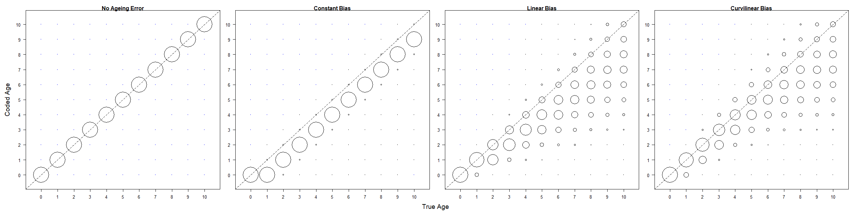

Figure 2. Ageing error scenarios examined in this study. The bubbles denote the probability a fish will be coded age (y axis) given true age (x-axis). The diagonal represents the 1-1 line.

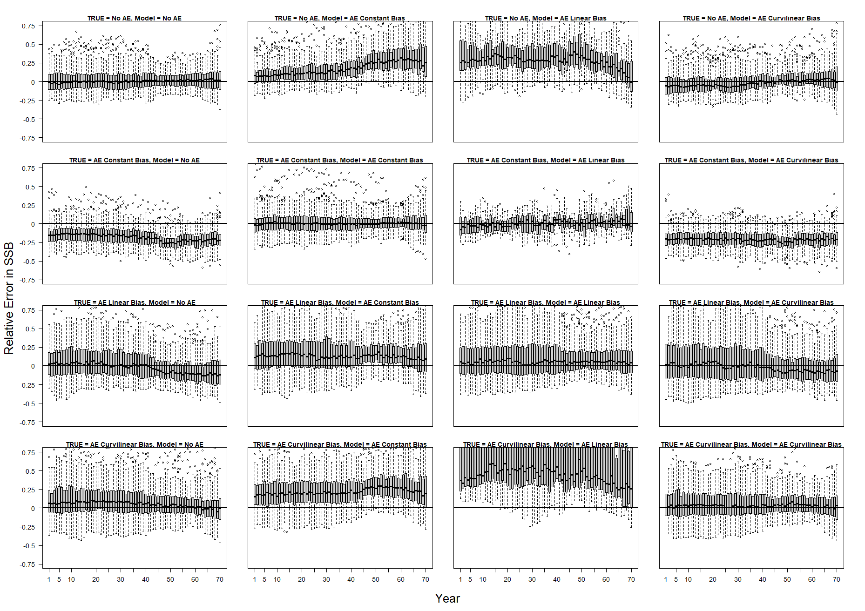

Figure 3. Relative error for spawning stock biomass in each year of the assessment.

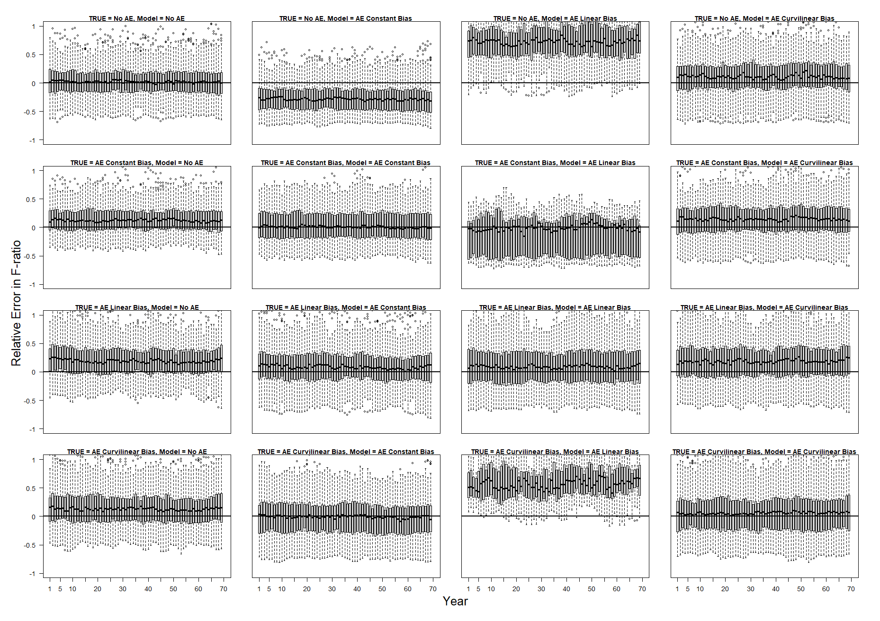

Figure 4. Relative error for F-ratio in each year of the assessment.

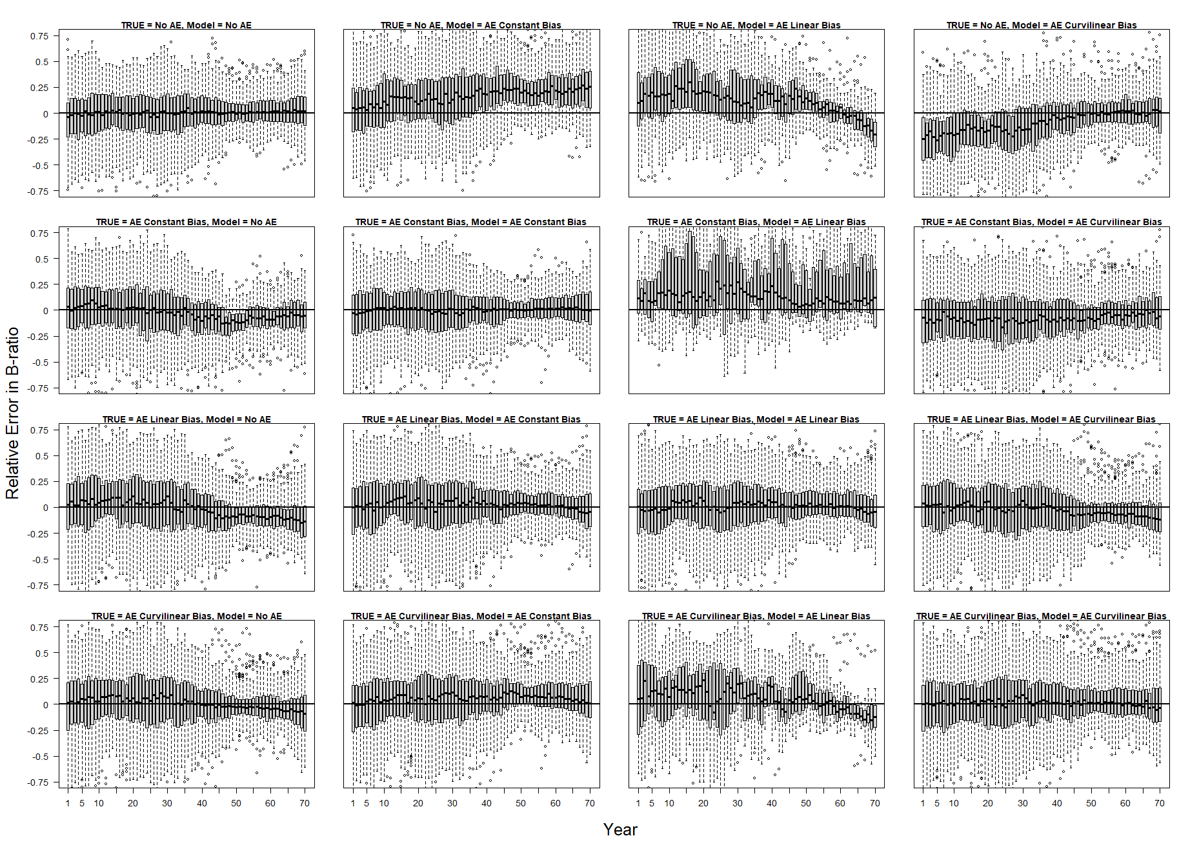

Figure 5. Relative error for B-ratio in each year of the assessment.