Table 1. Life history parameter values used in the population model simulation, largely similar to Ono et al., (2015) and Hurtado-ferro et al., (2015).

|  |  |  |  |  |  |
| --- | --- | --- | --- | --- | --- |
| **Parameter** | **Symbol** | **Estimated** | **Cod** | **Flatfish** | **Sardine** |
| Natural Mortality | *M* | Y | 0.2 | 0.2 | 0.4 |
| Start age | *a0* | N | 0 | 0 | 0 |
| Reference age | *a3* | N | 0.5 | 0.5 | 0.5 |
| Plus group age | *A* | N | 25 | 25 | 15 |
| Length at *a0* (cm) | *L0* | N | 20 | 12.7 | 10 |
| Length at *a+* (cm) | *L∞* | N | 132 | 47.4 | 25 |
| Growth rate (year-1) | *K* | N | 0.2 | 0.35 | 0.4 |
| Length-weight scaling (kg cm-3) | α | N | 6.8e-6 | 1.0e-5 | 1.7e-5 |
| Allometric factor | β | N | 3.1 | 3.0 | 2.9 |
| Maturity slope (cm-1) | Ω1 | N | -0.27 | -0.42 | -0.9 |
| Length at 50% maturity (cm) | Ω2 | N | 38.2 | 28.9 | 15.9 |
| Log mean virgin recruitment | *ln(R0)* | Y | 18.7 | 10.5 | 16 |
| Steepness | *h* | N | 0.65 | 0.76 | 0.59 |
| Recruitment SD | σr | Y | 0.4 | 0.7 | 0.73 |
| Mean fishery length-at-50% selectivity (cm) | S1 | Y | 38.2 | 28.9 | 15.9 |
| Fishery selectivity slope (cm) | S2 | Y | 10.6 | 7 | 3.3 |
| Max fishing mortality in fishing time series |  | N | 0.2025 | 0.5425 | 0.7875 |
| Terminal fishing mortality in fishing time series |  | N | 0.0623 | 0.1259 | 0.2037 |
| Annual fully selected fishing mortality |  | Y | * | * | * |
| Catchability of fishery index | *q* | Y | 0.0001 | 0.0001 | 0.0001 |

*see methods for derivation of annual fishing mortality levels in the operating model

Table 2. Population model equations (exclusive of CKMR equations). These apply to both simulator and estimator.

|  |  |
| --- | --- |
| Description | Equation |
| Length at age |  |
| Weight at age | = α |
| Maturity at age |  |
| Fecundity at age |  |
| Selectivity |  |
| Fishing mortality |  |
| Total mortality |  |
| Recruitment |  |
| Spawning biomass |  |
| Unfished survivorship |  |
| Initial abundance at age* |  |
| Abundance at age |  |
| **Predicted Data** |  |
| Predicted catch |  |
| Predicted composition |  |
| Predicted index |  |

*Note simulator starts in year 1 and estimator in year 26 (when fishing begins)

Table 3. Treatment levels within experimental design. These treatment levels were crossed to facilitate a full factorial design. Note that if CKMR data were collected, age composition data were also hence their combination within table. The sample size for CKMR/composition data refer to the annual number of samples collected. The length of data refers to years at the terminal end of the time series.

|  |  |  |  |  |
| --- | --- | --- | --- | --- |
| Life History Type | Index SD | Sample size for CKMR/Composition data | Length of CKMR/increased composition data | CKMR integration |
| Cod-like | No index | 100 | 5yrs | Included |
| Flatfish-like | 0.25 | 1,000 | 10yrs | Excluded |
| Sardine-like | 0.50 | 5,000 | 25yrs |  |

Table 4. Example CKMR dataset snapshot given to the assessment. This table depicts 10 randomly chosen rows of a dataset from 1 simulation iteration of the Flatfish sampling and population model. For context this specific dataset contains 1164 rows.

|  |  |  |  |  |  |  |
| --- | --- | --- | --- | --- | --- | --- |
| Birth year of older individual | Birth year of younger individual | Age Difference | Sample year of older individual | Number of comparisons made | Number of parent-offspring pairs found | Number of half-sibling pairs found |
|  |  |  |  |  |  |  |
| 60 | 68 | 8 | 68 | 7,165 | 0 | 0 |
| 64 | 67 | 3 | 73 | 3,186 | 0 | 0 |
| 66 | 68 | 2 | 74 | 30,093 | 0 | 3 |
| 66 | 67 | 1 | 69 | 178,947 | 0 | 15 |
| 58 | 63 | 5 | 68 | 1,304 | 0 | 0 |
| 71 | 73 | 2 | 73 | 7,350 | 1 | 0 |
| 56 | 72 | 16 | 70 | 362 | 0 | 0 |
| 63 | 71 | 8 | 72 | 16,016 | 3 | 0 |
| 60 | 71 | 11 | 66 | 13,013 | 0 | 0 |
| 64 | 66 | 2 | 72 | 9,027 | 0 | 1 |

Table 5. Mean number of pairs found (POP | HSP) for each treatment type over 100 simulations. The standard deviation is given in parentheses. Columns depict the annual number of CKMR samples taken and rows (within species life history type) depict the number of years CKMR data were collected. Values >100 were rounded to the whole number.

|  |  |  |  |
| --- | --- | --- | --- |
|  | N100 | N1000 | N5000 |
| **Cod** |  |  |  |
| 5yr | 0 (0) | 0 (0) | 0.02 (0.14) | 0.19 (0.42) | 1.38 (1.29) | 4.49 (2.25) |
| 10yr | 0 (0) | 0 (0) | 0.15 (0.39) | 0.56 (0.73) | 3.9 (1.76) | 12.96 (4.25) |
| 20yr | 0 (0) | 0.02 (0.14) | 0.43 (0.57) | 1.5 (1.17) | 10.1 (3.64) | 33.01 (7.07) |
| **Flatfish** |  |  |  |
| 5yrs | 1.82 (1.43) | 6.85 (3.13) | 196 (74.05) | 662 (225) | 4926 (1920) | 16486 (5479) |
| 10yrs | 6.25 (3.37) | 20.9 (7.33) | 671 (207) | 2072 (618) | 16784 (5055) | 51684 (15363) |
| 20yrs | 16.24 (6.19) | 48.82 (15.33) | 1623 (434) | 4793 (1259) | 40570 (10765) | 119467 (31464) |
| **Sardine** |  |  |  |
| 5yrs | 0.02 (0.14) | 0.03 (0.17) | 1.71 (1.85) | 4.95 (3.44) | 39.41 (22.03) | 127 (67.49) |
| 10yrs | 0.03 (0.17) | 0.11 (0.31) | 4.63 (2.86) | 14.44 (7.72) | 117 (52.98) | 350 (171) |
| 20yrs | 0.11 (0.35) | 0.38 (0.63) | 10.42 (5.76) | 30.71 (14.08) | 262 (117) | 750 (362) |

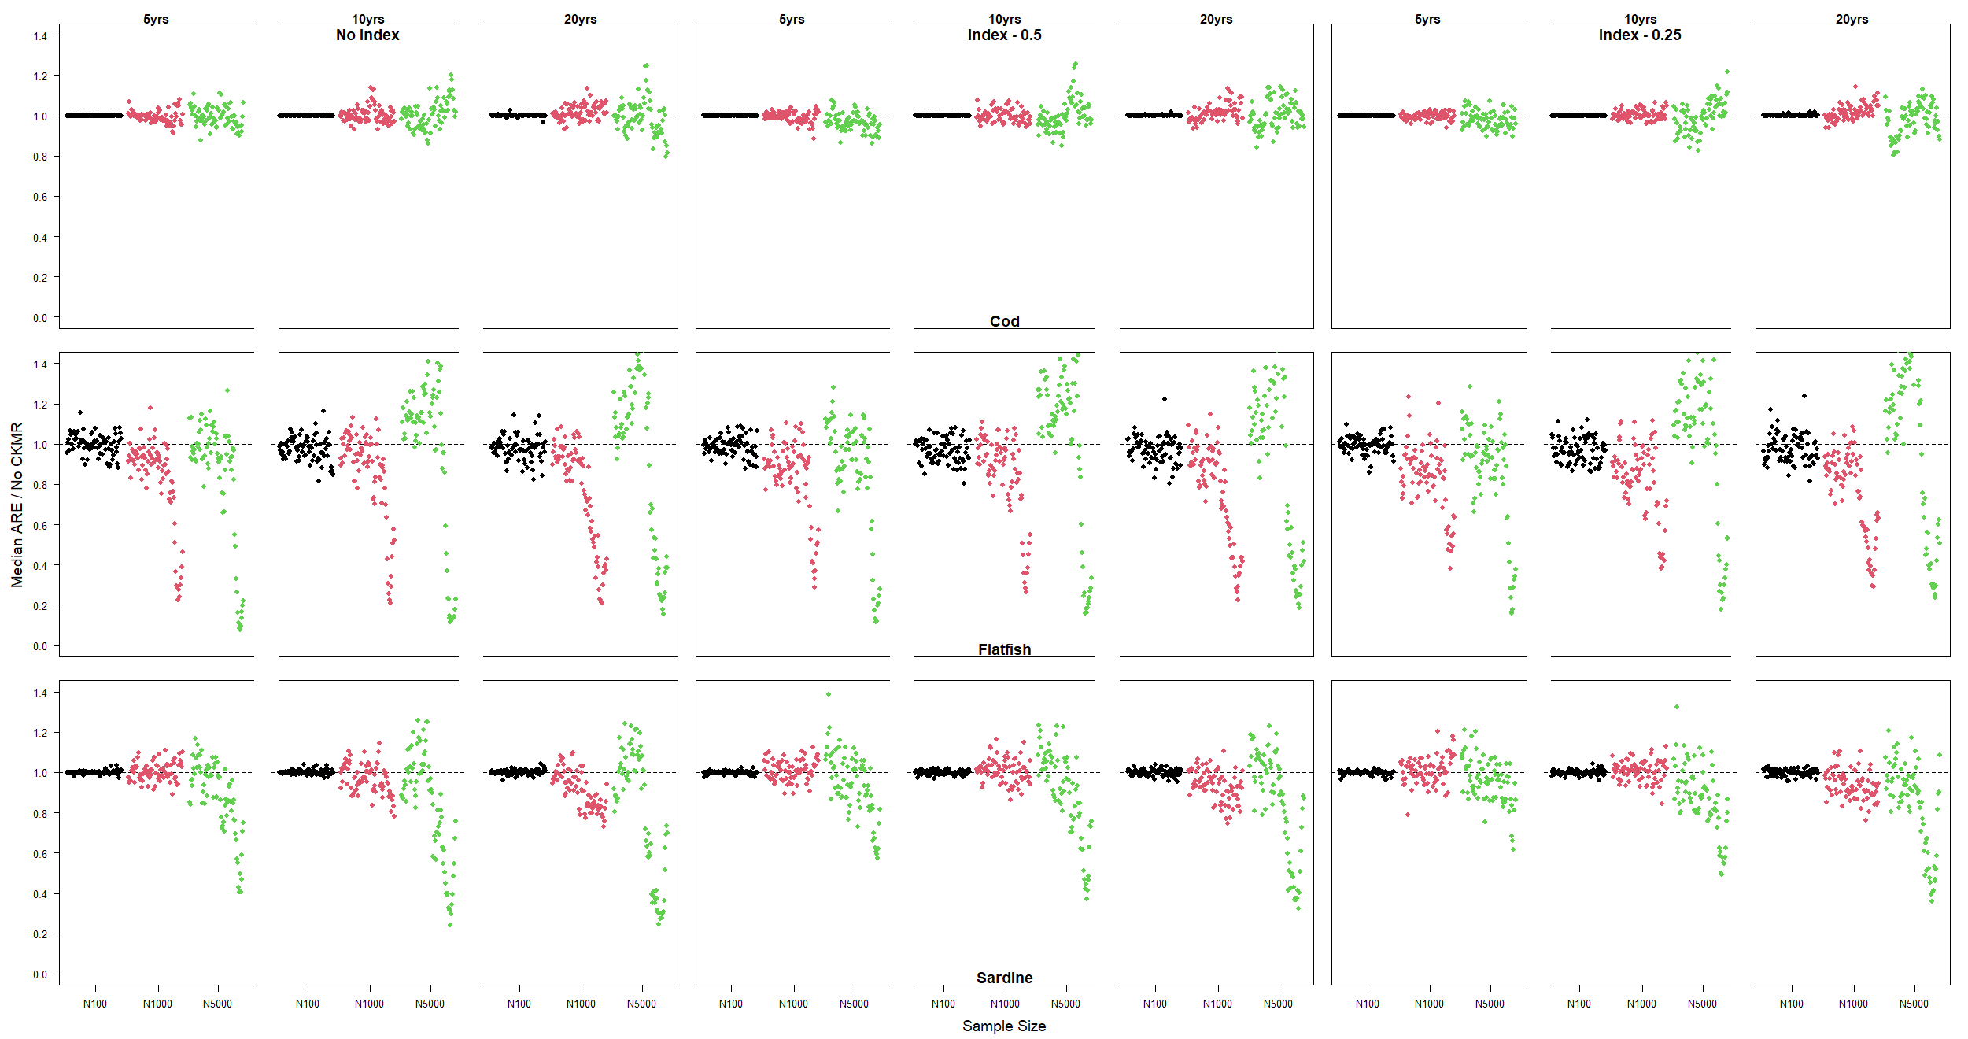

Figure X. The median absolute relative error for spawning stock biomass in each year of the time series of estimation models fit with CKMR divided by the same metric for identical estimation models fit without CKMR.

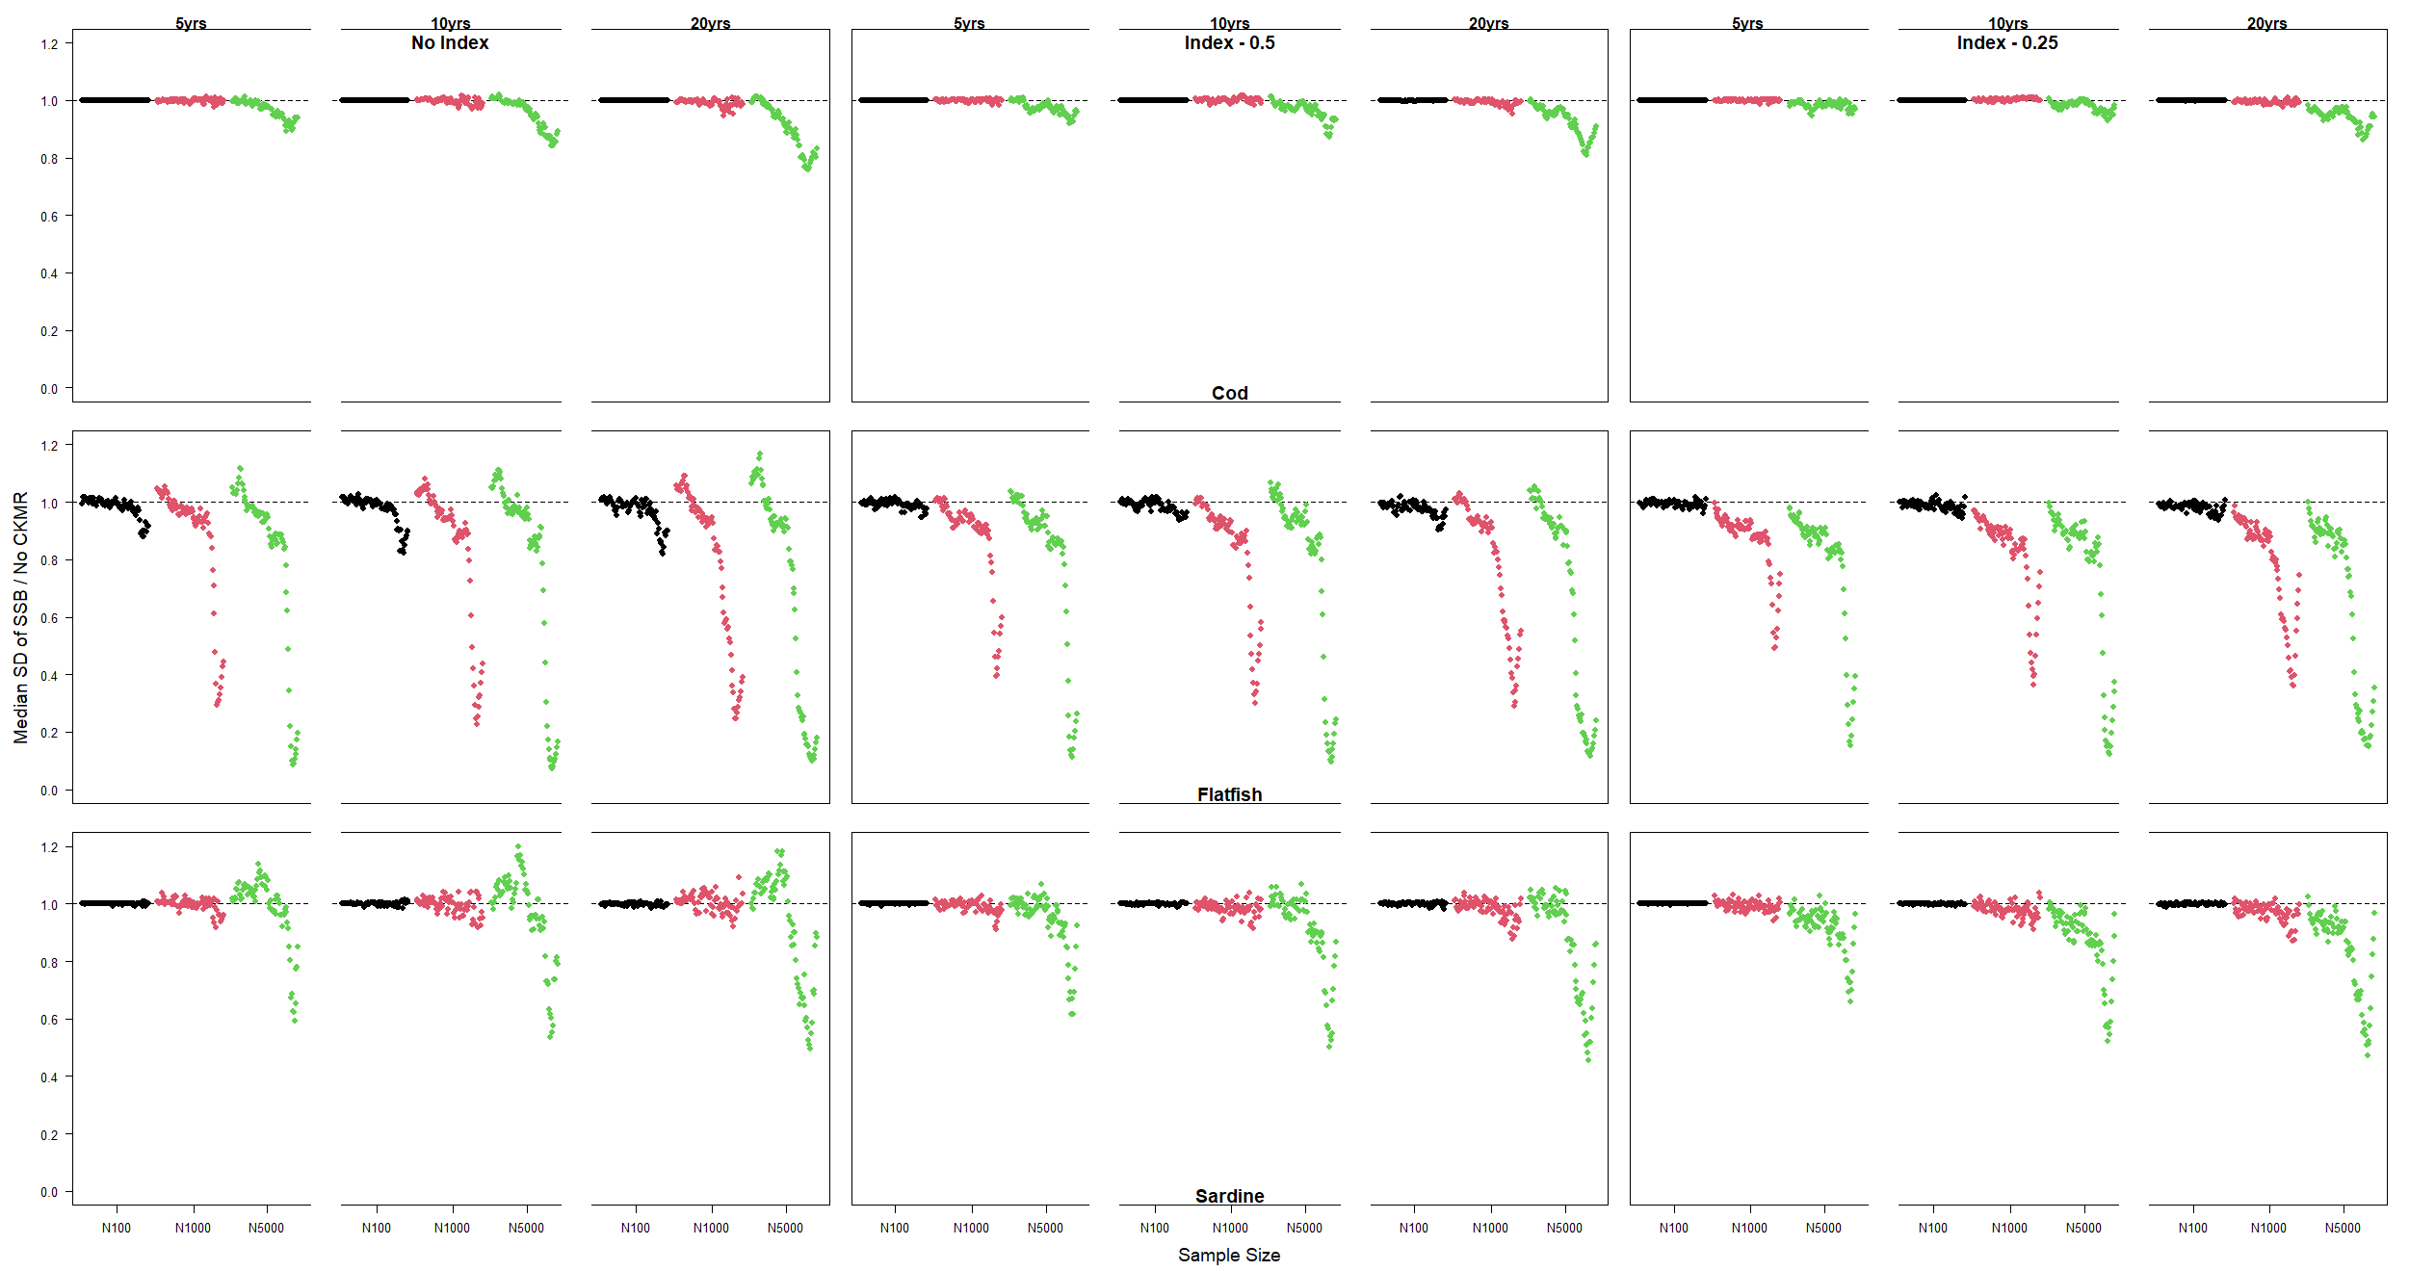

Figure X. The median standard deviation for spawning stock biomass in each year within a simulation (and median across simulations) for estimation models fit with CKMR divided by the same metric for identical estimation models fit without CKMR.

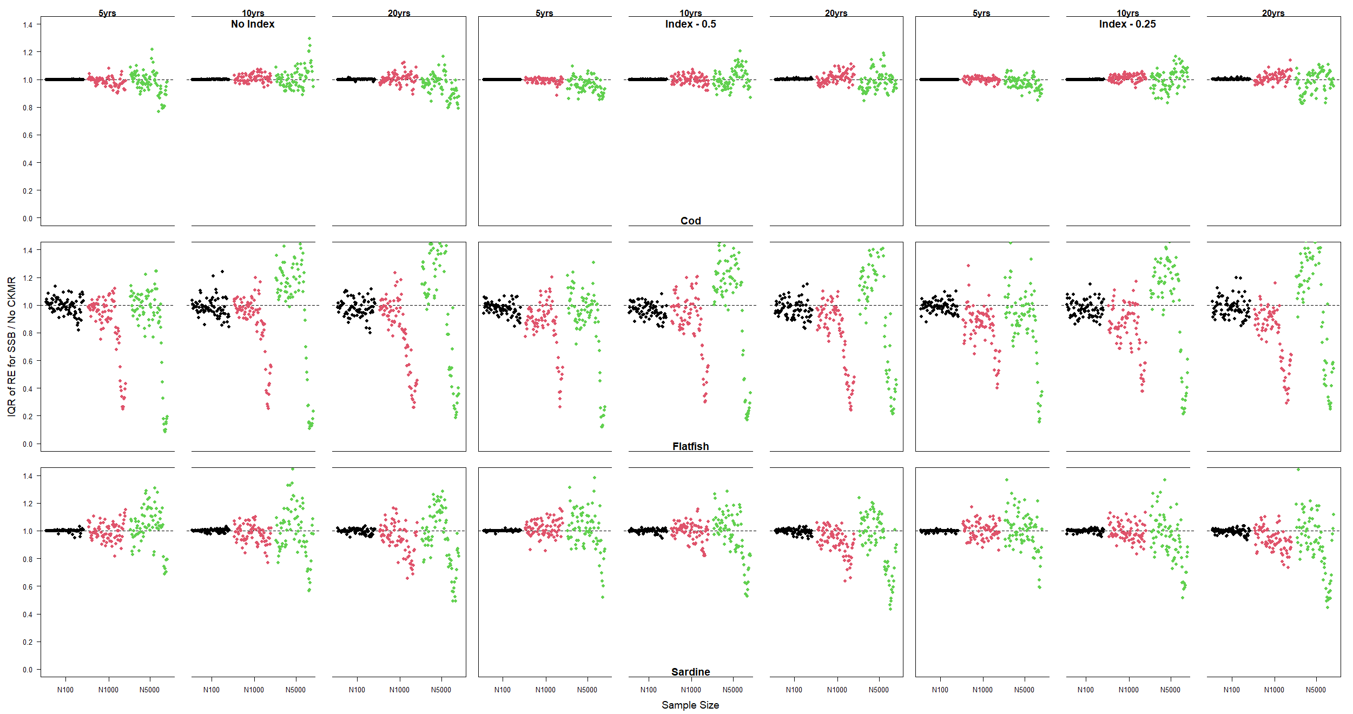

Figure X. The interquartile range of relative error across simulations for spawning stock biomass in each year for estimation models fit with CKMR divided by the same metric for identical estimation models fit without CKMR.

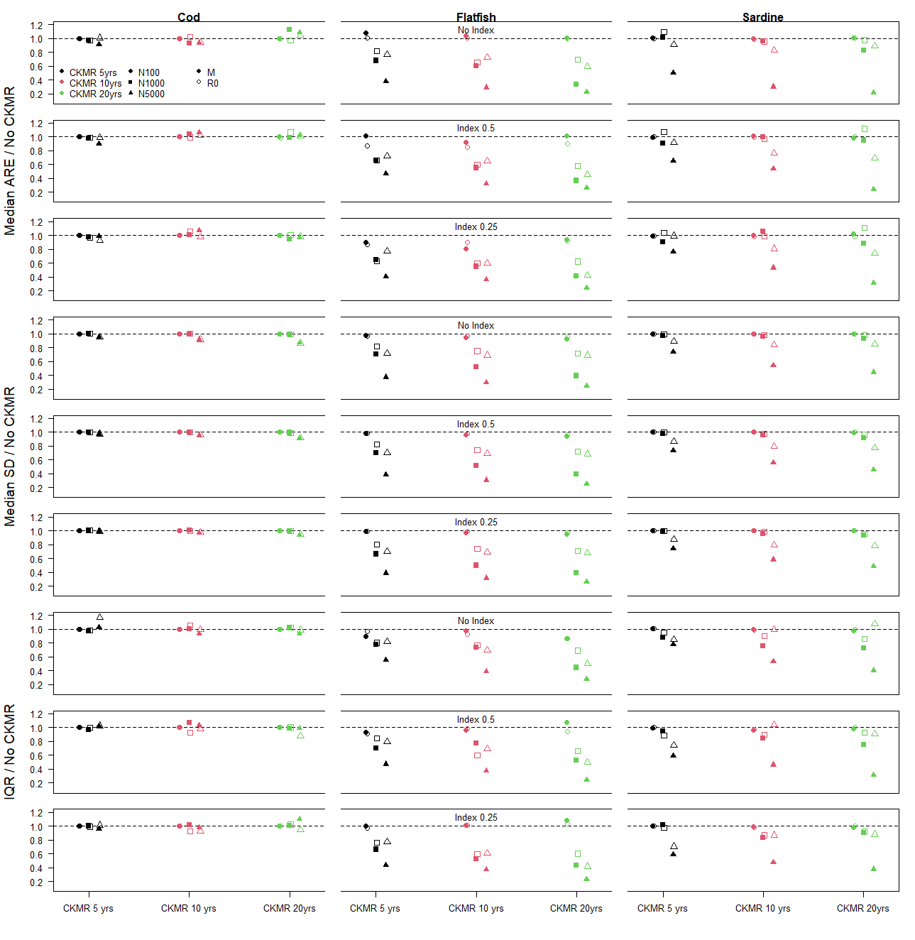

Figure X. Results for M and R0.

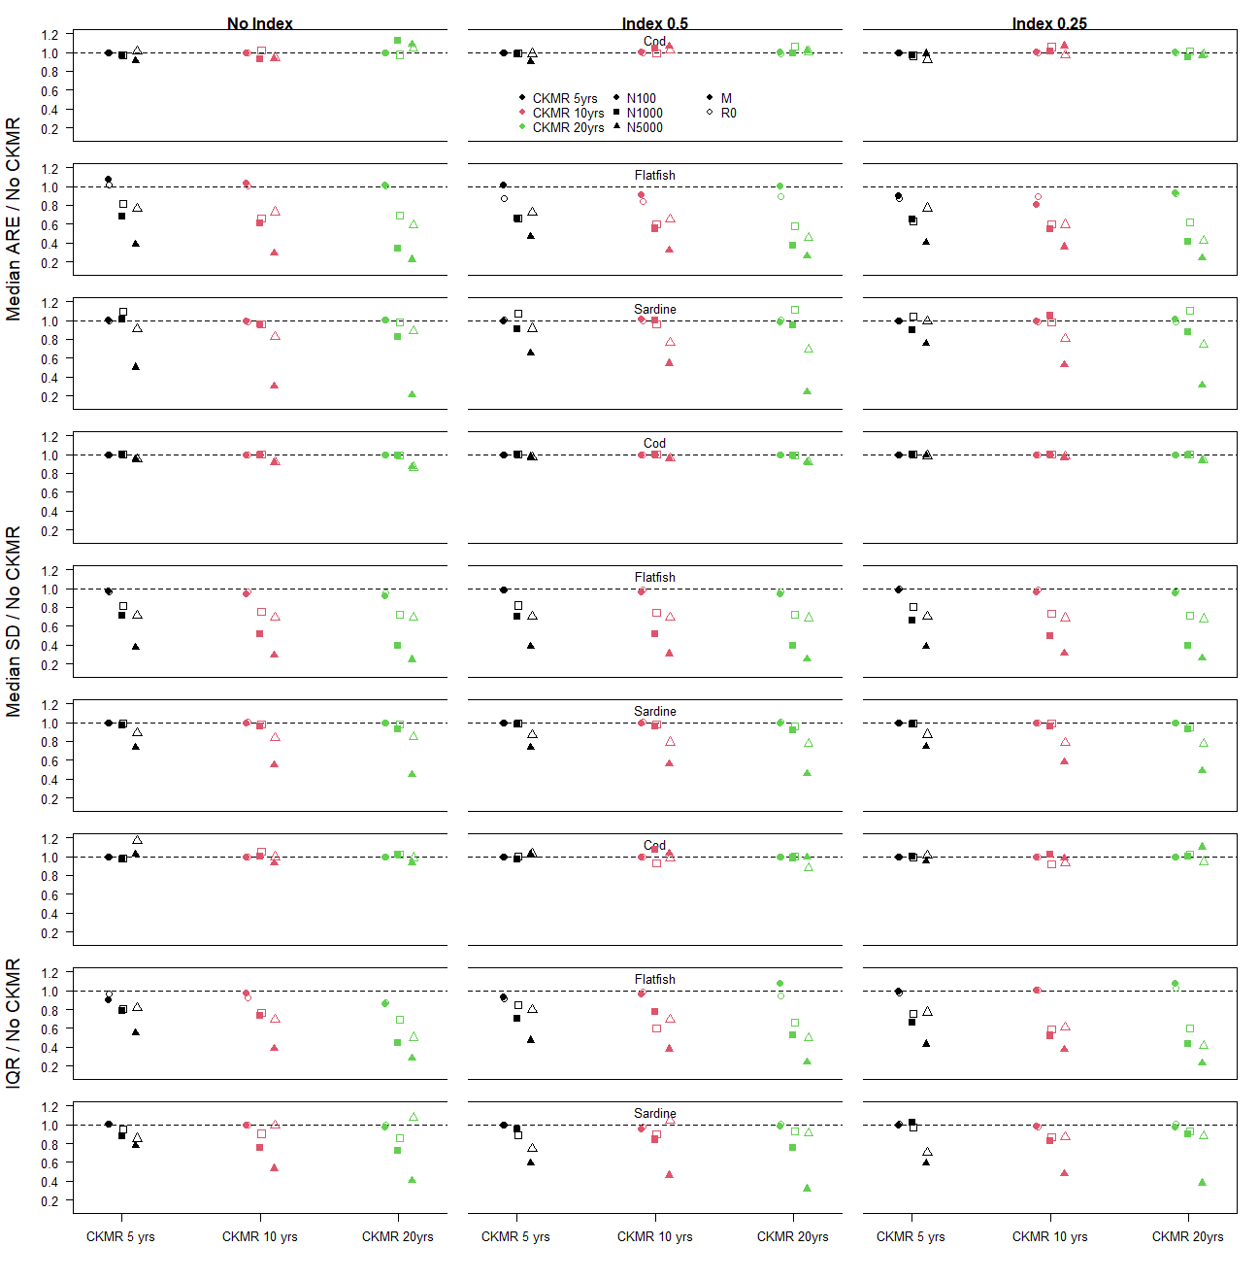

Flipped.

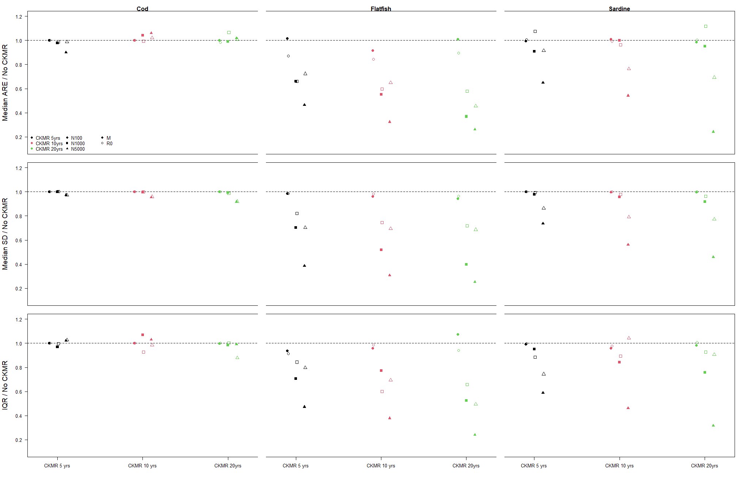

Figure X. Results for M and R0, only for SD 0.5.