DFX Project 2: Stitching

B00901022祝成豪＆B00902004徐粲翔

1. Project Description

The topic of this project is Image Stitching.

1. Algorithms
2. Code Implementation

When we were testing our blending function, we found out that some bizarre black areas appeared near the border between two photos. The blended result is shown below.

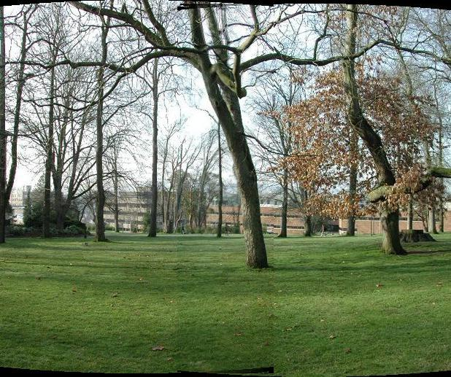

After further examination, we found the source of the problem. The reason is that when we were doing cylindrical reprojection. We saved the result as .jpg files. Since .jpg photos are the results of compressing processes. The cylindrical images we generated are flawed. Some pixels that were meant to be black (0,0,0) got contaminated by nearby pixels as shown below.

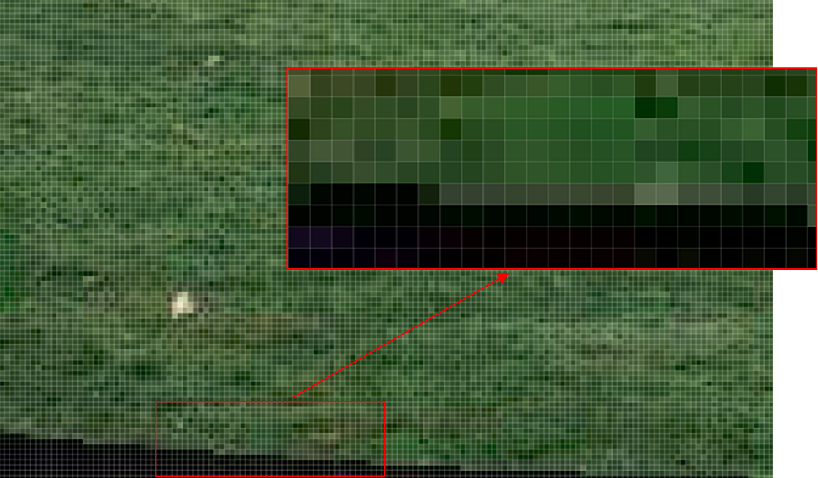

1. Results
2. Summary