1. If time is low then watch this video: <https://www.youtube.com/watch?v=qSJvVAC8uc8>

Otherwise:

1. Download Python
   1. Go to [python.org](https://python.org/) to download and install the latest version of Python. Now Python’s latest version Python 3.8.3. It can be a different version in the future.

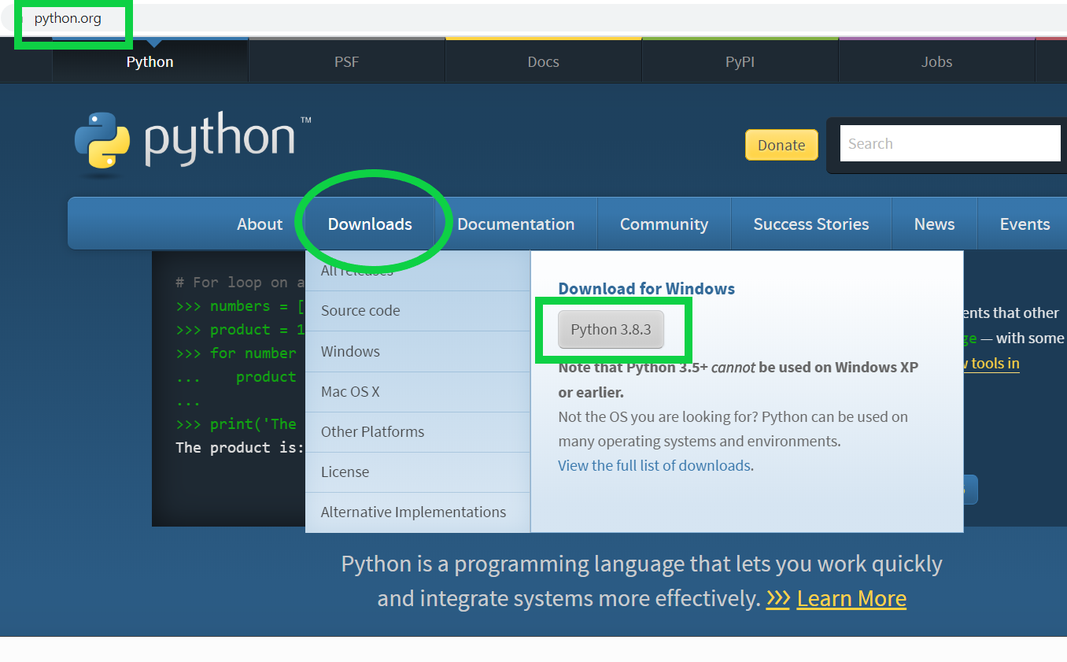

1. After downloading the latest version of Python click and execute it.
   1. Important Note here: You have to select ” Add Python 3.8 to PATH ” checkbox and then click “Install Now“

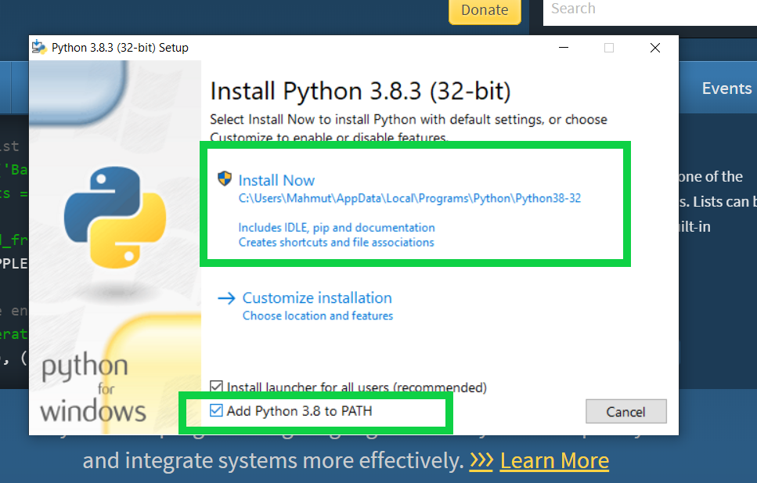

* 1. After installation finishes, click close.

1. Go to <http://jetbrains.com/pycharm/download> to download PyCharm Community. We do not need PyCharm Professional at this point in time.

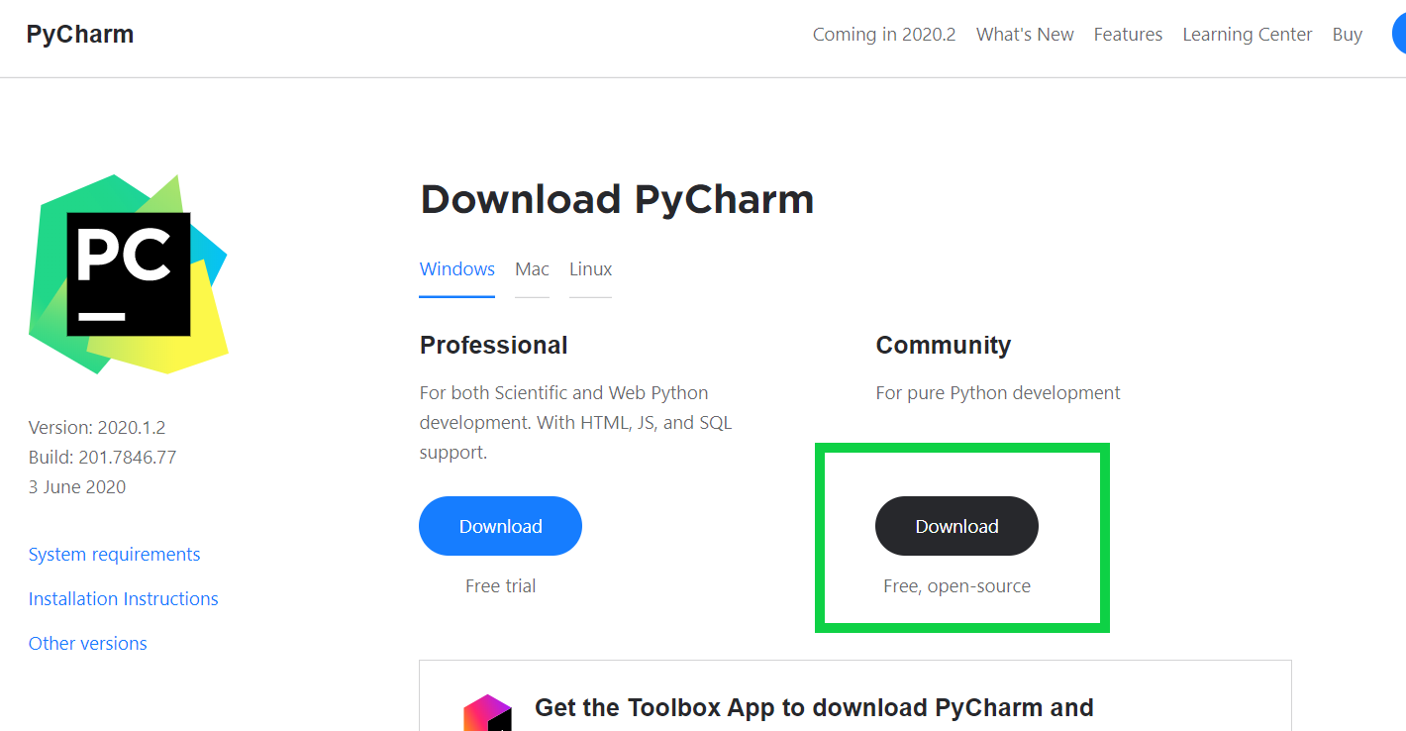

1. After download is complete, run the exe file to install PyCharm. Click “**Next**” and go on.

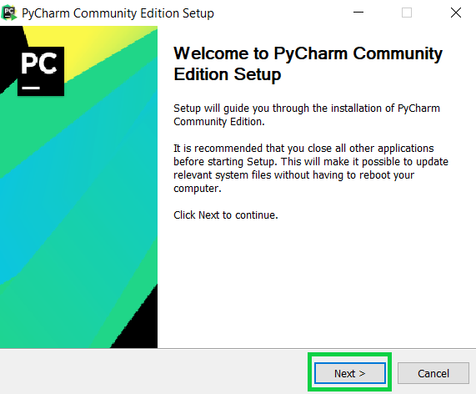

1. Choose your Destination folder for installation and click “**Next**“
2. If you want you can create a desktop shortcut ( 32 – bit or 64 – bit launcher depends on your computer ) and click “Next“

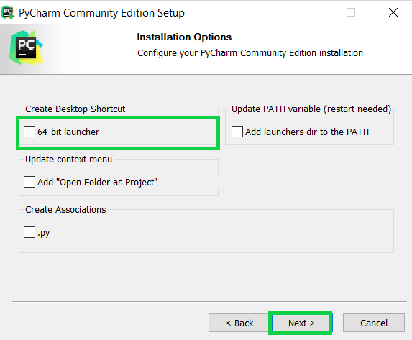

1. Select the Start Menu folder in which you would like to create the program’s shortcuts. Then click “Install“
2. Click “Run PyCharm Community Edition” and then click “Finish“.

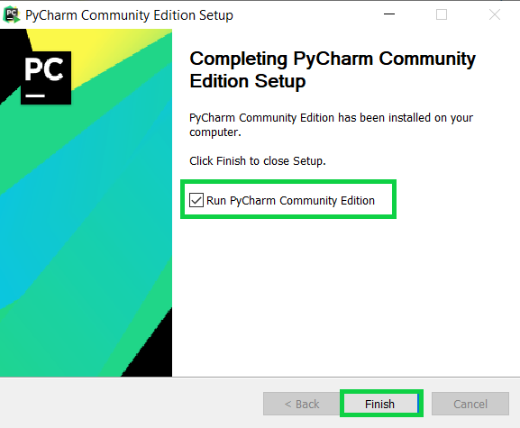

**CREATE YOUR FIRST PYTHON PROJECT**

1. Open PyCharm and Create New Project

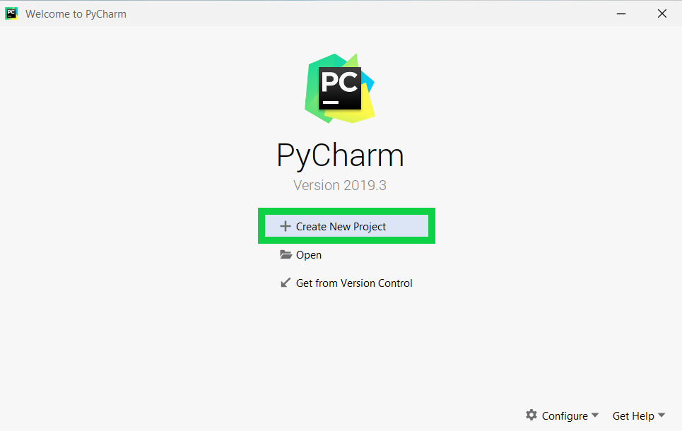

1. Set up environment
   1. **Location**: We select the location of the Python project where we want to be created and we give a name to our Python project. Type “**HelloWorld**” to our Python project.
   2. **Base Interpreter**: To create a project and run successfully Pycharm should found the Python interpreter you installed.
   3. Click the “**Create**” button.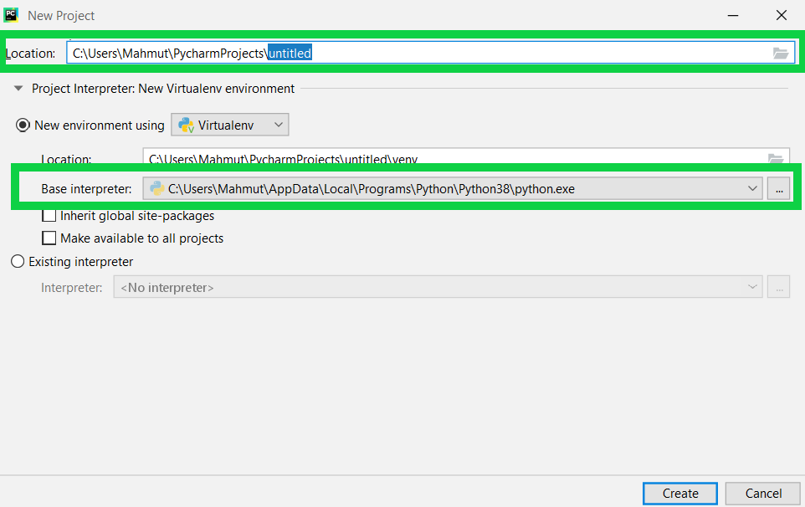
2. Click the “Hello World” project
   1. Then click new
      1. Then click python file

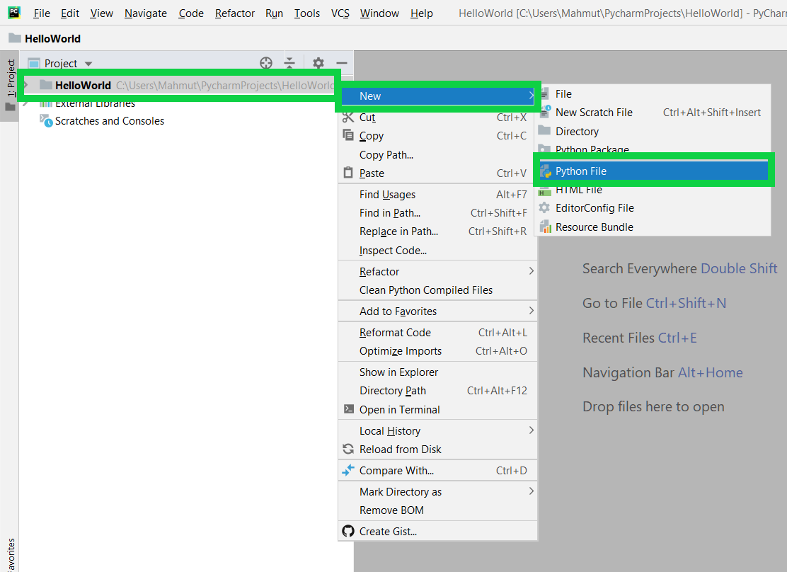

1. Name your file anything you’d like. Traditionally your first python file is called “Hello World”
2. In the editing field, type: print(“Hello World!”)

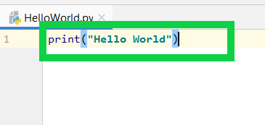

1. In the top menu click Run and then click Run in the dropdown

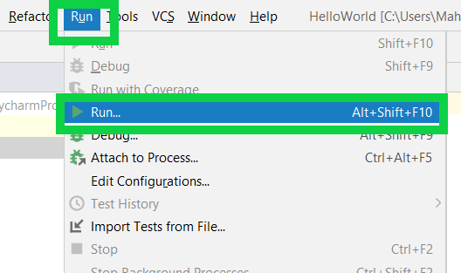

1. Admire your results in the results tab located below your code and try some new commands like
   1. print("Hello World")
   2. print(1 + 3)
   3. print(6 * 7)
   4. print()
   5. print("End of it")