Normalized Relations:
Sales Invoice

0NF:
SalesInvoice(InvoiceNo, Date, Salesman, CustName, Address, City, State, PostalCode, Telephone, SerialNumber, VehicleMake, VehicleModel, VehicleYear, VehicleColor, [InsuranceCoverage], [Code, Description, Price], [SerialNo, TradeInMake, TradeInModel, TradeInYear, TradeInAllowance], TotalPrice, Trade-InAllowance, Discount, Net, Taxes, TotalPayable)

1NF:
SalesInvoice(InvoiceNo, Date, Salesman, CustName, Address, City, State, PostalCode, Telephone, SerialNumber, VehicleMake, VehicleModel, VehicleYear, VehicleColor, TotalPrice, Trade-InAllowance, Discount, Net, Taxes, TotalPay)
Insurance(Coverage, InvoiceNo)
InvoiceOptions(Code, InvoiceNo, Description, Price)
InvoiceTrade-In(SerialNo, InvoiceNo, TradeInMake, TradeInModel, TradeInYear, TradeInAllowance)

2NF:
SalesInvoice(InvoiceNo, Date, Salesman, CustName, Address, City, State, PostalCode, Telephone, SerialNumber, VehicleMake, VehicleModel, VehicleYear, VehicleColor, TotalPrice, Trade-InAllowance, Discount, Net, Taxes, TotalPay)
Insurance(Coverage, InvoiceNo)
InvoiceOptions(Code, InvoiceNo)
Options(Code, Description, Price)
InvoiceTrade-In(SerialNo, InvoiceNo, Allowance)
Trade-In(SerialNo, TradeInMake,TradeInModel, TradeInYear)

3NF:
SalesInvoice(InvoiceNo, CustName, SerialNumber, Date, Salesman, TotalPrice, Trade-InAllowance, Discount, Net, Taxes, TotalPay)
Customer(CustName, Address, City, State, PostalCode, Telephone)
Vehicle(SerialNumber, VehicleMake, VehicleModel, VehicleYear, VehicleColor)
Insurance(Coverage, InvoiceNo)
InvoiceOptions(Code, InvoiceNo)
Options(Code, Description, Price)
InvoiceTrade-In(SerialNo, InvoiceNo, Allowance)
Trade-In(SerialNo, TradeInMake,TradeInModel, TradeInYear)
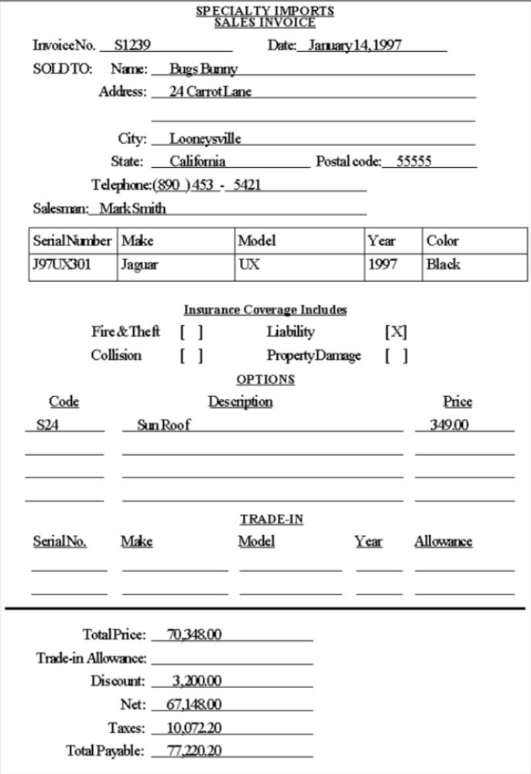
Vehicle Sales Accounting Supplement
0NF:
Supplement(SalesInvoiceNo, Customer, Date, [Item, Cost, Sale], Serial#, Freight&Prep, Tax, LicenseFees, Other, Commission, Total)

1NF:
Supplement(SalesInvoiceNo, Customer, Date, Serial#, Freight&Prep, Tax, LicenceFees, Commission)
SupplementOptions(Item, SalesInvoiceNo, Cost, Sale)

2NF:
Supplement(SalesInvoiceNo, Customer, Date, Serial#, Freight&Prep, Tax, LicenceFees, Commission)
SupplementOptions(Item, SalesInvoiceNo)
Options(Item, Cost, Sale)

3NF:
Supplement(SalesInvoiceNo, SerialNo, Customer, Date, Commission)
SupplementOptions(Item, SalesInvoiceNo)
Options(Item, Cost, Sale)
Vehicle(SerialNo, Freight&Prep, Tax, LicenceFees)
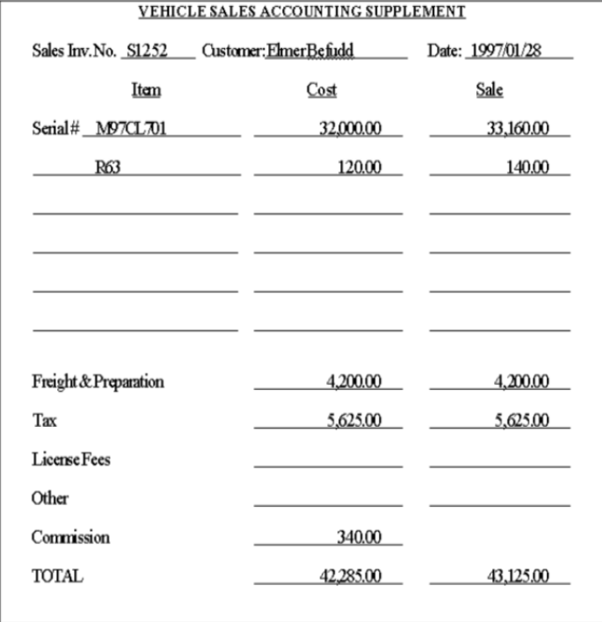

Service Work Order
0NF:
WorkOrder(ServiceInvoiceNo, Date, Name, Address, City, State, PostalCode, WorkPhone, HomePhone SerialNo, Make, Model, Year, Color, [WorkTODO], Parts, Labor, Tax, Total)
1NF:
WorkOrder(ServiceInvoiceNo, Date, Name, Address, City, State, PostalCode, WorkPhone, HomePhone Serial#, Make, Model, Year, Color, Parts, Labor, Tax, Total)
WorkList(WorkTODO, ServiceInvoiceNo)
2NF:
WorkOrder(ServiceInvoiceNo, Date, Name, Address, City, State, PostalCode, WorkPhone, HomePhone SerialNo, Make, Model, Year, Color, Parts, Labor, Tax, Total)
WorkList(WorkTODO, ServiceInvoiceNo)
3NF:
WorkOrder(ServiceInvoiceNo, Name, Serial#, Date, Parts, Labor, Tax, Total)
Customer(CustName, Address, City, State, PostalCode, WorkPhone, HomePhone)
Vehicle (SerialNo, Make, Model, Year, Colour)
WorkList(WorkTODO, ServiceInvoiceNo)
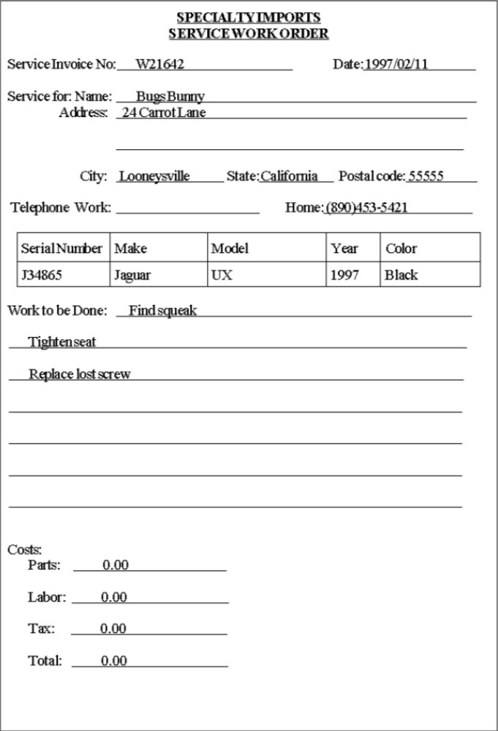

Service Log
0NF – 3NF:
ServiceLog(InventoryNo, SerialNo, Date, TotalCost)
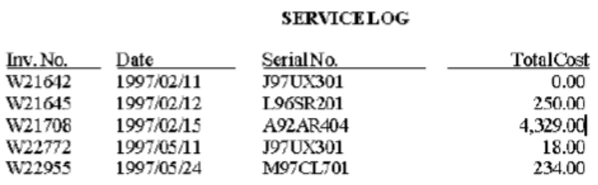

Vehicle Inventory Record
0NF:
VehicleRecord(SerialNo, Make, Model, Year, ExteriorColor, Trim PurchaseFrom, PurchaseInventory#, PurchaseDate, PurchaseCost, ListBasePrice, [Code, Desc, ListPrice])
1NF:
VehicleRecord(SerialNo, Make, Model, Year, ExteriorColor, Trim PurchaseFrom, PurchaseInventory#, PurchaseDate, PurchaseCost, ListBasePrice)
VehicleRecordOptions(Code, SerialNo, Desc, ListPrice)
2NF:
VehicleRecord(SerialNo,Make, Model, Year, ExteriorColor, Trim, PurchaseFrom, PurchaseInventory#, PurchaseDate, PurchaseCost, ListBasePrice)
VehicleRecordOptions(Code, SerialNo)
Options (SerialNo, Desc, ListPrice)
3NF:
VehicleRecord(SerialNo, PurchaseInventoryNo, Make, Model, Year, ExteriorColor, Trim, ListBasePrice)
InventoryPurchase(PurchaseInventoryNo, PurchaseFrom, PurchaseDate, PurchaseCost)
VehicleRecordOptions(Code, SerialNo)
Options (SerialNo, Desc, ListPrice)
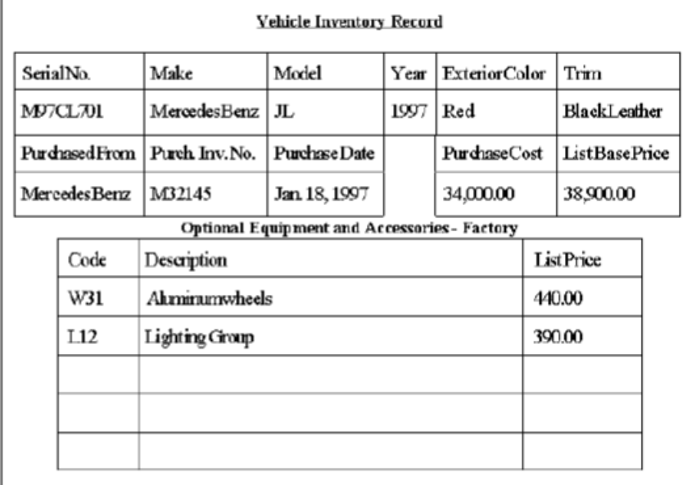

Prospect List
0NF:
ProspectList(CustName, [Year, [Color, [Brand, [Model, [Trim, [OptionsCode]]]]]])
ProspectListYear(CustName, Year, [Color, [Brand, [Model, [Trim, [OptionsCode]]]]])
ProspectListYear(CustName, Year)
ProspectListYearColor(CustName, Year, Color, [Brand, [Model, [Trim, [OptionsCode]]]])
ProspectListYear(CustName, Year)
ProspectListYearColor(CustName, Year, Color)
ProspectListYearColorBrand(CustName, Year, Color, Brand, [Model, [Trim, [OptionsCode]]])
ProspectListYear(CustName, Year)
ProspectListYearColor(CustName, Year, Color)
ProspectListYearColorBrand(CustName, Year, Color, Brand)
ProspectListYearColorBrandModel(CustName, Year, Color, Brand, Model, [Trim, [OptionsCode]])
ProspectListYear(CustName, Year)
ProspectListYearColor(CustName, Year, Color)
ProspectListYearColorBrand(CustName, Year, Color, Brand)
ProspectListYearColorBrandModel(CustName, Year, Color, Brand, Model)
ProspectListYearColorBrandModelTrim(CustName, Year, Color, Brand, Model, Trim, [OptionsCode])
1NF:
ProspectListYear(CustName, Year)
ProspectListYearColor(CustName, Year, Color)
ProspectListYearColorBrand(CustName, Year, Color, Brand)
ProspectListYearColorBrandModel(CustName, Year, Color, Brand, Model)
ProspectListYearColorBrandModelTrim(CustName, Year, Color, Brand, Model, Trim)
ProspectListYearColorBrandModelTrimCode(CustName, Year, Color, Brand, Model, Trim, OptionsCode)
2NF:
ProspectListYear(CustName, Year)
ProspectListYearColor(CustName, Year, Color)
ProspectListYearColorBrand(CustName, Year, Color, Brand)
ProspectListYearColorBrandModel(CustName, Year, Color, Brand, Model)
ProspectListYearColorBrandModelTrim(CustName, Year, Color, Brand, Model, Trim)
ProspectListYearColorBrandModelTrimCode(CustName, Year, Color, Brand, Model, Trim, OptionsCode) 7

3NF:
ProspectListYear(CustName, Year)
ProspectListYearColor(CustName, Year, Color)
ProspectListYearColorBrand(CustName, Year, Color, Brand)
ProspectListYearColorBrandModel(CustName, Year, Color, Brand, Model)
ProspectListYearColorBrandModelTrim(CustName, Year, Color, Brand, Model, Trim)
ProspectListYearColorBrandModelTrimCode(CustName, Year, Color, Brand, Model, Trim, OptionsCode)
