**Install And Configure Samba Server In CentOS 7**

As you may know, **Samba** is an open source, and free software suite that provides file and print services to the SMB/CIFS clients. It allows us to share files, folders, and printers between Linux server and Windows clients. Using Samba, we can setup a domain controller on Unix/Linux server, and integrate the Windows clients to the Domain controller.

This tutorial will describe you how to setup a basic samba server in CentOS 7 system. Also, this steps will work on RHEL 7, and Scientific Linux 7 operating systems.

**Scenario**

In this tutorial, I will using two systems as described below.

**Samba server:**

Operating system : CentOS 7 minimal server

Hostname : server.unixmen.local

IP Address : 192.168.1.101/24

**Samba client:**

Operating system : Windows 7 Professional

Hostname : client

IP Address : 192.168.1.102/24

**Install Samba**

Check for existing samba package if any using the following commands.

rpm -qa | grep samba

yum list installed | grep samba

If samba is installed, remove it using the below command:

yum remove samba*

Now, install samba using the following command.

yum install samba* -y

**1. Configure a fully accessed anonymous share**

Now, let us create a fully accessed anonymous share for the users. Any one can read/write in this share.

Create a directory called **‘/samba/anonymous_share’** and set full permission. You can name this share as per your liking.

mkdir -p /samba/anonymous_share

chmod -R 0777 /samba/anonymous_share

Edit Samba configuration file;

vi /etc/samba/smb.conf

Find the following directives, and make the changes as shown below.

**[...]**

**## Add the following lines under [global] section ##**

unix charset = UTF-8

dos charset = CP932

**## Change the to windows default workgroup ##**

workgroup = WORKGROUP

**## Uncomment and set the IP Range ##**

hosts allow = 127. 192.168.1.

**## Uncomment ##**

max protocol = SMB2

**## Uncomment, and change the value of 'Security' to 'user' ##**

security = user

**## Add the following line ##**

map to guest = Bad User

**## Add the following lines at the bottom ##**

[Anonymous share]

path = /samba/anonymous_share

writable = yes

browsable = yes

guest ok = yes

guest only = yes

create mode = 0777

directory mode = 0777

Start samba services, and enable them to start automatically on every reboot.

systemctl start smb

systemctl start nmb

systemctl enable smb

systemctl enable nmb

**Test the Samba server configuration**

We can test the Samba server configuration syntax errors using the command ‘testparm’.

testparm

Sample Output:

Load smb config files from /etc/samba/smb.conf

rlimit_max: increasing rlimit_max (1024) to minimum Windows limit (16384)

Processing section "[homes]"

Processing section "[printers]"

Processing section "[Anonymous share]"

Loaded services file OK.

WARNING: You have some share names that are longer than 12 characters.

These may not be accessible to some older clients.

(Eg. Windows9x, WindowsMe, and smbclient prior to Samba 3.0.)

Server role: ROLE_STANDALONE

Press enter to see a dump of your service definitions

[global]

    dos charset = CP932

    netbios name = UNIXMEN SAMBA SERVER

    server string = Samba Server Version %v

    map to guest = Bad User

    log file = /var/log/samba/log.%m

    max log size = 50

    server max protocol = SMB2

    idmap config * : backend = tdb

    hosts allow = 127., 192.168.1.

    cups options = raw

[homes]

    comment = Home Directories

    read only = No

    browseable = No

[printers]

    comment = All Printers

    path = /var/spool/samba

    printable = Yes

    print ok = Yes

    browseable = No

[Anonymous share]

    path = /samba/anonymous_share

    read only = No

    create mask = 0777

    directory mask = 0777

    guest only = Yes

    guest ok = Yes

If all good, you’re good to go now.

**Firewall configuration**

Allow Samba server default ports through firewall.

firewall-cmd --permanent --add-port=137/tcp

firewall-cmd --permanent --add-port=138/tcp

firewall-cmd --permanent --add-port=139/tcp

firewall-cmd --permanent --add-port=445/tcp

firewall-cmd --permanent --add-port=901/tcp

Restart firewall to apply the changes.

firewall-cmd --reload

**SELinux Configuration**

Turn the **samba_enable_home_dirs** Boolean on if you want to share home directories via Samba.

setsebool -P samba_enable_home_dirs on

If you create a new directory, such as a new top-level directory, label it with **samba_share_t** so that SELinux allows Samba to read and write to it. Do not label system directories, such as **/etc/** and **/home/**, with samba_share_t, as such directories should already have an SELinux label.

In our case, we already have created a anonymous directory. So let us label it as shown below.

chcon -t samba_share_t /samba/anonymous_share/

If you don’t want to mess up with the SELinux, just disable it as shown below, and continue.

To disable SELinux, edit file /etc/sysconfig/selinux,

vi /etc/sysconfig/selinux

Set SELinux value to disabled.

# This file controls the state of SELinux on the system.

# SELINUX= can take one of these three values:

# enforcing - SELinux security policy is enforced.

# permissive - SELinux prints warnings instead of enforcing.

# disabled - No SELinux policy is loaded.

**SELINUX=disabled**

# SELINUXTYPE= can take one of these two values:

# targeted - Targeted processes are protected,

# mls - Multi Level Security protection.

SELINUXTYPE=targeted

Restart the server to take effect the changes.

**Test Samba Shares**

Now, goto any windows client system. In this example, I am using Windows 7 system.

ClickStart -> Run. Enter the samba Server IP as shown below.

[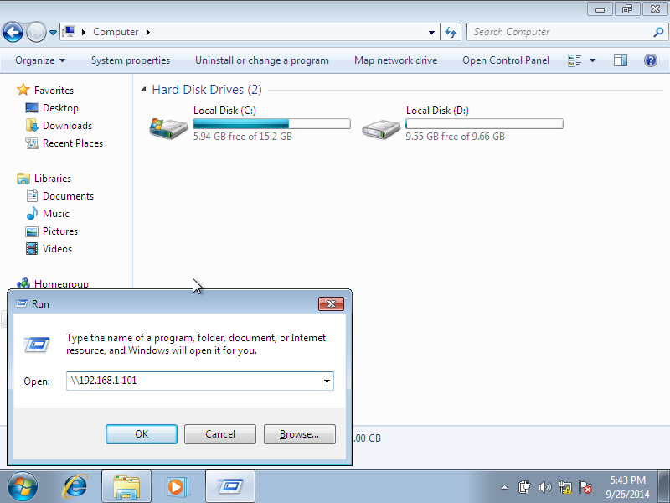](http://180016988.r.cdn77.net/wp-content/uploads/2014/09/Windows-7-1-nic-bridge-internet-Running-Oracle-VM-VirtualBox_001.png)

Now, you’ll be able to access the fully accessed samba shares.

[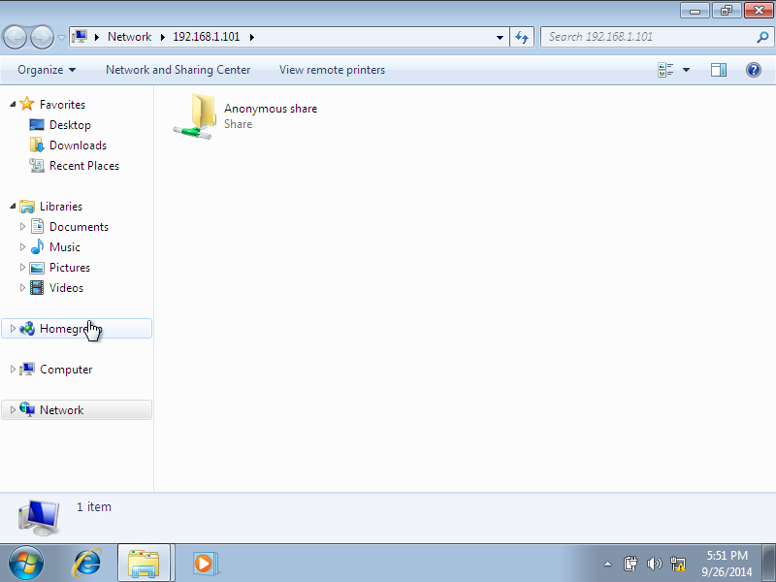](http://180016988.r.cdn77.net/wp-content/uploads/2014/09/Windows-7-1-nic-bridge-internet-Running-Oracle-VM-VirtualBox_002.png)

You can create, modify or delete the files/folders inside the shares. For example, let me create a sample folder called **‘unixmen’** inside the samba share folder.

[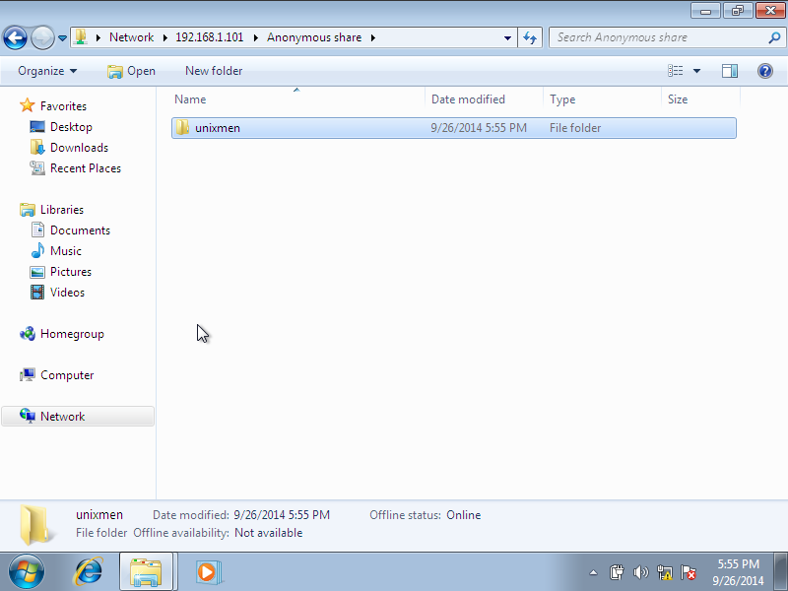](http://180016988.r.cdn77.net/wp-content/uploads/2014/09/Windows-7-1-nic-bridge-internet-Running-Oracle-VM-VirtualBox_003.png)

Check the newly created files or folders are present in the samba server

ls -l /samba/anonymous_share/

Sample Output:

total 0

drwxrwxrwx. 2 nobody nobody 6 Sep 26 17:55 **unixmen**

As you see in the result, the folder has been created in the **/samba/anonymous/** directory.

**2. Create security enabled share in samba server**

What we have seen so far is creating a fully accessed samba share. Anyone can access that share folder, and can create, delete files/folders in that share.

Now, let us create a password protected samba share so that the users should enter the valid username and password to access the share folder.

Create a user called **“unixmen”** and a group called **“smbgroup”**.

useradd -s /sbin/nologin unixmen

groupadd smbgroup

Assign the user **unixmen** to **smbgroup**, and set samba password to that user.

usermod -a -G smbgroup unixmen

smbpasswd -a unixmen

Create a new share called “/samba/secure_share” and set the permissions to that share.

mkdir /samba/secure_share

chmod -R 0755 /samba/secure_share

chown -R unixmen:smbgroup /samba/secure_share

Edit samba config file;

vi /etc/samba/smb.conf

Add the below lines at the bottom of samba config file.

[secure_share]

path = /samba/secure_share

writable = yes

browsable = yes

guest ok = no

valid users = @smbgroup

Test the samba configuration for any errors.

testparm

Sample output:

Load smb config files from /etc/samba/smb.conf

rlimit_max: increasing rlimit_max (1024) to minimum Windows limit (16384)

Processing section "[homes]"

Processing section "[printers]"

Processing section "[Anonymous share]"

Processing section "[secure_share]"

Loaded services file OK.

WARNING: You have some share names that are longer than 12 characters.

These may not be accessible to some older clients.

(Eg. Windows9x, WindowsMe, and smbclient prior to Samba 3.0.)

Server role: ROLE_STANDALONE

Press enter to see a dump of your service definitions

[global]

    dos charset = CP932

    netbios name = UNIXMEN SAMBA SERVER

    server string = Samba Server Version %v

    map to guest = Bad User

    log file = /var/log/samba/log.%m

    max log size = 50

    server max protocol = SMB2

    idmap config * : backend = tdb

    hosts allow = 127., 192.168.1.

    cups options = raw

[homes]

    comment = Home Directories

    read only = No

    browseable = No

[printers]

    comment = All Printers

    path = /var/spool/samba

    printable = Yes

    print ok = Yes

    browseable = No

[Anonymous share]

    path = /samba/anonymous_share

    read only = No

    create mask = 0777

    directory mask = 0777

    guest only = Yes

    guest ok = Yes

[secure_share]

    path = /samba/secure_share

    valid users = @smbgroup

    read only = No

Label  the **/samba/secure_share/** with **samba_share_t** so that SELinux allows Samba to read and write to it.

chcon -t samba_share_t /samba/secure_share/

Restart samba services.

systemctl restart smb

systemctl restart nmb

**Test Samba shares**

Now, goto windows client, check for the secured share folder.

[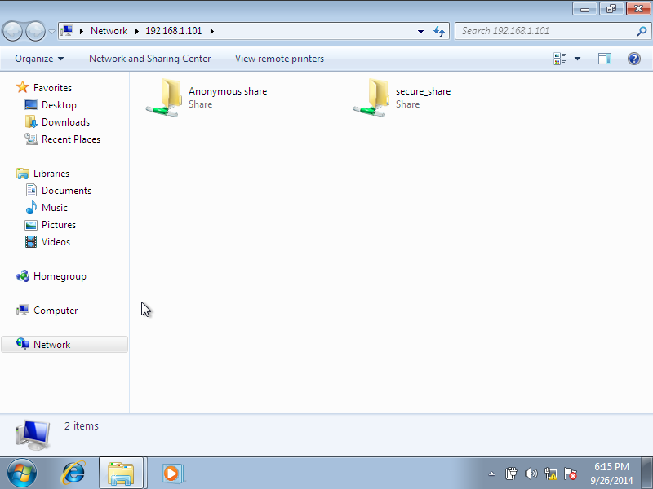](http://180016988.r.cdn77.net/wp-content/uploads/2014/09/Windows-7-1-nic-bridge-internet-Running-Oracle-VM-VirtualBox_004.png)

Double click to open the secured share. You’ll be asked to enter the user name and password to access the share.

[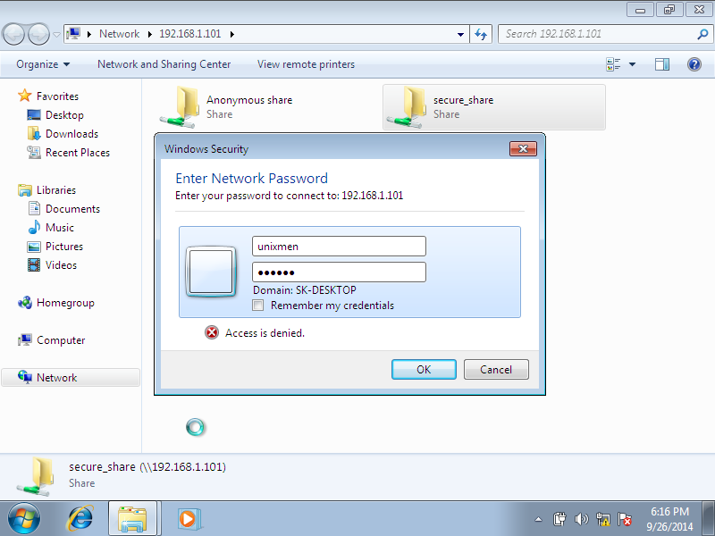](http://180016988.r.cdn77.net/wp-content/uploads/2014/09/Windows-7-1-nic-bridge-internet-Running-Oracle-VM-VirtualBox_005.png)

That’s it. Now, you can access the secured samba share folder.

[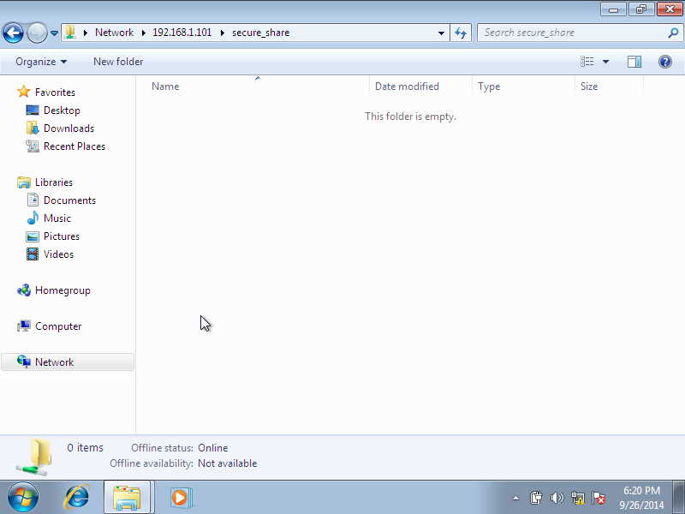](http://180016988.r.cdn77.net/wp-content/uploads/2014/09/Windows-7-1-nic-bridge-internet-Running-Oracle-VM-VirtualBox_006.png)

That’s it. Samba server is ready to use.

Cheers!