Titel
1 Inleiding 2
2 Prerequisites 2

Inleiding
Deze manual geeft de verschillende sensoren weer die te creeren zijn in PRTG voor Fortinet Firewall’s

Prerequisites
A working installation of PRTG \\jdn-file01\software$\Software - Windows Official\PRTG Network Monitor\PRTG - Software
The installation files with the new snmplibs \\jdn-file01\software$\Software - Windows Official\PRTG Network Monitor\PRTG - Vessel\1.1

Configuration
Remove all the old Juniper sensor’s if applicable (Jflow , Traffic , SNMP device info)
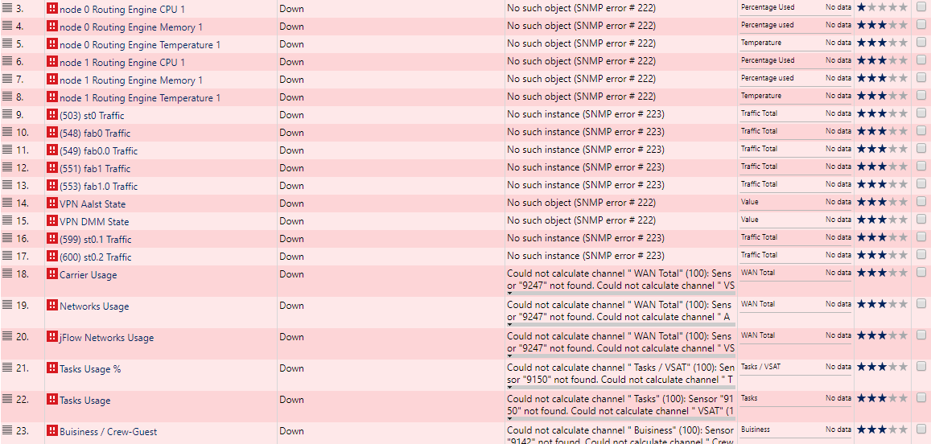

Open the PRTG Administration Tool on the Monitor server, stop the Core server, and Probe service.
Copy the files from
\\jdn-file01\software$\Software - Windows Official\PRTG Network Monitor\PRTG - Vessel\1.1
To
C:\Program Files (x86)\PRTG Network Monitor

Start the Monitor server, Start the Core server, and Probe service.

Open PRTG and go to the FW01 device.

Add new sensor and select SNMP Library.

Select the Fortinetha.oidlib
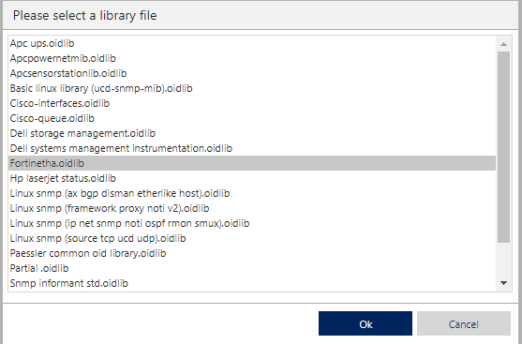

Select the fg ha starts :1 and 2 for CPU , MEM and NET usage
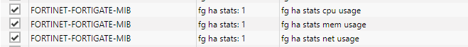

Add new sensor and select SNMP traffic sensor.
Add following traffic sensors:
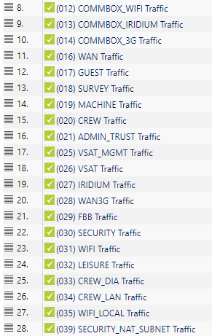

For the next step lookup, the values of the corresponding traffic sensors and prepare following channel values (Less variables used for sites/offices):
Ex: 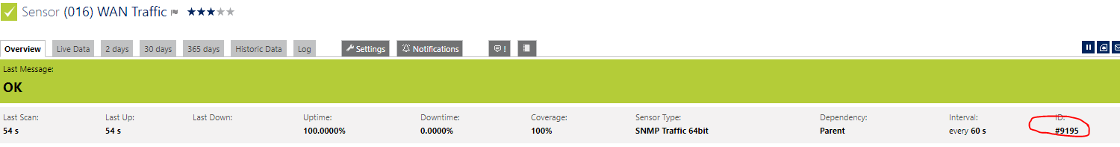
- Carrier Usage :
#100: WAN Total
Channel (9801, -1)
#101: VSAT
Channel (9808, -1)
#102: Iridium
Channel (9809, -1)
#103: 3G
Channel (9810, -1)
#104: FBB
Channel (9811, -1)
#105: Wifi
Channel (9813, -1)

- Networks Usage:
#100: WAN Total
Channel (9801, -1)
#101: Admin-Trust
Channel (9806, -1)
#102: Machine
Channel (9804, -1)
#103: Survey
Channel (9803, -1)
#104: Guest
Channel (9802, -1)
#105: Crew-DIA
Channel (9805, -1)
#106: Security
Channel (9812, -1)

Once you have these values create 2 Sensor Factory sensors One for Carrier usage and one for Network Usage and copy the values you just created to the Channel definition
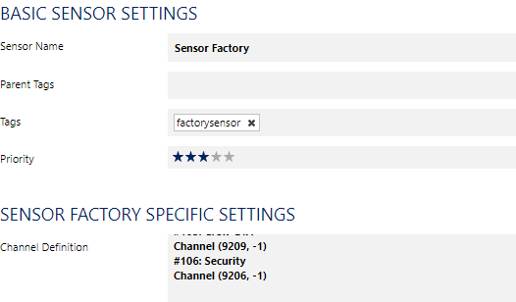

Create 7 Netflow9 sensors for the different VLANS in the network with UDP Port 2055 and the probe’s local ip selected.
Ex.
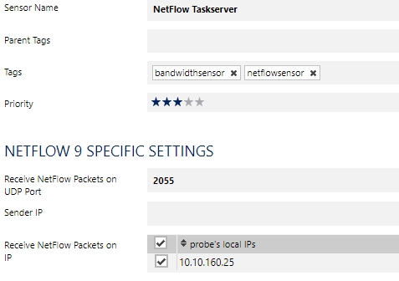
Active Flow Timeout (Minutes) >> 2

Add Following Settings in the Exclude Filter and replace the network ranges according to your setup. With 10.X.Y.* and
A = Y+1, B = Y+2, C = Y+3, D = Y+4, E = Y+5, Z = y+6

- Name : NetFlow Taskserver
(SourceIP[10.X.Y.15] OR DestinationIP[10.X.Y.15]) AND (SourceIP[10.128.*.*] OR SourceIP[10.136.*.*] OR SourceIP[10.137.*.*] OR DestinationIP[10.128.*.*] OR DestinationIP[10.136.*.*] OR DestinationIP[10.137.*.*])

- Name : NetFlow Admin-untrust
(DestinationIP[10.X.Y-Z.*] AND SourceIP[10.X.Y-Z.*]) OR SourceIP[10.X.Y.*] OR SourceIP[-10.X.B-D.*] OR DestinationIP[10.X.B.*] OR DestinationIP[-10.X.B-D.*]

- Name : NetFlow Admin-trust
(DestinationIP[10.X.Y-Z.*] AND SourceIP[10.X.Y-Z.*]) OR SourceIP[-10.X.A-Z.*] OR DestinationIP[-10.X.A-Z.*]

- Name : NetFlow Machine
(DestinationIP[10.X.Y-Z.*] AND SourceIP[10.X.Y-Z.*]) OR SourceIP[10.X.Y.*] OR SourceIP[-10.X.C-Z.*] OR DestinationIP[10.X.Y.*] OR DestinationIP[-10.X.C-Z.*]

- Name : NetFlow Survey
(DestinationIP[10.X.Y-Z.*] AND SourceIP[10.X.Y-Z.*]) OR SourceIP[10.X.Y-162.*] OR SourceIP[10.X.D-Z.*] OR DestinationIP[10.X.Y-B.*] OR DestinationIP[10.X.D-Z.*]

- Name : NetFlow Guest
(DestinationIP[10.X.Y-Z.*] AND SourceIP[10.X.Y-Z.*]) OR SourceIP[10.X.Y-C.*] OR SourceIP[10.X.E-Z.*] OR DestinationIP[10.X.Y-C.*] OR DestinationIP[10.X.E-Z.*]

- Name : NetFlow VPN
SourceIP[10.128.*.*] OR SourceIP[10.136.*.*] OR SourceIP[10.137.*.*] OR DestinationIP[10.128.*.*] OR DestinationIP[10.136.*.*] OR DestinationIP[10.137.*.*]
Add a Syslog Receiver Sensor and adjust the settings like shown below:
