No 1.
Script Name: ./a98220.sh
Description: This Prints numbers 99 to 110 and tells if each is even or odd

for number in {99..110} do
echo $number
if [ $((number % 2)) -eq 0 ] then
echo "I'm an even number!" else
echo "I'm an odd number!"
fi done

Execution Procedure:
1: Give execute permission using: chmod +x A98251.sh 2: Run the script using: ./a98220.sh
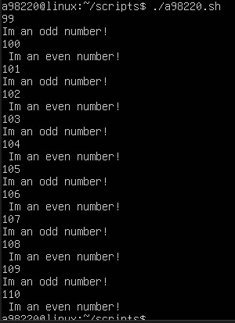

No 2a

Script Name:QN2Aa98220a.sh
Description: This displays your first name, last name, year of study, and program using command-line arguments

echo "My first name: $1" echo "My last name: $2" echo "I enrolled in: $4" echo "I am in year: $3"

Execution Procedure:
1: Give execute permission using: chmod +x QN2Aa98220.sh
2: Run it using: ./QN2Aa98220.sh <FirstName> <LastName> <Year> <Program> Example: ./A98220.sh Nicholas Ssentongo 3 Bachelor of Science in Information Technology(BSIT)

No 2b.

Script Name: QN2a98220.sh
Description: This asks for user details and displays them.

read -p "Enter your first name: " first_name read -p "Enter your last name: " last_name

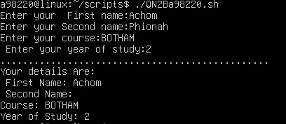
read -p "Enter your program: " program read -p "Enter your year of study: " year

echo "Your first name: $first_name" echo "Your last name: $last_name" echo "Your enrolled in: $program" echo "You're in year: $year"

1: Give execute permission using: chmod +x A98251b.sh 2: Run the script using: ./A98251b.sh

This will be the output
Enter your first name: Dave Enter your last name: Kwagala Enter your program: BSIT Enter your year of study: 3

Your first name: Dave Your last name: Kwagala Your enrolled in: BSIT You're in year: 3

No 3a

if [ -d ~/access ]; then
echo "Directory ~/access already exists" else
mkdir ~/access
echo "Directory ~/access created"
fi

b
if [ -f ~/access/myscript.sh ]; then
echo "File myscript.sh already exists" else
touch ~/access/myscript.sh echo "File myscript.sh created"
fi

#!/bin/bash
Script Name: A98251c.sh
Checks if directory ~/access exists and creates it if not. Checks if file ~/access/myscript.sh exists and creates it if not.

Check directory
if [ -d ~/access ]; then
echo "Directory ~/access already exists" else
mkdir ~/access
echo "Directory ~/access created"
fi

Check file
if [ -f ~/access/myscript.sh ]; then
echo "File myscript.sh already exists" else
touch ~/access/myscript.sh echo "File myscript.sh created"
fi

1: Give execute permission using: chmod +x A98251c.sh 2: Run the script using: ./A98251c.sh

This will be the output Directory ~/access created File myscript.sh created

