Nicholas Locnikar

COP1801 – Javascript

Professor Powell

Module 1 – Course Project

November 7, 2019

<http://sotd.us/nicholaslocnikar/COP1801/Module1/index.html>

https://github.com/nickel321/COP1801/Module1

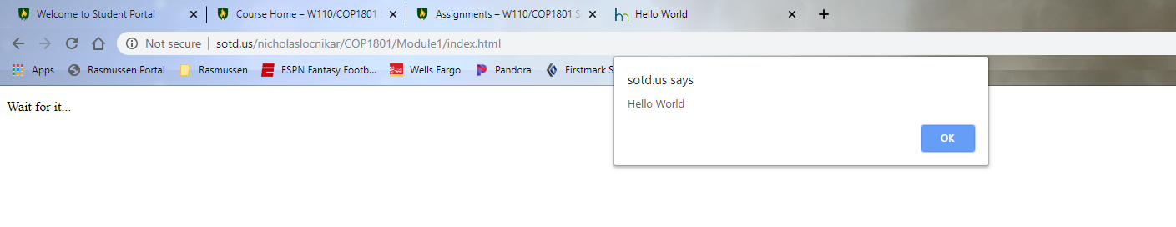

And then I was playing with the getElementById.innerhtml, but the delayed alert pops up. Additionally, if you give us your Github username, we can add you as collaborators in Github.