Nicholas Locnikar

COP1801 – Javascript

Professor Powell

Module 6 – Course Project

December 11, 2019

I think I spent too long on this trying different things. I was not sure if you wanted the header and that column to highlight, the row (which I did), or the individual element (which is what I wanted to do (I think that would be best done via CSS)).

https://github.com/nickel321/COP1801/Module6

<http://sotd.us/nicholaslocnikar/COP1801/Module6/mod6crsproj.html>

No hovering:

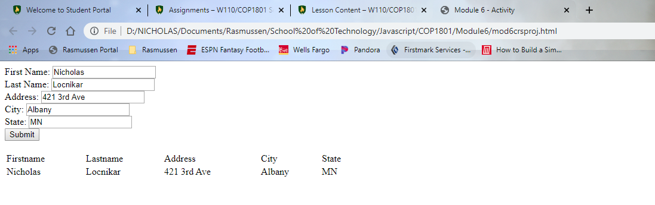

With me hovering over the text:

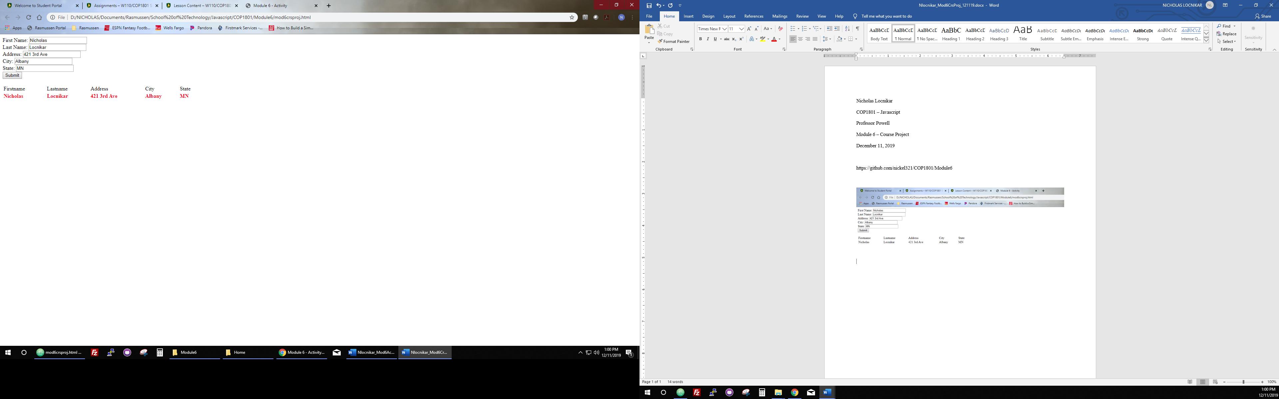

CODE:

<!DOCTYPE html>

<html lang="en">

<head>

<title>Module 6 - Activity</title>

</head>

<body>

<form id="myForm">

First Name: <input type="text" name="fname"><br>

Last Name: <input type="text" name="lname"><br>

Address: <input type="text" name="address"><br>

City: <input type="text" name="city"><br>

State: <input type="text" name="state"><br>

</form>

<button onclick="myFunction()">Submit</button>

<br><br>

<table id="mytable" style="width:600px">

<tr>

<td>Firstname</td>

<td>Lastname</td>

<td>Address</td>

<td>City</td>

<td>State</td>

</tr>

<tr>

<td id = "table1" class = "boldMe"></td>

<td id = "table2" class = "boldMe"></td>

<td id = "table3" class = "boldMe"></td>

<td id = "table4" class = "boldMe"></td>

<td id = "table5" class = "boldMe"></td>

</tr>

</table>

<!--Javascript to add bold event listener.-->

<script>

var x = document.getElementsByClassName('boldMe');

for(var i=0; i<x.length; i++){

x[i].addEventListener('mouseover', function(){

boldFunction(x, this);

})

}

for(var i=0; i<x.length; i++){

x[i].addEventListener('mouseout', function(){

unBoldFunction(x);

})

}

function boldFunction(z){

for(var i=0; i<z.length; i++){

z[i].style.fontWeight = '900';

z[i].style.color = 'red';

}

}

function unBoldFunction(z){

for(var i=0; i<z.length; i++){

z[i].style.fontWeight = '300';

z[i].style.color = 'black';

}

}

</script>

<!--Javascript from Module 5.-->

<script>

function myFunction() {

var x = document.getElementById("myForm");

document.getElementById("table1").innerHTML = x.elements[0].value;

document.getElementById("table2").innerHTML = x.elements[1].value;

document.getElementById("table3").innerHTML = x.elements[2].value;

document.getElementById("table4").innerHTML = x.elements[3].value;

document.getElementById("table5").innerHTML = x.elements[4].value;

}

</script>

</body>

</html>