_____________________________________________________________________________________

**Developer: Kris Nickeson**

**Project: BlackJack (“21”)**

1.0Background Information / Current Status:

BlackJack (“21”) is a well-known card game played throughout the world. I will be building a multi-player, multi-lingual, text-only (Terminal Window) version. The Players individually compete against the Dealer (computer), but not against each other. This game will follow the 'Bicycle' rules as closely as possible. See: <http://www.bicyclecards.com/how-to-play/blackjack> for details. Deviations from these rules will be noted where appropriate. The game will allow configuration parameters to be stored in a config file (including Language, Starting Chips Balance, Max Accrued Winnings, Number of Players, Number of Decks, Shuffle Marker, Min / Max Bet, etc.). A Player beats the Dealer by getting a higher score than the Dealer without going over 21. Play continues while each Player maintains a positive Bank Balance, or until game is exited. As Players 'Go Bust' (run out of money), their game is over until all remaining Players have 'Gone Bust' or the game is exited. Currently this version of the game has not undergone any development.

2.0 Terminology:

2.1: 'Hit' – Dealer provides Player with another card

2.2: 'Stand' – Player takes no more cards

2.3: 'Natural' BlackJack – Player has only and Ace (11pts) and Face-Card (10pts), totaling 21

2.4: 'Push' – Player and Dealer both have a score of 21; Bet is returned to Player

2.5:

3.0 Goals and Use Cases (Requirements):

**Use Case 1: Actors**

Use Case 1.1: Player(s)

Use Case 1.1.1: There will be a Minimum of 1 Player, Maximum of 8 Players + Dealer

Use Case 1.2: Dealer

Use Case 1.2.1: The Dealer will also be a Player

Use Case 1.2.2: The Dealer's role will be played by the computer

**Use Case 2: Equipment**

Use Case 2.1: Deck of Cards

2.1.1: Deck will consist of 52 cards: 13 each of 4 suits – Hearts, Diamonds, Spades, Clubs

2.1.2: No Jokers will be included in this game

2.1.3: Standard Card Values will be 2, 3, 4, 5, 6, 7, 8, 9, 10, Jack (10 pts), Queen (10 pts), King (10 pts). Non-face cards get the same number of points as the card's number

2.1.4: Ace will be implemented as two possible values: 1 or 11

2.1.5: Number of decks will be configurable (between 1 and 8 decks allowed)

2.1.6: Deck will contain a shuffle marker, placed randomly between 65 and 100 cards from the end of the deck(s). Once the shuffle marker is reached, all cards not in play are shuffled and the marker re-placed at random (between 65 and 100 cards from the end of the 'shoe')

Use Case 2.2: Chips

2.2.1: Available Chip Values: $1 (White), $5 (Red), $25 (Green), $100 (Black) 2.2.2: Chips are automatically 'cashed-in' or 'exchanged' by the game when smaller/larger Chip values are required for game play.

2.2.3: Opening Chip Balance can be stored / set in the game's config file.

**Use Case 3: Possible Unique Outcomes of a Hand**

Use Case 3.1: Player Loss

3.1.1: Player wins Chips in the amount of their bet + keeps original Chips

Use Case 3.2: Dealer Loss

3.2.1: Player loses bet Chips

Use Case 3.3: Push (Player / Dealer 'Tie' at 21)

3.3.1: No chips won or lost by Player

Use Case 3.4: 'Natural BlackJack' (Ace + Face Card = 21)

3.4.1: Player keeps original Chips and is paid by Dealer 1.5x the bet amount

**Use Case 4: Betting**

Use Case 4.1: Bets are placed at the beginning of each hand, prior to the hand being dealt

Use Case 4.2: Chips Total can be stored in config file (per-player) for re-use as next game's Opening Chips Balance

Use Case 4.3: Minimum / Maximum Bet Values are configurable in the game's config file

**Use Case 5: Game Play**

Use Case 5.1: Deal (Clockwise from Dealer's left)

5.1.1: Dealer provides one card to each player, face-up, print values to console

5.1.2: Dealer takes one card, face-down, no value printed to console

5.1.3: Dealer provides one card to each Player, face-up, print values to console

5.1.4: Dealer takes one card, face-up, print value to console

Use Case 5.2: Initial Win / Loss Check

5.2.1: 'Natural' 21 gets special win message. All Players (including Dealer) without 'Natural' 21 automatically lose this hand

5.2.2: If Dealer has a 'Natural' 21, outcome is 'Push' for Dealer and Player(s) (with 'Natural' 21)

Use Case 5.3: Player(s): Loop until each Player 'Stands' or 'Busts', one Player at a time

5.3.1: Play proceeds clockwise from Dealer's left

5.3.2: Prompt Players for Additional Cards (Hit or Stand?)

5.3.3: Hit (Deal another card)

5.3.4: Stand (No more cards dealt)

Use Case 5.4: Dealer Play Loops until Dealer Wins or 'Busts'

5.4.1: Dealer's turn commences after all Players 'Stand' or have 'Busted'

5.4.2: Dealer prints 'Hole' (face-down) Card value to console

5.4.3: Dealer must Hit when Dealer's Card Total <= 17

5.4.4: Dealer must Hit when Dealer has 'Soft' hand (when counting Ace=1, Dealer Card Totals <= 17)

Use Case 6.1: Print Final Win / Loss Results to console immediately prior to Bet Settlement

**Use Case 6: Bet Settlement**

Use Case 7.1: Bet Settlement occurs at the end of each Player's hand and is completed automatically by the Dealer, printing a message to the console with each Player's Total Chips Won or Lost for that hand

Use Case 7.2: Once a Player loses to the Dealer and their bet is collected, the bet is never returned, even if the Dealer also loses the hand (to another Player)

Use Case 7.3: When a Player is out of Chips, their game is over until all other Players have lost, the game is exited, or someone 'Busts the House' by going over 'Max Accrued Winnings' value (stored in the game's config file)

**Use Case 7: Game Conclusion**

Use Case 8.1: Update Chips Totals in config file

Use Case 8.2: 'Busted House' message prints when a Player(s) exceeds 'Max Accrued Winnings' value (stored in game's config file)

Use Case 8.3: 'Player Out' message prints when a Player(s) Chips balance becomes $0

Use Case 8.4: Print Console Message to Players (with remaining Chips) to 'Play Again' or 'Exit'

**Goal: Optional Phase II Development**

Use Case 9.1: 'Side Rules' – Discuss each common game play option and whether or not it should be implemented (See: <http://www.bicyclecards.com/how-to-play/blackjack> for details)

9.1.1: Double Down –

9.1.2: Splitting Pairs –

9.1.3: Insurance –

9.1.4: Surrender – Player can exit the hand after the initial deal, losing half their bet

9.1.5: 'Swedish Pub' Version

9.1.6: Player Win Bonus when winning with NumOfCards > Specified Value

Use Case 9.2: Develop 'GUI' version of game

Use Case 9.3: Develop Online version of game

4.0 Stakeholders:

|  |  |
| --- | --- |
| **Name** | **Feedback** |
| Kris Nickeson | 2nd S&R and PFD Complete |
| James Camire | Insert Feedback Here |
| Mike Downard | Insert Feedback Here |

5.0 Project Scope (Work to be performed):

|  |  |
| --- | --- |
| **Work to be performed** | **Time Estimate** |
|  |  |
|  |  |
|  |  |
|  |  |
|  |  |
|  |  |
|  |  |
|  |  |
|  |  |

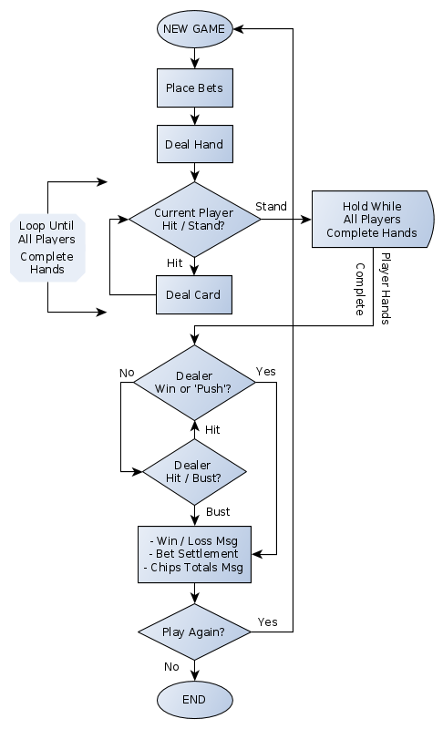

**BlackJack Process Flow Diagram**