**1.1**

Identify how you would collect a sample and identify the population of interest.

Computer science students want to use and apply a dataset for a project assigned to them.

**The population of interest would be the computer science students and they could go searching on the internet to find a dataset.**

**1.2**

From the data, construct a relative frequency diagram.

Agana, Guam

Agana, Guam

Agana, Guam

Agana, Guam

Algeria

Algeria

Amsterdam, Netherlands

Amsterdam, Netherlands

Amsterdam, Netherlands

Amsterdam, Netherlands

Amsterdam, Netherlands

Moscow, Russia

Moscow, Russia

Moscow, Russia

Moscow, Russia

Moscow, Russia

Moscow, Russia

Moscow, Russia

Moscow, Russia

This data represents a partial frequency of plane crashes at certain locations in the world.

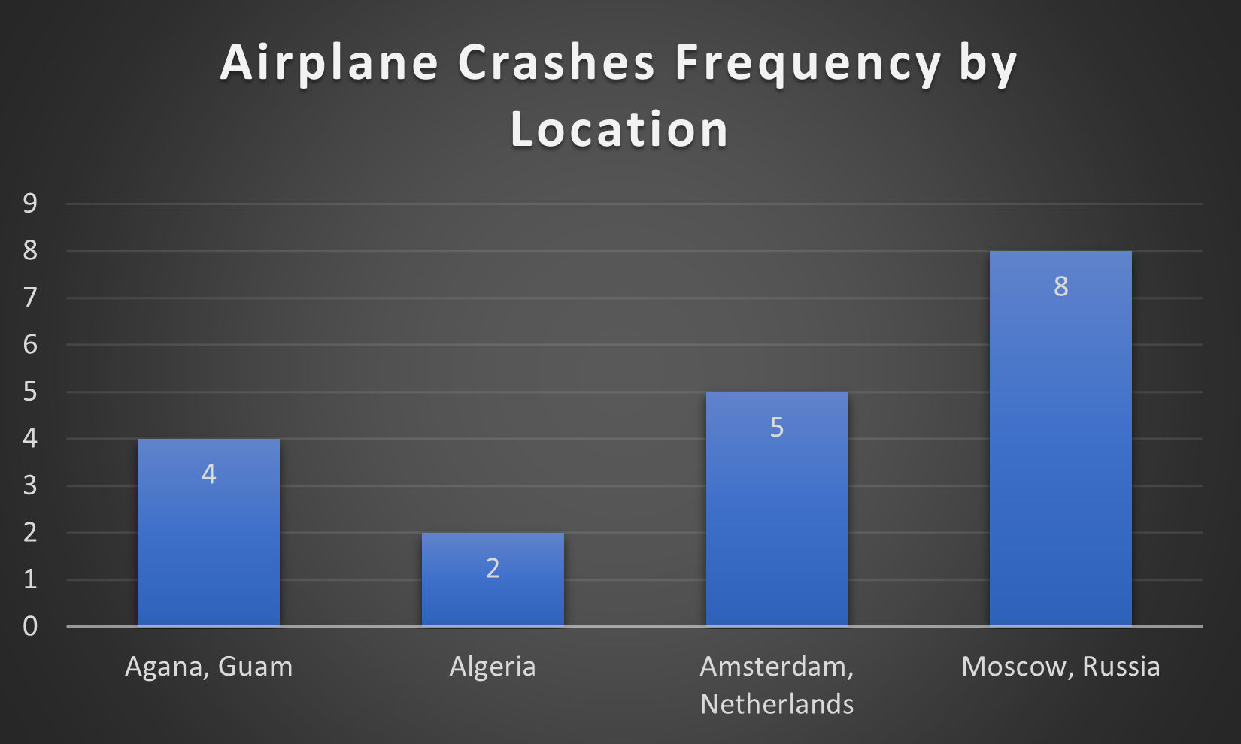

**1.3**

For all plane crashes in the dataset, what is the average number of fatalities?

**20.06830289**

**2.3**

Set S represents different types of aircraft that have been involved in an airplane crash.

S = {Douglas DC-3, Boeing 707-336C, Douglas DC-6AB, Boeing B-747-SP-09, Antonov AN-24, Cessna 180H, Cessna 402, Douglas C-47-DL}

Let set A be the subset of all Boeing aircraft and let set B be the subset of all Douglas aircraft.

Determine $A, B, A ∩ B and A ∪ B$.

**A = {Boeing 707-336C, Boeing B-747-SP-09}**

**B = {Douglas DC-3, Douglas DC-6AB, Douglas C-47-DL}**

$A ∩ B = ⊘$**(empty set)**

$A ∪ B =$**{Boeing 707-336C, Boeing B-747-SP-09, Douglas DC-3, Douglas DC-6AB, Douglas C-47-DL}**

**2.4**

List the sample space in terms of aircraft name for plane crashes that occurred after 4/16/2009.

**Antonov An-32, Britten-Norman BN-2A-27 Islander, Airbus A330-203, Antonov An-26, Lockheed, C-130 Hercules, Mi-35, Boeing B-737-200, Pilatus PC-6, Cessna 208B Grand Caravan**

**2.5**

Consider plane crashes between 9/17/1908 and 3/5/1915. Of those, what is the probability that only one fatality exists?

**1/3**

**2.6**

What is the probability of selecting three random incidents from crashes in which no fatalities exist?

**58 C 3 = 30856**

**2.7**

What is the probability that at least three fatalities exist given that the plane crashed in Anchorage, Alaska?

A = at least three fatalities

B = plane crashed in Alaska

$$\frac{11}{13}$$

**2.8**

Let A represent the event where zero fatalities exist and let B represent the event where exactly two fatalities exist. P(A) = 0.011035 and P(B) = 0.1005. A and B are independent. Determine $P(A∩B)$.

$$P\left(A∩B\right)=P\left(A\right) P(B)$$

0.011035 * 0.1005

**0.0011090**

**2.9**

P(A), the probability that exactly one person is on board a flight is 0.031202. What is the probability that no one or more than one person is on any given flight?

$$P\left(\overline{A}\right)=1-P\left(A\right)$$

**0.9688**

**2.10**

The probability that Aeroflot is the sole operator of a flight is 0.034056 and the probability that it was operated by someone else is 0.9659. Of the flights from Aeroflot, the probability that less than ten fatalities exist is 0.2291. Of the other flights, this probability is 0.5198. A random flight is chosen that has less than ten fatalities. Find the conditional probability that this flight was operated by Aeroflot.

A = flight came from Aeroflot

O = flight came from other

T = less than ten fatalities

P(A) = 0.034056

P(O) = 0.9659

P(T | A) = 0.2291

P(T | O) = 0.5198

$$P\left(A \right| T)= \frac{0.2291*0.034056 }{\left(0.2291*0.034056\right)+(0.5198*0.9659)}$$

**0.015302**

**3.2**

Let Y represent the number of fatalities in airplane crashes. Find the distributions for when Y equals 0, 1, 2 and 3.

**P(Y = 0) = 0.011035**

**P(Y = 1) = 0.077626**

**P(Y = 2) = 0.1005**

**P(Y = 3) = 0.087139**

**3.3**

Referencing the question in 3.2, what is the expected value of Y when Y = 3?

E(Y = 3) = (0 * 0.011035) + (1 * 0.077626) + (2 * 0.1005) + (3 * 0.087139)

**0.54**

**3.4**

Suppose that 30 people are victims of a plane crash. The probability that everyone survives is 0.011035. What is the probability that exactly 13 passengers survive?

$$P\left(Y=13\right)= \left({30 \atop 13}\right){0.011035}^{13}* {0.989}^{17}$$

$$3.5702* {10}^{-18}$$

**3.5**

Within the first hour of a day, the probability that a plane leaves the airport is 0.011986. What is the probability that a plane leaves within the third hour?

$$P\left(Y=3\right)= {0.988}^{2}*0.011986$$

**0.0117**

**3.7**

12 flights operated by the U.S. Air Force underwent training, 7 of those flights are randomly selected, and pilots are judged on their performance. Of the 7 selected, what is the probability that this includes the top 3 best ranked pilots from the group of 12?

$$P\left(Y=3\right)= \frac{\left({3 \atop 3}\right)\left({9 \atop 4}\right)}{\left({12 \atop 7}\right)}$$

**0.15909090909**

**3.8**

According to 4.2, 2/3 is the rate of fatality each hour for airplane crashes. During any given hour, what is the probability that 3 fatalities will occur?

$$P\left(Y=3\right)=\frac{{2/3}^{3}}{3!}ⅇ^{-2/3}$$

**0.02535**

**3.11**

From a group of 13 private flights that crashed, the average number of people on board is 4.384 with variance 10.923. Find the value of k such that P(|Y - 4.384| ≥ C) ≤ .10923

P(|Y - 4.384| ≥ C) ≤ .10923

1 - P(|Y - 4.384| < C) ≥ 0.89077

P(-C < Y – 4.384 < C) ≥ 0.89077

P(-C + 4.384 < Y < C + 4.384) ≥ 0.89077

$$1-\frac{1}{k^{2}}= 0.89077$$

$$k= 3.025722$$

**3.025722**

**4.2**

I couldn’t find a way to represent that data from my dataset where it would give me a clear equation as a function, so I improved and create this graph instead. This graph is a hypothetical representation that assumes airplane fatalities will grow quadratically as each hour progresses.

f(x) = 2x^2

What is the probability that a person will not survive a plane crash between hours 0 and 1?

$$P\left(0 ≤x ≤1\right)= \int_{0}^{1}{{2x}^{2} dx}$$

$$= \frac{2}{3} x^{3}{ |}_{0}^{1}$$

$$= \frac{2}{3} 1^{3}- \frac{2}{3} 0^{3}$$

**0.666666667**

*Note: I initially tried 13 and 21 as the bounds and got a probability of 4709.3. I’m assuming that this means that even a single fatality is inevitable. 4709.3 didn’t seem like a comfortable answer so I chose 0 and 1 as my bounds.*

**4.3**

$$f\left(x\right)= \left\{\begin{aligned}{2x}^{2}, 0 ≤x ≤1 \\ 0, elsewhere\end{aligned}\right.$$

Find the mean and variance of x.

$$E\left(x\right)= \int_{0}^{1}{{2x}^{3} dx}$$

$$= \frac{1}{2} x^{4}{ |}_{0}^{1}$$

$$= \frac{1}{2} 1^{4}- \frac{1}{2} 0^{4}$$

**E(x) = 0.5**

$$V\left(x\right)= \int_{0}^{1}{{2x}^{4} dx}$$

$$= \frac{2}{5} x^{5}{ |}_{0}^{1}$$

$$= \frac{2}{5} 1^{5}- \frac{2}{5} 0^{5}$$

$$= 0.4$$

$$= 0.4-{0.5}^{2}$$

*E(x^2) – E(x)^2*

**V(x) = 0.15**

**4.4**

Let X = the number of passengers

Let Y = the number of fatalities

If X = 1, then Y = 1 and if X = 2, then Y = 1; we have a uniform distribution at this interval.

Given this density function, find F(x):

$$f\left(x\right)=1, 1 ≤x ≤2$$

$$F\left(x\right)= \int_{1}^{2}{1 dx}$$

$$= x{ |}_{1}^{2}$$

$$= 2-1$$

**1**

**5.2**

A

**5.3**

A

**5.4**

A

Dataset source: <https://data.world/data-society/airplane-crashes>