MASTER'S LEVEL RESEARCH & SOFTWARE ENGINEERING PROJECT

NeuroFusion-AI
Explainable Multimodal Machine Learning for Alzheimer's Disease Classification and Longitudinal Progression Prediction Using ADNI
Python • Clinical & Cognitive Data • MRI/PET • Biomarkers • Genetics • Temporal ML • Explainable AI
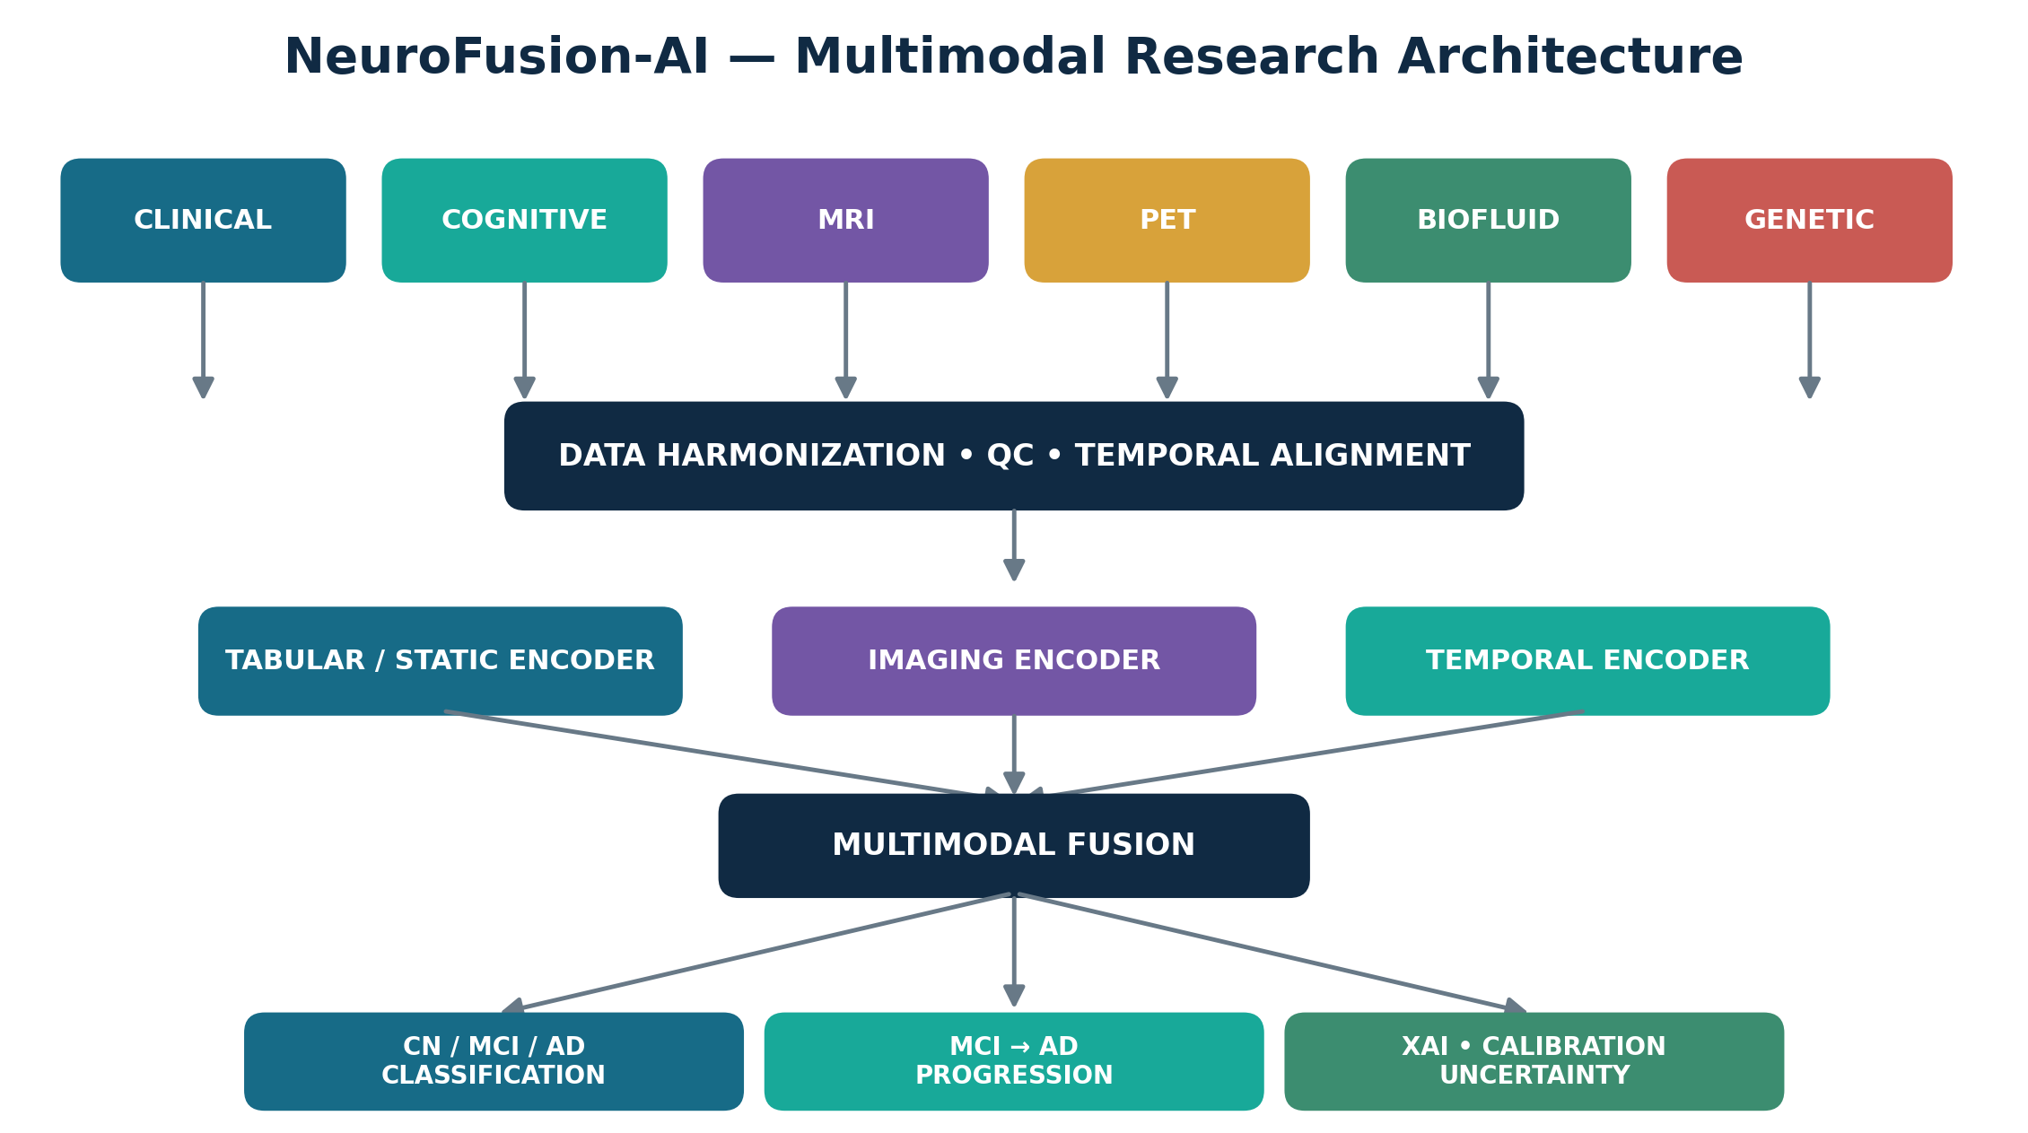
A rigorous research platform for disease-state modelling, MCI-to-AD progression forecasting, multimodal fusion, uncertainty quantification and reproducible evaluation.
PROJECT DIMENSION | SCOPE
Primary dataset | Alzheimer's Disease Neuroimaging Initiative (ADNI)
Core tasks | CN/MCI/AD classification; MCI→AD progression prediction
Data paradigm | Heterogeneous, longitudinal, multimodal patient data
Implementation | Python research platform + experiment manager + dashboard
Scientific emphasis | Fusion, temporal modelling, missing modalities, calibration, XAI

01 Research vision and project rationale
Alzheimer's disease research increasingly depends on combining heterogeneous evidence rather than interpreting one measurement in isolation. NeuroFusion-AI will design, implement and evaluate a Python-based research platform that integrates clinical, cognitive, neuroimaging, biofluid biomarker and genetic information from ADNI into unified predictive models.
ADNI is a longitudinal, multi-center observational study and provides clinical/cognitive assessments, MRI and PET imaging, biofluid biomarkers, genetic/omics information and demographic data to approved researchers. This multimodal structure makes it particularly suitable for studying both disease-state classification and longitudinal progression.

Central research question
Can multimodal machine learning that integrates heterogeneous and longitudinal ADNI information improve Alzheimer's disease-state classification and MCI-to-AD progression prediction compared with single-modality and conventional baseline models, while remaining calibrated, interpretable and robust to missing modalities?

Primary hypotheses
- H1 — Multimodal models will provide stronger out-of-sample discrimination and/or calibration than the best single-modality model.
- H2 — Longitudinal representations will add predictive information beyond baseline-only representations.
- H3 — Learned hybrid fusion will be competitive with or superior to simple concatenation and fixed late fusion.
- H4 — Explicit missing-modality handling and uncertainty estimation will improve robustness when diagnostic modalities are unavailable.

Research outputs
- A reproducible ADNI cohort-building pipeline.
- A benchmark suite of classical ML and deep-learning models.
- A multimodal fusion framework.
- Leakage-safe longitudinal progression experiments.
- Explainability, calibration, uncertainty and subgroup analyses.
- A research dashboard and auditable prediction ledger.

02 ADNI data foundation
The project will use ADNI as its primary dataset. The implementation must preserve participant identifiers only in the controlled research environment and must follow the ADNI Data Use Agreement and publication requirements. Data availability differs across ADNI phases and visits; therefore, the software must track provenance, acquisition time, modality availability and processing version.
MODALITY | REPRESENTATIVE INFORMATION | MODELLING ROLE
Clinical | Diagnosis, medical history, function, neurological/physical assessments | Tabular + longitudinal
Cognitive | ADAS-Cog, CDR, MMSE, MoCA, AVLT, FAQ and related instruments | Trajectory modelling
MRI | Structural/functional MRI; processed regional measures or raw images | Imaging / numeric biomarkers
PET | FDG, amyloid and tau PET where available | Molecular imaging
Biofluid | Blood/CSF biomarker measurements | Tabular biomarker encoder
Genetic/omics | APOE and selected genomic/omics features | Static / high-dimensional encoder
The core implementation should begin with standardized numerical features and processed imaging summaries. Direct 3D MRI/PET learning is an advanced extension, not a prerequisite for completing the scientifically rigorous multimodal pipeline.

03 System architecture
Figure 1. NeuroFusion-AI end-to-end architecture: heterogeneous ADNI modalities are harmonized, encoded, fused and evaluated through classification, progression, explainability and uncertainty layers.
The architecture separates data engineering from modelling. This is deliberate: cohort definition, temporal alignment, quality control and leakage prevention are first-class research components rather than preprocessing details.
LAYER | RESPONSIBILITY
Data governance | ADNI access, provenance, dictionaries, version tracking
Harmonization | Visit alignment, coding normalization, QC, missingness metadata
Representation | Static/tabular, imaging and temporal encoders
Fusion | Early, late and learned hybrid multimodal fusion
Prediction | CN/MCI/AD classification and MCI→AD progression
Trustworthiness | Calibration, uncertainty, XAI, subgroup and stress testing
Research interface | Experiment registry, prediction ledger, dashboard

04 Multimodal patient representation
For participant p at visit time t, NeuroFusion-AI constructs a multimodal state from modality-specific representations. The notation below is conceptual; the exact dimensionality depends on the selected ADNI cohort and feature set.
$$Z_{p,t}=\left[z_{p,t}^{clin} ‖ z_{p,t}^{cog} ‖ z_{p,t}^{MRI} ‖ z_{p,t}^{PET} ‖ z_{p,t}^{bio} ‖ z_{p}^{gen}\right]$$
The modality-availability vector explicitly records whether each information source is available:
$$M_{p}=\left[m_{clin},m_{cog},m_{MRI},m_{PET},m_{bio},m_{gen}\right], m_{j}∈\{0,1\}$$
Continuous features should be standardized using training-set statistics only:
$$z_{i}=\frac{x_{i}−μ_{i}}{σ_{i}}$$
Where appropriate, MRI region-of-interest volumes can be normalized by intracranial volume:
$$V_{norm}=\frac{V_{ROI}}{V_{ICV}}$$
The project must maintain both the transformed value and the transformation provenance so that each experiment can be reproduced exactly.

05 Multimodal fusion strategies
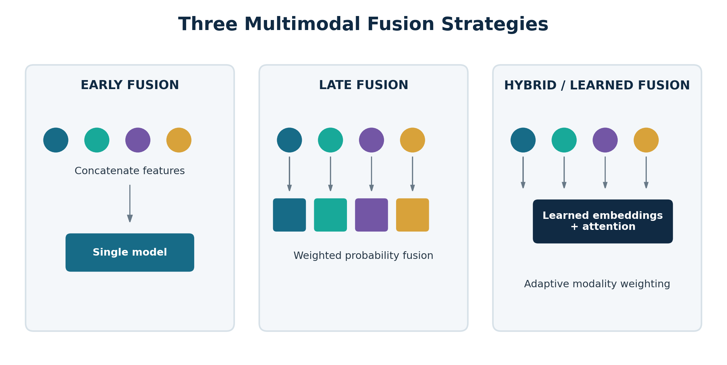
Figure 2. Early, late and learned hybrid fusion strategies to be compared experimentally.

Early fusion
$$Z_{early}=\left[Z_{clin}‖Z_{cog}‖Z_{MRI}‖Z_{PET}‖Z_{bio}‖Z_{gen}\right]$$
$$\hat{y}=f_{θ}​\left(Z_{early}\right)$$

Late fusion
$$P\left(Y=c∣X\right)=\sum_{m=1}^{M}{w_{m}} P_{m}\left(Y=c∣X_{m}\right)$$
$$w_{m}≥0, \sum_{m=1}^{M}{w_{m}}=1$$

Learned hybrid fusion
$$h_{m}=f_{m}\left(X_{m}\right)$$
$$α_{m}=\frac{exp\left(e_{m}\right)}{\sum_{k=1}^{M}{exp}\left(e_{k}\right)}$$
$$h_{fusion}=\sum_{m=1}^{M}{α_{m}}h_{m}$$
Attention weights may help characterize how the fusion model combines modalities, but they must not be presented as causal explanations.

06 Task A — CN / MCI / AD classification
The first predictive task is multiclass disease-state classification. The model must return a probability distribution, not only a hard label.
$$Y∈\{CN,MCI,AD\}$$
$$P\left(Y=c∣X\right)=\frac{exp\left(z_{c}\right)}{\sum_{k=1}^{K}{exp}\left(z_{k}\right)}$$
Classical baselines should include multinomial logistic regression, SVM, Random Forest and gradient-boosted trees. Neural baselines can include an MLP for tabular data and modality-specific encoders when imaging is introduced.
MODEL FAMILY | PURPOSE
Logistic regression | Transparent linear baseline and calibration reference
SVM | Strong nonlinear baseline for standardized feature spaces
Random Forest | Nonlinear interactions and robust tabular baseline
XGBoost / LightGBM | High-performance tabular benchmark
MLP | Neural tabular representation
3D CNN / medical imaging network | Advanced direct MRI/PET representation

07 Task B — MCI-to-AD progression prediction
The primary research task predicts future progression among participants with MCI at an index time t₀. Prediction horizons should be selected only after inspecting follow-up coverage and class counts; candidate horizons are 12, 24 and 36 months.
$$R_{p}\left(T\right)=P​\left(AD_{p,t_{0}+T}=1∣X_{p,≤t_{0}}\right)$$
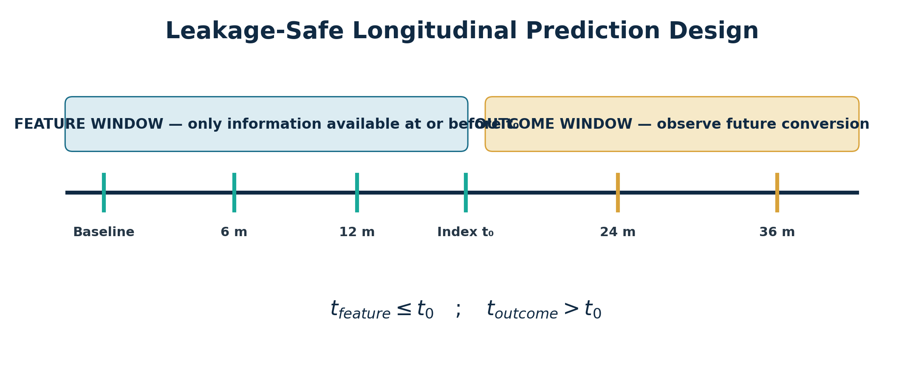
Figure 3. Leakage-safe temporal design. All predictors must be available at or before the index time; the outcome is observed strictly afterward.
The cohort builder must define conversion consistently, document diagnostic-label rules, handle censoring transparently and report the number of eligible participants for every horizon.
$$t_{feature}≤t_{0}$$
$$t_{outcome}>t_{0}$$

08 Longitudinal and trajectory modelling
ADNI's repeated assessments permit trajectory-aware modelling. A participant history is represented as an ordered sequence:
$$X_{p}=\left\{x_{p,t_{1}},x_{p,t_{2}},…,x_{p,t_{n}}\right\}$$
The project will compare baseline-only prediction with temporal models such as GRU, LSTM and, if data volume supports it, Transformer-style encoders.
$${\hat{y}}_{static}=f​\left(X_{p,t_{0}}\right)$$
$${\hat{y}}_{long}=f​\left(X_{p,t_{1}},X_{p,t_{2}},…,X_{p,t_{0}}\right)$$

Cognitive trajectory features
$$ΔC_{p}=C_{p}\left(t_{2}\right)−C_{p}\left(t_{1}\right)$$
$$v_{C}=\frac{C\left(t_{2}\right)−C\left(t_{1}\right)}{t_{2}−t_{1}}$$
$$C_{p}\left(t\right)=β_{0}+β_{1}t+β_{2}t^{2}+ε$$
Trajectory features should be computed using only observations within the permitted feature window. The software must reject any feature whose timestamp violates the experiment's prediction cut-off.

09 MRI and PET intelligence
The imaging subsystem should be implemented in two stages. Stage 1 uses processed numerical imaging summaries to establish a complete multimodal benchmark with manageable computational cost. Stage 2 may use raw or preprocessed 3D images and a dedicated imaging encoder.
STAGE | MRI/PET REPRESENTATION | BENEFIT
Stage 1 | ROI volumes, cortical measures, PET regional uptake summaries | Fast, interpretable, reproducible
Stage 2 | 3D MRI/PET volumes | Learns spatial representation directly

PET normalization
$$SUVR=\frac{\text{Tracer uptake in target ROI}}{\text{Tracer uptake in reference region}}$$

Direct imaging encoder
$$h_{MRI}=f_{CNN}​\left(I_{MRI};θ_{MRI}\right)$$
$$h_{PET}=f_{CNN}​\left(I_{PET};θ_{PET}\right)$$
If direct imaging is used, preprocessing, registration, image selection, scanner/site metadata and split integrity must be documented. Multiple scans from the same participant must remain within the same train/validation/test partition.

10 Missing data and missing-modality robustness
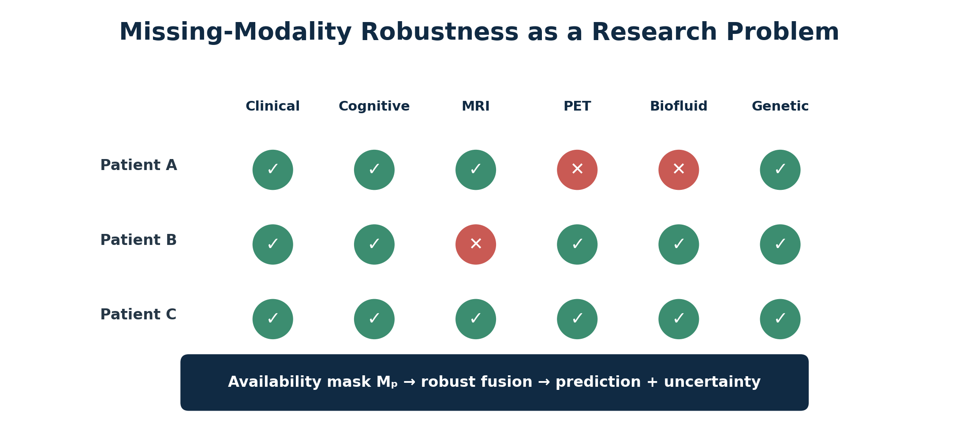
Figure 4. Real multimodal cohorts are incomplete. NeuroFusion-AI explicitly models modality availability rather than assuming a fully observed patient.
The project should distinguish ordinary feature-level missingness from complete modality absence. Candidate methods include median/robust imputation, iterative imputation, missingness indicators, modality masks, modality dropout during training and mixture-of-experts or attention mechanisms that operate on available modalities.
$$x_{j}^{*}=Impute​\left(x_{j}∣X_{observed}\right)$$
$$q_{p}=\frac{1}{M}\sum_{m=1}^{M}{m_{p,m}}$$
Here qₚ is a simple modality-completeness score. More sophisticated quality scores may incorporate within-modality missingness, acquisition quality and temporal recency.

11 Biofluid and genetic intelligence
Biofluid measurements and APOE/genetic information provide complementary biological evidence. The project should begin with well-covered, well-documented variables and expand only when sample size remains adequate.
$$B_{p}=\left[B_{1},B_{2},…,B_{k}\right]$$
$$G_{APOE}∈\{0,1,2\}$$
The APOE representation above denotes the number of ε4 alleles for a simple baseline. High-dimensional genomic or omics data require separate feature selection or representation learning and careful control of dimensionality relative to cohort size.

Feature-selection safeguards
- Fit feature selection inside the training fold only.
- Never use the full dataset to choose biomarkers before cross-validation.
- Report retained features and selection stability.
- Prefer parsimonious models when sample size is limited.

12 Calibration, confidence and uncertainty
A clinically oriented research model should distinguish discrimination from probability reliability. NeuroFusion-AI therefore evaluates calibration and attaches uncertainty and data-quality metadata to each prediction.
$$P_{p}=\left({\hat{y}}_{p},C_{p},U_{p},Q_{p}\right)$$
$$BS=\frac{1}{N}\sum_{i=1}^{N}{{\left(p_{i}−y_{i}\right)}^{2}}$$
$$ECE=\sum_{b=1}^{B}{\frac{\left|S_{b}\right|}{N}}\left|acc\left(S_{b}\right)−conf\left(S_{b}\right)\right|$$
Calibration methods may include Platt scaling, isotonic regression or temperature scaling, fitted only on validation data. Confidence should not be a cosmetic transformation of the predicted probability; its definition must be explicit and experimentally justified.

13 Explainable AI and model interpretation
The platform must provide global and participant-level explanations. For tree-based models, SHAP is a suitable baseline. Neural models can use integrated gradients or modality-level ablation. Explanations should be framed as model contributions, not biological causation.
$$f\left(x\right)=E\left[f\left(X\right)\right]+\sum_{j=1}^{d}{ϕ_{j}}$$
The project should also quantify modality contribution by retraining or evaluating models after removing one modality:
$$Δ_{m}={Metric}_{full}−{Metric}_{\left(−m\right)}$$
A positive Δₘ indicates that removing modality m degraded the selected metric; a negative value indicates that the full model did not benefit under that experimental configuration.

14 Evaluation framework
Accuracy alone is insufficient. The evaluation suite must address discrimination, class imbalance, calibration and uncertainty. Confidence intervals should accompany the principal results.
$$Sensitivity=\frac{TP}{TP+FN}$$
$$Specificity=\frac{TN}{TN+FP}$$
$$Precision=\frac{TP}{TP+FP}$$
$$F_{1}=2 \frac{Precision⋅Recall}{Precision+Recall}$$
TASK | PRIMARY METRICS | SECONDARY ANALYSES
CN/MCI/AD | Macro-F1, class sensitivity, one-vs-rest AUROC | Confusion matrix, calibration
MCI→AD | AUROC, AUPRC, sensitivity, specificity | Brier score, calibration, PPV/NPV
Fusion | Δ performance vs best single modality | Bootstrap paired CIs
Robustness | Performance under missing modalities | Degradation curves
Subgroups | Metric estimates by prespecified strata | Uncertainty and sample-size reporting
For the principal metrics, bootstrap confidence intervals can be estimated from patient-level resamples. Model comparison must use the same held-out participants whenever possible.

15 Experimental programme
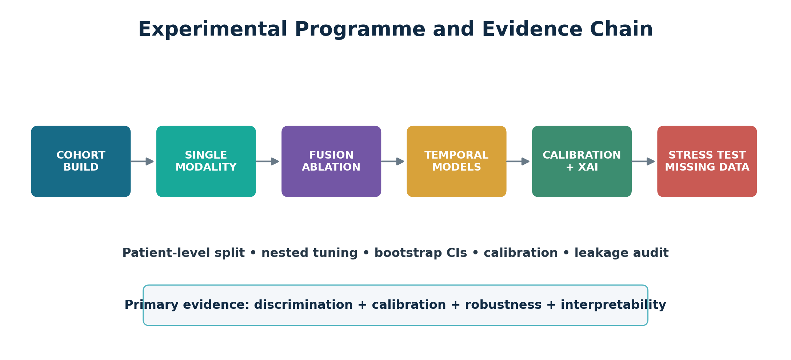
Figure 5. Experimental evidence chain from cohort construction to stress testing.
ID | EXPERIMENT | SCIENTIFIC QUESTION
E1 | CN/MCI/AD classification | How accurately can current disease state be classified?
E2 | 12/24/36-month progression | Can MCI→AD conversion be forecast prospectively?
E3 | Single-modality benchmark | Which modality is most informative alone?
E4 | Multimodal fusion | Does fusion improve over the best single modality?
E5 | Early vs late vs hybrid | Which fusion architecture is most robust?
E6 | Static vs longitudinal | Do trajectories improve prediction?
E7 | Classical ML vs DL | Is additional model complexity justified?
E8 | Missing modalities | How gracefully does performance degrade?
E9 | Calibration | Are estimated risks probabilistically reliable?
E10 | Explainability | Which features/modalities drive outputs?
E11 | Subgroup analysis | Does performance vary across prespecified groups?

16 Validation, leakage prevention and reproducibility
All splitting must occur at participant level. Repeated visits or scans from the same participant may not cross partitions. Hyperparameter tuning, imputation, scaling, feature selection and calibration must be learned without using the final test set.
$$D_{train}∩D_{validation}∩D_{test}=⌀ \text{(participant level)}$$
$${Train}_{≤t} → {Predict}_{t+Δ} → Observe outcome$$
- Use nested cross-validation or a fixed train/validation/test design with tuning restricted to training/validation data.
- Persist random seeds, cohort query version, feature dictionary, preprocessing parameters, model configuration and software environment.
- Maintain a prediction ledger containing participant pseudonym, prediction timestamp, model version, input-modality mask and output probabilities.
- Report exclusions and cohort attrition transparently.

17 Python software architecture
MODULE | RESPONSIBILITY
ADNI Data Manager | Import approved ADNI tables/files; provenance and dictionary mapping
Cohort Builder | Eligibility, labels, index dates, prediction horizons
Patient Timeline Engine | Longitudinal visit and feature alignment
Clinical/Cognitive Engines | Feature construction and trajectories
MRI/PET Engines | Imaging summaries and optional 3D encoders
Biomarker/Genetic Engines | Biological feature processing
Missing Data Engine | Imputation, masks, quality/completeness
Fusion Engine | Early, late, hybrid and attention fusion
Classification Engine | CN/MCI/AD modelling
Progression Engine | MCI→AD horizon-specific prediction
Calibration/Uncertainty | Probability reliability and uncertainty
Explainable AI Engine | Global, local and modality explanations
Experiment Manager | Runs, seeds, splits, hyperparameters, metrics
Dashboard | Research visualization and model inspection

Recommended technology stack
Python; Pandas; NumPy; SciPy; scikit-learn; XGBoost/LightGBM; PyTorch; MONAI and NiBabel for advanced neuroimaging; SHAP; PostgreSQL or Parquet-based analytical storage; FastAPI for services; Plotly/Dash for the research interface; MLflow or an equivalent experiment registry if desired.

18 NeuroFusion-AI research dashboard
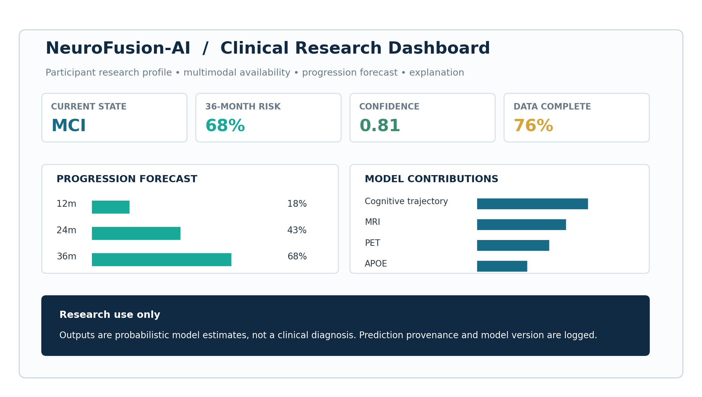
Figure 6. Conceptual NeuroFusion-AI research dashboard. Values are illustrative; the implemented system must display actual model outputs and provenance.
The dashboard is a research interface, not a clinical diagnostic device. It should support cohort inspection, participant-level trajectories, model comparison, modality availability, calibration plots, SHAP summaries, progression forecasts, experiment metadata and exportable research reports.

19 Research governance, ethics and limitations
The project uses de-identified research data under ADNI access and use conditions. It must preserve those conditions throughout storage, processing and publication. The system must not attempt participant re-identification.
RISK / LIMITATION | REQUIRED RESPONSE
Selection bias / research cohort | Describe cohort composition; avoid claims of population-wide clinical validity
Missing modalities | Report availability and evaluate robustness explicitly
Site/scanner heterogeneity | Include QC and, where appropriate, site/scanner covariates or harmonization
Temporal leakage | Enforce timestamp cut-offs and patient-level splits
Class imbalance | Use appropriate metrics, weighting/resampling only inside training
Overfitting | Nested tuning, held-out evaluation, confidence intervals
Interpretability misuse | Describe associations with model output, not causation
Clinical overclaim | Frame as research decision support, not diagnosis or treatment advice

20 Deliverables and expected thesis contribution
DELIVERABLE | CONTENT
D1 — Data & cohort specification | ADNI variables, inclusion/exclusion, labels, horizons, provenance
D2 — Reproducible Python pipeline | Import, harmonization, QC, feature engineering, splits
D3 — Baseline benchmark | Classical ML and single-modality results
D4 — Multimodal models | Early, late and hybrid fusion implementations
D5 — Longitudinal predictor | MCI→AD progression models at selected horizons
D6 — Trustworthiness suite | Calibration, uncertainty, XAI, subgroup and robustness analyses
D7 — Research dashboard | Interactive experiment and participant-level visualization
D8 — Master's thesis | Methods, experiments, results, limitations and reproducibility package

Master's-level contribution
The project is not defined by a single classifier. Its contribution is an integrated, reproducible study of heterogeneous patient representation, multimodal fusion, temporal prediction, missing-modality robustness and trustworthy AI using a major Alzheimer's research resource. A successful implementation should produce both a substantial software system and a defensible experimental study suitable for extension into a research publication.

Success criteria
- A leakage-safe, documented ADNI cohort can be reconstructed from code and configuration.
- At least four conventional baselines and two multimodal fusion strategies are evaluated.
- MCI→AD prediction is evaluated at one or more defensible horizons.
- Calibration and uncertainty are assessed, not merely classification accuracy.
- Missing-modality and modality-ablation experiments are completed.
- Participant-level explanations and model provenance are available in the dashboard.

Selected methodological and data references
- Alzheimer's Disease Neuroimaging Initiative (ADNI). ADNI Data and Data Access documentation. https://adni.loni.usc.edu/data-samples/adni-data/
- ADNI. Data Collection documentation: clinical assessments, biofluids, genetics/omics and neuroimaging. https://adni.loni.usc.edu/quick-start-guide-asset/datacollection.html
- ADNI. Clinical Assessments documentation. https://adni.loni.usc.edu/data-samples/adni-data/clinical-assessments/
- ADNI. About the Study / study phases and objectives. https://adni.loni.usc.edu/about/
- Lundberg, S. M., & Lee, S.-I. (2017). A Unified Approach to Interpreting Model Predictions. Advances in Neural Information Processing Systems.
- Niculescu-Mizil, A., & Caruana, R. (2005). Predicting Good Probabilities With Supervised Learning. ICML.
- Van Calster, B. et al. (2019). Calibration: the Achilles heel of predictive analytics. BMC Medicine, 17, 230.
Note: exact ADNI files, variables, cohort counts and biomarker definitions must be documented from the approved data release used by the student. The project brief intentionally avoids hard-coding counts that may change as ADNI evolves.

