**Short instructions**

1. Download and install: Oracle Database Express Edition 11g Release 2 for **Windows x32.** Remember the SYS password you entered!
2. Download and install: Oracle SQL Developer.
3. Start Oracle SQL Developer and create a new connection for the SYS user:

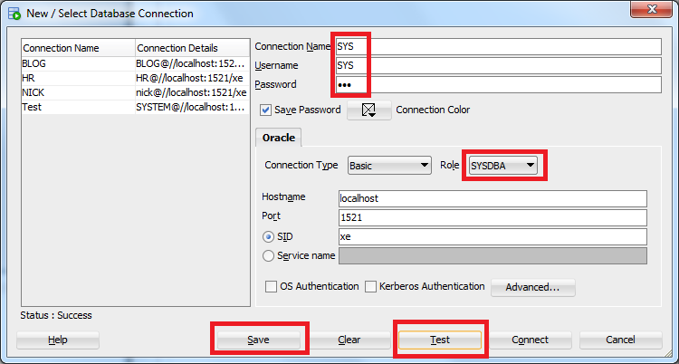

Choose SYSDBA role, enter the password from step 1, test if the connection is successful, save and click connect.

1. Open the SYS user, go to Other users, right click Create user:

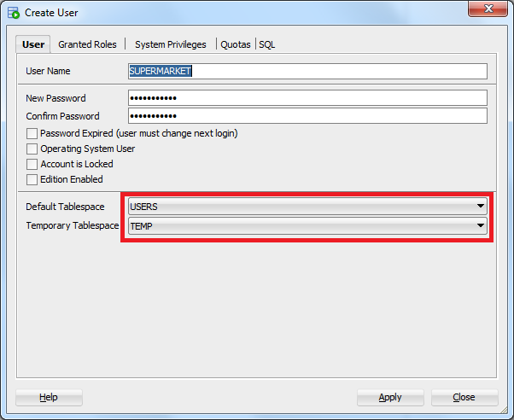

Enter a password you can remember, I used the same as the schema name. Choose Tablespace USERS and TEMP.

1. Check the roles Connect and Resource:

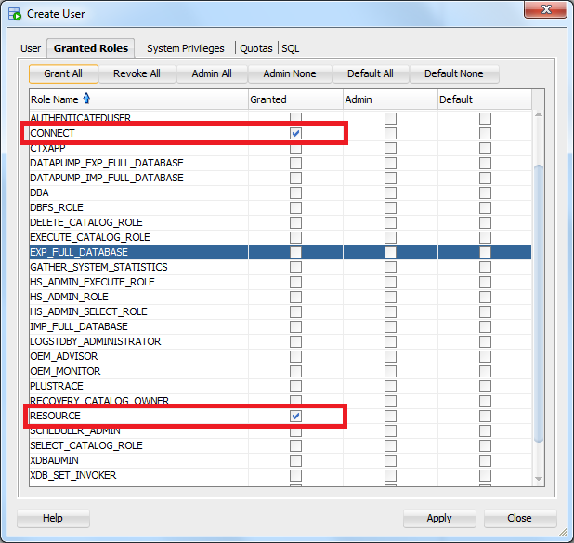

1. Check Unlimited quota:

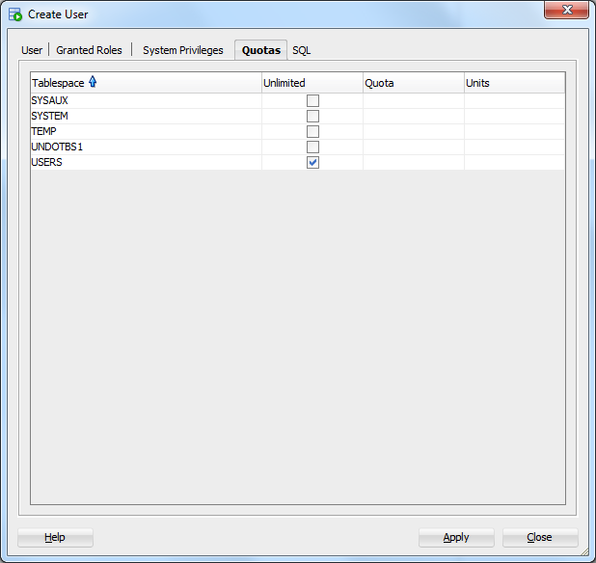

1. Create a new connection for the user we created:

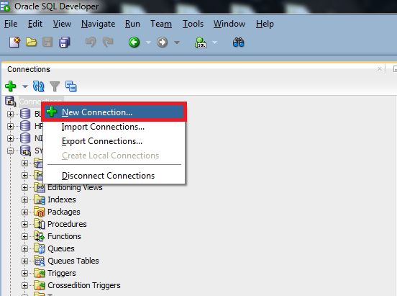

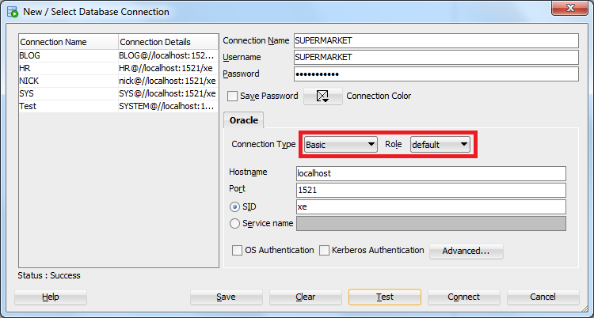

1. Connect with the new user.