The task was to create a model that given a set of pairs (X,y) where X is a 2D image of a concrete sample and y is a binary image that indicates the positions of pumice particles within the image (as seen in Image 1), can detect whether a new (unseen) image has pumice particles, as well as their exact position in the image.
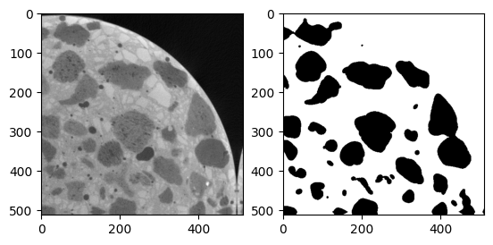
Image 1 – Training images pair: Image (left) and pumice particles (right)
To implement this, a Deep Neural Network was used. The exact architecture that was a modification of the original U-NET (Ronneberger, Fischer and Brox 2015) with 512 x 512-pixel, grayscale images as an input. This network consists of a sequence of convolutional and pooling layers that initially reduce the grid size and then a series of convolutional and up-sampling layers that expand the grid to its original size. Skip connections between input and output layers are used to minimize the effect of exploding/vanishing gradients in the training process.
The training utilized a GPU powered, virtual machine in the cloud. The process resulted in a model with a testing accuracy of around 96% (a ground truth and prediction example can be seen in Image 2).
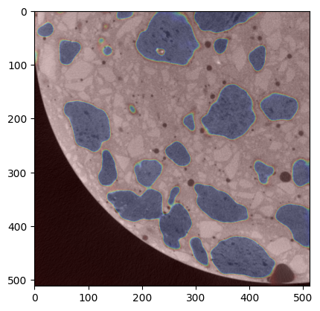
Image 2 – Ground truth (left) and prediction (right)

Bibliography
Ronneberger, Olaf, Philipp Fischer, and Thomas Brox. 2015. U-Net: Convolutional Networks for Biomedical Image Segmentation. arXiv, May 18. https://arxiv.org/abs/1505.04597.

