**FUNDAMENTALS OF DATABASES – WEEK 3 – ACTIVITY 1**

Supply/perform what is asking in the following statements. Attach or put a screenshot for each number to support your answers.

1. Search a website or install a free software (for those who have laptop) which can be used as example of different types of interfaces for database or data management in the software/system.
2. Capture or make a screenshot for each types of interface given below and briefly explain its importance or benefits to the users.
   1. Menu-Based Interface
   2. Forms-Based Interface
   3. Graphical User Interface
   4. Natural language Interface
   5. Speech Input and Output
   6. Interfaces for DBA



1.

2.

A. Menu-Based Interfac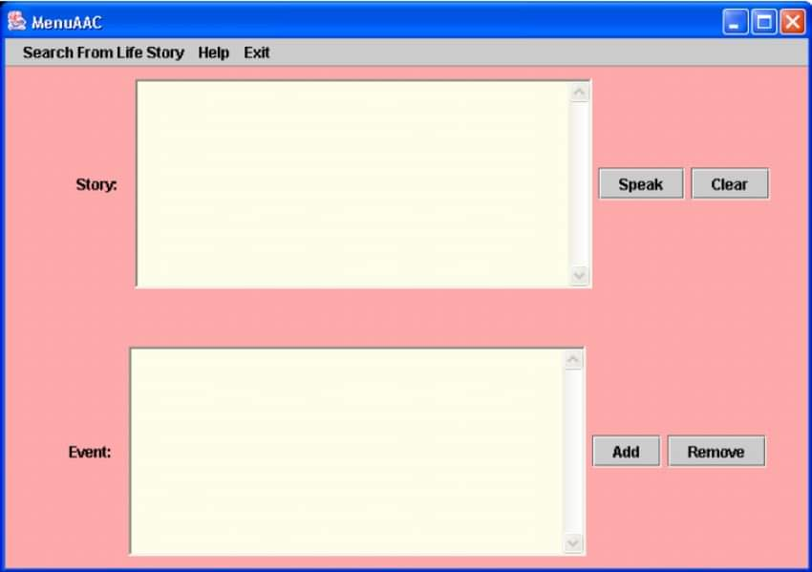e

The menu-based interface for accessing the

biographical text database.

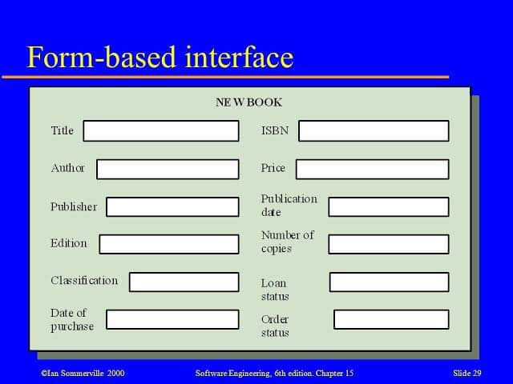

B. Forms-Based Interface

A type of user interface used, for example, on the internet, to organize questions or options for the user so that they resemble a traditional paper form to be filled out by pointing to the fields and typing text, or by choosing from a list.

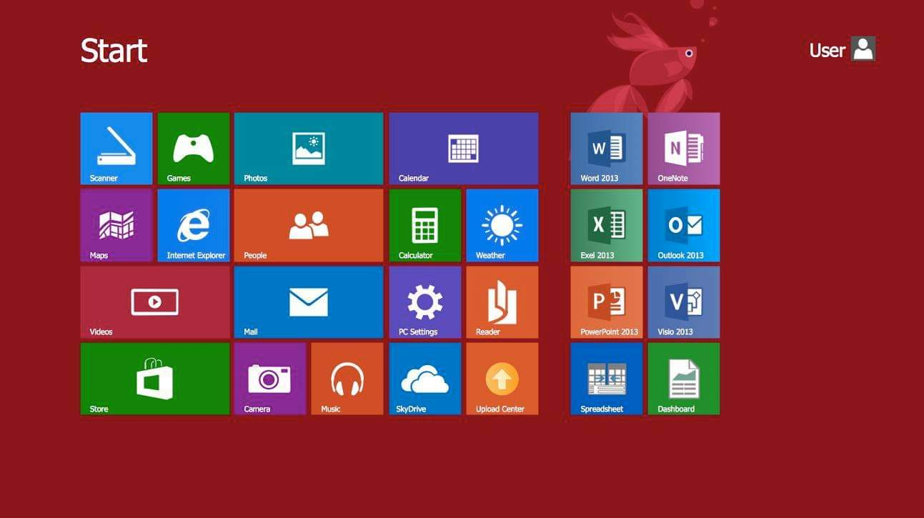

C. Graphical User Interface

The graphical user interface, developed in the late 1970s by the Xerox Palo Alto research laboratory and deployed commercially in Apple’s Macintosh and Microsoft’s Windows operating systems, was designed as a response to the problem of inefficient usability in early, text-based command-line interfaces for the average user.

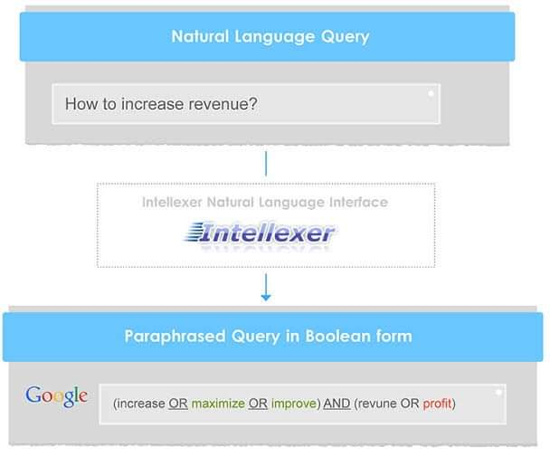

D. Natural language Interface

Natural Language Interface can transform queries in natural language into Boolean queries, expanding them with possible ways of combining and paraphrasing. NLI can also expand the original queries with synonyms but due to the fact that the number of total synonyms is rather limited, and a set of synonyms applicable to a certain domain needs to be customized, this functionality isn't provided out-of-the-box, but can be added after a customization request.

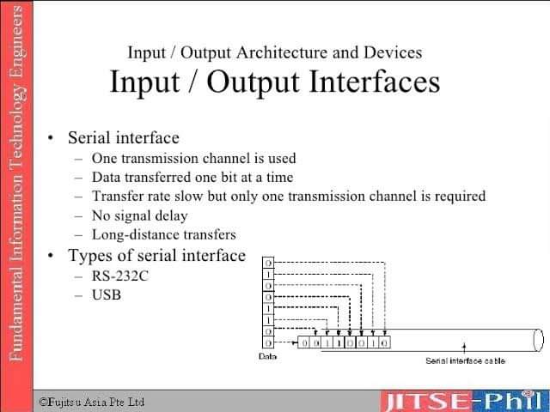

E. Speech Input and Output

When a user speaks to a conversational interface, the system has to be able to recognize what was said. The automatic speech recognition (ASR) component processes the acoustic signal that represents the spoken utterance and outputs a sequence of word hypotheses, thus transforming the speech into text.

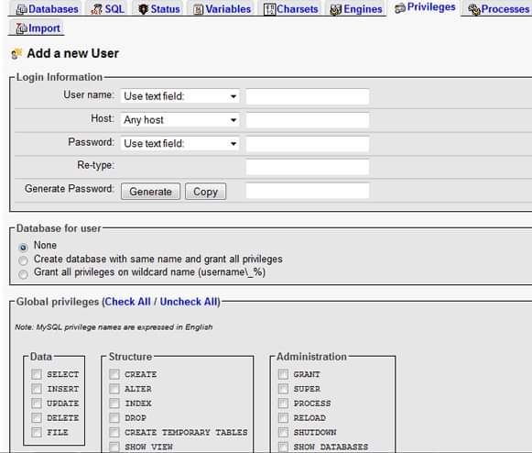

F. Interfaces for DBA

Most database system contains privileged commands that can be used only by the DBA's staff. These include commands for creating accounts, setting system parameters, granting account authorization, changing a schema, reorganizing the storage structures of a databases.