Performance Optimisation of the Lebwohl–Lasher Liquid Crystal Model Using Python-Based Acceleration Techniques

Introduction
Python is one of the most widely used computational languages due to its readability and numerous available libraries, however its major limitation is its performance. Python’s interpreter executes code line by line, and the frequent context switching between high-level objects makes numerical loops extremely slow. This can become very obvious in simulations where the same numerical operation is repeated multiple times.
There are several optimisation approaches however, which can aid this issue and get a code running very efficiently. The first is NumPy, this replaces Python loops with vectorised array operations, executed in precompiled C. Speed-ups are achieved by the arrays going through compiled functions rather than iterating element by element in Python.
Numba uses just-in-time (JIT) compilation to translate functions into optimised machine code at runtime, allowing ordinary Python syntax, but achieving near C level performance. Numba can also be parallelised, through parallelising loops on multi-core CPUs.
Cython explicitly compiles Python into C extensions. This translates the code into fast C loops which are compiled before execution. OpenMP, which is often combined with Cython, involves dividing a computational task into smaller, independent parts that can be executed simultaneously across multiple CPU cores. This leverages modern multi-core processors to reduce overall runtime by processing these parts concurrently, as opposed to sequentially.
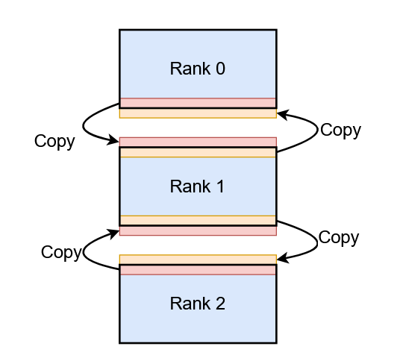
Message Passing Interface (MPI), is a portable message-passing standard widely used in parallel computing architectures, facilitates communication between processes on distributed memory systems, enabling extensive simulations and data analysis. Each process holds only a portion of the data, and neighbouring processes exchange ghost rows at their boundaries to maintain continuity of physical interactions, as shown below in Figure 1.
Figure 1: Exchange of ghost rows between processes.¹ -
The Lebwohl-Lasher model of liquid crystals represents each lattice site as a molecule with an oriental vector interacting with its nearest neighbours. Through Monte Carlo sampling, the model exhibits a nematic-isotropic phase transition, meaning the molecular alignment decreases sharply with increasing temperature. This simulation is extremely computationally demanding due to the repeated trigonometric evaluations with each Monte Carlo iteration.
Each lattice site in the model is represented by a unit vector, $u_{i}=(\cos{θ_{i},\sin{θ_{i})}}$, describing the molecular orientation at site i. The interaction energy between neighbouring sites i and j is given by:
$E_{ij}= -εP_{2}(\cos\left(θ_{i}-θ_{j}\right))= -ε(\frac{{3cos}^{2}\left(θ_{i}-θ_{j}\right)-1}{2})$, (1)
Where P₂ is the second Legendre polynomial and ε sets the interaction strength. The total energy of the system is obtained by summing over all nearest-neighbour pairs. During each Monte Carlo step, a random lattice site is selected and its orientation ϑ_{i} is perturbed by a small random angle. The corresponding change in energy, ΔE, is calculated and the move is accepted according to the Metropolis criterion:
$P\left(accept\right)=\min{(1, e^{\frac{-∆E}{k_{B}T}})}$. (2)
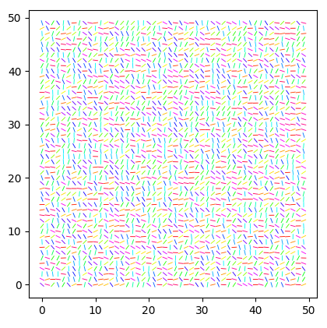
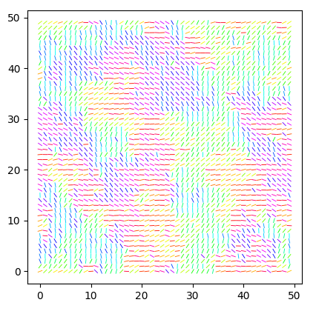
This process allows the system to evolve towards an equilibrium at a reduced temperature T*.
Figure 2: Monte Carlo simulation of the Lebwohl-Lasher model, with grid size = 50 and T* = 0.65. Left hand image shows the initial random configuration. Right hand image shows the configuration after 50 Monte Carlo steps (MCS)
This report covers the methods used to utilise these optimisation approaches, to make a comparison between them through analysing how they scale with grid size and parallelising, whilst keeping as much accuracy as possible to the core Lebwohl-Lasher model.
Methodology
A GitHub repository was initialised, pytests were added to test the core Python code, alongside a requirements file, a pyproject.toml and a test.yml file within a workflow.² This allowed for automatic pytesting with all pushes to the repository, to ensure the main working branch stayed clean.
A cProfile of the core code was obtained, which highlighted the current bottlenecks, and which areas of the code to look to improve.
First, Numpy.py was created, where trigonometric operations were applied to compute the local energy difference with neighbouring spins. Numpy functions, such as np.cos and np.sum were implemented to speed up the maths. A sequential version of this code was then created, this built on the basic numpy code by removing random site selection and instead performing deterministic, ordered updates across the lattice. This ensured that every spin was visited exactly once per Monte Carlo sweep, providing a consistent and reproducible baseline for benchmarking subsequent optimisation methods. Finally for Numpy, a vectorised version was created, which introduced full array operations, as well as implementing a checkerboard update pattern. The grid was divided into two interleaved sub-lattices (black and white), allowing half the spins to be updated simultaneously without interacting neighbours. This was achieved by constructing parity masks using NumPy broadcasting, which identified which subset of spins to modify on each half-sweep. Each sub-lattice was updated independently, ensuring no data dependencies between neighbouring sites. This approach significantly reduced the number of loops, swapping to compiled NumPy operations.
Numba.py was then tested to reduce Python overhead, where JIT was implemented with @njit, optimising the Python functions by removing interpretation costs. The arguments: (nopython=True, cache=True) were used, with nopython=True, ensuring the function would execute entirely in compiled machine code, and cache=True allowed the compiled code to be stored locally, so further runs could reuse the existing compiled functions. The checkerboard pattern was also implemented within the compiled loops. This Numba code was then copied and parallelised by adding an argument of parallel=True, where it was tested for the optimal number of threads, and implementing prange loops. The checkerboard remained as this ensured no neighbouring spins were updated in the same pass, so there were no races between threads.
A Cython.pyx code was created to translate the code to compiled C. Type declarations were introduced for all numerical variables, enabling direct compilation to C and eliminating dynamic type checking. The checkerboard structure was retained and implemented through nested C loops. Parallelisation for Cython was done using OpenMP, the main loop was improved with prange and compiled with OpenMP flags, allowing parallel updates across multiple threads. The number of threads was passed as an argument to the Python runner script, enabling controlled scalability tests. The OpenMP reduction clause was used to safely aggregate quantities such as the total energy and order parameter across threads. This version maintained the same checkerboard scheme for consistency, ensuring correctness under concurrent updates.
MPI was finally implemented via the mpi4py library, splitting the grid horizontally into ranks according to the set number of processors. To maintain periodicity, ghost rows were implemented: each process sent its top and bottom boundary rows to its neighbouring processes using Isend and Irecv for non-blocking communication, followed by Wait synchronisation to ensure message completion before proceeding. This allowed continuous updates across boundaries without data conflicts. Load balance was preserved even when the grid size was not evenly divisible by the number of processes, with row indices computed dynamically for each rank. After completing local computations, the partial lattices were gathered on the root process using Gatherv, reconstructing the full grid for final order parameter evaluation and output. Timing was measured using MPI.Wtime(). This code was then copied twice and had Numba and Cython implemented to test combining approaches.
Finally, all codes were ran three times for 1000 simulations at T* = 0.65 on grid sizes of: 10, 25, 50, 75, 100, +50 steps until 700, then +100 steps. The time taken was recorded for each grid and averaged over the 3 runs, with the standard mean error calculated. If the average run time was >100s, that would be the final grid ran, as any more would have been pointless and time consuming. Calculations were also ran at every .05 T* from 0.3 to 1.6 with the order recorded for each of the codes, as a check to make sure the physics calculations were not broken, and the code was still logically identical.
All calculations were ran on a 2019 11th Gen Intel® Core™ i7-1165G7 Laptop.
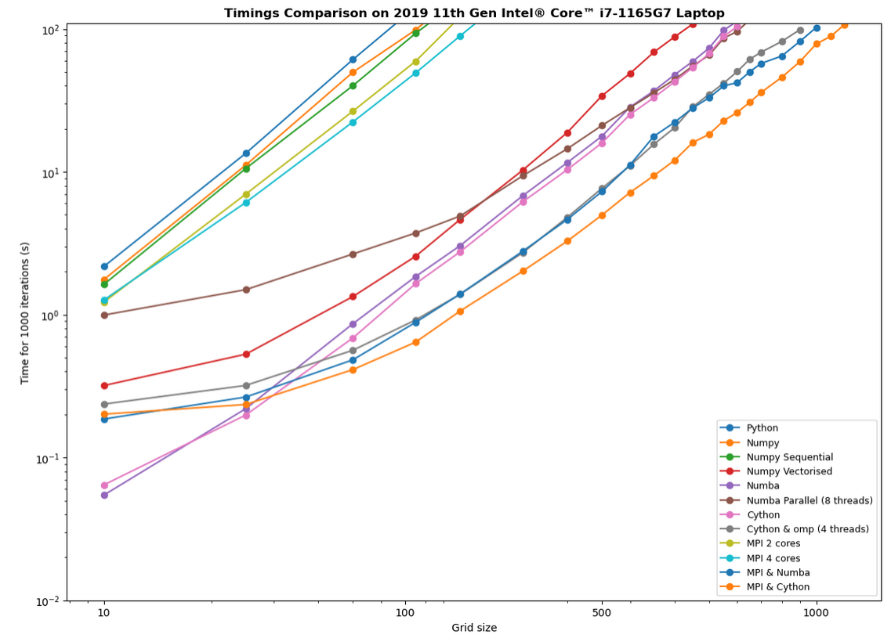
Results
Figure 3: Timings for all 11 codes to run for 1000 iterations and T*=0.65.
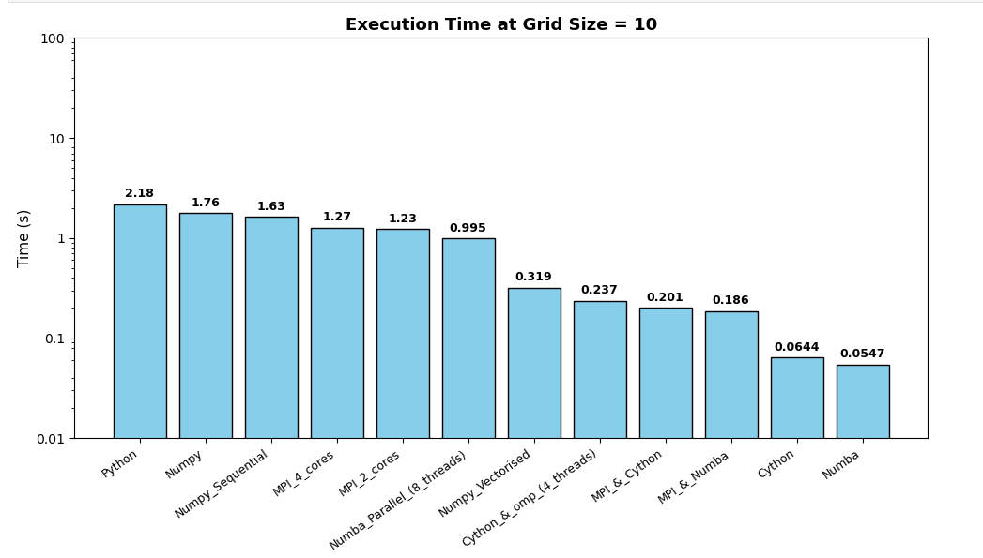
Figure 4: Timings from Fig. 3 for grid size = 10
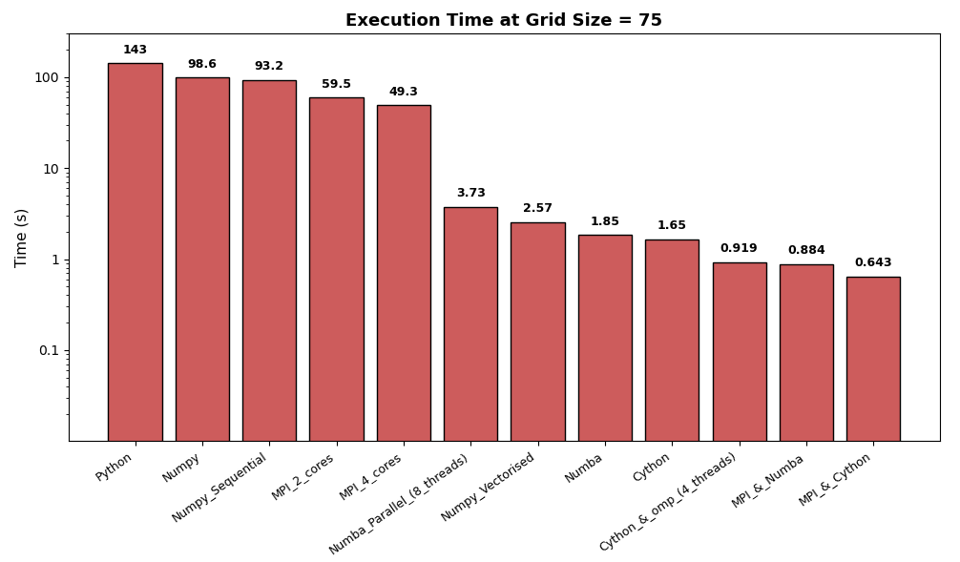

Figure 5: Timings from Fig.3 for grid size = 75
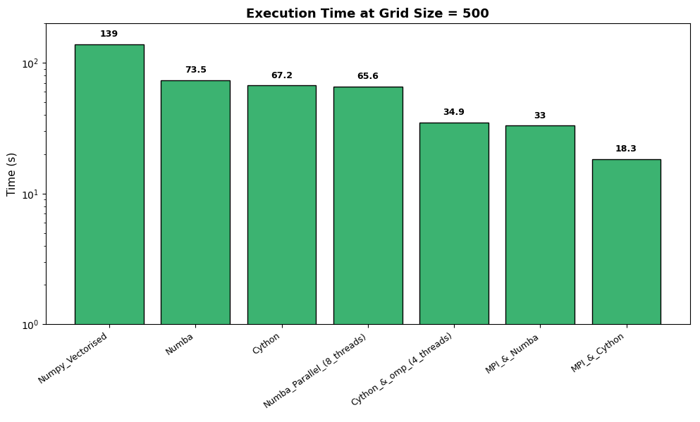
Figure 6: Timings from Fig.3 for grid size = 500
Figure 3 presents the complete set of timing results for all implemented codes. The baseline core program is clearly the slowest, confirming that every optimisation method achieved at least some degree of performance improvement—though with varying effectiveness. The NumPy and sequential NumPy versions showed only marginal gains, with the sequential variant performing slightly better due to its more deterministic update pattern compared to random sampling.
MPI performed below expectations, following a near-linear scaling trend similar to the core and NumPy implementations but with a small overall speed advantage. This suggests that MPI alone introduces too much communication overhead relative to its parallel benefit, especially at smaller grid sizes. For grids around N ≈ 10, the cost of coordination and halo exchange dominates the computation, explaining why two-process MPI runs were occasionally faster than those using four processes. However, for larger grids, MPI with four processes consistently outperformed the two-process configuration, indicating that the overhead becomes less significant as the computational workload per process increases. This led to the further MPI calculations with Numba and Cython to be carried out on 4 cores.
Interestingly, Numba was the fastest at a grid size of 10, which was unexpected since Cython usually outperforms it. This is likely due to caching effects making such small calculations unusually efficient, giving Numba an edge. The standard Numba implementation actually stayed faster than the parallelised version up to around a grid size of 500, as shown more clearly in Figure 6, where the overhead from threading outweighed any speedup for smaller grids. Cython with OpenMP, however, significantly outperformed the standard Cython implementation beyond a grid size of roughly 60 — at 500 it achieved about a twofold speedup. It was also notable how close Cython and Numba were in their serial forms, yet once parallelised their performance diverged sharply. The vectorised NumPy was incredibly faster than the other two non-vectorised forms, with about a 36x speedup for the grid of 75, which highlights the insane time shortcuts that can be taken without the long loops, presenting the idea of vectorising the other programs to sped them up even more.
Finally, the mashups of MPI with Numba and especially Cython have turned out to be the best tested speedup methods, showing that MPI does have its worth definitely, but maybe not solo. The MPI & Cython was about twice as quick as omp (Fig 6) and about four times as fast as standard Cython. This shows that the ranks and halo exchanges with the checkerboard is more effective than threads with the checkerboard.
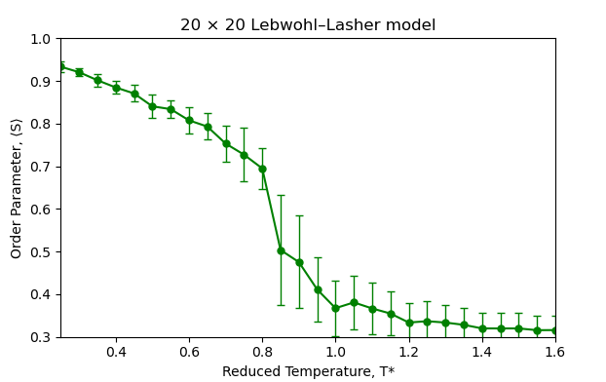
One issue encountered during data collection was the laptop itself. After several runs, it would overheat, causing the fan to spin aggressively and throttle performance. This became a noticeable problem, as allowing the system to cool for a few minutes — or even manually cooling it — could reduce the runtime of an identical calculation by as much as 25%. As a result, the timings presented here should be viewed as indicative rather than absolute, since thermal fluctuations likely influenced performance consistency. Running the simulations on a desktop with greater cooling capacity and memory, or ideally on a high-performance computing (HPC) system, would provide a more reliable and stable comparison of execution times.
Figure 7: Order vs reduced temperature in a 20x20 grid for the core Python file.
Comparing Figure 7 with the equivalent plots for the other ten programs (Appendix A) shows that all implementations produce identical results, confirming that the mathematical consistency of the model was preserved across every optimisation and parallelisation method. In each case, the order parameter remains high at low temperatures before dropping sharply between T* = 0.7–0.9, reaching equilibrium around 0.3–0.4 at higher temperatures. This consistent behaviour indicates that the optimisations affected only computational performance, not the physical accuracy of the simulation. In short, the model runs far faster but, as intended, the physics remain unchanged.
Conclusions
In conclusion, this project demonstrated that significant performance gains can be achieved in Python through progressively advanced optimisation techniques. While NumPy provided only modest improvements over the baseline implementation, the use of Numba and Cython resulted in far greater speedups by reducing interpretation overhead and compiling code to machine level. Parallelisation through OpenMP and MPI further enhanced performance for larger grids, with the hybrid MPI–Cython implementation proving the most efficient overall. All optimised codes reproduced identical physical results, confirming that computational improvements did not compromise accuracy. Due to the overheating problem with the laptop causing fluctuations in efficiency I think if I were to have carried on with this project I would have tried it on an HPC. As well as that I would have tried to implement the vectorisation as that clearly results in major speedups compared to loops.
References
- https://teaching.wence.uk/phys52015/exercises/mpi-stencil/
- https://github.com/nickhardman3/Y4_Assignment1
Appendix
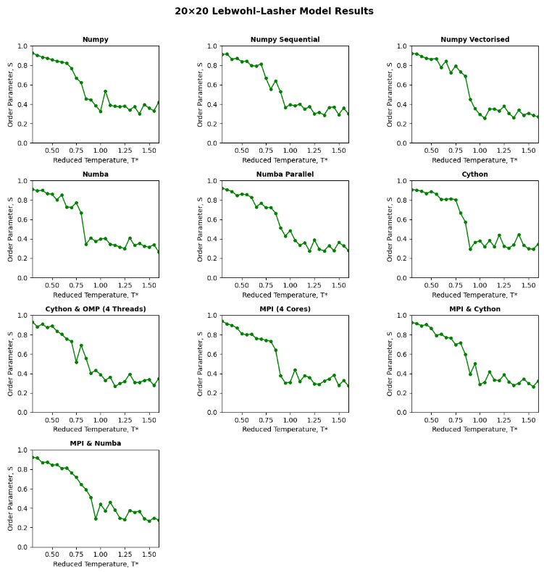
Appendix A) Order vs T* for each of the created programs

