Layout Test Demo

Your Name

Thursday, July 31, 2025

# Layout Test Demo

## Overview

Brief introduction to your presentation topic.

## Problem Statement

Describe the challenge or opportunity you’re addressing.

## Solution Overview

solution-overview

solution-overview

High-level approach to solving the problem.

## Technical Architecture

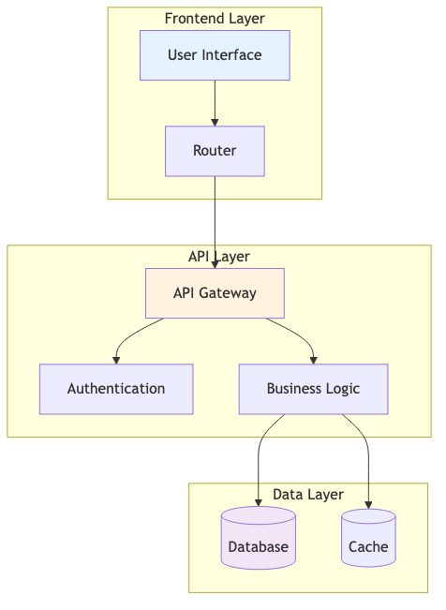

architecture

System components and their relationships.

## Implementation Details

### Key Features

* Feature 1: Description
* Feature 2: Description
* Feature 3: Description

### Technical Stack

* Frontend: Technology choice
* Backend: Technology choice
* Database: Technology choice

## Results & Impact

### Metrics

* Metric 1: Improvement
* Metric 2: Improvement
* Metric 3: Improvement

### Next Steps

1. Future enhancement 1
2. Future enhancement 2
3. Future enhancement 3

## Questions & Discussion

**Contact:** your.email@example.com  
**Date:** Thursday, July 31, 2025