Project 3 Report

Analysis in README text file

***Time based on number of words:***

Time to Encrypt 10000 Words: 0.0482564 seconds
Time to Decrypt 10000 Words: 0.0482097 seconds

Time to Encrypt 50000 Words: 0.202583 seconds
Time to Decrypt 50000 Words: 0.20245 seconds

Time to Encrypt 90000 Words: 0.371385 seconds
Time to Decrypt 90000 Words: 0.371173 seconds

Time to Encrypt 130000 Words: 0.524546 seconds
Time to Decrypt 130000 Words: 0.524947 seconds

Time to Encrypt 170000 Words: 0.738881 seconds
Time to Decrypt 170000 Words: 0.736854 seconds

Time to Encrypt 210000 Words: 0.873982 seconds
Time to Decrypt 210000 Words: 0.875968 seconds

Time to Encrypt 250000 Words: 1.06542 seconds
Time to Decrypt 250000 Words: 1.06231 seconds

Time to Encrypt 290000 Words: 1.22442 seconds
Time to Decrypt 290000 Words: 1.22353 seconds

Time to Encrypt 330000 Words: 1.34719 seconds
Time to Decrypt 330000 Words: 1.34788 seconds

Time to Encrypt 370000 Words: 1.50186 seconds
Time to Decrypt 370000 Words: 1.50239 seconds

Time to Encrypt 410000 Words: 1.66806 seconds
Time to Decrypt 410000 Words: 1.66762 seconds

Time to Encrypt 450000 Words: 1.83779 seconds
Time to Decrypt 450000 Words: 1.83768 seconds

Time to Encrypt 490000 Words: 2.08565 seconds
Time to Decrypt 490000 Words: 2.0834 seconds

Time to Encrypt 530000 Words: 2.16275 seconds
Time to Decrypt 530000 Words: 2.16355 seconds

Time to Encrypt 570000 Words: 2.32766 seconds
Time to Decrypt 570000 Words: 2.32677 seconds

Time to Encrypt 610000 Words: 2.56846 seconds
Time to Decrypt 610000 Words: 2.56501 seconds

Time to Encrypt 650000 Words: 2.89528 seconds
Time to Decrypt 650000 Words: 2.88462 seconds

Time to Encrypt 690000 Words: 2.98834 seconds
Time to Decrypt 690000 Words: 2.97985 seconds

Time to Encrypt 730000 Words: 3.14005 seconds
Time to Decrypt 730000 Words: 3.13194 seconds

Time to Encrypt 770000 Words: 3.31772 seconds
Time to Decrypt 770000 Words: 3.30805 seconds
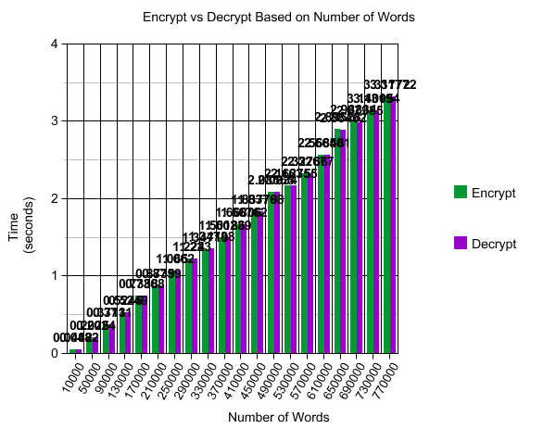

***Time based on size of words:***

Time to Encrypt 10000 Sized Word: 0.0024753 seconds
Time to Decrypt 10000 Sized Word: 0.00236156 seconds

Time to Encrypt 50000 Sized Word: 0.0138223 seconds
Time to Decrypt 50000 Sized Word: 0.0259787 seconds

Time to Encrypt 90000 Sized Word: 0.04619 seconds
Time to Decrypt 90000 Sized Word: 0.0230928 seconds

Time to Encrypt 130000 Sized Word: 0.0561741 seconds
Time to Decrypt 130000 Sized Word: 0.0386392 seconds

Time to Encrypt 170000 Sized Word: 0.0762533 seconds
Time to Decrypt 170000 Sized Word: 0.0408947 seconds

Time to Encrypt 210000 Sized Word: 0.0757371 seconds
Time to Decrypt 210000 Sized Word: 0.0504635 seconds

Time to Encrypt 250000 Sized Word: 0.0863338 seconds
Time to Decrypt 250000 Sized Word: 0.0613795 seconds

Time to Encrypt 290000 Sized Word: 0.0976403 seconds
Time to Decrypt 290000 Sized Word: 0.0696911 seconds

Time to Encrypt 330000 Sized Word: 0.112295 seconds
Time to Decrypt 330000 Sized Word: 0.0800199 seconds

Time to Encrypt 370000 Sized Word: 0.115291 seconds
Time to Decrypt 370000 Sized Word: 0.0898821 seconds

Time to Encrypt 410000 Sized Word: 0.121768 seconds
Time to Decrypt 410000 Sized Word: 0.103008 seconds

Time to Encrypt 450000 Sized Word: 0.142225 seconds
Time to Decrypt 450000 Sized Word: 0.109104 seconds

Time to Encrypt 490000 Sized Word: 0.141973 seconds
Time to Decrypt 490000 Sized Word: 0.117918 seconds

Time to Encrypt 530000 Sized Word: 0.171478 seconds
Time to Decrypt 530000 Sized Word: 0.130154 seconds

Time to Encrypt 570000 Sized Word: 0.163479 seconds
Time to Decrypt 570000 Sized Word: 0.138631 seconds

Time to Encrypt 610000 Sized Word: 0.193319 seconds
Time to Decrypt 610000 Sized Word: 0.148671 seconds

Time to Encrypt 650000 Sized Word: 0.179393 seconds
Time to Decrypt 650000 Sized Word: 0.175277 seconds

Time to Encrypt 690000 Sized Word: 0.184415 seconds
Time to Decrypt 690000 Sized Word: 0.169371 seconds

Time to Encrypt 730000 Sized Word: 0.203189 seconds
Time to Decrypt 730000 Sized Word: 0.189972 seconds

Time to Encrypt 770000 Sized Word: 0.210445 seconds
Time to Decrypt 770000 Sized Word: 0.190547 seconds
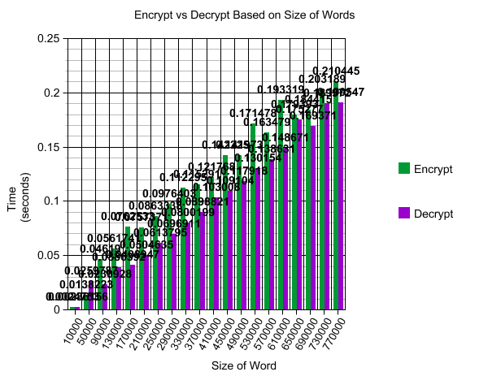

***Time to Login based on number of words:***

Time to login 50001 users: 0.64503 seconds
Time to login 100001 users: 1.89167 seconds
Time to login 150001 users: 3.74381 seconds
Time to login 200001 users: 6.21031 seconds
Time to login 250001 users: 9.59245 seconds
Time to login 300001 users: 14.107 seconds
Time to login 350001 users: 19.9423 seconds
Time to login 400001 users: 25.6719 seconds
Time to login 450001 users: 31.235 seconds

**Note that login is the process of searching hash table for the username/password and then decryption the user info to display.**

