**Guided Capstone Project Report - Big Mountain Resort**

After applying the data science method to the problem of adjusting the ticket price of Big Mountain Ski Resort based on the pricing of its competitors, I gained some valuable insights, which I will now summarize here.

I began by exploring the data graphically in order to gain initial insights. I was able to determine some possible trends in ticket price based on certain significant features. I was also able to visualize the importance of the features using the feature importances attribute of a Random Forest regressor

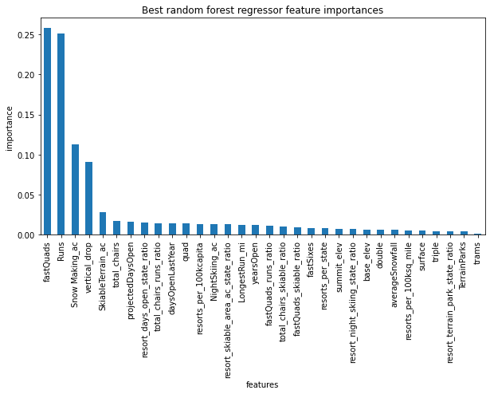

Features such as runs, vertical drop, fast quads, total chairs, and snow making ac could be observed as particularly important, and requiring additional analysis in the modeling stage.

During modeling, I graphically explored the placement of Big Mountain among the other resorts regarding these features, and observed that it was in a high percentile regarding most of them. Deciding that a Random Forest regressor was the most suitable model, my modeling results indicated that the ticket price could feasibly be increased from $81 to $95, with a mean absolute error of approximately $10, meaning that a price increase was strongly supported by the data.

I also explored how adjustment of the features listed above would affect ticket price. For example, adding an additional run which would increase vertical drop would provide support for increasing ticket price. It would be necessary for management to evaluate whether the additional costs of installing a new run are lower than the expected increased revenue it would generate.

In conclusion, analyzing the available data led to a strong conclusion that increasing the ticket price without making any changes to the resort would be a prudent move, and that the ticket price could be increased further if adjustments to certain features of the resort were made.