# Obtaining desktop GIS software Fall 2022 and Spring 2023

**Introduction**

There are currently three ways you can obtain desktop GIS software:

1. download ArcGIS Pro 3.x (PC only) from RIT’s ArcGIS Online.
2. use the software in a public lab on the RIT campus if you are on campus in rooms GOL 2000/2025, GOL2350 and the Magic Labs of 3110,2150,2175.
3. use the Remote Laboratory Emulation System (RLES) environment access to the software using a virtual machine, and

Option 1 is perhaps the easiest options as you can then have the software on your own (PC‐only) machine and will have for 1 year (long after the class is over).

**Option 1:**

## Before you install ArcGIS Pro 3.X

* 1. Check: https://pro.arcgis.com/en/pro‐app/latest/get‐started/arcgis‐pro‐system‐requirements.htm to make sure your computer has the hardware and software required.

## Access the software via RIT’s ArcGIS Online

**\*\* Note: Before you being these steps, contact your instructor to obtain a subscription to RIT’s ArcGIS Online**

* 1. Visit: https://ritarcgis.maps.arcgis.com/ to begin the process of activating and downloading your ArcGIS for Desktop Student Trial software.
  2. Log in using your RIT Account (like you were checking your email).
  3. After logging in, on top right under your user name, select My Profile

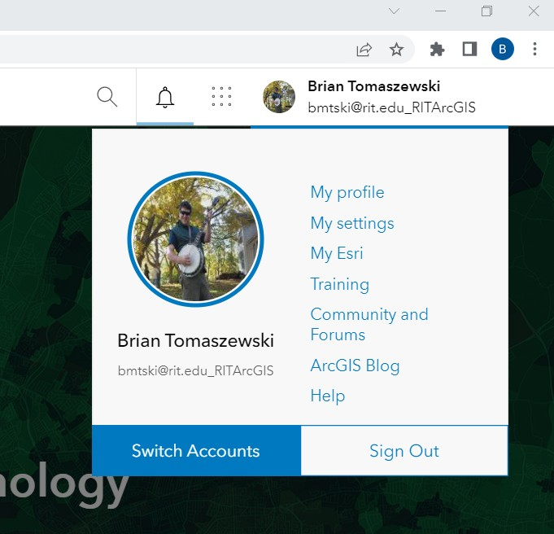

* 1. On the page that follows, on the bottom left, select View my settings:

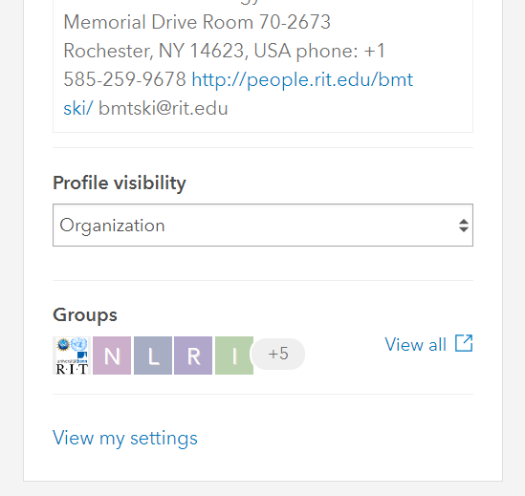

* 1. On the page that follows, on the top left, select Licenses:

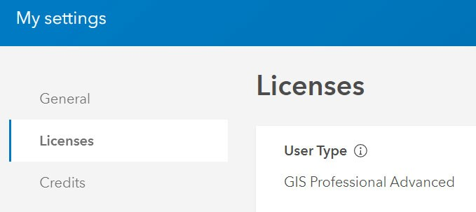

* 1. Scroll down the licenses page until you see ArcGIS Pro Download ArcGIS Pro

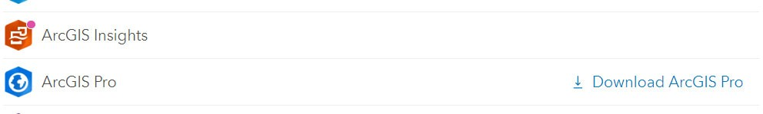

* 1. Click the download ArcGIS Pro link to access the software, note that ArcGIS Pro 3.X is a large download (~2.16 gb)

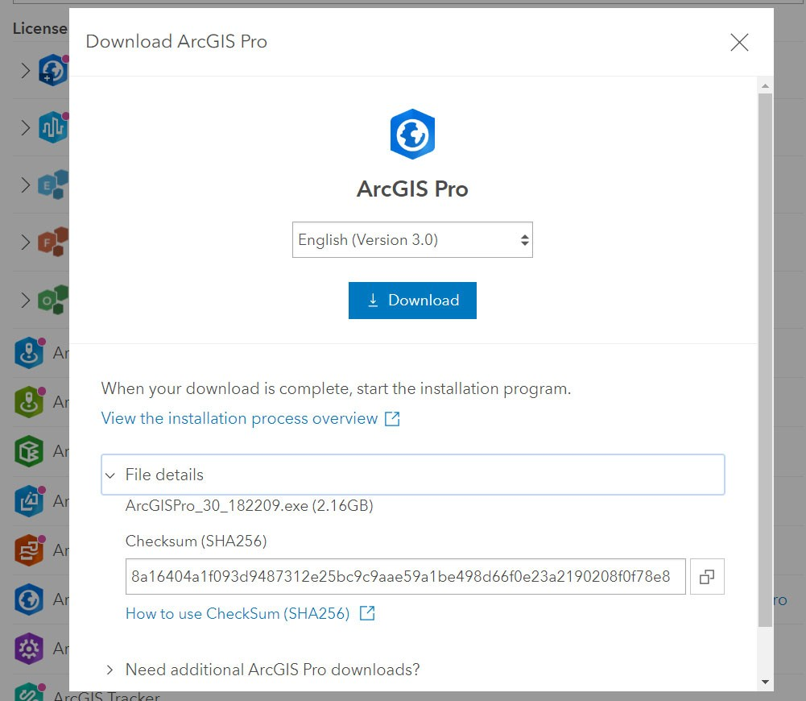

## Download and install ArcGISPro for Desktop Student Trial

**Note that the following software must be installed before installing ArcGIS Pro: Microsoft .NET Desktop Runtime 6.0.5 ‐ Windows x64**

## Once you have installed ArcGIS Pro, follow these steps to login:

**When opening the software for the first time, if you see a login prompt, enter your RIT credentials:**

ArcGIS Sign In **X**



Login to ritarcgis.maps.arcgis.com

Username

I RIT Username

Password

Password

**Login**

**Forgot Username? I Forgot Password?**

**Change Password**



0 Sign in automatically Configure Licensing Sign In Using Browser

## If you see a different screen and need to select an enterprise login enter:

**ritarcgis**

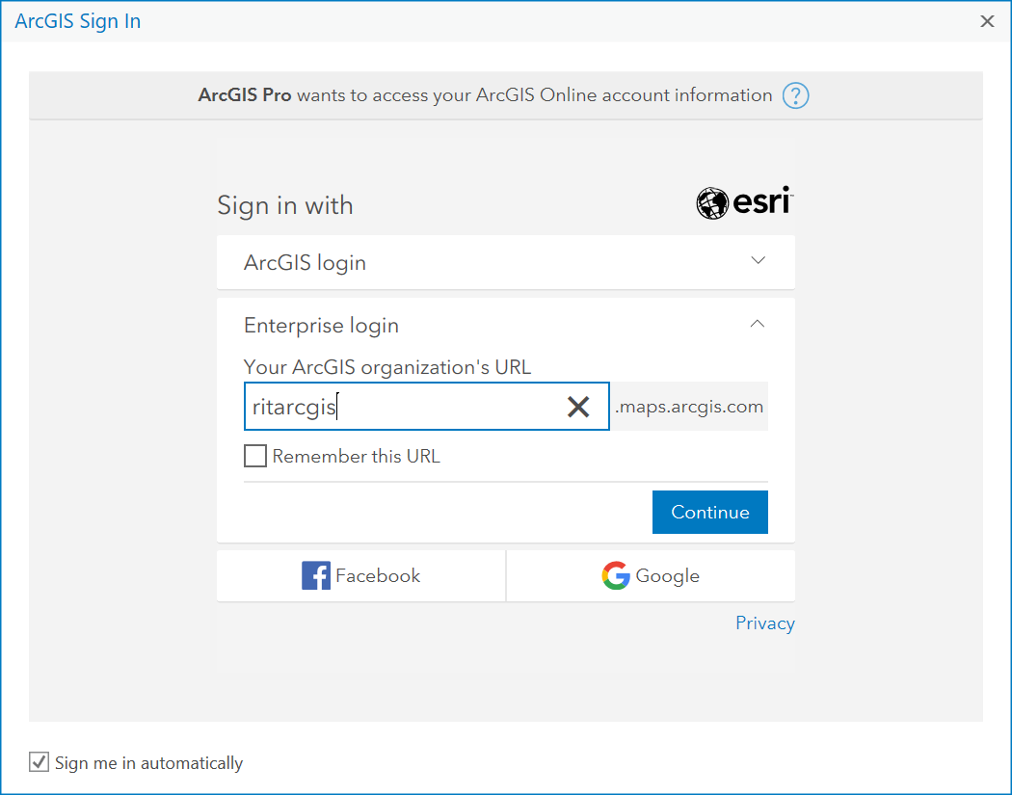

## use your RIT Credentials to login in (like you were checking your email)

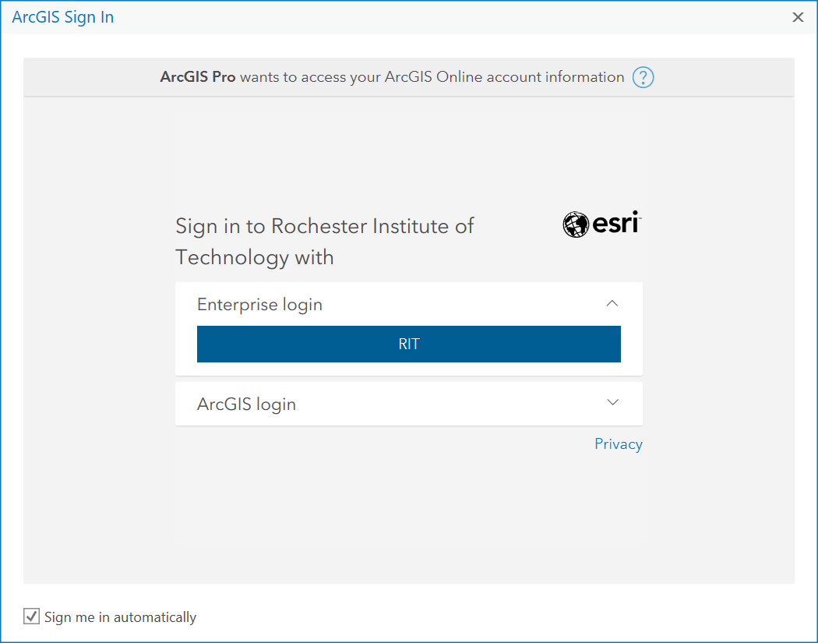

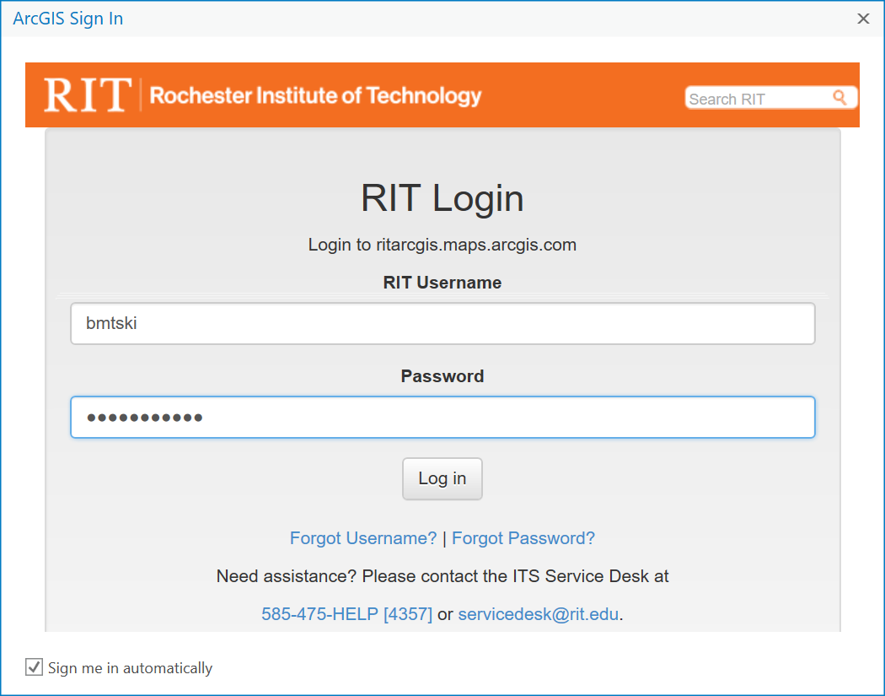

**Option 2:**

# If you are on the RIT campus, you can access ArcGIS Pro in GOL 2000/2025, GOL2350 and the Magic Labs of 3110,2150,2175.

**Option 3:** *The Remote Laboratory Emulation System (RLES) environment access tothe software*

*Note: Steps 1 to 7 are instructions for accessing RLES for the first time. If you have already logged into RLES previously, start at this step (step 7) for accessing your Remote Console after a previous RLES login.

1. Log in at https://rlescloud.rit.edu using your RIT credentials (If prompted for a “Domain” just click “Next” as it should already say “main.ad.rit.edu.”)
2. On the screen that follows after step 1, you should see the “Catalog” screen. We will be working with GIS 2022‐2023

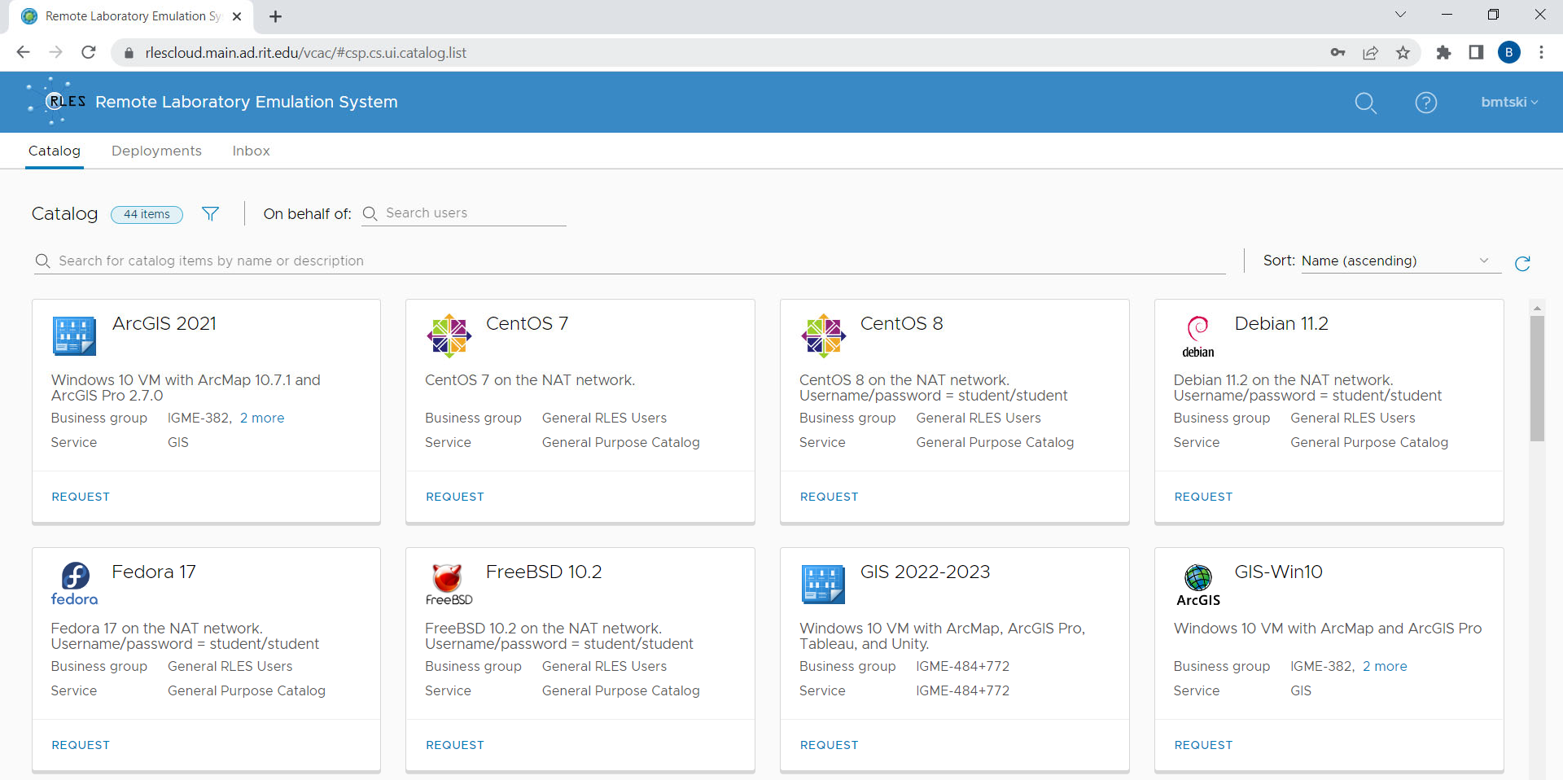

1. Click “Request” GIS 2022‐2023



1. On the screen that follows, click “Submit” on the next page to begin the deployment:

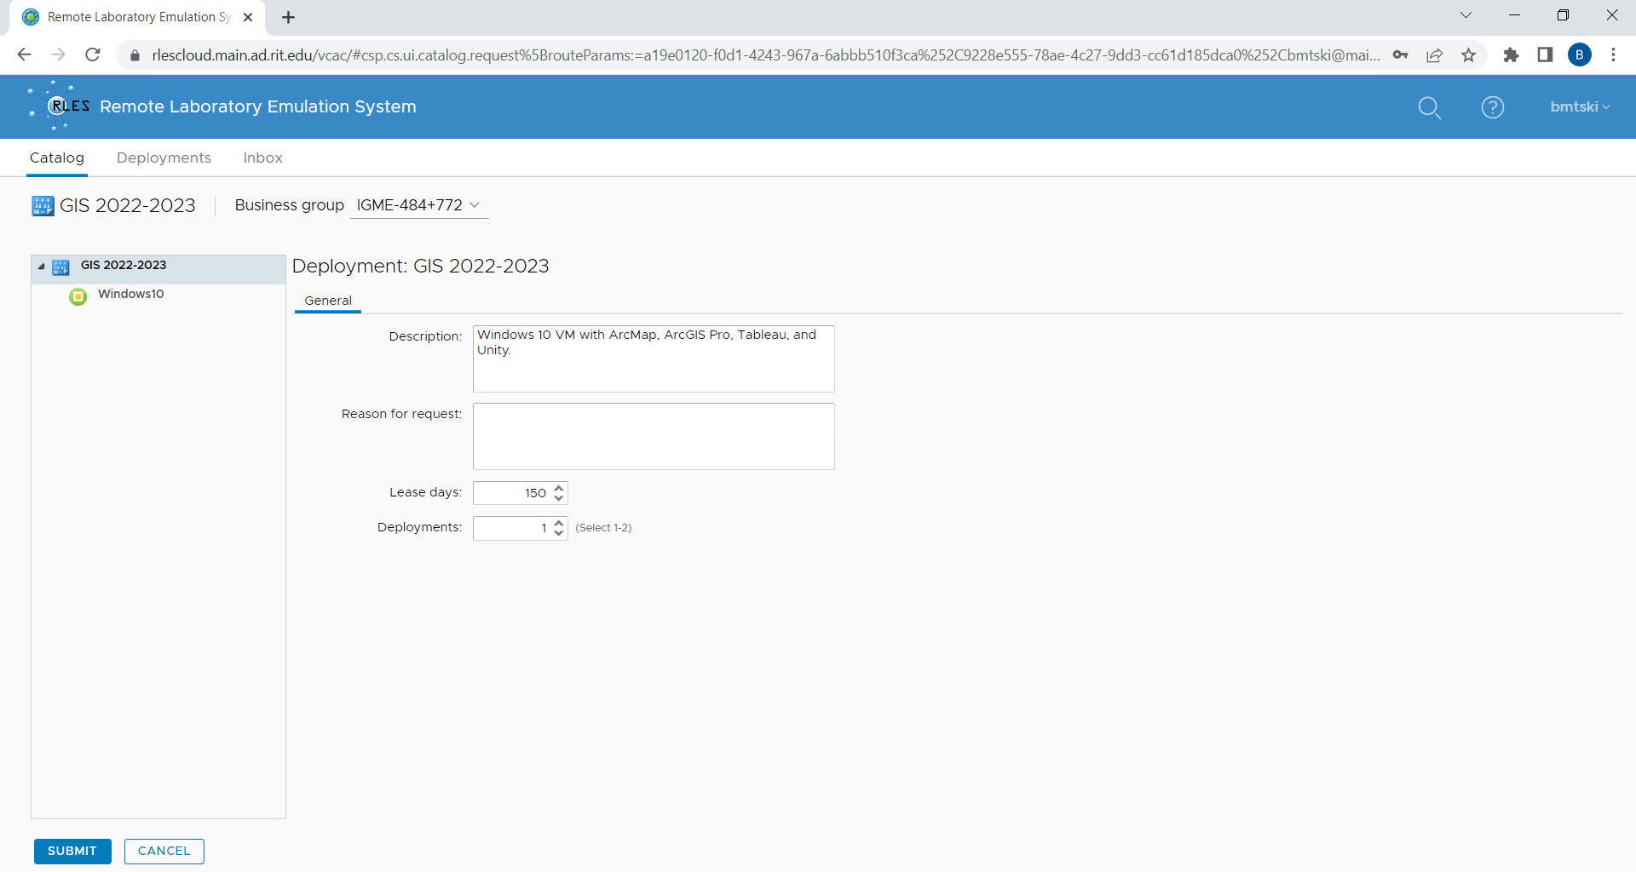

1. The deployment will start and take about 15 minutes

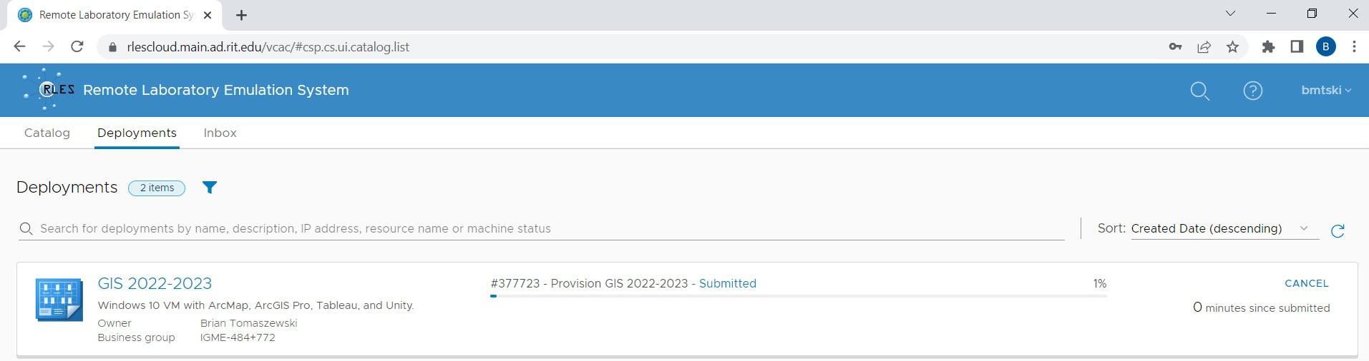

1. Once it has been deployed, it will show up on the “Deployments” page.

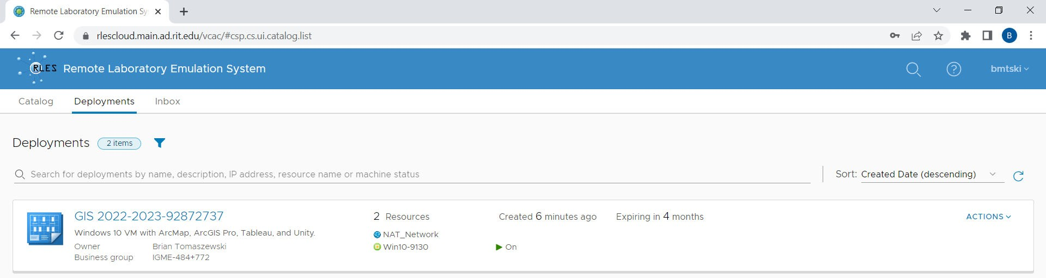

1. To access the VM, navigate to the “Deployments” page, expand GIS 2022‐2023



1. On the screen that follows, select the name of your class (aka Business group) under Components, click the Gear icon and then select “Power on deployment” from the gear icon menu:

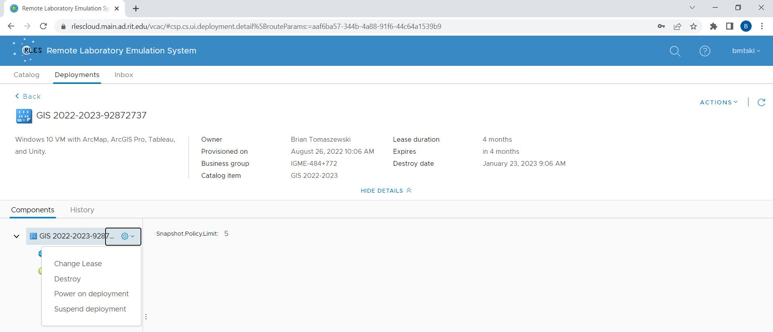

1. Click submit

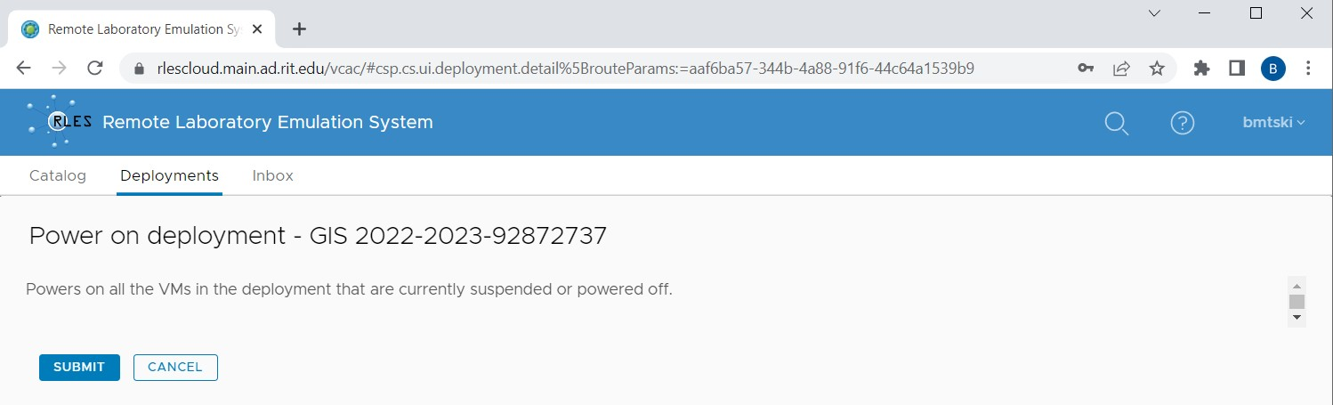

It may take a few minutes for the virtual machine to turn on.

1. Once Power On has been completed, you will be returned to the deployments screen. To open the remote machine, select the name of your class (aka Business group) under Components, click the Gearicon and then select “Connect to Remote Console” from the gear icon menu.

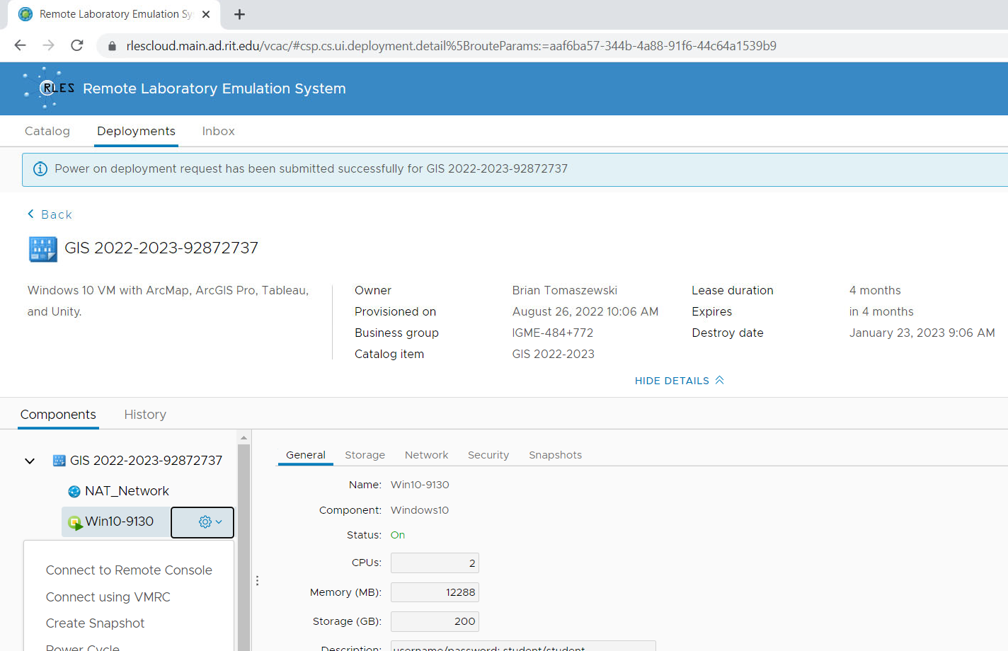

Tip: If you receive a message "Power on deployment" was completed successfully but do see the gear icon, refresh your browser.

A popup window will open with the Remote Console, and you will be able to interact with the Remote Console.

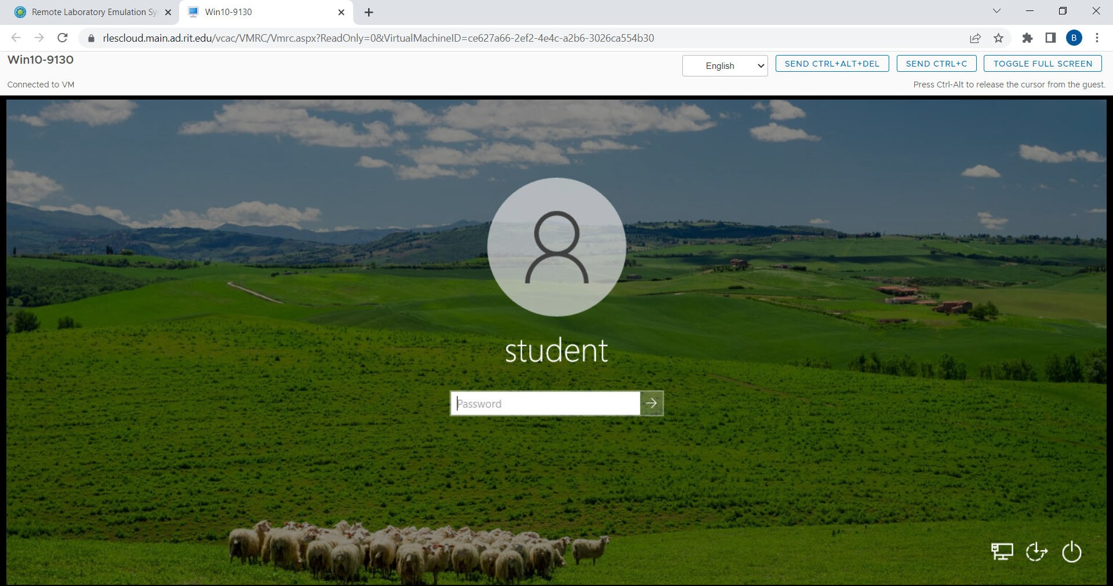The default view looks like this:

The password to login in is: **student**

Note that you can store downloaded items on the machine but there is no way to directly transfer files onto the Remote Console like you would do with a USB stick drive. It is recommended you use a web‐ based approach such as google drive or dropbox if you need to get files onto the Remote Console.

1. When you are done working with your Remote Console, close the Remote Console window by clicking the X at the top right of the window (if the window is in its own browser) or by closing

thebrowser tab (if you do not have other items open).

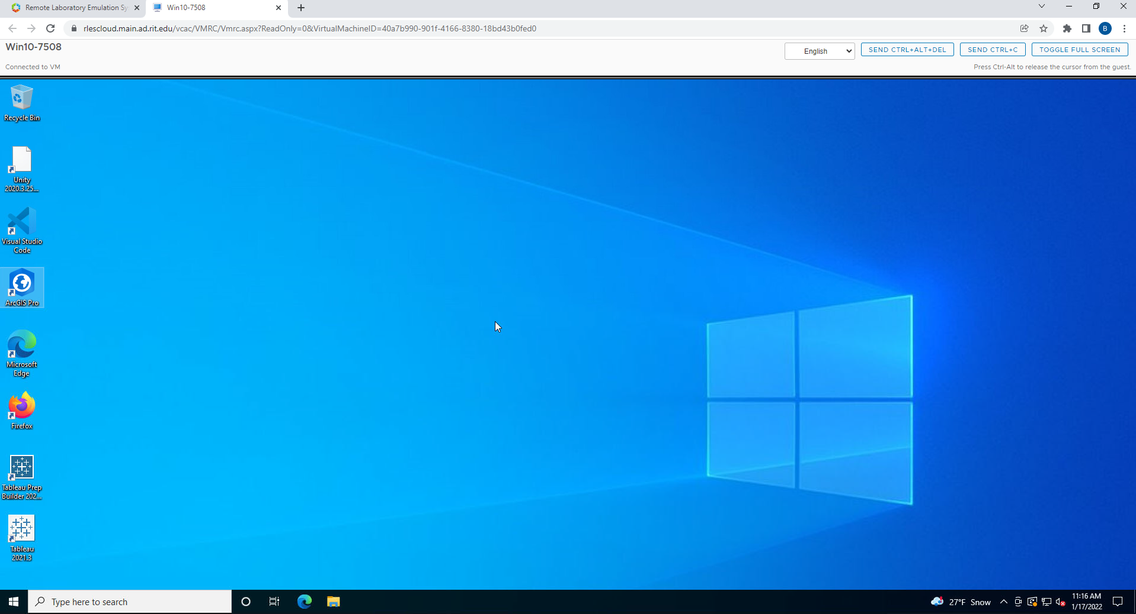

1. To shutdown your Remote Console, select the name of your class (aka Business group) underComponents, click the Gear icon and then select “Shutdown” from the gear icon menu.

Remote Laboratory Emulation S;. x +

f-- C Qi rlescloud.main.ad.rit.edu/vcac/#csp.cs.ui.deployment.detail%5BrouteParams:=aaf6ba57 -344b-4a88-91f6-44c64a153969

.

.

•

i@ Remote Laboratory Emulation System

-·

Catalog Deployments lnbox

CD Power on deployment request has been submitted successfully for GIS 2022-2023-92872737

< Back

GIS 2022-2023-92872737

Windows 10 VM with ArcMap. ArcGIS Pro. Tableau, and Unity.

Owner Provisioned on Business group Catalog item

Brian Tomaszewski August 26, 202210:06 AM IGME-484+772

GIS 2022-2023

Lease duration Expires Destroy date

4 months

in 4 months

January 23, 2023 9:06 AM

HIDE DETAILS ;:;::;

Components History

v Ill GIS 2022-2023-92872737

Cil NAT_Network

Win10-9130 [B

Connect to Remote Console

i

General Storage Network Security Snapshots

Name: Winl0-9130 Component' WindowslO

Status· On

CPUs:

|  |  |  |
| --- | --- | --- |
| Connect using VMRC | Memory (MB)' | 12288 |
| Create Snapshot | Storage (GB)· | 200 |

Power Cycle Power Off

i

Description· username/password: student/student