Next-Steps Analysis: P.528 Propagation, Real Pass Statistics, Ground UWB Baseline, and Mitigations
UWB Channel 9 Drones and NASA EESS Earth Stations, Working Paper Addendum, Rev 0
November 7, 2026
DRAFT - PRE-DECISIONAL AND DELIBERATIVE
Prepared with AI assistance. Reviewer: [CONFIRM]
Public and cleared sources only.

Summary
This addendum replaces two of the most criticized simplifications in the Rev 0 working paper, free-space propagation and fixed dish pointing, and adds a ground UWB baseline, a quantified mitigation menu, and a risk metric. The run used next_steps_analysis_rev1.m on MATLAB R2025b; the full log is in docs/next_steps_run_log_rev1.txt.
- The dish rarely points where low drones are. Over 30 days of SGP4 passes of Aqua, Terra, Landsat 8, and Landsat 9, the WG1 (Wallops) dish tracks 11.1% of the time and AS1 (Fairbanks) 23.2%. Only 8.3% (WG1) and 6.7% (AS1) of tracking time is at 5° to 6° elevation, the band where a 400 ft drone can enter the main beam.
- With P.528 and real pointing, smaller geofences suffice. The long-term criterion is met by at least 13.8 dB at every density tested. The short-term criterion is met with no geofence at 0.01 and 0.1 active drones per km² at both sites. At 1 active drone per km², it needs a geofence of 0.4 km at WG1 and 0.2 km at AS1, compared with 1.3 km under the Rev 0 fixed-pointing assumption.
- Ground UWB already permitted near a site contributes comparable long-term interference. At ECC Report 327 urban densities, handheld and indoor UWB give long-term margins of -12.6 dB and -10.5 dB at WG1, against -13.8 dB for drones at 1 active per km². Drones matter mainly through the short-term tail, when one comes close to the dish’s main beam.
- Several single conditions close the gap at 1 active drone per km²: a 1% duty cycle, or a 30 m altitude cap with a downward-directed antenna, or the European aircraft limit of -64.3 dBm/MHz.
- The short-term tail is statistically noisy. It rests on 5-10 Monte Carlo samples, and two runs of the same case differed by up to 3.8 dB. Results within a few dB of the criterion are undecided until the final runs use more iterations.

What changed in the model
Element | Rev 0 | This addendum
Propagation | Free space, paths beyond the radio horizon dropped | ITU-R P.528-5 basic transmission loss from the validated MATLAB port (itu_p528), time percentage drawn uniformly from 1% to 99% per device per iteration, as the 2.7 GHz working paper randomizes ITM reliability
Dish pointing | Fixed 13° (long term) and 5° (short term), random azimuth | Azimuth and elevation of a random tracking instant from 30 days of SGP4 passes, CelesTrak elements cached in data/tle_eess.txt
Percent of time | Share of all iterations | Share of tracking time (the dish isn’t receiving when idle)
Victim antenna | 11.3 m, 57.48 dBi derived | 11.3 m with NEN Users’ Guide G/T for AS1 and WG1
Populations | Drones only | Drones, outdoor handheld UWB, indoor UWB (with ITU-R P.2108-1 clutter and 17 dB building entry loss)
Code | aggregate_drone_mc_rev1 | aggregate_drone_mc_rev3 (same model as rev2, about 1.6 times faster)

Results

Single drone: P.528 against free space
One drone at 121.92 m in the dish azimuth, ITU-R SA.509-3 single-entry pattern, NEN 11.3 m antenna at 8160 MHz.
Dish elevation | Long term, free space | Long term, P.528 at 50% | Long term, P.528 at 1% | Short term, free space | Short term, P.528 at 50% | Short term, P.528 at 1%
5° | 1.71 km | 1.71 km | 2.00 km | 1.35 km | 1.35 km | 1.41 km
13° | 0.62 km | 0.62 km | 0.65 km | 0.52 km | 0.52 km | 0.52 km
Inside the line-of-sight range, the P.528 median matches free space. The 1% values include ground reflection and atmospheric variability and set an upper bound.

Dish pointing
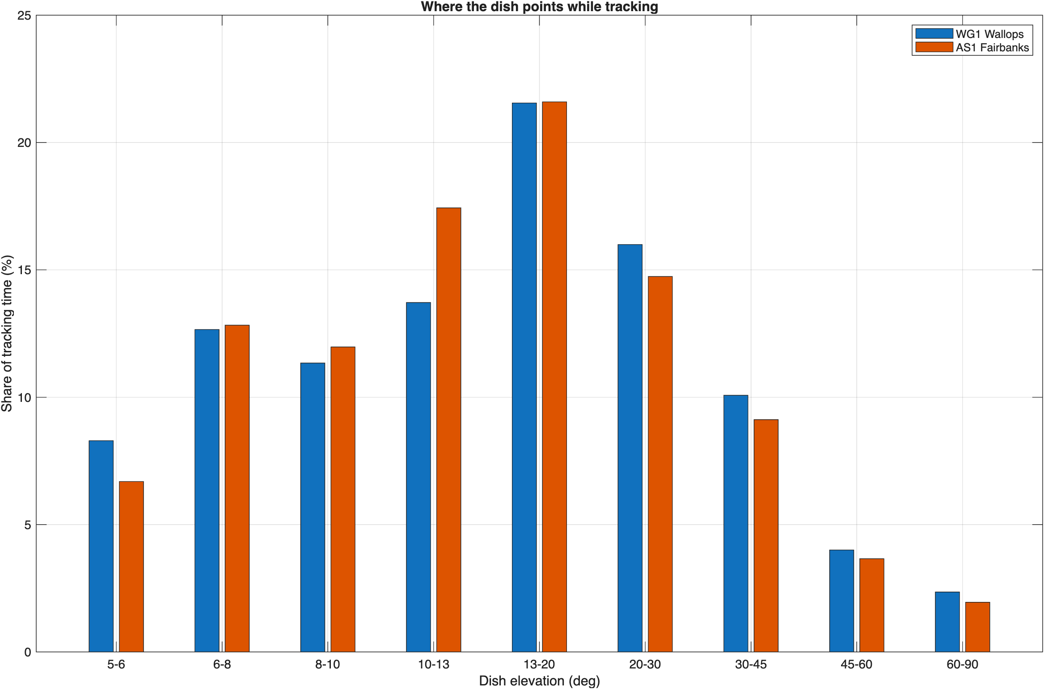
Figure 1: Share of tracking time by dish elevation at WG1 and AS1.
Site | Share of time tracking | Tracking minutes per day | Share of tracking time at 5°-6° | Share at 5°-10°
WG1 Wallops | 11.1% | 160 | 8.3% | 32.3%
AS1 Fairbanks | 23.2% | 335 | 6.7% | 31.5%

Aggregate drones
Short-term margins and radii come from 100,000 iterations at 0.01 and 0.1 active drones per km², and 20,000 iterations at 1 per km² (resolution limited; see “Uncertainty”).
Site | Active drones per km² | Long-term margin | Short-term margin | Geofence needed | Share of tracking time above short-term criterion | Minutes per year above it
WG1 Wallops | 0.01 | -36.8 dB | -15.6 dB | 0 km | 0.001% | 0.6
WG1 Wallops | 0.1 | -25.3 dB | -8.4 dB | 0 km | 0.001% | 0.6
WG1 Wallops | 1 | -13.8 dB | +7.5 dB | 0.4 km | 0.030% | 17.5
AS1 Fairbanks | 0.01 | -36.8 dB | -14.8 dB | 0 km | 0% | 0
AS1 Fairbanks | 0.1 | -25.3 dB | -0.3 dB | 0 km | 0.005% | 6.1
AS1 Fairbanks | 1 | -13.8 dB | +2.3 dB | 0.2 km | 0.015% | 18.3
Negative margin means the criterion is met. The minutes column is the share above the criterion, times the share of time tracking, times one year.

Ground UWB baseline at WG1
Urban active densities from ECC Report 327 as summarized by FiRa (2025): 7 outdoor and 500 indoor devices per km². WG1 is rural, so this is an upper bound for today’s environment.
Population | Active devices per km² | Long-term margin | Short-term margin
Outdoor handheld, 1.5 m | 7 | -12.6 dB | -14.2 dB
Indoor, 1.5 m, 17 dB building entry loss | 500 | -10.5 dB | -23.7 dB

Mitigation menu at WG1
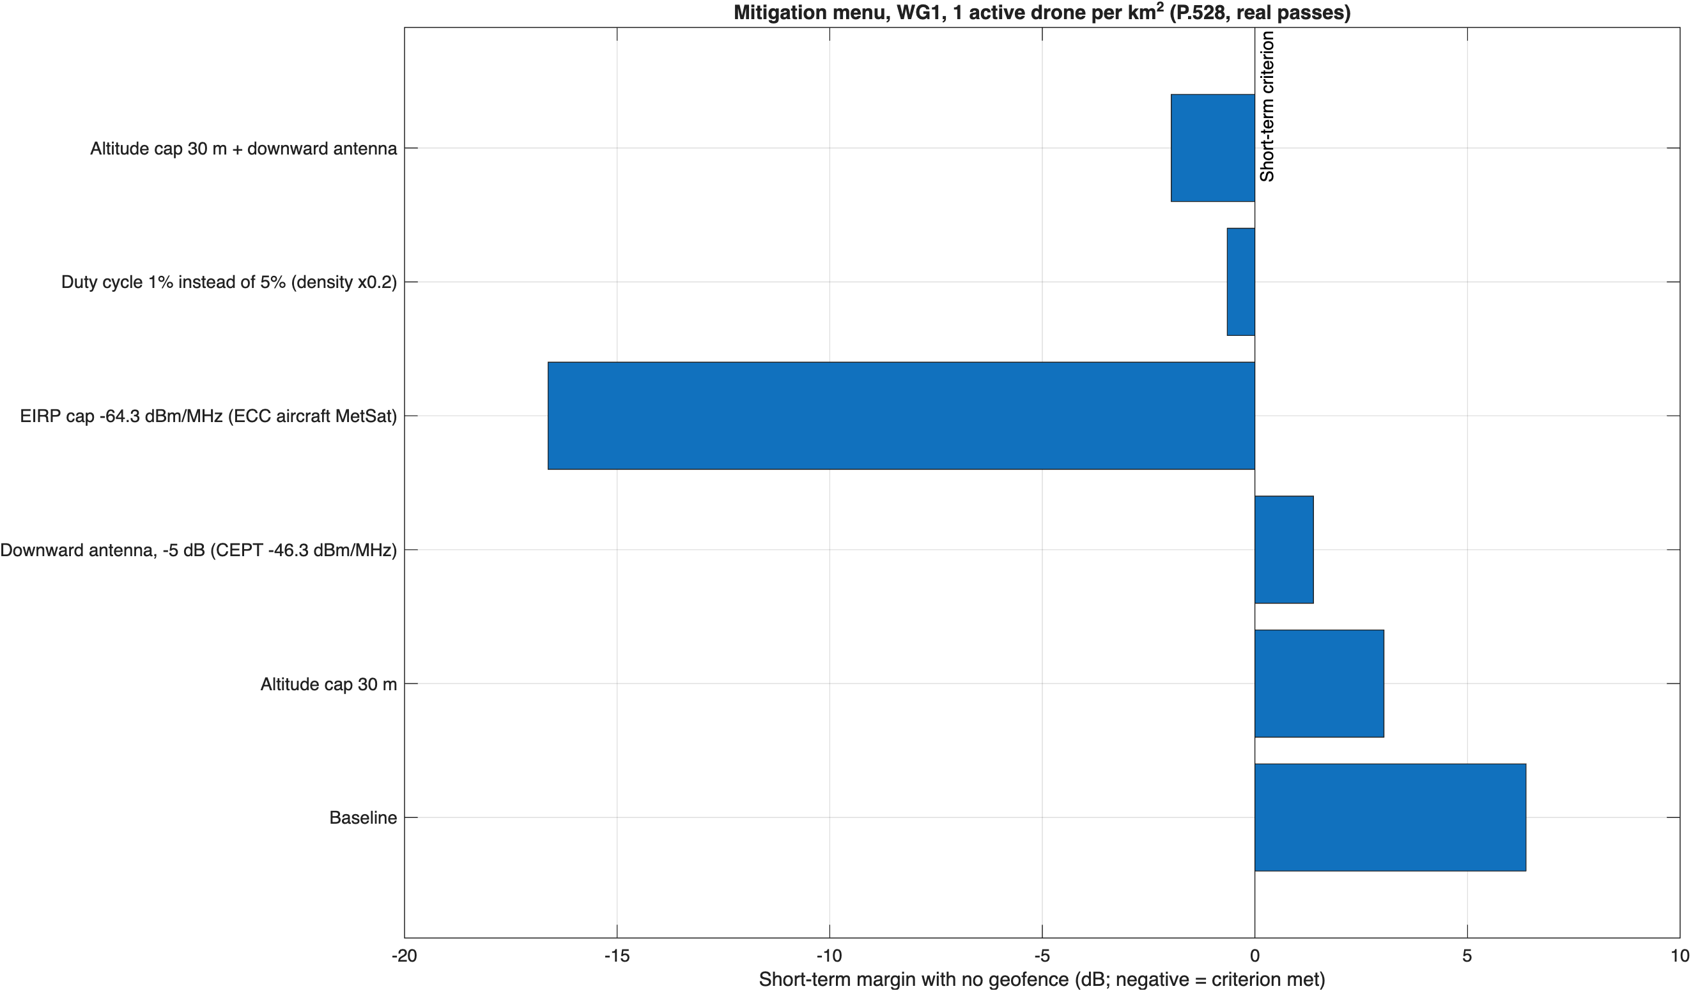
Figure 2: Short-term margin with no geofence for each mitigation, 1 active drone per km².
Mitigation | Short-term margin, 0.1 per km² | Short-term margin, 1 per km² | Geofence needed at 1 per km² | Minutes per year above, 1 per km²
Baseline | -8.4 dB | +6.4 dB | 0.4 km | 11.7
Altitude cap 30 m | -7.4 dB | +3.0 dB | 0.2 km | 7.0
Downward antenna, -5 dB (CEPT -46.3 dBm/MHz above 2.5 m) | -13.4 dB | +1.4 dB | 0.2 km | 5.8
EIRP cap -64.3 dBm/MHz (ECC Decision (12)03, aircraft, MetSat band) | -31.4 dB | -16.6 dB | 0 km | 0
Duty cycle 1% instead of 5% | -13.5 dB | -0.7 dB | 0 km | 2.3
Altitude cap 30 m and downward antenna | -12.4 dB | -2.0 dB | 0 km | 2.3
The two EIRP-reduction rows are exact dB shifts of the baseline run, not separate Monte Carlo runs. At 0.1 per km² the altitude cap shows a slightly worse margin than the baseline; that is Monte Carlo noise, not an effect (see “Uncertainty”).

Risk metric and the percent-of-time basis
ITU-R SA.1027-6 allows the short-term level to be exceeded 0.005% of the time, which is 26.3 minutes per year of total time. At 1 active drone per km², WG1 exceeds it for 0.03% of tracking time, which fails on a tracking-time basis, but only 11.7 to 17.5 minutes per year, which passes on a total-time basis. Which basis applies changes the conclusion, so it is item T1 in the joint assumptions agreement and should be settled before final runs.

Uncertainty
- Short-term tail. With 100,000 iterations, the 0.005% point has about 5 samples beyond it; with 20,000, about 1. The same WG1 case at 0.1 per km² gave -4.6 dB in one run and -8.4 dB in another (different random streams). Treat short-term margins within about 4 dB of zero as undecided. The pre-registration protocol should require at least 1,000,000 iterations, or importance sampling, for final short-term results.
- Minutes per year are quantized at one iteration’s share of time (0.6 to 6.1 minutes per year here, shown in the run log).
- Pass statistics use 30 days and four missions. Other missions supported at each site would raise tracking time.

Not done
- Calibration against ECC Report 327. Its EESS earth station parameters (section 5.5) weren’t retrievable from the public text, so the model hasn’t been run against its 300-3,600 m single-entry and 100 m and 700 m aggregate results. This is the top open item.
- P.2108-1 Eqn 3b (location standard deviation) is implemented from a reconstructed form and needs checking against the official text. It affects only the ground UWB baseline.

Performance note
The Monte Carlo was already vectorized. Profiling on R2025b showed the time going to random-number generation, the P.528 interpolation, and per-device trigonometry. The run took 463 s after three changes:
- Switching to the Threefry generator, whose randn is 10 times faster than mrg32k3a.
- Removing angle round trips.
- Deriving the EIRP-offset mitigation cases exactly from the baseline run.
parfor gives identical results but was slower on a two-worker laptop pool.

