ITM, ITU-R P.2001, and ITU-R P.452 from 1 GHz to 10 GHz: How the Models Compare
Working paper, revision 2 (draft)
November 2026
Preliminary calculations to show where deeper analysis is needed. Not for decisions.

Summary
Question. Terrestrial interference and coverage analyses from 1 GHz to 10 GHz use one of three common propagation models: the Irregular Terrain Model (ITM, Longley-Rice) version 1.4, Recommendation ITU-R P.2001-6, or Recommendation ITU-R P.452-18. This paper asks how the three models compare across that range, mechanism by mechanism, and which of them public U.S. measurements support.
Method. Every model received the same 30 m terrain profile in each calculation, so the differences are model differences. The paper runs a few targeted calculations at 2.7 GHz, 4.9 GHz, and 7.25 GHz, splits ITM's diffraction loss into its terms, and compares all three models with measured basic transmission loss from 30 MHz to 10 GHz in the ITU-R Study Group 3 databank.
The preliminary findings are the following:
- Line of sight: the models agree. On 18 real-terrain line-of-sight links, the ITU models differ from ITM by a median of 0.05 dB at 2.7 GHz and 0.11 dB at 7.25 GHz, at 50% of time.
- Diffraction over rough terrain: ITM predicts far more loss, and the gap grows with frequency. On real-terrain diffraction links, P.2001 is below ITM by a median of 30.6 dB at 2.7 GHz, 37.5 dB at 4.9 GHz, and 47.9 dB at 7.25 GHz.
- Most of that gap comes from three ITM ingredients. ITM adds two knife-edge losses, one at each horizon, where delta-Bullington uses one equivalent edge; it adds a clutter term of up to 15 dB; and it extends a diffraction line computed beyond the horizons back to the path. Removing all three cuts the median gap at 2.7 GHz from 30.7 dB to -8.7 dB.
- Measurements: on 118 measured datasets from 1 GHz to 10 GHz in the ITU-R Study Group 3 databank, the mean error in the median is 0.5 dB for ITM, -1.8 dB for P.452, and -0.6 dB for P.2001, with RMS errors of 10.8 dB, 8.7 dB, and 9.1 dB. From 30 MHz to 1 GHz (455 datasets) the mean errors are -2.9 dB for ITM, -3.4 dB for P.452, and -3.3 dB for P.2001. A positive error means the model predicts more loss than was measured. All three are close to unbiased at the median, and the ITU models scatter about 2 dB less than ITM. From 6 GHz to 10 GHz, ITM predicts 7.1 dB too much loss on average, while the ITU models are within 2.5 dB. At 1% of time, the ITU models predict about 8 dB too little loss on average, while ITM is unbiased.
- Terrain data matter as much as the model. On 30 m terrain at the listed site coordinates, the RMS error in the median from 1 GHz to 10 GHz is 25.3 dB for ITM and 18.4 dB for P.2001; on the databank's surveyed profiles it is 10.7 dB and 9.0 dB. Old site coordinates put antennas below nearby ridges on modern terrain data, and moving each site to match its surveyed elevation made the errors larger, not smaller.
- P.2001 and P.452 agree at 50%. Their median difference is at most 0.02 dB in every mechanism class and at every frequency; they share the delta-Bullington method.
- The tails differ by mechanism. Below about 10% of time the ITU models add ducting, which ITM does not model; at 1% of time on a 127 km over-sea path P.2001 predicts 35.3 dB less loss than ITM. Above 99% P.2001 adds clear-air and rain fading.
- Measurements are sparse above 3 GHz. The databank has 19 usable datasets from 3 GHz to 6 GHz and 26 from 6 GHz to 10 GHz, most of them outside the U.S.

The question
Analyses of terrestrial interference and coverage turn a protection criterion into a separation distance, an exclusion zone, or a coordination zone, and the propagation model sets that distance. Analysts often treat ITM, P.2001, and P.452 as interchangeable. The models come from different traditions, though, and the paths that usually decide a separation distance are beyond line of sight: diffraction over terrain sets the median loss, and ducting and troposcatter set the loss at the small time percentages that interference criteria use. Those are the mechanisms where the models are most likely to differ.
This paper answers three questions for frequencies from 1 GHz to 10 GHz:
- How much do ITM, P.2001, and P.452 differ, and in which propagation mechanisms?
- Why do they differ, equation by equation?
- What do public U.S. measurements say about which model to trust?
The detailed calculations use three frequencies spread across the range: 2.7 GHz, 4.9 GHz, and 7.25 GHz. A frequency sweep from 100 MHz to 10 GHz on archetype paths fills in between them, and the measurements span 30 MHz to 10 GHz; below 1 GHz they show how the differences between the models change with frequency.

How this paper is organized
The paper is a working draft and grows by section. The sections and their status are the following:
- The three models and how their equations differ (complete). Each model's method for each mechanism, with code references.
- Results at 50% of time (complete, preliminary). Smooth earth, a knife edge, real terrain, resolution, frequency, and elevation angles.
- Why ITM's diffraction loss is higher (new in revision 2). ITM's diffraction terms, one at a time.
- Results over the time distribution (complete, preliminary). Tails, spread, and the dominant mechanism.
- Comparison with measurements (new in revision 2). The ITU-R Study Group 3 databank from 30 MHz to 10 GHz.
- What the differences mean in distance (complete, preliminary).
- What the comparison means for analyses (new in revision 2, preliminary).
- Where to look deeper (updated). The open questions in priority order.
Planned for later revisions: western-U.S. terrain samples, aggregate interference over many emitters, P.452 with clutter, and new measurements from 3 GHz to 10 GHz if a campaign is funded.

The three models
The models come from different traditions and answer slightly different questions:
- ITM v1.4 (NTIA/ITS, 2019) is semi-empirical. Longley and Rice developed it in the 1960s from measured attenuation; it fits straight lines and curves and predicts a distribution of loss over time, locations, and situations. This paper uses matlab_itm, a line-by-line port of the NTIA C++ that matches it to 4 × 10⁻¹³ dB.
- P.452-18 (ITU-R, 2023) predicts interference between stations on the surface of the earth for 0.001% to 50% of time. This paper uses matlab_itu_p452, built from the ITU-R reference code.
- P.2001-6 (ITU-R, 2025) is a wide-range method for the whole year, 0% to 100% of time, that combines four sub-models including fading. This paper uses itu_p2001, built from the ITU-R reference code; it reproduces all 4,430 ITU validation cases.

Inputs and method

Terrain, climate, and statistics
Each calculation builds one terrain profile along the WGS84 geodesic at about 30 m spacing, from USGS 3DEP 1 arc-second data with Copernicus GLO-30 where 3DEP has no data, and passes it to all three models. Each model applies its own earth curvature: ITM from the surface refractivity Nₛ, P.452 and P.2001 from the refractivity lapse rate ΔN on their ITU maps.
ITM's radio climate and N₀ come from the ITU-R P.617 and P.452 maps at the path midpoint, as in the WInnForum reference model. ITM uses ground permittivity 25, conductivity 0.02 S/m, variability mode 13 (broadcast point-to-point, so location variability is removed), and 50% confidence. All three models report the loss not exceeded for a percentage of time; P.452 stops at 50%.

Calculations
Eleven small calculations each isolate one mechanism or test one explanation. MATLAB scripts in the matlab_itm repository run them and draw every figure:
- Smooth earth over flat land and sea, 1 km to 200 km.
- A single knife edge on a 20 km path with 100 m antennas, against ITU-R P.526 J(v).
- Real terrain: 60 random links of 10 km to 150 km in three mid-Atlantic regions (coastal plain, piedmont, Appalachian).
- Terrain resolution, frequency (100 MHz to 10 GHz), and receiver height sweeps.
- The full time distribution on five archetype paths.
- Distance to a loss threshold on smooth earth and along four real-terrain radials.
- ITM climate and N₀ sensitivity.
- Diffraction decomposition: ITM's diffraction terms on every real-terrain diffraction link, removed one at a time.
- Measured data: all three models against the ITU-R Study Group 3 databank, Table III, from 30 MHz to 10 GHz, on surveyed profiles, with a check on 30 m terrain.
Links are classified by ITM's propagation mode in the ITM 1.2.2 codes that SEADLib returns: line of sight (0), diffraction (5 and 9), and troposcatter (6 and 10).

How the equations differ by mechanism
Table 1 sets the methods side by side. The sections after it explain the differences that matter for the results.
Table 1. Methods by mechanism.
Element | ITM v1.4 | P.452-18 | P.2001-6
Line of sight | Two-ray model with a complex ground reflection coefficient, blended with an extrapolated diffraction line | Free space plus gases plus a multipath and focusing term, 2.6(1 − e^(−0.1(dlt+dlr)))·log(p/50) | Sub-model 1: free space, diffraction, clear-air fading, rain fading, and gases
Diffraction | Weighted blend of a double knife edge at the two horizons and smooth-earth diffraction, plus a clutter term; computed at two distances beyond the horizons and extended to the path as a straight line | Delta-Bullington: Bullington on the profile, minus Bullington on a smooth profile, plus spherical-earth diffraction | Delta-Bullington with median and p-dependent effective earth radii
Troposcatter | Rice et al. frequency-gain function H₀ and attenuation function F(θd); a straight line beyond dₓ | 190 + L_f + 20 log d + 0.573θ − 0.15N₀ + L_c + A_g − 10.1(−log(p/50))^0.7 | Parameters by climate zone at the common volume; at least free space
Anomalous propagation | None; small-percentage enhancement comes only from variability curves by climate | Ducting and layer reflection, L_ba | Ducting and layer reflection, and sporadic-E
Absorption and fading | None | Gaseous absorption; no rain | Gases, clear-air multipath fading, and rain fading
Combination | One regime selected by distance, then variability added | Power sum of the blended terms with troposcatter | Power sum of four sub-models

Diffraction
ITM summarizes the terrain by its two horizons and an interdecile terrain irregularity Δh. Its diffraction loss is A_d = w·A_se + (1 − w)·A_k + A_fo: a smooth-earth term A_se, a double knife edge A_k, and a clutter term A_fo of up to 15 dB, with a weight w = 25.1/(25.1 + √q) that falls as Δh·f grows. ITM computes A_d at two distances d₃ and d₄ beyond the sum of the horizon distances and extends the line through them to the path. The delta-Bullington method of P.452 and P.2001 instead finds the single most obstructing edge on the actual profile, subtracts the same construction on a smoothed profile, and adds a spherical-earth term.

Troposcatter
ITM's troposcatter term uses the Rice frequency-gain function and the scattering angle from the two horizon angles. P.452 uses a closed form with an explicit time-percentage term, and P.2001 chooses its parameters by climate zone and limits the result to at least free-space loss.

Anomalous propagation, fading, and combination
P.452 and P.2001 model ducting and layer reflection as a separate mechanism that becomes the lowest loss at small time percentages, and P.452 lowers line-of-sight loss below free space for p < 50% through its focusing term. ITM has no ducting; its small-percentage loss comes from variability curves. P.2001 adds clear-air and rain fading at large percentages. ITM selects one regime by distance; the ITU models add every mechanism as powers.

Results at 50% of time

Smooth earth
On flat land the three models track each other through line of sight and smooth-earth diffraction (Figure 1). ITM changes to troposcatter at about 70 km for 30 m and 10 m antennas, and beyond that its loss rises more slowly: at 200 km it is 1 dB to 5 dB below the ITU models. On smooth earth the models agree within about 7 dB out to 60 km, so the large real-terrain differences below don't come from smooth-earth physics.
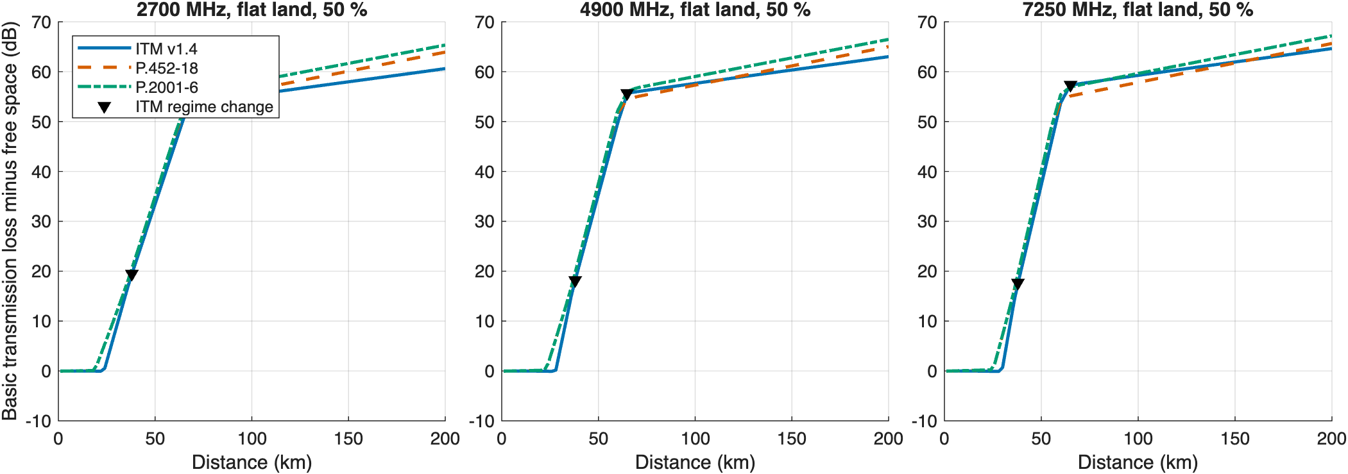
Figure 1. Basic transmission loss minus free-space loss on flat land, 50% of time, 30 m and 10 m antennas. Triangles mark ITM's regime changes.

Single knife edge
With 100 m antennas on a 20 km path, so that the smooth-earth term is small, all three models track the shape of the ITU-R P.526 knife-edge function J(v) but add loss beyond it (Figure 2). Their mean absolute difference from J(v) for v ≥ 0 is 7.0 dB for ITM and 10.2 dB for P.2001 at 2.7 GHz, and 12.0 dB and 10.4 dB at 7.25 GHz (Figure 3). ITM's difference grows with frequency; the ITU models' difference doesn't. This is a coarse check, not a validation: a single raised profile point is not a physical ridge.
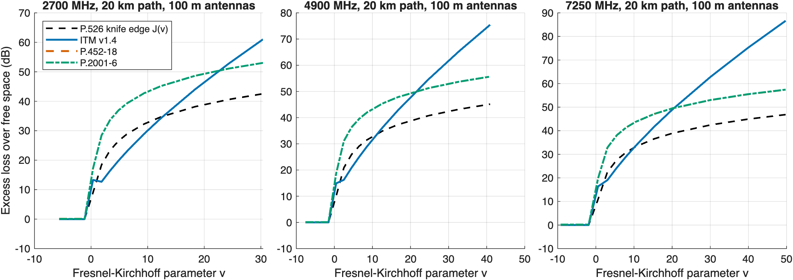
Figure 2. Excess loss over free space for one knife-edge obstacle at the middle of a 20 km path with 100 m antennas, against the P.526 function J(v).
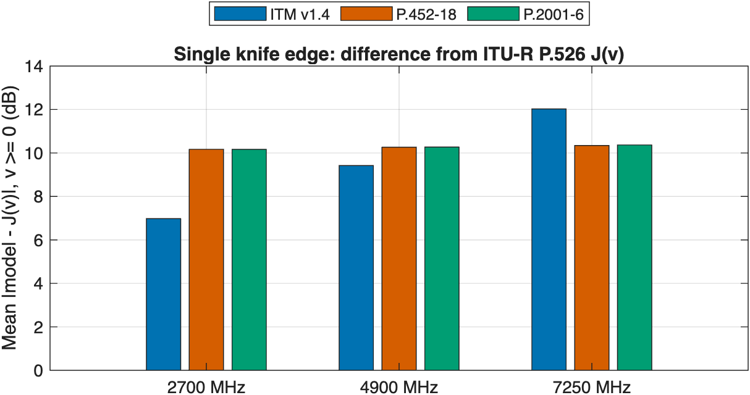
Figure 3. Mean absolute difference from J(v) for v ≥ 0, by model and frequency.

Real terrain by mechanism
On 60 real-terrain links the ITU models agree with ITM on line-of-sight links and fall far below it on diffraction and troposcatter links (Figure 4). The median P.2001 minus ITM difference on diffraction links is -30.6 dB at 2.7 GHz, -37.5 dB at 4.9 GHz, and -47.9 dB at 7.25 GHz; the largest single-link difference is 102 dB. P.2001 and P.452 agree with each other within 0.02 dB at the median in every class.
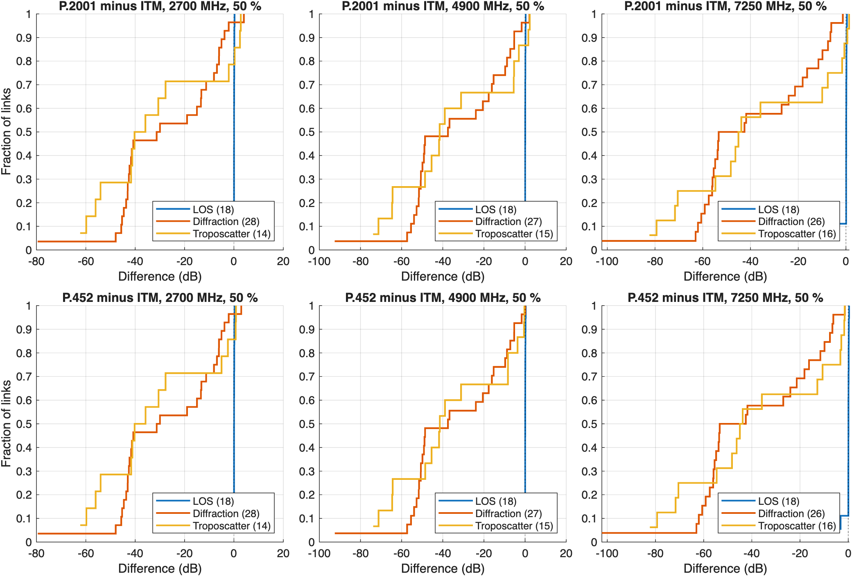
Figure 4. Distribution over links of the difference from ITM at 50% of time, by ITM's mechanism class. Top: P.2001 minus ITM. Bottom: P.452 minus ITM.
The gap tracks ITM's terrain irregularity Δh (Figure 5). Line-of-sight links average Δh = 23 m and sit near zero; diffraction links average 308 m, most of them in the Appalachian region.
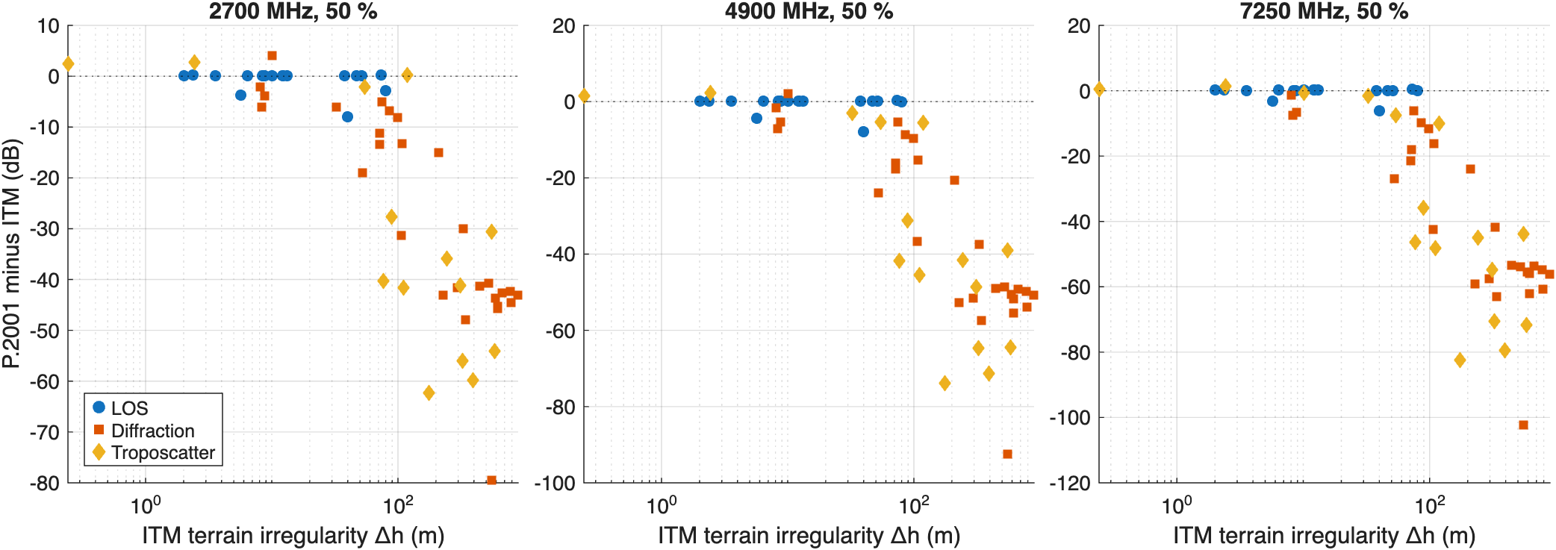
Figure 5. P.2001 minus ITM at 50% of time against ITM's terrain irregularity Δh, by ITM mechanism class.

Terrain resolution
Terrain resolution does not explain the gap (Figure 6). Resampling the diffraction links at 2.7 GHz from 30 m to 90 m changed the median loss by -0.02 dB for ITM and -0.04 dB for P.2001. Smoothing over 1 km lowered every model's loss by 3 dB to 4 dB and left the gap almost unchanged.
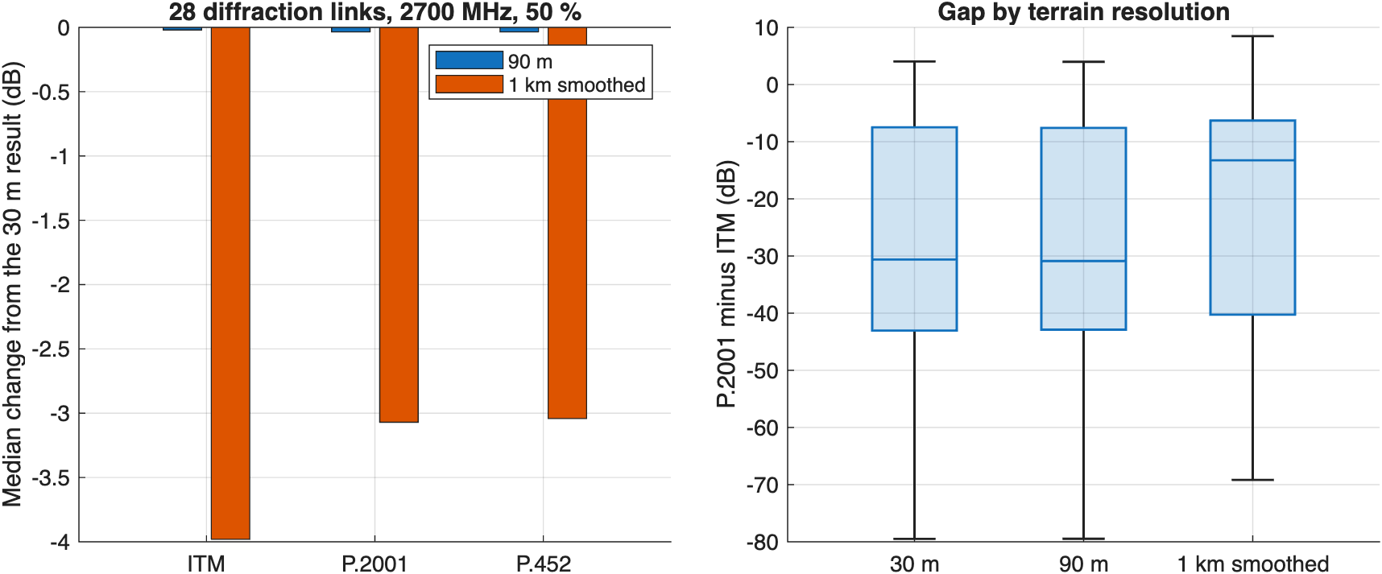
Figure 6. Left: median change in loss when the 30 m profile is resampled at 90 m or smoothed over 1 km. Right: the P.2001 minus ITM gap at each resolution.

Frequency and antenna height
Across 100 MHz to 10 GHz, the line-of-sight archetype stays within a few dB in every model, while ITM's excess loss on the diffraction archetypes grows faster with frequency than the ITU models' (Figure 7). The trend is smooth with frequency, so results at the three calculation frequencies carry over to the frequencies between them.
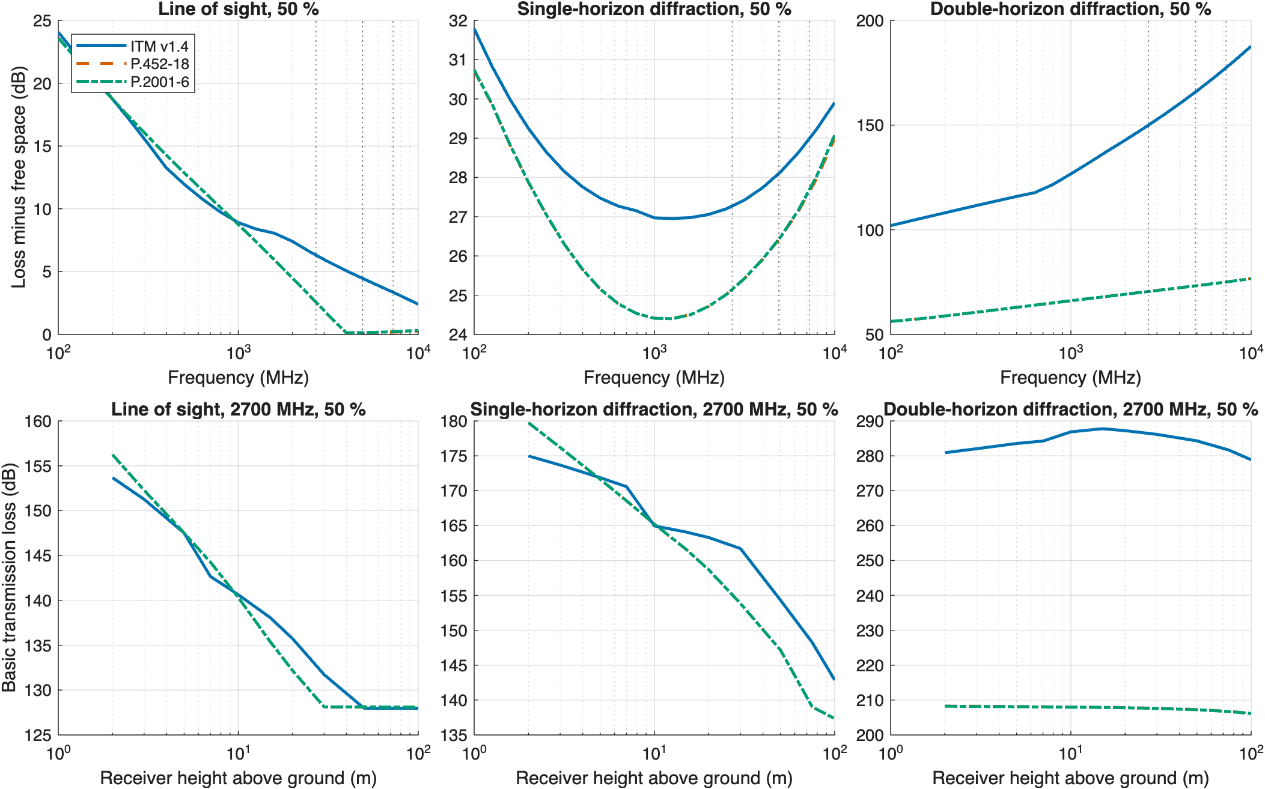
Figure 7. Top: loss minus free space against frequency at 50% of time; dotted lines mark 2.7 GHz, 4.9 GHz, and 7.25 GHz. Bottom: loss against receiver height at 2.7 GHz.

Elevation angles and a steep-horizon case
The models compute nearly the same elevation angles at each terminal: P.2001 differs from ITM by a mean of 0.00° at the transmitter and P.452 by 0.04°. The loss differences don't come from horizon geometry; they come from what each model does with it.
The deepest diffraction archetype, a 65 km Appalachian path, shows how far ITM can depart. ITM predicts 287.3 dB at 2.7 GHz and 50% of time; P.2001 predicts 207.8 dB. The receiver sits below a 395 mrad (22.6°) horizon 0.63 km away, beyond ITM's small-angle approximations, which ITM flags; 4 of 60 sample links carried that flag. MathWorks' Longley-Rice returns 287.30 dB on the same profile, which rules out a porting error.

Why ITM's diffraction loss is higher
The diffraction gap is the largest difference in this paper and the one most likely to change an analysis result, so this section takes ITM's diffraction loss apart. The calculation recomputes ITM's terms with ITM's own equations on every real-terrain diffraction link, checks that they reproduce ITM's reference attenuation to 10⁻⁹ dB, and compares them with the delta-Bullington terms of P.452 on the same profile.

The terms
Figure 8 shows the terms. Three features stand out:
- Two edges instead of one. ITM's knife-edge term A_k adds a Fresnel loss at each horizon, and each edge sees the full bending angle θ = d/aₑ − θ_los. Delta-Bullington builds one equivalent edge. On double-horizon paths, ITM's A_k at d₃ is typically well above P.452's Bullington loss on the same profile (left panel).
- Little weight on smooth earth. The weight w falls as Δh·f grows. On these links the median w at 2.7 GHz is 0.10, so the knife-edge term carries most of the loss (center panel). At 7.25 GHz the median w is 0.09.
- A clutter term. A_fo adds a median 12.2 dB at 2.7 GHz and 14.9 dB at 7.25 GHz. Delta-Bullington has no counterpart; P.452 treats clutter separately, through its ground-cover heights.
ITM evaluates these terms at d₃ and d₄, both beyond the horizon distances, and extends the line through them toward the path. On 24 of 28 diffraction links at 2.7 GHz the path is shorter than ITM's smooth-earth horizon distance d_sML, so ITM doesn't use the line at the path directly: it interpolates between its two-ray line-of-sight loss and the line's value at d_sML. That interpolation lowers ITM's loss below its value at d₃, which is the negative light-gray bar in the right panel. Even so, the knife-edge and clutter terms carried into the interpolation keep ITM's loss far above delta-Bullington's.
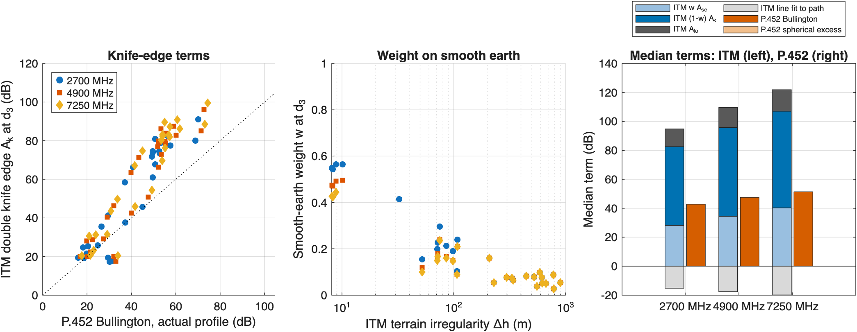
Figure 8. ITM's diffraction terms on the real-terrain diffraction links. Left: ITM's double knife edge A_k at d₃ against P.452's Bullington loss on the actual profile. Center: ITM's smooth-earth weight w against Δh. Right: median terms by frequency, ITM (left bar) and P.452 (right bar).

Removing one ingredient at a time
Figure 9 removes ITM's ingredients one at a time and reports the median gap between ITM's reference attenuation and P.452's diffraction loss. At 2.7 GHz the median gap is 30.7 dB as ITM stands. Using one edge instead of two leaves 7.7 dB; removing the clutter term leaves 18.6 dB; evaluating A_d at the path instead of through the d₃-d₄ line leaves 20.0 dB; and all three together leave -8.7 dB. At 7.25 GHz the corresponding values are 48.2 dB, 17.8 dB, 33.7 dB, 33.7 dB, and -6.8 dB.
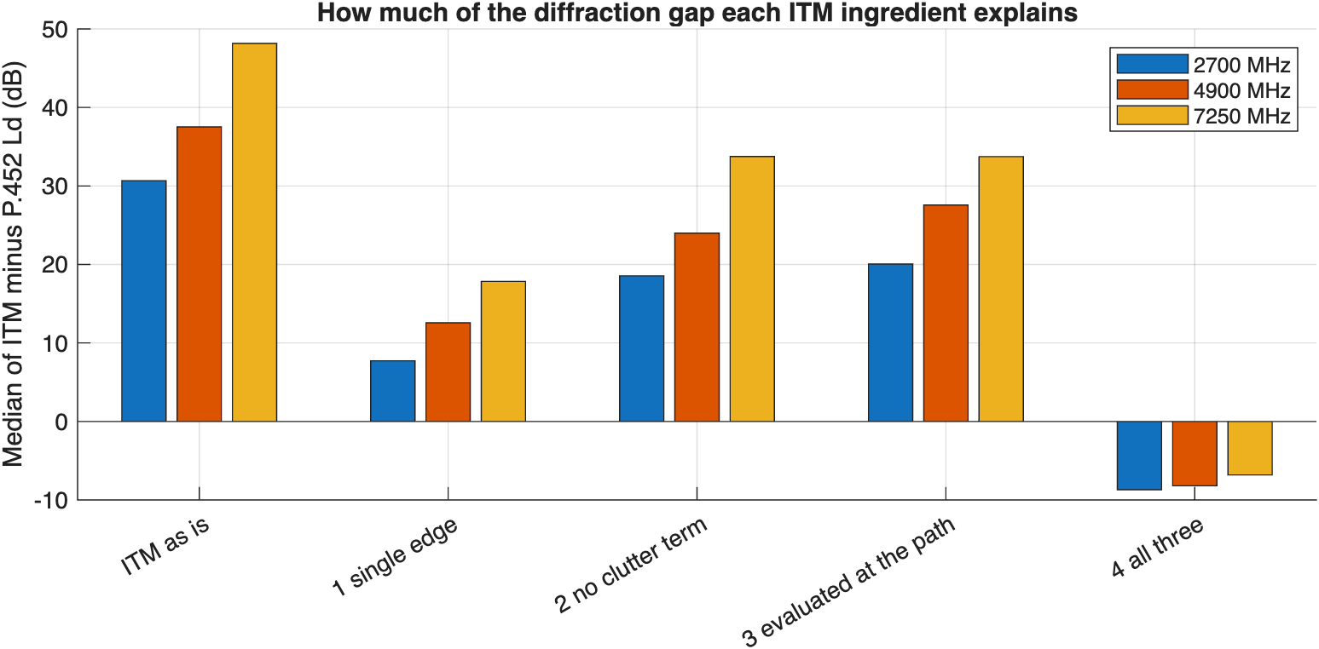
Figure 9. Median of ITM's reference attenuation minus P.452's diffraction loss, as ITM stands and with one ingredient removed at a time.
The double knife edge is the largest single ingredient: it accounts for about 23 dB of the 30.7 dB median gap at 2.7 GHz and about 30 dB of 48.2 dB at 7.25 GHz. The clutter term accounts for about 12 dB to 15 dB. With all three removed, ITM falls below delta-Bullington by a few dB, so the three ingredients more than explain the gap.
These changes are diagnostic, not proposed fixes: ITM's terms were fitted to measurements as a set, and removing one changes how the others fit. The point is to locate where the models part ways, so that measurements can test those specific terms.

Results over the time distribution
Figure 10 shows the loss over the time distribution on five archetype paths at 2.7 GHz, with ITM's 10% to 90% confidence band, and Figure 11 summarizes the values at 50% and 1% of time and the spread. Three patterns stand out:
- Low tail. On the troposcatter and over-sea paths the ITU models fall steeply below about 10% of time, where ducting takes over. At 1% of time on the 127 km over-sea path, P.2001 predicts 136.7 dB, 6.4 dB below free-space loss; ITM predicts 172.0 dB.
- Spread. ITM's spread from 1% to 99% is 3.9 dB on the line-of-sight path and 34.3 dB on the troposcatter path; P.2001's spreads are 13.3 dB and 78.9 dB.
- High tail. On the line-of-sight path P.2001 rises steeply above 99% of time from clear-air and rain fading; ITM's curve stays nearly flat.
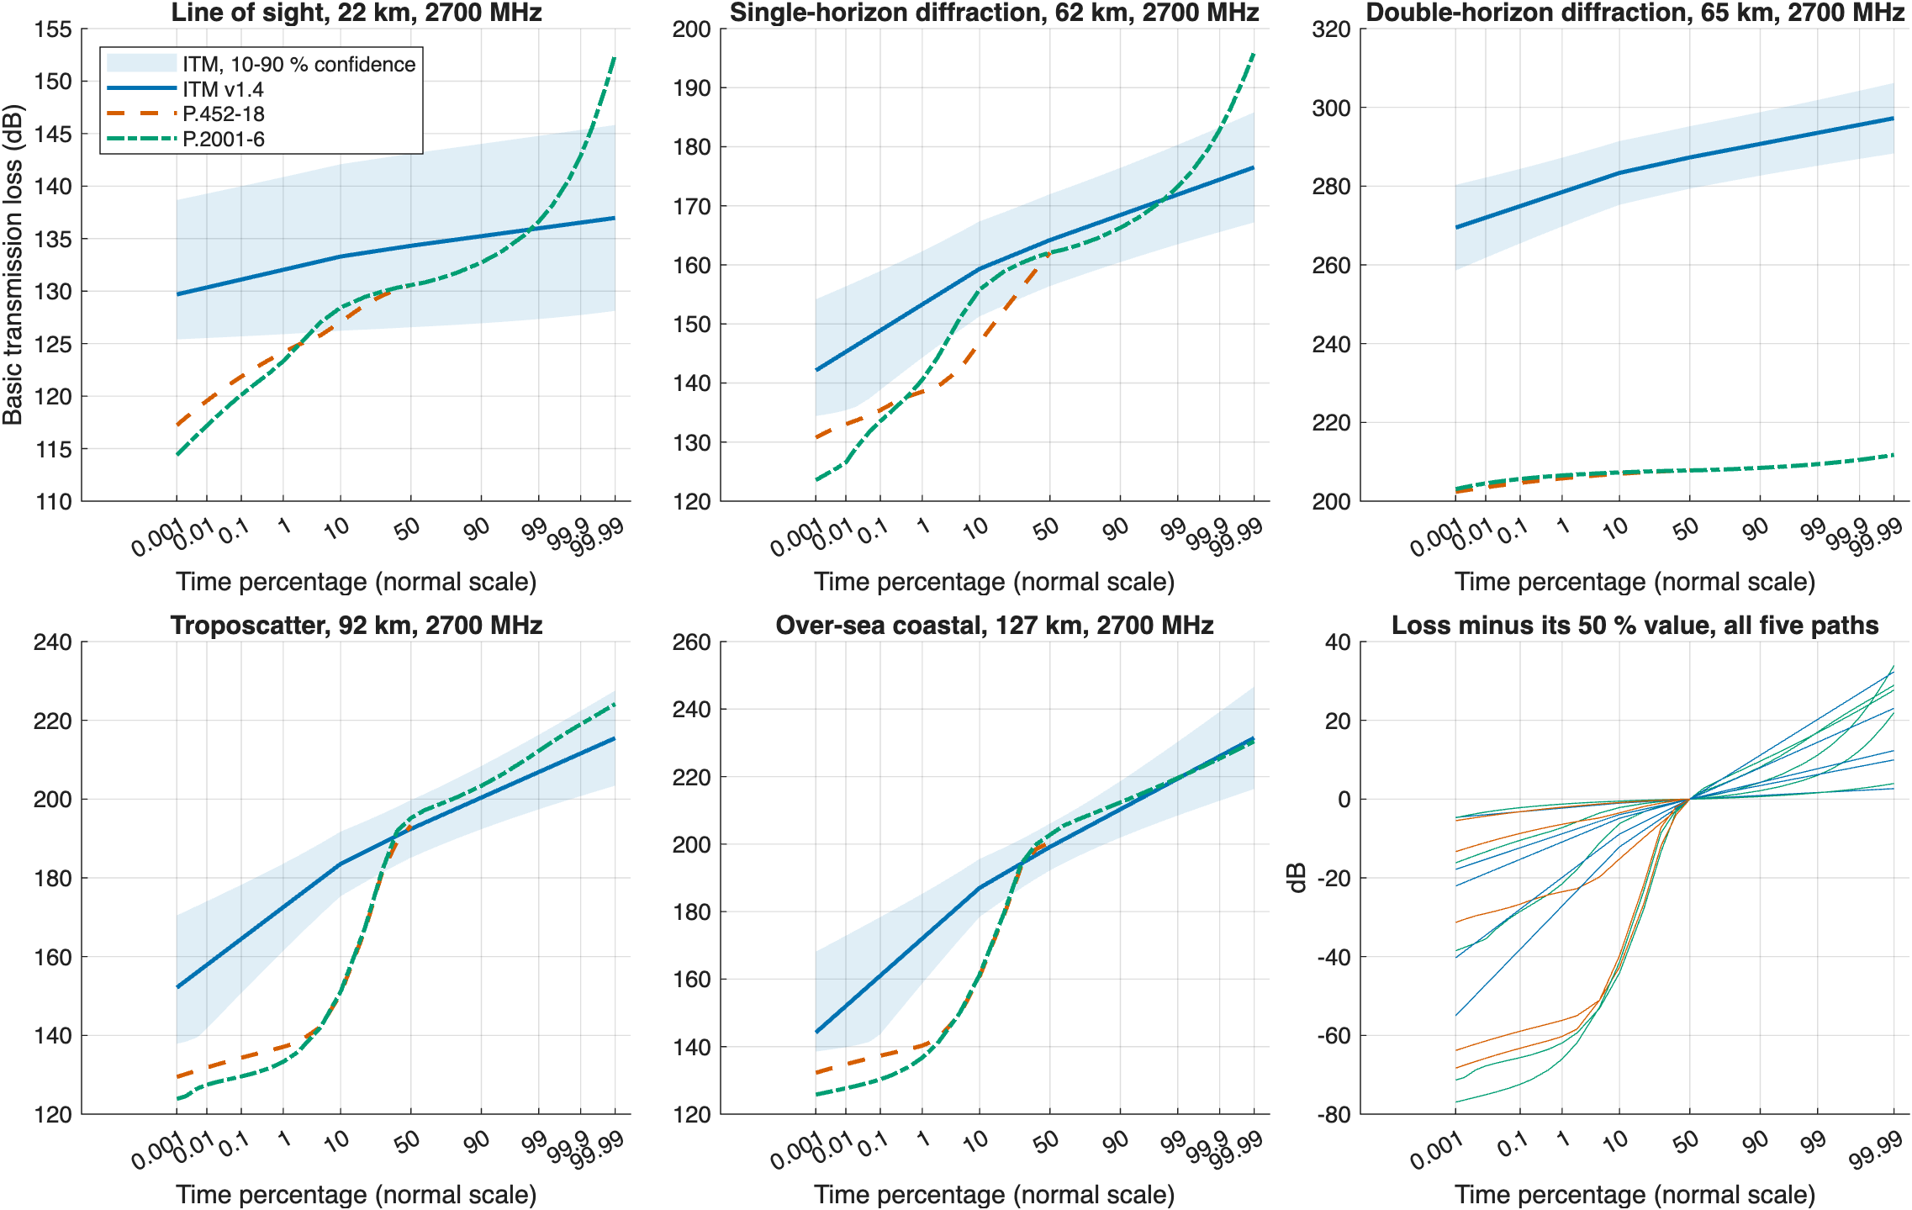
Figure 10. Basic transmission loss against time percentage on five archetype paths at 2.7 GHz. The shaded band is ITM's 10% to 90% confidence range. The last panel shows each curve minus its 50% value.
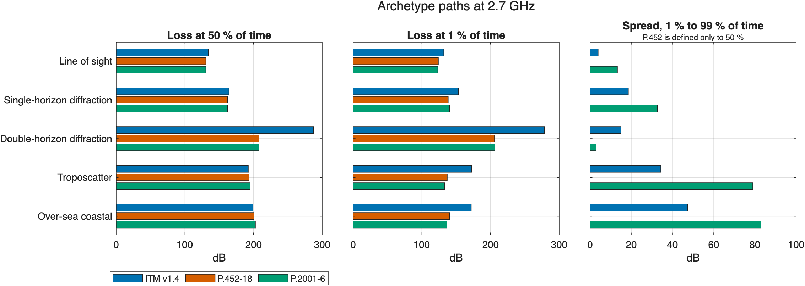
Figure 11. Archetype paths at 2.7 GHz: loss at 50% and 1% of time, and the spread from 1% to 99%.

Which mechanism dominates
Figure 12 maps the dominant P.2001 and P.452 sub-model over distance and time percentage on smooth earth, with ITM's regime as a strip at the top, and Figure 13 shows the dominant P.2001 sub-model along the distribution for each archetype path.
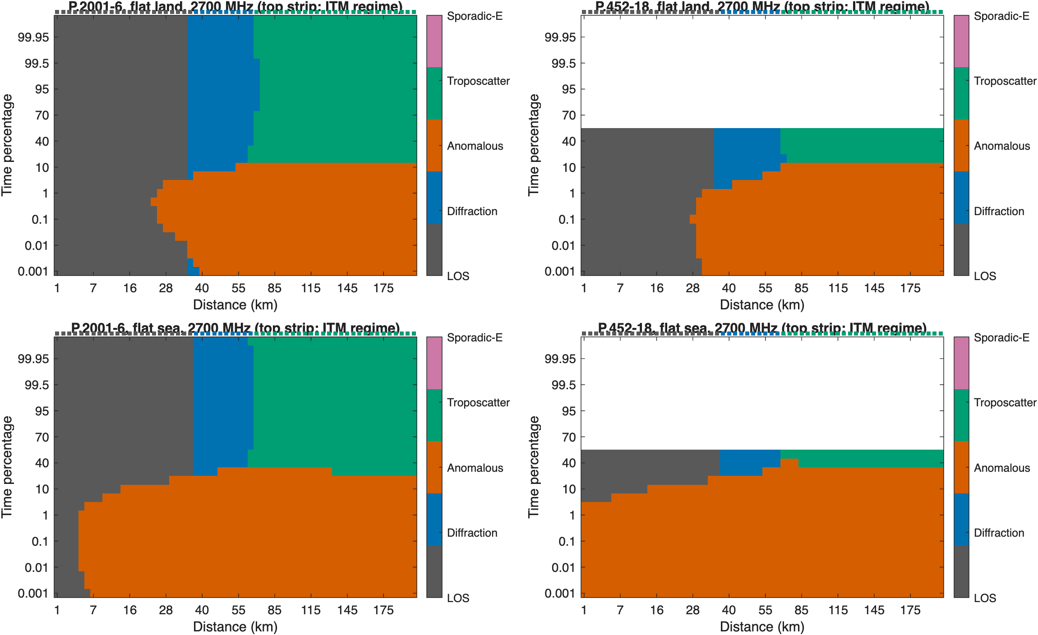
Figure 12. Dominant mechanism of P.2001 and P.452 over distance and time percentage, flat land and flat sea, 2.7 GHz. The top strip shows ITM's regime.
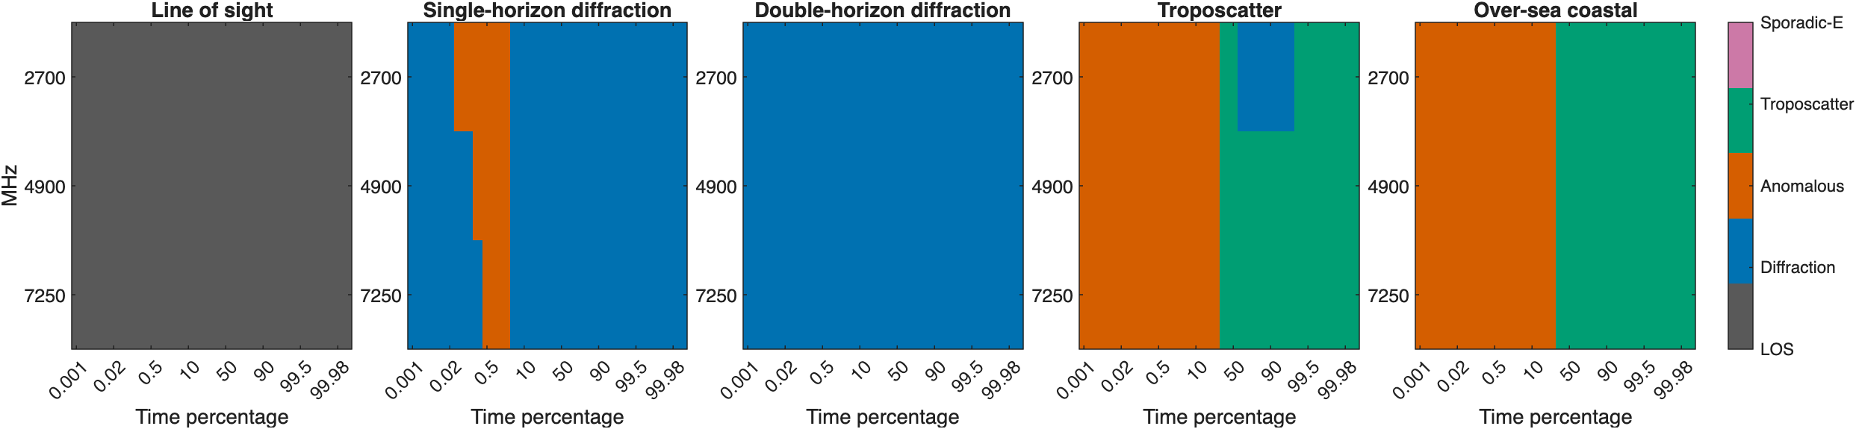
Figure 13. Dominant P.2001 sub-model against time percentage for each archetype path and calculation frequency.

Across all real-terrain links
Over all 60 links at 2.7 GHz, the median P.2001 minus ITM difference is -20.7 dB at 0.01% of time, -20.6 dB at 1%, -9.7 dB at 50%, and -7.8 dB at 99.9% (Figure 14).
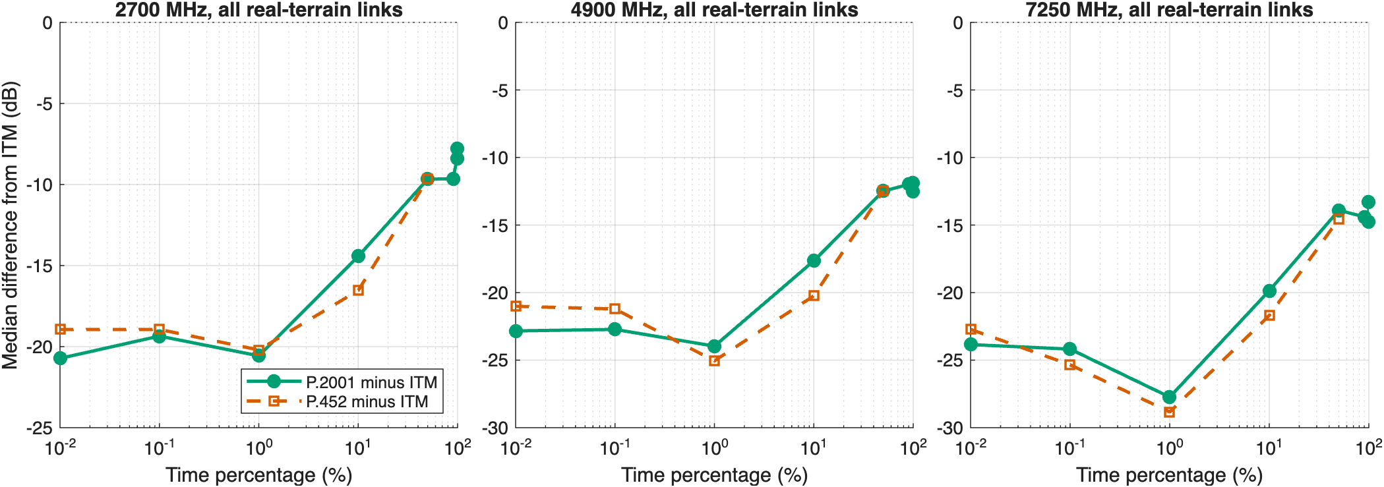
Figure 14. Median difference from ITM over all real-terrain links against time percentage. P.452 is defined only up to 50%.

Comparison with measurements

The data
The paper compares the models with Table III of the ITU-R Study Group 3 databank (DBSG3), clear-air trans-horizon basic transmission loss, which ITU-R distributes free. Its long-term data hold 1,124 measured distributions on 747 paths from 38 MHz to 30 GHz in North America, Europe, Japan, and elsewhere. Each dataset gives the site coordinates, antenna heights, frequency, and the attenuation relative to free space not exceeded for 0.01% to 99.99% of the time, and 397 of the paths have a terrain profile surveyed from maps.
From 30 MHz to 10 GHz, 608 datasets have both site coordinates, both antenna heights, a measured median, and loss given relative to free space, and 577 of them have a surveyed profile (Figure 15). Measured basic transmission loss is free-space loss at the listed distance plus the listed attenuation. Coordinates in Japan, which the databank gives on the old Tokyo datum, were converted to WGS84.
The databank includes the paths that Longley, Reasoner, and Fuller compiled in OT/TRER 16. As a check, the medians of 10 paths read independently from that report's page images match the databank exactly.
These data are not an independent test of any of the models. ITU-R used the databank to develop and test P.452 and P.2001, and ITM's developers used many of the same U.S. measurements. The comparison shows how the models perform on the data they were built from, which is still the best public evidence on how they differ.
Other public sources were checked and don't meet the need: recent ITS troposcatter work at 3.475 GHz in Colorado reports results but not a public dataset; NIST measurements at 4.9 GHz and 7 GHz are short urban links dominated by clutter; and NTIA Report TR-22-561 is at 37 GHz.
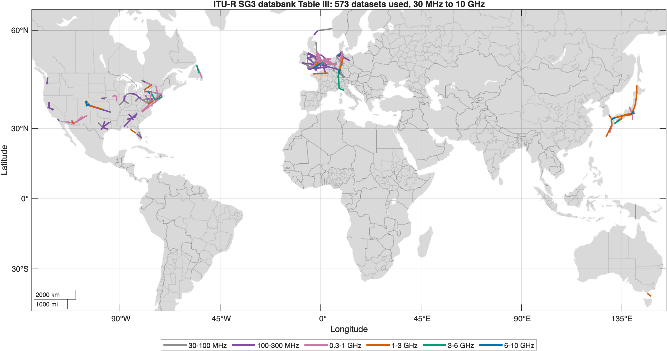
Figure 15. The databank datasets used in the comparison, colored by frequency.

Terrain and site locations
Old site coordinates are the weak point of these data. Many sites are on hilltops, and coordinates from 1950s and 1960s maps, often on local datums, can sit a few hundred meters off the summit. On a 30 m terrain model, the antenna then sits below a ridge right next to it. A first run on 30 m terrain at the listed coordinates showed this on about 20 of 75 paths outside the U.S.; on one 18.8 km path in Japan measured at 139 dB, ITM predicted 236 dB. Those results are not in this paper.
The comparison uses two remedies:
- Surveyed profiles (main results). All three models run on the databank's own surveyed profiles, resampled to uniform spacing. These profiles put each terminal at its surveyed site elevation. Datasets without a surveyed profile are left out.
- 30 m terrain with site correction (check). From 1 GHz to 10 GHz, the models also run on 30 m terrain. Each terminal moves to the 30 m terrain point within 500 m whose elevation best matches the surveyed site elevation.
A quality screen leaves out datasets whose listed distance and coordinates disagree by more than 3% (13 datasets), whose surveyed profile length and listed distance disagree by more than 5% (1), or that have no surveyed profile (31). On the 30 m terrain check, it also leaves out datasets whose corrected terminals still differ from the surveyed elevation by more than 20 m, or whose terrain puts a horizon within 500 m of a terminal at more than 30 mrad. 573 of 608 datasets remain in the main comparison.
Figure 16 shows what the site correction and the terrain source do on the 114 datasets from 1 GHz to 10 GHz that both runs kept. For ITM, the RMS error in the median is 25.3 dB on 30 m terrain at the listed coordinates, 38.0 dB with corrected sites, and 10.7 dB on the surveyed profiles; for P.2001 the values are 18.4 dB, 38.2 dB, and 9.0 dB.
The site correction made the errors larger, not smaller. Matching the surveyed elevation within 500 m brings each terminal to the right height (left panel), but on a mountainside many points share that height, and the nearest one is often on a different slope, behind terrain that the real site cleared. The Cheyenne Mountain site in Colorado is the clearest case: moving it 263 m to match its surveyed elevation added about 100 dB of diffraction loss on several paths. On hilltop sites in Japan and Germany, the elevation already matched at the listed coordinates, yet the 30 m terrain still put a ridge next to the antenna. Recovering these sites would take the original site descriptions, not an elevation match. The surveyed profiles avoid the problem, which is why they carry the main results.
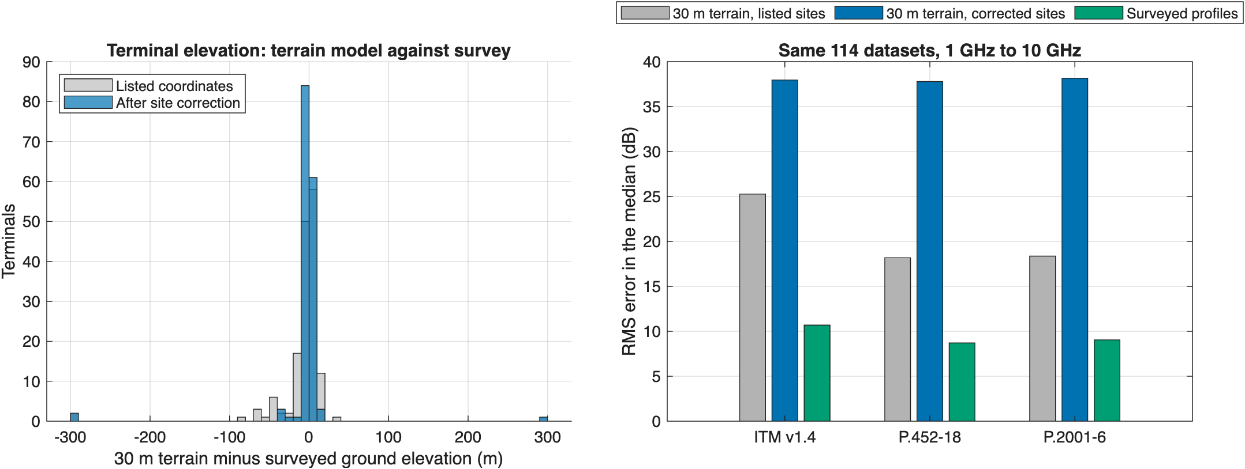
Figure 16. Left: 30 m terrain minus surveyed ground elevation at each terminal, at the listed coordinates and after the site correction. Right: RMS error in the median on the same datasets for 30 m terrain at the listed sites, 30 m terrain with corrected sites, and the surveyed profiles.

Results at the median
Figure 17 shows each model's error in the median against frequency, and Figure 18 summarizes it by frequency band. A positive error means the model predicts more loss than was measured. From 1 GHz to 10 GHz (118 datasets), the mean error is 0.5 dB for ITM, -1.8 dB for P.452, and -0.6 dB for P.2001, and the RMS error is 10.8 dB for ITM, 8.7 dB for P.452, and 9.1 dB for P.2001. From 30 MHz to 1 GHz (455 datasets), the mean error is -2.9 dB for ITM, -3.4 dB for P.452, and -3.3 dB for P.2001, and the RMS error is 9.9 dB for ITM, 8.6 dB for P.452, and 8.8 dB for P.2001. P.452 starts at 100 MHz, so its values below 1 GHz cover 100 MHz to 1 GHz only. All three models are close to unbiased at the median from 1 GHz to 10 GHz, and the ITU models scatter about 2 dB less than ITM. Below 1 GHz, all three predict about 3 dB less loss than was measured.
By band, the mean errors from 1 GHz to 3 GHz (73 datasets) are -1.2 dB for ITM, -1.7 dB for P.452, and 0.0 dB for P.2001; from 3 GHz to 6 GHz (19) -2.2 dB for ITM, -1.1 dB for P.452, and -0.6 dB for P.2001; and from 6 GHz to 10 GHz (26) 7.1 dB for ITM, -2.5 dB for P.452, and -2.4 dB for P.2001. ITM's bias from 6 GHz to 10 GHz, with an RMS error of 14.9 dB against about 10 dB for the ITU models, matches the direction of the diffraction gap in the calculations: ITM's extra loss grows with frequency. It is much smaller than the 30 dB to 48 dB median gap on the mid-Atlantic diffraction links because few of the databank paths are rough-terrain diffraction paths. The short 7,273 MHz path between Fuchu and Zama, Japan, is one that is: ITM predicts about 30 dB too much loss there, while the ITU models are within 8 dB (Figure 20).
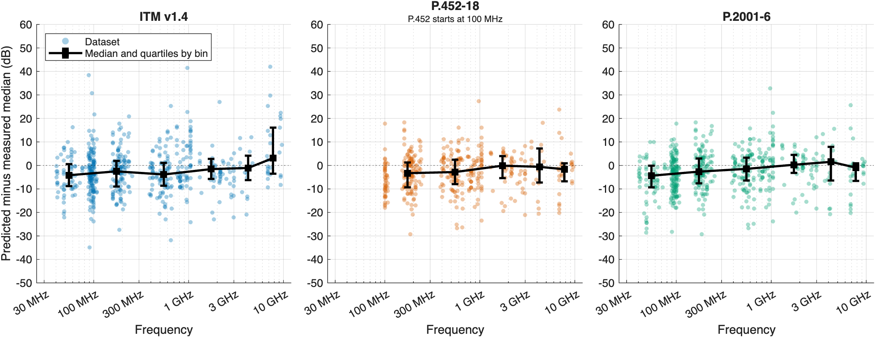
Figure 17. Predicted minus measured median basic transmission loss on each databank dataset against frequency, with the median and quartiles in each frequency band.
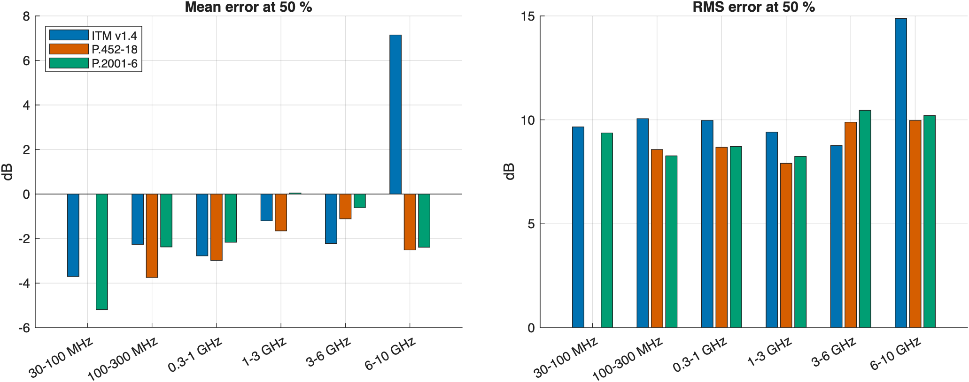
Figure 18. Mean and RMS error in the median by frequency band.

Results over the time distribution
Figure 19 shows the mean error at 1%, 10%, 50%, 90%, and 99% of time in each band, and Figure 20 compares the whole distribution on six datasets from 1 GHz to 10 GHz. From 1 GHz to 10 GHz, the mean error at 1% of time is 0.1 dB for ITM, -8.8 dB for P.452, and -7.7 dB for P.2001; at 99% it is 1.6 dB for ITM and 0.6 dB for P.2001. The ITU models predict too little loss at small time percentages, by 16 dB on average at 1% of time from 3 GHz to 6 GHz (19 datasets): their ducting term enhances the signal more than was measured. ITM, which has no ducting term, is closer at 1% from 1 GHz to 6 GHz, but predicts too much loss at 1% from 6 GHz to 10 GHz.
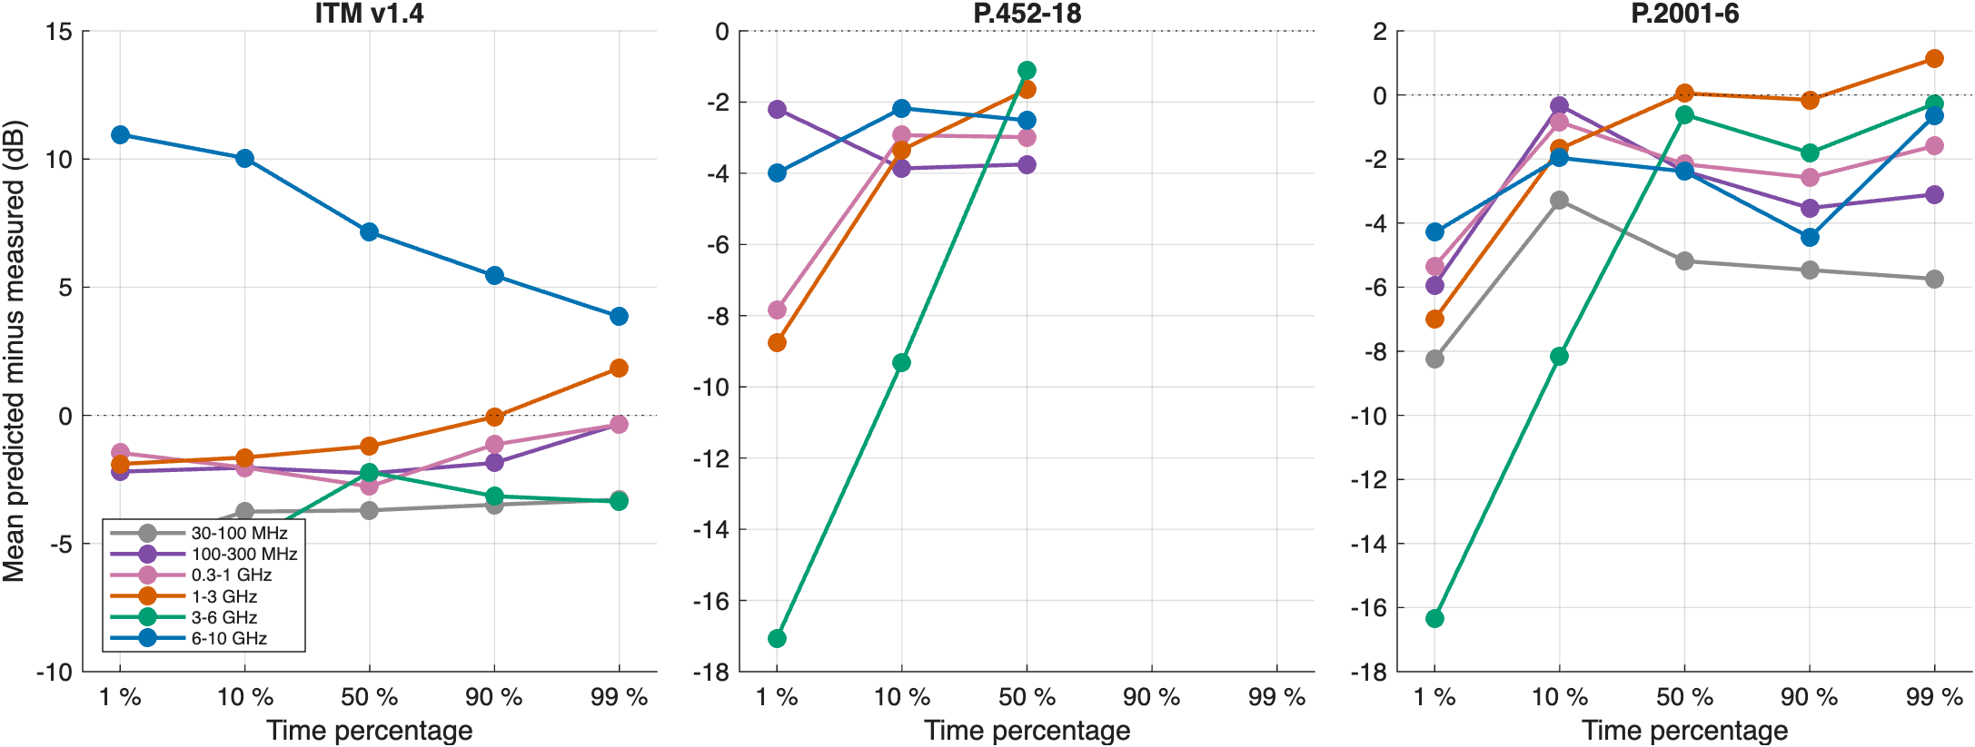
Figure 19. Mean predicted minus measured basic transmission loss by time percentage and frequency band. P.452 is defined only up to 50%.
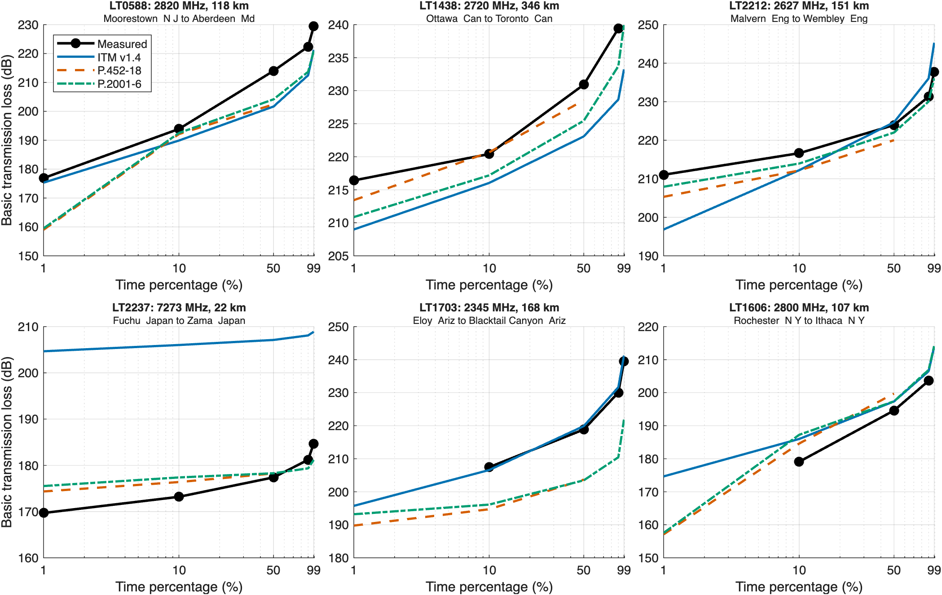
Figure 20. Measured and predicted distributions of basic transmission loss on six databank datasets from 1 GHz to 10 GHz.

Terrain irregularity
Figure 21 plots the error in the median against ITM's terrain irregularity Δh. It tests whether ITM's extra diffraction loss on rough terrain, found in the calculations above, shows up in the measurements.
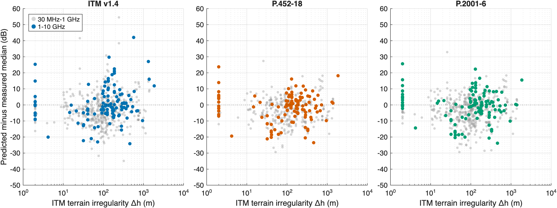
Figure 21. Predicted minus measured median against ITM's terrain irregularity Δh, from 1 GHz to 10 GHz (colored) and 30 MHz to 1 GHz (gray).
These comparisons rest on measurements from the 1940s to the 1970s, mostly on long trans-horizon paths, with few datasets above 3 GHz. They can show whether a model is biased on such paths; they can't settle which model is right for short, rough-terrain paths in a particular region.

What the differences mean in distance
On smooth earth the differences barely move a separation distance: for thresholds from 150 dB to 180 dB, the three models reach the threshold within a few kilometers of each other (Figure 22), because the steep diffraction slope beyond the radio horizon makes distance insensitive to a few dB.
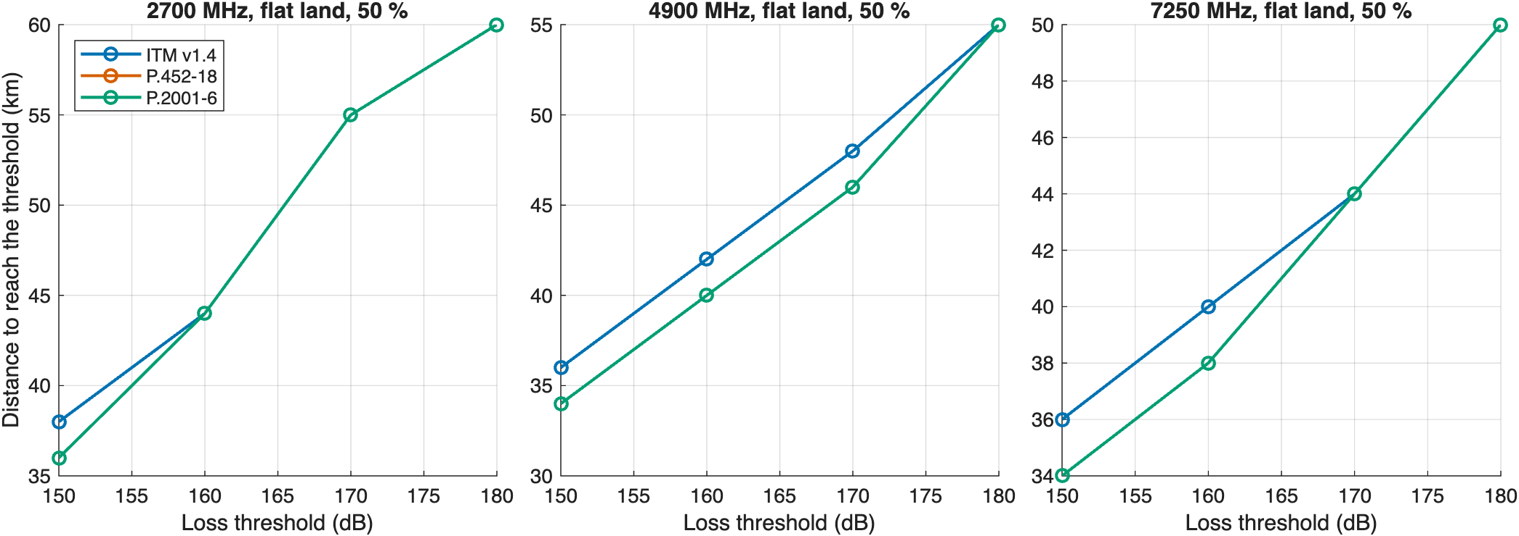
Figure 22. Distance at which the 50% loss first reaches each threshold on flat land.
Over real terrain the picture changes (Figure 23). Along four radials from a piedmont site, ITM's higher diffraction loss lets it reach a threshold at shorter distances where terrain blocks the path, so ITM gives smaller protection distances there. The radial distances are in table_radial_distance_to_threshold.csv.
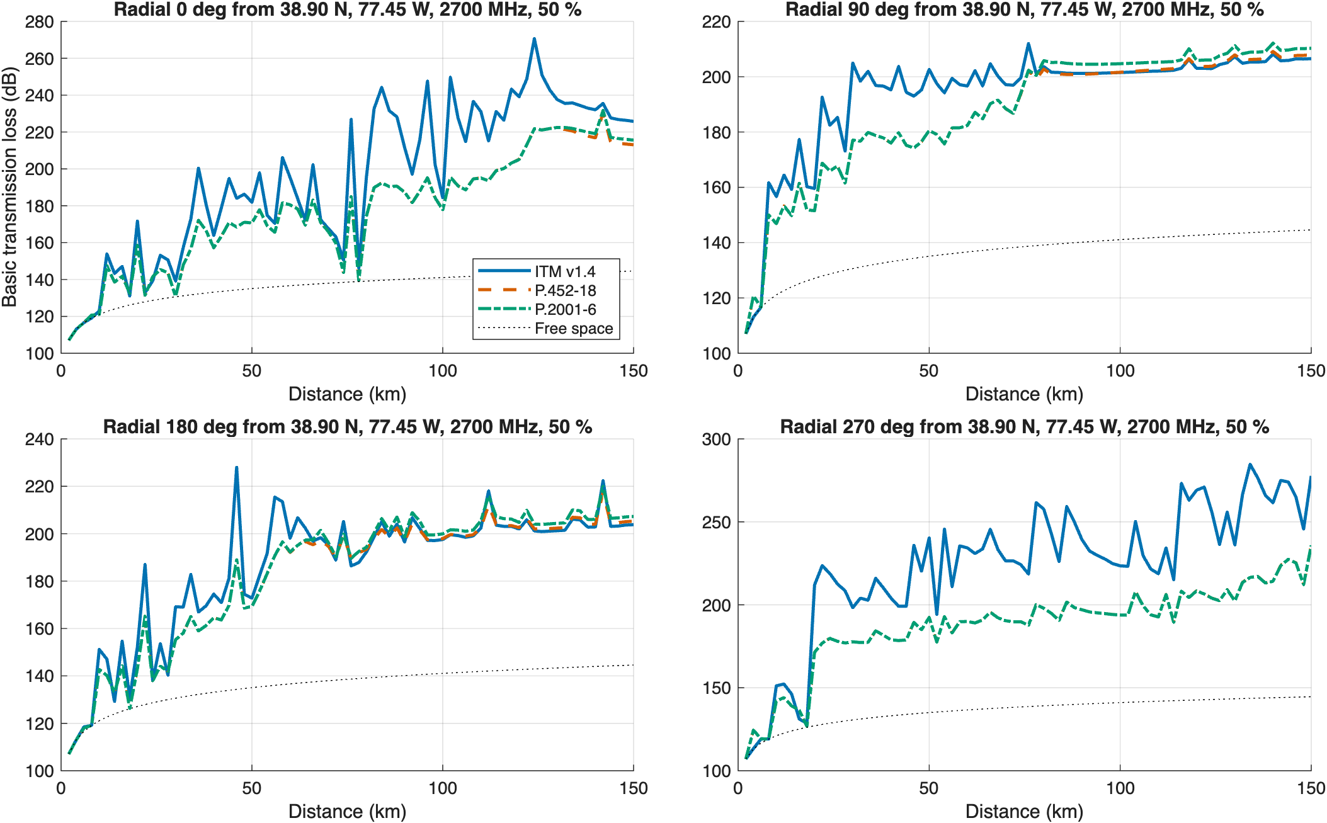
Figure 23. Loss along four radials from 38.90° N, 77.45° W at 2.7 GHz and 50% of time, with free-space loss for reference.

What the comparison means for analyses
These points are preliminary and follow from the calculations above:
- Line of sight: the choice of model matters little. At the median the three models agree within a fraction of a dB on line-of-sight links from 2.7 GHz to 7.25 GHz.
- Diffraction over rough terrain: the choice matters most, and more at higher frequencies. The median gap between ITM and the ITU models grows from about 31 dB at 2.7 GHz to about 37 dB at 4.9 GHz and 48 dB at 7.25 GHz. An analysis that uses ITM on rough terrain computes smaller separation distances at the median than one that uses P.452 or P.2001.
- Small time percentages: the choice matters through ducting. The ITU models' ducting term gives much less loss than ITM at 1% of time and below, so an analysis that uses them computes larger separation distances at those percentages, especially over water and on long paths.
- Measurements from 1 GHz to 3 GHz. On 73 databank datasets, the mean error in the median is -1.2 dB for ITM, -1.7 dB for P.452, and 0.0 dB for P.2001, and at 1% of time it is -1.9 dB for ITM, -8.8 dB for P.452, and -7.0 dB for P.2001. A negative error at 1% means the model overstates the loss enhancement at small time percentages, which would overstate interference.
The differences are large enough to change an analysis outcome, so the model choice should be stated, justified, and tested for sensitivity.

Where to look deeper
These calculations point to the following questions, in priority order:
- Which diffraction prediction is right over rough terrain from 1 GHz to 10 GHz? The gap is 30 dB to 48 dB at the median on diffraction links and grows with frequency. The decomposition points to three testable ITM ingredients: the double knife edge, the clutter term, and the extended diffraction line. Measurements on rough-terrain diffraction paths across the range would test them directly.
- Should NTIA measure from 3 GHz to 10 GHz? The databank has few usable datasets above 3 GHz, most of them outside the U.S. A short campaign on a few diffraction and troposcatter paths, such as ITS's Table Mountain capability already supports at 3.475 GHz, would anchor the comparison across the upper part of the range.
- Do aggregate-interference results depend on ducting? The ITU models predict about 20 dB less loss than ITM at 0.01% to 1% of time on the real-terrain sample, from a mechanism ITM lacks.
- How should analyses treat ITM on steep horizons? ITM flagged horizon angles above 200 mrad on 4 of 60 links. Analyses that use ITM should decide whether to exclude, cap, or replace such links, and record the flag.
- Do availability results depend on fading? P.2001's high tail includes rain and clear-air fading that ITM and P.452 omit.
- How large are the regional effects? The real-terrain sample covers three mid-Atlantic regions. Western terrain may change the size of the gap.
- How much does ground cover change P.452? P.452-18 can take a ground-cover profile, which can move its loss by several dB.

Limitations
- The real-terrain sample is small: 60 links in three mid-Atlantic regions and five archetype paths.
- The measurements are old, mostly long trans-horizon paths, and sparse above 3 GHz, and the models' developers used many of them.
- Each model ran with defaults this paper chose (ITM ground constants, variability mode 13, 50% confidence, no P.452 clutter). Other choices change the results.
- The knife-edge test uses a single raised profile point; treat it as a coarse check.
- All results are basic transmission loss with isotropic antennas. Clutter, building entry loss, and antenna patterns are not included.

References
- A. G. Longley and P. L. Rice, Prediction of Tropospheric Radio Transmission Loss over Irregular Terrain: A Computer Method-1968, ESSA Technical Report ERL 79-ITS 67, 1968.
- P. L. Rice, A. G. Longley, K. A. Norton, and A. P. Barsis, Transmission Loss Predictions for Tropospheric Communication Circuits, NBS Technical Note 101, revised 1967.
- A. G. Longley, R. K. Reasoner, and V. L. Fuller, Measured and Predicted Long-Term Distributions of Tropospheric Transmission Loss, OT/TRER 16, Office of Telecommunications, July 1971. https://its.ntia.gov/publications/download/OT-TRER-16.pdf
- NTIA Institute for Telecommunication Sciences, Irregular Terrain Model (ITM), version 1.4, C++ source. https://github.com/NTIA/itm
- Recommendation ITU-R P.2001-6, A general purpose wide-range terrestrial propagation model in the frequency range 30 MHz to 50 GHz.
- Recommendation ITU-R P.452-18, Prediction procedure for the evaluation of interference between stations on the surface of the Earth at frequencies above about 0.1 GHz.
- Recommendation ITU-R P.526-15, Propagation by diffraction.
- Recommendation ITU-R P.617, Propagation prediction techniques and data required for the design of trans-horizon radio-relay systems.
- Wireless Innovation Forum, Requirements for Commercial Operation in the U.S. 3550-3700 MHz Citizens Broadband Radio Service Band, WINNF-TS-0112.
- A. C. Hicks, J. D. Ewan, W. Kozma Jr., and M. G. Cotton, Measuring Tropospheric Propagation in the 21st Century, Proc. 2022 IEEE International Symposium on Electromagnetic Compatibility, Signal & Power Integrity, Spokane, Washington, August 2022, pp. 198-203. https://its.ntia.gov/publications/details?pub=3285
- A. C. Hicks, J. McLean, and J. D. Ewan, Preliminary Mid-Band Troposcatter Measurement Results Using Different High-Gain Receiver Antennas, 2024 USNC-URSI National Radio Science Meeting, Boulder, Colorado, January 2024, pp. 225-226. https://its.ntia.gov/publications/details?pub=4483
- D. W. Matolak, K. A. Remley, C. Gentile, C. L. Holloway, Q. Wu, and Q. Zhang, Ground-Based Urban Channel Characteristics for Two Public Safety Frequency Bands, NIST. https://www.nist.gov/system/files/documents/itl/antd/Ground-Based-Urban-Channel-Characteristics-for-Two-Public-Safety-Frequency-Bands.pdf
- T. T. Nguyen, N. Yoza Mitsuishi, and R. Caromi, Deep Learning for Path Loss Prediction at 7 GHz in Urban Environment, IEEE Access, 2023. doi:10.1109/ACCESS.2023.3264230
- NTIA Report TR-22-561, Outdoor Propagation Measurements. https://www.its.ntia.gov/publications/download/TR-22-561.pdf
- ITU-R Study Group 3 databanks (DBSG3), Table III, clear-air trans-horizon basic transmission loss statistics, long-term data. https://www.itu.int/oth/R0A04/en
- EPSG Geodetic Parameter Dataset, Tokyo to WGS 84 (1). https://epsg.io/63016405
- MathWorks, propagationModel, Antenna Toolbox documentation. https://www.mathworks.com/help/antenna/ref/propagationmodel.html
- U.S. Geological Survey, 3D Elevation Program (3DEP), 1 arc-second digital elevation models.

Appendix: reproducing the figures
Every figure comes from MATLAB code in the matlab_itm repository, folder docs/model_comparison. To reproduce them, do the following:
- Clone matlab_itm, itu_p2001, and matlab_itu_p452 into one folder.
- In MATLAB R2025b with Mapping Toolbox, add docs/model_comparison to the path and run, in order: make_wp_figures_rev1, make_wp_summary_figures_rev1, diffraction_decomposition_rev1, compare_dbsg3_rev1 (surveyed profiles), compare_dbsg3_rev1 with Terrain="dem", Download=false, MinFreq=1000, and Figures=false (the 30 m terrain check), and compare_dbsg3_terrain_rev1.
- Run node build_wp_docx_rev2.js in docs/model_comparison to rebuild this document from the figures and CSV tables.
The model code cited in the footnotes is pinned to these commits:
- matlab_itm: 03feac58ae3db28c2ae66226ae73109e61172a98
- itu_p2001: 286e68cbac94d616261f9cb514e94ec8f5464881
- matlab_itu_p452: 75e39de3a3177c95d40a38a1c0a2659a0ee8b28a
The measured data are data/dbsg3/dbsg3_tableiii_30mhz_10ghz.csv, built from the ITU-R databank download in data/dbsg3; the model results for every dataset are in figures/table_dbsg3_by_dataset_survey.csv.

A. G. Longley and P. L. Rice, Prediction of Tropospheric Radio Transmission Loss over Irregular Terrain: A Computer Method-1968, ESSA Technical Report ERL 79-ITS 67, 1968.
NTIA/ITS, Irregular Terrain Model (ITM), version 1.4, C++ source. https://github.com/NTIA/itm
ITM effective earth curvature: https://github.com/nicklasorte/matlab_itm/blob/03feac58ae3db28c2ae66226ae73109e61172a98/private/itm_p2p_core.m#L193-L197
P.452 median effective earth radius: https://github.com/nicklasorte/matlab_itu_p452/blob/75e39de3a3177c95d40a38a1c0a2659a0ee8b28a/p452_p2p_rev1.m#L126-L126
Wireless Innovation Forum, Requirements for Commercial Operation in the U.S. 3550-3700 MHz Citizens Broadband Radio Service Band, WINNF-TS-0112.
ITM diffraction blend and weight: https://github.com/nicklasorte/matlab_itm/blob/03feac58ae3db28c2ae66226ae73109e61172a98/private/itm_p2p_core.m#L469-L483
ITM diffraction line, d₃ and d₄: https://github.com/nicklasorte/matlab_itm/blob/03feac58ae3db28c2ae66226ae73109e61172a98/private/itm_p2p_core.m#L387-L392
P.452 delta-Bullington: https://github.com/nicklasorte/matlab_itu_p452/blob/75e39de3a3177c95d40a38a1c0a2659a0ee8b28a/p452_p2p_rev1.m#L474-L481
ITM troposcatter: https://github.com/nicklasorte/matlab_itm/blob/03feac58ae3db28c2ae66226ae73109e61172a98/private/itm_p2p_core.m#L566-L608
P. L. Rice, A. G. Longley, K. A. Norton, and A. P. Barsis, Transmission Loss Predictions for Tropospheric Communication Circuits, NBS Technical Note 101, revised 1967.
P.452 troposcatter, eq. (45): https://github.com/nicklasorte/matlab_itu_p452/blob/75e39de3a3177c95d40a38a1c0a2659a0ee8b28a/p452_p2p_rev1.m#L206-L209
P.2001 troposcatter: https://github.com/nicklasorte/itu_p2001/blob/286e68cbac94d616261f9cb514e94ec8f5464881/p2001_profile_rev1.m#L325-L330
P.452 ducting, eq. (47): https://github.com/nicklasorte/matlab_itu_p452/blob/75e39de3a3177c95d40a38a1c0a2659a0ee8b28a/p452_p2p_rev1.m#L192-L193
P.452 line of sight: https://github.com/nicklasorte/matlab_itu_p452/blob/75e39de3a3177c95d40a38a1c0a2659a0ee8b28a/p452_p2p_rev1.m#L170-L174
ITM time variability: https://github.com/nicklasorte/matlab_itm/blob/03feac58ae3db28c2ae66226ae73109e61172a98/private/itm_p2p_core.m#L756-L756
P.2001 sub-model 1: https://github.com/nicklasorte/itu_p2001/blob/286e68cbac94d616261f9cb514e94ec8f5464881/p2001_profile_rev1.m#L297-L306
ITM regime selection: https://github.com/nicklasorte/matlab_itm/blob/03feac58ae3db28c2ae66226ae73109e61172a98/private/itm_p2p_core.m#L400-L463
P.2001 combination: https://github.com/nicklasorte/itu_p2001/blob/286e68cbac94d616261f9cb514e94ec8f5464881/p2001_profile_rev1.m#L392-L400
P.452 combination, eq. (64): https://github.com/nicklasorte/matlab_itu_p452/blob/75e39de3a3177c95d40a38a1c0a2659a0ee8b28a/p452_p2p_rev1.m#L212-L212
Recommendation ITU-R P.526-15, Propagation by diffraction, 2019.
MathWorks, propagationModel (Antenna Toolbox) documentation, Longley-Rice model. https://www.mathworks.com/help/antenna/ref/propagationmodel.html
ITU-R Study Group 3 databanks (DBSG3), Table III, clear-air trans-horizon basic transmission loss statistics, long-term data. https://www.itu.int/oth/R0A04/en
Tokyo datum to WGS 84 transformation; see EPSG, Tokyo to WGS 84 (1). https://epsg.io/63016405
A. G. Longley, R. K. Reasoner, and V. L. Fuller, Measured and Predicted Long-Term Distributions of Tropospheric Transmission Loss, OT/TRER 16, Office of Telecommunications, July 1971. https://its.ntia.gov/publications/download/OT-TRER-16.pdf
A. C. Hicks, J. McLean, and J. D. Ewan, Preliminary Mid-Band Troposcatter Measurement Results Using Different High-Gain Receiver Antennas, USNC-URSI National Radio Science Meeting, Boulder, Colorado, January 2024. https://its.ntia.gov/publications/details?pub=4483
A. C. Hicks, J. D. Ewan, W. Kozma Jr., and M. G. Cotton, Measuring Tropospheric Propagation in the 21st Century, Proc. IEEE International Symposium on EMC, SI & PI, Spokane, Washington, August 2022, pp. 198-203. https://its.ntia.gov/publications/details?pub=3285
D. W. Matolak, K. A. Remley, C. Gentile, C. L. Holloway, Q. Wu, and Q. Zhang, Ground-Based Urban Channel Characteristics for Two Public Safety Frequency Bands, NIST. https://www.nist.gov/system/files/documents/itl/antd/Ground-Based-Urban-Channel-Characteristics-for-Two-Public-Safety-Frequency-Bands.pdf
T. T. Nguyen, N. Yoza Mitsuishi, and R. Caromi, Deep Learning for Path Loss Prediction at 7 GHz in Urban Environment, IEEE Access, 2023, doi:10.1109/ACCESS.2023.3264230.
NTIA Report TR-22-561, Outdoor Propagation Measurements. https://www.its.ntia.gov/publications/download/TR-22-561.pdf

