ITM, ITU-R P.2001, and ITU-R P.452 at 3 GHz: How the Models Compare
Working paper, revision 3 (draft)
November 2026
Preliminary calculations to show where deeper analysis is needed. Not for decisions.

Summary
Question. Terrestrial interference and coverage analyses use one of three common propagation models: the Irregular Terrain Model (ITM) version 1.4, Recommendation ITU-R P.2001-6, or Recommendation ITU-R P.452-18. This paper compares them at one frequency, 3 GHz, to show where they differ, why, and what public measurements say.
Findings at 3 GHz, 50% of time:
- Line of sight: the models agree. On 18 real-terrain line-of-sight links, ITM and P.2001 differ by a median of -0.1 dB.
- Beyond the horizon: ITM predicts much more loss. The median gap is 33 dB on 27 diffraction links and 37 dB on 15 troposcatter links. P.2001 and P.452 agree within 0.02 dB at the median in every class.
- The cause is ITM's diffraction method, not its knife-edge formula. ITM adds a knife-edge loss at each of the two horizons, adds a clutter term, and gives a small weight to a smooth-earth loss that can be very large. Removing all three cuts the median gap from 33 dB to -9 dB.
- The split is a jump inside a window. A link is either close (median 8 dB) or far apart (median 44 dB), depending on ITM's smooth-earth weight. The large gaps fall on rough-terrain paths from about 15 km to 150 km; on longer troposcatter paths the models agree again.
- The gap is robust to ITM's settings, uncertain in size. No ITM setting tested closes it: on the diffraction links the median gap stays between 23 dB and 42 dB across ground constants, confidence, radio climate, N₀, and polarization. Its 95% bootstrap interval is 14 dB to 44 dB, because the 27 links fall into two groups.
- Separation distance: the ITU models give larger exclusion areas. For a single transmitter 30 m high around a receiver 10 m high, at a required loss of 160 dB, P.2001 and P.452 exclude 1575 km² around Washington, DC, against 600 km² for ITM, and 3125 km² against 1750 km² around Los Angeles.
- Ducting: the ITU models add it, ITM doesn't. On a 127 km over-sea path at 1% of time, ITM predicts 173 dB and P.2001 138 dB.
- Measurements from 30 MHz to 10 GHz: all three are close at the median. On 573 measured datasets, the mean error in the median is -2.2 dB for ITM, -2.9 dB for P.452, and -2.7 dB for P.2001. Few measured paths fall in the window where the models split, and they point both ways: from 1 GHz to 10 GHz ITM predicts too much loss there and P.2001 is close, while below 1 GHz ITM is close and P.2001 predicts too little.

The question
Analyses of terrestrial interference and coverage turn a protection criterion into a separation distance, an exclusion zone, or a coordination zone, and the propagation model sets that distance. Analysts often treat ITM, P.2001, and P.452 as interchangeable, but the paths that usually decide a separation distance are beyond line of sight, where diffraction, troposcatter, and ducting set the loss. This paper asks three questions:
- How much do the models differ at 3 GHz, and in which propagation mechanisms?
- Why do they differ, equation by equation?
- What do public measurements say about which model to trust?
All calculations use 3 GHz. One sweep from 100 MHz to 10 GHz shows how the gap changes with frequency, and the measurements span 30 MHz to 10 GHz because few datasets sit near 3 GHz alone.

The three models
- ITM v1.4 (NTIA/ITS, 2019) is semi-empirical. Longley and Rice developed it in the 1960s from measured attenuation; it predicts a distribution of loss over time, locations, and situations. This paper uses matlab_itm, a line-by-line port of the NTIA C++ that matches it to 4 × 10⁻¹³ dB.
- P.452-18 (ITU-R, 2023) predicts interference between stations on the surface of the earth for 0.001% to 50% of time. This paper uses matlab_itu_p452, built from the ITU-R reference code.
- P.2001-6 (ITU-R, 2025) covers 0% to 100% of time by combining four sub-models, including fading. This paper uses itu_p2001, which reproduces all 4,430 ITU validation cases.
Table 1. Methods by mechanism.
Element | ITM v1.4 | P.452-18 | P.2001-6
Line of sight | Two-ray model with ground reflection, blended with an extrapolated diffraction line | Free space plus gases plus a multipath and focusing term | Free space, diffraction, clear-air fading, rain fading, and gases
Diffraction | Weighted blend of a double knife edge at the two horizons and smooth-earth diffraction, plus a clutter term, extended to the path as a straight line | Delta-Bullington: one equivalent knife edge on the profile, corrected by a smooth-earth term | Delta-Bullington with median and time-dependent effective earth radii
Troposcatter | Rice et al. frequency-gain function and scattering angle | Closed form with an explicit time-percentage term | Parameters by climate zone; at least free space
Ducting | None; small-percentage loss comes from variability curves | Ducting and layer reflection | Ducting and layer reflection, and sporadic-E
Combination | One regime selected by distance, then variability added | Power sum of the blended terms with troposcatter | Power sum of four sub-models

Inputs and method
Each calculation builds one terrain profile at about 30 m spacing from USGS 3DEP 1 arc-second data and passes it to all three models. Each model applies its own earth curvature and climate inputs. ITM uses ground permittivity 25, conductivity 0.02 S/m, variability mode 13, and 50% confidence, with its radio climate and N₀ from the ITU maps at the path midpoint. P.452 stops at 50% of time.
The calculations, all at 3 GHz, are the following:
- Smooth earth over flat land and sea, 1 km to 200 km.
- A single knife edge on a 20 km path with 100 m antennas.
- Real terrain: 60 random links of 10 km to 150 km in three mid-Atlantic regions (coastal plain, Piedmont, Appalachians).
- Four radials of 150 km from a Piedmont site at 38.90 N, 77.45 W.
- Five archetype paths over the full time distribution: line of sight, single-horizon diffraction, double-horizon diffraction, troposcatter, and over-sea coastal.

Results at 50% of time

Smooth earth and a knife edge
On smooth land the three models agree within 4.8 dB at every distance from 1 km to 200 km (Figure 1). Over a single raised point on a 20 km path, all three follow the shape of the ITU-R P.526 knife-edge function J(v) but add loss beyond it (Figure 2); ITM's loss rises fastest at large v.
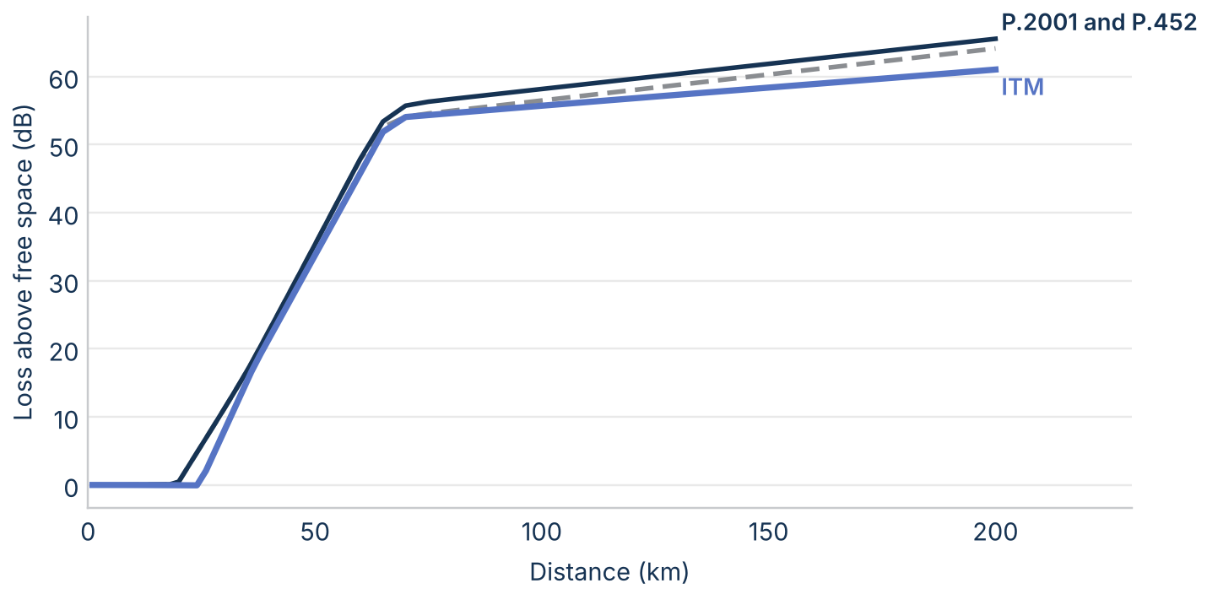
Figure 1. Loss above free space on smooth land at 3 GHz and 50% of time, with 30 m and 10 m antennas.
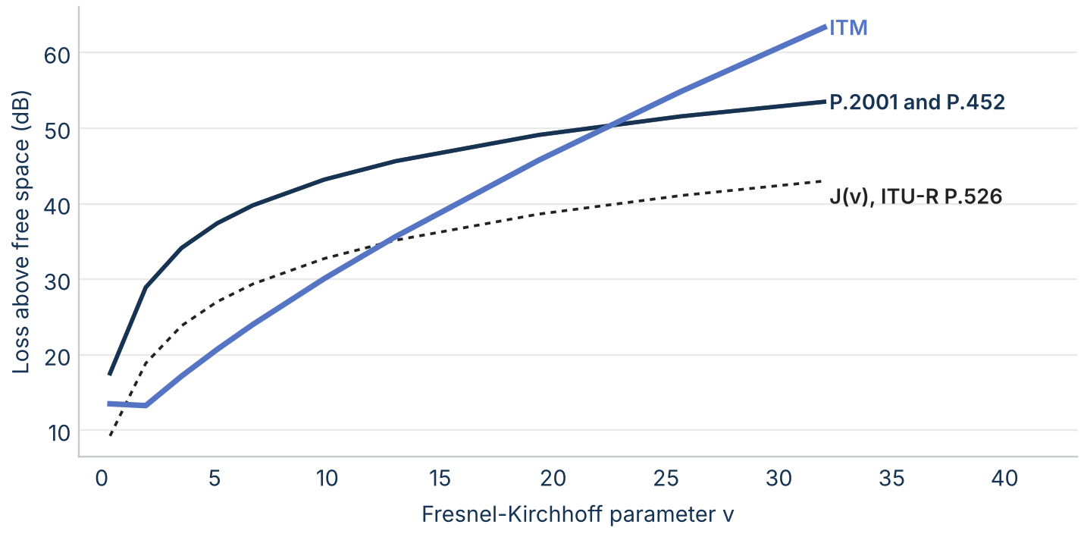
Figure 2. Loss above free space over a single raised point on a 20 km path at 3 GHz, against the Fresnel-Kirchhoff parameter v, with ITU-R P.526 J(v) for reference.

Real terrain by mechanism
On real terrain the models agree in line of sight and split beyond it (Figure 3). The median ITM minus P.2001 is -0.1 dB on line-of-sight links, 32.7 dB on diffraction links, and 36.9 dB on troposcatter links, with ITM's mechanism class deciding the group. P.452 matches P.2001 within 0.02 dB at the median in every class, so the figures show P.2001 only.
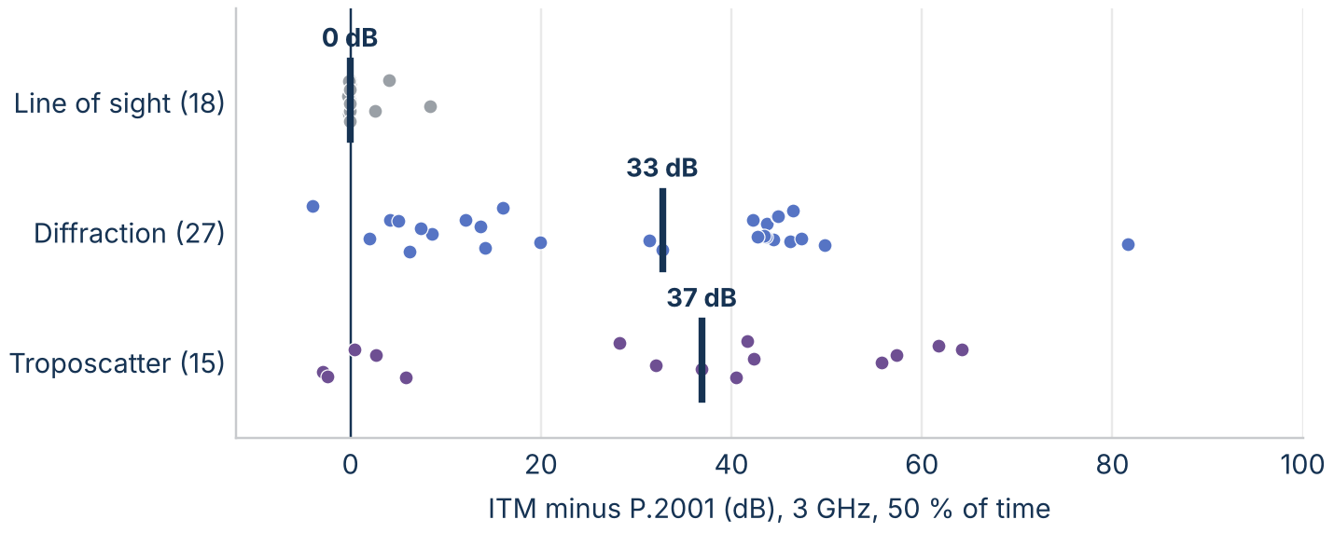
Figure 3. ITM minus P.2001 on each real-terrain link at 3 GHz and 50% of time, by ITM's mechanism class. The bar is the median.
The gap tracks terrain roughness (Figure 4): its median is -0.1 dB on links with a terrain irregularity Δh under 50 m and 44 dB on links with Δh over 200 m.
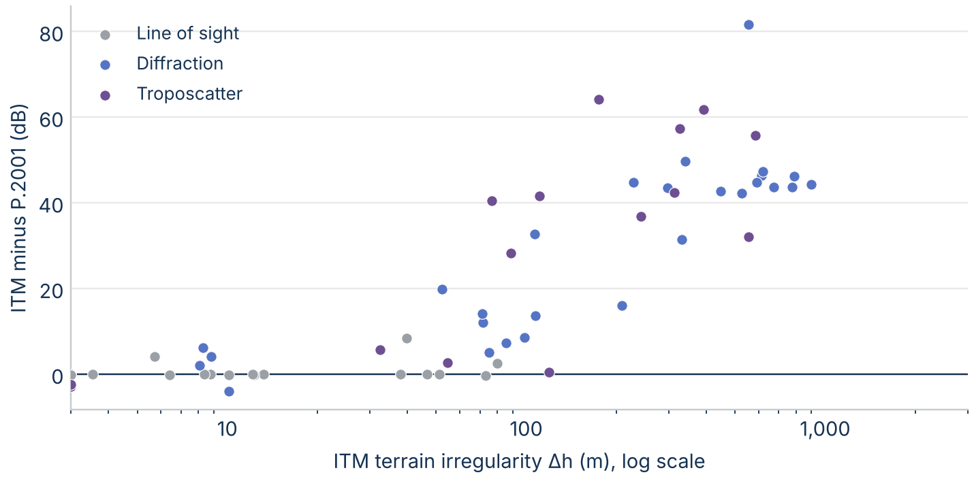
Figure 4. ITM minus P.2001 on each real-terrain link at 3 GHz against ITM's terrain irregularity Δh.

Frequency
Figure 5 sweeps frequency from 100 MHz to 10 GHz on three archetype paths. On the line-of-sight and single-horizon paths the models stay within 5 dB at every frequency. On the double-horizon Appalachian path the gap grows from 46 dB at 100 MHz to 83 dB near 3 GHz and 111 dB at 10 GHz, so results at 3 GHz understate the gap at higher frequencies.
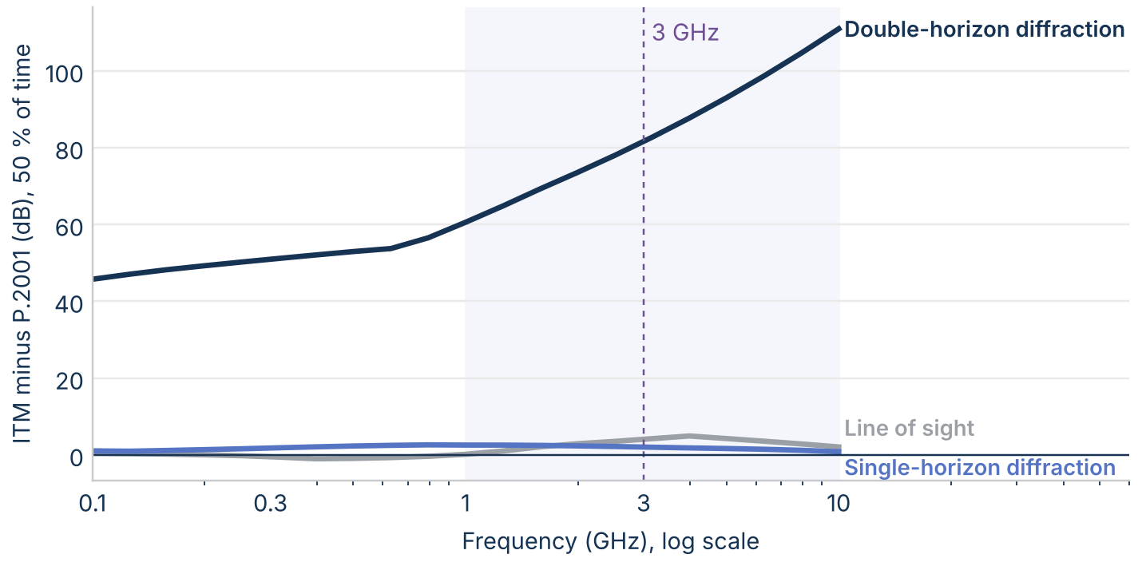
Figure 5. ITM minus P.2001 at 50% of time on three archetype paths from 100 MHz to 10 GHz. The shaded band is 1 GHz to 10 GHz.

Terrain resolution
Resampling the 27 diffraction links from 30 m to 90 m changes the median loss by -0.02 dB for ITM and -0.03 dB for P.2001 (Figure 6). Smoothing over 1 km lowers ITM's loss by a median of -5.2 dB and P.2001's by -3.4 dB. The typical link's gap moves by 1.9 dB, but 7 links move by more than 10 dB, up to 47 dB; a later section explains why.
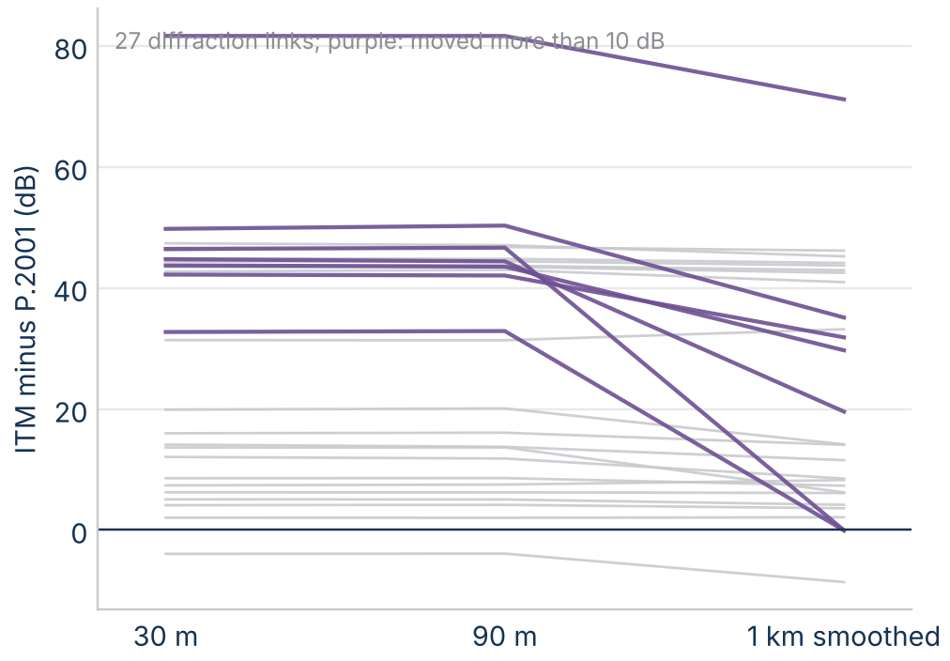
Figure 6. ITM minus P.2001 on each diffraction link at 3 GHz on the 30 m profile, resampled at 90 m, and smoothed over 1 km.

Diffraction: one edge or two

The knife-edge formula is not the difference
P.452 and P.2001 compute a knife-edge loss of 6.9 + 20 log(√((v − 0.1)² + 1) + v − 0.1), and ITM uses 6.02 + 9.11v − 1.27v² below v = 2.4 and 12.953 + 20 log v above. Both stay within 0.12 dB of J(v) from v = 0 to 10 (Figure 7). The difference is that ITM adds one knife edge at each horizon, where the ITU models use a single equivalent edge. Two edges roughly double the loss, and double its growth with frequency: about 6 dB per doubling of frequency against 3 dB for one edge.
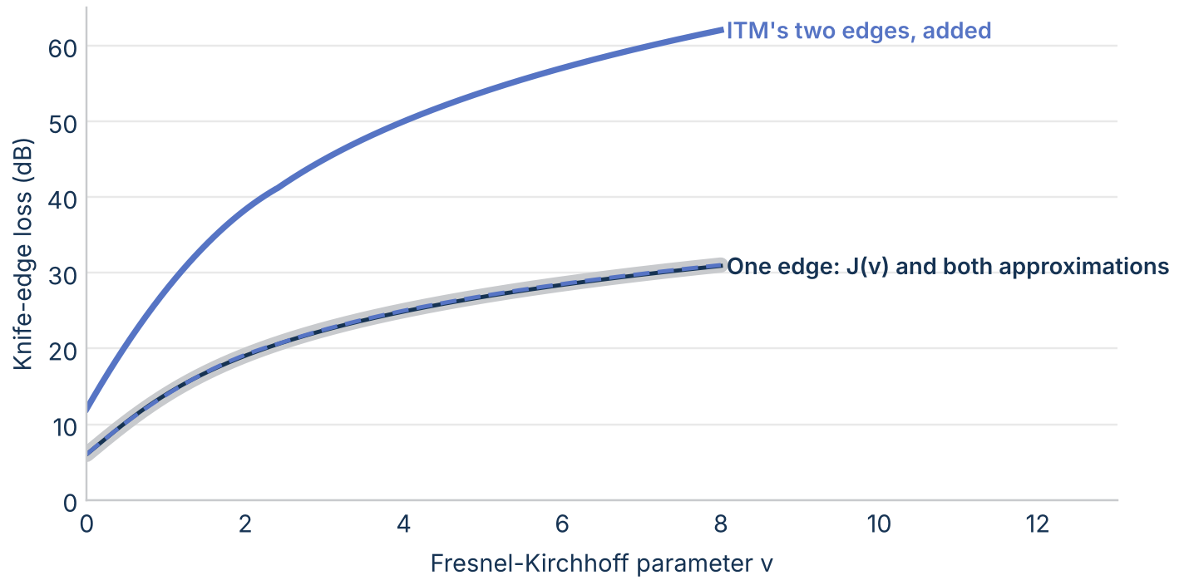
Figure 7. Knife-edge loss against the Fresnel-Kirchhoff parameter v: J(v) from the Fresnel integrals (wide gray), the ITU and ITM approximations for one edge, and ITM's two edges added.

What ITM's diffraction loss is made of
ITM's diffraction loss is A_d = w·A_se + (1 − w)·A_k + A_fo: a smooth-earth loss A_se with weight w, a double knife edge A_k, and a clutter term A_fo of up to 15 dB. The weight falls as terrain irregularity rises. On the 27 diffraction links at 3 GHz (Figure 8), the median terms are 29 dB from the weighted smooth earth, 57 dB from the weighted knife edges, and 13 dB from clutter, against 45 dB for P.452's single knife edge.
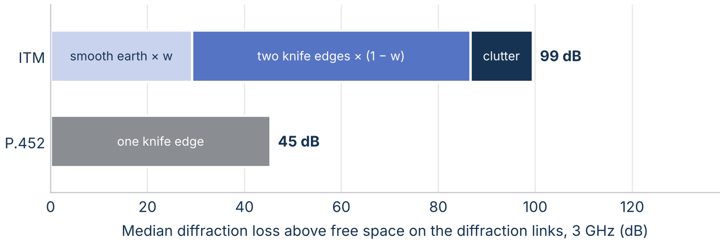
Figure 8. Median diffraction loss above free space on the diffraction links at 3 GHz, split into its terms.
Removing ITM's ingredients one at a time locates the gap (Figure 9). The median gap to P.452 is 32.8 dB as ITM stands; 8.4 dB with one knife edge instead of two; 21.6 dB without the clutter term; 23.4 dB with the loss evaluated at the path instead of extended from beyond the horizons; and -8.7 dB with all three removed. These are diagnostics, not proposed fixes: ITM's terms were fitted to measurements as a set.
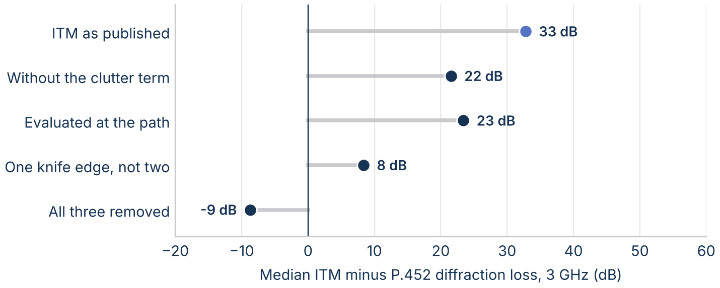
Figure 9. Median ITM minus P.452 diffraction loss at 3 GHz, as ITM stands and with one ingredient removed at a time.
ITM predicts more diffraction loss than P.452 on 26 of 27 diffraction links, with a median ratio of 1.75 (Figure 10).
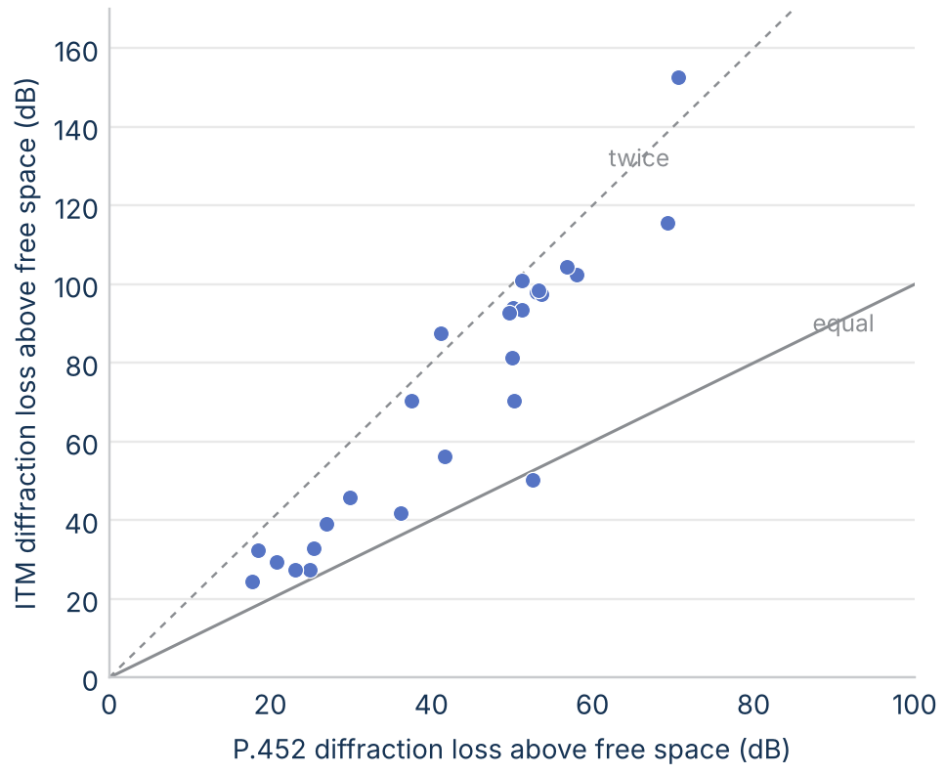
Figure 10. ITM's diffraction loss above free space against P.452's on each diffraction link at 3 GHz. The solid line is equal loss; the dashed line is twice P.452's loss.

One link in detail
Figure 11 takes the double-horizon archetype, a 65 km Appalachian link. The transmitter's horizon is a ridge 5.8 km away, so the rays from the two horizons meet about 5 km above the path, where P.452 and P.2001 put their single edge. ITM weights its smooth-earth loss by only 0.039, but that loss is over 1,300 dB, so the small weight still adds about 50 dB; the two knife edges and the clutter term add about 100 dB more.
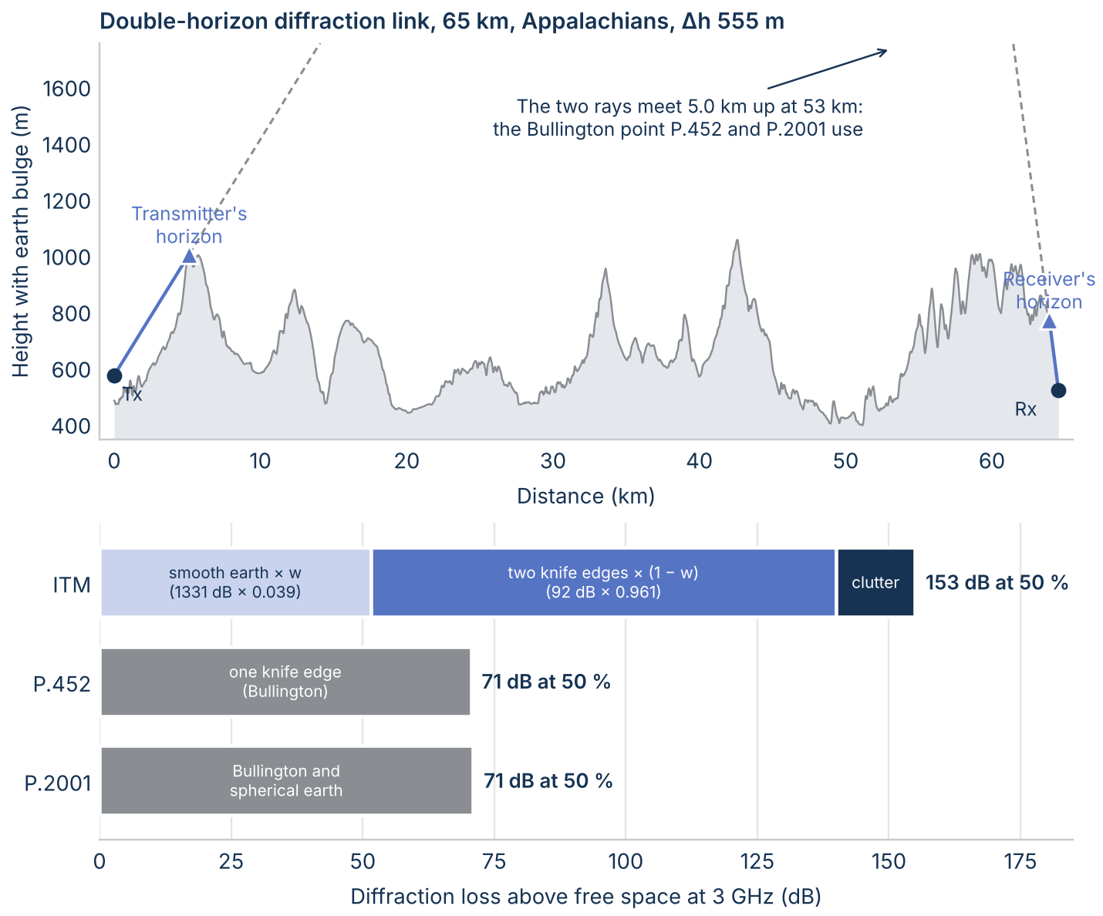
Figure 11. Top: the double-horizon archetype profile with the earth's bulge, both horizons, and the rays that meet at the Bullington point. Bottom: how each model's diffraction loss adds up at 3 GHz and 50% of time.

Where the models start to diverge
Along four radials (Figure 12), the models agree for the first few kilometers and split as soon as the path goes beyond line of sight. To the east and south the gap reaches 29 dB to 40 dB within 60 km and then stays within about 4 dB beyond 80 km, where both models are in troposcatter. To the west, into the Appalachians, it stays at a median of 44 dB from 80 km to 150 km.
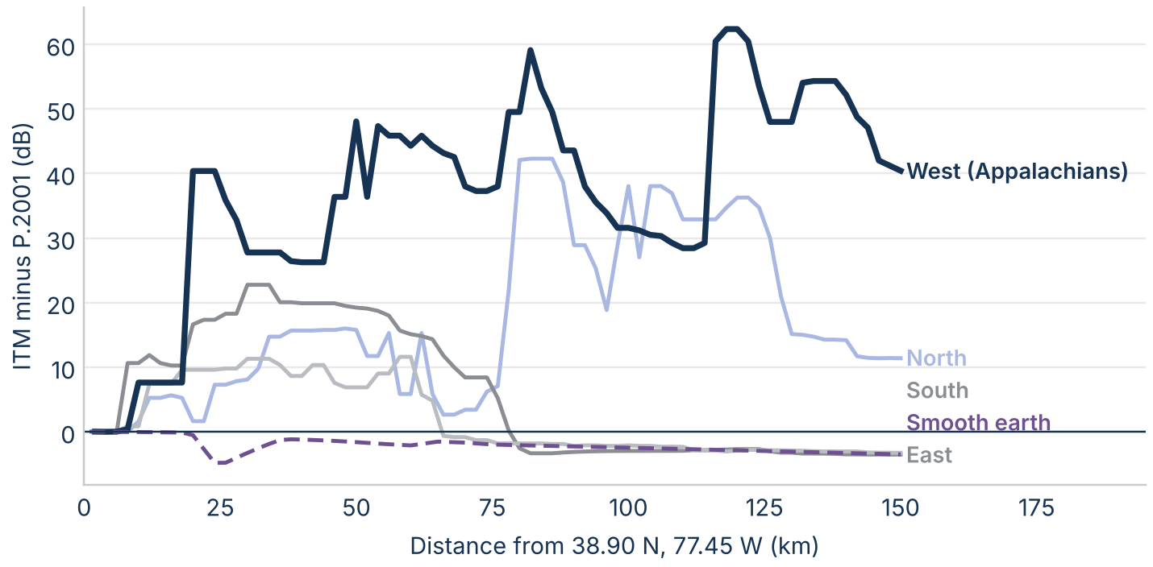
Figure 12. ITM minus P.2001 at 3 GHz and 50% of time along four radials from 38.90 N, 77.45 W (median over 10 km), and on smooth earth.
The links and the measured paths show the same window (Figure 13). The large gaps fall on calculated links from about 15 km to 150 km. On the 367 measured databank paths longer than 150 km, ITM and P.2001 differ by a median of -2.6 dB, which is why the measurement comparison finds the models close.
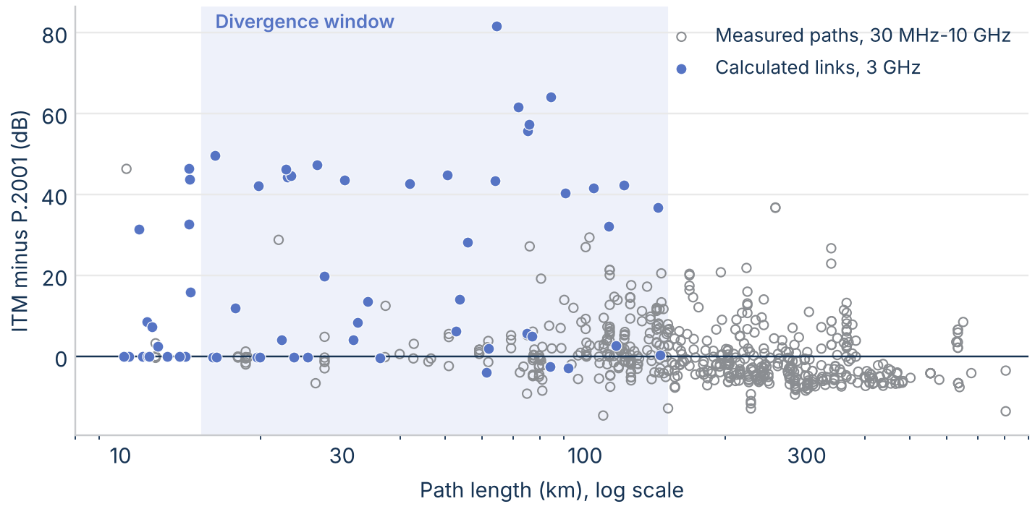
Figure 13. ITM minus P.2001 on the calculated links at 3 GHz and on the measured databank paths from 30 MHz to 10 GHz, against path length.
ITM's smooth-earth weight w decides which side of the split a link falls on (Figure 14). Where w is 0.12 or more, the median gap is 8 dB (12 links); where w is under 0.12, it is 44 dB (15 links). Few links fall between, which also explains the terrain-resolution result: smoothing raises w on a few links enough to switch groups.
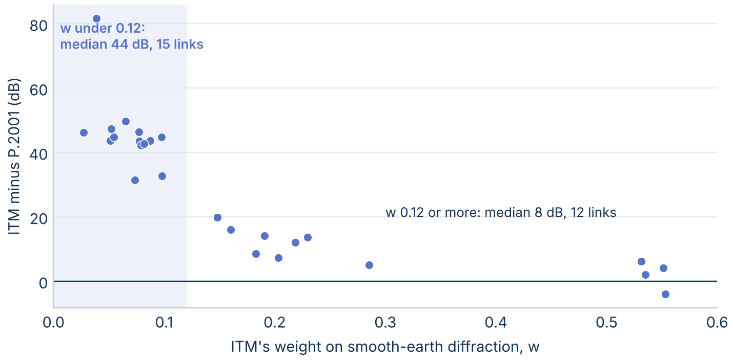
Figure 14. ITM minus P.2001 on the diffraction links at 3 GHz against ITM's smooth-earth weight w.
Of the 22 calculated links with Δh over 150 m and length under 150 km, 21 have a gap over 20 dB (Figure 15). 45 measured datasets from 30 MHz to 10 GHz fall in that corner, and ITM classes 31 of them as line of sight. On the 13 datasets there where ITM and P.2001 differ by more than 10 dB, from 8 paths, the evidence splits by frequency. From 1 GHz to 10 GHz (5 datasets on 3 paths), ITM predicts a mean of 24 dB too much loss and P.2001 is within 1 dB. Below 1 GHz (8 datasets on 5 paths), ITM is within 1 dB and P.2001 predicts 12 dB too little loss. Neither model is right in the window across the whole range, and the data are too few to settle the question at 3 GHz.
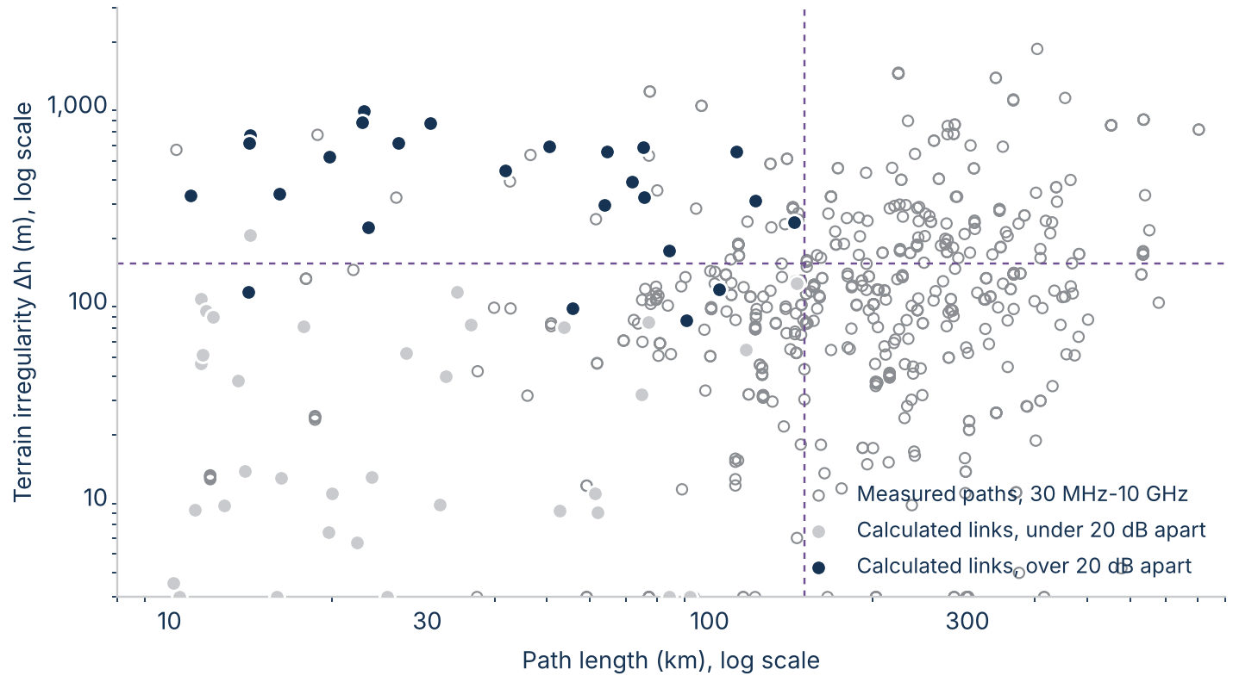
Figure 15. Calculated links at 3 GHz, marked by whether ITM and P.2001 are more than 20 dB apart, and measured databank paths from 30 MHz to 10 GHz, by path length and terrain irregularity Δh.

Results over the time distribution
Figure 16 shows each model's loss relative to its own 50% value on the five archetype paths. From 50% to 0.01% of time, P.2001's loss falls about twice as far as ITM's on the troposcatter, over-sea, and single-horizon paths: by 68 dB against 35 dB on the troposcatter path and 75 dB against 47 dB on the over-sea path, because ducting takes over in P.2001.
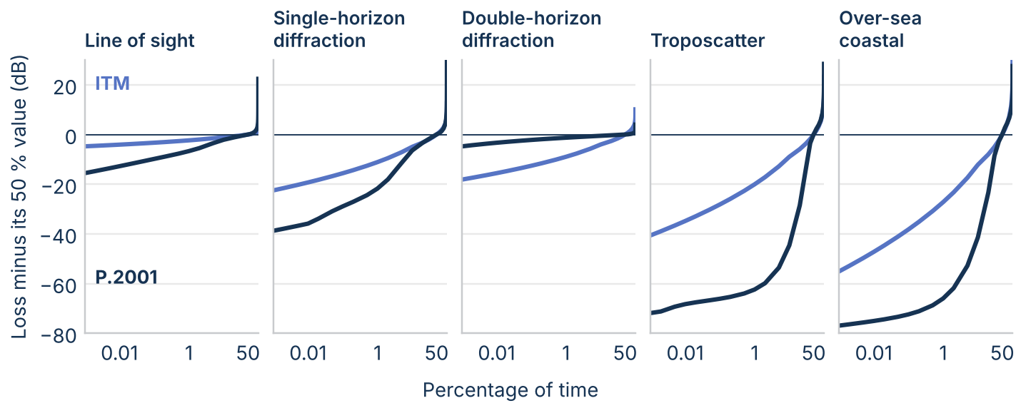
Figure 16. Loss minus its 50% value against time percentage on the five archetype paths at 3 GHz, ITM and P.2001.
On the real-terrain links (Figure 17), the gap on diffraction links holds across the distribution, from 42 dB at 0.001% of time to 30 dB at 99%. On line-of-sight links the models agree at 50% and split by about 11 dB at 0.001%, where P.2001 adds ducting.
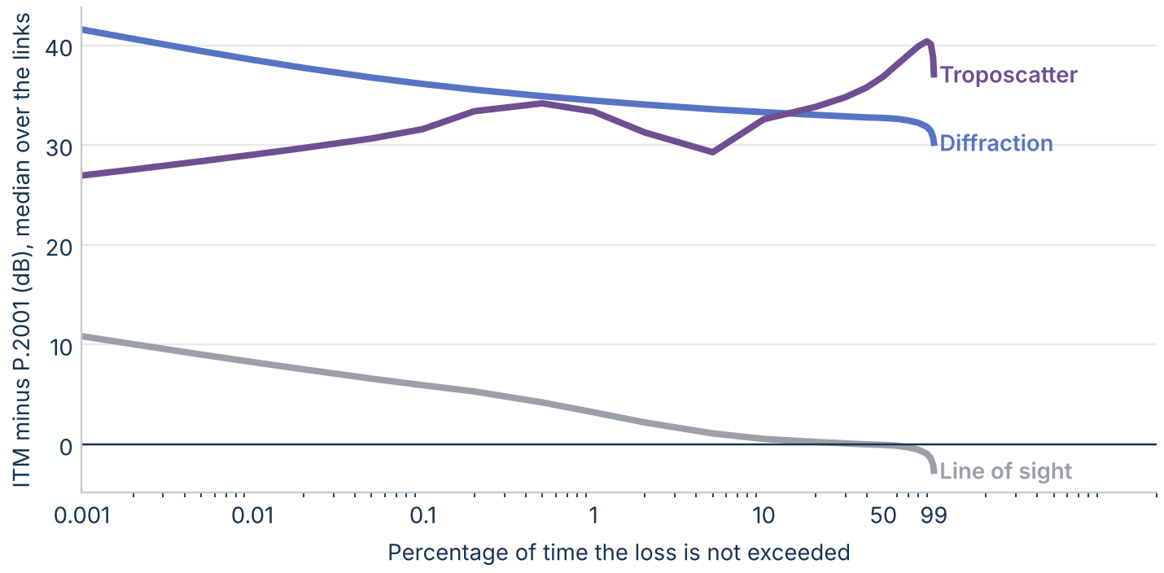
Figure 17. Median ITM minus P.2001 over the real-terrain links at 3 GHz against time percentage, by ITM's mechanism class.

Ducting: the mechanism ITM leaves out
P.452 and P.2001 model ducting and layer reflection as their own mechanism. In P.452 the loss is L_ba = A_f + A_d(p) + A_g, where the time-dependent part depends on β, the time percentage for which strong refractivity lapse rates can be expected near the path. P.2001 uses the same structure. ITM has no ducting term; its small-percentage loss comes from variability curves chosen by radio climate.
On the 127 km over-sea archetype (Figure 18), both ITU models predict less loss than free space (144.1 dB) for 2% of time or less. At 1% of time ITM predicts 173.3 dB and P.2001 137.9 dB; at 0.01% the values are 153.3 dB and 128.8 dB.
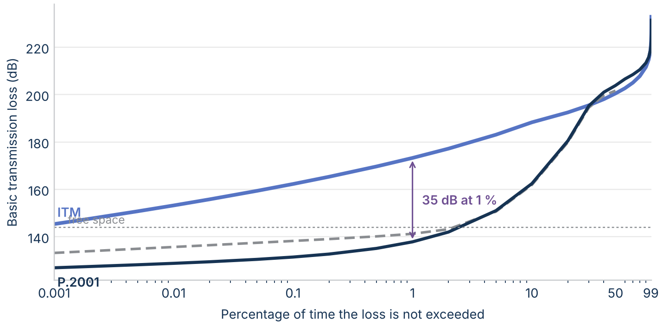
Figure 18. Basic transmission loss on the 127 km over-sea coastal archetype at 3 GHz against time percentage.
On smooth earth (Figure 19), P.2001 uses ducting for up to 10% of time on land paths beyond about 60 km and for up to 20% to 30% of time on sea paths beyond about 30 km.
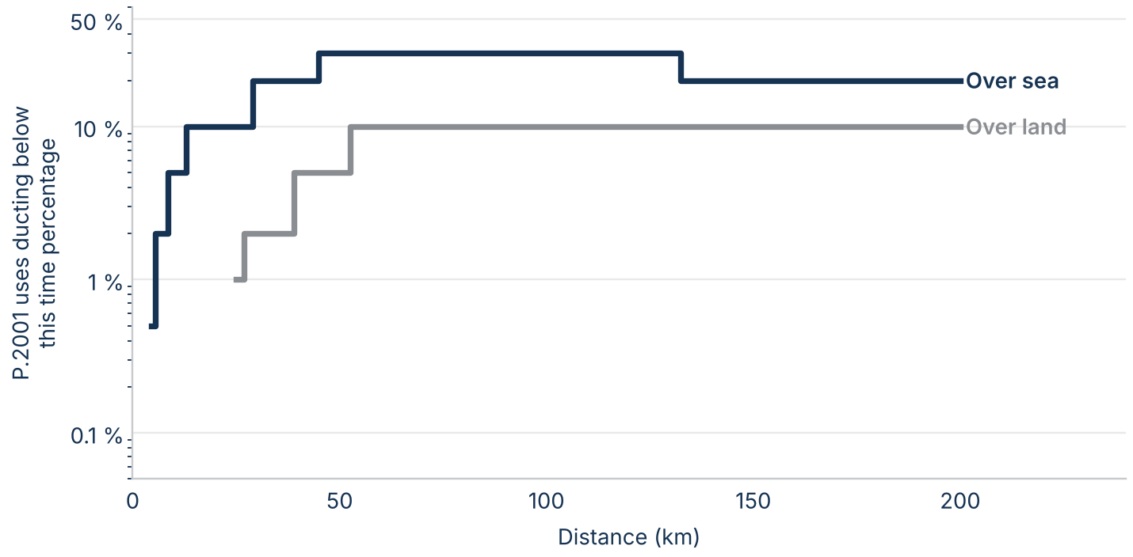
Figure 19. The largest time percentage at which ducting is P.2001's lowest-loss mechanism, against distance, on smooth land and sea at 3 GHz.
On the inland real-terrain links, steep horizons limit ducting (Figure 20). From 50% to 1% of time, P.2001's signal strengthens by a median of 3.9 dB on line-of-sight links and 2.3 dB on diffraction links, against 0.5 dB and 1.8 dB for ITM. On troposcatter links ITM's wide variability gives the larger change: 19.8 dB against 10.7 dB.
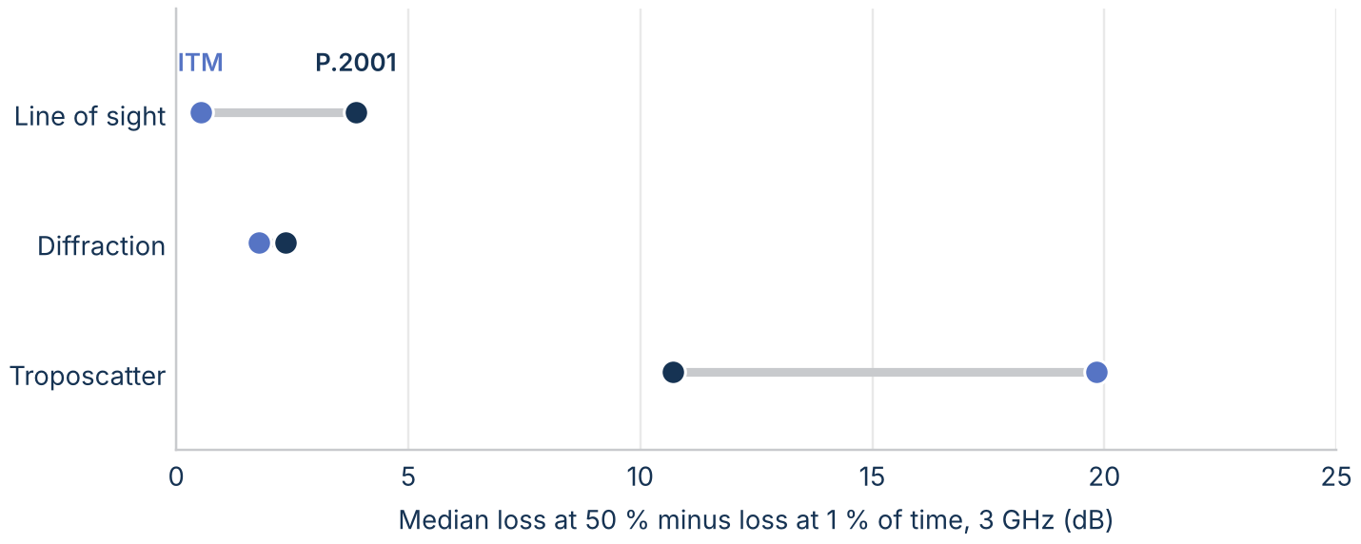
Figure 20. Median loss at 50% minus loss at 1% of time on the real-terrain links at 3 GHz, by ITM's mechanism class.
On the measured paths from 30 MHz to 10 GHz (Figure 21), the signal strengthens by a median of 16.6 dB from 50% to 1% of time. All three models predict more: 21.7 dB for ITM, 17.4 dB for P.452, and 18.5 dB for P.2001. ITM's only lever on this part of the distribution is its radio climate: on the double-horizon archetype, the seven climates move ITM's loss at 1% of time from 276.3 dB to 287.0 dB.
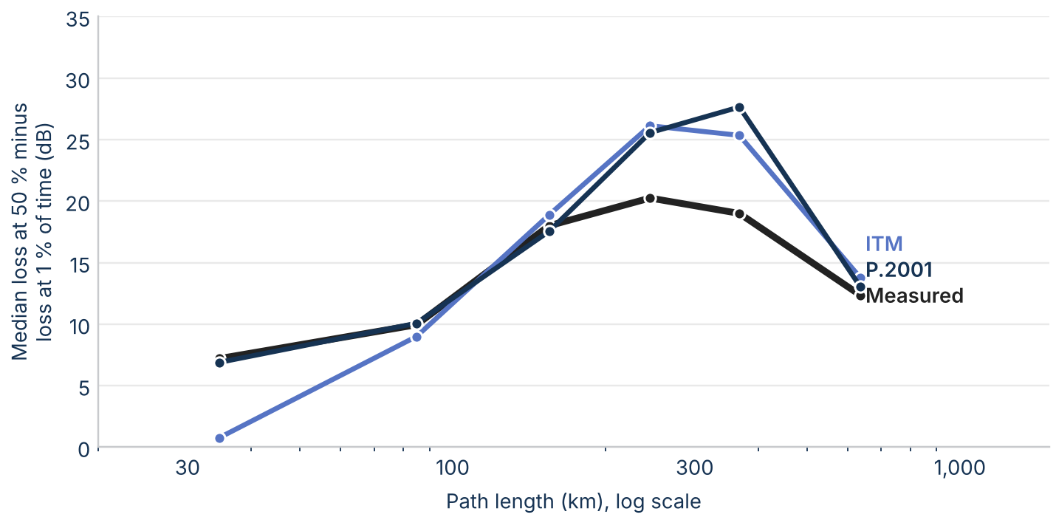
Figure 21. Median loss at 50% minus loss at 1% of time against path length on the measured databank paths from 30 MHz to 10 GHz, measured and predicted.

Comparison with measurements

The data
The comparison uses Table III of the ITU-R Study Group 3 databank (DBSG3), clear-air trans-horizon basic transmission loss. From 30 MHz to 10 GHz, 608 datasets have site coordinates, antenna heights, a measured median, and a surveyed profile or coordinates; after a quality screen, 573 remain, measured in North America, Europe, and Japan (Figure 22). Coordinates in Japan were converted from the Tokyo datum to WGS84. The databank includes the U.S. paths of OT/TRER 16; the medians of 10 paths read from that report match the databank exactly.
Few datasets sit near 3 GHz: 73 from 1 GHz to 3 GHz and 19 from 3 GHz to 6 GHz. The comparison therefore uses all 573 datasets from 30 MHz to 10 GHz, reported in two groups, 30 MHz to 1 GHz and 1 GHz to 10 GHz, and by band. P.452 starts at 100 MHz. These data are not an independent test: ITU-R used the databank to develop P.452 and P.2001, and ITM's developers used many of the same U.S. measurements.
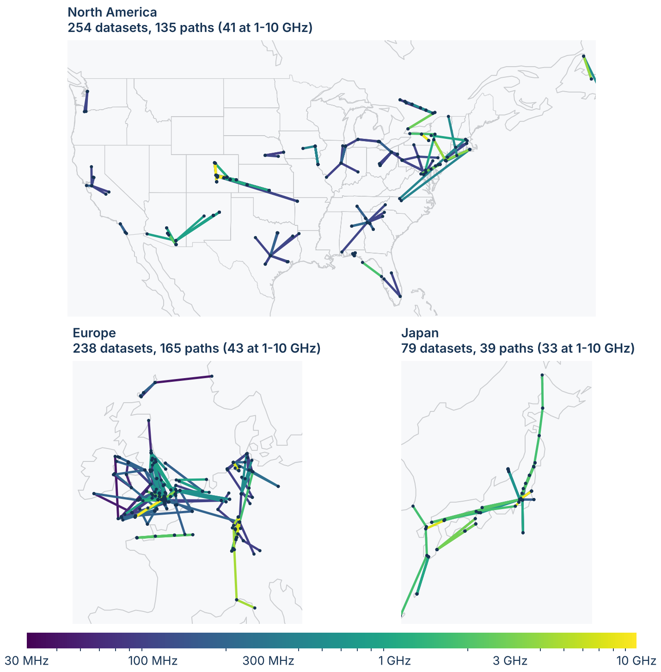
Figure 22. The databank datasets used in the comparison, in the three regions where they were measured. One Australian path is not shown. Paths are colored by frequency.

Terrain and site locations
Many sites are on hilltops, and coordinates from 1950s and 1960s maps can sit a few hundred meters off the summit, so a 30 m terrain model can put a ridge next to the antenna. The main results therefore use the databank's surveyed profiles. Figure 23 shows the effect on the 114 datasets that both runs kept: for ITM the RMS error in the median is 25.3 dB on 30 m terrain at the listed coordinates, 38.0 dB after moving each site to the nearby point that best matches its surveyed elevation, and 10.7 dB on the surveyed profiles. The site correction made the errors larger, because on a mountainside the nearest point at the right height is often on the wrong slope.
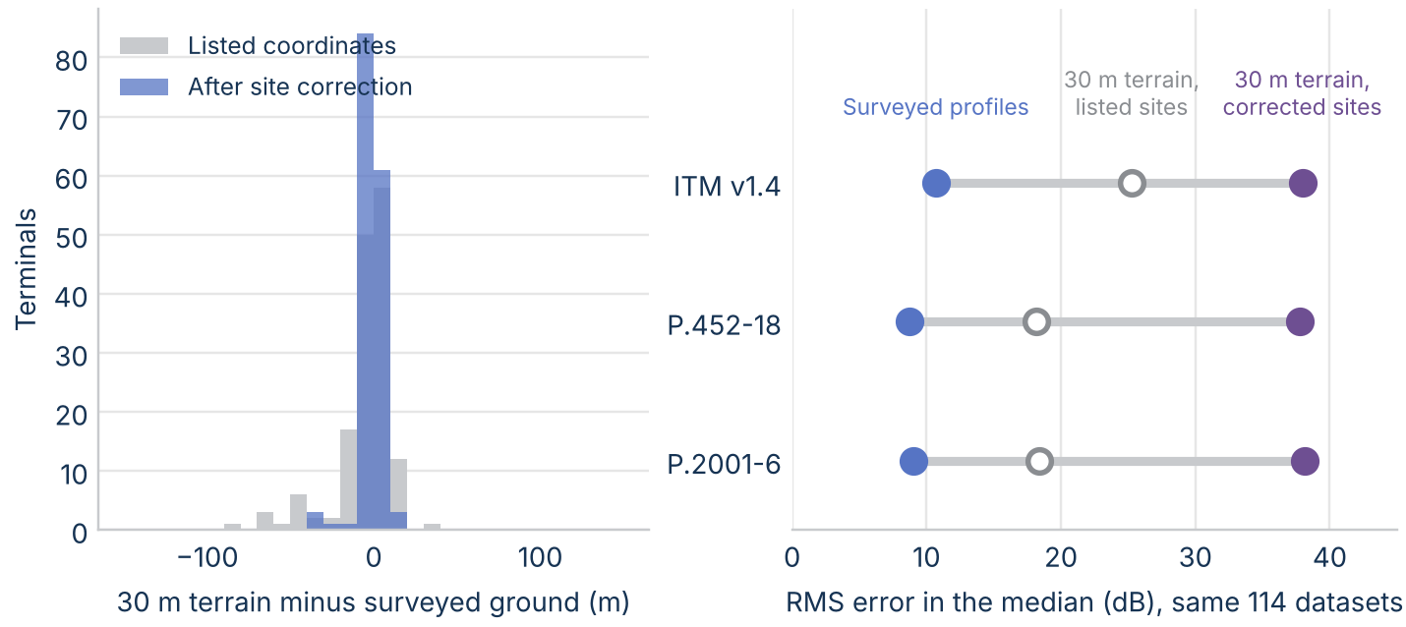
Figure 23. Left: 30 m terrain minus surveyed ground elevation at each terminal, at the listed coordinates and after the site correction. Right: RMS error in the median for each terrain source.

Results
Over all 573 datasets from 30 MHz to 10 GHz, the mean error in the median is -2.2 dB for ITM, -2.9 dB for P.452, and -2.7 dB for P.2001, and the RMS error is 10.1 dB for ITM, 8.7 dB for P.452, and 8.9 dB for P.2001. From 30 MHz to 1 GHz (455 datasets) all three predict about 3 dB too little loss: -2.9 dB for ITM, -3.4 dB for P.452, and -3.3 dB for P.2001. From 1 GHz to 10 GHz (118 datasets) the mean error is 0.5 dB for ITM, -1.8 dB for P.452, and -0.6 dB for P.2001, and the RMS error is 10.8 dB for ITM, 8.7 dB for P.452, and 9.1 dB for P.2001. From 1 GHz to 3 GHz the mean error is -1.2 dB for ITM, -1.7 dB for P.452, and 0.0 dB for P.2001, and from 3 GHz to 6 GHz it is -2.2 dB for ITM, -1.1 dB for P.452, and -0.6 dB for P.2001. ITM drifts toward too much loss from 6 GHz to 10 GHz (Figure 24).
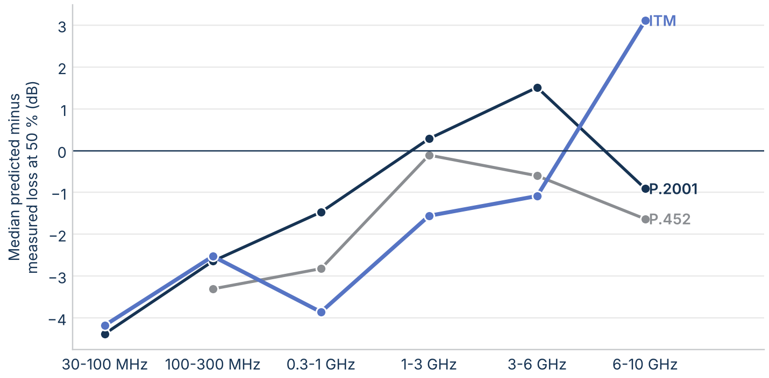
Figure 24. Median predicted minus measured loss at 50% of time by frequency band, 30 MHz to 10 GHz.
At 1% of time the mean error over all datasets is -2.4 dB for ITM, -5.7 dB for P.452, and -6.7 dB for P.2001 (Figure 25): the ITU models predict too little loss at small percentages, because their ducting term enhances the signal more than was measured.
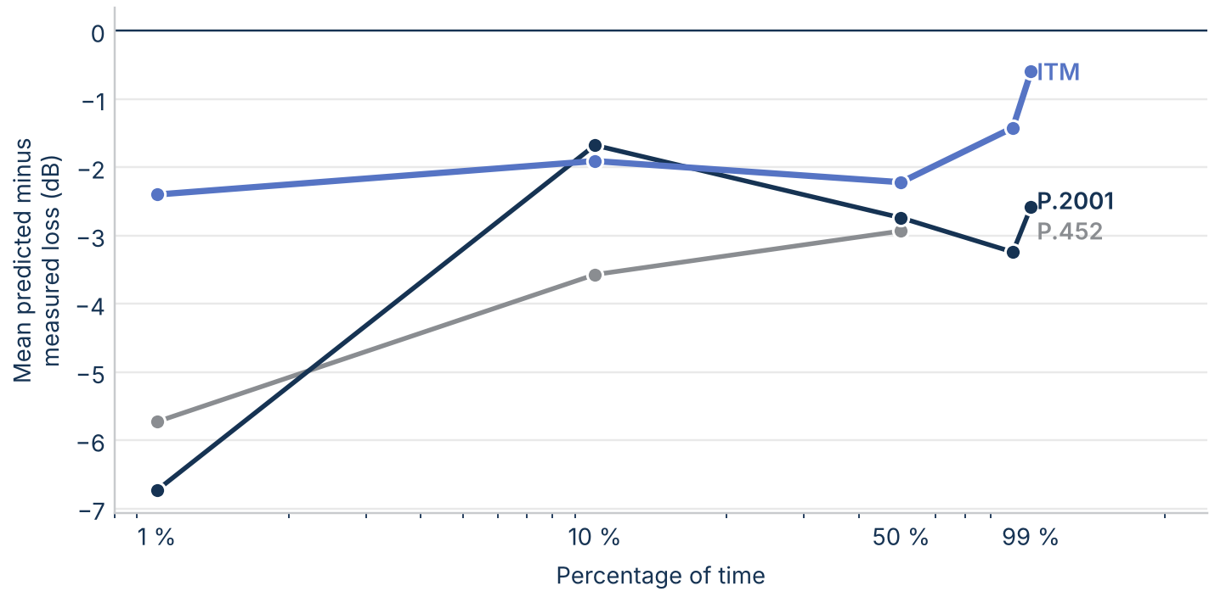
Figure 25. Mean predicted minus measured loss over all datasets from 30 MHz to 10 GHz against time percentage. P.452 is defined only up to 50% and from 100 MHz.
Against terrain irregularity (Figure 26), the median errors show no rough-terrain trend comparable to the calculated gap, because most measured paths are long troposcatter paths outside the divergence window.
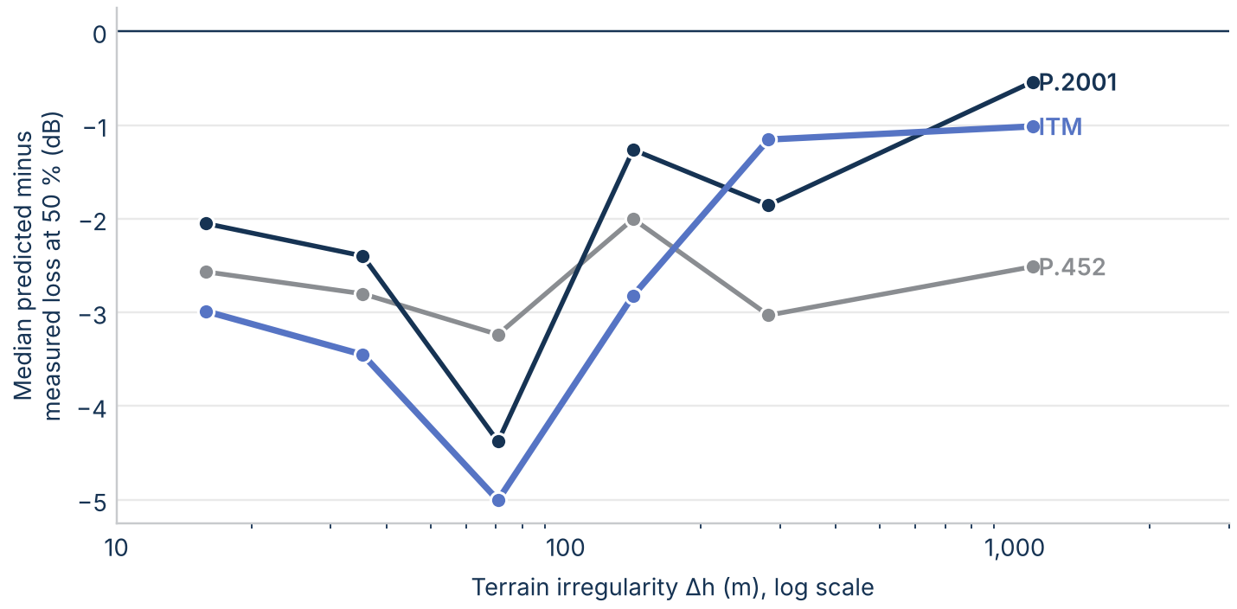
Figure 26. Median predicted minus measured loss at 50% of time from 30 MHz to 10 GHz against ITM's terrain irregularity Δh.

Point-to-area measurements
The databank also holds VHF and UHF measurements relating to terrestrial broadcasting (Recommendation ITU-R P.311, Tables VI-1 and VI-2), which ITU-R distributes free. Each spatial record is a location median: the field strength exceeded at 50% of the locations measured around a point, for 1 kW e.r.p., which converts to basic transmission loss as 141.45 dB minus the field strength plus 20 log f. Keeping the records with site coordinates, a surveyed profile that matches them, a receiving antenna at least 10 m high, and a path of at least 1 km leaves 2890 records from 14 experiments, from 62 MHz to 2180 MHz on paths of 1.1 km to 124.9 km. They include 289 NTIA measurements at 2,180 MHz in Virginia, the closest to 3 GHz in the databank.
All three models predict much less loss than these measurements (Figure 27): over all records the mean error is -14.6 dB for ITM and -13.6 dB for P.2001, and at 2,180 MHz it is -24.9 dB for ITM, -27.9 dB for P.452, and -27.8 dB for P.2001. The error grows with frequency and is largest on the U.S. experiments in rural Virginia, which used antennas 11 m to 15 m high, so it most likely reflects clutter and vegetation loss near the terminals that none of the three models includes without a clutter model such as Recommendation ITU-R P.2108. On these paths the three models agree with each other within about 3 dB on average, so the data say more about the missing clutter term than about which model to prefer.
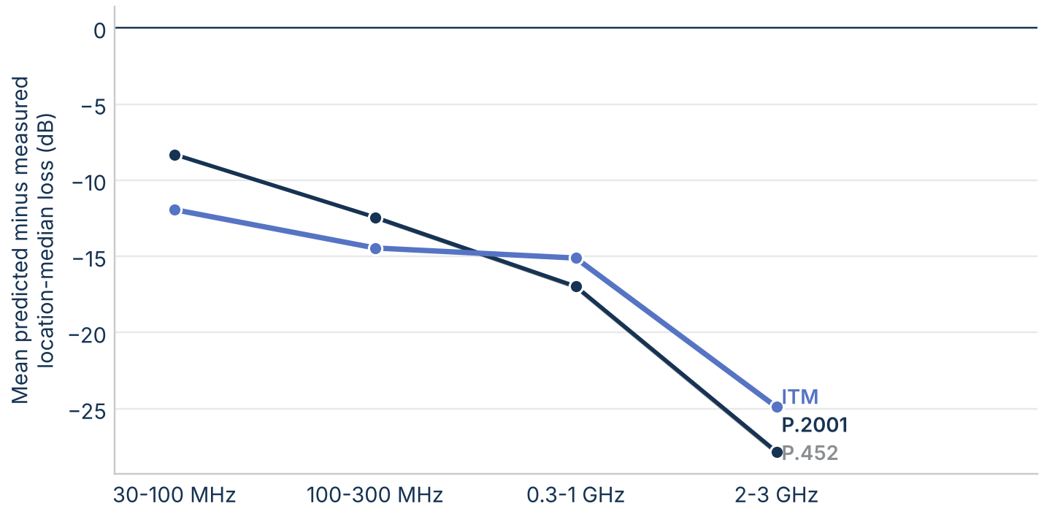
Figure 27. Mean predicted minus measured location-median loss on the ITU-R point-to-area records by frequency band.

How certain are these numbers?
The headline numbers come from small samples, so this section puts 95% confidence intervals on them by bootstrap: 10,000 resamples of the links, or of the measured paths, with a fixed seed. Resampling paths rather than datasets matters for the measurements, because datasets on one path share its terrain and its errors.
The class medians are uncertain (Figure 28). The median gap on the 27 diffraction links is 33 dB, with an interval of 14 dB to 44 dB, and on the 15 troposcatter links 37 dB, with an interval of 6 dB to 56 dB. The intervals are wide because each class mixes two groups of links, and a resample that draws a few more from one group moves the median from one group to the other. The groups themselves are tight: 44 dB (43 dB to 46 dB) where ITM's smooth-earth weight is under 0.12, and 8 dB (5 dB to 14 dB) elsewhere. The share of diffraction links more than 20 dB apart is 56% (37% to 74%), a more stable summary than the median. The weight that best separates the groups is 0.1, with an interval of 0.04 to 0.205. With 27 links the formal bimodality tests are inconclusive: a two-group mixture (means of 9 dB and 45 dB) fits only slightly better than one group by BIC, and Sarle's bimodality coefficient is 0.35, below the 0.555 that suggests two groups. In the line-of-sight class the interval is 0 dB to 0 dB.
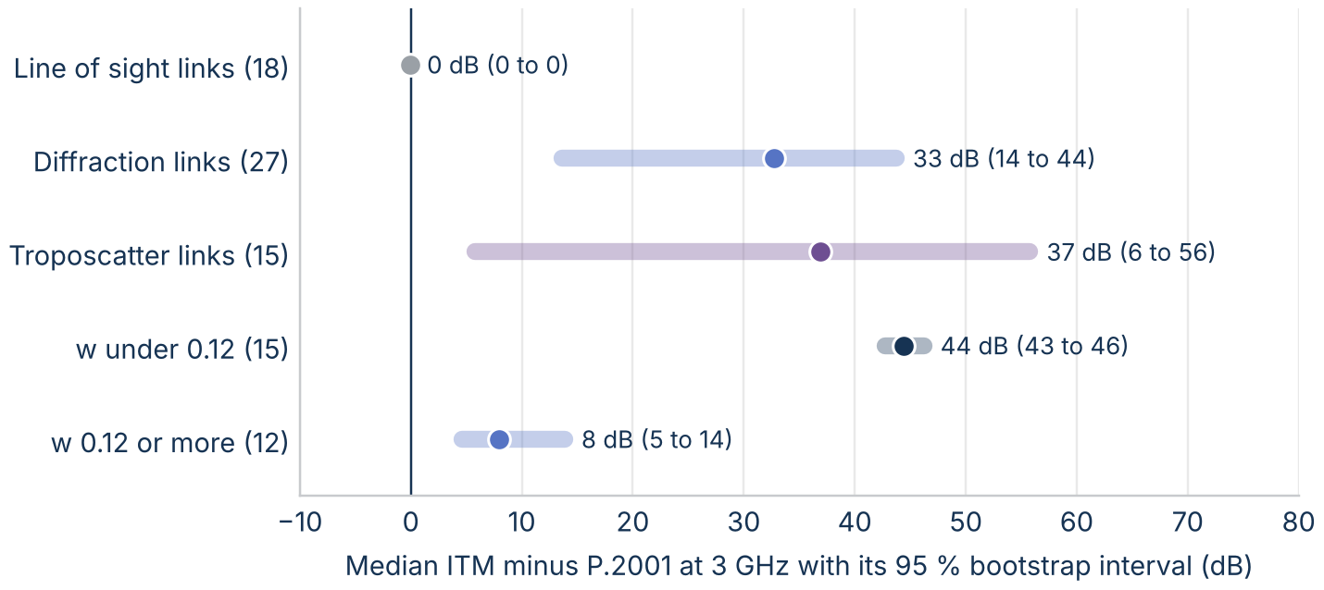
Figure 28. Median ITM minus P.2001 at 3 GHz with 95% bootstrap intervals, by ITM's mechanism class and by ITM's smooth-earth weight w on the diffraction links.
Against the measurements (Figure 29), the mean errors over all 573 datasets are -2.2 dB for ITM (-3.4 dB to -1.0 dB), -2.9 dB for P.452, and -2.7 dB for P.2001, so all three predict slightly too little loss overall, and the intervals overlap. From 1 GHz to 10 GHz, on 76 paths, every interval includes zero: -1.9 dB to 2.9 dB for ITM and -3.1 dB to 1.7 dB for P.2001. The measurements can't separate the models at the median.
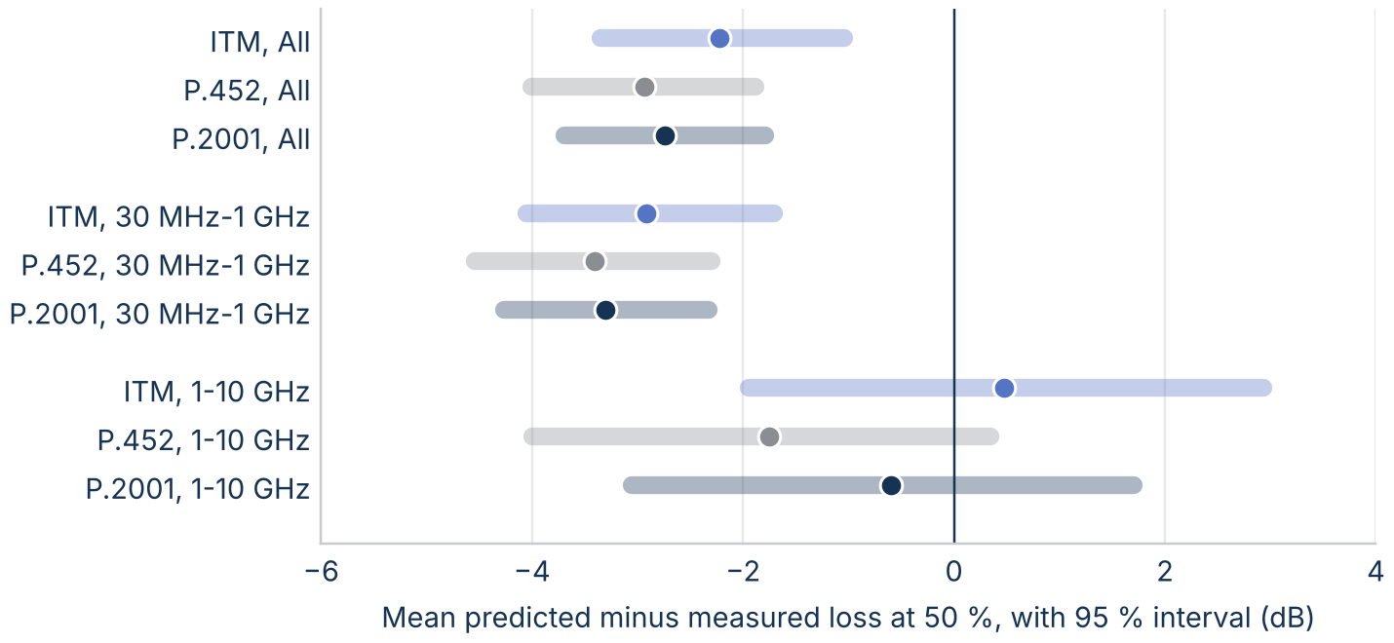
Figure 29. Mean predicted minus measured loss at 50% of time with 95% intervals from resampling measured paths, by group.

Sensitivity to model settings
The results use one set of model settings. To test whether another setting closes the gap, the 60 real-terrain links were rerun at 3 GHz and 50% of time with each ITM setting changed in turn: ground constants (poor and average), confidence (10% and 90%), each of the seven radio climates, N₀ of 280 and 360 N-units, and horizontal polarization. P.452 was also run with surface heights from the Copernicus surface model added to the profile, and P.452 and P.2001 with horizontal polarization.
No setting closes the gap (Figure 30). On the diffraction links the median ITM minus P.2001 is 32.7 dB with the baseline settings. Confidence moves it most, to 23.2 dB at 10% and 42.2 dB at 90%, because it shifts every ITM prediction by about 9 dB. Ground constants, radio climate, N₀, and polarization each move it by less than 1 dB at the median, although radio climate moves individual links by up to 5.3 dB. Adding surface heights raises P.452's loss by a median of 2.0 dB and up to 37.4 dB on one link; the ITU models' polarization changes their loss by less than 0.01 dB at the median.
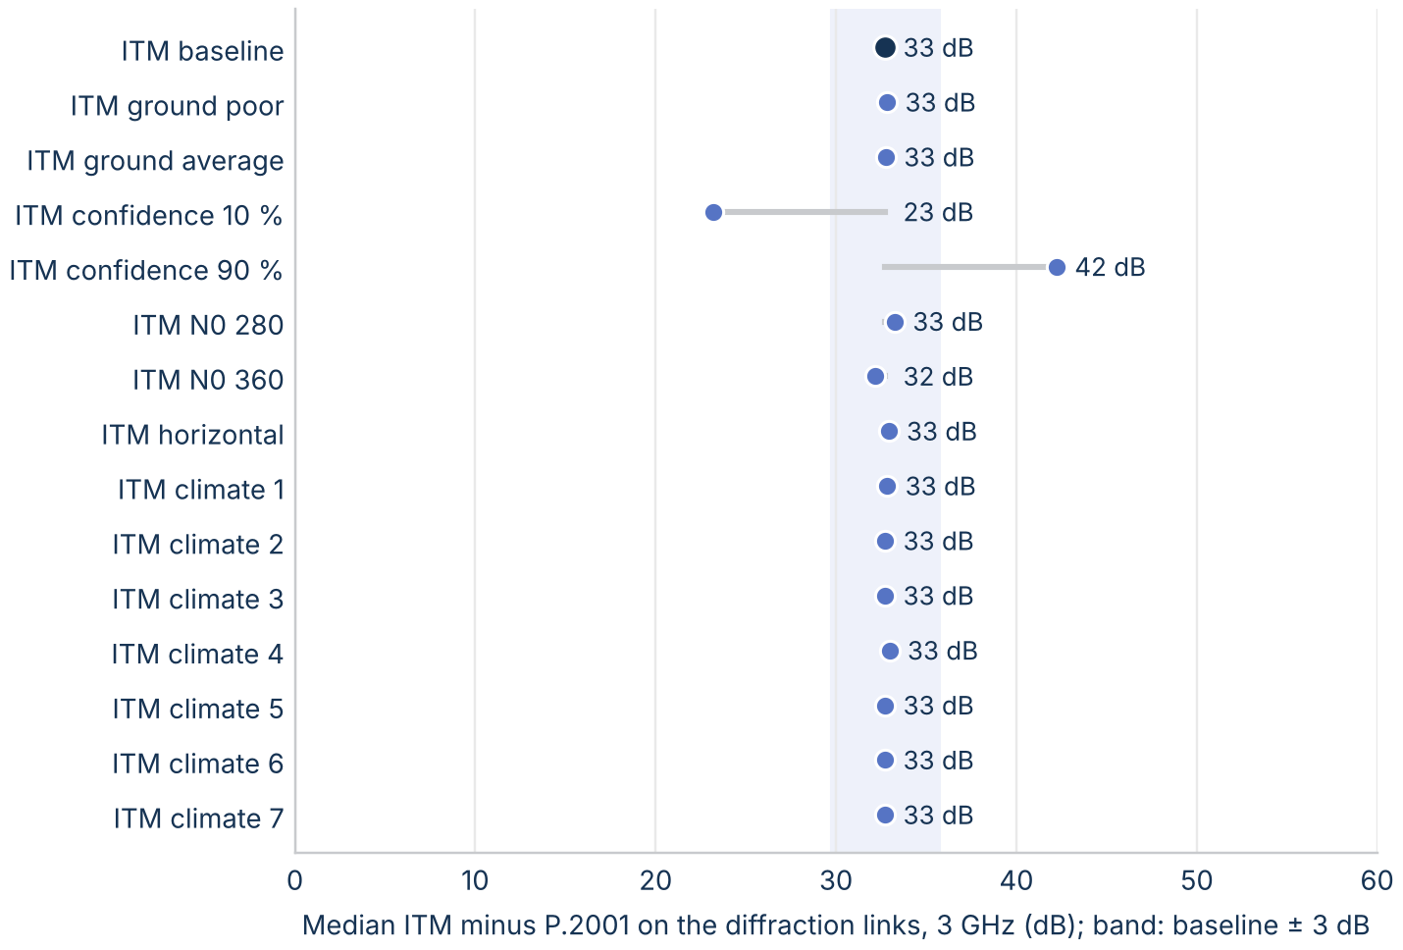
Figure 30. Median ITM minus P.2001 on the diffraction links at 3 GHz for each ITM setting tested. The band is the baseline ± 3 dB.

What the differences mean in distance
On smooth land, the models reach each loss threshold from 150 dB to 180 dB within 5 km of each other (Figure 31), because the steep slope beyond the radio horizon makes distance insensitive to a few dB. Over rough terrain, ITM's extra 30 dB to 45 dB of diffraction loss lets it reach a threshold much sooner, so an analysis with ITM computes smaller separation distances there than one with P.452 or P.2001.
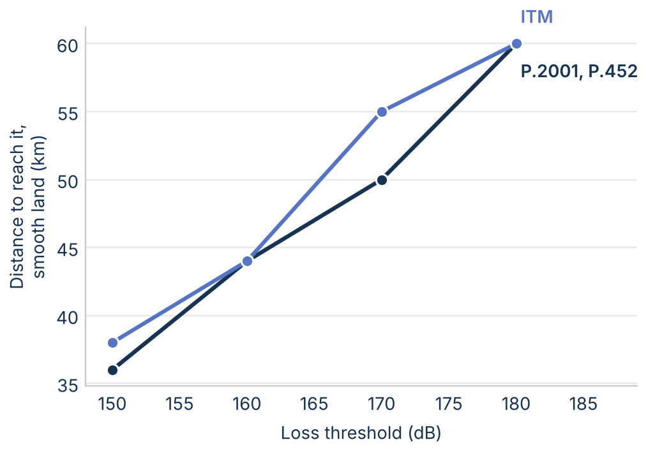
Figure 31. Distance at which the 50% loss first reaches each threshold on smooth land at 3 GHz.

Two real scenarios: Washington, DC, and Los Angeles
To see what the gap does to an exclusion area, a receiver with a 10 m antenna was placed at the Washington Monument and at Los Angeles City Hall, and a grid of transmitters with 30 m antennas was laid out over 100 km by 100 km around each, at a 5 km step: 440 transmitter sites per city. Each transmitter is evaluated alone (single entry) at 3 GHz on its own 30 m terrain profile with all three models.
Around Washington, DC, ITM predicts more loss than P.2001 at most sites, by a median of 14.0 dB; 11% of sites differ by more than 20 dB (Figure 32). Around Los Angeles, where the San Gabriel Mountains rise north of the city, the median is 24.2 dB and 57% of sites differ by more than 20 dB, up to 79 dB. P.452 matches P.2001 within 0.09 dB at every Los Angeles site and within 4.42 dB around DC.
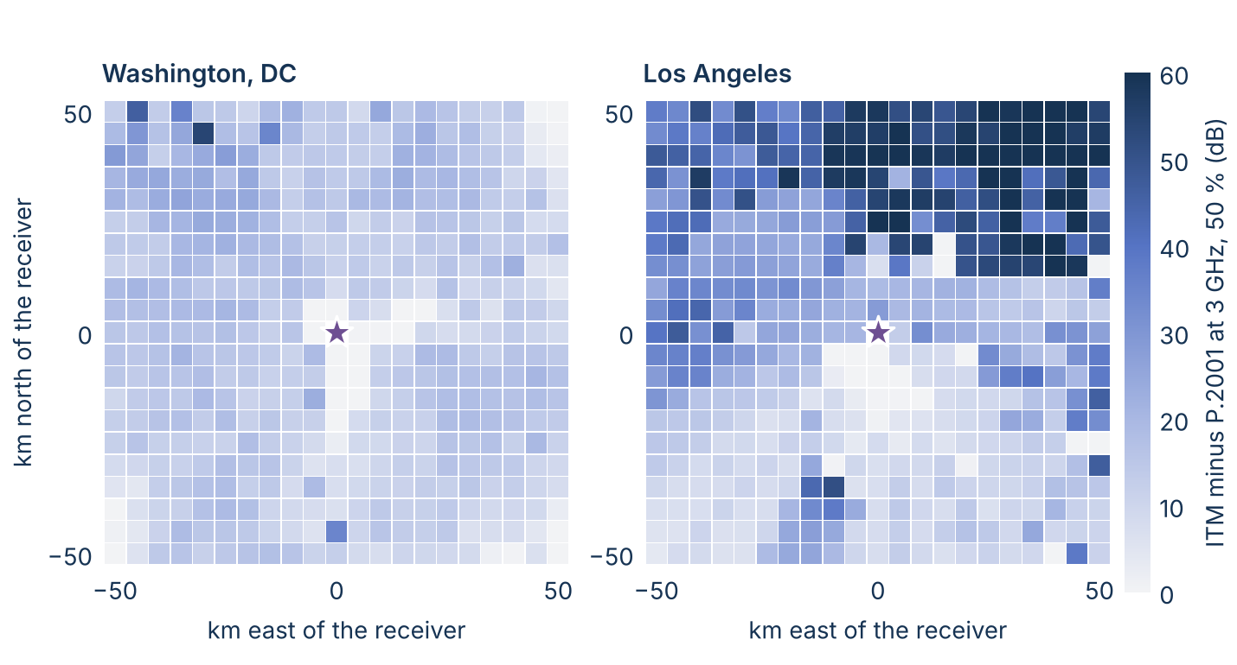
Figure 32. ITM minus P.2001 at 3 GHz and 50% of time from each transmitter site (30 m antenna) to the receiver (star, 10 m antenna), single entry.
A required loss turns these maps into an exclusion area: the sites where one transmitter alone would get less loss than the protection criterion needs. The required loss is the transmitter's e.i.r.p. plus the receiving antenna gain minus the interference threshold, all in decibels; for example, 61 dBm in 10 MHz into a 0 dBi antenna with a threshold of -105 dBm in 10 MHz needs 166 dB. At a required loss of 160 dB (Figure 33), P.2001 and P.452 exclude 1575 km² around DC and ITM 600 km²; around Los Angeles the areas are 3125 km² and 1750 km². At 140 dB, where the excluded sites are close to the receiver, the models are closer: 450 km² against 400 km² around DC. The grid ends 50 km from the receiver, so areas at the largest required losses are lower bounds.
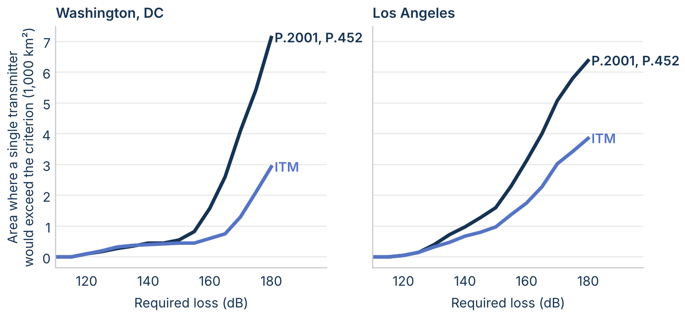
Figure 33. Area of the 100 km by 100 km grid where a single transmitter would get less loss than the required loss, at 50% of time, by model. P.452 matches P.2001.

What the comparison means for analyses
- Line of sight: the choice of model matters little. The three models agree within a fraction of a decibel at the median.
- Rough-terrain paths of about 15 km to 150 km: the choice matters most. ITM predicts a median of 33 dB more loss than the ITU models on diffraction links, so it gives smaller separation distances at the median. The gap grows with frequency.
- Exclusion areas can differ by a factor of about two. In the two city scenarios, the ITU models' exclusion area at a required loss of 160 dB is 2.6 times ITM's around DC and 1.8 times around Los Angeles.
- Small time percentages: the choice matters through ducting. The ITU models give much less loss than ITM at 1% of time and below over water and on long paths, so they give larger separation distances at those percentages.
- Measurements don't settle the rough-terrain question. Where the models split, the few measured datasets favor P.2001 from 1 GHz to 10 GHz and ITM below 1 GHz.
The differences are large enough to change an analysis outcome, so the model choice should be stated, justified, and tested for sensitivity.

Where to look deeper
- Which diffraction prediction is right over rough terrain? Measurements on rough-terrain diffraction paths of 15 km to 150 km near 3 GHz would test ITM's double knife edge, clutter term, and extended diffraction line directly.
- Should NTIA measure from 3 GHz to 10 GHz? The databank has few usable datasets above 3 GHz. A short campaign on a few diffraction and troposcatter paths would anchor the comparison.
- Do aggregate-interference results depend on ducting? The ITU models predict far less loss than ITM at small time percentages, from a mechanism ITM lacks.
- How large are the regional effects? The real-terrain sample covers three mid-Atlantic regions; western terrain may change the size of the gap.

Limitations
- The real-terrain sample is small: 60 links in three mid-Atlantic regions and five archetype paths, at one frequency.
- The measurements are old, mostly long trans-horizon paths, sparse above 3 GHz, and used by the models' developers.
- Each model ran with defaults this paper chose; the sensitivity section tests the main ones, but not ITM's variability mode or P.2108 clutter loss.
- The city scenarios are single entry, on a 100 km grid at a 5 km step, with one antenna height each; aggregate interference and finer grids can change the areas.
- All results are basic transmission loss with isotropic antennas, without clutter or building entry loss.

References
- A. G. Longley and P. L. Rice, Prediction of Tropospheric Radio Transmission Loss over Irregular Terrain: A Computer Method-1968, ESSA Technical Report ERL 79-ITS 67, 1968.
- P. L. Rice, A. G. Longley, K. A. Norton, and A. P. Barsis, Transmission Loss Predictions for Tropospheric Communication Circuits, NBS Technical Note 101, revised 1967.
- A. G. Longley, R. K. Reasoner, and V. L. Fuller, Measured and Predicted Long-Term Distributions of Tropospheric Transmission Loss, OT/TRER 16, Office of Telecommunications, July 1971. https://its.ntia.gov/publications/download/OT-TRER-16.pdf
- NTIA Institute for Telecommunication Sciences, Irregular Terrain Model (ITM), version 1.4, C++ source. https://github.com/NTIA/itm
- Recommendation ITU-R P.2001-6, A general purpose wide-range terrestrial propagation model in the frequency range 30 MHz to 50 GHz.
- Recommendation ITU-R P.452-18, Prediction procedure for the evaluation of interference between stations on the surface of the Earth at frequencies above about 0.1 GHz.
- Recommendation ITU-R P.526-15, Propagation by diffraction.
- Recommendation ITU-R P.617, Propagation prediction techniques and data required for the design of trans-horizon radio-relay systems.
- Wireless Innovation Forum, Requirements for Commercial Operation in the U.S. 3550-3700 MHz Citizens Broadband Radio Service Band, WINNF-TS-0112.
- ITU-R Study Group 3 databanks (DBSG3), Table III, clear-air trans-horizon basic transmission loss statistics, long-term data. https://www.itu.int/oth/R0A04/en
- EPSG Geodetic Parameter Dataset, Tokyo to WGS 84 (1). https://epsg.io/63016405
- U.S. Geological Survey, 3D Elevation Program (3DEP), 1 arc-second digital elevation models.

Appendix: reproducing the analysis
All analysis is MATLAB code in the matlab_itm repository, folder docs/model_comparison. MATLAB writes every result to CSV files in the repository, and Python only draws the figures from those files. To reproduce the paper, do the following:
- Clone matlab_itm, itu_p2001, and matlab_itu_p452 into one folder.
- In MATLAB R2025b with Mapping and Statistics and Machine Learning Toolboxes, run run_3ghz_rev1. It runs make_wp_figures_rev1 at 3 GHz, diffraction_decomposition_rev1, export_deep_dive_data_rev1, sensitivity_rev1, grid_separation_rev1 for Washington, DC, and Los Angeles, uncertainty_rev1, and paper_numbers_3ghz_rev1.
- For the measurements, run compare_dbsg3_rev1 (point-to-point, Table III) and compare_dbsg3_area_rev1 (point-to-area, Tables VI-1 and VI-2) before paper_numbers_3ghz_rev1.
- Run python3 make_wp_figures_3ghz.py and python3 make_wp_body_figures_rev1.py to draw the figures from the CSV files.
- Run node build_wp_docx_rev3.js to rebuild this document. Every number in the text comes from figures/numbers_3ghz.json, which paper_numbers_3ghz_rev1 writes.
The results are in chart_data/ (model results, uncertainty, sensitivity, grids, and measurement summaries) and figures/table_*.csv (model tables and the measurement comparisons). The model code cited in the footnotes is pinned to these commits:
- matlab_itm: 03feac58ae3db28c2ae66226ae73109e61172a98
- itu_p2001: 286e68cbac94d616261f9cb514e94ec8f5464881
- matlab_itu_p452: 75e39de3a3177c95d40a38a1c0a2659a0ee8b28a

A. G. Longley and P. L. Rice, Prediction of Tropospheric Radio Transmission Loss over Irregular Terrain: A Computer Method-1968, ESSA Technical Report ERL 79-ITS 67, 1968.
NTIA/ITS, Irregular Terrain Model (ITM), version 1.4, C++ source. https://github.com/NTIA/itm
ITM effective earth curvature: https://github.com/nicklasorte/matlab_itm/blob/03feac58ae3db28c2ae66226ae73109e61172a98/private/itm_p2p_core.m#L193-L197
Wireless Innovation Forum, Requirements for Commercial Operation in the U.S. 3550-3700 MHz Citizens Broadband Radio Service Band, WINNF-TS-0112.
Recommendation ITU-R P.526-15, Propagation by diffraction, 2019.
P.452 knife-edge loss, eq. (13): https://github.com/nicklasorte/matlab_itu_p452/blob/d578e5aa9c942d8cc0cd4cc4b3d15b5649c828eb/private/p452_core.m#L404-L404
ITM knife-edge function: https://github.com/nicklasorte/matlab_itm/blob/03feac58ae3db28c2ae66226ae73109e61172a98/private/itm_p2p_core.m#L486-L501
ITM diffraction blend and weight: https://github.com/nicklasorte/matlab_itm/blob/03feac58ae3db28c2ae66226ae73109e61172a98/private/itm_p2p_core.m#L469-L483
P.452 ducting and layer reflection, eq. (47) to (57): https://github.com/nicklasorte/matlab_itu_p452/blob/d578e5aa9c942d8cc0cd4cc4b3d15b5649c828eb/private/p452_core.m#L483-L527
P.2001 anomalous propagation, Attachment D: https://github.com/nicklasorte/itu_p2001/blob/286e68cbac94d616261f9cb514e94ec8f5464881/private/tl_anomalous_reflection.m#L1-L265
ITU-R Study Group 3 databanks (DBSG3), Table III, clear-air trans-horizon basic transmission loss statistics, long-term data. https://www.itu.int/oth/R0A04/en
EPSG Geodetic Parameter Dataset, Tokyo to WGS 84 (1). https://epsg.io/63016405
A. G. Longley, R. K. Reasoner, and V. L. Fuller, Measured and Predicted Long-Term Distributions of Tropospheric Transmission Loss, OT/TRER 16, Office of Telecommunications, July 1971. https://its.ntia.gov/publications/download/OT-TRER-16.pdf
ITU-R Study Group 3 databank, VHF/UHF measurements relating to terrestrial broadcasting, rsg3-dbsg5-rssdata.zip. https://www.itu.int/oth/R0A0400005B/en

