ITM, ITU-R P.2001, and ITU-R P.452 at 3 GHz: How the Models Compare
Working paper, revision 4 (draft)
November 2026
Preliminary calculations to show where deeper analysis is needed. Not for decisions.

Summary
Question. Terrestrial interference and coverage analyses use one of three common propagation models: the Irregular Terrain Model (ITM) version 1.4, Recommendation ITU-R P.2001-6, or Recommendation ITU-R P.452-18. This paper compares them at one frequency, 3 GHz, to show where they differ, why, and what public measurements say.
Findings at 3 GHz, 50% of time:
- Line of sight: the models agree. On 18 real-terrain line-of-sight links, ITM and P.2001 differ by a median of -0.1 dB.
- Beyond the horizon: ITM predicts much more loss. The median gap is 33 dB on 27 diffraction links and 37 dB on 15 troposcatter links. P.2001 and P.452 agree within 0.02 dB at the median in every class.
- The cause is ITM's diffraction method, not its knife-edge formula. ITM adds a knife-edge loss at each of the two horizons, adds a clutter term, and gives a small weight to a smooth-earth loss that can be very large. Removing all three cuts the median gap from 33 dB to -9 dB.
- The split is a jump inside a window. A link is either close (median 8 dB) or far apart (median 44 dB), depending on ITM's smooth-earth weight. The large gaps fall on rough-terrain paths from about 15 km to 150 km; on longer troposcatter paths the models agree again.
- The gap is robust to ITM's settings, uncertain in size. No ITM setting tested closes it: on the diffraction links the median gap stays between 23 dB and 42 dB across ground constants, confidence, radio climate, N₀, and polarization. Its 95% bootstrap interval is 14 dB to 44 dB, because the 27 links fall into two groups.
- Separation distance: the ITU models give larger exclusion areas. For a single transmitter 30 m high around a receiver 10 m high, at a required loss of 160 dB, P.2001 and P.452 exclude 1569 km² around Washington, DC, against 669 km² for ITM, and 4000 km² against 2056 km² around Los Angeles.
- Clutter at the receiver matters as much as the model. Adding Recommendation ITU-R P.2108 clutter loss (30 dB at the median) at the receiver cuts the 160 dB exclusion area around DC to 331 km² for ITM and 319 km² for P.2001; the models differ again at larger required losses.
- Ducting: the ITU models add it, ITM doesn't. On a 127 km over-sea path at 1% of time, ITM predicts 173 dB and P.2001 138 dB.
- The models are built differently. ITM picks one mechanism by distance and adds a fixed variability curve; P.2001 computes every mechanism with its own statistics and combines them. Over smooth earth they agree within 5.1 dB at the median from 3 km to 700 km; they part where ITM extends its diffraction line from beyond the horizons (rough terrain) and where P.2001 adds ducting.
- On synthetic ridges P.2001 is near the classical references and ITM isn't. For two equal 280 m ridges, Epstein-Peterson and Deygout give 63 dB and 68 dB above free space, P.2001 50 dB, and ITM 127 dB; on synthetic rough terrain the gap follows roughness and reaches 68 dB at 1,000 m.
- Most of the diffraction gap is ITM's horizon-based terms. On the real diffraction links, 16 dB of a mean 42 dB gap comes from ITM's knife edge at each horizon and 15 dB from its smooth-earth term; the two models' smooth-earth formulas themselves agree within 3.2 dB.
- Western terrain widens the gap. On 60 links drawn the same way in Colorado, Nevada, and southern California, where the median terrain irregularity is 627 m against 78 m in the east, ITM predicts a median of 48 dB more loss than P.2001, and 53 of the 60 links differ by more than 20 dB.
- Rough-terrain measurements near 3 GHz fall between the models. On ITS spot measurements in the Colorado mountains beyond 15 km, ITM predicts a median of 29 dB too much loss and P.2001 17 dB too little, counting paths where the signal was too weak to measure. On open Colorado sites overall, ITM is within 0.5 dB at the median and P.2001 predicts 3.0 dB too little loss.
- Measurements from 30 MHz to 10 GHz: all three are close at the median. On 573 measured datasets, the mean error in the median is -2.2 dB for ITM, -2.9 dB for P.452, and -2.7 dB for P.2001. Few measured paths fall in the window where the models split, and they point both ways: from 1 GHz to 10 GHz ITM predicts too much loss there and P.2001 is close, while below 1 GHz ITM is close and P.2001 predicts too little.

The question
Analyses of terrestrial interference and coverage turn a protection criterion into a separation distance, an exclusion zone, or a coordination zone, and the propagation model sets that distance. Analysts often treat ITM, P.2001, and P.452 as interchangeable, but the paths that usually decide a separation distance are beyond line of sight, where diffraction, troposcatter, and ducting set the loss. This paper asks three questions:
- How much do the models differ at 3 GHz, and in which propagation mechanisms?
- Why do they differ, equation by equation?
- What do public measurements say about which model to trust?
All calculations use 3 GHz. One sweep from 100 MHz to 10 GHz shows how the gap changes with frequency, and the measurements span 30 MHz to 10 GHz because few datasets sit near 3 GHz alone.

The three models
- ITM v1.4 (NTIA/ITS, 2019) is semi-empirical. Longley and Rice developed it in the 1960s from measured attenuation; it predicts a distribution of loss over time, locations, and situations. This paper uses matlab_itm, a line-by-line port of the NTIA C++ that matches it to 4 × 10⁻¹³ dB.
- P.452-18 (ITU-R, 2023) predicts interference between stations on the surface of the earth for 0.001% to 50% of time. This paper uses matlab_itu_p452, built from the ITU-R reference code.
- P.2001-6 (ITU-R, 2025) covers 0% to 100% of time by combining four sub-models, including fading. This paper uses itu_p2001, which reproduces all 4,430 ITU validation cases.
Table 1. Methods by mechanism.
Element | ITM v1.4 | P.452-18 | P.2001-6
Line of sight | Two-ray model with ground reflection, blended with an extrapolated diffraction line | Free space plus gases plus a multipath and focusing term | Free space, diffraction, clear-air fading, rain fading, and gases
Diffraction | Weighted blend of a double knife edge at the two horizons and smooth-earth diffraction, plus a clutter term, extended to the path as a straight line | Delta-Bullington: one equivalent knife edge on the profile, corrected by a smooth-earth term | Delta-Bullington with median and time-dependent effective earth radii
Troposcatter | Rice et al. frequency-gain function and scattering angle | Closed form with an explicit time-percentage term | Parameters by climate zone; at least free space
Ducting | None; small-percentage loss comes from variability curves | Ducting and layer reflection | Ducting and layer reflection, and sporadic-E
Combination | One regime selected by distance, then variability added | Power sum of the blended terms with troposcatter | Power sum of four sub-models

How ITM and P.2001 compute each mechanism
This section compares the algorithms of ITM and P.2001 one propagation mechanism at a time, in the manner of the ITS comparison of ITM and TIREM. For each mechanism it gives what ITM does, what P.2001 does, and what the difference does to the loss. The ITM description follows matlab_itm, a port of the NTIA C++ code for version 1.4; the P.2001 description follows Recommendation ITU-R P.2001-6 (09/2025) and itu_p2001, a port of the ITU-R reference code. P.452 shares most of P.2001's diffraction and ducting methods, so most of what follows applies to it too. The figures come from algorithm_comparison_rev1, which runs both models on the same profiles at 3 GHz with a 30 m transmitting antenna and a 10 m receiving antenna, and reads ITM's internal construction from a diagnostic output added for this paper (info.lines).

Two architectures
The models are built differently (Figure 1). ITM computes one reference attenuation, A_ref, the loss above free space at the median. It decides by distance which region the path is in (line of sight, diffraction, or troposcatter) and evaluates only that region's method, then adds a variability term for the time percentage. P.2001 doesn't choose. It computes four end-to-end mechanisms in parallel, each with its own statistics over time: sub-model 1 (line of sight and diffraction, with clear-air fading and rain), sub-model 2 (ducting and layer reflection), sub-model 3 (troposcatter), and sub-model 4 (sporadic-E). Three more mechanisms (gaseous absorption, rain, and multipath or focusing) add loss to those paths rather than carrying a signal themselves.
P.2001 combines the sub-models according to how their causes are correlated. Sub-models 1 and 2 are largely correlated, so their powers add at the same time percentage: L_bm12 = −10 log(10^(−0.1 L_bm1) + 10^(−0.1 L_bm2)). Troposcatter and sporadic-E are largely uncorrelated with them; the Recommendation says a correct combination needs the full distributions and a Monte Carlo method, and gives a simpler blend for a single time percentage: L_b = −5 log(10^(−0.2 L_bm12) + 10^(−0.2 L_bm3) + 10^(−0.2 L_bm4)). The lowest loss dominates, two equal losses combine to 1.5 dB below either, and a mechanism 10 dB weaker than the strongest changes the result by less than 0.5 dB. This paper, like most uses, uses the single-percentage blend.
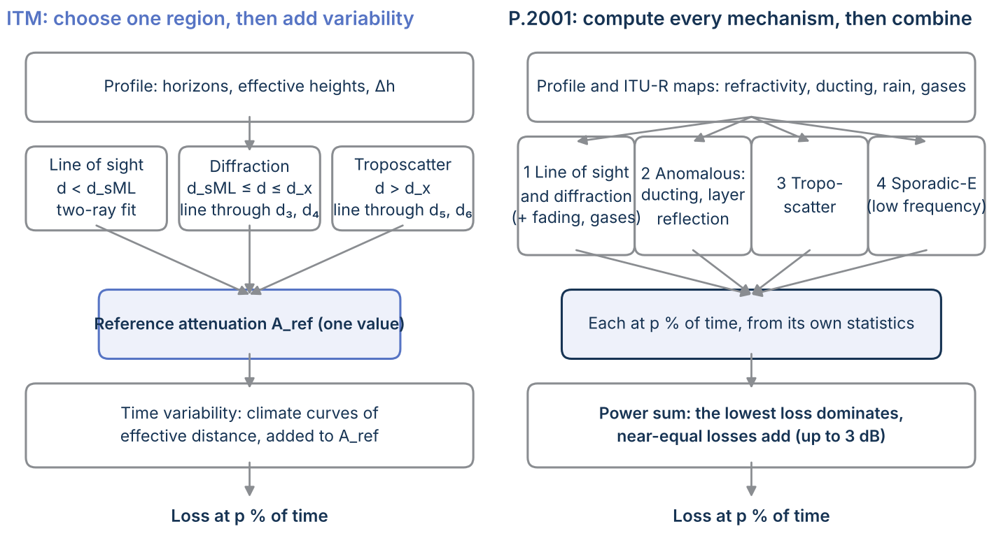
Figure 1. How each model builds its answer: ITM selects one region and adds a variability curve; P.2001 computes four sub-models, each with its own time statistics, and combines them.

Earth curvature and refraction
ITM takes a surface refractivity N_s, scales it to the path's mean elevation (N_s = N_0 exp(−h_s/9,460 m)), and sets the effective earth curvature γ_e = γ_a(1 − 0.04665 exp(N_s/179.3)), with γ_a the true curvature. That curvature is fixed: it is the same for every time percentage. P.2001 reads the median refractivity gradient in the lowest 1 km, N_d1km50 (negative; P.452's ΔN with the sign reversed), from an ITU-R map at the path's midpoint and sets the median effective radius a_e50 = 157 a/(157 + N_d1km50). For other time percentages it moves the gradient along map-derived slopes and recomputes the radius, so its diffraction loss is recomputed at each time percentage on a differently curved earth. On the smooth test path in central Kansas the median radii nearly match: 8264 km for ITM and 8317 km for P.2001 (N_d1km50 = -36.7 N-units per km). At 1% of time P.2001's radius grows to 12385 km, so the horizon moves out and the diffraction loss falls; ITM's earth stays the same and its variability term does that job instead.

Terrain analysis and effective heights
ITM reduces the profile to a few numbers: each terminal's horizon distance and elevation angle, the terrain irregularity Δh (the interdecile range of heights about a straight-line fit, starting the smaller of 15 antenna heights and a tenth of the horizon distance in from each end, corrected for the length of that span), and an effective height for each antenna: its height above ground plus any amount by which its ground stands above a least-squares fit to the terrain near it, so never less than the antenna's own height. Everything after that uses those numbers, not the profile. P.2001 also fits a smooth surface to find effective heights (one pair for diffraction and another for ducting) and a roughness parameter, but its diffraction method returns to the full profile to find the obstacle that matters. The consequence shows up in diffraction: on rough terrain ITM's numbers (short horizons, large Δh) drive its loss, while P.2001's loss depends on the one obstacle with the largest diffraction parameter.

Line of sight
ITM's line-of-sight method is a two-ray model: a direct ray plus a ground-reflected ray with a complex reflection coefficient for the ground constants and polarization, reduced for terrain roughness, blended with the extrapolated diffraction line by a weight that falls as Δh rises. It evaluates that loss at only two distances, d_0 = 0.04 f h_e1 h_e2 (limited to half the horizon distance) and a second point between d_0 and the horizon, then fits a smooth curve A_o + k_1 d + k_2 ln d through them and the diffraction line's value at the smooth-earth horizon. P.2001 has no ground reflection. Its sub-model 1 is L_bm1 = L_bfs + L_d + A_1 plus gaseous absorption: free space, the full diffraction loss of Attachment A at every distance (near zero until terrain enters the first Fresnel zone), and a fade A_1 that combines clear-air multipath and focusing with rain and sets the fades and enhancements over time.
At the median both models therefore stay at free space over smooth earth (Figure 3): within 0.1 dB for ITM and 0.7 dB for P.2001 out to 20 km, where a two-ray calculation swings from -6 dB to +46 dB with the interference lobes. Neither predicts the lobes: ITM's two-ray values only shape its fitted curve, and P.2001 leaves multipath to its statistics. The models leave free space as the earth enters the first Fresnel zone, P.2001 at 20.5 km and ITM at 25 km on this path.
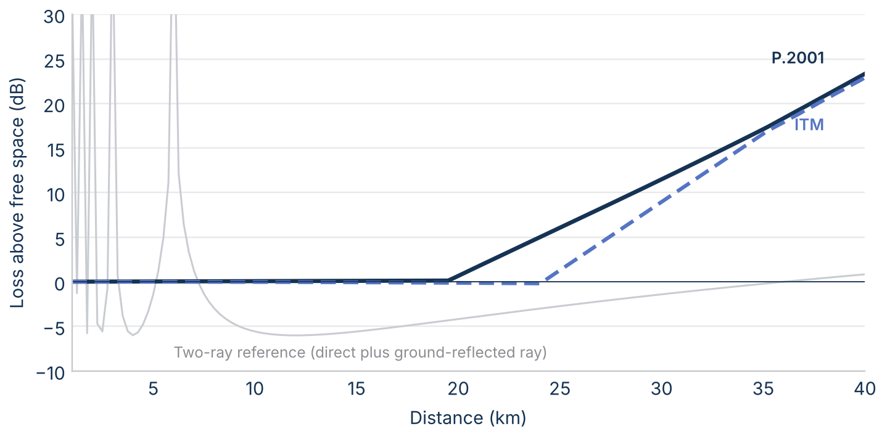
Figure 3. Loss above free space at 3 GHz and 50% of time over smooth earth within line of sight (30 m and 10 m antennas), with a two-ray reference for the same ground.

Diffraction
ITM computes diffraction at two distances beyond the horizons, not at the path: d_3 = max(d_sML, d_L + 5 X) and d_4 = d_3 + 10 X, where d_sML is the smooth-earth horizon distance, d_L the sum of the actual horizon distances, and X = (a_e²/f)^(1/3) is about 2.8 km at 3 GHz. At each it computes A_d = w A_se + (1 − w) A_k + A_fo: a smooth-earth loss (Vogler's three-radius method) weighted by w, a knife edge at each horizon, and a clutter term of up to 15 dB. It then draws a straight line through the two values and reads the loss at the path's distance from that line. The diffraction section of this paper breaks these terms down.
P.2001 computes diffraction at the path's own distance with the delta-Bullington method: L_d = L_dba + max(L_dsph − L_dbs, 0). L_dba is the loss over the actual profile, found from the single Bullington point where the lines from the two terminals to their steepest obstacles cross; L_dsph is the first-term spherical-earth loss; and L_dbs is the Bullington loss over a smooth profile, which keeps the spherical-earth loss from being counted twice. P.2001 adds its own empirical term to the knife-edge loss J(ν): L_dba = J(ν) + (1 − exp(−J(ν)/6))(10 + 0.02 d), up to 10 dB plus 0.02 dB per km once the edge is well into shadow, a counterpart to ITM's clutter term.
Figure 4 shows ITM's construction on two paths. On 120 km of smooth earth, d_3 and d_4 are 49.3 km and 77.6 km, the path is past the distance where ITM switches to troposcatter (67.9 km), and ITM's 62.5 dB above free space is close to P.2001's 59.7 dB. The rough western link (front range, 47 km) shows what happens on rough terrain (ITM raises no warning on it). The actual horizons total only 16.3 km, but ITM decides the region from the smooth-earth horizon of its effective heights, 74.1 km, so it treats the path as line of sight. Its line-of-sight values at d_0 and d_1 are themselves almost entirely the diffraction line extended back, because the weight on the two-ray term, 1/(1 + f Δh/d_sML), is tiny when Δh is nearly 1 km. ITM's result, 134 dB above free space, is read from a curve that ends at its diffraction value of 150 dB at 74 km, well beyond the path; P.2001's delta-Bullington loss at the path is 64 dB. The experiments later in this section test how much of the gap that construction explains.
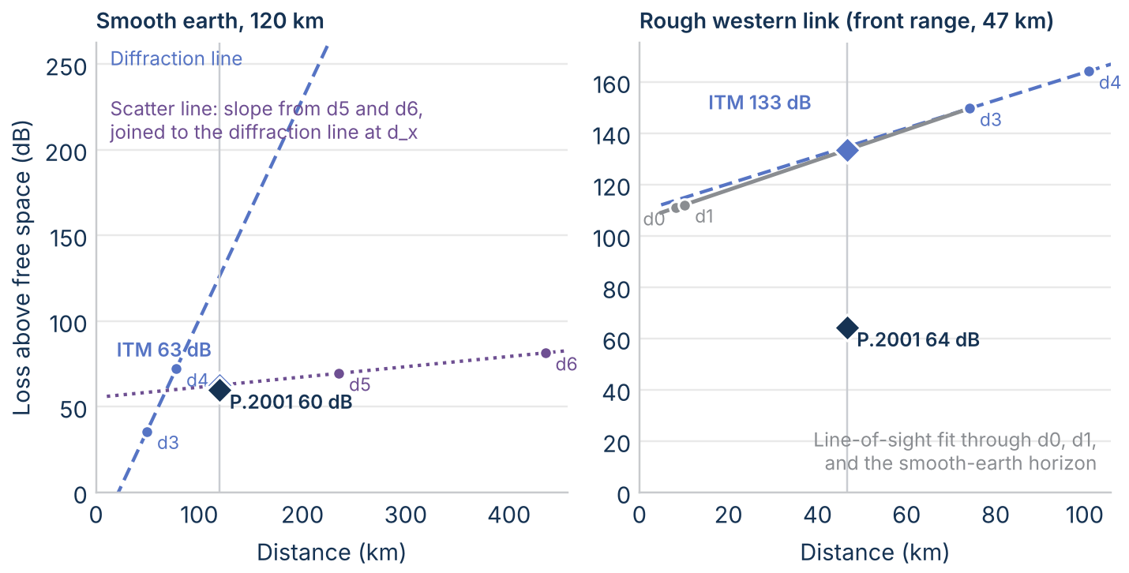
Figure 4. ITM's construction at 3 GHz and 50% of time on two paths: the diffraction line through its values at d₃ and d₄, the scatter line, and each model's result at the path's distance (diamonds).

Troposcatter
ITM's troposcatter loss is the Rice et al. method of NBS Technical Note 101: A_s = F(θd) + 10 log(k H θ⁴) − 0.1(N_s − 301) exp(−θd/40 km) + H_0, with θ the scattering angle, F an attenuation function of θd, and H_0 a frequency-gain function of the effective heights. As with diffraction it evaluates this at two fixed distances, d_L + 200 km and d_L + 400 km, takes the slope, and joins the scatter line to the diffraction line at the crossover distance d_x. P.2001's sub-model 3 reads a climate zone (one of six, or sea) at the common volume from an ITU-R map, and computes L_bs = M + L_freq + L_dist + L_coup − Y_p from that zone's meteorological parameter, the frequency, the scattering angle and distance, the antenna coupling, and a time-percentage term; it never lets troposcatter fall below free space, and it adds gaseous absorption and rain on the two legs to the common volume.
Over smooth earth the two troposcatter methods agree closely (Figure 2, left): from 50 km to 400 km at 50% of time ITM minus P.2001 stays between -2.3 dB and 2.1 dB, and both hand over from diffraction to troposcatter at about 68 km. Across the whole sweep from 3 km to 700 km the models never differ by more than 5.1 dB at the median.

Ducting and layer reflection
ITM has no ducting mechanism. Its low-percentage losses come from its variability curves, which are fitted to measured distributions and so include ducting only as an average effect. P.2001's sub-model 2, shared with P.452, is L_ba = A_ac + A_ad + A_at: a coupling loss into the duct (site shielding by the terminals' horizons and over-sea corrections), a loss proportional to the angular distance, and a time-dependent loss that depends on a ducting percentage β taken from an ITU-R map and adjusted for the path's terrain and land fraction. On the smooth path ducting takes over from 26 km at 1% of time (Figure 2, right); at 120 km P.2001 predicts 153.5 dB against ITM's 180.5 dB, a difference of 27 dB. The ducting section of this paper looks at this on real paths.
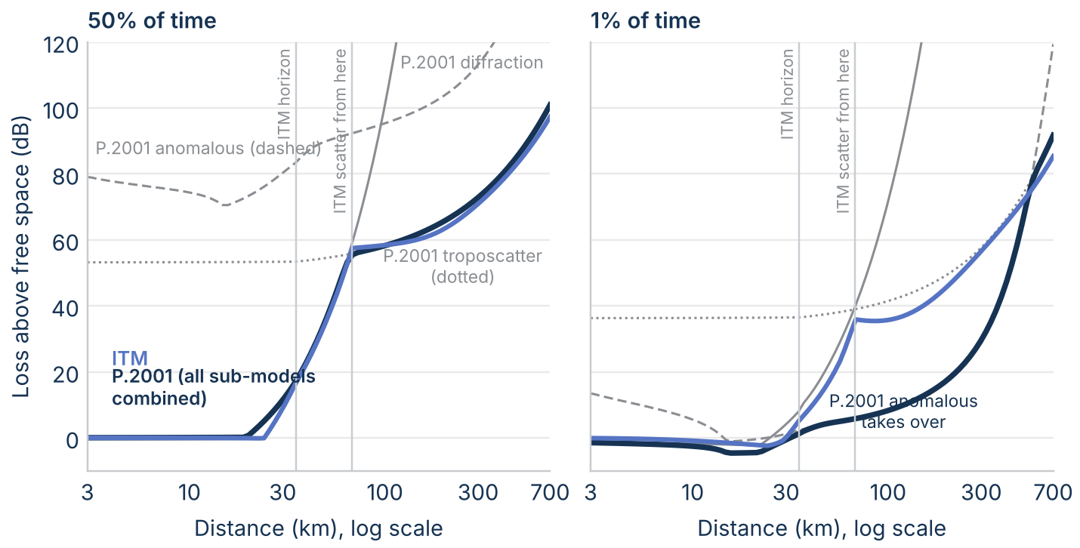
Figure 2. Loss above free space over smooth earth at 3 GHz (30 m and 10 m antennas, central Kansas), at 50% and 1% of time: ITM's single result, P.2001's sub-models (thin gray), and P.2001's combined result.

Sporadic-E, gases, rain, and fading
P.2001 models four more effects that ITM leaves to its empirical constants. Sporadic-E reflection (sub-model 4) matters for long paths at low frequencies; at 3 GHz its loss is millions of decibels above the others and plays no part. Gaseous absorption follows Recommendation ITU-R P.676 along the surface path and the troposcatter legs. Rain and wet-snow fading and clear-air multipath fading are combined as mutually exclusive conditions (the time percentages add) and set the high-percentage tail. At 3 GHz these terms are small at the median (gaseous absorption is under 0.01 dB per km) but shape the tails of the time distribution.

Variability over time
ITM adds a variability term to A_ref. It converts the path to an effective distance d_e (130 km at a reference distance set by the effective heights and frequency, scaled linearly below it and offset above it) and reads the time variability from climate-dependent curves of d_e. The shape of the distribution depends on the climate, d_e, and frequency, not on which region produced A_ref. In P.2001 the distribution comes from the mechanisms: diffraction varies through the effective earth radius, ducting through β, troposcatter through Y_p, and fading through Attachments B and C, and the combination at each time percentage decides which one sets the loss.
On the smooth 120 km path (Figure 5, left) ducting sets P.2001's loss up to 10% of time, and its loss from 1% to 99% of time spans 67 dB against 39 dB for ITM; above about 20% both follow troposcatter and agree. On the rough western link (right) P.2001's loss is diffraction at all percentages and changes by only 2.8 dB, because the effective earth radius barely matters behind high nearby horizons, while ITM applies its full variability curve and spans 11 dB.
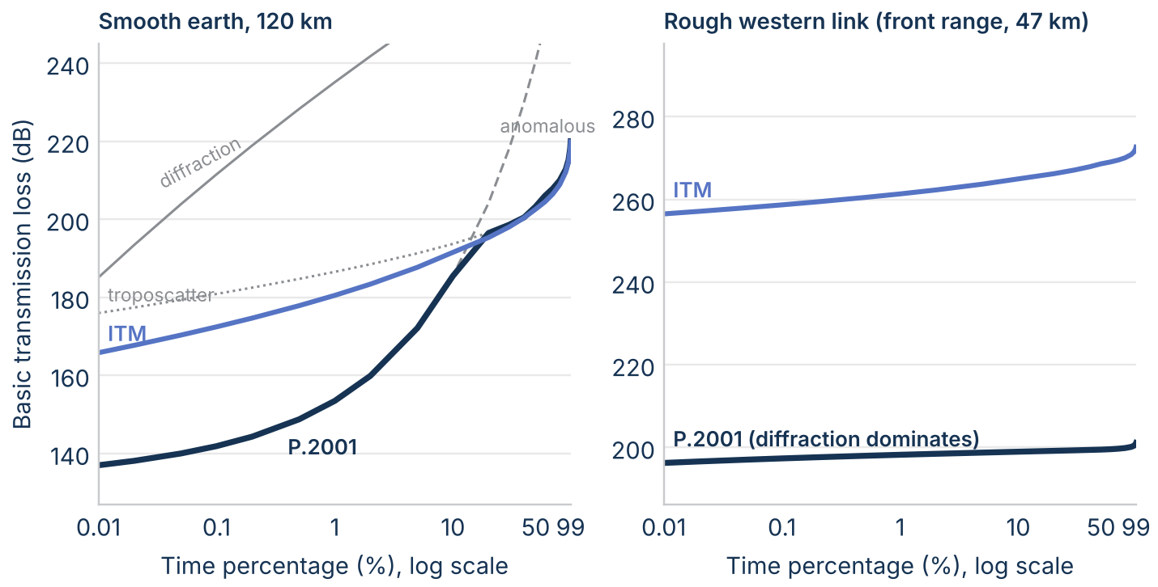
Figure 5. Basic transmission loss against time percentage at 3 GHz: ITM, P.2001's sub-models (thin gray), and P.2001's combined result, on 120 km of smooth earth and on the rough western link.

Do the models agree on the mechanism?
ITM reports the region it used, and P.2001's dominant mechanism is the sub-model with the lowest loss. On the 120 real links at 3 GHz (60 eastern and 60 western), the two agree on 94 at 50% of time (Figure 6). Most of the disagreements are links where ITM uses its troposcatter line and P.2001 says diffraction dominates: 26 of the 30 links ITM calls troposcatter. On those links ITM's scatter line starts from its diffraction line at the crossover distance, so it carries the diffraction level forward. At 1% of time the models agree on 80 links, and P.2001 names ducting on 16 links where ITM has no such mechanism.
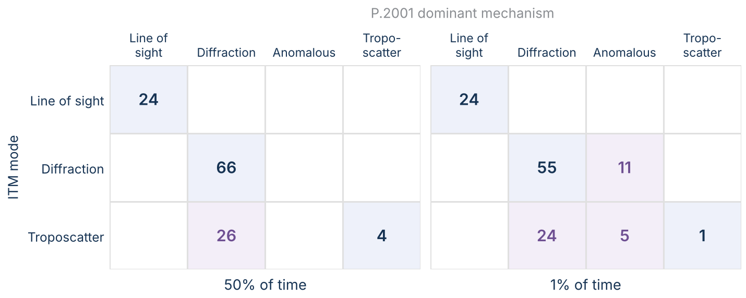
Figure 6. Number of links (120: 60 eastern, 60 western) by ITM's propagation mode and P.2001's dominant mechanism at 3 GHz, at 50% and 1% of time. Shaded blue: the models agree.

Testing the diffraction geometry
Three synthetic experiments from the plan in the next section isolate the diffraction geometry, using profiles where the right answer is known or the inputs can be controlled. They run both models on the same profiles at 3 GHz and 50% of time with the same antennas as above (diffraction_families_rev1).
Two ridges. A 30 km path over flat ground carries two triangular ridges, 300 m wide at the base, at 10 km and 20 km, each 0 m to 300 m high. For a reference, two classical multiple-knife-edge methods were computed on the same geometry with the knife-edge loss of Recommendation ITU-R P.526: Epstein-Peterson, which takes each edge against the line joining its neighbours, and Deygout, which takes the main edge first and then the edge on each side of it. With both ridges 280 m high, the references give 63 dB and 68 dB above free space, P.2001 50 dB, and ITM 127 dB (Figure 7). Over all 256 ridge pairs, P.2001 is within 10 dB of the references' midpoint in 65% of cases, with a median of 8.9 dB; ITM is never within 10 dB, and its median is 37 dB above. P.2001 is high for a single ridge (46 dB against 36 dB to 38 dB for one 280 m ridge, mostly its empirical add-on of 10 dB plus 0.02 dB per km) and low for two equal ridges, the known weakness of a single equivalent edge.
ITM's excess has a specific cause in its code. Its terrain irregularity Δh is at most 4.7 m on these profiles, because narrow ridges barely move an interdecile range, so the weight w puts most of its diffraction loss on the smooth-earth term. That term takes its curvature radii from the short horizon distances the ridges create, and the path is in ITM's line-of-sight region (d is less than d_sML on all 256 profiles), so the result is read from the line-of-sight fit that ends at that diffraction value.
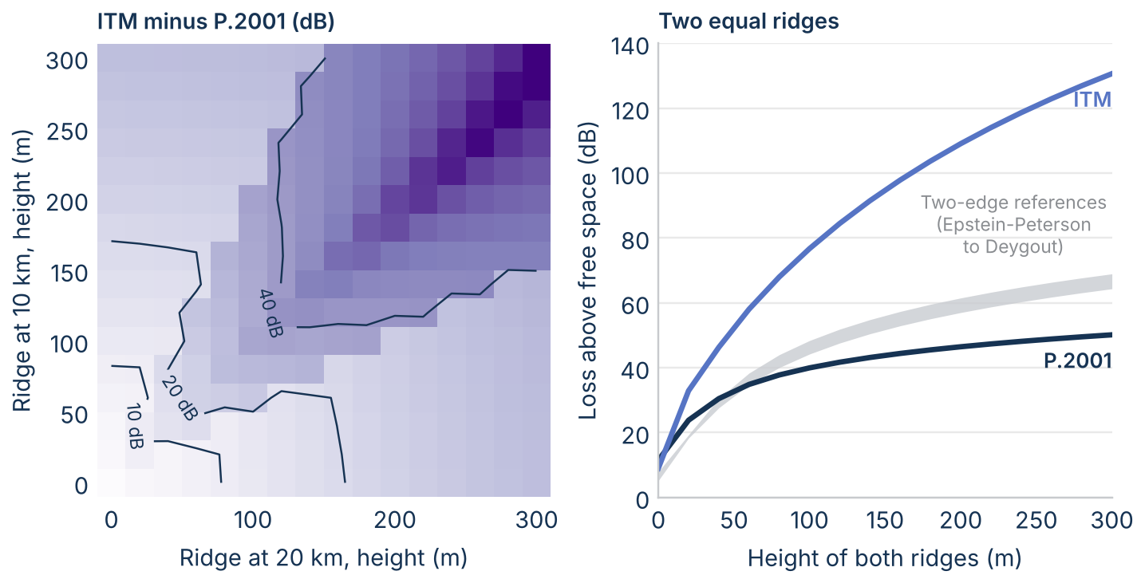
Figure 7. Two triangular ridges on a 30 km path at 3 GHz: ITM minus P.2001 for every pair of heights (left), and loss above free space for two equal ridges with the Epstein-Peterson and Deygout references (right).
Synthetic rough terrain. 1,120 profiles of filtered random terrain (2 km correlation length) were scaled to a target roughness, the interdecile range of heights about a straight-line fit, from 10 m to 1,000 m, at lengths of 10 km to 150 km, 20 per cell. The median gap follows roughness (Figure 8): -2 dB to 4 dB at 10 m, -2 dB to 24 dB at 100 m, 23 dB to 51 dB at 500 m, and 47 dB to 68 dB at 1,000 m. At 150 km the models agree within 0.9 dB up to 200 m, where both are troposcatter. This reproduces the divergence window found on real links (rough terrain, shorter than about 100 km) from terrain with no other structure, so the window comes from the models, not from features of the sampled regions. ITM flags a horizon angle over 200 mrad on 6% of these profiles, almost all at 1,000 m. ITM's own Δh differs from the target because of its distance correction: about 2.8 times the target at 10 km and 1.0 times at 150 km.
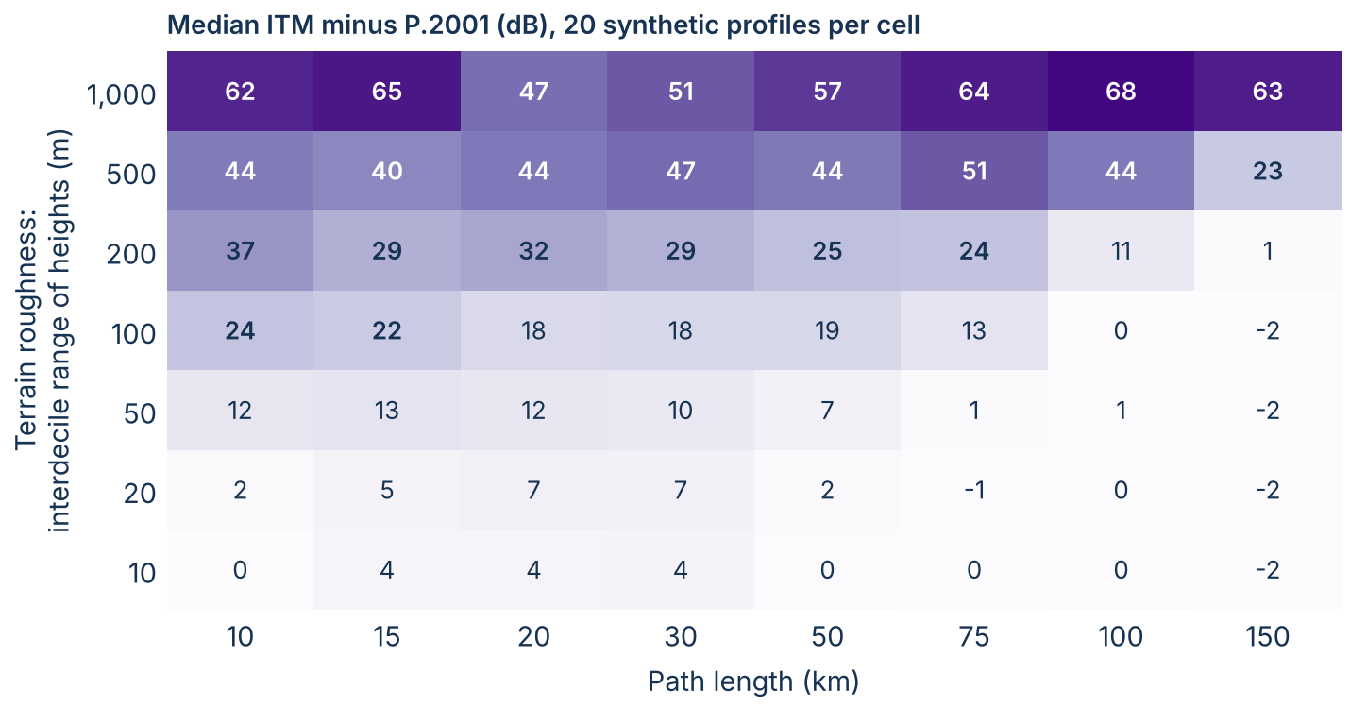
Figure 8. Median ITM minus P.2001 at 3 GHz and 50% of time on synthetic rough terrain, by roughness (interdecile range of heights about a straight-line fit) and path length; 20 profiles per cell.
Moving P.2001's evaluation point. To test whether ITM's habit of computing diffraction beyond the path explains the gap, P.2001 was given the same construction: flat terrain was inserted midway between ITM's two horizon points to lengthen each path to ITM's d_3 and d_4 without moving either horizon, and P.2001's loss at those lengths was extended back to the true distance. On the 54 of 120 real links where this applies, the median gap went from 45 dB to 49 dB, and it narrowed by more than half on only 1 link (Figure 9). Where ITM evaluates its diffraction is not, by itself, the source of the gap.
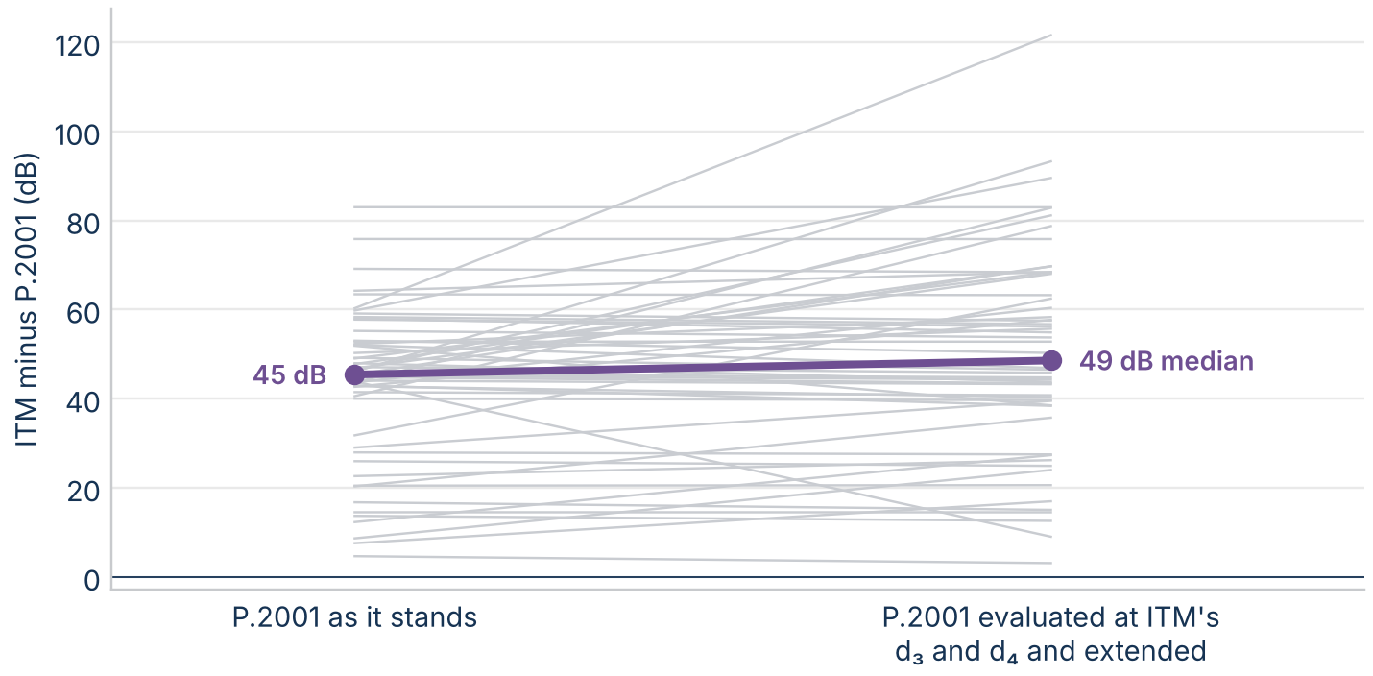
Figure 9. ITM minus P.2001 at 3 GHz on the real links where ITM's d₃ lies beyond the path, with P.2001 as it stands and with P.2001 computed at ITM's d₃ and d₄ and extended back to the path.
Together the experiments point at how ITM splits its diffraction loss rather than where it evaluates it: on rough or ridged terrain, ITM's horizon-based terms (two knife edges and a smooth-earth term with radii from short horizons) produce losses well above both P.2001 and the classical two-edge references. P.2001's single edge errs the other way on multiple equal obstacles. This matches the ITS mountain measurements, where the measured loss fell between the two models.

The terms side by side
Five more items from the plan put the two models' terms next to each other on the same paths (term_splits_rev1). ITM's terms come from a function that recomputes them from ITM's own equations and checks that they rebuild ITM's reference attenuation to within 10⁻⁹ dB.
Smooth-earth diffraction. Both models carry a smooth-earth diffraction formula: Vogler's three-radius method in ITM and the first-term spherical-earth loss in P.2001. Over smooth earth from 40 km to 300 km they agree within 0.7 dB to 1.9 dB for vertical polarization and 0.8 dB to 3.2 dB for horizontal (Figure 10); at 150 km, for example, 166.8 dB against 165.9 dB. The physics of a smooth earth is not where the models differ.
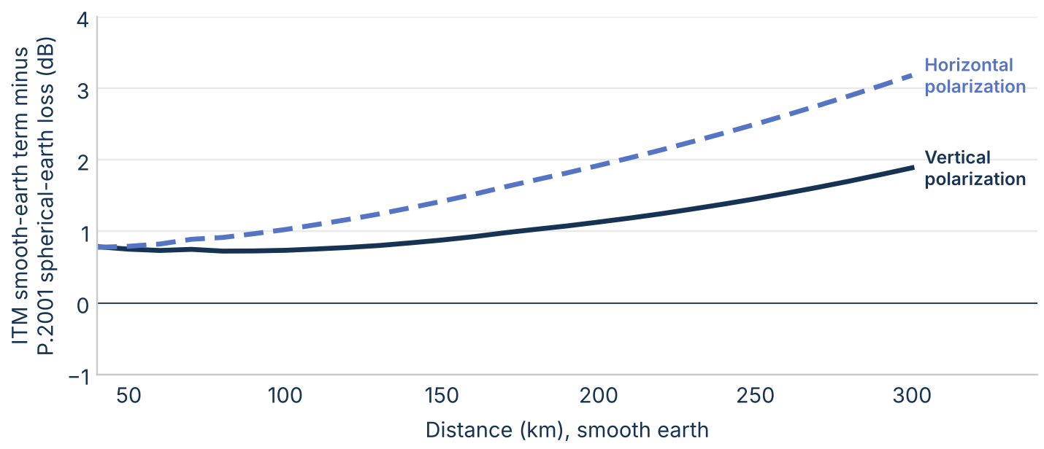
Figure 10. ITM's smooth-earth diffraction term minus P.2001's spherical-earth diffraction loss over smooth earth at 3 GHz, 30 m and 10 m antennas, both polarizations.
Where the diffraction gap comes from. On the 59 real links ITM classes as diffraction (of 66; the other seven end within a metre of ITM's horizon distance, where its terms at the path aren't defined), the difference splits exactly into five parts (Figure 11). Of a mean gap of 41.5 dB, 15.5 dB comes from ITM's knife edge at each horizon against P.2001's single Bullington edge, and 14.8 dB from ITM's weighted smooth-earth term, which ITM always adds; P.2001 adds its spherical-earth loss only where it exceeds the Bullington loss over a smooth profile, and on these links that excess has a median of 0 dB. ITM's clutter term outweighs P.2001's empirical add-on by 2.3 dB, extending the diffraction line from d_3 and d_4 back to the path adds 9.1 dB (median 3.6 dB), and gases and P.2001's other terms take off 0.2 dB. At the path, the median ITM terms are 12.5 dB of weighted smooth earth, 59.1 dB of weighted knife edges, and 13.9 dB of clutter; P.2001's are 41.8 dB of knife edge and 10.7 dB of add-on.
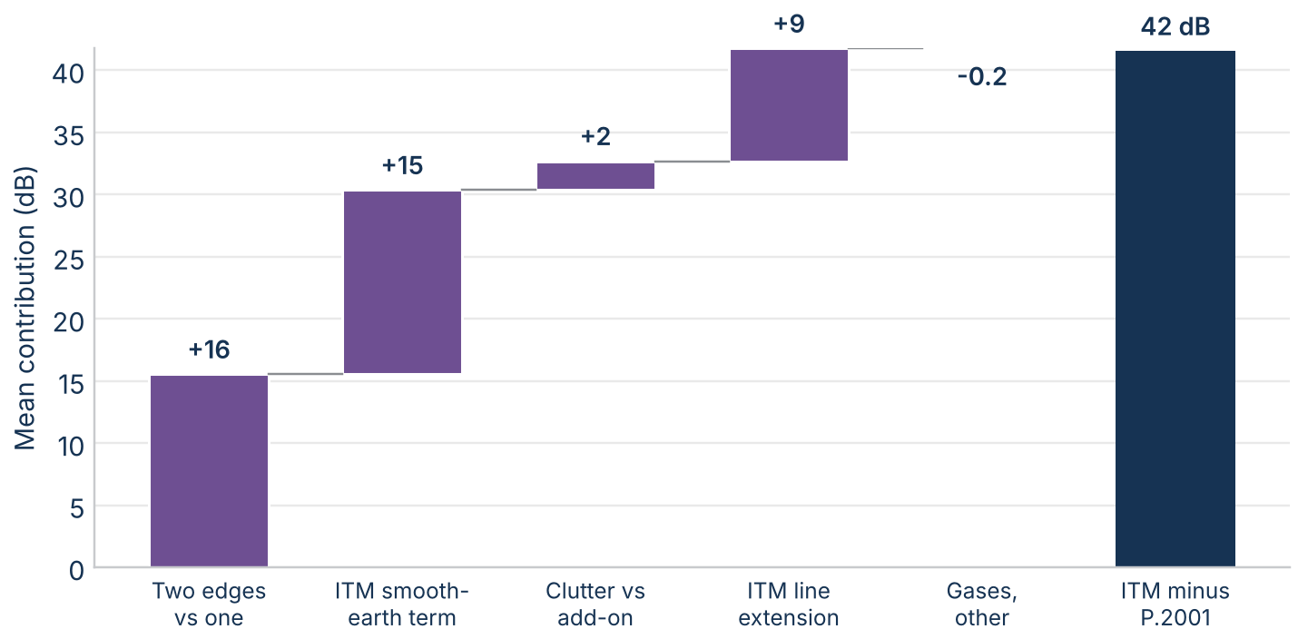
Figure 11. Mean ITM minus P.2001 loss on the real diffraction links at 3 GHz and 50% of time, split into its parts; the parts add to the total.
The empirical add-ons. Each model adds an empirical term to its diffraction loss, and they are similar in size (Figure 12). ITM's clutter term A_fo runs from 5.4 dB to its cap of 15 dB (median 13.9 dB; at the cap on 20 links), set by the antenna heights, frequency, and terrain roughness. P.2001's add-on runs from 8.6 dB to 12.4 dB (median 10.7 dB) and grows with path length (correlation 0.8), as its formula, 10 dB plus 0.02 dB per km once the edge is well into shadow, implies.
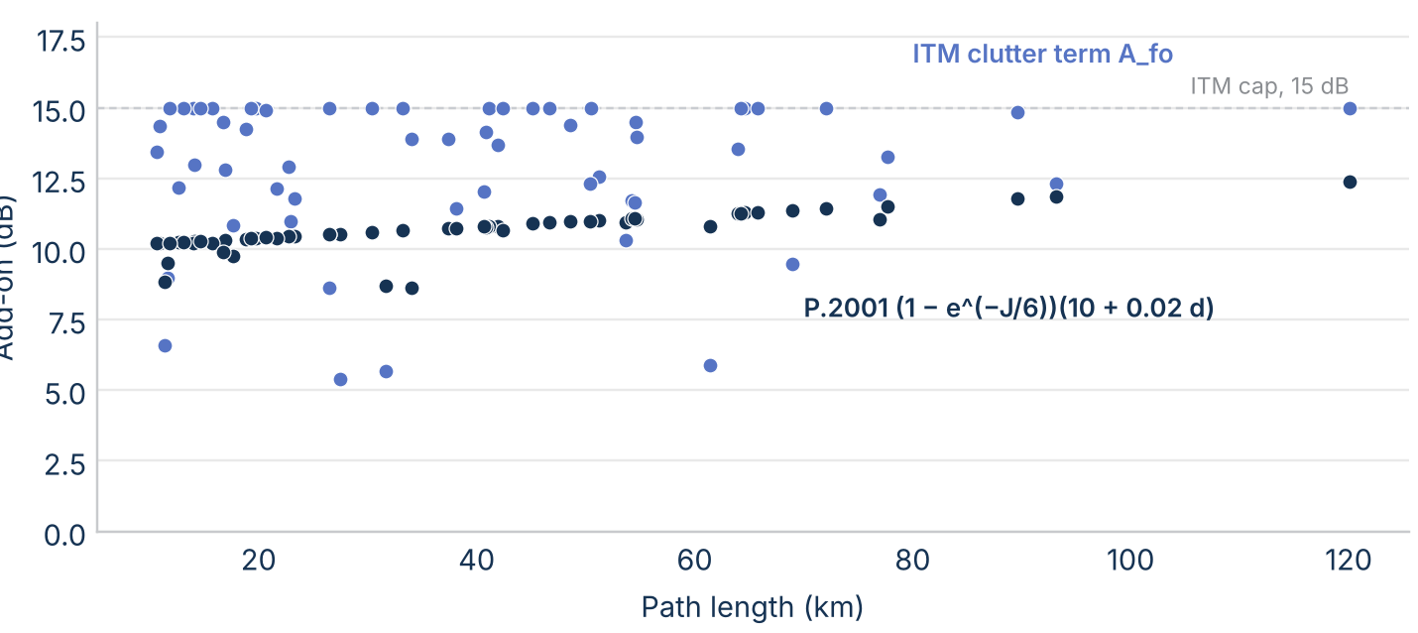
Figure 12. Each model's empirical diffraction add-on on the real diffraction links at 3 GHz: ITM's clutter term A_fo and P.2001's term in eq. (A.23).
The ducting terms. P.2001's ducting loss is the sum of a coupling loss, an angular-distance loss, and a time-dependent loss (Figure 13). On the smooth path at 1% of time, the coupling loss is 138 dB to 143 dB at every distance (it includes 102.45 + 20 log(f(d_lt + d_lr)), with the terminals' horizon distances, and site shielding); the angular-distance loss grows from 1.1 dB at 50 km to 33.5 dB at 500 km; and the time term rises from -3.9 dB to 44.5 dB. The result is far below ITM at moderate distances, 10.4 dB above free space against ITM's 37.4 dB at 125 km, and the two come within 4 dB of each other near 500 km (68.5 dB against 72.4 dB). On the 120 real links at 1% of time the ducting sub-model gives less loss than diffraction on 17.
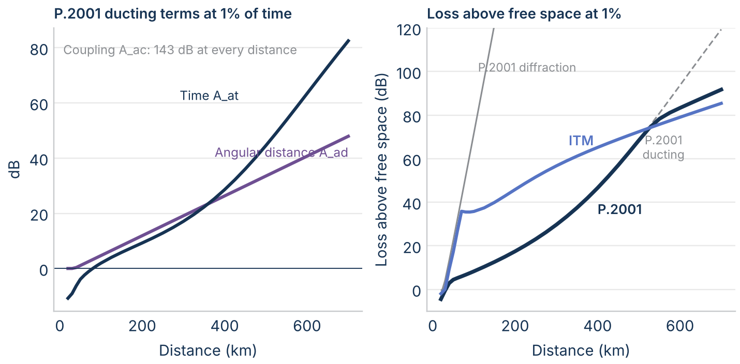
Figure 13. P.2001's ducting terms (Attachment D) over smooth earth at 3 GHz and 1% of time, and the resulting loss above free space against ITM's and P.2001's other sub-models.
Combining the sub-models by Monte Carlo. The Recommendation calls its single-percentage blend an approximation and gives a Monte Carlo method for combining the uncorrelated sub-models correctly: draw an independent time percentage for each, read its loss, and add the powers (sec. 5.3, eq. 60). Applied with 200,000 draws on five paths (Figure 14), the two methods agree within about 0.3 dB, the Monte Carlo sampling noise, up to a few percent of time, which is where interference studies usually work. They part in the middle of the distribution, where troposcatter and diffraction or ducting are comparable and uncorrelated: at 50% of time the Monte Carlo loss is 3.0 dB lower on 120 km of smooth earth, 2.0 dB lower at 300 km, and 5.6 dB lower on the over-sea path (up to 5.8 dB at 60%). Where one mechanism dominates, as on the rough western link, they agree. The blend therefore overstates the loss in the middle of the distribution, which matters for medians and coverage rather than for small-percentage interference.
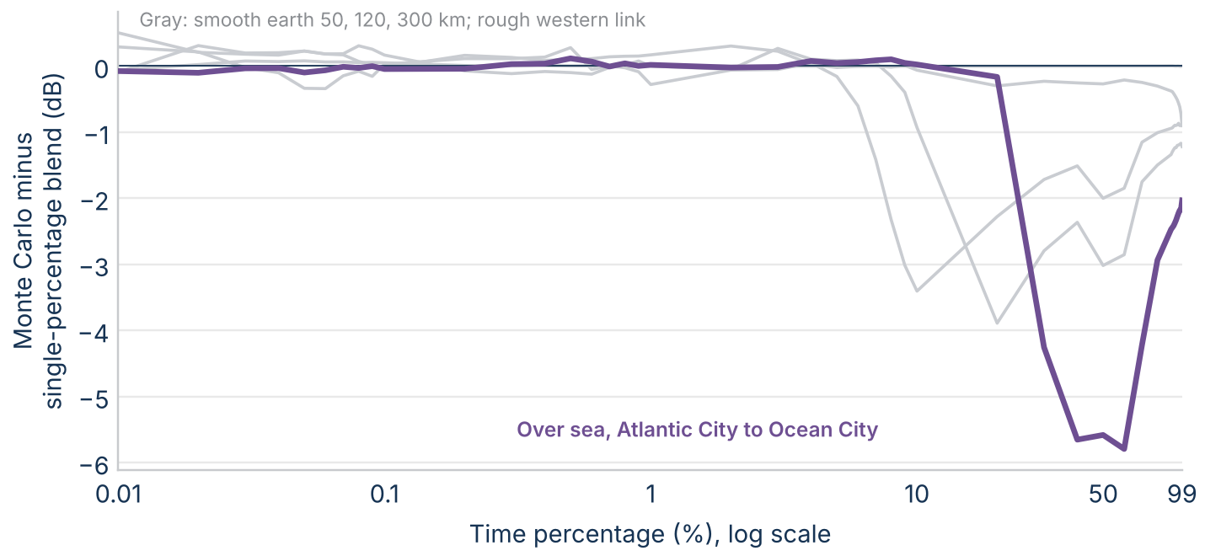
Figure 14. P.2001's loss combined by the Monte Carlo method of sec. 5.3 minus the single-percentage blend of sec. 5.2, at 3 GHz on five paths.

Checks on the inputs and the implementations
Five more items from the plan test whether the gap could come from how each model reads the terrain or from a fault in either implementation, rather than from the equations themselves (implementation_checks_rev1). All use the 120 real links at 3 GHz and 50% of time.
Roughness. ITM measures roughness as the interdecile terrain range Δh; P.2001 uses a roughness height h_m above a smooth fit. The two rank the links almost the same way (Spearman correlation 0.88), with medians of 78 m and 52 m on the eastern links and 627 m and 508 m on the western links (Figure 15). The gap follows either measure about as closely (correlations 0.78 and 0.81). So the gap isn't an artifact of ITM's choice of roughness measure: the models see the same rough paths and respond to them differently.
Effective antenna heights. The effective heights differ more. Across 240 terminal ends, the median is 69 m for ITM, 121 m for P.2001's diffraction heights, and 50 m for its ducting heights. P.2001's diffraction height is the larger on 60% of ends; the median difference is 35 m and the largest 953 m. Neither model ever sets an effective height below the structural height. Higher effective heights tend to lower P.2001's smooth-earth loss, so this input difference adds to the gap rather than offsetting it; the effective-height swap below measures by how much.
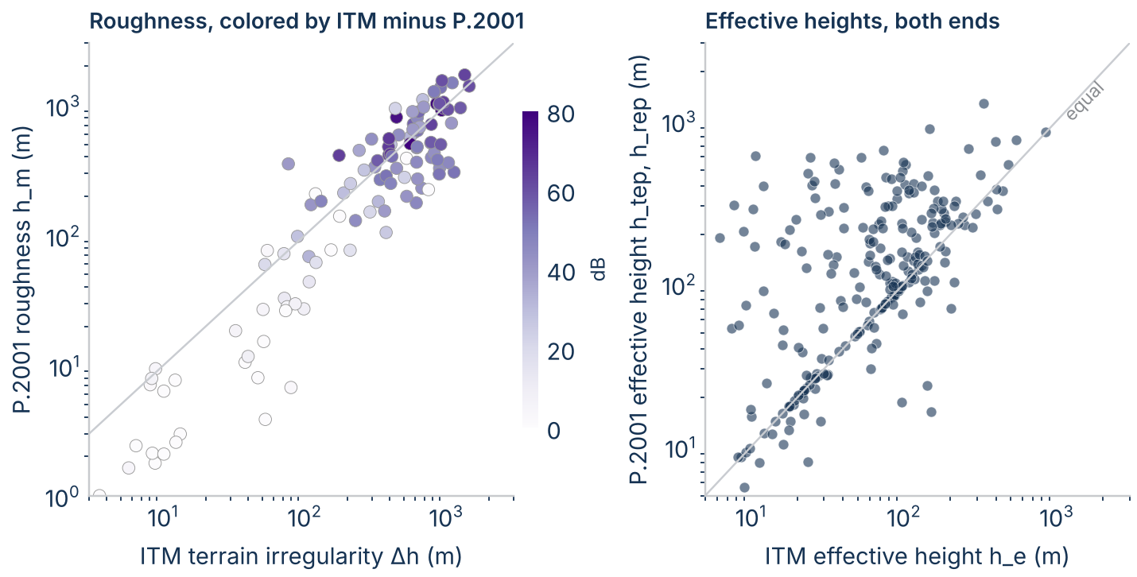
Figure 15. Left: ITM's terrain irregularity against P.2001's roughness height on the real links, shaded by ITM minus P.2001 at 3 GHz and 50% of time. Right: ITM's effective antenna height against P.2001's diffraction effective height, both terminals of every link.
Earth radius. The median effective earth radius is 8,596 km for ITM and 8,424 km for P.2001; on single links ITM's is 1,349 km smaller to 425 km larger. To test whether this matters, each model was rerun with the other's radius. ITM's loss changes by a median of 0.1 dB (at most 1.7 dB) and P.2001's by less than 0.1 dB (at most 9.1 dB). The median gap is 40.5 dB as run, 40.2 dB with ITM on P.2001's radius, and 40.4 dB with P.2001 on ITM's (Figure 16). Earth radius doesn't explain the gap.
Reciprocity. Swapping the two terminals should leave a point-to-point loss unchanged. P.2001's loss changes by at most 0.01 dB. ITM's changes by more than 0.01 dB on 8 links, by at most 0.59 dB. That is small against the gap but isn't rounding; its cause is explained under "Remaining terms and checks" below.
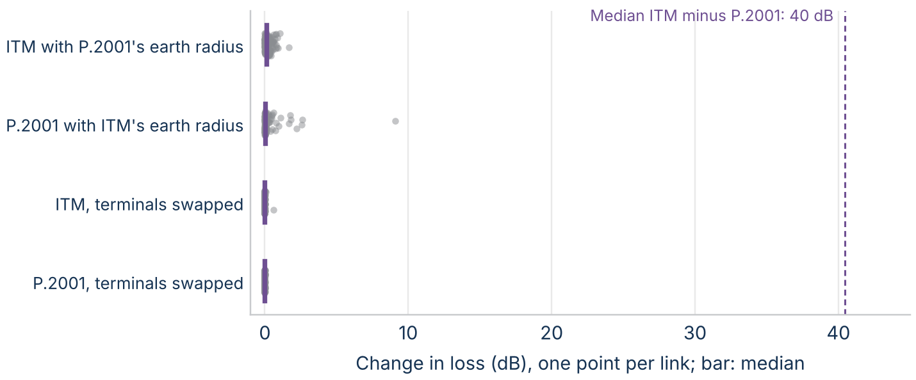
Figure 16. Change in each model's loss on the real links at 3 GHz and 50% of time when it uses the other model's effective earth radius, or when the terminals are swapped, against the median ITM minus P.2001 difference.
Continuity. Both models were run every 100 m along two paths. Over smooth earth from 1 km to 300 km, neither steps by more than 0.2 dB between points, including at their mode changes. Along a real Piedmont radial to 150 km, both step where new obstacles come into view, but ITM's steps are larger and more frequent: the largest is 34.2 dB for ITM and 15.7 dB for P.2001, with 145 and 57 steps over 3 dB (Figure 17). ITM changes mode 50 times along the radial and P.2001 changes its dominant mechanism 4 times. The jumps come from the terrain, not from discontinuities in either model's formulas. ITM's larger steps fit its construction: a new horizon changes its knife-edge terms, and each longer profile changes its Δh. Past about 85 km the radial runs over flat ground and the two models settle within a few decibels of each other.
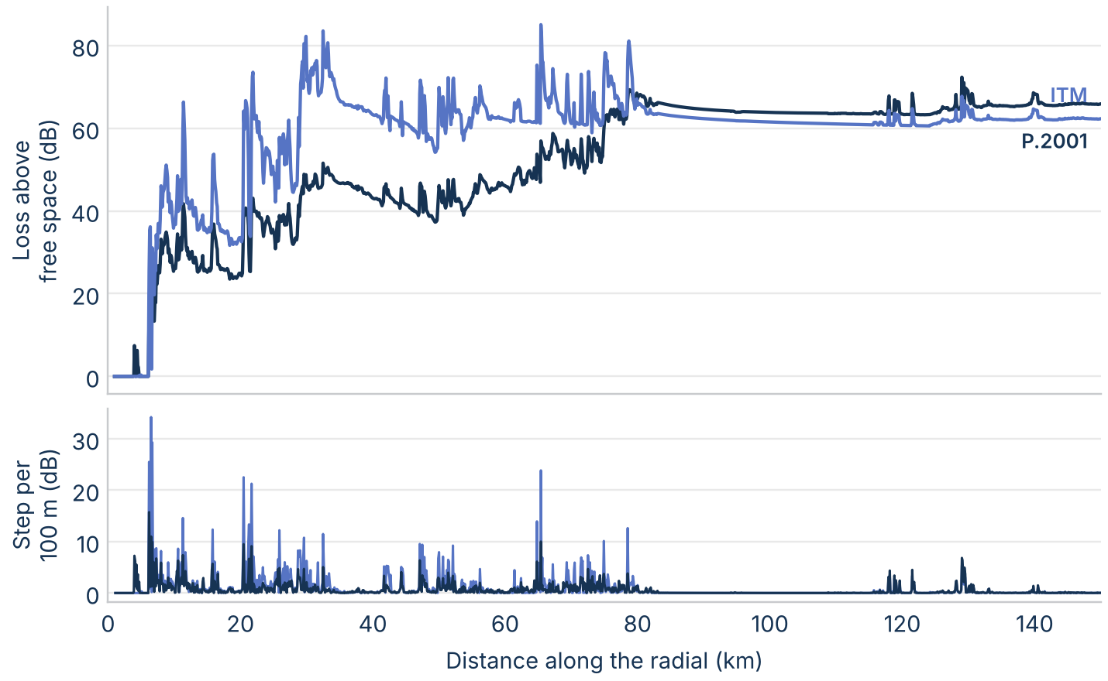
Figure 17. Loss above free space every 100 m along a Piedmont radial at 3 GHz and 50% of time (top), and the absolute change between neighboring points (bottom).

Time distributions
Three items from the plan compare how the models spread the loss over time: troposcatter by climate on smooth earth, and the shape of the predicted distributions against the databank measurements (timedist_rev1).
Troposcatter by climate. Both models pick their troposcatter statistics by climate, but from different classifications: ITM from seven radio climates, P.2001 from six zones and a sea-path class read from a map at the common volume (Table E.1). Over smooth earth from 70 km to 700 km at 3 GHz (30 m and 10 m antennas), ITM is in its troposcatter mode for every climate. With N_0 held at 301 for all climates, so that only ITM's variability curves change, its loss at 50% of time spans 57.5 dB to 69.3 dB above free space across the climates at 150 km and 67.7 dB to 81.1 dB at 300 km. P.2001's troposcatter loss spans 47.2 dB to 67.5 dB and 57.4 dB to 77.7 dB across its zones, a wider range set mostly by zone 3, which has the lowest M in Table E.1 (109.3 dB, against 116 dB to 129.6 dB for the others) (Figure 18). For the Kansas path, ITM's continental temperate climate and the zone P.2001 reads from its map (zone 6) agree at 50% of time at every distance: ITM minus P.2001 runs from −1.2 dB to 2.0 dB. At 300 km they agree at 1% of time too (56.7 dB and 56.2 dB above free space), but P.2001's combined loss there is 29.7 dB because ducting dominates. The spread from 1% to 99% of time depends on the climate more in ITM than in P.2001: at 300 km it is 20.6 dB to 53.9 dB across ITM's climates and 20.7 dB to 42.6 dB across P.2001's zones. The two classifications don't map one to one, so a study that runs both models needs to choose the climate inputs together.
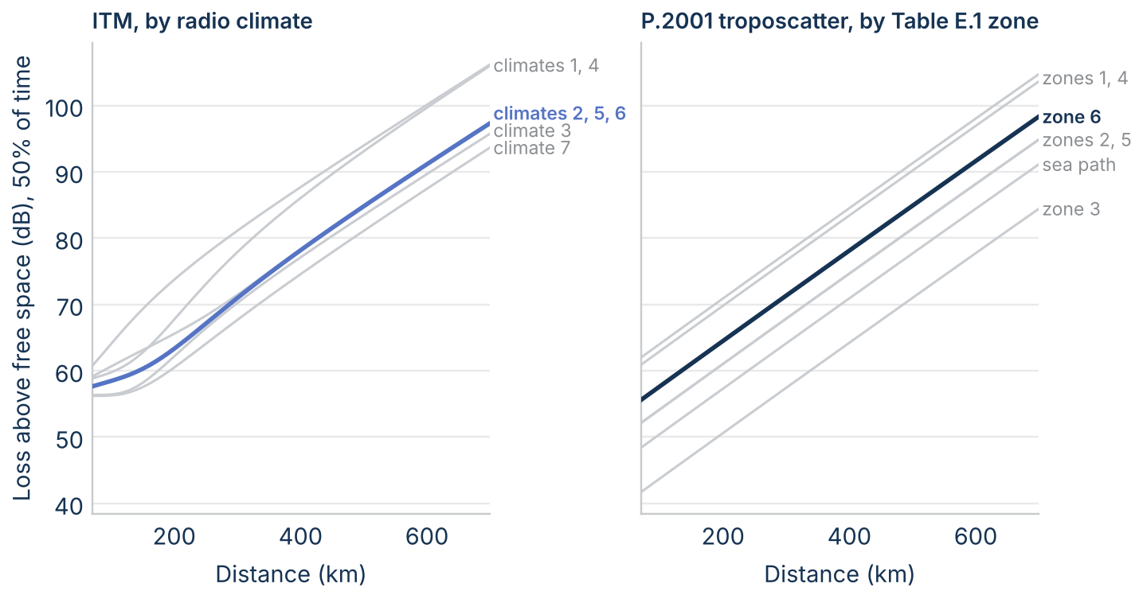
Figure 18. Loss above free space at 50% of time over smooth earth in central Kansas at 3 GHz (30 m and 10 m antennas): ITM for each radio climate with N_0 = 301 (1 equatorial, 2 continental subtropical, 3 maritime subtropical, 4 desert, 5 continental temperate, 6 maritime temperate over land, 7 maritime temperate over sea), and P.2001's troposcatter loss for each Table E.1 zone. Highlighted: ITM's continental temperate climate and the zone P.2001 reads from its map for this path.
Measured distributions. The databank gives measured loss at 1%, 10%, 50%, 90%, and 99% of time on 379 of the datasets kept by the quality screen (82 of them at 1 GHz and above). Subtracting each distribution's own 50% value removes each model's median bias and leaves only the shape, which is what the time-variability equations set. The median absolute error in that shape is 5.9 dB for ITM and 6.4 dB for P.2001 at 1% of time (5.7 dB for P.452 on the 283 datasets it covers), 2.9 dB and 2.4 dB at 10%, 2.2 dB and 1.9 dB at 90%, and 4.1 dB and 3.3 dB at 99% (Figure 19). P.2001 is closer to the measured shape at 99% on 64% of datasets; at 1% and 10% neither model is closer more often than the other (46% and 51%).
The spread from 1% to 99% of time has a median of 26.9 dB measured, 36.0 dB for ITM, and 31.0 dB for P.2001. Path by path, the predicted spread is off by a median of 9.2 dB for ITM and 8.6 dB for P.2001, and is within 5 dB of the measurement on only 30% of datasets for ITM and 30% for P.2001; the rank correlations with the measured spread are 0.58 and 0.62. The errors follow the mechanism. On the 207 paths ITM classes as troposcatter, both models predict more enhancement at 1% of time than was measured (median shape errors −4.8 dB and −6.6 dB). On the 68 line-of-sight paths both predict too narrow a distribution (median spread errors −6.6 dB and −2.2 dB). At 1 GHz and above, the median absolute error at 1% of time is 7.2 dB for ITM and 7.1 dB for P.2001. On single paths near 2 GHz, each model follows the measurement closely on some paths and misses it by tens of decibels on others (Figure 20).
So the measurements don't favor either model's time-variability equations for small time percentages; both carry an uncertainty of several decibels on any one path. P.2001 follows the deep fades at 90% and 99% of time somewhat better. A choice between the models for interference at small percentages therefore rests more on the mechanisms each represents, such as P.2001's explicit ducting, than on measured skill in the databank.
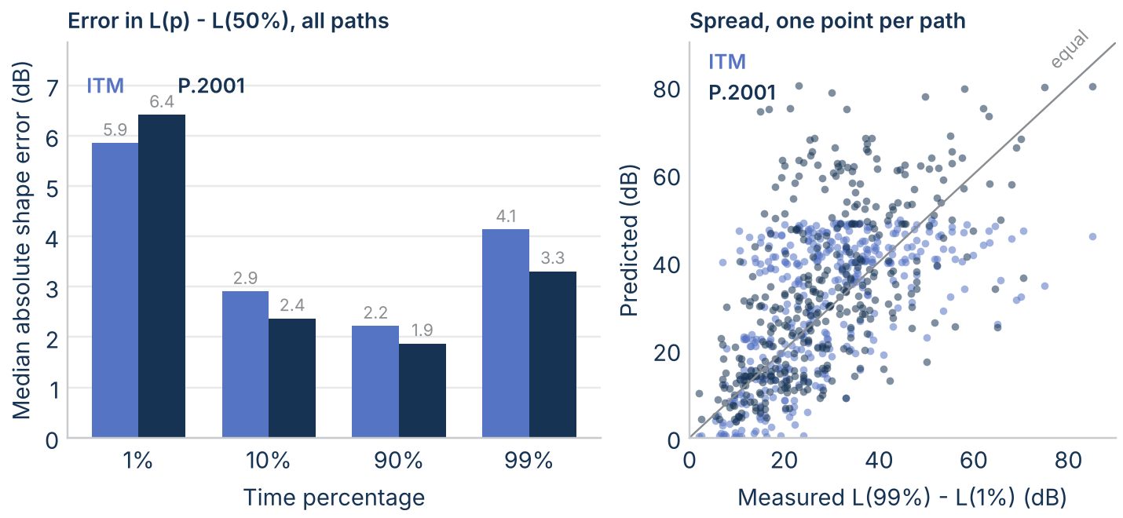
Figure 19. Left: median absolute error in the predicted loss at each time percentage minus the 50% loss, against the measured value, on the databank datasets from 30 MHz to 10 GHz. Right: predicted against measured spread from 1% to 99% of time, one point per dataset.
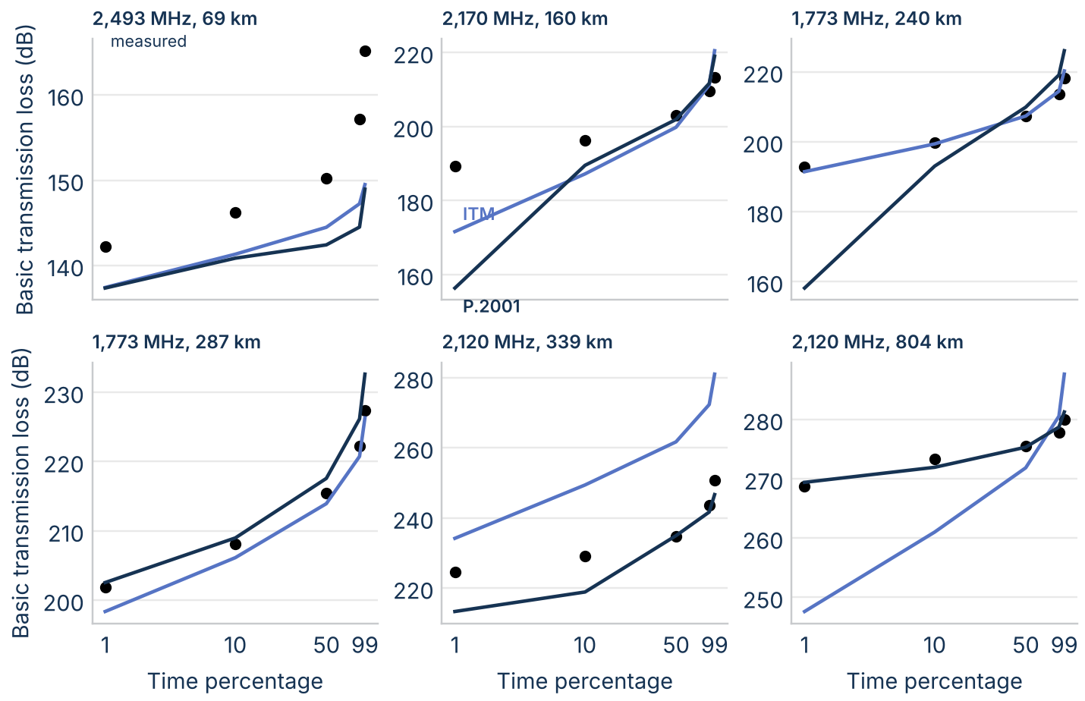
Figure 20. Measured (dots) and predicted basic transmission loss against time percentage on six databank paths from 1.7 GHz to 4.5 GHz, chosen to span path length.

Remaining terms and checks
The last items in the plan cover the terms P.2001 adds that ITM has no counterpart for, polarization and ground, the effective-height swap, and the cause of ITM's small asymmetry (remaining_terms_rev1 and implementation_checks_rev1).
Gases, rain, and sporadic-E. P.2001 adds gaseous absorption, clear-air fading and precipitation, and sporadic-E explicitly (Attachments F, B and C, and G); ITM has none of them, and whatever their effect on the measurements that fixed its empirical constants is folded into those constants. Over smooth earth in Kansas, P.2001's gaseous absorption at 3 GHz and 50% of time is 0.3 dB at 50 km, 1.0 dB at 150 km, and 2.0 dB at 300 km (Figure 21). At 300 km it grows to 3.9 dB at 10 GHz and 29.1 dB at 20 GHz, near the water-vapour line. That is more than the 13.0 dB by which P.2001's loss exceeds ITM's on that path at 20 GHz (1.9 dB at 3 GHz), so ITM's constants can't be carrying absorption of that size. Rain on the troposcatter path is 0.2 dB to 0.3 dB at 3 GHz even at 99.99% of time; it passes 1 dB at 5 GHz on the 300 km path and 7 GHz on the 50 km path, and reaches 15.4 dB to 30.8 dB at 10 GHz. The clear-air fading term matters more at 3 GHz: on the 50 km path it is −7.4 dB at 0.01% of time, −2.3 dB at 1%, 3.2 dB at 99%, and 10.7 dB at 99.99%. Sporadic-E never changes the combined loss on these paths: its sub-model's loss is at least 506 dB above free space from 0.1 GHz to 50 GHz, as expected for a mechanism that matters at VHF on paths of 1,000 km or more.
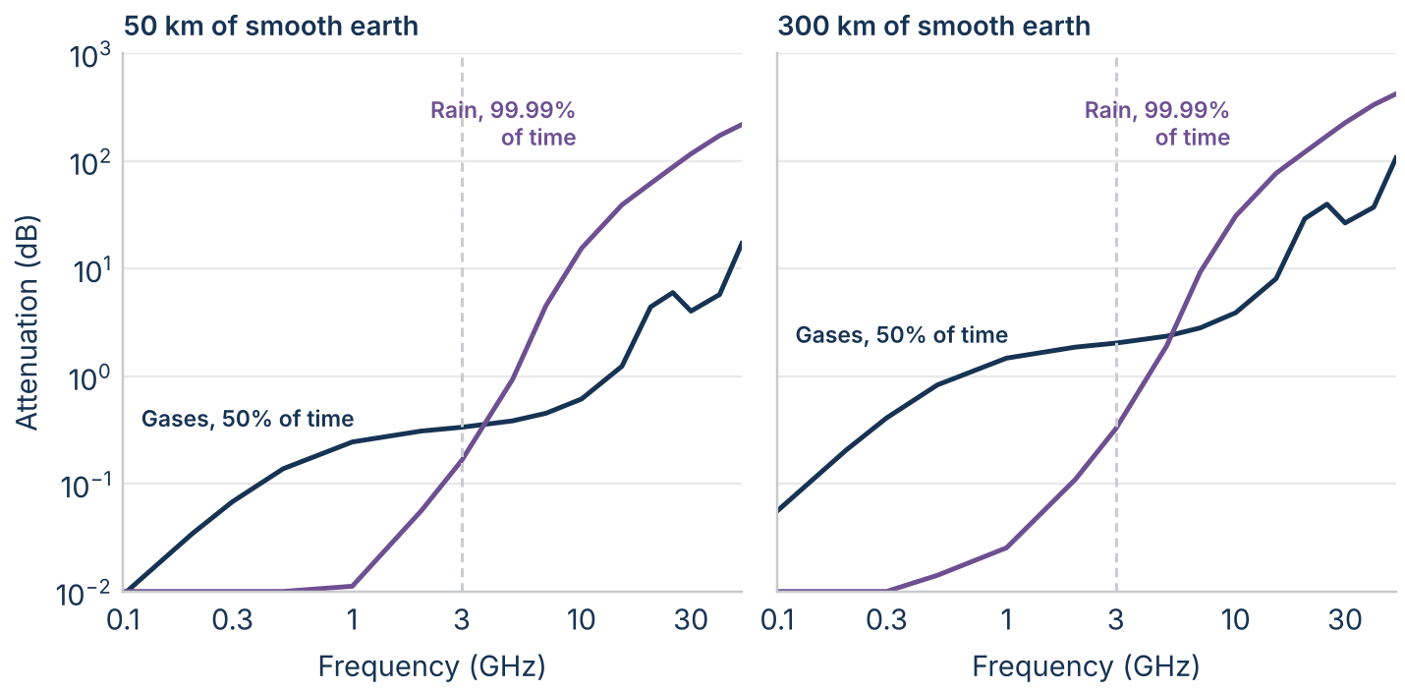
Figure 21. P.2001's gaseous absorption at 50% of time and its rain attenuation on the troposcatter path at 99.99% of time against frequency, over smooth earth in central Kansas (30 m and 10 m antennas). The dashed line marks 3 GHz.
Polarization and ground. ITM takes the ground's permittivity and conductivity as inputs; they enter its two-ray and smooth-earth terms. P.2001 fixes them from the radio-climatic zone (land or sea, Table 2) and uses them only in its spherical-earth diffraction term. Over smooth land from 1 km to 150 km at 0.1 GHz to 3 GHz, vertical and horizontal polarization differ by at most 0.6 dB in ITM and 0.1 dB in P.2001, and changing ITM's ground from P.2001's land constants to dry ground moves its loss by at most 0.22 dB (Figure 22). At 3 GHz, polarization is under 0.3 dB in both models on every ground. It matters only at low frequency over sea: at 0.1 GHz vertical polarization lowers the loss by up to 7.4 dB in ITM and 2.9 dB in P.2001, and at 0.3 GHz the difference is already down to 2.8 dB and 0.2 dB. Neither input explains any part of the gap at 3 GHz.
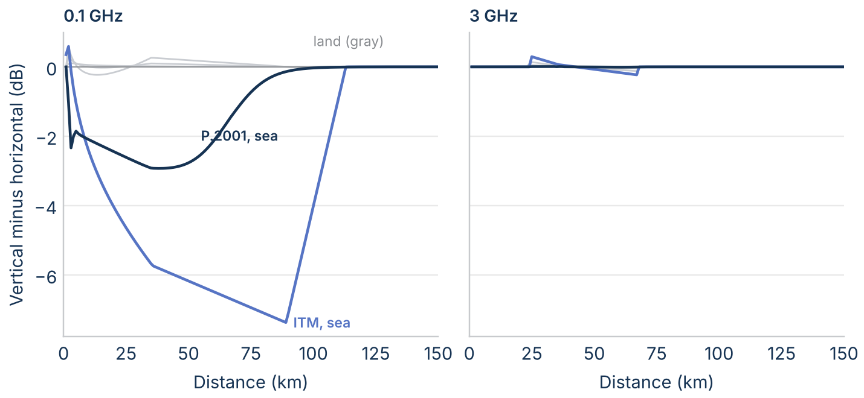
Figure 22. Loss with vertical minus horizontal polarization over smooth earth at 50% of time (30 m and 10 m antennas), at 0.1 GHz and 3 GHz. ITM is shown with three grounds and P.2001 with its land and sea constants; land cases in gray.
Effective-height swap. Each model was rerun on the 120 links with the other's effective antenna heights: ITM with P.2001's diffraction heights h_tep and h_rep in place of its h_e, and P.2001 with ITM's h_e (its ducting heights unchanged), through temporary copies of the code as in the earth-radius swap. ITM changes little on most links: its loss changes by a median of 0.0 dB, though by up to 16.8 dB on single links, and the median gap goes from 40.5 dB to 41.3 dB. P.2001 responds strongly on some links: with ITM's lower heights its loss rises by up to 60.7 dB, and the median gap falls to 25.8 dB (Figure 23). The effect sits almost entirely on the 30 links ITM classes as troposcatter, where P.2001 changes by more than 0.1 dB on 27 links and the median gap falls from 45.3 dB to 17.6 dB. On the 66 diffraction-class links the median gap is unchanged (43.7 dB), and line-of-sight links don't change. On the longer links, then, much of the gap comes from how the two models define effective height: the effective heights enter P.2001's diffraction loss only through its smooth-earth part, the correction max(L_dsph − L_dbs, 0) in eq. (A.1), and on these longer links that correction grows quickly as the heights fall, while ITM's loss depends little on them. On the diffraction-class links, the gap comes from the horizon-edge terms described earlier, not from the heights.
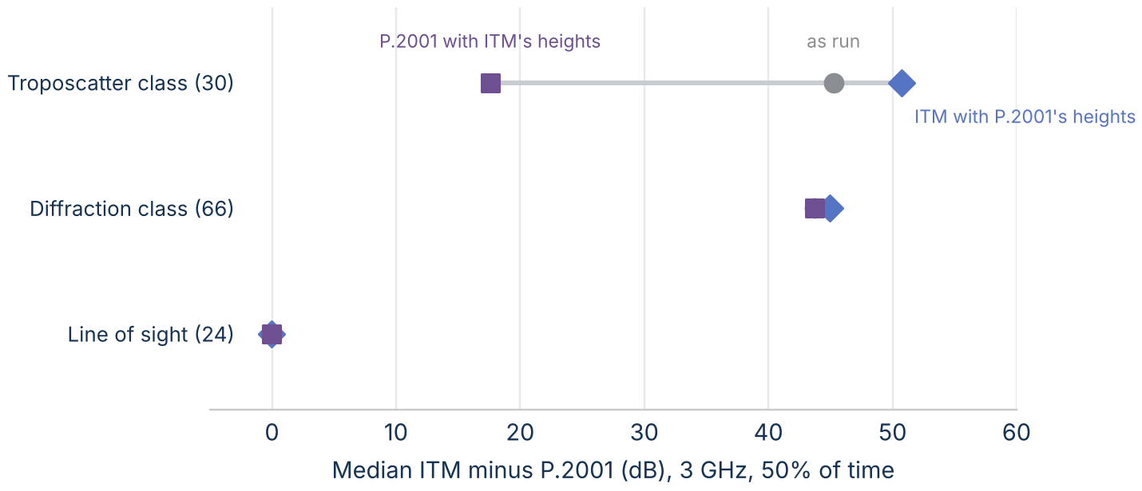
Figure 23. Median ITM minus P.2001 at 3 GHz and 50% of time on the real links by ITM's mechanism class: as run, with ITM given P.2001's diffraction effective heights, and with P.2001 given ITM's effective heights. Link counts in parentheses.
Why ITM isn't exactly reciprocal. On all 8 links where ITM's loss changes by more than 0.01 dB with the terminals swapped, the only intermediate value that differs is one effective antenna height, by 0.5 m to 13.3 m. The terrain irregularity Δh is identical, the horizon distances agree within 10⁻⁸ m, and the mode doesn't change. ITM fits a straight line to the profile near each terminal to set h_e, over a window whose ends are converted to whole profile points by truncation. When a window end falls on, or within rounding of, a profile point, the last digit of the horizon distance decides which point is used, and that can differ between the two directions. Scaling the profile spacing by 1 + 10⁻⁹ confirms the sensitivity: the asymmetry disappears on some links and appears on 4 others, and single losses change by up to 0.48 dB. The behavior is ITM's own, not the MATLAB port's: the NTIA C++ reference gives the same kind of asymmetry on one of NTIA's own example profiles. It is small against the differences in this paper, and worth noting only where a study relies on exact reciprocity.

Summary of the differences
Table 2. ITM and P.2001, mechanism by mechanism.
Element | ITM v1.4 | P.2001-6 | Effect on the loss
Structure | One region selected by distance; one reference attenuation; variability added | Four sub-models computed in parallel, each over time, combined by correlation | P.2001 can switch mechanism with time percentage; ITM can't
Earth curvature | From surface refractivity; fixed for all time percentages | From the ΔN map; recomputed for each time percentage | Same at the median; P.2001's diffraction eases at small percentages
Terrain | Reduced to horizons, Δh, and effective heights | Full profile for diffraction; smooth fit for heights | ITM's loss tracks Δh; P.2001's tracks the main obstacle
Line of sight | Two-ray at two distances, fitted to a smooth curve | Free space, gases, and statistical multipath | Both near free space at the median; no lobes in either
Diffraction | Two knife edges and smooth earth at two points beyond the horizon, plus clutter; straight line to the path | Delta-Bullington at the path: one equivalent edge plus spherical earth | Agree on smooth earth; ITM far higher on rough terrain with low antennas
Troposcatter | NBS TN101 at two distances; line joined to diffraction at d_x | Climate-zone method at the path, at least free space | Agree on smooth earth; ITM inherits its diffraction level on rough paths
Ducting | None explicit | Sub-model 2: coupling, angular distance, and time from β | P.2001 predicts much less loss at small percentages
Gases, rain, fading, sporadic-E | Implicit in empirical constants | Explicit attachments | Small at the median; shape the tails
Time variability | Climate curves of effective distance, the same for every region | Each mechanism's own statistics, combined at each percentage | Spreads differ by tens of decibels on some paths

Plan: comparing the models equation by equation
The section above compares the two models mechanism by mechanism. The next revision will pair every equation in the two loss calculations: what each computes, from which inputs, and what one figure shows the difference. This section is that plan. It is kept as ALGORITHM_COMPARISON_PLAN.md in the repository and printed here so readers can see what is done, what is next, and in what order. Items marked done are in this revision.
This plan extends the working paper's section "How ITM and P.2001 compute each mechanism" (revision 4) into a comparison that pairs every equation in the two loss calculations. It is also printed in the paper, so the two copies should be kept the same. Status values: done (in revision 4), next (planned for revision 5), later.
Conventions:
- ITM references are line ranges in private/itm_p2p_core.m at commit 5081c68 of nicklasorte/matlab_itm (the port of NTIA ITM v1.4).
- P.2001 references are sections and equations of Recommendation ITU-R P.2001-6 (09/2025) and files in nicklasorte/itu_p2001 at commit 286e68c.
- Every item has one test case, one CSV written by MATLAB, and one figure drawn by Python. The test cases reuse the paper's profiles (smooth earth in central Kansas, the 60 eastern and 60 western links, the five archetypes) unless the item says otherwise.
- The order is by expected effect on a 3 GHz separation distance, largest first.

The equation ledger
One row per step of the calculation. "Same inputs" asks whether the two models start the step from the same quantities; where they don't, the difference in inputs is usually a bigger cause than the difference in formulas.
Table 3. The equation ledger: one row per step of the loss calculation.
# | Step | ITM v1.4 | P.2001-6 | Same inputs? | Test case | Figure | Status
1 | Profile preparation | Equally spaced profile; horizons by maximum elevation angle on ITM's effective earth (L245-275); when the horizon distances add to more than 1.5 d, smooth-earth estimates replace them (L224-237) | Equally spaced profile; horizons by maximum elevation angle on the median effective earth a_e50 (sec. 3.7, eqs. 16-25); on a line-of-sight path the "horizon" is the point of largest ν (eqs. 18-20) | No (different a_e; line-of-sight paths handled differently) | 120 links, 30 m and 10 m spacing | Horizon distance and angle, ITM against P.2001, one point per link and terminal | done (resolution study); next (horizon scatter)
2 | Terrain irregularity | Δh = Δh_d / (1 − 0.8 e^(−(d_end − d_start)/50 km)), Δh_d the interdecile range about a straight-line fit over the span d_start to d_end (L277-330); Δh(d) = Δh (1 − 0.8 e^(−d/50 km)) is applied later (L659-661) | No Δh; roughness h_m for ducting is the highest terrain above the smooth surface between horizons (sec. 3.8) | No | 120 links | Δh against h_m, colored by the ITM minus P.2001 gap | done
3 | Effective antenna heights | h_e = h_g + max(z − fit, 0), so never below h_g; the fit runs from min(15 h_g, 0.1 d_L) to 0.9 d_L at each end on a transhorizon path (L216, L239-242), over the whole span on a line-of-sight path (L224-227) | Height above a smooth surface fitted to the whole profile, two variants: h_tep, h_rep for diffraction, h_tea, h_rea for ducting (sec. 3.8) | No | 120 links | Dumbbell per link: ITM h_e and P.2001 h_tep for each terminal | done
4 | Earth curvature | γ_e = γ_a(1 − 0.04665 e^(N_s/179.3)); N_s from N_0 and mean elevation; fixed over time (L191-208) | a_e50 = 157 a/(157 + N_d1km50), with N_d1km50 = −S_dN the median refractivity gradient in the lowest 1 km (negative; P.452's ΔN with the sign reversed), from a map; a_p from map slopes (sec. 3.4.1, 3.5, eqs. 9-13) | No (N_0 versus ΔN map) | Smooth earth, 120 km, 10 U.S. midpoints | Effective earth radius against time percentage, both models, 10 locations | done (one location); next (10 locations)
5 | Region selection and combination | Line of sight if d < d_sML; diffraction up to d_x; scatter beyond (L393-484) | Four sub-models always computed; correlated power sum for 1 and 2 (eq. 58), then a −5 log Σ10^(−0.2 L) blend with 3 and 4 (eq. 59); Monte Carlo alternative (sec. 5.3, eq. 60); Attachment J | No | Smooth earth sweep; 120 links | Architecture diagram; mechanism agreement matrix | done
6 | Free space | 32.45 + 20 log f + 20 log d (L667-669) | Same, with the slant distance including the height difference (sec. 3.11) | Yes | Any | None needed; difference under 0.01 dB on the paper's paths | done (noted)
7 | Knife-edge function | 6.02 + 9.11√v² − 1.27v² (v² < 5.76), else 12.953 + 10 log v² (L512-518); each horizon edge gets v² from the full diffraction angle with the factor 1/(4π) (L503-510), which equals ν² for half the angle, and the two edge losses are added (12.0 dB at grazing against J(0) = 6.0 dB for one edge) | J(ν) = 6.9 + 20 log(√((ν − 0.1)² + 1) + ν − 0.1) for ν > −0.78 (sec. 3.12, eq. 43a) | Functions yes; arguments no | ν from 0 to 10 | Both against the Fresnel integral | done
8 | Which edges | One edge at each horizon, v from the horizon angles and distances (L503-510) | One equivalent Bullington edge where the lines from the terminals to their steepest obstacles cross (A.4, eqs. A.15 to A.22) | No | 20 km single knife edge; two-obstacle family (see item 20) | Loss against obstacle height for one and two obstacles | done
9 | Smooth-earth diffraction | Vogler three-radius method: G(x) − F(x_1) − F(x_2) − 20 with K from the ground constants (L520-560) | First-term spherical-earth loss −F_X − G(Y_t) − G(Y_r), K from the fixed land and sea constants of Table 2 weighted by the sea fraction ω (eqs. A.7, A.8); below d_los it interpolates using a_em (A.2, A.3, eqs. A.2 to A.14) | Only with the same a_e, heights, and ground constants | Smooth earth 20 km to 300 km, 30 m and 10 m antennas, both polarizations | Both smooth-earth losses against distance, with their difference | done
10 | Blending the diffraction terms | A_d = w A_se + (1 − w) A_k + A_fo; w from Δh, f, and the horizon geometry; A_fo ≤ 15 dB (L486-501) | L_d = L_dba + max(L_dsph − L_dbs, 0): the smooth-earth excess over a smooth Bullington path is added to the actual Bullington loss (A.1, eq. A.1) | No | 120 links | Term stack per model on the diffraction links (ITM: w A_se, (1 − w) A_k, A_fo; P.2001: J(ν), the empirical term, the spherical excess) | done
11 | Empirical additions | A_fo = min(15, 5 log(1 + 10⁻⁵ h_g1 h_g2 f σ_h)), σ_h from Δh(d_sML), f in MHz, h_g in metres (L489-491) | (1 − e^(−J/6))(10 + 0.02 d) (A.4, eq. A.23) | No | 120 links | Both terms against path length | done
12 | Where diffraction is evaluated | At d_3 = max(d_sML, d_L + 5X) and d_4 = d_3 + 10X, X = (a_e²/f)^(1/3); straight line to the path (L393-398) | At the path's distance | No | Smooth 120 km; rough western link; 120 links | ITM construction lines (done); ITM evaluated at the path instead of extended, against P.2001 (ablation, done) | done
13 | Line of sight | Two-ray with complex reflection coefficient and roughness, weighted with the diffraction line by 1/(1 + f Δh/max(10 km, d_sML)); two-ray values at d_0 and d_1 and the diffraction-line value at d_sML, fitted by A_o + k_1 d + k_2 ln d (L412-453, L562-581) | L_bm1 = L_bfs + L_d + A_1 + gas terms (eq. 47): free space, the diffraction loss L_d of eq. A.1 always (near zero until terrain enters the Fresnel zone), gases, and A_1, the combined clear-air and rain fade (eq. 46; Attachments B and C) | No | Smooth earth 1 km to 40 km; the 24 line-of-sight links | Both against a two-ray reference (done); fade depth against time percentage at 1 km to 40 km (next) | done; next
14 | Troposcatter | A_s = F(θd) + 10 log(k H θ⁴) − 0.1(N_s − 301) e^(−θd/40 km) + H_0, at d_L + 200 km and d_L + 400 km (L583-657) | L_bs = M + L_freq + L_dist + L_coup − Y_p, climate zone from a map at the common volume, floored at free space (Attachment E, eqs. E.16, E.17) | No | Smooth earth 70 km to 700 km; ITM's 7 radio climates and P.2001's 6 land zones plus the sea-path zone | Both against distance (done); troposcatter loss by climate, ITM climates 1 to 7 against P.2001 zones 1 to 6 and sea (Table E.1) (done) | done
15 | Diffraction to scatter transition | Crossover d_x where the scatter line meets the diffraction line; scatter line joined there (L456-482) | None: the power sum lets the lower loss dominate smoothly | No | Smooth earth; 120 links | dL/dd against distance, both models, to show ITM's slope change at d_x and d_sML | next
16 | Ducting and layer reflection | None | L_ba = A_ac + A_ad + A_at: coupling (site shielding, sea), angular distance, and time term from β (Attachment D, eqs. D.1 to D.25) | Not applicable | Smooth earth at 1%; over-sea archetype; 120 links at 0.1%, 1%, 10% | P.2001's three ducting terms against distance; ITM minus P.2001 against β | done
17 | Time variability | Effective distance d_e; climate curves for time, location, and situation; A_ref + V(p) (L674-795) | Each mechanism's own statistics: a_e(p) for diffraction, β and A_at(p) for ducting, Y_p for troposcatter, Q_caf and Q_rain for fading (sec. 4, Attachments B, C, D, E) | No | Five archetypes; smooth 120 km; rough link | Loss against time percentage with P.2001 sub-models (done); the same against measured distributions from the databank (done) | done
18 | Gases, rain, sporadic-E | None explicit | Attachments F, C, G | Not applicable | Smooth earth at 3 GHz and 10 GHz | Size of each term against frequency, to show where they start to matter | done
19 | Polarization and ground | ε_r, σ enter Z_g for the two-ray and smooth-earth terms (L191-208) | Fixed land and sea ε_r, σ (Table 2), weighted by ω, enter K in the spherical-earth term only; polarization selects K_H or K_V (eqs. A.7, A.8) | No | Smooth earth, both polarizations, three grounds | Loss difference between polarizations, both models | done

Experiments that isolate one equation at a time
These go beyond reading the code: each swaps or holds one quantity so the effect of a single difference can be measured.
Table 4. Experiments that isolate one equation at a time.
# | Experiment | What it isolates | Test case | Output | Status
20 | Two-obstacle family | Item 8: one Bullington edge against two horizon edges | Synthetic profiles with two knife edges of heights h_1, h_2 at 1/3 and 2/3 of a 30 km path, h from 0 to 300 m | Heat map of ITM minus P.2001 over (h_1, h_2), with Epstein-Peterson and Deygout references | done
21 | Roughness family | Items 2 and 10: how the gap grows with Δh | Random rough profiles (filtered noise) scaled to Δh from 10 m to 1,000 m, 10 km to 150 km, 20 draws each | Heat map of the median gap over (Δh, d); the paper's "divergence window" drawn from synthetic terrain | done
22 | Earth-radius swap | Item 4 | Smooth earth and 120 links with ITM's curvature set to P.2001's a_e50 directly in a test branch (changing N_0 would also move ITM's troposcatter term and is limited to N_s 150-400), and P.2001's a_e50 and a_p both set to ITM's a_e | Gap before and after the swap | done
23 | Effective-height swap | Item 3 | 120 links with each model given the other's effective heights (code change in a test branch, not in the released functions) | Gap before and after | done
24 | Evaluation-point swap | Item 12 | ITM evaluated at the path (done in the ablation) and P.2001 evaluated at d_3 and d_4 and extended | Gap before and after | done
25 | Monte Carlo combination | Item 5: the single-percentage blend of sec. 5.2 against the Monte Carlo method of sec. 5.3 | Five archetypes, 10,000 draws | Loss against time percentage, both combinations, with their difference | done
26 | Reciprocity | Both models should give the same loss with the terminals swapped; P.2001 states it (sec. 1.2) | 120 links, both directions | Largest asymmetry per model | done
27 | Continuity | Items 13 and 15 | Smooth earth and one Piedmont radial at 100 m steps (done); the other radials later | Jumps in loss and slope at d_sML, d_x, and the Bullington LoS or NLoS switch | done
28 | Input sensitivity per equation | Which inputs each equation is most sensitive to | 120 links, one input at a time (N_0 or ΔN, ε_r, σ, spacing, antenna heights ±1 m) | Tornado chart per model | done (sensitivity section, in part); next (per equation)
29 | Measured distributions | Item 17 | Databank Table III datasets with measured and predicted loss at 1, 10, 50, 90, and 99 % of time (379 kept) | ITM and P.2001 against the measured distribution per path | done

Figure plan
Each figure states one idea, uses gray for context and one accent for the point, and labels marks directly. ITM is light blue, P.2001 dark blue, and the difference purple, as elsewhere in the paper. All data come from the MATLAB CSV files; Python draws only.
Table 5. Figure plan for the equation-by-equation comparison.
Figure | Type | Axes and marks | The one callout
Equation map | Two-column flow diagram (done as the architecture figure); next version adds the equation numbers and code lines in each box | Boxes per step, arrows for data flow | Where the two columns stop matching
Horizon scatter (item 1) | Scatter with the equal line | ITM horizon distance against P.2001's, one point per terminal | Points off the line are the links where the horizons differ
Roughness measures (item 2) | Scatter | Δh against h_m, log axes, colored by gap | The gap follows Δh, not h_m
Effective heights (item 3) | Dumbbell | One row per link; ITM h_e and P.2001 h_tep as two dots joined by a line | Links where ITM's effective height is tens of metres above P.2001's
Earth radius (item 4) | Small multiples, 10 locations | Radius against time percentage, log x | ITM flat; P.2001 rising to the left
Smooth-earth diffraction (item 9) | Two lines and a difference band | Loss against distance | The two methods agree within a stated tolerance
Term stacks (item 10) | Paired stacked bars, one pair per link class | Median dB per term | The ITM term that has no counterpart
Empirical additions (item 11) | Two lines | dB against path length | Where each add-on reaches its cap
Two-obstacle heat map (item 20) | Heat map with a zero contour | h_1 by h_2, color is ITM minus P.2001, diverging palette with gray at zero | The band where one edge and two edges agree
Roughness heat map (item 21) | Heat map with contours at 10 dB and 20 dB | Δh by d, log axes | The synthetic terrain reproduces the measured divergence window
Swap experiments (items 22 to 24) | Slope chart | Gap before and after each swap, one line per experiment | The swap that closes most of the gap
Monte Carlo combination (item 25) | Line with a band | Loss against time percentage; blend and Monte Carlo | Largest difference in dB and at which percentage
Continuity (item 27) | Small multiples of dL/dd | Slope against distance for both models | ITM's steps at d_sML and d_x
Tornado (item 28) | Two tornado charts side by side | Change in loss per input | The input that moves each model most
Measured distributions (item 29) | Small multiples of CDFs | Loss against time percentage per path: measured, ITM, P.2001 | Which model follows the measured tail

Order of work
- Items 20, 21, and 24 (the diffraction geometry): done in revision 4. They show the gap comes mostly from ITM's horizon-based diffraction terms.
- Items 9, 10, 11 (the diffraction terms side by side), 16 (the ducting terms), and 25 (the Monte Carlo combination): done in revision 4. The term split puts three quarters of the mean gap on the two horizon edges and the smooth-earth term, and about a fifth on ITM's line extension.
- Items 2, 3, 22, 26, 27 (inputs, swaps, reciprocity, continuity): done in revision 4. The models rank roughness alike, the earth-radius swap moves the median gap by less than 0.5 dB, P.2001 is reciprocal, ITM is reciprocal within 0.6 dB, and neither model's formulas are discontinuous. ITM's small asymmetry comes from its effective-height fit (see item 5 of this list).
- Items 14, 17, 29 (troposcatter, variability, measured distributions): done in revision 4. The two climate classifications move the troposcatter loss by similar amounts but don't map one to one; against the databank, neither model's time-variability equations predict a single path's distribution shape better than the other at small percentages, and P.2001 follows the deep fades somewhat better.
- Items 18, 19, 23 and the cause of ITM's asymmetry: done in revision 4. At 3 GHz, P.2001's gas, rain, and sporadic-E terms and the polarization and ground inputs of both models are too small to matter; gases and rain grow fast above 10 GHz. Given ITM's effective heights, P.2001 closes most of the gap on the troposcatter-class links (median 45 dB to 18 dB). ITM's asymmetry on 8 links comes from one effective height, set by a fit whose window ends are truncated to profile points; the NTIA C++ reference shows the same asymmetry on NTIA's second example profile (0.12 dB at 3 GHz, 10 m and 3 m antennas), checked on 2026-11-08.

Checks
The ledger was checked against both codebases and the Recommendation by an independent review on 2026-11-08; its six errors and nine imprecisions are corrected above.
- Every number quoted in the paper's text comes from numbers_3ghz.json, which paper_numbers_3ghz_rev1 writes; no number is typed by hand.
- Before a new figure is used, its MATLAB run reproduces one published or reference value: the ITM test suite (NTIA examples) and the ITU-R P.2001 validation set (4,430 cases) both pass at the cited commits.
- Each experiment runs on both models through the same profile struct, so a difference can't come from terrain preparation.
- An independent review of the finished section by someone who hasn't seen the drafts is still required before the paper circulates.

Inputs and method
Each calculation builds one terrain profile at about 30 m spacing from USGS 3DEP 1 arc-second data and passes it to all three models. Each model applies its own earth curvature and climate inputs. ITM uses ground permittivity 25, conductivity 0.02 S/m, variability mode 13, and 50% confidence, with its radio climate and N₀ from the ITU maps at the path midpoint. P.452 stops at 50% of time.
The calculations, all at 3 GHz, are the following:
- Smooth earth over flat land and sea, 1 km to 200 km.
- A single knife edge on a 20 km path with 100 m antennas.
- Real terrain: 60 random links of 10 km to 150 km in three mid-Atlantic regions (coastal plain, Piedmont, Appalachians).
- Western terrain: 60 links drawn with the same rules in three western regions (Colorado Front Range, Nevada Basin and Range, and southern California).
- Four radials of 150 km from a Piedmont site at 38.90 N, 77.45 W.
- Five archetype paths over the full time distribution: line of sight, single-horizon diffraction, double-horizon diffraction, troposcatter, and over-sea coastal.

Results at 50% of time

Smooth earth and a knife edge
On smooth land the three models agree within 4.8 dB at every distance from 1 km to 200 km (Figure 24). Over a single raised point on a 20 km path, all three follow the shape of the ITU-R P.526 knife-edge function J(v) but add loss beyond it (Figure 25); ITM's loss rises fastest at large v.
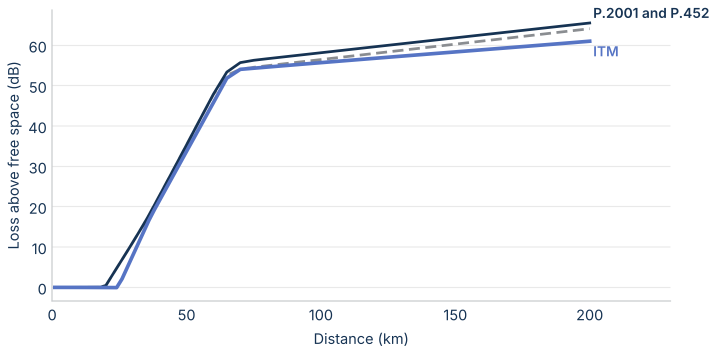
Figure 24. Loss above free space on smooth land at 3 GHz and 50% of time, with 30 m and 10 m antennas.
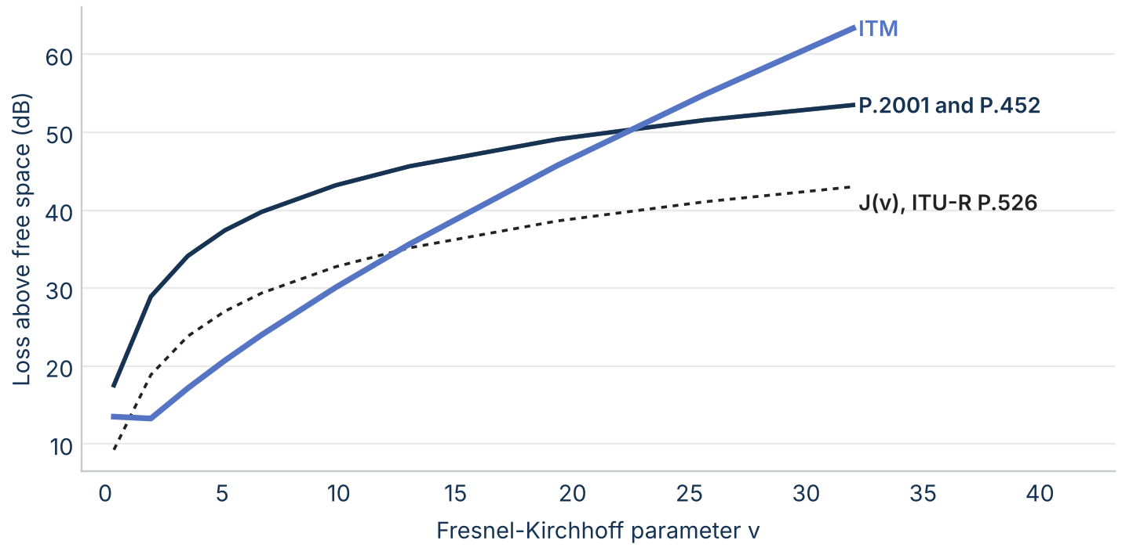
Figure 25. Loss above free space over a single raised point on a 20 km path at 3 GHz, against the Fresnel-Kirchhoff parameter v, with ITU-R P.526 J(v) for reference.

Real terrain by mechanism
On real terrain the models agree in line of sight and split beyond it (Figure 26). The median ITM minus P.2001 is -0.1 dB on line-of-sight links, 32.7 dB on diffraction links, and 36.9 dB on troposcatter links, with ITM's mechanism class deciding the group. P.452 matches P.2001 within 0.02 dB at the median in every class, so the figures show P.2001 only.
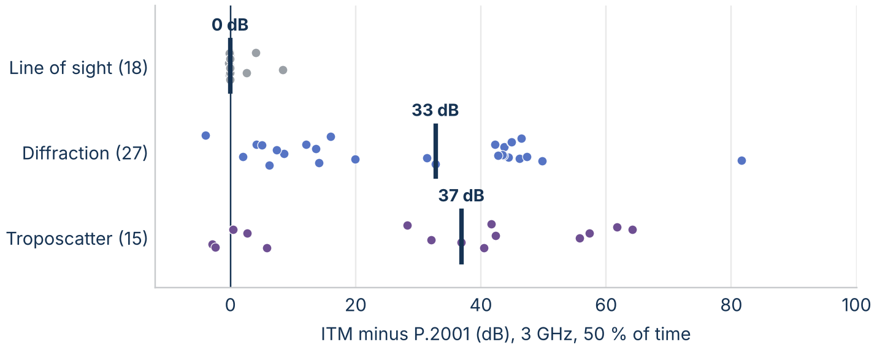
Figure 26. ITM minus P.2001 on each real-terrain link at 3 GHz and 50% of time, by ITM's mechanism class. The bar is the median.
The gap tracks terrain roughness (Figure 27): its median is -0.1 dB on links with a terrain irregularity Δh under 50 m and 44 dB on links with Δh over 200 m.
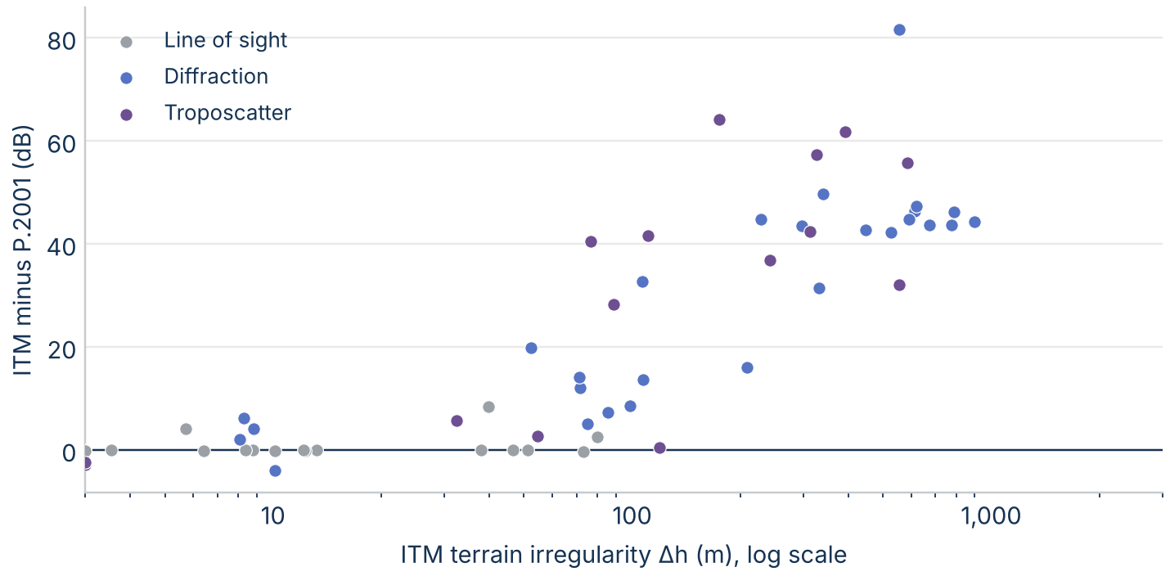
Figure 27. ITM minus P.2001 on each real-terrain link at 3 GHz against ITM's terrain irregularity Δh.

Frequency
Figure 28 sweeps frequency from 100 MHz to 10 GHz on three archetype paths. On the line-of-sight and single-horizon paths the models stay within 5 dB at every frequency. On the double-horizon Appalachian path the gap grows from 46 dB at 100 MHz to 83 dB near 3 GHz and 111 dB at 10 GHz, so results at 3 GHz understate the gap at higher frequencies.
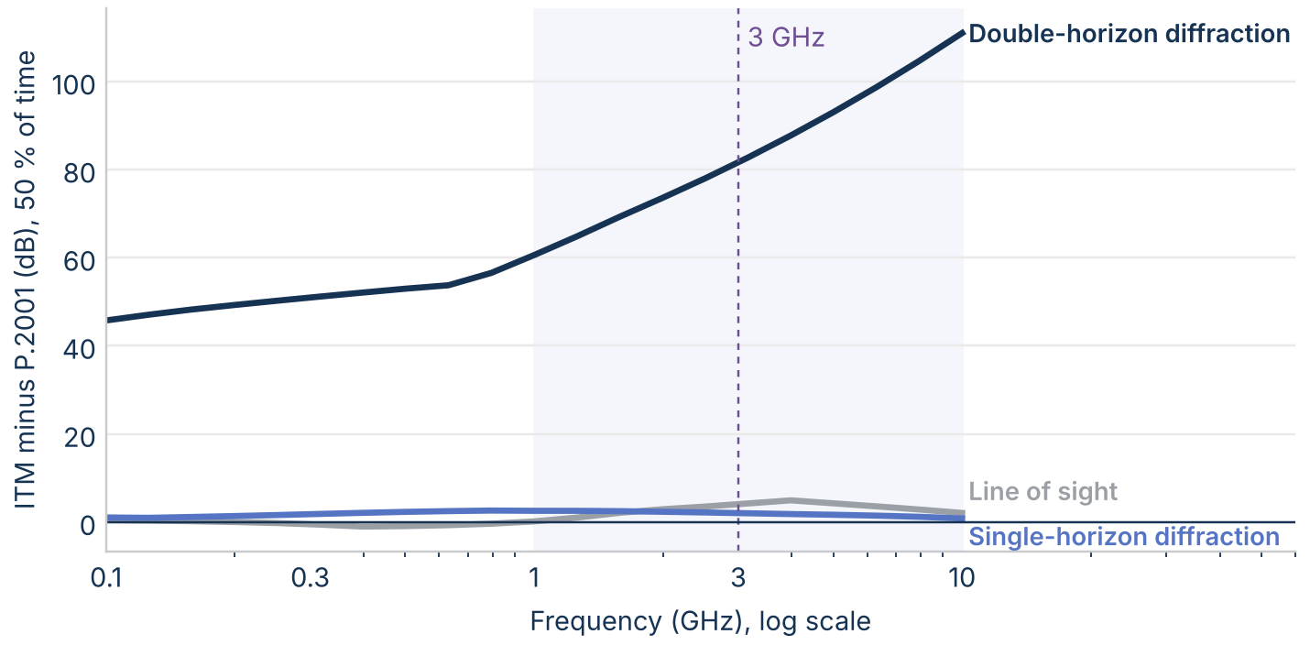
Figure 28. ITM minus P.2001 at 50% of time on three archetype paths from 100 MHz to 10 GHz. The shaded band is 1 GHz to 10 GHz.

Terrain resolution
Resampling the 27 diffraction links from 30 m to 90 m changes the median loss by -0.02 dB for ITM and -0.03 dB for P.2001 (Figure 29). Smoothing over 1 km lowers ITM's loss by a median of -5.2 dB and P.2001's by -3.4 dB. The typical link's gap moves by 1.9 dB, but 7 links move by more than 10 dB, up to 47 dB; a later section explains why.
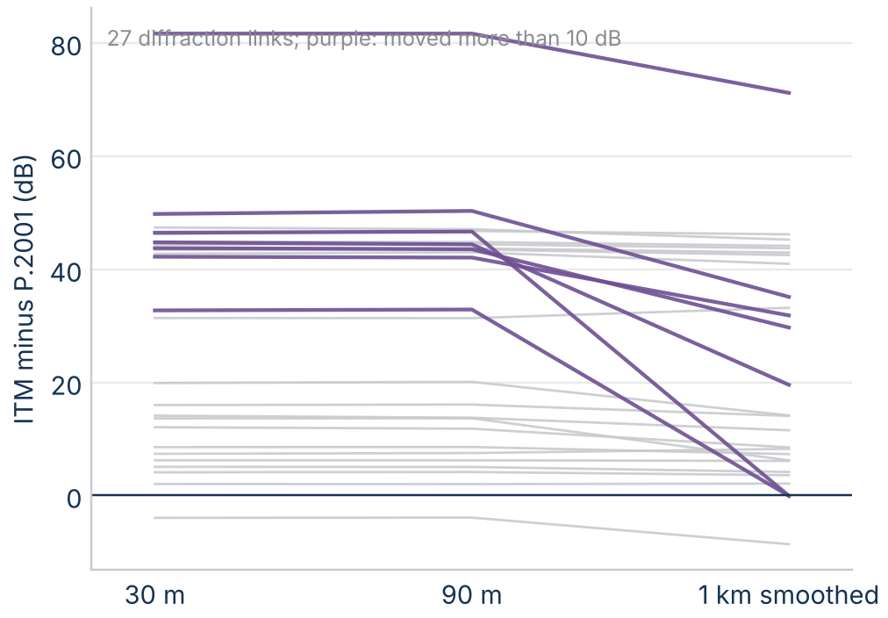
Figure 29. ITM minus P.2001 on each diffraction link at 3 GHz on the 30 m profile, resampled at 90 m, and smoothed over 1 km.

Diffraction: one edge or two

The knife-edge formula is not the difference
P.452 and P.2001 compute a knife-edge loss of 6.9 + 20 log(√((v − 0.1)² + 1) + v − 0.1), and ITM uses 6.02 + 9.11v − 1.27v² below v = 2.4 and 12.953 + 20 log v above. Both stay within 0.12 dB of J(v) from v = 0 to 10 (Figure 30). The difference is that ITM adds one knife edge at each horizon, where the ITU models use a single equivalent edge. Two edges roughly double the loss, and double its growth with frequency: about 6 dB per doubling of frequency against 3 dB for one edge.
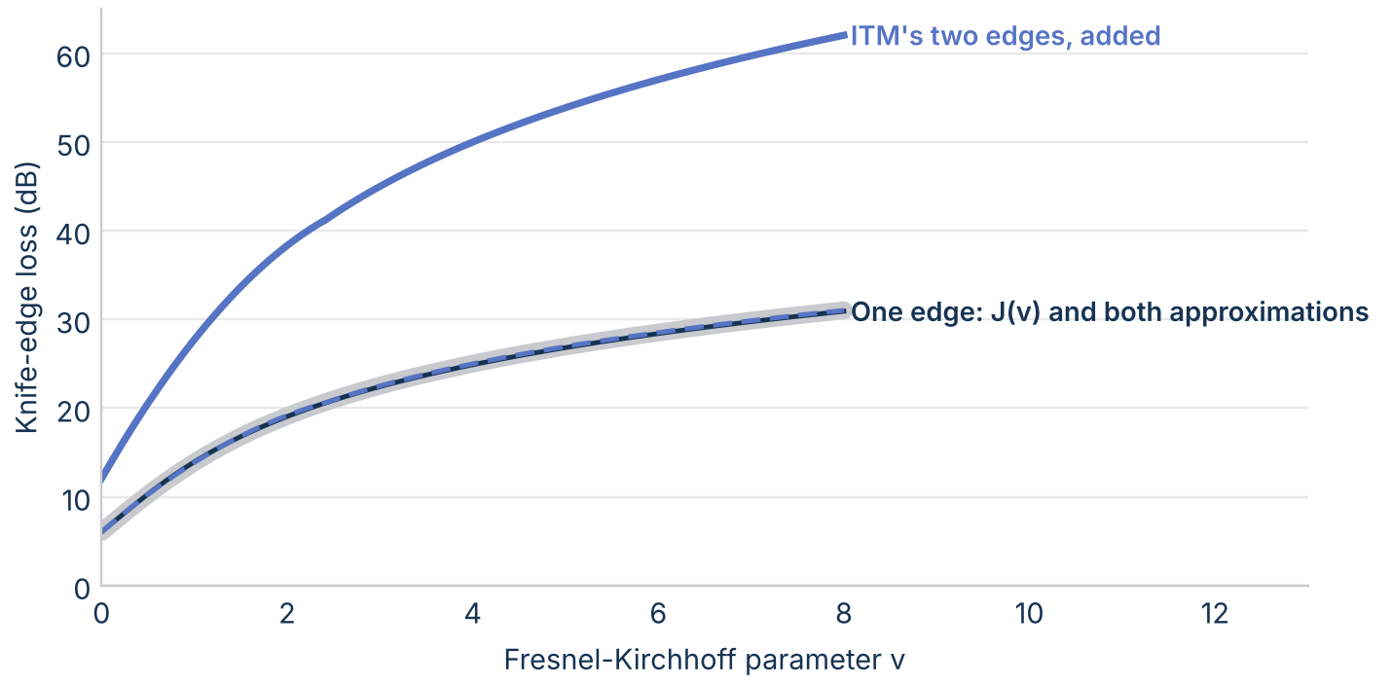
Figure 30. Knife-edge loss against the Fresnel-Kirchhoff parameter v: J(v) from the Fresnel integrals (wide gray), the ITU and ITM approximations for one edge, and ITM's two edges added.

What ITM's diffraction loss is made of
ITM's diffraction loss is A_d = w·A_se + (1 − w)·A_k + A_fo: a smooth-earth loss A_se with weight w, a double knife edge A_k, and a clutter term A_fo of up to 15 dB. The weight falls as terrain irregularity rises. On the 27 diffraction links at 3 GHz (Figure 31), the median terms are 29 dB from the weighted smooth earth, 57 dB from the weighted knife edges, and 13 dB from clutter, against 45 dB for P.452's single knife edge.
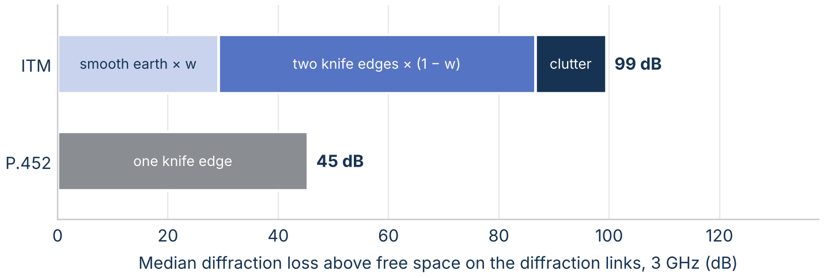
Figure 31. Median diffraction loss above free space on the diffraction links at 3 GHz, split into its terms.
Removing ITM's ingredients one at a time locates the gap (Figure 32). The median gap to P.452 is 32.8 dB as ITM stands; 8.4 dB with one knife edge instead of two; 21.6 dB without the clutter term; 23.4 dB with the loss evaluated at the path instead of extended from beyond the horizons; and -8.7 dB with all three removed. These are diagnostics, not proposed fixes: ITM's terms were fitted to measurements as a set.
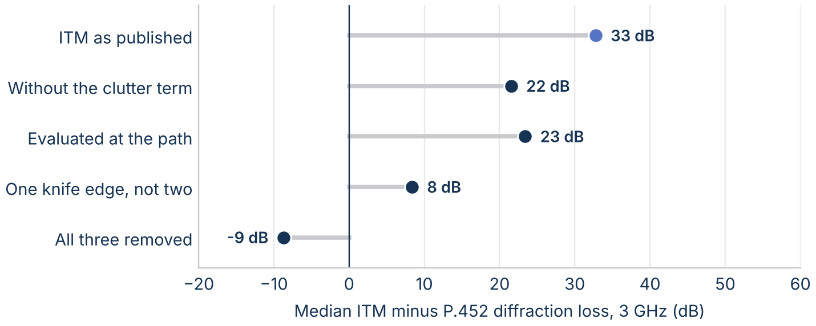
Figure 32. Median ITM minus P.452 diffraction loss at 3 GHz, as ITM stands and with one ingredient removed at a time.
ITM predicts more diffraction loss than P.452 on 26 of 27 diffraction links, with a median ratio of 1.75 (Figure 33).
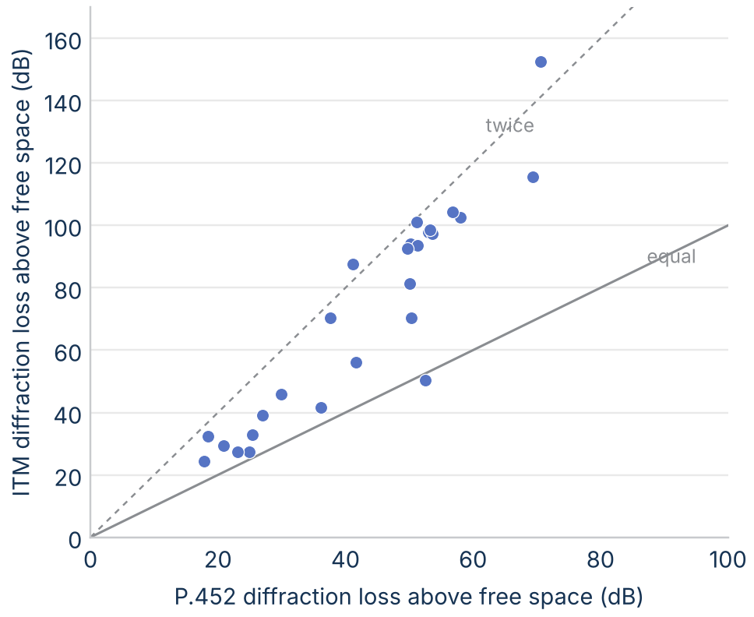
Figure 33. ITM's diffraction loss above free space against P.452's on each diffraction link at 3 GHz. The solid line is equal loss; the dashed line is twice P.452's loss.

One link in detail
Figure 34 takes the double-horizon archetype, a 65 km Appalachian link. The transmitter's horizon is a ridge 5.8 km away, so the rays from the two horizons meet about 5 km above the path, where P.452 and P.2001 put their single edge. ITM weights its smooth-earth loss by only 0.039, but that loss is over 1,300 dB, so the small weight still adds about 50 dB; the two knife edges and the clutter term add about 100 dB more.
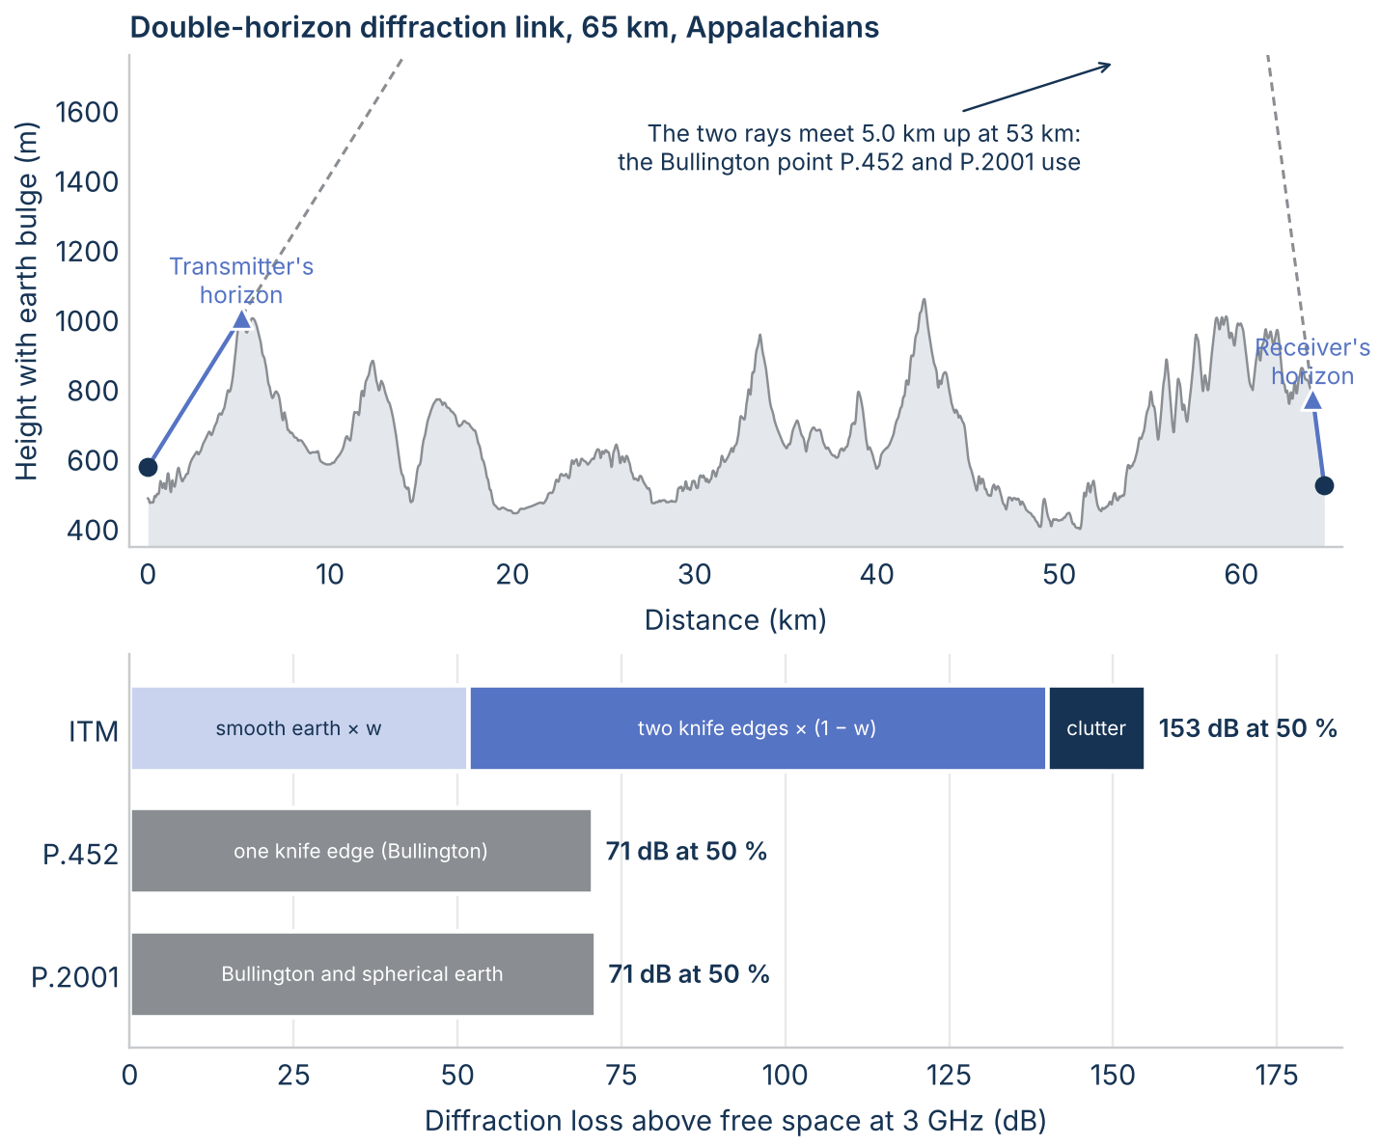
Figure 34. Top: the double-horizon archetype profile with the earth's bulge, both horizons, and the rays that meet at the Bullington point. Bottom: how each model's diffraction loss adds up at 3 GHz and 50% of time.

Where the models start to diverge
Along four radials (Figure 35), the models agree for the first few kilometers and split as soon as the path goes beyond line of sight. To the east and south the gap reaches 29 dB to 40 dB within 60 km and then stays within about 4 dB beyond 80 km, where both models are in troposcatter. To the west, into the Appalachians, it stays at a median of 44 dB from 80 km to 150 km.
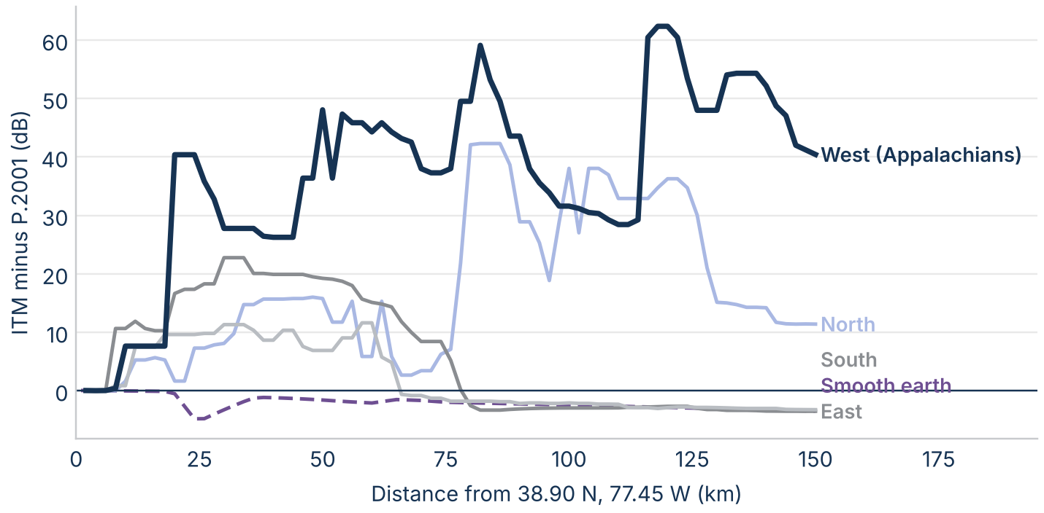
Figure 35. ITM minus P.2001 at 3 GHz and 50% of time along four radials from 38.90 N, 77.45 W (median over 10 km), and on smooth earth.
The links and the measured paths show the same window (Figure 36). The large gaps fall on calculated links from about 15 km to 150 km. On the 367 measured databank paths longer than 150 km, ITM and P.2001 differ by a median of -2.6 dB, which is why the measurement comparison finds the models close.
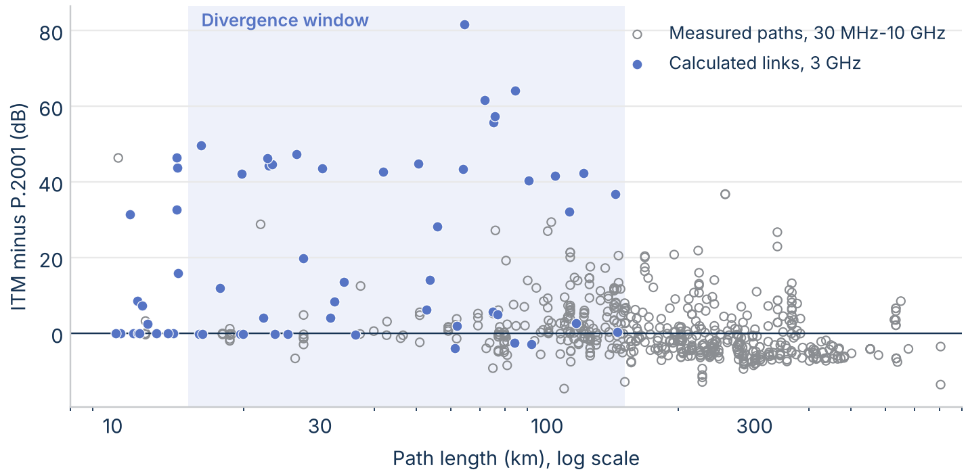
Figure 36. ITM minus P.2001 on the calculated links at 3 GHz and on the measured databank paths from 30 MHz to 10 GHz, against path length.
ITM's smooth-earth weight w decides which side of the split a link falls on (Figure 37). Where w is 0.12 or more, the median gap is 8 dB (12 links); where w is under 0.12, it is 44 dB (15 links). Few links fall between, which also explains the terrain-resolution result: smoothing raises w on a few links enough to switch groups.
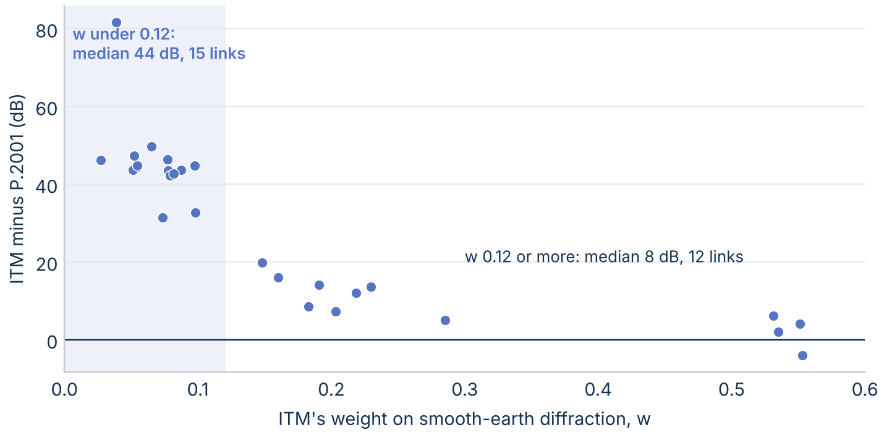
Figure 37. ITM minus P.2001 on the diffraction links at 3 GHz against ITM's smooth-earth weight w.
Of the 22 calculated links with Δh over 150 m and length under 150 km, 21 have a gap over 20 dB (Figure 38). 45 measured datasets from 30 MHz to 10 GHz fall in that corner, and ITM classes 31 of them as line of sight. On the 13 datasets there where ITM and P.2001 differ by more than 10 dB, from 8 paths, the evidence splits by frequency. From 1 GHz to 10 GHz (5 datasets on 3 paths), ITM predicts a mean of 24 dB too much loss and P.2001 is within 1 dB. Below 1 GHz (8 datasets on 5 paths), ITM is within 1 dB and P.2001 predicts 12 dB too little loss. Neither model is right in the window across the whole range. The ITS spot measurements in the measurement section test the window nearer 3 GHz.
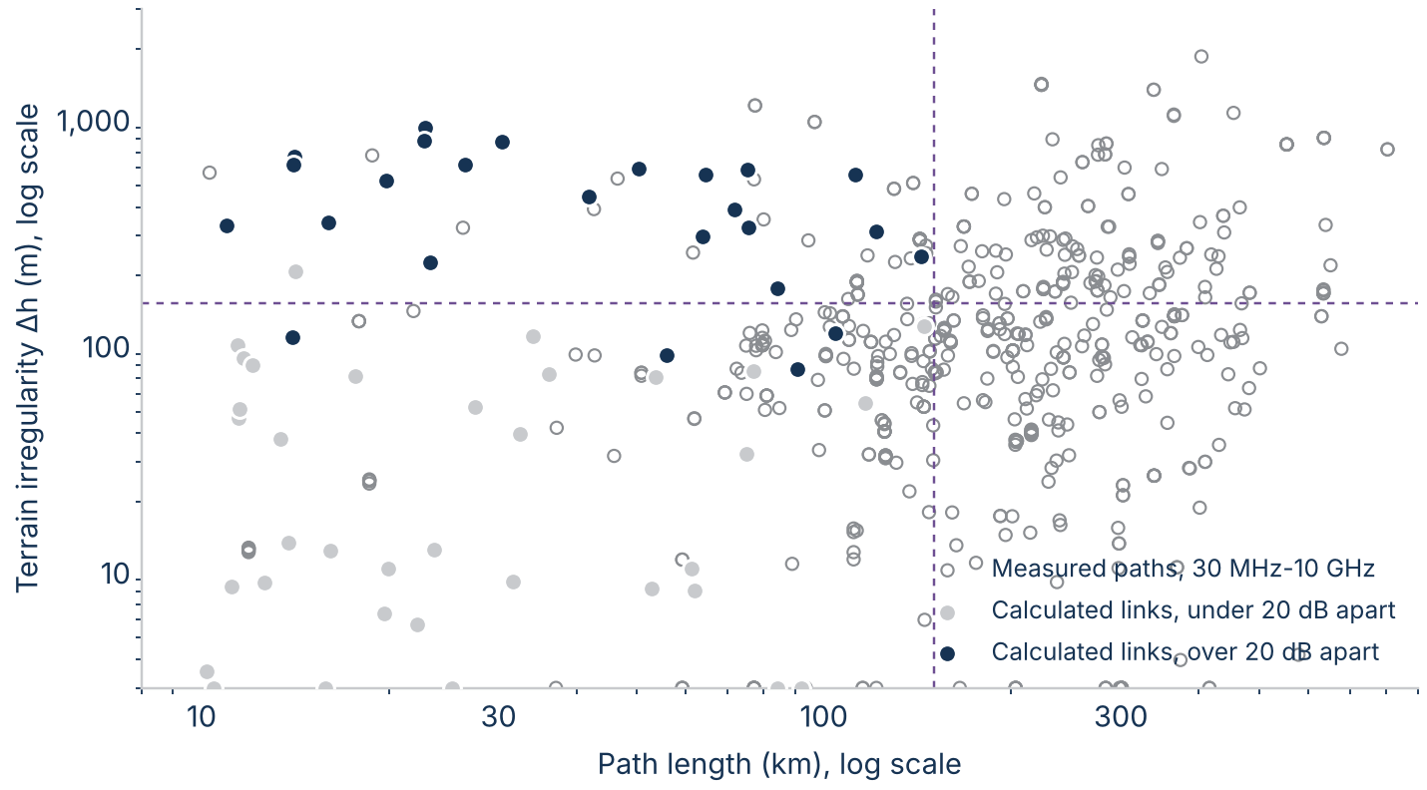
Figure 38. Calculated links at 3 GHz, marked by whether ITM and P.2001 are more than 20 dB apart, and measured databank paths from 30 MHz to 10 GHz, by path length and terrain irregularity Δh.

Western terrain
The mid-Atlantic sample is mostly gentle terrain. To see whether rougher terrain changes the picture, the same calculation was repeated on 60 links drawn with the same rules in three western regions: the Colorado Front Range, the Nevada Basin and Range, and the Los Angeles basin and Transverse Ranges. The median terrain irregularity Δh is 627 m in the west against 78 m in the east, and 56 of the 60 western links fall in the divergence window.
The western links sit at the rough end of the same trend (Figure 39). The median ITM minus P.2001 is 47.8 dB in the west against 10.3 dB in the east, and 53 of the 60 western links differ by more than 20 dB, against 25 eastern links. By region the median is 48.9 dB in the Front Range, 46.2 dB in the Basin and Range, and 46.1 dB in southern California. ITM classes 39 links as diffraction and 15 as troposcatter, with medians of 48.8 dB and 52.0 dB; unlike in the east, the troposcatter links don't reconverge within 150 km. P.452 and P.2001 still agree within 0.4 dB on every link.
The same mechanism explains the gap. On 36 of the 39 western diffraction links, ITM's smooth-earth weight w is under 0.12, and the median gap there is 50 dB. ITM flags a horizon angle over 200 mrad on 8 western links, outside its stated range; leaving them out, the median gap is 46 dB. At 1% of time the median gap is still 43 dB, so on this terrain ducting doesn't close it.
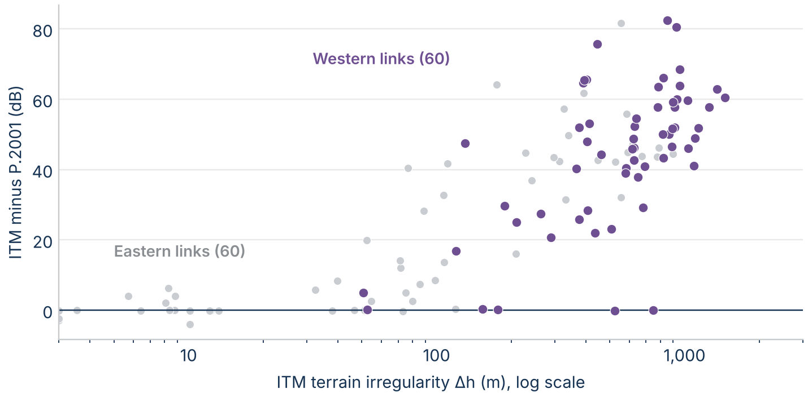
Figure 39. ITM minus P.2001 at 3 GHz and 50% of time against ITM's terrain irregularity Δh, on the 60 eastern links and the 60 western links.

Results over the time distribution
Figure 40 shows each model's loss relative to its own 50% value on the five archetype paths. From 50% to 0.01% of time, P.2001's loss falls about twice as far as ITM's on the troposcatter, over-sea, and single-horizon paths: by 68 dB against 35 dB on the troposcatter path and 75 dB against 47 dB on the over-sea path, because ducting takes over in P.2001.
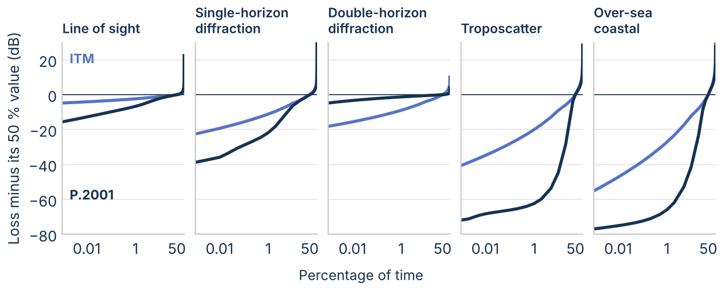
Figure 40. Loss minus its 50% value against time percentage on the five archetype paths at 3 GHz, ITM and P.2001.
On the real-terrain links (Figure 41), the gap on diffraction links holds across the distribution, from 42 dB at 0.001% of time to 30 dB at 99%. On line-of-sight links the models agree at 50% and split by about 11 dB at 0.001%, where P.2001 adds ducting.
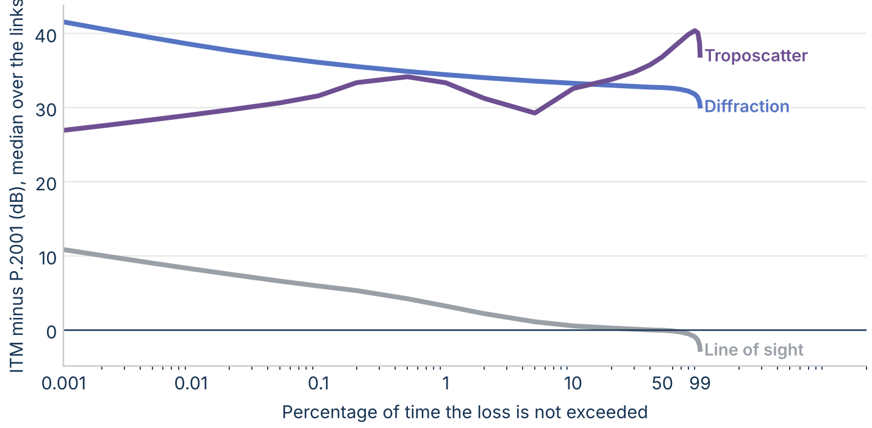
Figure 41. Median ITM minus P.2001 over the real-terrain links at 3 GHz against time percentage, by ITM's mechanism class.

Ducting: the mechanism ITM leaves out
P.452 and P.2001 model ducting and layer reflection as their own mechanism. In P.452 the loss is L_ba = A_f + A_d(p) + A_g, where the time-dependent part depends on β, the time percentage for which strong refractivity lapse rates can be expected near the path. P.2001 uses the same structure. ITM has no ducting term; its small-percentage loss comes from variability curves chosen by radio climate.
On the 127 km over-sea archetype (Figure 42), both ITU models predict less loss than free space (144.1 dB) for 2% of time or less. At 1% of time ITM predicts 173.3 dB and P.2001 137.9 dB; at 0.01% the values are 153.3 dB and 128.8 dB.
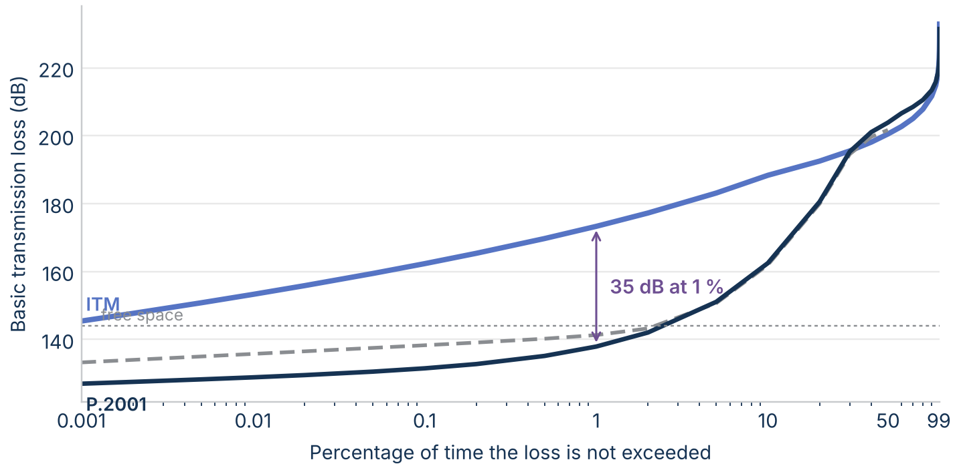
Figure 42. Basic transmission loss on the 127 km over-sea coastal archetype at 3 GHz against time percentage.
On smooth earth (Figure 43), P.2001 uses ducting for up to 10% of time on land paths beyond about 60 km and for up to 20% to 30% of time on sea paths beyond about 30 km.
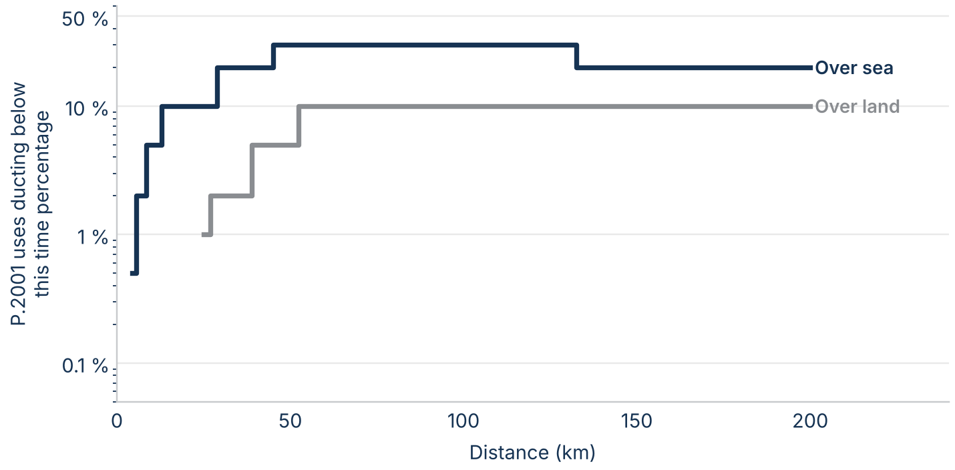
Figure 43. The largest time percentage at which ducting is P.2001's lowest-loss mechanism, against distance, on smooth land and sea at 3 GHz.
On the inland real-terrain links, steep horizons limit ducting (Figure 44). From 50% to 1% of time, P.2001's signal strengthens by a median of 3.9 dB on line-of-sight links and 2.3 dB on diffraction links, against 0.5 dB and 1.8 dB for ITM. On troposcatter links ITM's wide variability gives the larger change: 19.8 dB against 10.7 dB.
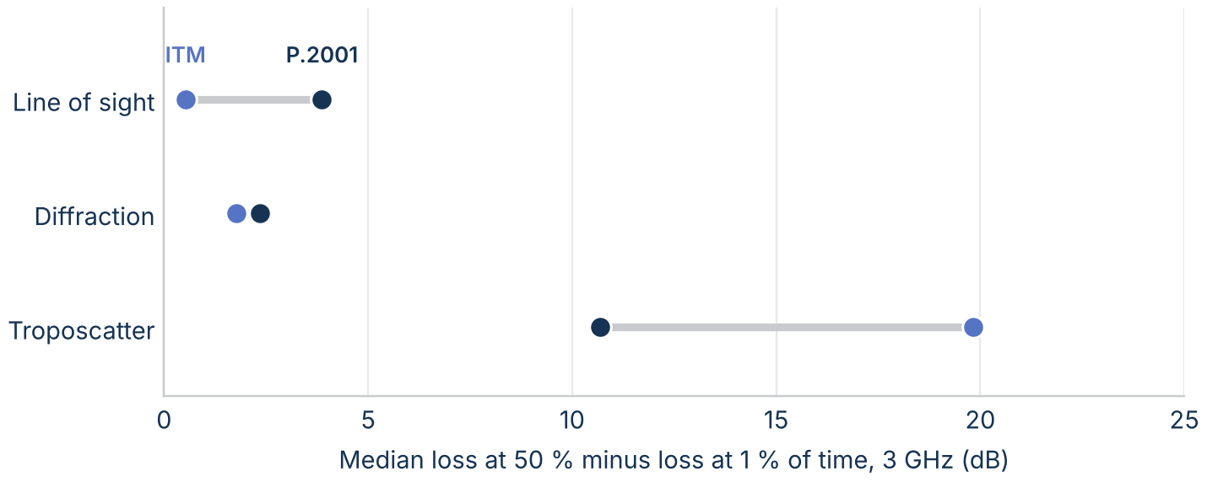
Figure 44. Median loss at 50% minus loss at 1% of time on the real-terrain links at 3 GHz, by ITM's mechanism class.
On the measured paths from 30 MHz to 10 GHz (Figure 45), the signal strengthens by a median of 16.6 dB from 50% to 1% of time. All three models predict more: 21.7 dB for ITM, 17.4 dB for P.452, and 18.5 dB for P.2001. ITM's only lever on this part of the distribution is its radio climate: on the double-horizon archetype, the seven climates move ITM's loss at 1% of time from 276.3 dB to 287.0 dB.
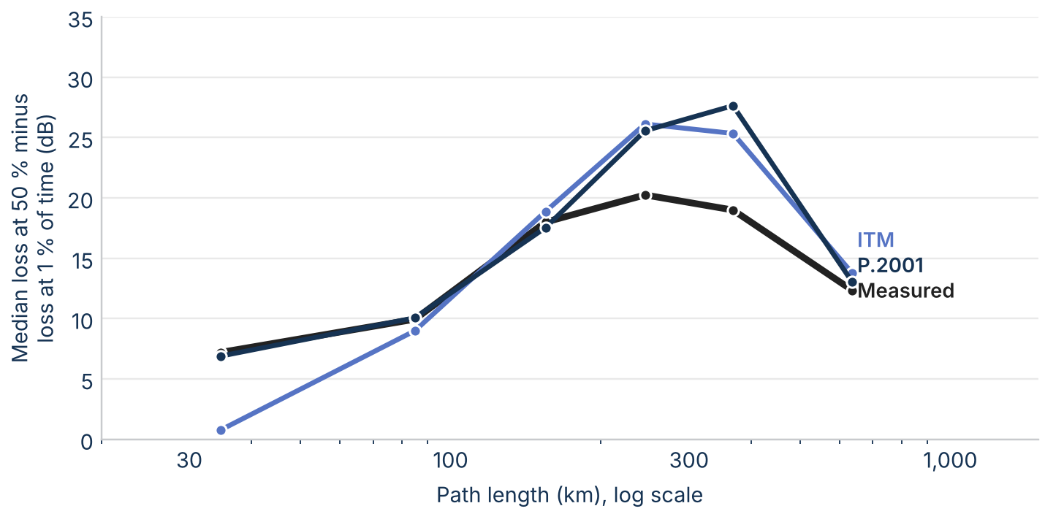
Figure 45. Median loss at 50% minus loss at 1% of time against path length on the measured databank paths from 30 MHz to 10 GHz, measured and predicted.

Comparison with measurements

The data
The comparison uses Table III of the ITU-R Study Group 3 databank (DBSG3), clear-air trans-horizon basic transmission loss. From 30 MHz to 10 GHz, 608 datasets have site coordinates, antenna heights, a measured median, and a surveyed profile or coordinates; after a quality screen, 573 remain, measured in North America, Europe, and Japan (Figure 46). Coordinates in Japan were converted from the Tokyo datum to WGS84. The databank includes the U.S. paths of OT/TRER 16; the medians of 10 paths read from that report match the databank exactly.
Few datasets sit near 3 GHz: 73 from 1 GHz to 3 GHz and 19 from 3 GHz to 6 GHz. The comparison therefore uses all 573 datasets from 30 MHz to 10 GHz, reported in two groups, 30 MHz to 1 GHz and 1 GHz to 10 GHz, and by band. P.452 starts at 100 MHz. These data are not an independent test: ITU-R used the databank to develop P.452 and P.2001, and ITM's developers used many of the same U.S. measurements.
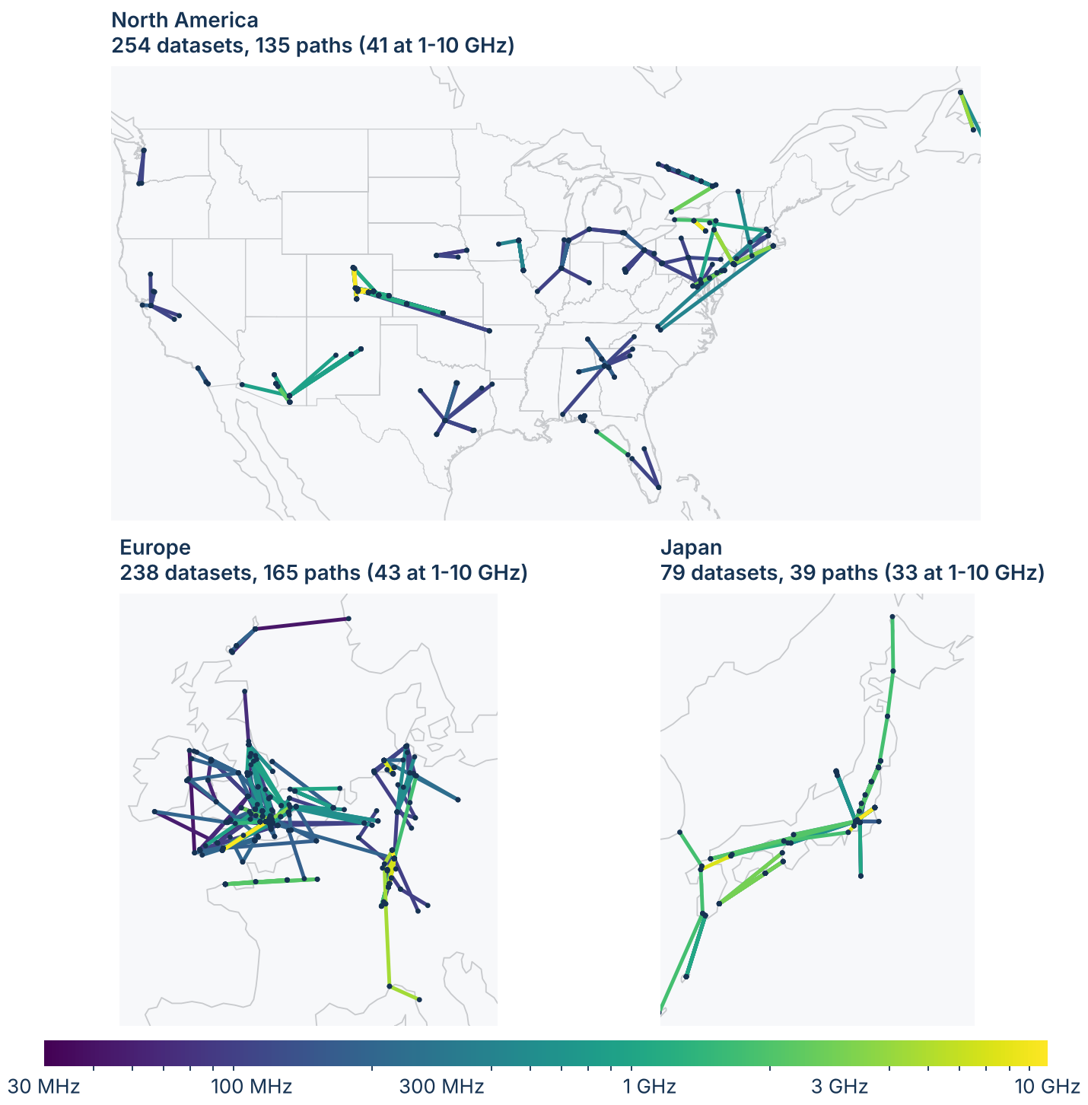
Figure 46. The databank datasets used in the comparison, in the three regions where they were measured. One Australian path is not shown. Paths are colored by frequency.

Terrain and site locations
Many sites are on hilltops, and coordinates from 1950s and 1960s maps can sit a few hundred meters off the summit, so a 30 m terrain model can put a ridge next to the antenna. The main results therefore use the databank's surveyed profiles. Figure 47 shows the effect on the 114 datasets that both runs kept: for ITM the RMS error in the median is 25.3 dB on 30 m terrain at the listed coordinates, 38.0 dB after moving each site to the nearby point that best matches its surveyed elevation, and 10.7 dB on the surveyed profiles. The site correction made the errors larger, because on a mountainside the nearest point at the right height is often on the wrong slope.
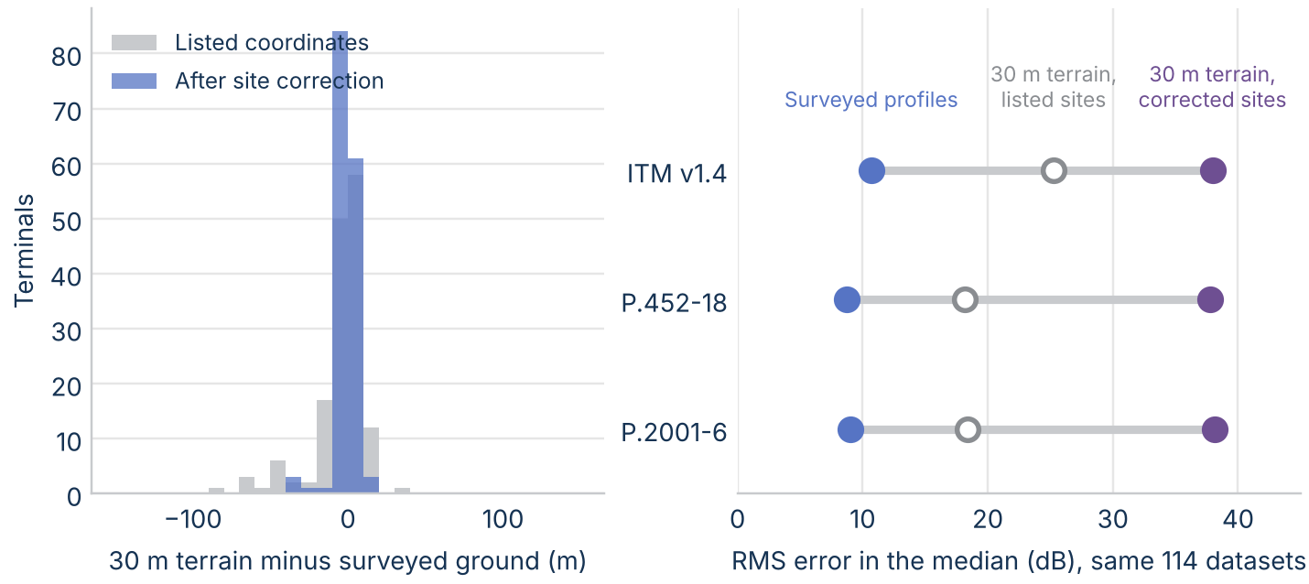
Figure 47. Left: 30 m terrain minus surveyed ground elevation at each terminal, at the listed coordinates and after the site correction. Right: RMS error in the median for each terrain source.

Results
Over all 573 datasets from 30 MHz to 10 GHz, the mean error in the median is -2.2 dB for ITM, -2.9 dB for P.452, and -2.7 dB for P.2001, and the RMS error is 10.1 dB for ITM, 8.7 dB for P.452, and 8.9 dB for P.2001. From 30 MHz to 1 GHz (455 datasets) all three predict about 3 dB too little loss: -2.9 dB for ITM, -3.4 dB for P.452, and -3.3 dB for P.2001. From 1 GHz to 10 GHz (118 datasets) the mean error is 0.5 dB for ITM, -1.8 dB for P.452, and -0.6 dB for P.2001, and the RMS error is 10.8 dB for ITM, 8.7 dB for P.452, and 9.1 dB for P.2001. From 1 GHz to 3 GHz the mean error is -1.2 dB for ITM, -1.7 dB for P.452, and 0.0 dB for P.2001, and from 3 GHz to 6 GHz it is -2.2 dB for ITM, -1.1 dB for P.452, and -0.6 dB for P.2001. ITM drifts toward too much loss from 6 GHz to 10 GHz (Figure 48).
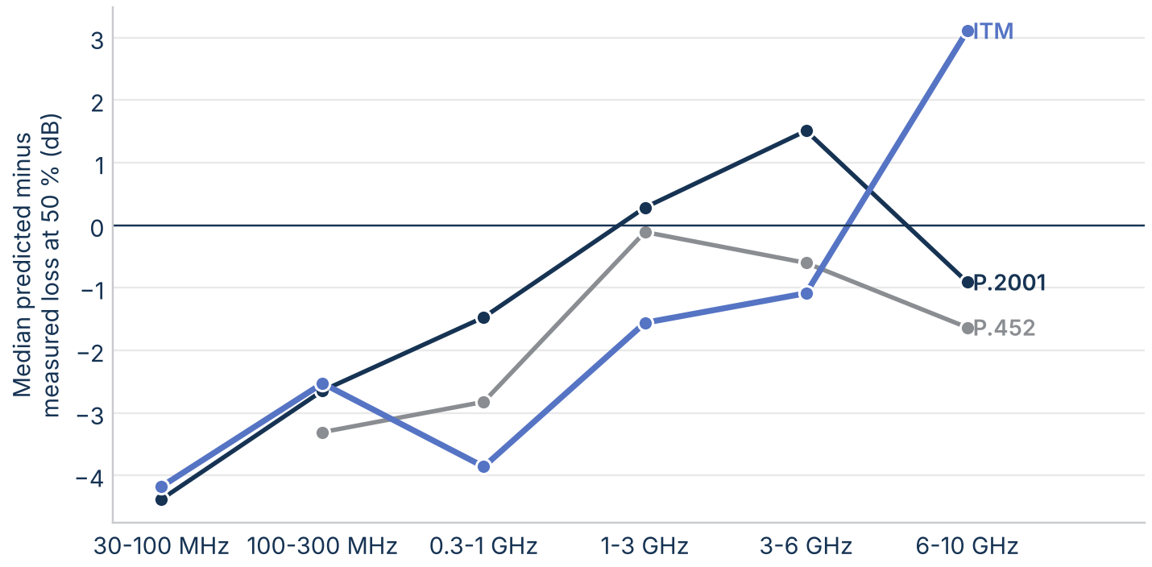
Figure 48. Median predicted minus measured loss at 50% of time by frequency band, 30 MHz to 10 GHz.
At 1% of time the mean error over all datasets is -2.4 dB for ITM, -5.7 dB for P.452, and -6.7 dB for P.2001 (Figure 49): the ITU models predict too little loss at small percentages, because their ducting term enhances the signal more than was measured.
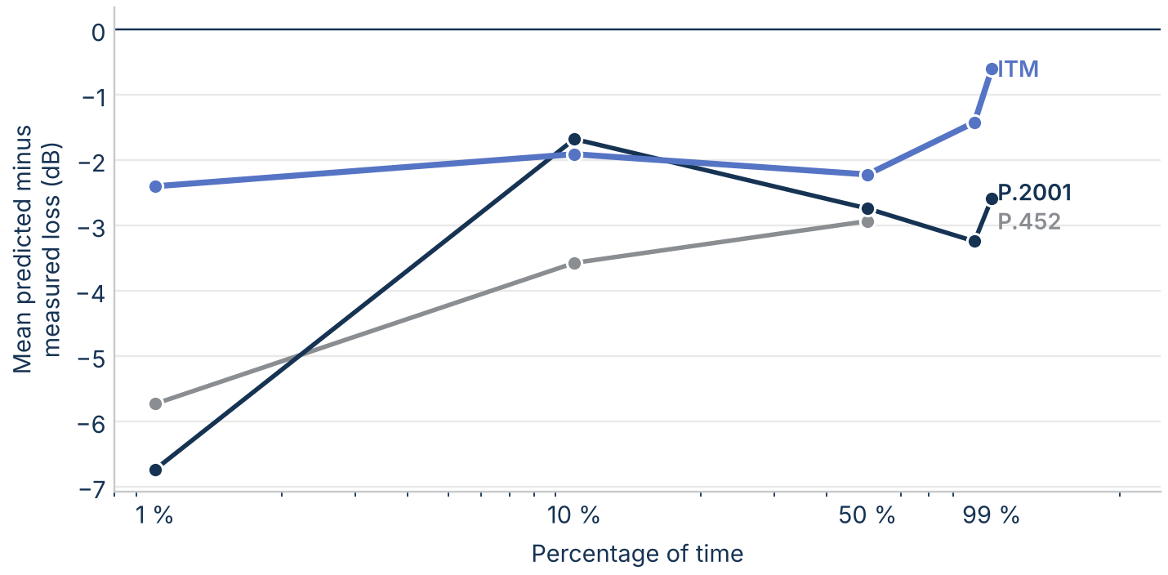
Figure 49. Mean predicted minus measured loss over all datasets from 30 MHz to 10 GHz against time percentage. P.452 is defined only up to 50% and from 100 MHz.
Against terrain irregularity (Figure 50), the median errors show no rough-terrain trend comparable to the calculated gap, because most measured paths are long troposcatter paths outside the divergence window.
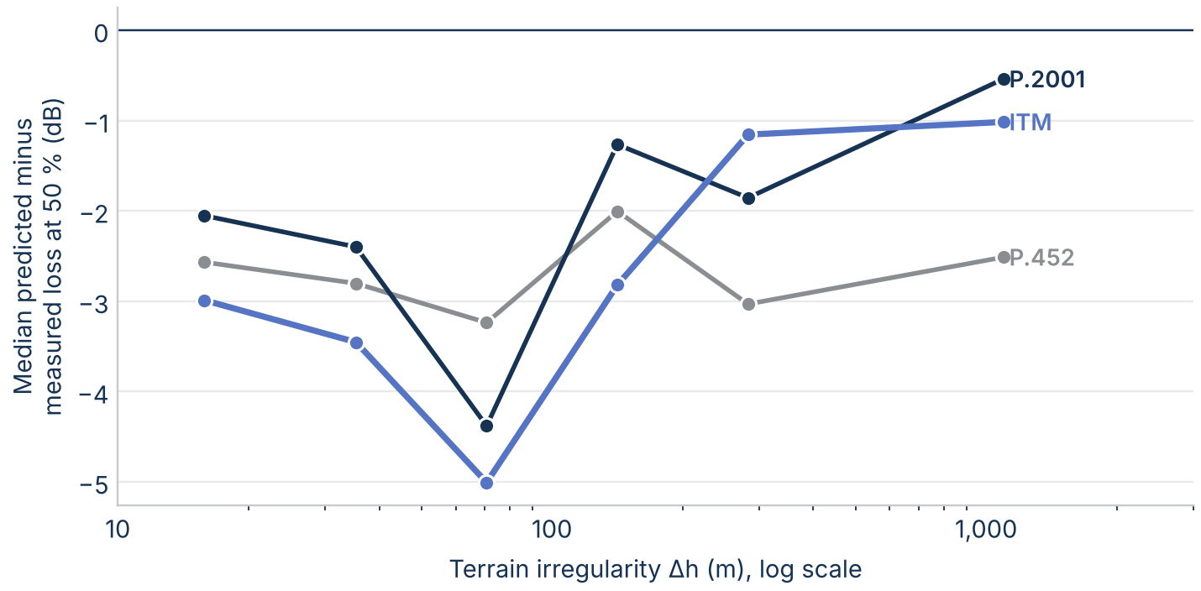
Figure 50. Median predicted minus measured loss at 50% of time from 30 MHz to 10 GHz against ITM's terrain irregularity Δh.

Point-to-area measurements
The databank also holds VHF and UHF measurements relating to terrestrial broadcasting (Recommendation ITU-R P.311, Tables VI-1 and VI-2), which ITU-R distributes free. Each spatial record is a location median: the field strength exceeded at 50% of the locations measured around a point, for 1 kW e.r.p., which converts to basic transmission loss as 141.45 dB minus the field strength plus 20 log f. Keeping the records with site coordinates, a surveyed profile that matches them, a receiving antenna at least 10 m high, and a path of at least 1 km leaves 2890 records from 14 experiments, from 62 MHz to 2180 MHz on paths of 1.1 km to 124.9 km. They include 289 NTIA measurements at 2,180 MHz in Virginia, the closest to 3 GHz in the databank.
All three models predict much less loss than these measurements (Figure 51): over all records the mean error is -14.6 dB for ITM and -13.6 dB for P.2001, and at 2,180 MHz it is -24.9 dB for ITM, -27.9 dB for P.452, and -27.8 dB for P.2001. The error grows with frequency and is largest on the U.S. experiments in rural Virginia, which used antennas 11 m to 15 m high, so it most likely reflects clutter and vegetation loss near the terminals that none of the three models includes without a clutter model such as Recommendation ITU-R P.2108. On these paths the three models agree with each other within about 3 dB on average, so the data say more about the missing clutter term than about which model to prefer.
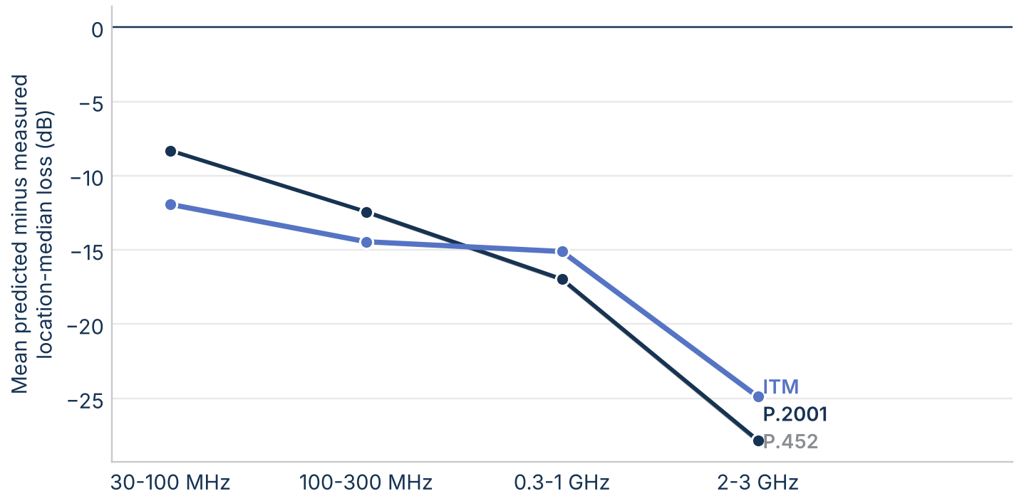
Figure 51. Mean predicted minus measured location-median loss on the ITU-R point-to-area records by frequency band.

Rough-terrain spot measurements near 3 GHz
The databank has few paths in the divergence window near 3 GHz. The ITS "Phase 2" spot measurements, which NTIA publishes free, fill part of that gap: short and medium paths over irregular terrain from 230 MHz to 9.2 GHz, each with a profile surveyed from topographic maps. Four sets have profiles: the Colorado plains (Gunbarrel Hill receiver), the Colorado mountains (Fritz Peak receiver), North Table Mountain near Golden, Colorado, and the Virginia piedmont, measured from 1965 to 1967. The comparison keeps 515 measured paths, from 0.4 km to 124.9 km, and uses the frequencies on either side of 3 GHz: 1,846 MHz and 4,595 MHz in Colorado, and 2,180 MHz and 4,820 MHz in Virginia. Transmitting antennas were 6.6 m to 15 m high with horizontal polarization; in Colorado each receiving antenna was raised from 1 m to 13 m, and the comparison uses every height from 3 m, counting each path once. The models ran on the surveyed profiles.
On many long paths the signal was too weak to measure, so the data give only a lower bound on the loss. Leaving those paths out would favor whichever model predicts less loss, so the medians below use the Kaplan-Meier estimate, which counts each bound as "at least this much loss."
On the 258 open Colorado sites, ITM is the closest: its median error is 0.5 dB, against -3.1 dB for P.452 and -3.0 dB for P.2001 (Figure 52). ITM's error grows with distance, from -1.4 dB under 5 km to 2.4 dB from 50 km to 150 km, while the ITU models stay 1.7 dB to 3.6 dB on the low side. Most of these paths are in the plains and near Golden, where ITM and P.2001 differ by only a few decibels.
The Colorado mountains are the real test. On the 47 mountain paths longer than 15 km, where the median Δh is 697 m, 55% of the results were below the receiver's sensitivity. Counting those as lower bounds, ITM predicts a median of 29 dB too much loss and P.2001 17 dB too little; P.452 matches P.2001. Where the signal was too weak to measure, P.2001 predicts less loss than the bound on 64% of the results and ITM on 0%. The measured loss falls between the two predictions: on this terrain ITM overstates the loss and the ITU models understate it, each by tens of decibels. Over all 59 measured paths in the divergence window (Δh over 150 m, 15 km and longer), the medians are 6.2 dB for ITM and -8.1 dB for P.2001.
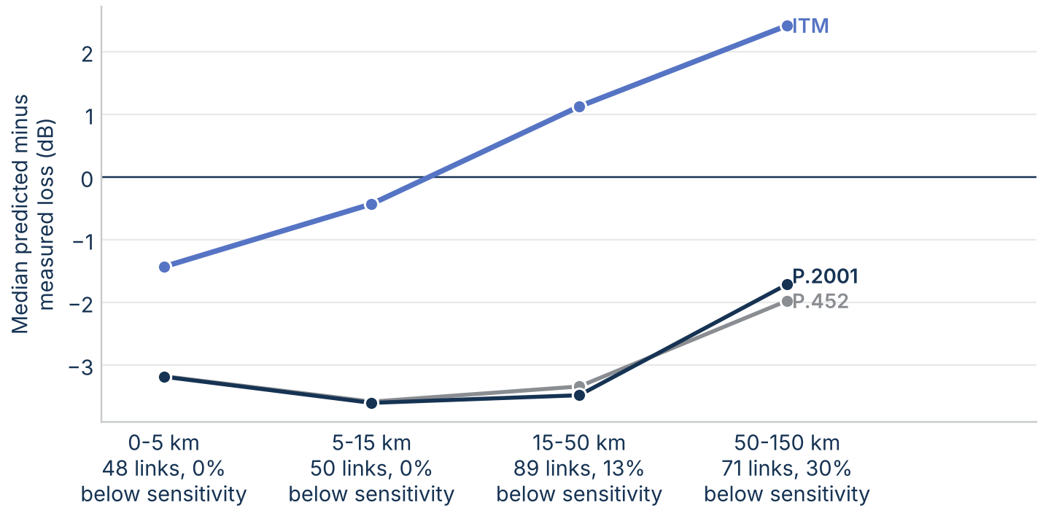
Figure 52. Median predicted minus measured loss on the ITS Phase 2 open Colorado sites at 1,846 MHz and 4,595 MHz, by path length. Medians count paths below the receiver's sensitivity as lower bounds (Kaplan-Meier).
In Virginia all three models predict too little loss even at open sites: the median error is -10.6 dB for ITM and -13.0 dB for P.2001 on 512 links, at every distance. That matches the ITU point-to-area records from the same region and most likely reflects trees near the terminals, which bare-earth profiles leave out.
The paired sites measure that clutter directly. On 78 paths, a second receiver site sat behind trees or a building next to the open one. Near 3 GHz the concealed site had a median of 8.0 dB more loss than the open one (middle half 2.3 dB to 16.7 dB, 88 pairs), rising from 3.0 dB below 1 GHz to 10.8 dB above 3 GHz (Figure 53). The models predict almost no difference, because the two sites share nearly the same bare-earth profile. A clutter model such as Recommendation ITU-R P.2108 would be needed to capture it.
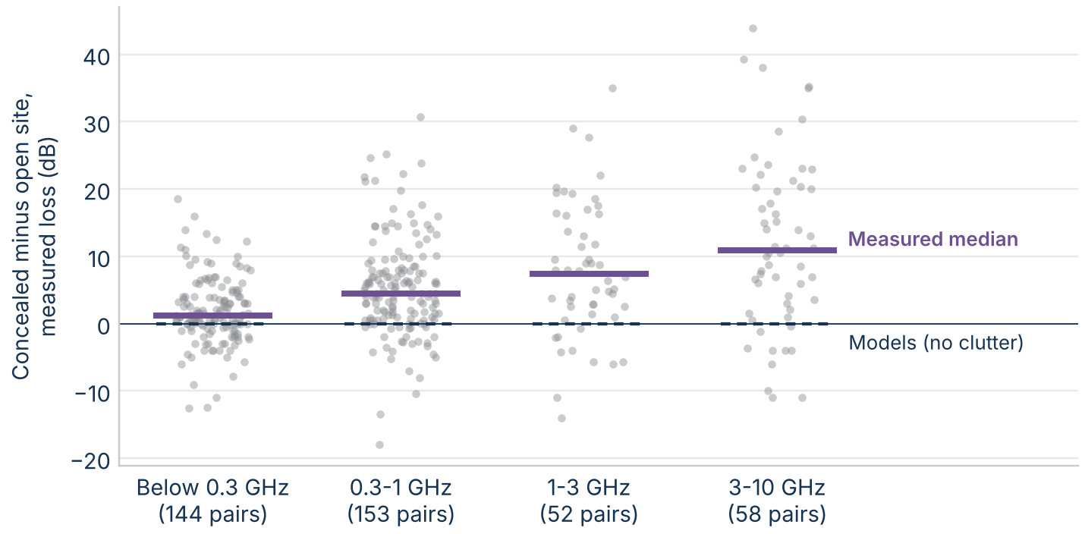
Figure 53. Measured loss at a concealed site (behind trees or a building) minus the nearby open site, ITS Phase 2, by frequency band. The bar is the median; the dashed line is the models' median difference.

Low antennas and low frequencies
Two more ITS spot-measurement sets test the models with antennas near the ground. Phase 1 (1963 and 1964) measured at 50 MHz and 100 MHz in the Colorado plains, the Colorado mountains, and the Ohio hills, with transmitting antennas about 4 m high and receiving antennas 0.55 m to 9 m high, on surveyed profiles. The low-antenna set (1968) measured at 230 MHz and 416 MHz in three arid western regions (the Laramie Mountains, the Snake River Plateau, and the Columbia Plateau) with both antennas 3 m high or lower. It has no profiles, so the models ran on 30 m terrain at the listed coordinates. Together the two sets add 608 paths.
All three models predict too little loss with antennas this low (Figure 54). The median error is -16.7 dB for ITM and -16.0 dB for P.2001 on the 466 Phase 1 paths, and -6.7 dB for ITM and -8.8 dB for P.2001 on the 142 low-antenna paths. On these paths ITM and P.2001 differ by a median of only 0.7 dB, because the gap between the models is small at these low frequencies (it grows with frequency, as the frequency sweep shows), so the data say more about losses near the ground (ground reflection, vegetation, and small obstacles a map profile misses) than about which model to prefer. The low-antenna sites were said to be on the highest ground within 100 m of a chosen point; moving each terminal to the highest 30 m terrain point within 100 m lowers ITM's prediction by a median of 2.5 dB, so at these heights the site position matters as much as the model.
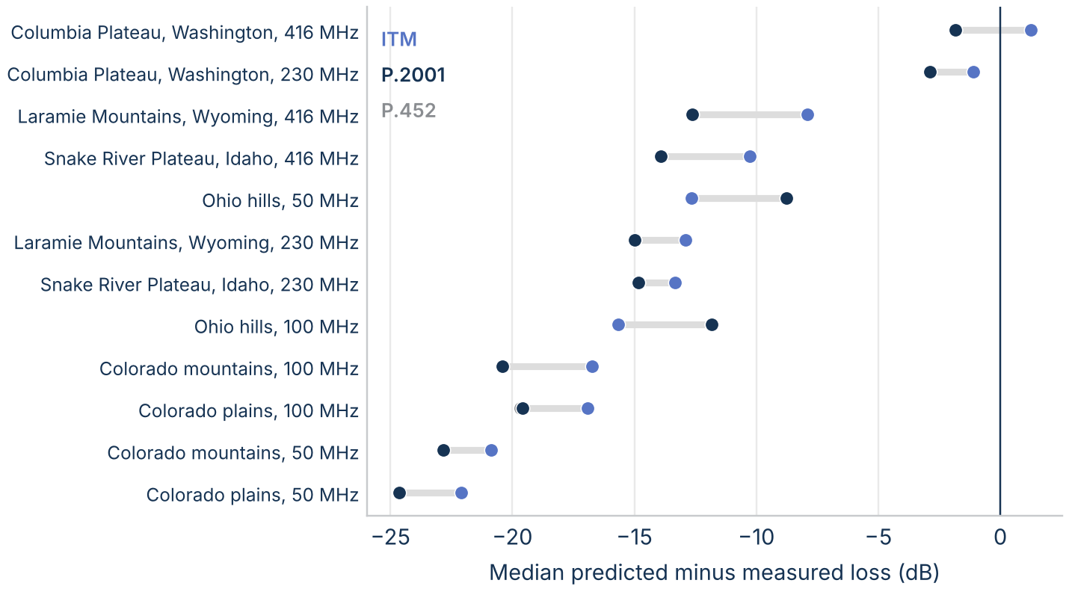
Figure 54. Median predicted minus measured loss at 50% of time on the ITS Phase 1 (50 MHz and 100 MHz) and low-antenna (230 MHz and 416 MHz) spot measurements, by measurement set and frequency. Medians count results below the receiver's sensitivity as lower bounds.

How certain are these numbers?
The headline numbers come from small samples, so this section puts 95% confidence intervals on them by bootstrap: 10,000 resamples of the links, or of the measured paths, with a fixed seed. Resampling paths rather than datasets matters for the measurements, because datasets on one path share its terrain and its errors.
The class medians are uncertain (Figure 55). The median gap on the 27 diffraction links is 33 dB, with an interval of 14 dB to 44 dB, and on the 15 troposcatter links 37 dB, with an interval of 6 dB to 56 dB. The intervals are wide because each class mixes two groups of links, and a resample that draws a few more from one group moves the median from one group to the other. The groups themselves are tight: 44 dB (43 dB to 46 dB) where ITM's smooth-earth weight is under 0.12, and 8 dB (5 dB to 14 dB) elsewhere. The share of diffraction links more than 20 dB apart is 56% (37% to 74%), a more stable summary than the median. The weight that best separates the groups is 0.1, with an interval of 0.04 to 0.205. With 27 links the formal bimodality tests are inconclusive: a two-group mixture (means of 9 dB and 45 dB) fits only slightly better than one group by BIC, and Sarle's bimodality coefficient is 0.35, below the 0.555 that suggests two groups. In the line-of-sight class the interval is 0 dB to 0 dB.
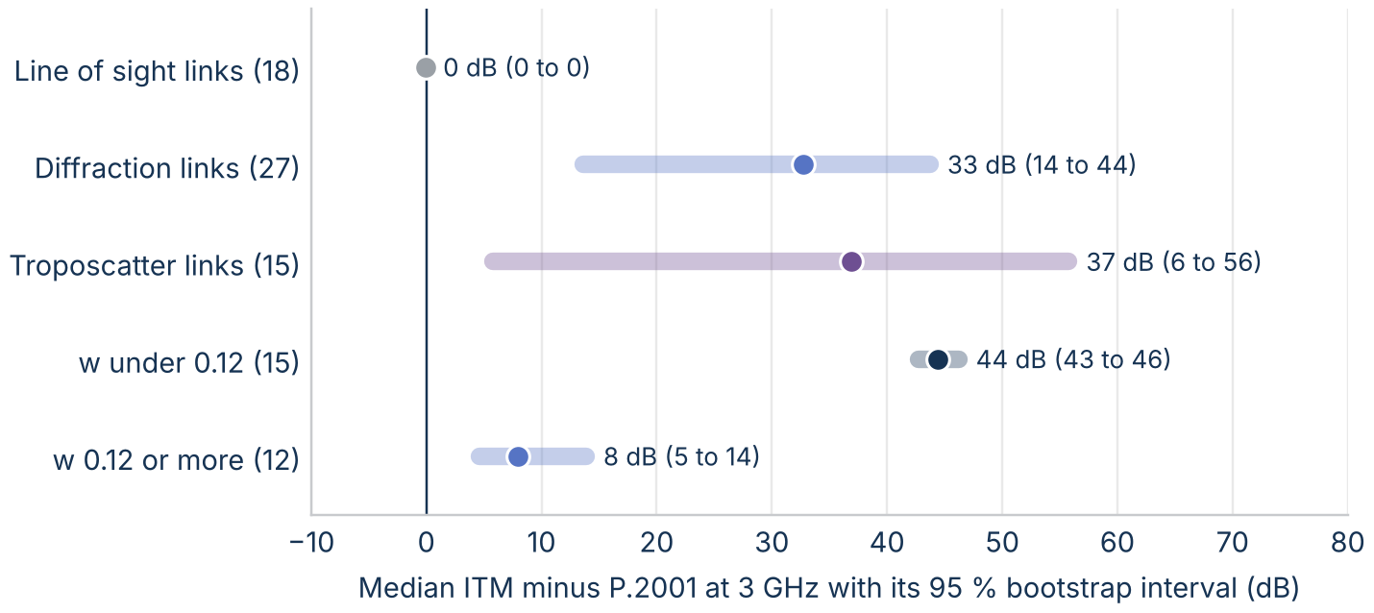
Figure 55. Median ITM minus P.2001 at 3 GHz with 95% bootstrap intervals, by ITM's mechanism class and by ITM's smooth-earth weight w on the diffraction links.
Against the measurements (Figure 56), the mean errors over all 573 datasets are -2.2 dB for ITM (-3.4 dB to -1.0 dB), -2.9 dB for P.452, and -2.7 dB for P.2001, so all three predict slightly too little loss overall, and the intervals overlap. From 1 GHz to 10 GHz, on 76 paths, every interval includes zero: -1.9 dB to 2.9 dB for ITM and -3.1 dB to 1.7 dB for P.2001. The measurements can't separate the models at the median.
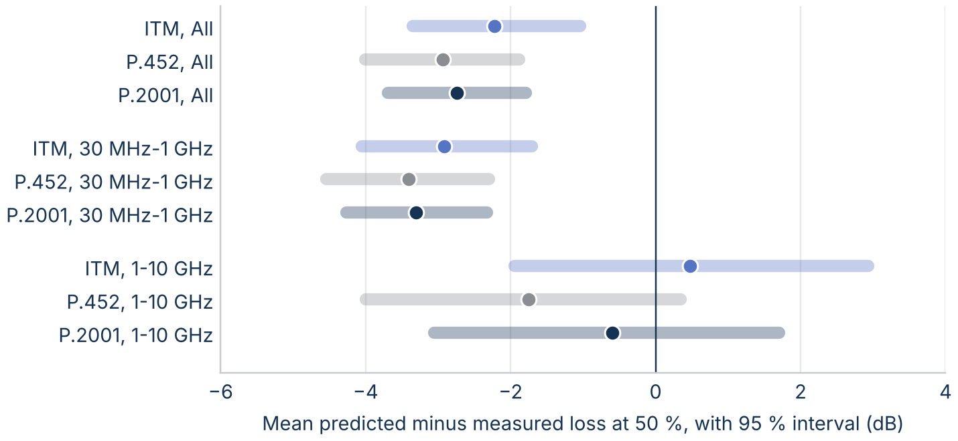
Figure 56. Mean predicted minus measured loss at 50% of time with 95% intervals from resampling measured paths, by group.

Sensitivity to model settings
The results use one set of model settings. To test whether another setting closes the gap, the 60 real-terrain links were rerun at 3 GHz and 50% of time with each ITM setting changed in turn: ground constants (poor and average), confidence (10% and 90%), each of the seven radio climates, N₀ of 280 and 360 N-units, and horizontal polarization. P.452 was also run with surface heights from the Copernicus surface model added to the profile, and P.452 and P.2001 with horizontal polarization.
No setting closes the gap (Figure 57). On the diffraction links the median ITM minus P.2001 is 32.7 dB with the baseline settings. Confidence moves it most, to 23.2 dB at 10% and 42.2 dB at 90%, because it shifts every ITM prediction by about 9 dB. Ground constants, radio climate, N₀, and polarization each move it by less than 1 dB at the median, although radio climate moves individual links by up to 5.3 dB. Adding surface heights raises P.452's loss by a median of 2.0 dB and up to 37.4 dB on one link; the ITU models' polarization changes their loss by less than 0.01 dB at the median.
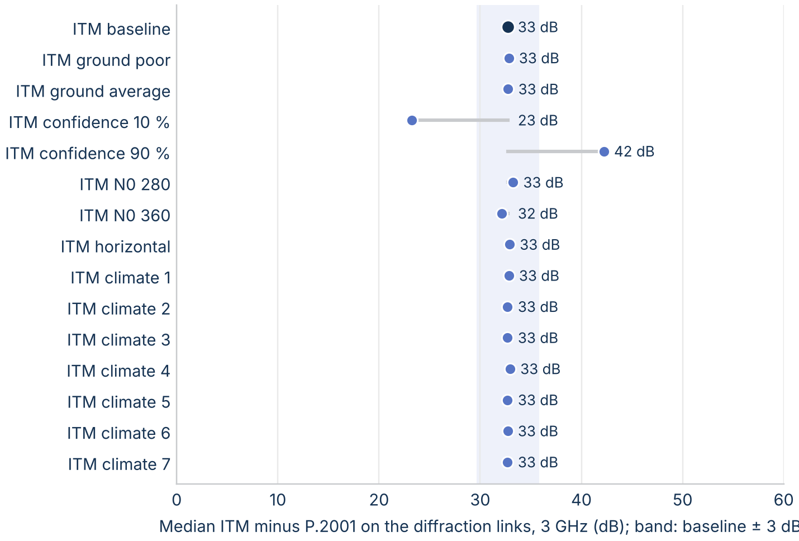
Figure 57. Median ITM minus P.2001 on the diffraction links at 3 GHz for each ITM setting tested. The band is the baseline ± 3 dB.

What the differences mean in distance
On smooth land, the models reach each loss threshold from 150 dB to 180 dB within 5 km of each other (Figure 58), because the steep slope beyond the radio horizon makes distance insensitive to a few dB. Over rough terrain, ITM's extra 30 dB to 45 dB of diffraction loss lets it reach a threshold much sooner, so an analysis with ITM computes smaller separation distances there than one with P.452 or P.2001.
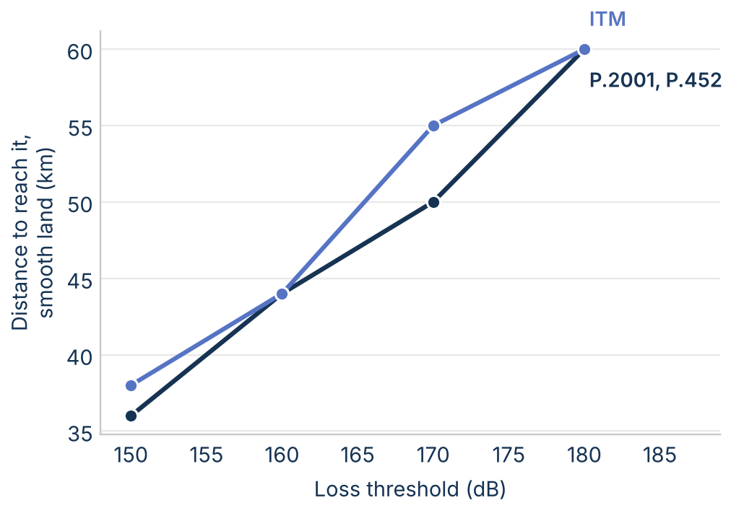
Figure 58. Distance at which the 50% loss first reaches each threshold on smooth land at 3 GHz.

Two real scenarios: Washington, DC, and Los Angeles
To see what the gap does to an exclusion area, a receiver with a 10 m antenna was placed at the Washington Monument and at Los Angeles City Hall, and a grid of transmitters with 30 m antennas was laid out over 300 km by 300 km around each, at a 2.5 km step: 14640 transmitter sites per city. Each transmitter is evaluated alone (single entry) at 3 GHz on its own 30 m terrain profile with all three models. The next subsection shows that this grid is fine enough and large enough.
Around Washington, DC, the models agree over most of the grid, with a median difference of 0.2 dB, but 11% of sites differ by more than 20 dB, mostly in the Blue Ridge and Appalachians to the west and northwest (Figure 59). Around Los Angeles, where mountains ring the basin, the median difference is 33.3 dB and 65% of sites differ by more than 20 dB, up to 92 dB. P.452 matches P.2001 within 5.7 dB around DC and within 10.0 dB around Los Angeles. The outlines show where a single transmitter would need more than 160 dB of loss: the ITU models' exclusion zone extends well beyond ITM's.
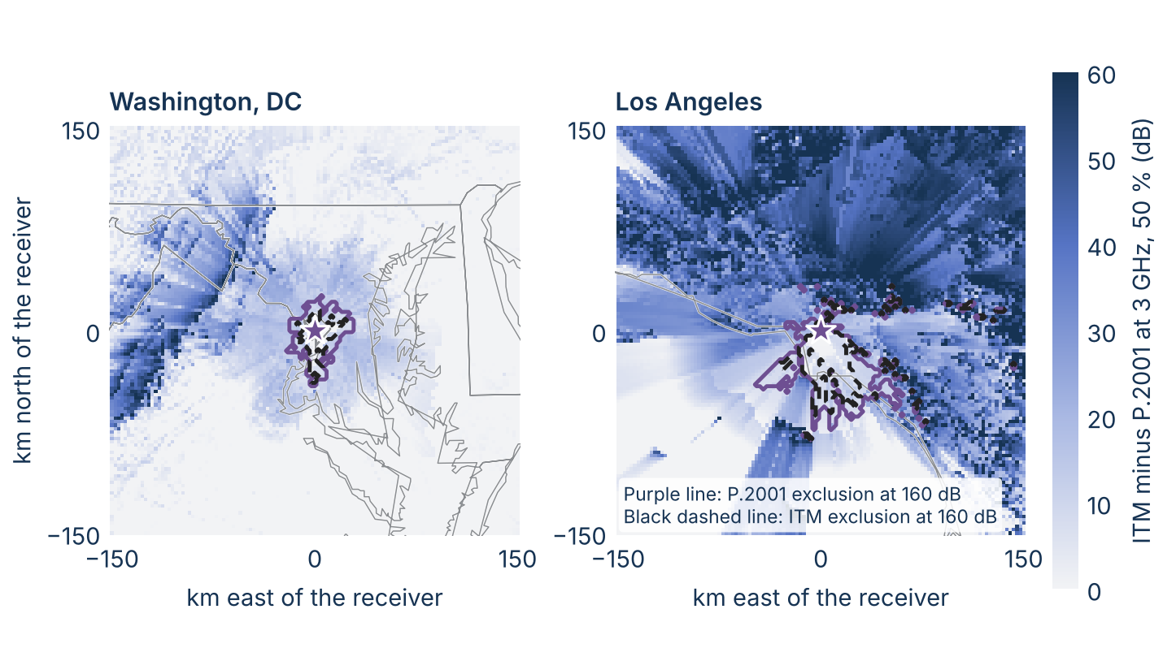
Figure 59. ITM minus P.2001 at 3 GHz and 50% of time from each transmitter site (30 m antenna) to the receiver (star, 10 m antenna), single entry, on a 300 km grid at a 2.5 km step. Outlines: exclusion zones at a required loss of 160 dB, P.2001 (purple) and ITM (black dashed). State lines and coastlines in gray.
A required loss turns these maps into an exclusion area: the sites where one transmitter alone would get less loss than the protection criterion needs. The required loss is the transmitter's e.i.r.p. plus the receiving antenna gain minus the interference threshold, all in decibels; for example, 61 dBm in 10 MHz into a 0 dBi antenna with a threshold of -105 dBm in 10 MHz needs 166 dB. At a required loss of 160 dB (Figure 60), P.2001 and P.452 exclude 1569 km² around DC and ITM 669 km²; around Los Angeles the areas are 4000 km² and 2056 km², and the farthest P.2001 exclusion is 145 km from the receiver. At 140 dB, close to the receiver, the models are close: 425 km² against 388 km² around DC.
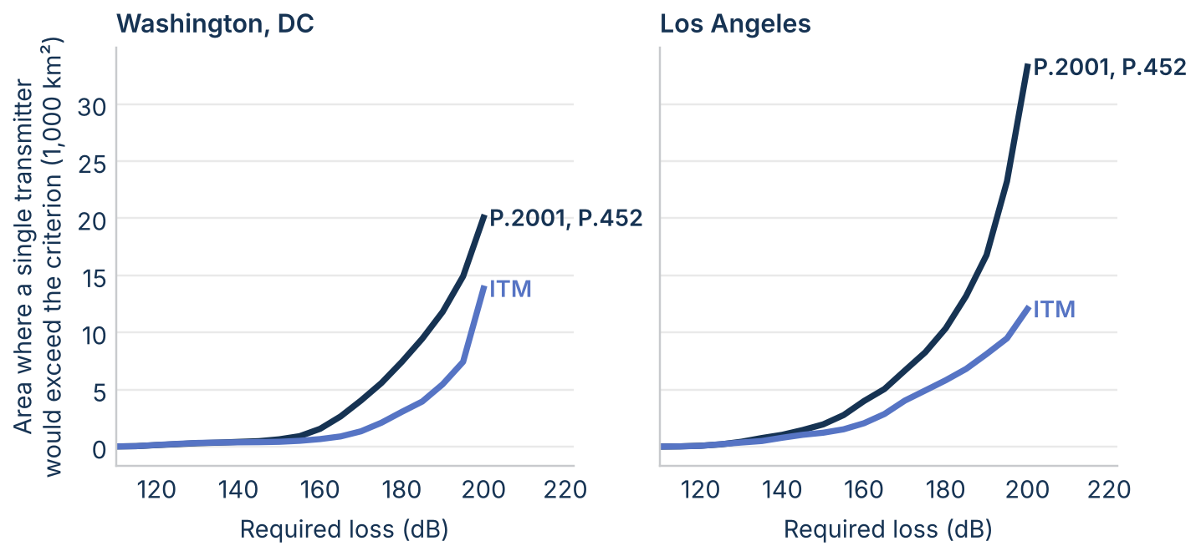
Figure 60. Area of the 300 km grid where a single transmitter would get less loss than the required loss, at 50% of time, by model. P.452 matches P.2001.

Is the grid fine enough and large enough?
Two extra runs per city test the grid: the 300 km grid at a 2.5 km step, and a 100 km grid at a 1 km step. Coarser and smaller grids are subsets of these, so the exclusion area can be recomputed for widths of 100 km, 200 km, and 300 km and steps of 1 km, 2.5 km, and 5 km (Figure 61). Two checks decide whether a grid is adequate: the area changes little when the step is refined, and no excluded site lies on the grid's outer edge.
Step: on the 100 km grid from 150 dB to 170 dB, a 2.5 km step gives areas within 3% of the 1 km step, and a 5 km step within 13%. A 2.5 km step is fine enough; 5 km is adequate for a first look. Extent: around DC the 100 km grid already holds the whole exclusion zone up to 170 dB (1569 km² at 160 dB for P.2001 on every grid size). Around Los Angeles it does not: excluded sites reach the edge of the 100 km grid from 150 dB up, and the P.2001 area at 160 dB grows from 3188 km² on the 100 km grid to 3900 km² on the 200 km grid and 4000 km² on the 300 km grid, with no excluded sites on its edge. The 100 km grid used in the first draft understated the Los Angeles exclusion area by about a fifth. Rough terrain, where mountain sites with long views of the receiver lie far from it, needs a wider grid than flat terrain.
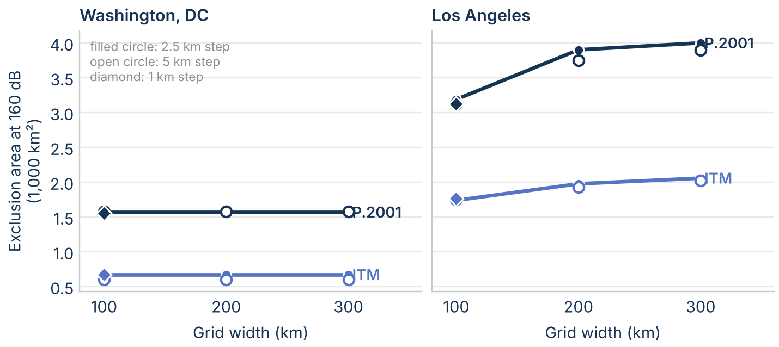
Figure 61. Exclusion area at a required loss of 160 dB against grid width, for grid steps of 1 km (diamond), 2.5 km (filled circle), and 5 km (open circle).

Clutter at the receiver
The grids so far use bare-earth loss. A receiver 10 m high in a suburban or urban area sits in clutter, so the grids were rerun with the terrestrial clutter loss of Recommendation ITU-R P.2108-1 Section 3.2 added at the receiver. That loss depends only on frequency, distance, and the percentage of locations, so it is the same for all three models: at 3 GHz and 2 km or more it is 24.6 dB at 10% of locations, 29.7 dB at 50%, and 34.9 dB at 90%. The 30 m transmitter is taken to be above the clutter.
Clutter changes the areas more than the choice of model does (Figure 62). At a required loss of 160 dB and 50% of locations, the exclusion area around Washington, DC, falls from 669 km² to 331 km² for ITM and from 1569 km² to 319 km² for P.2001, and around Los Angeles from 2056 km² to 375 km² for ITM and from 4000 km² to 456 km² for P.2001. The models nearly agree at 160 dB with clutter, because the excluded points move inside about 25 km, where most paths are line of sight. The difference returns at larger required losses: at 190 dB, P.2001's area is 1625 km² against 669 km² for ITM around DC, and 4069 km² against 2088 km² around Los Angeles. Clutter acts like lowering the required loss by about 30 dB: it decides where on the curve an analysis sits, and the model decides the curve.
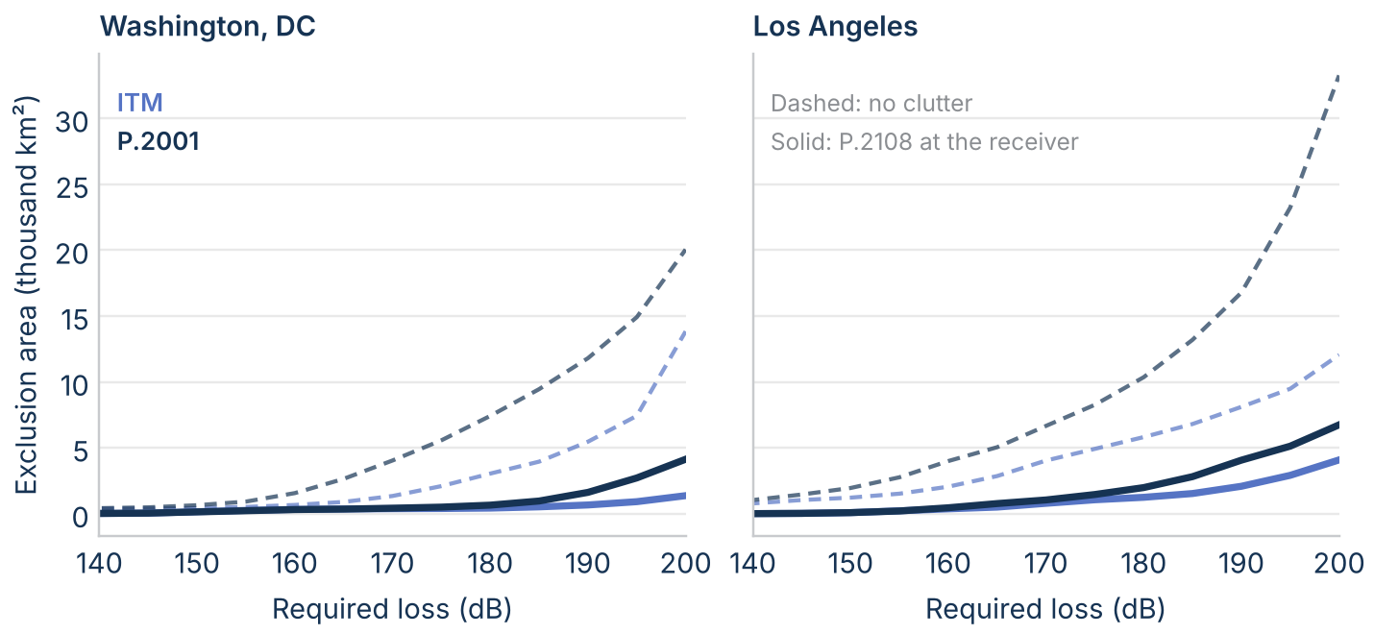
Figure 62. Single-entry exclusion area against required loss at 3 GHz and 50% of time, without clutter (dashed) and with ITU-R P.2108 Section 3.2 clutter loss at 50% of locations at the receiver (solid), on the 300 km grids.

What the comparison means for analyses
- Line of sight: the choice of model matters little. The three models agree within a fraction of a decibel at the median.
- Rough-terrain paths of about 15 km to 150 km: the choice matters most. ITM predicts a median of 33 dB more loss than the ITU models on diffraction links, so it gives smaller separation distances at the median. The gap grows with frequency.
- Exclusion areas can differ by a factor of about two. In the two city scenarios, the ITU models' exclusion area at a required loss of 160 dB is 2.3 times ITM's around DC and 1.9 times around Los Angeles.
- Small time percentages: the choice matters through ducting. The ITU models give much less loss than ITM at 1% of time and below over water and on long paths, so they give larger separation distances at those percentages.
- In mountains, the truth lies between the models. Near 3 GHz on rough Colorado paths beyond 15 km, ITM predicts a median of 29 dB too much loss and the ITU models 17 dB too little. On gentler terrain ITM is closer. Neither model should be used on mountainous paths without a sensitivity run with the other.
- Western analyses are the most exposed. On western terrain the median gap is 48 dB, so the model choice can change a western separation distance far more than an eastern one.
- Clutter can matter as much as the model. Trees or a building next to a terminal added a median of 8.0 dB near 3 GHz in the ITS measurements, and P.2108 clutter at the receiver shrinks the city exclusion areas several times over. An analysis should state its clutter assumption as clearly as its model.
The differences are large enough to change an analysis outcome, so the model choice should be stated, justified, and tested for sensitivity.

Where to look deeper
- The equation-by-equation comparison. The plan section lists 29 items, starting with synthetic two-obstacle and rough-terrain families that would map where ITM's extended diffraction line and P.2001's delta-Bullington loss part, and a Monte Carlo combination of P.2001's sub-models.
- Which diffraction prediction is right over rough terrain? The ITS mountain measurements put the truth between ITM and the ITU models, but 55% of those results were below the receiver's sensitivity, and the profiles come from 1950s maps. New measurements on rough paths of 15 km to 150 km near 3 GHz, with more sensitive receivers and 30 m terrain, would pin down the diffraction loss.
- Should NTIA measure from 3 GHz to 10 GHz? The databank has few usable datasets above 3 GHz. A short campaign on a few diffraction and troposcatter paths would anchor the comparison.
- Do aggregate-interference results depend on ducting? The ITU models predict far less loss than ITM at small time percentages, from a mechanism ITM lacks.
- Which clutter loss fits each site? P.2108 Section 3.2 is a statistical model for urban and suburban terminals. Site-specific clutter from land-cover or lidar data, and measured clutter near 3 GHz, would show whether the statistical value fits a given receiver.

Limitations
- The real-terrain sample is small: 60 links in three mid-Atlantic regions, 60 in three western regions, and five archetype paths, at one frequency.
- The measurements are old, mostly long trans-horizon paths, sparse above 3 GHz, and used by the models' developers.
- The ITS spot measurements are single median values, so they test 50% of time only; their profiles come from 1950s topographic maps, and many mountain results are only lower bounds.
- Each model ran with defaults this paper chose; the sensitivity section tests the main ones, but not ITM's variability mode; P.2108 clutter loss is tested on the grids only.
- The city scenarios are single entry, with one antenna height each, on a 300 km grid at a 2.5 km step; aggregate interference from many transmitters can change the areas.
- All results are basic transmission loss with isotropic antennas, without clutter or building entry loss.

References
- A. G. Longley and P. L. Rice, Prediction of Tropospheric Radio Transmission Loss over Irregular Terrain: A Computer Method-1968, ESSA Technical Report ERL 79-ITS 67, 1968.
- P. L. Rice, A. G. Longley, K. A. Norton, and A. P. Barsis, Transmission Loss Predictions for Tropospheric Communication Circuits, NBS Technical Note 101, revised 1967.
- A. G. Longley, R. K. Reasoner, and V. L. Fuller, Measured and Predicted Long-Term Distributions of Tropospheric Transmission Loss, OT/TRER 16, Office of Telecommunications, July 1971. https://its.ntia.gov/publications/download/OT-TRER-16.pdf
- NTIA Institute for Telecommunication Sciences, Irregular Terrain Model (ITM), version 1.4, C++ source. https://github.com/NTIA/itm
- Recommendation ITU-R P.2001-6, A general purpose wide-range terrestrial propagation model in the frequency range 30 MHz to 50 GHz.
- Recommendation ITU-R P.452-18, Prediction procedure for the evaluation of interference between stations on the surface of the Earth at frequencies above about 0.1 GHz.
- Recommendation ITU-R P.526-15, Propagation by diffraction.
- Recommendation ITU-R P.617, Propagation prediction techniques and data required for the design of trans-horizon radio-relay systems.
- Wireless Innovation Forum, Requirements for Commercial Operation in the U.S. 3550-3700 MHz Citizens Broadband Radio Service Band, WINNF-TS-0112.
- ITU-R Study Group 3 databanks (DBSG3), Table III, clear-air trans-horizon basic transmission loss statistics, long-term data. https://www.itu.int/oth/R0A04/en
- EPSG Geodetic Parameter Dataset, Tokyo to WGS 84 (1). https://epsg.io/63016405
- U.S. Geological Survey, 3D Elevation Program (3DEP), 1 arc-second digital elevation models.
- P. L. McQuate, J. M. Harman, and A. P. Barsis, Tabulations of Propagation Data over Irregular Terrain in the 230- to 9200-MHz Frequency Range, Part I: Gunbarrel Hill Receiver Site, ESSA Technical Report ERL 65-ITS 58, 1968. https://its.ntia.gov/publications/download/essa_erl_65-ITS_58.pdf
- G. A. Hufford and F. K. Steele, Tabulations of Propagation Data over Irregular Terrain in the 75- to 8400-MHz Frequency Range, Part V: Virginia, NTIA Report 91-282, 1991. https://its.ntia.gov/publications/download/91-282.pdf
- NTIA Institute for Telecommunication Sciences, Legacy radio propagation data. https://its.ntia.gov/data/legacy-radio-propagation-data/
- Recommendation ITU-R P.2108-1, Prediction of clutter loss, 2021.
- M. E. Johnson, M. J. Miles, P. L. McQuate, and A. P. Barsis, Tabulations of VHF Propagation Data Obtained over Irregular Terrain at 20, 50, and 100 MHz, ESSA Technical Report IER 38-ITSA 38, 1967.
- L. G. Hause, F. G. Kimmett, and J. M. Harman, UHF Radio Propagation Data for Low Antenna Heights, ESSA Technical Report ERL 134-ITS 93, 1969.
- E. L. Kaplan and P. Meier, Nonparametric estimation from incomplete observations, Journal of the American Statistical Association, 53(282), 1958.

Appendix: reproducing the analysis
All analysis is MATLAB code in the matlab_itm repository, folder docs/model_comparison. MATLAB writes every result to CSV files in the repository, and Python only draws the figures from those files. To reproduce the paper, do the following:
- Clone matlab_itm, itu_p2001, and matlab_itu_p452 into one folder.
- In MATLAB R2025b with Mapping and Statistics and Machine Learning Toolboxes, run run_3ghz_rev1. It runs make_wp_figures_rev1 at 3 GHz, diffraction_decomposition_rev1, export_deep_dive_data_rev1, sensitivity_rev1, grid_separation_rev1 for Washington, DC, and Los Angeles, western_terrain_rev1, uncertainty_rev1, paper_numbers_3ghz_rev1, and figure_data_3ghz_rev1, which computes the data every figure plots. Run grid_convergence_rev1 for the 300 km and 1 km grids.
- For the measurements, run compare_dbsg3_rev1 (point-to-point, Table III), compare_dbsg3_area_rev1 (point-to-area, Tables VI-1 and VI-2), compare_its_phase2_rev1 (ITS Phase 2 spot measurements), and compare_its_spot_rev1 (ITS Phase 1 and low-antenna measurements) before paper_numbers_3ghz_rev1. For the grids with clutter, run grid_clutter_rev1 (needs nicklasorte/itu_p2108).
- For the algorithm comparison, run algorithm_comparison_rev1, which uses ITM's info.lines diagnostic (matlab_itm commit 5081c68 or later).
- Run python3 make_wp_figures_3ghz.py, python3 make_wp_body_figures_rev1.py, and python3 make_wp_algorithm_figures.py to draw the figures from the CSV files.
- Run node build_wp_docx_rev4.js to rebuild this document. Every number in the text comes from figures/numbers_3ghz.json, which paper_numbers_3ghz_rev1 writes.
The results are in chart_data/ (model results, uncertainty, sensitivity, grids, and measurement summaries) and figures/table_*.csv (model tables and the measurement comparisons). The model code cited in the footnotes is pinned to these commits:
- matlab_itm: 03feac58ae3db28c2ae66226ae73109e61172a98
- itu_p2001: 286e68cbac94d616261f9cb514e94ec8f5464881
- matlab_itu_p452: 75e39de3a3177c95d40a38a1c0a2659a0ee8b28a

A. G. Longley and P. L. Rice, Prediction of Tropospheric Radio Transmission Loss over Irregular Terrain: A Computer Method-1968, ESSA Technical Report ERL 79-ITS 67, 1968.
NTIA/ITS, Irregular Terrain Model (ITM), version 1.4, C++ source. https://github.com/NTIA/itm
ITS, A Comparison of the Algorithms Used in the ITM and TIREM Propagation Models (draft). https://github.com/nicklasorte/matlab_tirem/blob/main/A%20Comparison%20of%20the%20Algorithms%20Used%20in%20the%20ITM%20and%20TIREM%20Propagation%20Models.pdf
Recommendation ITU-R P.2001-6, A general purpose wide-range terrestrial propagation model in the frequency range 30 MHz to 50 GHz, 09/2025. https://www.itu.int/rec/R-REC-P.2001-6-202509-I/en
ITM region selection and reference attenuation: https://github.com/nicklasorte/matlab_itm/blob/5081c685bf29aaa08e3a98e6d73c764ab9753eae/private/itm_p2p_core.m#L367-L484
P.2001-6, sec. 4 and Attachment J. https://www.itu.int/rec/R-REC-P.2001-6-202509-I/en
P.2001 combination, sec. 5.1 and 5.2, eqs. 58 and 59; itu_p2001: https://github.com/nicklasorte/itu_p2001/blob/286e68cbac94d616261f9cb514e94ec8f5464881/p2001_profile_rev1.m#L392-L400
ITM refractivity and curvature: https://github.com/nicklasorte/matlab_itm/blob/5081c685bf29aaa08e3a98e6d73c764ab9753eae/private/itm_p2p_core.m#L191-L208
P.2001-6, sec. 3.4.1 and 3.5, eqs. 9-13; itu_p2001: https://github.com/nicklasorte/itu_p2001/blob/286e68cbac94d616261f9cb514e94ec8f5464881/p2001_profile_rev1.m#L201-L236
ITM profile analysis: https://github.com/nicklasorte/matlab_itm/blob/5081c685bf29aaa08e3a98e6d73c764ab9753eae/private/itm_p2p_core.m#L210-L330
P.2001-6, sec. 3.7 and 3.8. https://www.itu.int/rec/R-REC-P.2001-6-202509-I/en
ITM line-of-sight loss: https://github.com/nicklasorte/matlab_itm/blob/5081c685bf29aaa08e3a98e6d73c764ab9753eae/private/itm_p2p_core.m#L562-L581
ITM line-of-sight fit: https://github.com/nicklasorte/matlab_itm/blob/5081c685bf29aaa08e3a98e6d73c764ab9753eae/private/itm_p2p_core.m#L412-L453
P.2001-6, sec. 4.1, eqs. 46 and 47, and Attachments A, B, and C. https://www.itu.int/rec/R-REC-P.2001-6-202509-I/en
ITM diffraction line: https://github.com/nicklasorte/matlab_itm/blob/5081c685bf29aaa08e3a98e6d73c764ab9753eae/private/itm_p2p_core.m#L392-L398
ITM diffraction loss and its terms: https://github.com/nicklasorte/matlab_itm/blob/5081c685bf29aaa08e3a98e6d73c764ab9753eae/private/itm_p2p_core.m#L486-L540
P.2001-6, Attachment A, eq. (A.1); itu_p2001: https://github.com/nicklasorte/itu_p2001/blob/286e68cbac94d616261f9cb514e94ec8f5464881/private/dl_p.m#L56-L56
P.2001-6, eq. (A.23); itu_p2001: https://github.com/nicklasorte/itu_p2001/blob/286e68cbac94d616261f9cb514e94ec8f5464881/private/dl_bull_actual.m#L63-L64
ITM troposcatter loss: https://github.com/nicklasorte/matlab_itm/blob/5081c685bf29aaa08e3a98e6d73c764ab9753eae/private/itm_p2p_core.m#L583-L626
ITM troposcatter line and crossover: https://github.com/nicklasorte/matlab_itm/blob/5081c685bf29aaa08e3a98e6d73c764ab9753eae/private/itm_p2p_core.m#L456-L482
P.2001-6, sec. 4.3 and Attachment E; itu_p2001: https://github.com/nicklasorte/itu_p2001/blob/286e68cbac94d616261f9cb514e94ec8f5464881/private/tl_troposcatter.m#L241-L251
P.2001-6, Attachment D, eq. (D.25); itu_p2001: https://github.com/nicklasorte/itu_p2001/blob/286e68cbac94d616261f9cb514e94ec8f5464881/private/tl_anomalous_reflection.m#L184-L264
P.2001-6, Attachments B, C, F, and G. https://www.itu.int/rec/R-REC-P.2001-6-202509-I/en
ITM variability: https://github.com/nicklasorte/matlab_itm/blob/5081c685bf29aaa08e3a98e6d73c764ab9753eae/private/itm_p2p_core.m#L674-L760
J(ν) from Recommendation ITU-R P.526-15, Propagation by diffraction, 2019, eq. (31). J. Epstein and D. W. Peterson, An experimental study of wave propagation at 850 Mc, Proc. IRE 41(5), 1953; J. Deygout, Multiple knife-edge diffraction of microwaves, IEEE Trans. Antennas Propag. AP-14(4), 1966.
ITM effective earth curvature: https://github.com/nicklasorte/matlab_itm/blob/03feac58ae3db28c2ae66226ae73109e61172a98/private/itm_p2p_core.m#L193-L197
Wireless Innovation Forum, Requirements for Commercial Operation in the U.S. 3550-3700 MHz Citizens Broadband Radio Service Band, WINNF-TS-0112.
Recommendation ITU-R P.526-15, Propagation by diffraction, 2019.
P.452 knife-edge loss, eq. (13): https://github.com/nicklasorte/matlab_itu_p452/blob/d578e5aa9c942d8cc0cd4cc4b3d15b5649c828eb/private/p452_core.m#L404-L404
ITM knife-edge function: https://github.com/nicklasorte/matlab_itm/blob/03feac58ae3db28c2ae66226ae73109e61172a98/private/itm_p2p_core.m#L486-L501
ITM diffraction blend and weight: https://github.com/nicklasorte/matlab_itm/blob/03feac58ae3db28c2ae66226ae73109e61172a98/private/itm_p2p_core.m#L469-L483
P.452 ducting and layer reflection, eq. (47) to (57): https://github.com/nicklasorte/matlab_itu_p452/blob/d578e5aa9c942d8cc0cd4cc4b3d15b5649c828eb/private/p452_core.m#L483-L527
P.2001 anomalous propagation, Attachment D: https://github.com/nicklasorte/itu_p2001/blob/286e68cbac94d616261f9cb514e94ec8f5464881/private/tl_anomalous_reflection.m#L1-L265
ITU-R Study Group 3 databanks (DBSG3), Table III, clear-air trans-horizon basic transmission loss statistics, long-term data. https://www.itu.int/oth/R0A04/en
EPSG Geodetic Parameter Dataset, Tokyo to WGS 84 (1). https://epsg.io/63016405
A. G. Longley, R. K. Reasoner, and V. L. Fuller, Measured and Predicted Long-Term Distributions of Tropospheric Transmission Loss, OT/TRER 16, Office of Telecommunications, July 1971. https://its.ntia.gov/publications/download/OT-TRER-16.pdf
ITU-R Study Group 3 databank, VHF/UHF measurements relating to terrestrial broadcasting, rsg3-dbsg5-rssdata.zip. https://www.itu.int/oth/R0A0400005B/en
NTIA/ITS, Legacy radio propagation data, Phase 2. https://its.ntia.gov/data/legacy-radio-propagation-data/
P. L. McQuate, J. M. Harman, and A. P. Barsis, Tabulations of Propagation Data over Irregular Terrain in the 230- to 9200-MHz Frequency Range, Part I: Gunbarrel Hill Receiver Site, ESSA Technical Report ERL 65-ITS 58, 1968; Parts II and III, 1968 and 1970. https://its.ntia.gov/publications/download/essa_erl_65-ITS_58.pdf
G. A. Hufford and F. K. Steele, Tabulations of Propagation Data over Irregular Terrain in the 75- to 8400-MHz Frequency Range, Part V: Virginia, NTIA Report 91-282, 1991. https://its.ntia.gov/publications/download/91-282.pdf
E. L. Kaplan and P. Meier, Nonparametric estimation from incomplete observations, Journal of the American Statistical Association, 53(282), 1958.
M. E. Johnson, M. J. Miles, P. L. McQuate, and A. P. Barsis, Tabulations of VHF Propagation Data Obtained over Irregular Terrain at 20, 50, and 100 MHz, ESSA Technical Report IER 38-ITSA 38, Parts I to III, 1967.
L. G. Hause, F. G. Kimmett, and J. M. Harman, UHF Radio Propagation Data for Low Antenna Heights, ESSA Technical Report ERL 134-ITS 93, volumes 1 to 3, 1969.
Recommendation ITU-R P.2108-1, Prediction of clutter loss, 2021. Implementation: nicklasorte/itu_p2108, a port of the NTIA reference code (NTIA/p2108 v1.1).

