2.7 GHz Study: Large-Ship Routes and Frequency-Dependent Zones
Nov 10, 2026 · @Nick LaSorte
DRAFT//PRE-DECISIONAL
These are draft sections for the 2.7 GHz aggregate zones working paper. Section 1 maps where ships that carry 2900–3100 MHz maritime radionavigation radars operate in the lower 48 states and explains how the routes were built from public data. Section 2 is reserved for the electromagnetic compatibility (EMC) analysis. Section 3 shows how frequency-dependent zones are drawn from the Section 1 routes, using example distances. The MATLAB code for every figure and number is in the matlab_shipping_gis repository.

1. Large-Ship Routes
Large ships that carry 2900–3100 MHz radars travel the coasts, the Great Lakes, and a few deep-draft rivers. They reach every major port, including Baton Rouge on the Mississippi. Figure 1 shows the routes built from 104 days of 2023 and 2024 vessel tracking data. No zone or buffer is drawn on it.
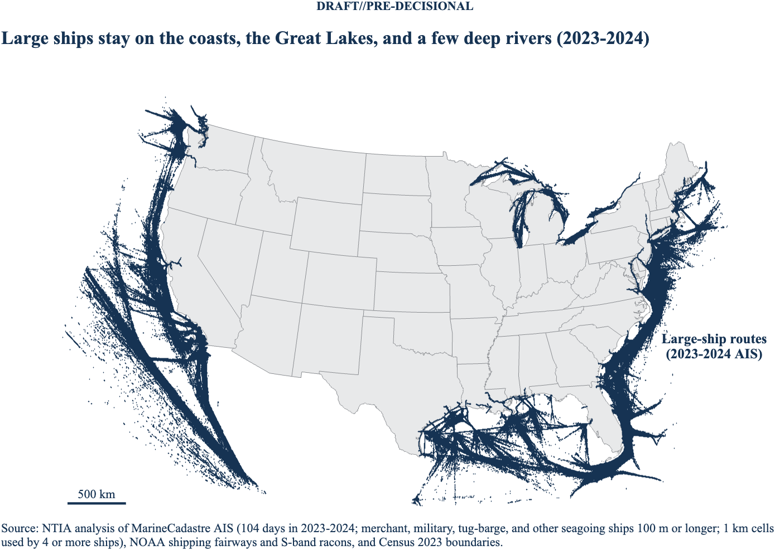
Figure 1. Large-ship routes in the lower 48 states, 2023–2024. Each dark blue mark is a 1 km cell that large ships used on the 104 sampled days, plus NOAA fairways and S-band racons. No buffer is drawn.

1.1 Which ships use 2900–3100 MHz
The 2900–3100 MHz band is allocated to maritime radionavigation. Its main users are shipborne navigation radars, Coast Guard and Navy ships, shore-based Vessel Traffic Service radars, and radar beacons (racons).
International rules set which ships carry a radar in this band. SOLAS Chapter V, Regulation 19 requires ships of 300 gross tonnage (GT) and up to carry a 9 GHz radar. Ships of 3,000 GT and up must also carry a 3 GHz radar, or a second 9 GHz radar where the flag state allows it. In practice, large merchant ships carry the 3 GHz (S-band) radar. U.S. navigation safety rules in 33 CFR 164.35 also require a marine radar on large U.S. ships, without naming a band.
Vessel tracking data don't report gross tonnage or radar band. This analysis therefore uses ship type, length, and IMO number as a proxy for a ship of 3,000 GT or more (Section 1.4).

1.2 Data sources
All data are public.
Data | Source | Use
Ship positions (AIS) | MarineCadastre.gov, Bureau of Ocean Energy Management and NOAA Office for Coastal Management, from Coast Guard terrestrial AIS receivers | Where large ships go
Shipping fairways and traffic separation schemes | NOAA ENC Direct | Charted lanes, added to the routes
Racons | NOAA ENC Direct (general, coastal, and approach chart layers) | Fixed S-band sites, added to the routes
States | Census Bureau cartographic boundary file, 1:500,000, 2023 | Land and water reference, maps
Coastline | Census Bureau TIGER/Line coastline, 2023 | Tug-barge rule; distances inland (Section 3)
Ports | U.S. Army Corps of Engineers Principal Ports | Checks that routes reach the ports
Gross tonnage | Wikidata ship records (IMO number, gross tonnage, length) | Check of the length proxy
AIS (Automatic Identification System) reports give each ship's position about once a minute. MarineCadastre publishes one file per day for U.S. waters, including the Great Lakes and inland waterways. A day holds about 10 million reports from about 22,000 ships. This analysis uses six fields from each report: ship identifier (MMSI), latitude, longitude, AIS ship type, length, and IMO number.

1.3 Sampling
The analysis uses one day a week for two years: every Wednesday from January 4 to December 27, 2023, and from January 3 to December 25, 2024. That is 104 days.
- One day a week covers seasonal traffic, such as the Great Lakes winter closure, at one-seventh of the data volume.
- Two years keep one unusual year from setting the routes. In 2024, the Francis Scott Key Bridge collapse closed Baltimore's main channel from March 26 until it was fully restored on June 10.

1.4 Filtering
Each AIS report passes four tests. A report is kept only if it passes all of them.
- Ship type. The AIS ship type is cargo (70–79), tanker (80–89), passenger (60–69), military (35), law enforcement (55), dredging (33), other or unknown (0, 90–99), or towing (31, 32, 52). Fishing, sailing, pleasure, and special craft are left out.
- Length. The reported length is 100 m or more. This is the proxy for 3,000 GT.
- IMO number. The report carries an IMO number, which is issued to seagoing ships. Military and law enforcement ships have no IMO number and are kept without one.
- Location. The position is inside the analysis grid (22–50° N, 66–130° W), which covers the lower 48 states, the Great Lakes, the Florida Straits, and waters up to several hundred kilometers offshore.
Table 1 shows how much each test keeps on one full day from each year. About 1 ship in 12 that reported that day passed all four tests.
Table 1. AIS reports and ships kept after each filter step
Step | Reports, 2023-07-12 | Ships, 2023-07-12 | Reports, 2024-07-10 | Ships, 2024-07-10
All reports | 9,962,704 | 22,344 | 9,626,350 | 22,414
Ship type kept | 6,112,915 | 8,948 | 5,670,287 | 8,295
and length 100 m or more | 1,109,600 | 1,844 | 1,884,907 | 2,754
and IMO number (or military or law enforcement) | 1,080,250 | 1,805 | 1,347,288 | 2,184
and inside the analysis grid | 1,030,044 | 1,671 | 1,237,989 | 1,980
The two years differ at the length step because of how towing ships report length. In the 2024 files, many towing ships report the length of the whole tow, so 761 of them reached 100 m on July 10, 2024, compared with 15 on July 12, 2023. The IMO test removes most of the 2024 river towboats. The tug-barge rule in Section 1.5 handles the rest.
Table 2. Ships kept on each day, by AIS ship type
Ship type | 2023-07-12 | 2024-07-10
Cargo | 970 | 946
Tanker | 534 | 635
Passenger | 70 | 90
Towing | 8 | 237
Military | 6 | 15
Law enforcement | 0 | 2
Dredging | 1 | 8
Other and unknown | 82 | 47
Total | 1,671 | 1,980
How well length stands in for gross tonnage. Figure 2 tests the length test against registry gross tonnage. Cargo, tanker, and passenger ships with an IMO number, seen on four days in 2024 (January 10, April 10, July 10, and October 9), were matched by IMO number to Wikidata ship records; 4,129 ships matched. Of the 3,873 matched ships of 3,000 GT or more, the 100 m test keeps 3,801 (98.1%). Of the 3,818 ships it keeps, all but 17 are 3,000 GT or more (99.6%). Of the 72 large ships it drops, 45 are cargo ships, 22 are passenger ships, and 5 are tankers. Most are just under 100 m; a few gray dots far to the left are ships whose AIS length is clearly wrong.
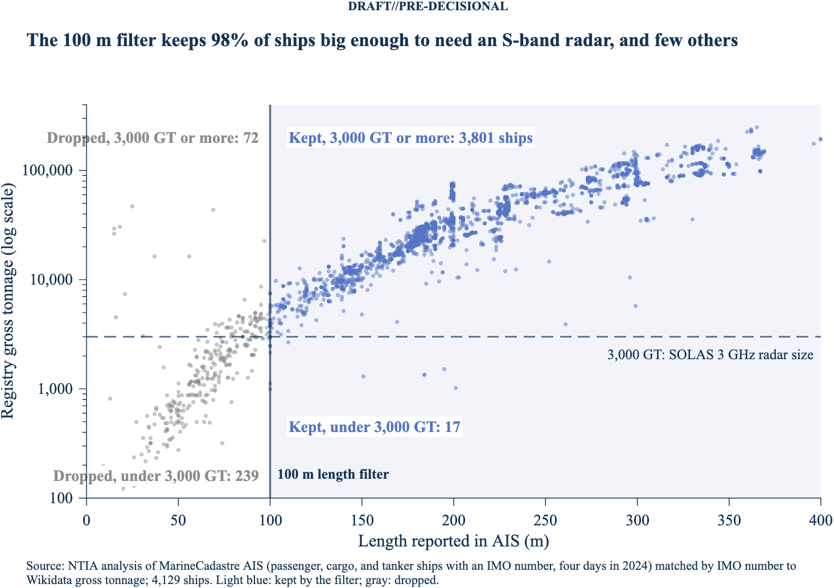
Figure 2. What the 100 m length test keeps and drops. Each dot is a ship, placed by its AIS length and its registry gross tonnage. Light blue ships pass the length test; gray ships fail it. The dashed line is 3,000 GT, the SOLAS size for a 3 GHz radar.

1.5 From reports to routes
The kept reports become routes on a grid of 0.01° cells, about 1 km on a side, covering 22–50° N and 66–130° W. A cell is a route cell when enough different ships used it.
- Ship threshold. A cell is a route cell when at least four different ships (by MMSI) reported from it in one calendar year. Each year is counted separately, and a cell that meets the threshold in either year counts. Four ships removes one-off visits and scattered reports.
- Port approaches. Within 50 km of a deep-draft port, two ships in one year are enough. Deep-draft ports are the 73 coastal and Great Lakes Principal Ports with at least 1 million tons of foreign trade. Small ports such as Searsport, Maine, and Coos Bay, Oregon, see fewer distinct ships on their approaches.
- Tug-barges. Towing ships 100 m or longer with an IMO number count only within 25 km of the Census coastline, which includes bays and the Great Lakes. This keeps ocean-going tug-barges and drops river towboats. Some river towboats also report IMO numbers. Without this rule, the routes reached 15 inland river ports.
- Charted lanes and racons. Cells crossed by NOAA shipping fairways and traffic separation schemes are added, as are cells holding a charted S-band racon.
Table 3. Route cells by source
Source | Cells
AIS cells with 4 or more large ships in a year (tug-barges near the coast included) | 661,136
Port approaches (2 or more ships within 50 km of 73 deep-draft ports) | 14,629
NOAA fairways and traffic separation schemes not already AIS cells | 1,166
S-band racons not already route cells | 16
Total route cells | 676,947
The routes are written as polygons in a shapefile, a KML file, and a KMZ file (shipping_zone_2023_2024_routes). A second set holds the AIS cells only, without fairways and racons.

1.6 Checks
Three checks test the filter and the routes against data from outside the analysis.
- Length as a proxy for 3,000 GT. Against registry gross tonnage, the 100 m test is right for 99.6% of the ships it keeps and keeps 98.1% of ships of 3,000 GT or more (Section 1.4 and Figure 2; 4,129 of 5,674 ships matched). Reported AIS length and registry length differed by a median of 0.1 m.
- Two independent implementations. The daily cell files were built by a Python streaming reader and checked against the MATLAB reader. On 2024-01-03, both produced the same 166,382 cell and ship pairs. On the two full days in Table 1, the MATLAB step counts matched the Python files exactly (1,080,250 reports and 1,805 ships in 2023; 1,347,288 reports and 2,184 ships in 2024).
- Ports reached. A port counts as reached when a continuous chain of route cells connects it to the open-water route network.
  - All 24 major ports in the check list are reached, including Baltimore, Albany, Stockton, Duluth, and Baton Rouge.
  - 69 of the 73 deep-draft Principal Ports are reached. The four that aren't are Portland, Oregon, and Illinois International Port, where the Corps reference point sits several kilometers from the ship berths, and Panama City, Florida, and Searsport, Maine, where approach traffic is thin.
  - None of the 36 inland river Principal Ports are reached, as expected for barge ports.

1.7 New Orleans to Baton Rouge
Large ships use the whole Mississippi River from New Orleans to Baton Rouge, the head of deep-draft navigation on the river. On the 104 sampled days, 267 different large ships reported within 3 km of Baton Rouge: 136 in 2023 and 138 in 2024. Figure 3 shows the route cells along this reach. The route is continuous from the Gulf to Baton Rouge. It continues about 35 km past the city, to 30.77° N, and it reaches none of the 36 inland river ports farther upstream.
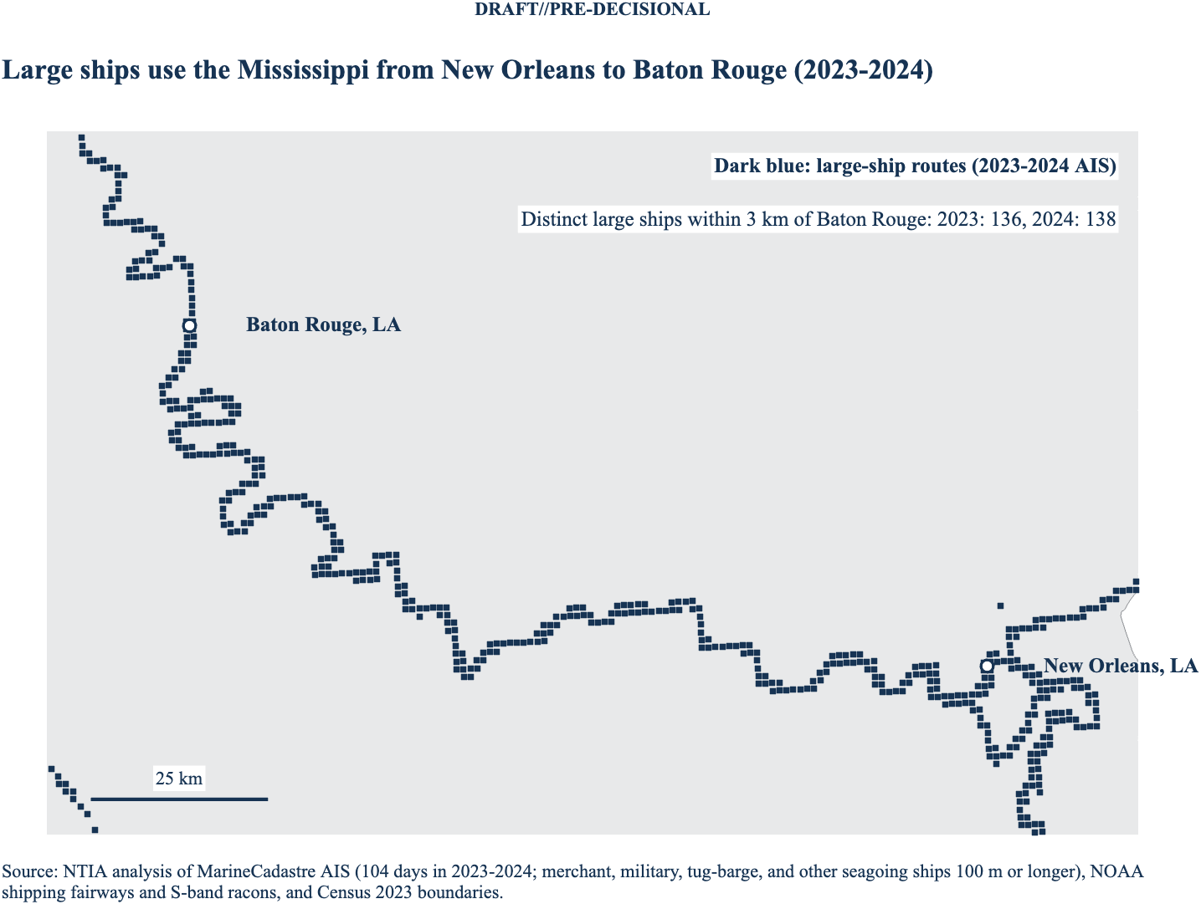
Figure 3. Large-ship route cells on the Mississippi River from New Orleans to Baton Rouge, 2023–2024. Each square is a 1 km route cell. No buffer is drawn.

1.8 Major ports included
The routes reach every major U.S. port that large ships serve. Two lists were checked.
Busiest ports first. The analysis gives the most weight to the ports with the most large-ship traffic, because that is where S-band radars operate most often. Table 5 ranks the deep-draft ports by distinct large ships within 10 km over the 104 sampled days. Five port complexes lead: Galveston Bay (Galveston, Houston, and Texas City), the lower Mississippi (New Orleans, Plaquemines, and South Louisiana), Los Angeles–Long Beach, New York–New Jersey, and Sabine Pass–Port Arthur. Thirteen ports see 1,000 or more large ships.
The ranking differs from the Corps tonnage rank, which counts cargo tons, not ships. Galveston ranks first because every ship bound for Houston, Texas City, or Galveston passes its 10 km circle at the Bolivar Roads entrance. Neighboring ports share ships where their circles overlap, so the counts don't add. The mix differs by coast: tankers lead at Galveston, Sabine Pass, and Port Arthur, while cargo and container ships lead at Los Angeles, Long Beach, New York, Baltimore, and Virginia.
Table 5. The 15 busiest deep-draft ports by distinct large ships within 10 km, 2023–2024
Rank | Port | Corps tonnage rank | Large ships | Tankers | Cargo | Passenger | Military and law enforcement
1 | Galveston, TX | 46 | 2,839 | 1,715 | 987 | 8 | 0
2 | New Orleans, LA | 5 | 2,413 | 740 | 1,533 | 7 | 0
3 | Plaquemines Port District, LA | 12 | 2,161 | 757 | 1,349 | 5 | 0
4 | Port of Long Beach, CA | 6 | 1,894 | 558 | 1,288 | 24 | 4
5 | Port of Los Angeles, CA | 9 | 1,833 | 516 | 1,272 | 24 | 1
6 | New York, NY & NJ | 4 | 1,683 | 613 | 977 | 43 | 2
7 | Houston Port Authority, TX | 1 | 1,637 | 778 | 800 | 1 | 0
8 | South Louisiana, LA | 2 | 1,397 | 493 | 901 | 1 | 0
9 | Sabine Pass Port Authority, TX | 73 | 1,263 | 903 | 250 | 0 | 0
10 | Port Arthur, TX | 15 | 1,135 | 746 | 281 | 0 | 0
11 | San Francisco Port, CA | 107 | 1,078 | 338 | 687 | 26 | 3
12 | Port of Oakland, CA | 36 | 1,053 | 331 | 669 | 25 | 4
13 | Baltimore, MD | 18 | 1,045 | 49 | 973 | 4 | 1
14 | Virginia, VA | 10 | 997 | 39 | 921 | 4 | 10
15 | Port of Savannah, GA | 13 | 984 | 149 | 820 | 0 | 0
Large ships count each ship once over 2023 and 2024. The four type columns use the AIS ship-type code (tanker 80–89, cargo 70–79, passenger 60–69, military 35 and law enforcement 55) with the same 100 m and IMO rules; ships of other types and tug-barges make up the rest of the total. Appendix A.14 maps all 73 ports, and Appendix A.15 maps where each type goes.
Named major ports (24). All 24 are on the route network: Baton Rouge, LA; New Orleans, LA; Houston, TX; Corpus Christi, TX; Mobile, AL; Tampa, FL; Miami, FL; Savannah, GA; Charleston, SC; Norfolk, VA; Baltimore, MD; Philadelphia, PA; Newark, NJ (New York/New Jersey); Albany, NY; Boston, MA; Los Angeles/Long Beach, CA; Oakland, CA; Sacramento, CA; Stockton, CA; Portland, OR; Seattle, WA; Tacoma, WA; Duluth, MN; Chicago, IL.
Deep-draft ports (73). Table 6 lists every U.S. Army Corps of Engineers Principal Port on the coasts or the Great Lakes with at least 1 million tons of foreign trade, ranked by total tonnage. 69 of the 73 are on the route network, and all 73 are inside the 25 km zone. The four that aren't on the network are Portland, Oregon, and Illinois International Port, where the Corps reference point sits 6 to 13 km from the route cells at the ship berths, and Panama City, Florida, and Searsport, Maine, where the route cells at the port don't connect to the open-water lanes because approach traffic is thin.
Table 6. Deep-draft ports and the large-ship routes, 2023–2024
Rank | Port | Foreign trade (million tons) | Distance to route (km) | On the route network | In 25 km zone
1 | Houston Port Authority, TX | 196.8 | 0.3 | Yes | Yes
2 | South Louisiana, LA, Port of | 112.7 | 0.3 | Yes | Yes
3 | Corpus Christi, TX | 125.7 | 0.4 | Yes | Yes
4 | New York, NY & NJ | 83.6 | 0.3 | Yes | Yes
5 | New Orleans, LA | 37.8 | 0.1 | Yes | Yes
6 | Port of Long Beach, CA | 65.7 | 0.7 | Yes | Yes
7 | Port of Greater Baton Rouge, LA | 28.3 | 0.5 | Yes | Yes
8 | Beaumont, TX | 45.8 | 1.1 | Yes | Yes
9 | Port of Los Angeles, CA | 55.0 | 0.3 | Yes | Yes
10 | Virginia, VA, Port of | 53.1 | 0.3 | Yes | Yes
11 | Mobile, AL | 34.4 | 0.4 | Yes | Yes
12 | Plaquemines Port District, LA | 20.9 | 0.6 | Yes | Yes
13 | Port of Savannah, GA | 42.3 | 0.0 | Yes | Yes
14 | Lake Charles Harbor District, LA | 22.7 | 0.8 | Yes | Yes
15 | Port Arthur, TX | 23.9 | 0.6 | Yes | Yes
16 | Port Freeport, TX | 34.6 | 3.1 | Yes | Yes
18 | Baltimore, MD | 31.0 | 0.5 | Yes | Yes
20 | Texas City, TX | 21.2 | 0.4 | Yes | Yes
23 | Philadelphia Regional Port, PA | 16.9 | 3.8 | Yes | Yes
24 | Tampa Port Authority, FL | 12.6 | 0.3 | Yes | Yes
26 | Duluth-Superior, MN and WI | 5.7 | 0.4 | Yes | Yes
27 | Port of Charleston, SC | 23.1 | 0.5 | Yes | Yes
29 | Jackson County Port, MS | 14.8 | 0.7 | Yes | Yes
30 | Seattle, WA | 18.1 | 0.4 | Yes | Yes
31 | Tacoma, WA | 17.4 | 0.6 | Yes | Yes
32 | Richmond, CA | 14.8 | 0.8 | Yes | Yes
33 | Port of Portland, OR | 14.3 | 6.3 | No | Yes
34 | Port Everglades, FL | 9.3 | 0.3 | Yes | Yes
35 | South Jersey Port District, NJ | 11.9 | 0.4 | Yes | Yes
36 | Port of Oakland, CA | 18.1 | 0.9 | Yes | Yes
37 | Port of Kalama, WA | 16.7 | 0.2 | Yes | Yes
38 | Jacksonville, FL | 8.8 | 3.9 | Yes | Yes
43 | Two Harbors, MN | 1.8 | 0.3 | Yes | Yes
44 | Boston, MA | 9.9 | 0.8 | Yes | Yes
46 | Galveston, TX | 6.7 | 0.5 | Yes | Yes
47 | Port of Longview, WA | 9.9 | 4.8 | Yes | Yes
48 | Port of Vancouver USA, WA | 7.6 | 1.2 | Yes | Yes
49 | Cleveland-Cuyahoga Port, OH | 1.8 | 0.5 | Yes | Yes
51 | Illinois International Port, IL | 1.9 | 12.7 | No | Yes
52 | Toledo-Lucas County Port, OH | 4.7 | 0.3 | Yes | Yes
55 | PortMiami, FL | 8.2 | 0.4 | Yes | Yes
57 | Detroit-Wayne County Port, MI | 2.4 | 0.6 | Yes | Yes
58 | New Haven, CT | 3.3 | 0.4 | Yes | Yes
63 | Port of Providence, RI | 4.5 | 0.5 | Yes | Yes
64 | Conneaut, OH | 2.1 | 0.4 | Yes | Yes
65 | Anacortes, WA | 1.3 | 1.5 | Yes | Yes
66 | Brownsville, TX | 4.0 | 0.4 | Yes | Yes
67 | Wilmington, NC | 5.8 | 0.5 | Yes | Yes
71 | Marquette, MI | 1.2 | 0.3 | Yes | Yes
72 | Wilmington, DE | 4.8 | 0.2 | Yes | Yes
73 | Sabine Pass Port Authority, TX | 3.4 | 0.3 | Yes | Yes
77 | Calhoun Port Authority, TX | 2.1 | 2.7 | Yes | Yes
78 | Stockton, CA | 4.6 | 0.3 | Yes | Yes
79 | Albany Port District, NY | 1.1 | 2.0 | Yes | Yes
80 | Canaveral Port District, FL | 3.4 | 0.3 | Yes | Yes
82 | Portland, ME | 3.7 | 0.6 | Yes | Yes
84 | Manatee County Port, FL | 3.2 | 0.2 | Yes | Yes
93 | Grays Harbor Port District, WA | 2.9 | 0.1 | Yes | Yes
98 | Milwaukee, WI | 1.5 | 3.0 | Yes | Yes
99 | Portsmouth, NH | 2.5 | 0.3 | Yes | Yes
101 | Port of Brunswick, GA | 2.4 | 0.3 | Yes | Yes
106 | Port of Palm Beach District, FL | 1.4 | 0.5 | Yes | Yes
107 | San Francisco Port, CA | 1.1 | 0.4 | Yes | Yes
110 | Panama City Port Authority, FL | 1.6 | 0.2 | No | Yes
115 | Redwood City, CA | 1.9 | 1.1 | Yes | Yes
118 | Oxnard Harbor District, CA | 1.8 | 0.5 | Yes | Yes
119 | Coos Bay OR, Port of | 1.8 | 2.4 | Yes | Yes
123 | Morehead City, NC | 1.2 | 1.8 | Yes | Yes
125 | Sandusky, OH | 1.1 | 0.6 | Yes | Yes
128 | Gulfport, MS | 1.6 | 0.6 | Yes | Yes
129 | Searsport, ME | 1.5 | 2.4 | No | Yes
133 | San Diego Unified Port, CA | 1.2 | 0.5 | Yes | Yes
143 | Sacramento-Yolo Port, CA | 1.2 | 0.5 | Yes | Yes
Distance to route is from the Corps reference point to the nearest large-ship route cell. Inland river ports (36 Principal Ports on the Mississippi, Ohio, and other rivers) are not on the route network; they sit about 50 to 700 km from it.

1.9 How far up rivers and ship channels large ships go
Large ships thin out as they pass the ports along a river or ship channel: on 9 of 15 corridors, fewer than half of the large ships seen at the entrance reach the head port. Table 7 extends the New Orleans to Baton Rouge count in Section 1.7 to 14 more corridors, which answers a question any zone drawn along a river raises: how much of the traffic reaches the inland end.
For each corridor, distance runs from the entrance to the head port along the busiest chain of route cells. Each step between neighboring cells costs its length times (1 + 100 / ships), so the path keeps to the main channel instead of a shorter, lightly used lane. Route cells within 2 km of that path belong to the corridor. A ship counts at the entrance or at the head port if it used a corridor cell within 3 km of that point, measured along the path.
Table 7. Large ships at the entrance and at the head port of 15 rivers and ship channels, 2023–2024
Corridor | Head port | Length (km) | Ships at entrance | Ships at head port | Share reaching head | At head, 2023 | At head, 2024
Mobile Bay | Mobile | 55 | 459 | 424 | 92% | 221 | 248
Savannah River | Garden City | 39 | 750 | 682 | 91% | 387 | 444
Cape Fear River | Wilmington, NC | 43 | 212 | 168 | 79% | 80 | 99
Chesapeake Bay | Baltimore | 291 | 1,384 | 789 | 57% | 487 | 423
Calcasieu Ship Channel | Lake Charles | 58 | 401 | 206 | 51% | 109 | 109
Columbia River | Vancouver, WA | 175 | 546 | 280 | 51% | 133 | 158
St. Johns River | Jacksonville | 31 | 361 | 152 | 42% | 85 | 89
San Joaquin River | Stockton | 145 | 746 | 187 | 25% | 117 | 85
Sabine-Neches Waterway | Beaumont | 76 | 1,007 | 215 | 21% | 104 | 126
Houston Ship Channel | Houston | 92 | 2,586 | 481 | 19% | 243 | 260
Delaware River | Trenton | 214 | 803 | 136 | 17% | 70 | 69
Mississippi River | Baton Rouge | 360 | 2,084 | 267 | 13% | 136 | 138
Sacramento River | West Sacramento | 156 | 746 | 86 | 12% | 41 | 53
Hudson River | Albany | 248 | 1,347 | 78 | 6% | 50 | 36
James River | Hopewell (routes end 22 km below Richmond) | 122 | 938 | 36 | 4% | 23 | 17
- Short channels keep most of their traffic. Nine in ten large ships that enter Mobile Bay or the Savannah River reach the head port, because the main terminals sit at the head.
- Long rivers lose it step by step. Traffic drops at each port it passes: on the Delaware, from about 800 ships below Wilmington to about 70 above Philadelphia; on the Hudson, from 1,347 at the Narrows to about 60 above the George Washington Bridge.
- Every head port still sees large ships every year. The smallest yearly count is 17 ships, at the head of the James. Large-ship routes on the James stop at Hopewell, 22 km below the Port of Richmond.
- Head counts hold steady between years. Baton Rouge saw 136 large ships in 2023 and 138 in 2024; Houston saw 243 and 260.
- Entrance counts include ships bound for ports at the entrance. Hampton Roads traffic to Norfolk, Narrows traffic to Newark, and Golden Gate traffic to Oakland all count at the entrance, so the share is a share of entrance traffic, not of ships bound up the river.
Distances follow route cells, so they run a few kilometers longer than channel miles; the Mississippi corridor puts Baton Rouge 356 km above Head of Passes, against 351 km in Section 1.7. Appendix A.18 shows every corridor's profile, and Appendix A.19 maps each one.

1.10 Limits of the route data
- Carriage, not use. The filter models the SOLAS carriage rule. Smaller ships that carry an S-band radar by choice, such as many research ships under 100 m, aren't counted.
- Ships without AIS. Navy ships often turn AIS off, so military traffic is undercounted. Navy operating areas aren't modeled.
- Terrestrial coverage. The Coast Guard receivers are on shore, so coverage thins far offshore. This doesn't move the routes near land.
- Sampled days. A port served less than about once a month may not reach the ship threshold, although the lower threshold near deep-draft ports helps (Section 1.5).
- Not for navigation. MarineCadastre data are published for planning, not navigation. Charted fairways and racons fill some gaps.

2. EMC Analysis

3. Frequency-Dependent Zones
Each part of the 2900–3100 MHz band can have its own zone distance, drawn from the same Section 1 routes. In the example below, the widest zone, 100 km, applies only at 3030–3070 MHz. These distances are examples to show the method. The EMC analysis in Section 2 will set the actual distances.
Table 4. Example zone distance for each frequency range
Frequency range (MHz) | Zone distance (km) | Zone file
2900–3000 | 25 | shipping_zone_2023_2024_band_2900-3000MHz_25km
3000–3030 | 50 | shipping_zone_2023_2024_band_3000-3030MHz_50km
3030–3070 | 100 | shipping_zone_2023_2024_band_3030-3070MHz_100km
3070–3100 | 50 | shipping_zone_2023_2024_band_3070-3100MHz_50km
Each zone file comes as a shapefile, a KML file, and a KMZ file, and covers both the ship water and the land.
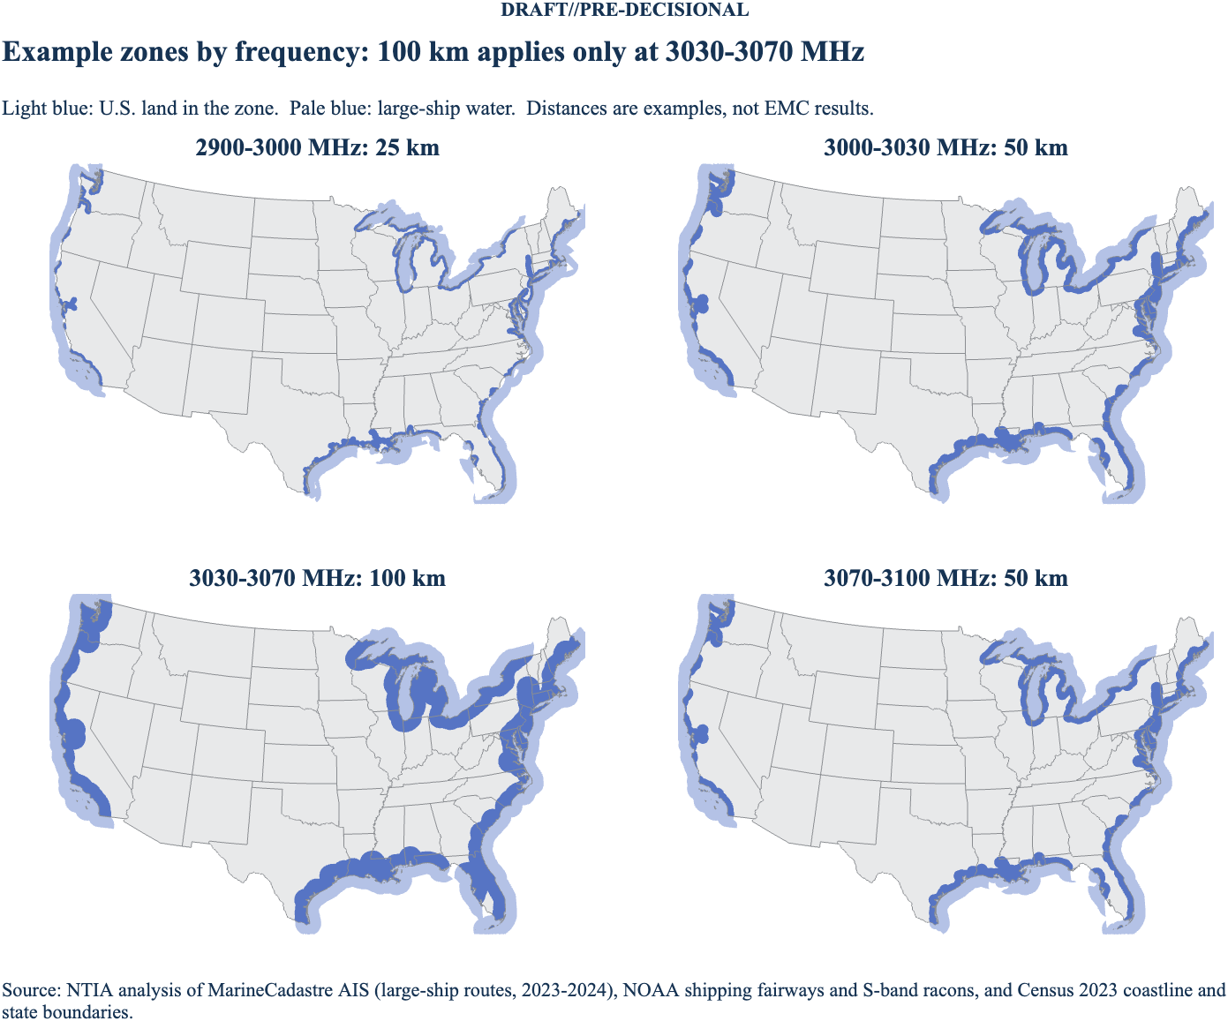
Figure 4. Example frequency-dependent zones drawn from the Section 1 routes. Each panel shows the U.S. land within that range's distance of large-ship water (light blue). The distances are examples, not EMC results.

3.1 How a zone is drawn
A zone covers the water where large ships operate and the land within the zone distance of that water.
- Ship water. Water within 25 km of a route cell counts as ship water.
- Distance inland. Land distance is measured from the Census coastline where it faces ship water. On rivers that the coastline file doesn't cover, such as the Mississippi above New Orleans, distance is measured from the route cells themselves.
- Distance method. Distances are great-circle distances on the same 1 km grid, using a spherical Earth with the mean radius of 6,371 km.
- Boundary. The zone boundary is traced at the zone distance and simplified to about 0.5 km.
Because the frequency ranges share one set of routes, a narrower zone always sits inside a wider one. The 3000–3030 MHz and 3070–3100 MHz ranges use the same 50 km zone.

Appendix A. Where Large S-Band Ships Operate: Supporting Figures
These figures support Section 1. They show where ships that carry 2900–3100 MHz radars operate, how far from shore they run, which ports and fixed S-band sites they reach, and which ships the filter counts. All use the same 104 sampled AIS days in 2023 and 2024 and the same filter as Section 1. Each was computed twice, in MATLAB and in Python, and the two agree to within one grid cell.

A.1 Where the traffic concentrates
Large-ship traffic is concentrated in a small set of lanes. The busiest 7% of route cells carry half of all large-ship traffic, counted as distinct ships per cell. Of the 661,137 route cells, 472 saw 1,000 or more different large ships, and 343,084 saw fewer than 10. The darkest lanes are the port approaches and inland channels: Puget Sound, San Francisco Bay, Los Angeles and Long Beach, the Houston Ship Channel, the lower Mississippi, and the Chesapeake and Delaware approaches.
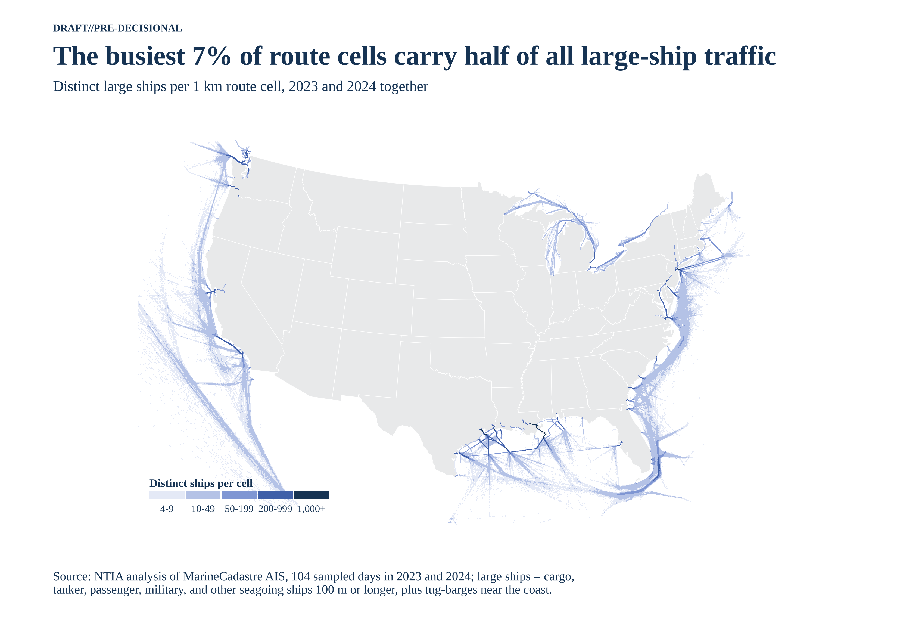
Figure A-1. Distinct large ships per route cell, 2023–2024.

A.2 How far offshore the routes run
Most large-ship routes run close to shore. Half of all route cells are within 133 km of the coastline on the Pacific coast, 142 km on the Gulf, within 82 km on the Atlantic, and within 21 km on the Great Lakes. Ninety percent of Great Lakes route cells are within 49 km of shore. The Pacific curve has the longest tail because coastwise and transpacific lanes run far offshore, out to the edge of the analysis grid at 130° W.
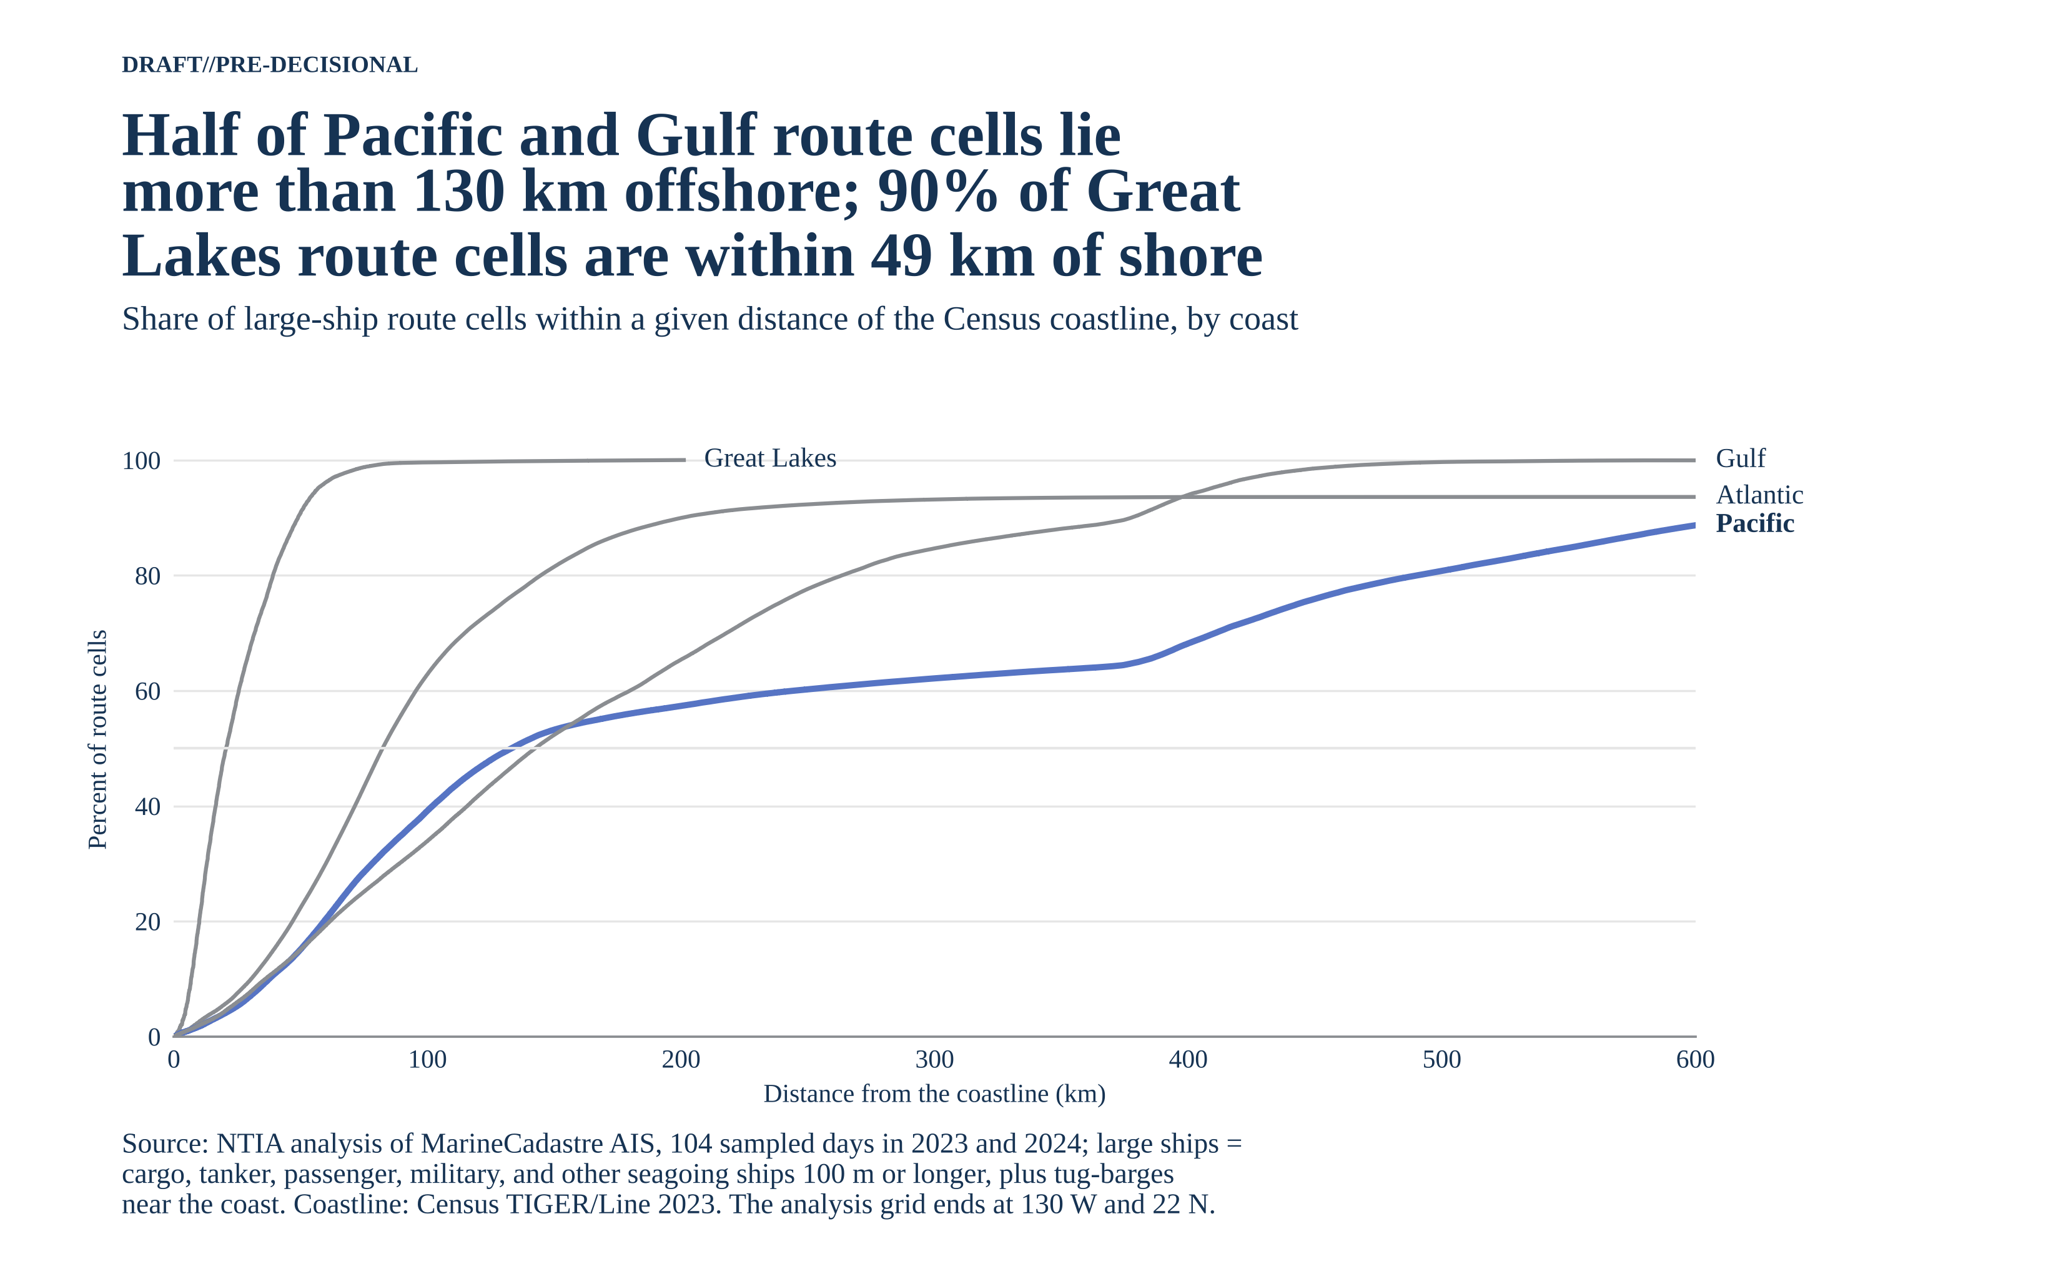
Figure A-2. Share of route cells within a given distance of the Census coastline, by coast.

A.3 Ports and fixed S-band sites near the routes
The routes reach the places where S-band radars are used ashore and at the berth. All 24 named major ports are within 1.7 km of a route cell, and 71 of the 73 deep-draft ports (97%) are within 5 km. Racons (75 charted, 24 of them as S-band) sit a median of 0.6 km from a route, and 9 of the 10 Vessel Traffic Service areas are within 1 km; the tenth, Louisville on the Ohio River, serves towboats and is 393 km away. Inland river ports sit 48 to 700 km from the nearest route, which confirms that the filter keeps river barge traffic out.
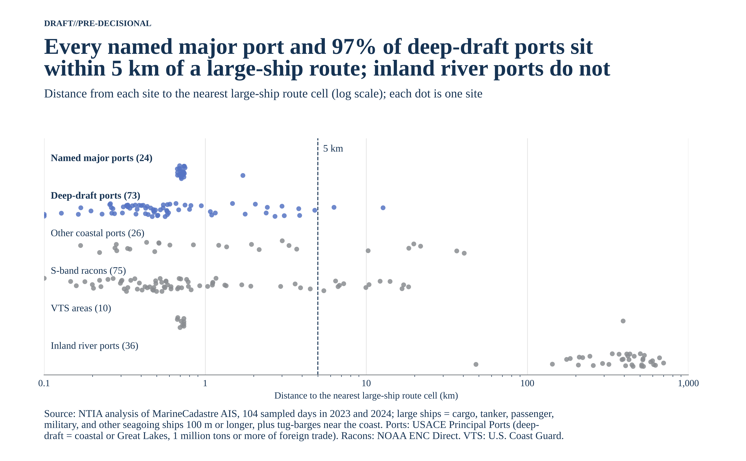
Figure A-3. Distance from each site to the nearest large-ship route cell (log scale).

A.4 How far inland large ships go on the Mississippi
The Mississippi River is the one place where large S-band ships go far inland. About 2,100 different large ships used each 5 km reach of the river below New Orleans. Traffic thins above New Orleans (156 river km above Head of Passes), but 170 to 240 different large ships still used each reach near Baton Rouge, 351 river km upstream. The route ends about 5 km above Baton Rouge. River distance here is measured through the route cells; the New Orleans value agrees with the published river mile there (about mile 95).
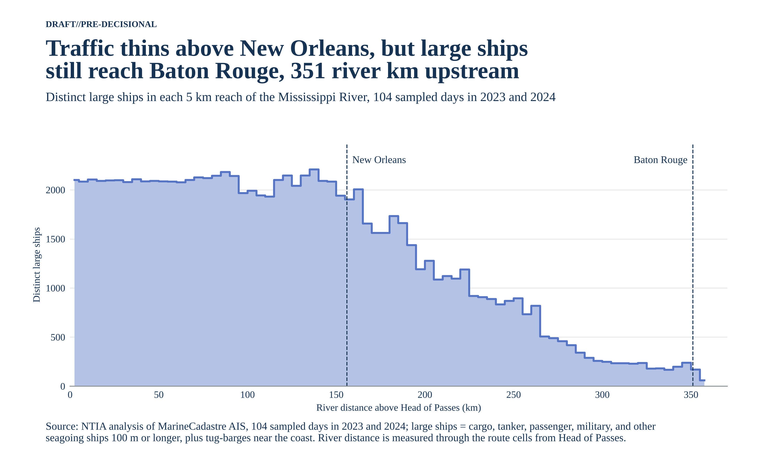
Figure A-4. Distinct large ships by river distance above Head of Passes.
Figures A-4b and A-4c put the Mississippi beside the 14 other rivers and ship channels from Section 1.9. Each line counts the distinct large ships seen at or beyond each point on any sampled day, starting 3 km in from the entrance so ships passing the entrance drop out. That count can only fall going upstream, so anchorage spikes and lane splits disappear and each drop marks ships stopping at a port. Distance is scaled so 1 is the head port. Savannah, Houston, the Mississippi, and the Hudson are highlighted; the other 11 are gray.
Figure A-4b divides each count by the ships that entered: 69% of the large ships that enter the Savannah reach Garden City, against 13% for Houston, 7% for the Mississippi, and 5% for the Hudson. These shares run lower than Table 7, whose denominator counts only ships seen at the entrance itself. A single-day sample often catches a ship at a berth or anchorage rather than crossing the entrance, so the entrance count misses many ships that the continuation count includes.
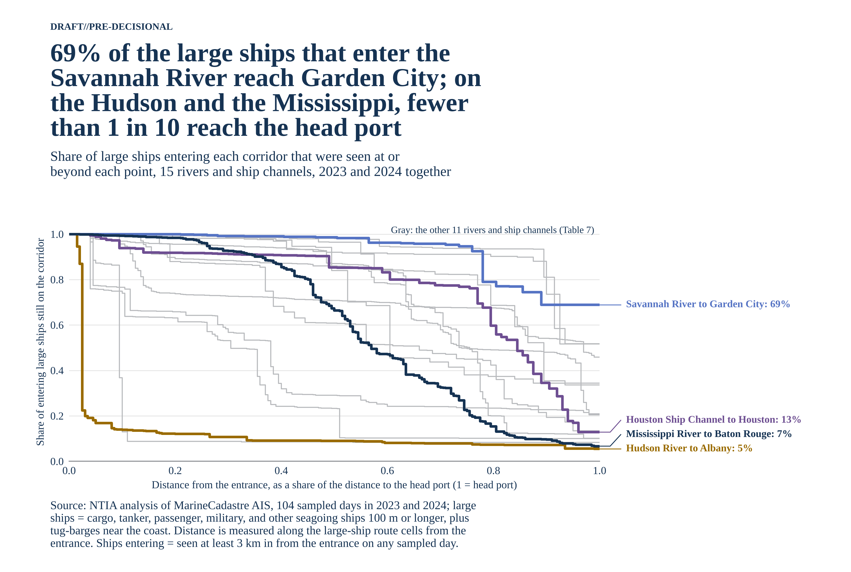
Figure A-4b. Share of entering large ships still on each corridor, by scaled distance to the head port.
Figure A-4c shows the same curves as ship counts. About 4,500 large ships enter the Mississippi and 3,750 the Houston Ship Channel, more than any other corridor, but only about 300 reach Baton Rouge and 480 reach Houston. The Baton Rouge count here (299) is higher than Table 7 (267) because it includes ships seen above Baton Rouge but not within 3 km of it.
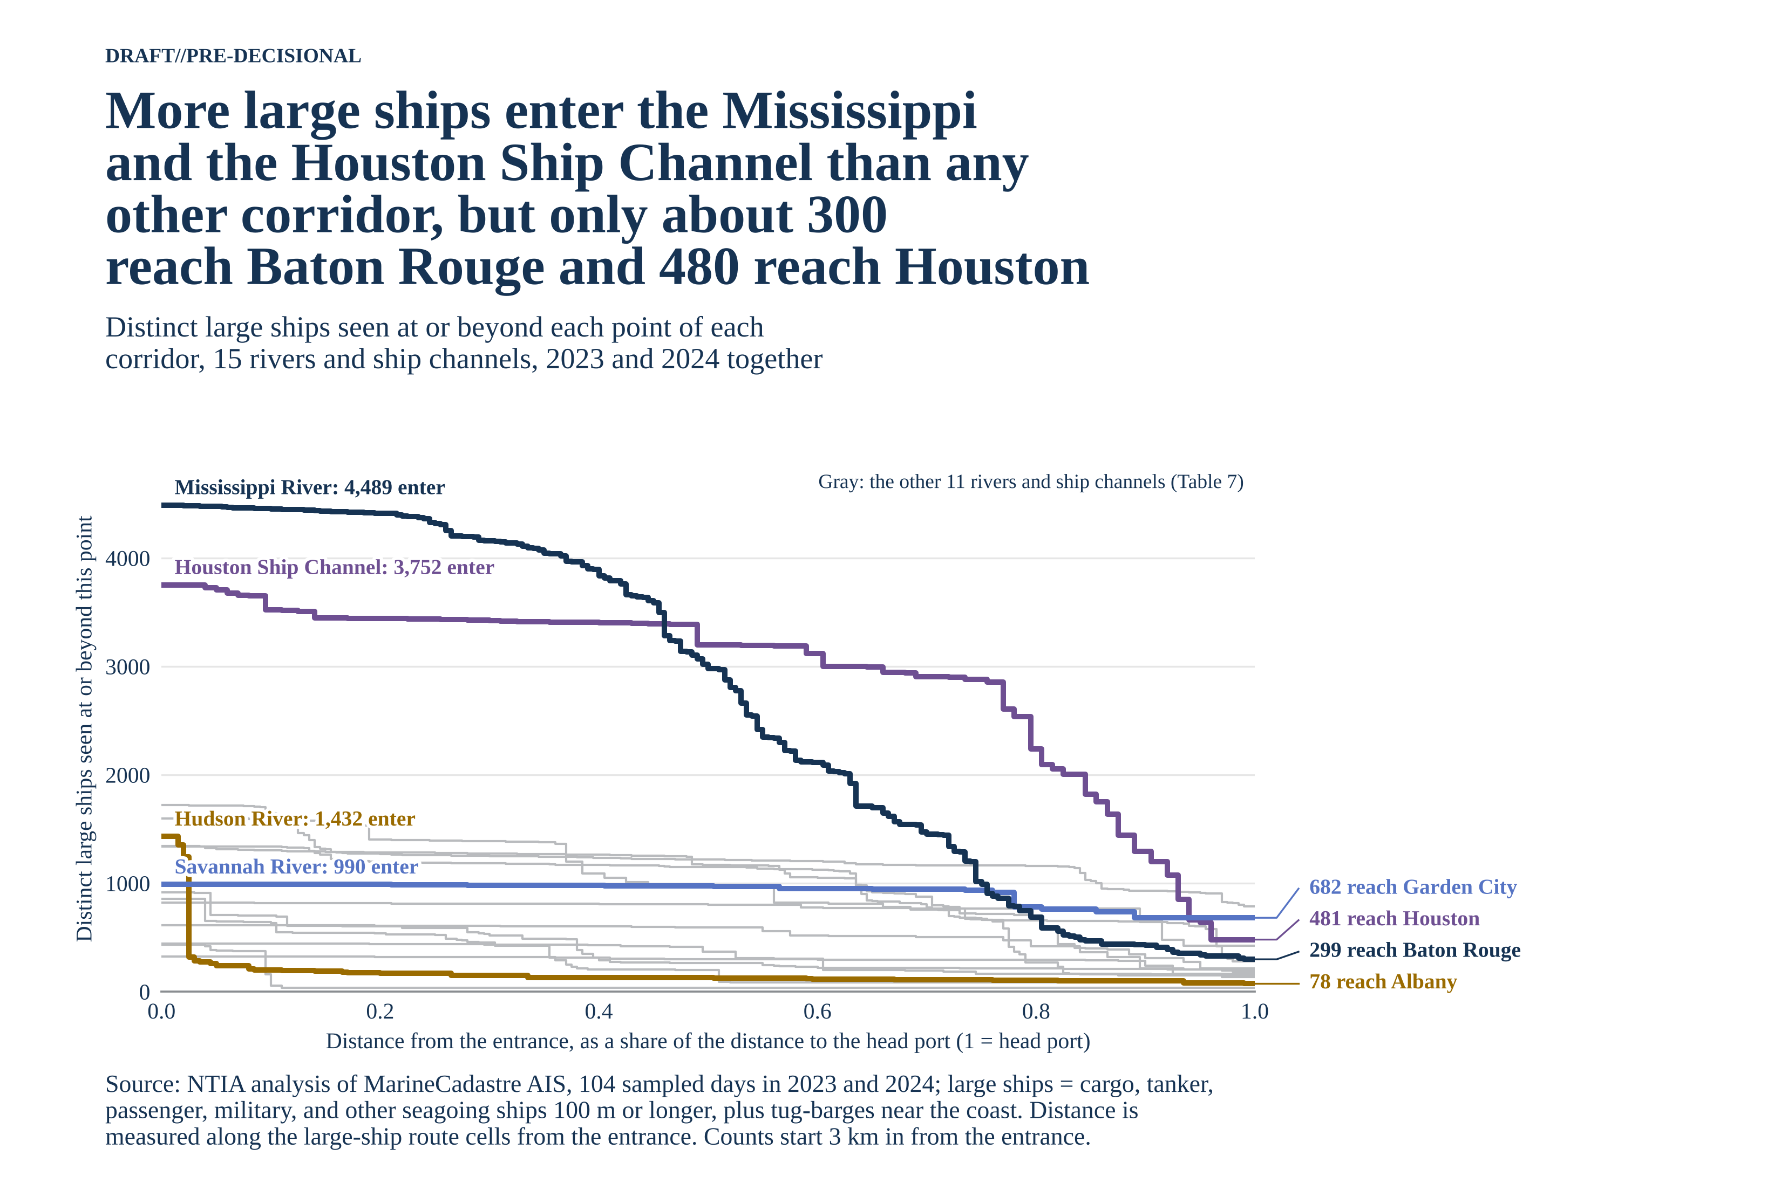
Figure A-4c. Distinct large ships still on each corridor, by scaled distance to the head port.

A.5 Where tug-barges add to the routes
Ocean-going tug-barges add little beyond the large-ship lanes. Counting them adds 6,515 route cells, 1% more than the 654,622 cells from the other large ships. The added cells are coastal: 2,471 on the Atlantic, 2,101 on the Gulf, 1,449 on the Great Lakes, and 493 on the Pacific. Most lie along the Gulf and Northeast shorelines and the Great Lakes shores, all within 25 km of the coastline by design (Section 1.5).
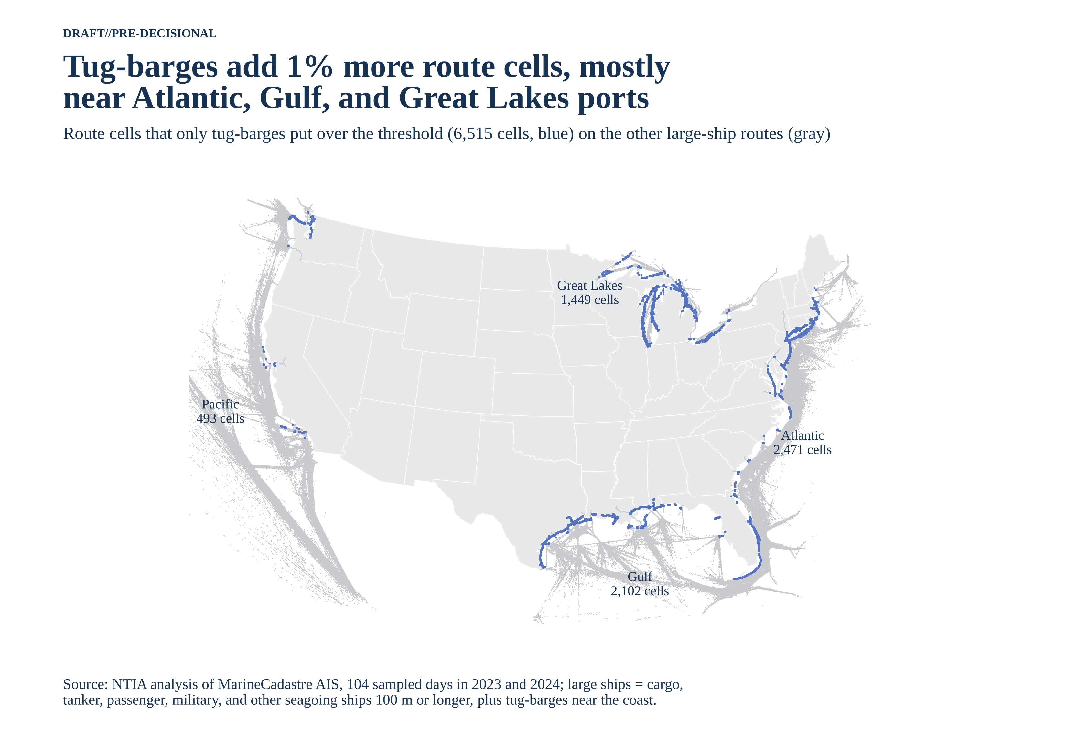
Figure A-5. Route cells that only tug-barges put over the ship threshold.

A.6 Which route cells are the same in both years
The main lanes are the same in both years. 337,735 route cells pass the ship threshold in both 2023 and 2024, and they carry 85% of all large-ship traffic. The other 323,402 cells pass in only one year; they are the edges of the lanes and scattered offshore cells where a few ships pass. Using both years keeps those edge cells, so the routes cover any place large ships went in either year.
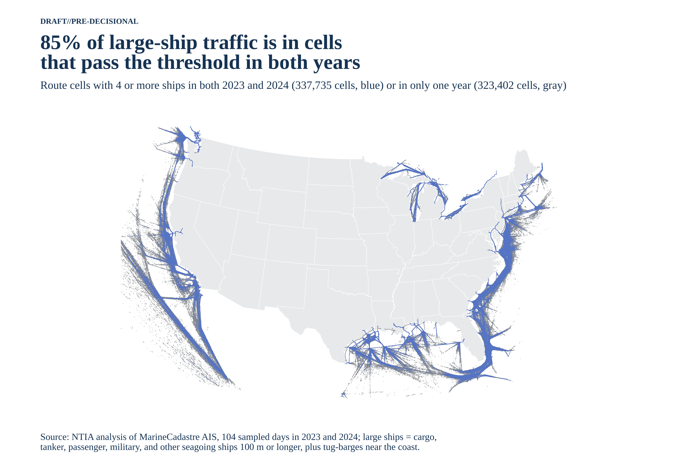
Figure A-6. Route cells with 4 or more ships in both years or in only one year.

A.7 Which ships the filter keeps
The filter keeps the ships that SOLAS requires to carry a 3 GHz radar and drops the rest. On July 10, 2024, 22,414 ships reported on AIS in U.S. waters. The ship-type test kept 8,295, the 100 m length test kept 2,754, the IMO-number test kept 2,184, and 1,980 of those were inside the analysis grid: about 1 ship in 11 (Table 1 gives both days).
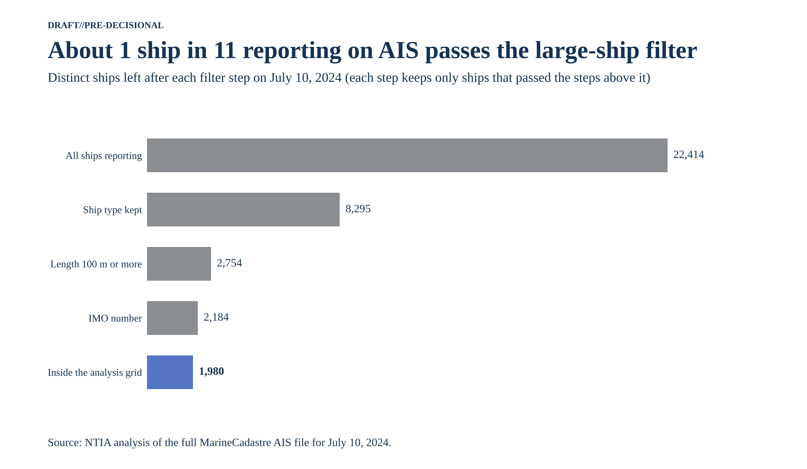
Figure A-7. Distinct ships left after each filter step, July 10, 2024.

A.8 Why 100 m
A 100 m length cutoff is the best single stand-in for 3,000 GT. At 100 m, 99.6% of the ships the test keeps are 3,000 GT or more, and the test keeps 98.1% of all ships of 3,000 GT or more. A shorter cutoff keeps more small ships that don't need an S-band radar; a longer one drops large ships that do, and above about 145 m it misses more than 1 in 10 of them. Figure 2 in Section 1.4 shows the same check ship by ship.
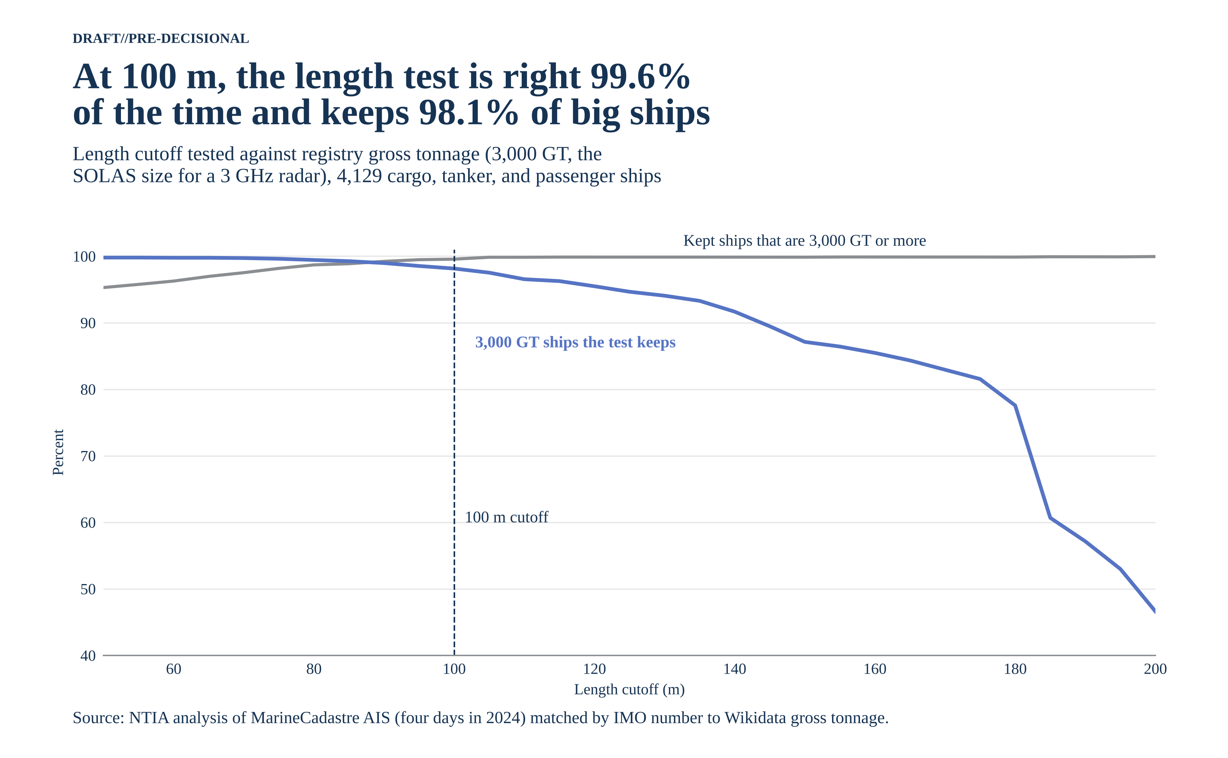
Figure A-8. Length cutoff tested against registry gross tonnage, 4,129 cargo, tanker, and passenger ships.

A.9 Hexagon grid
At a 25 km scale, large-ship traffic forms a ring around the lower 48 states that is thickest at a few port complexes. The map groups the route cells into 7,578 equal-area hexagons and counts the different large ships in each. The busiest 5% of hexagons carry 41% of the traffic, and 132 hexagons saw 1,000 or more different large ships.
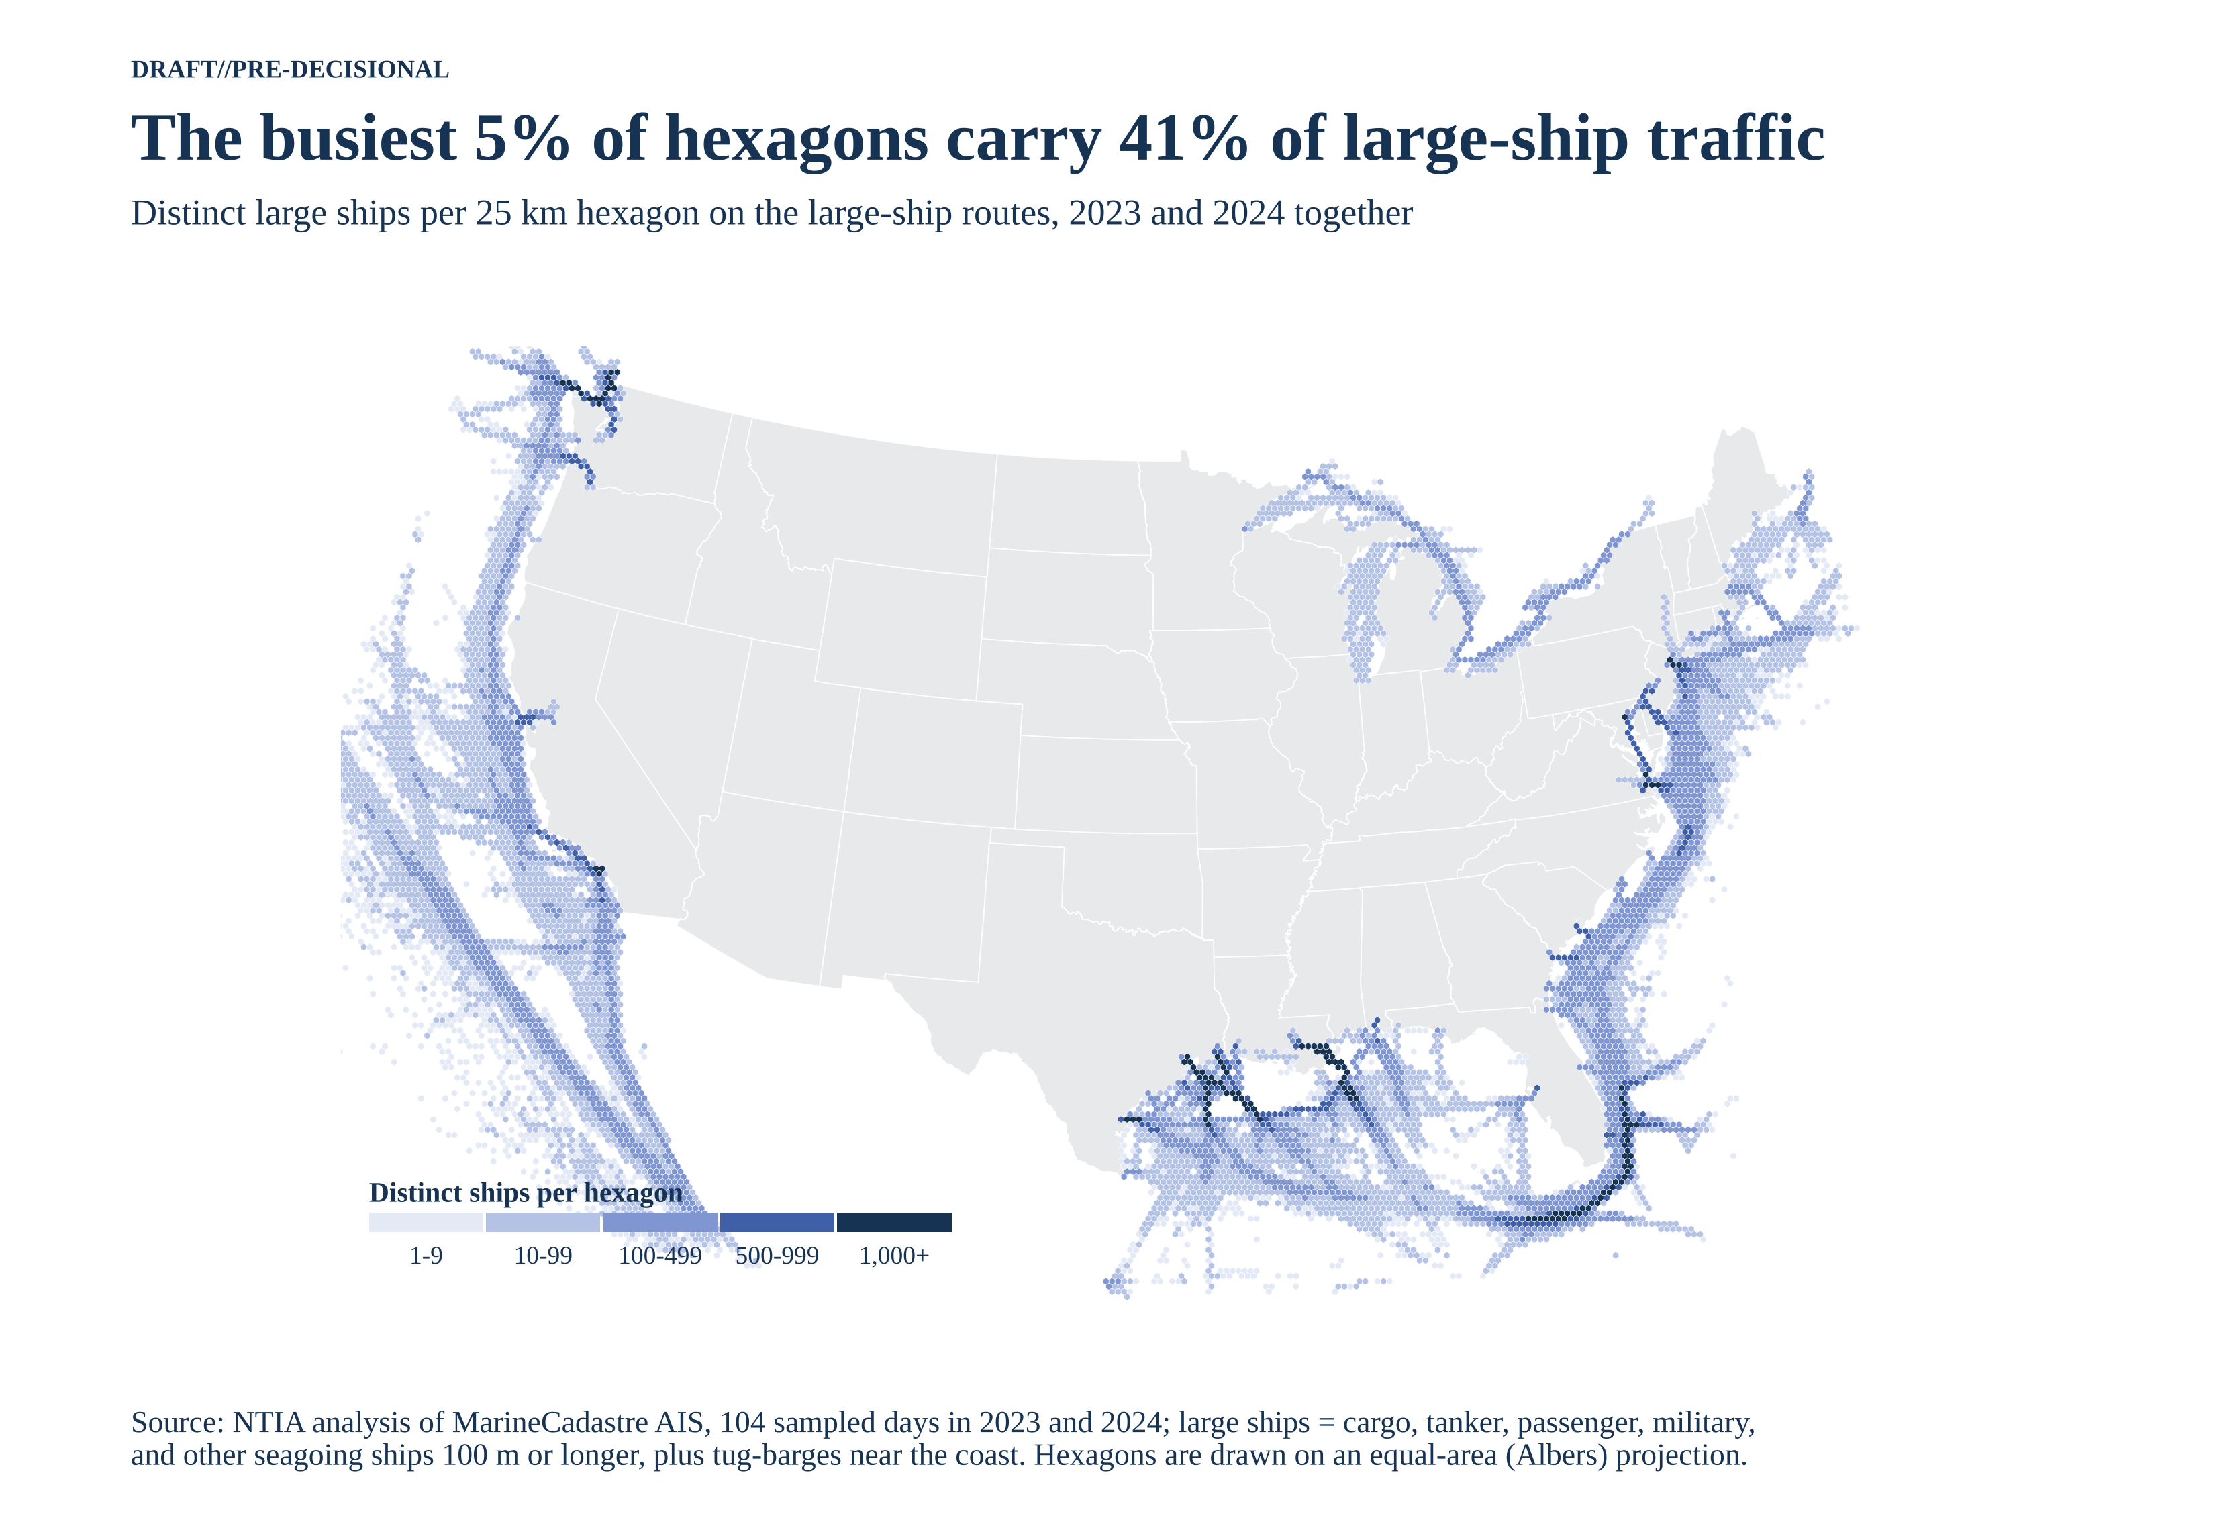
Figure A-9. Distinct large ships per 25 km hexagon, 2023–2024.

A.10 Spike map
The same hexagons drawn as spikes show where traffic peaks. The tallest spikes stand at Galveston Bay (the entrance shared by Houston, Texas City, and Galveston), the lower Mississippi, Los Angeles and Long Beach, and New York. The tallest single hexagon saw 3,120 different large ships. Hexagons with fewer than 10 ships are left off so the peaks read clearly.
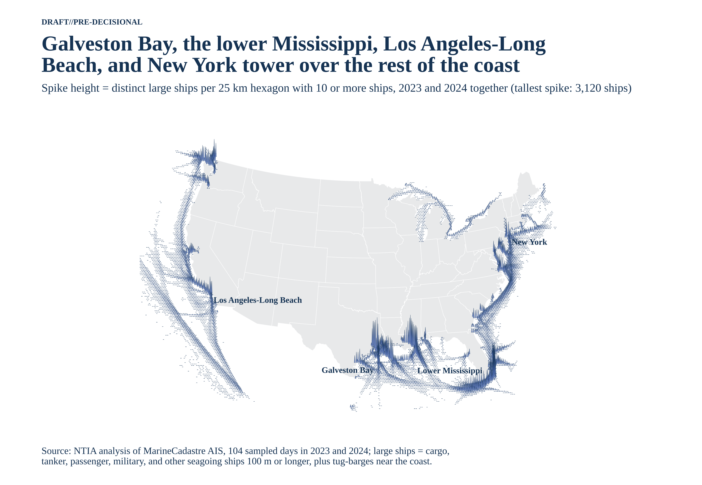
Figure A-10. Spike map of large-ship traffic per 25 km hexagon.

A.11 Port close-ups
Inside the busiest port areas, large ships keep to a few narrow dredged channels. The six areas shown (New York and New Jersey, the Chesapeake and Delaware Bays, Houston and Galveston, the lower Mississippi, Los Angeles and Long Beach, and Puget Sound) hold 25% of the busiest route cells, those used by 200 or more different large ships.
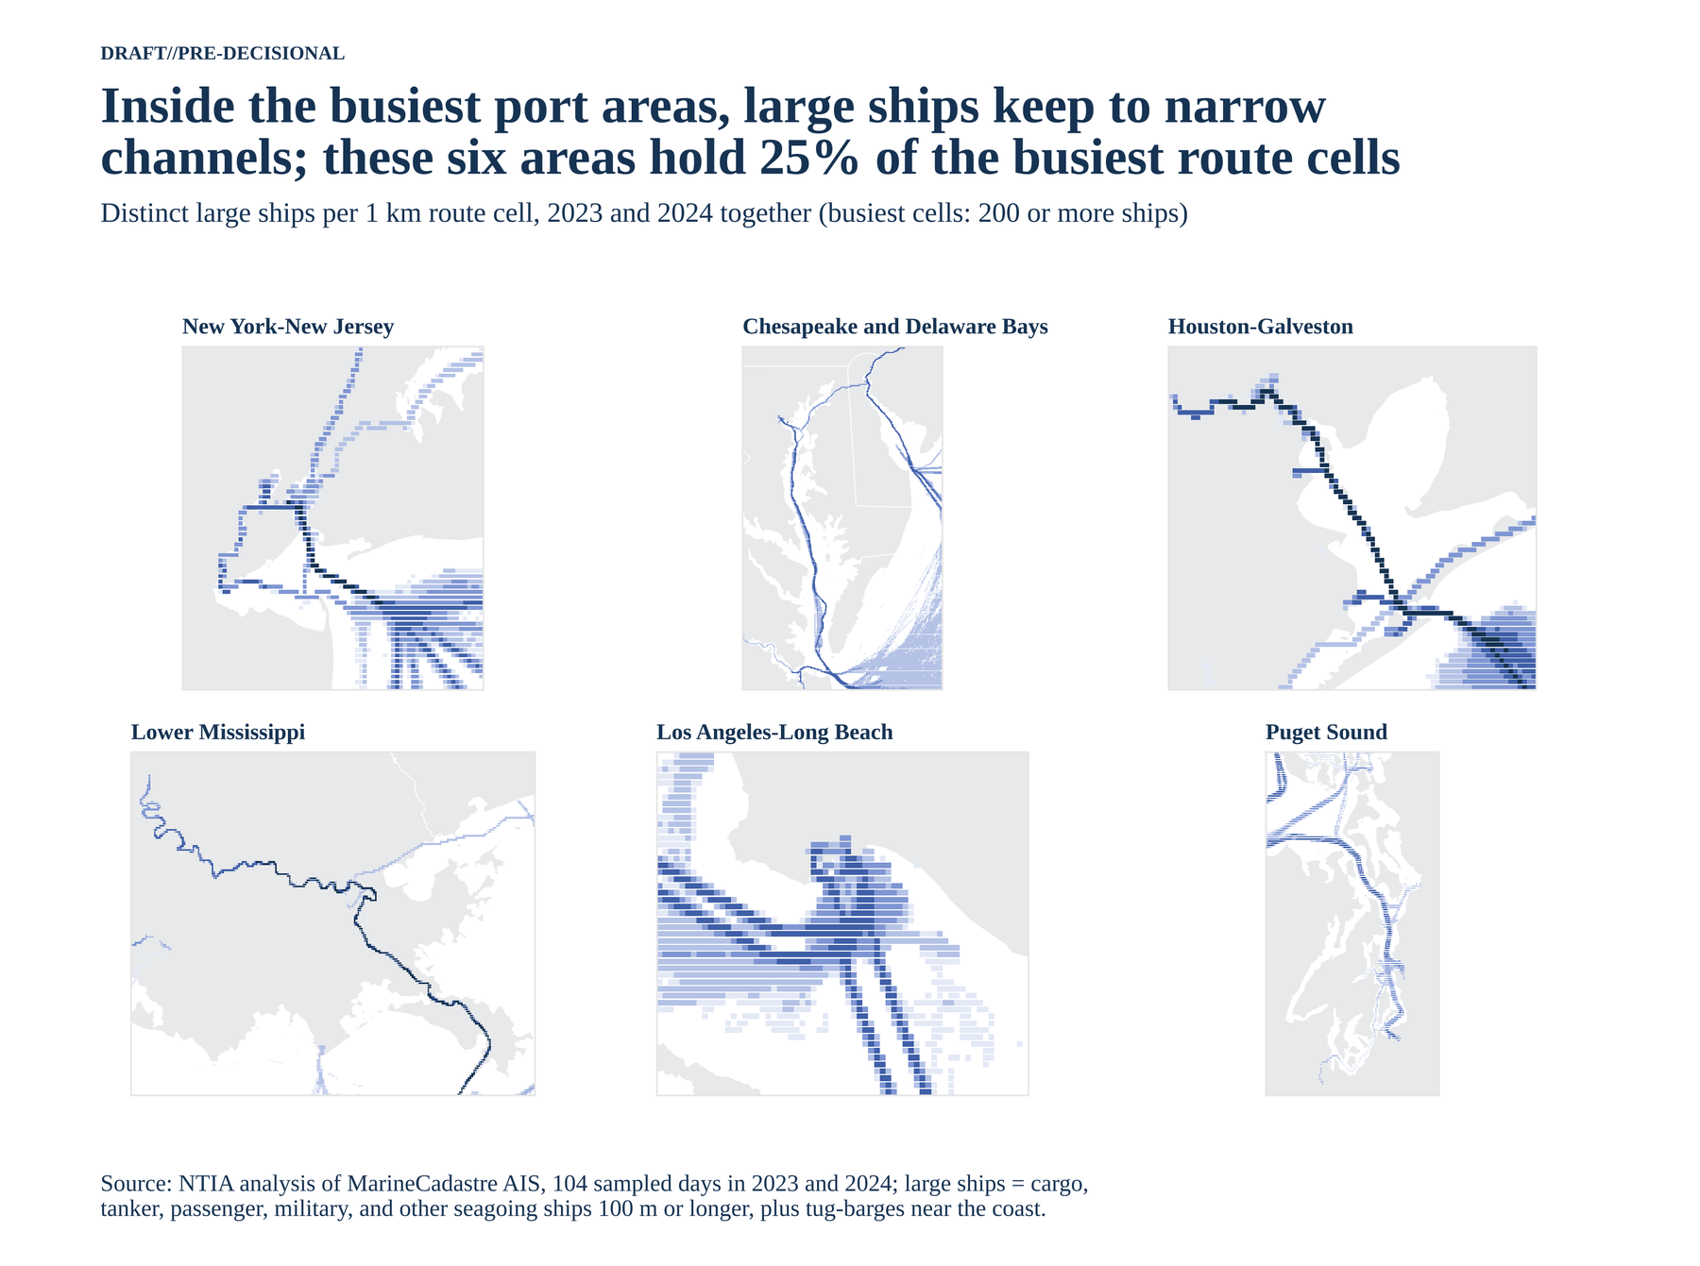
Figure A-11. Large-ship route cells in six port areas, 1 km cells.

A.12 Distance from shore, mapped
The nearest-shore routes are the port approaches, inland channels, and the Great Lakes. 10% of route cells are within 25 km of the coastline, 23% within 50 km, and 51% within 100 km. Figure A-2 gives the same distances as curves by coast.
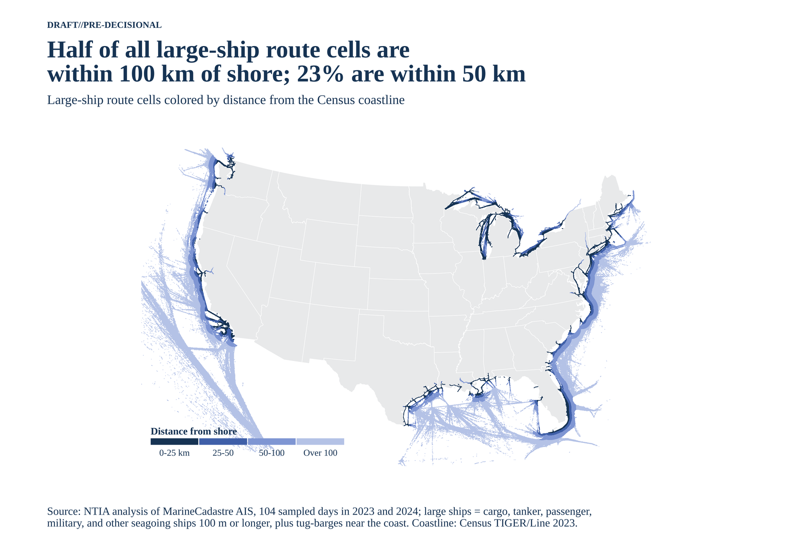
Figure A-12. Large-ship route cells by distance from the Census coastline.

A.13 Traffic along the coast
Near-shore traffic peaks at the major port complexes. Counting the different large ships within 50 km of shore in each half degree along the coast, the peaks are Houston and Galveston on the Gulf (3,891 ships), the Mississippi delta close behind (3,644), New York on the Atlantic (2,152), and Los Angeles and Long Beach on the Pacific (2,076). Long stretches between the ports, such as the Big Bend of Florida and the Oregon coast, see far fewer ships.
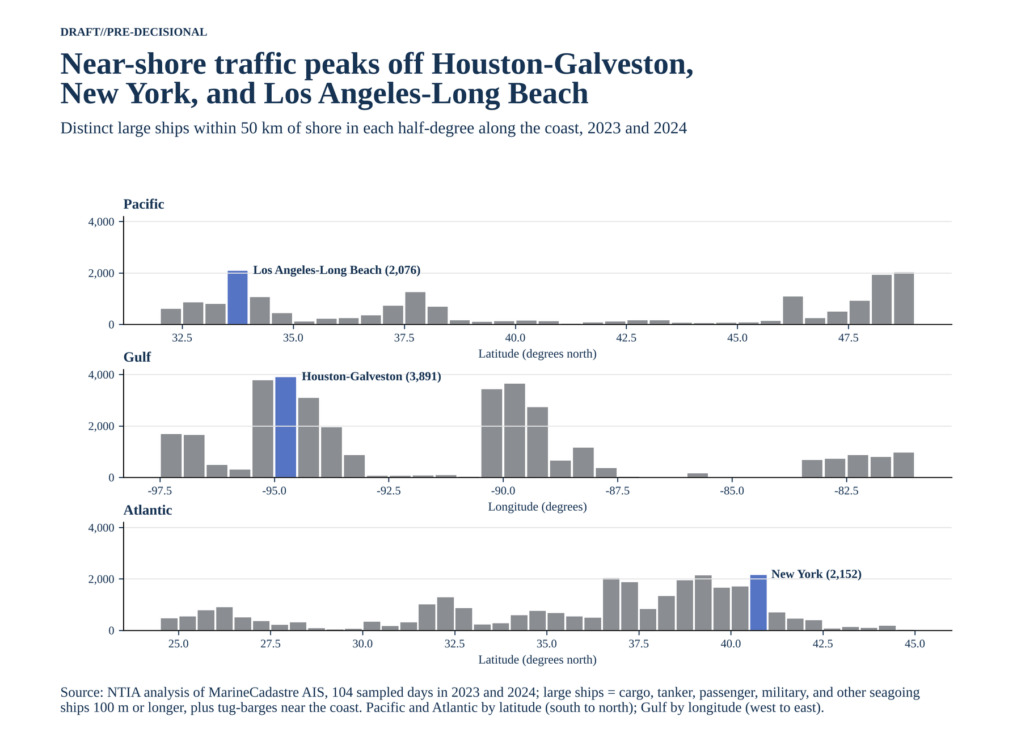
Figure A-13. Distinct large ships within 50 km of shore per half degree along each coast.

A.14 Ports by traffic
Thirteen deep-draft ports each saw 1,000 or more different large ships within 10 km. The busiest are Galveston (2,839), New Orleans (2,413), Plaquemines (2,161), Long Beach (1,894), Los Angeles (1,833), New York and New Jersey (1,683), and Houston (1,637). Ports that share an approach, such as those around Galveston Bay, share many of the same ships.
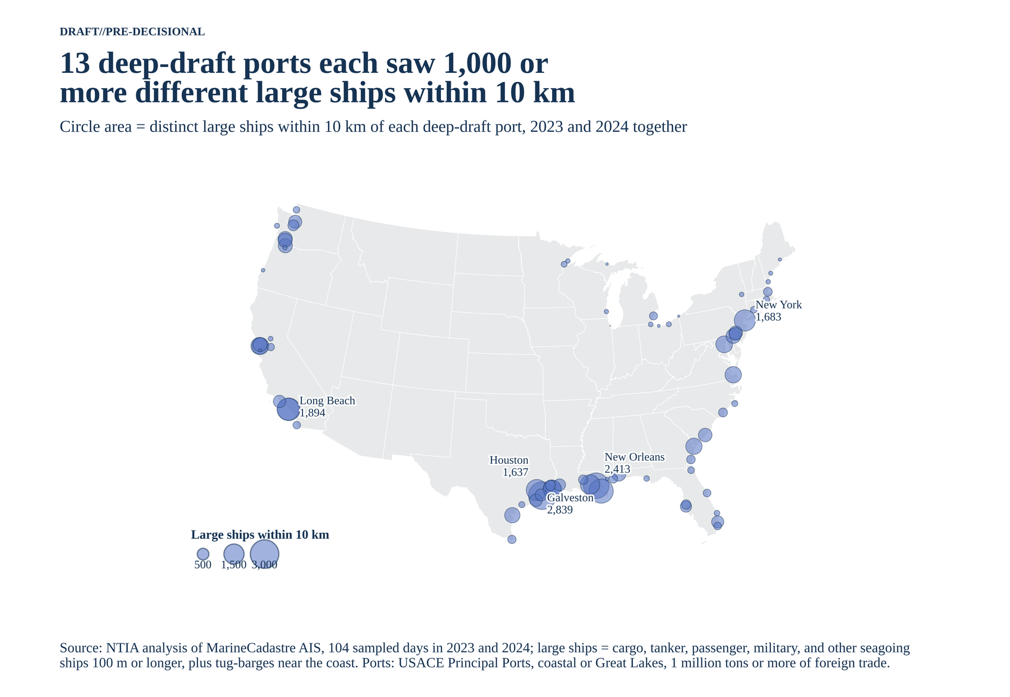
Figure A-14. Distinct large ships within 10 km of each deep-draft port.

A.15 Where each ship type goes
Tankers concentrate in the Gulf: 87% of the 4,452 large tankers sailed in Gulf waters, against 51% of the 10,216 large cargo ships. The 282 large passenger ships cluster at the cruise ports of south Florida, and the 68 military and law-enforcement ships cluster around San Diego, Hampton Roads, and Jacksonville. Types come from the AIS ship-type code with the same 100 m and IMO rules as the main filter; Table 5 gives the type counts at the busiest ports.
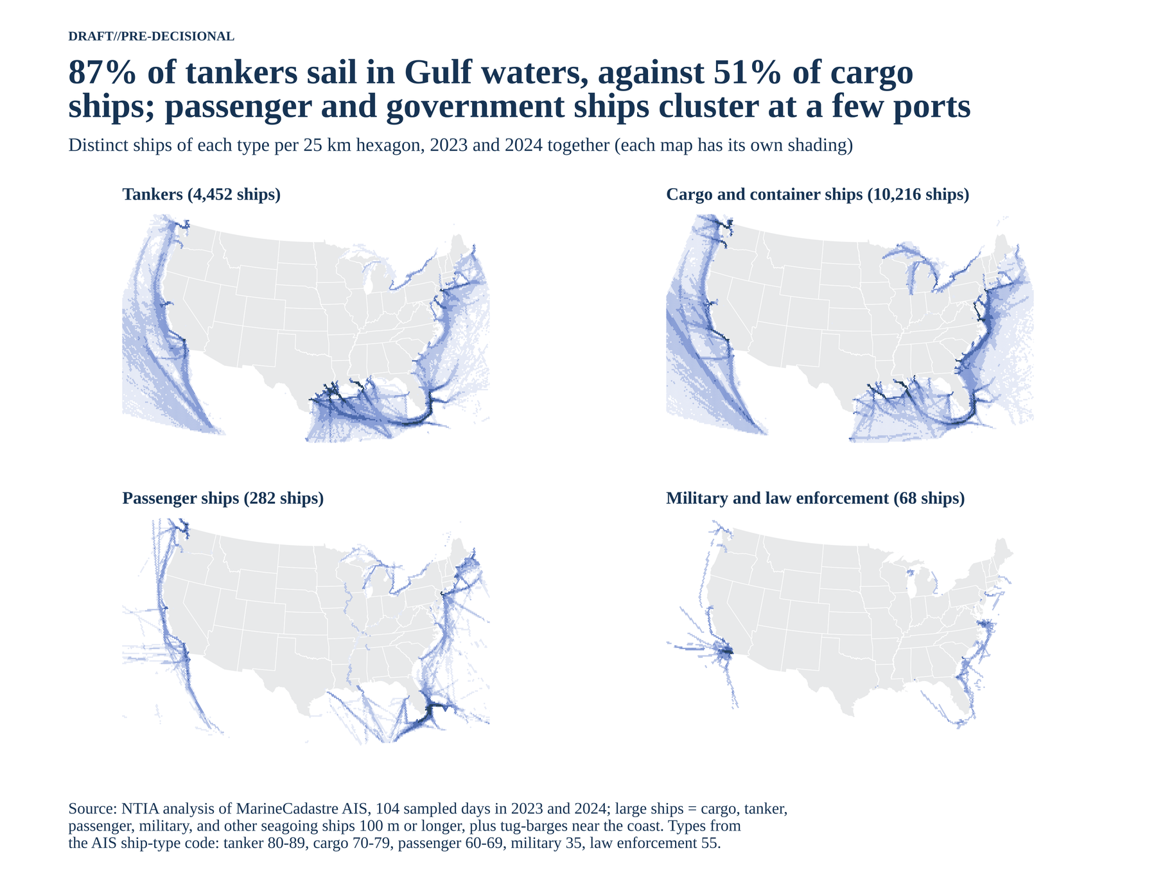
Figure A-15. Distinct ships of each type per 25 km hexagon, 2023 and 2024 together.

A.16 How far inland the routes reach
Away from the coasts, only the Great Lakes and a few deep rivers bring large-ship routes inland: the lower Mississippi to Baton Rouge, the Hudson to Albany, the Columbia to Portland and Vancouver, and the Sacramento and San Joaquin to Sacramento and Stockton. The map shades each point of land by its distance to the nearest route cell. It shows where the ships are, not the zones; Section 3 draws the zones.
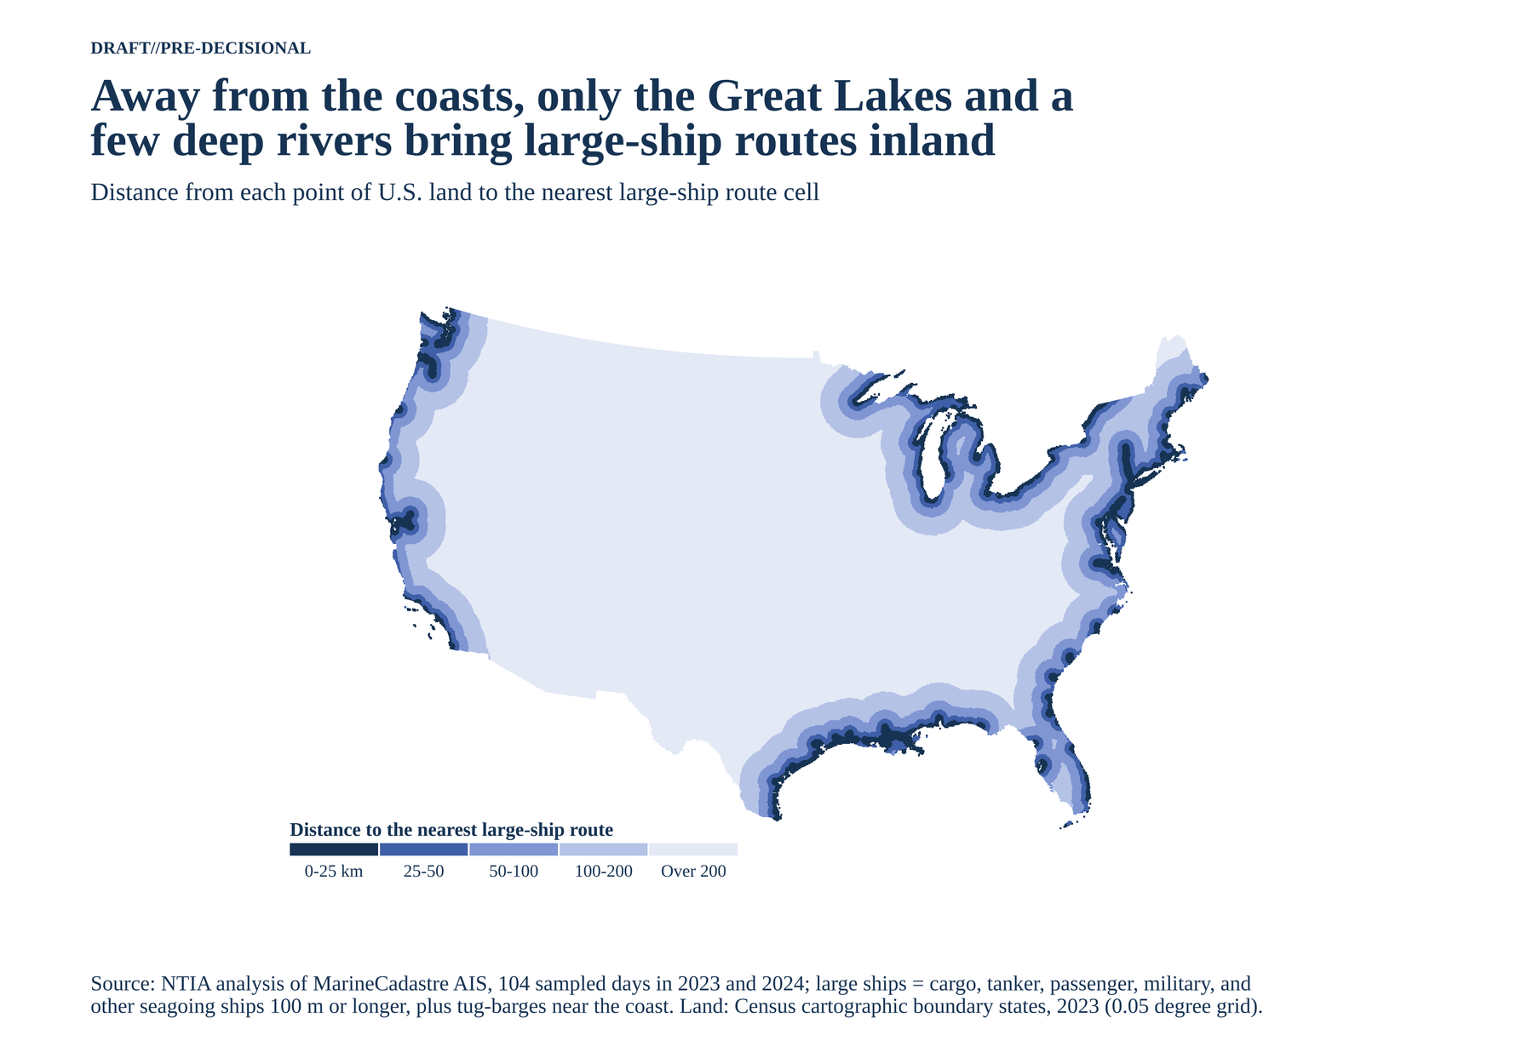
Figure A-16. Distance from U.S. land to the nearest large-ship route cell.

A.17 Fixed S-band sites on the lanes
Fixed S-band sites sit on the large-ship lanes. Of the 24 racons charted as S-band, 17 are within 5 km of a route; many of them are offshore in the Gulf of Mexico, along the fairways. Nine of the 10 Vessel Traffic Service areas are within 1 km of a route; the tenth, Louisville, serves river towboats.
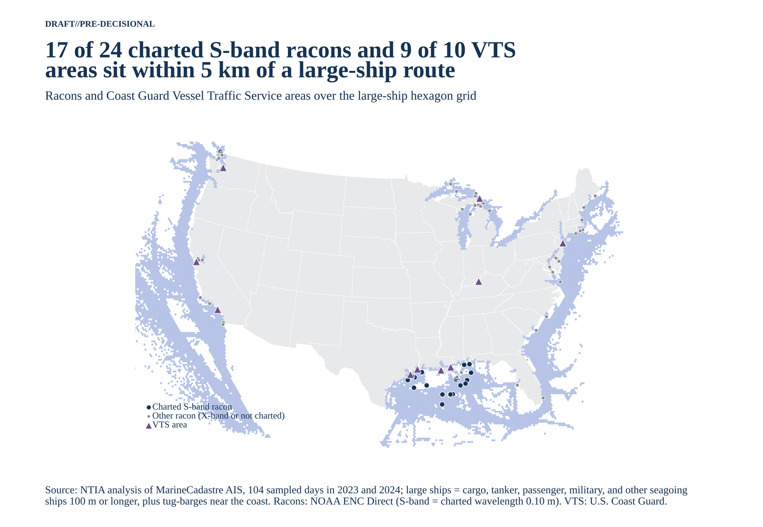
Figure A-17. Racons and Vessel Traffic Service areas over the large-ship hexagon grid.

A.18 Rivers and ship channels: reach and profiles
These two figures carry Section 1.9. Figure A-18 compares the large ships at each corridor's entrance with those at its head port. Figure A-19 shows how traffic steps down along each corridor as it passes its ports; each panel has its own scale.
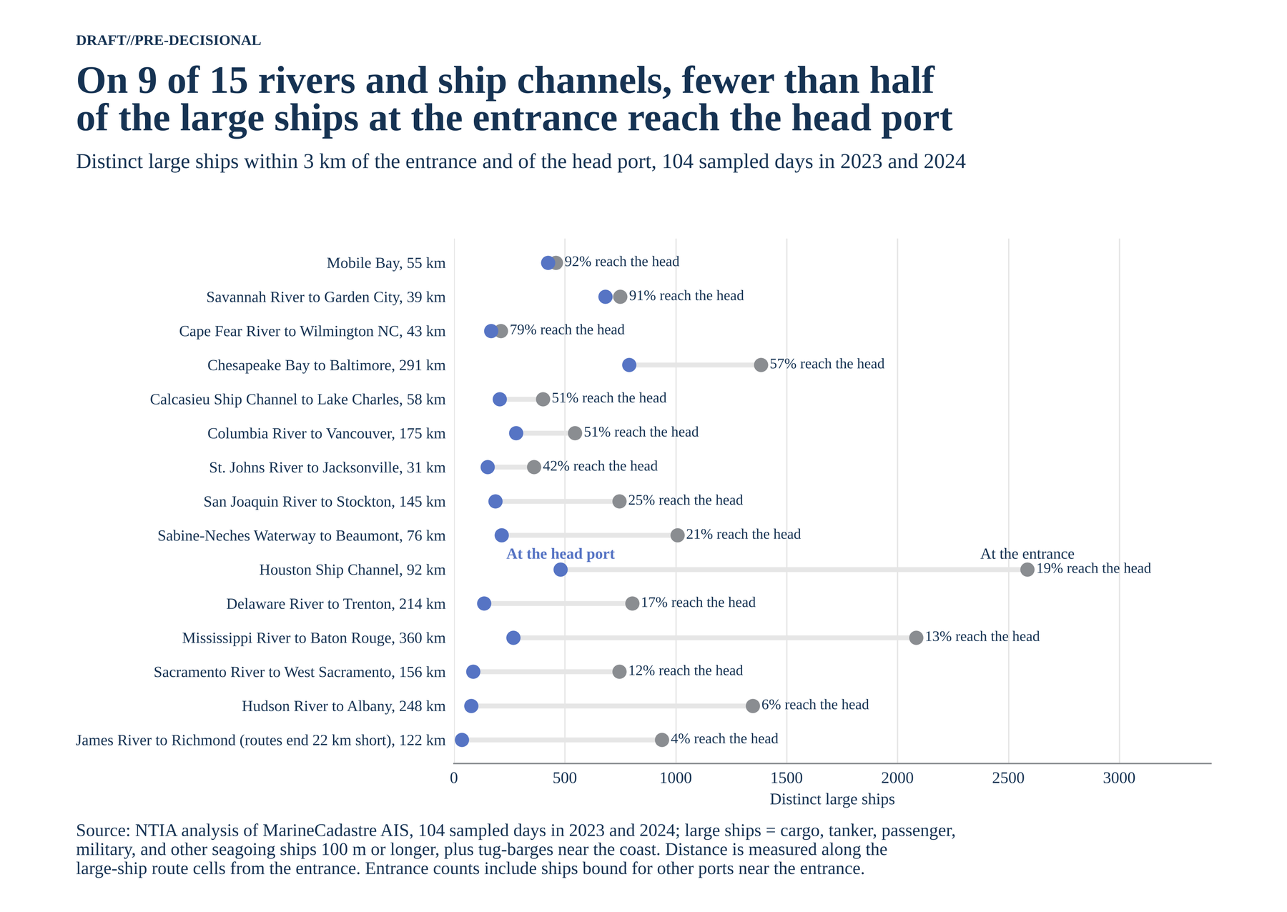
Figure A-18. Distinct large ships within 3 km of the entrance and of the head port, by corridor.
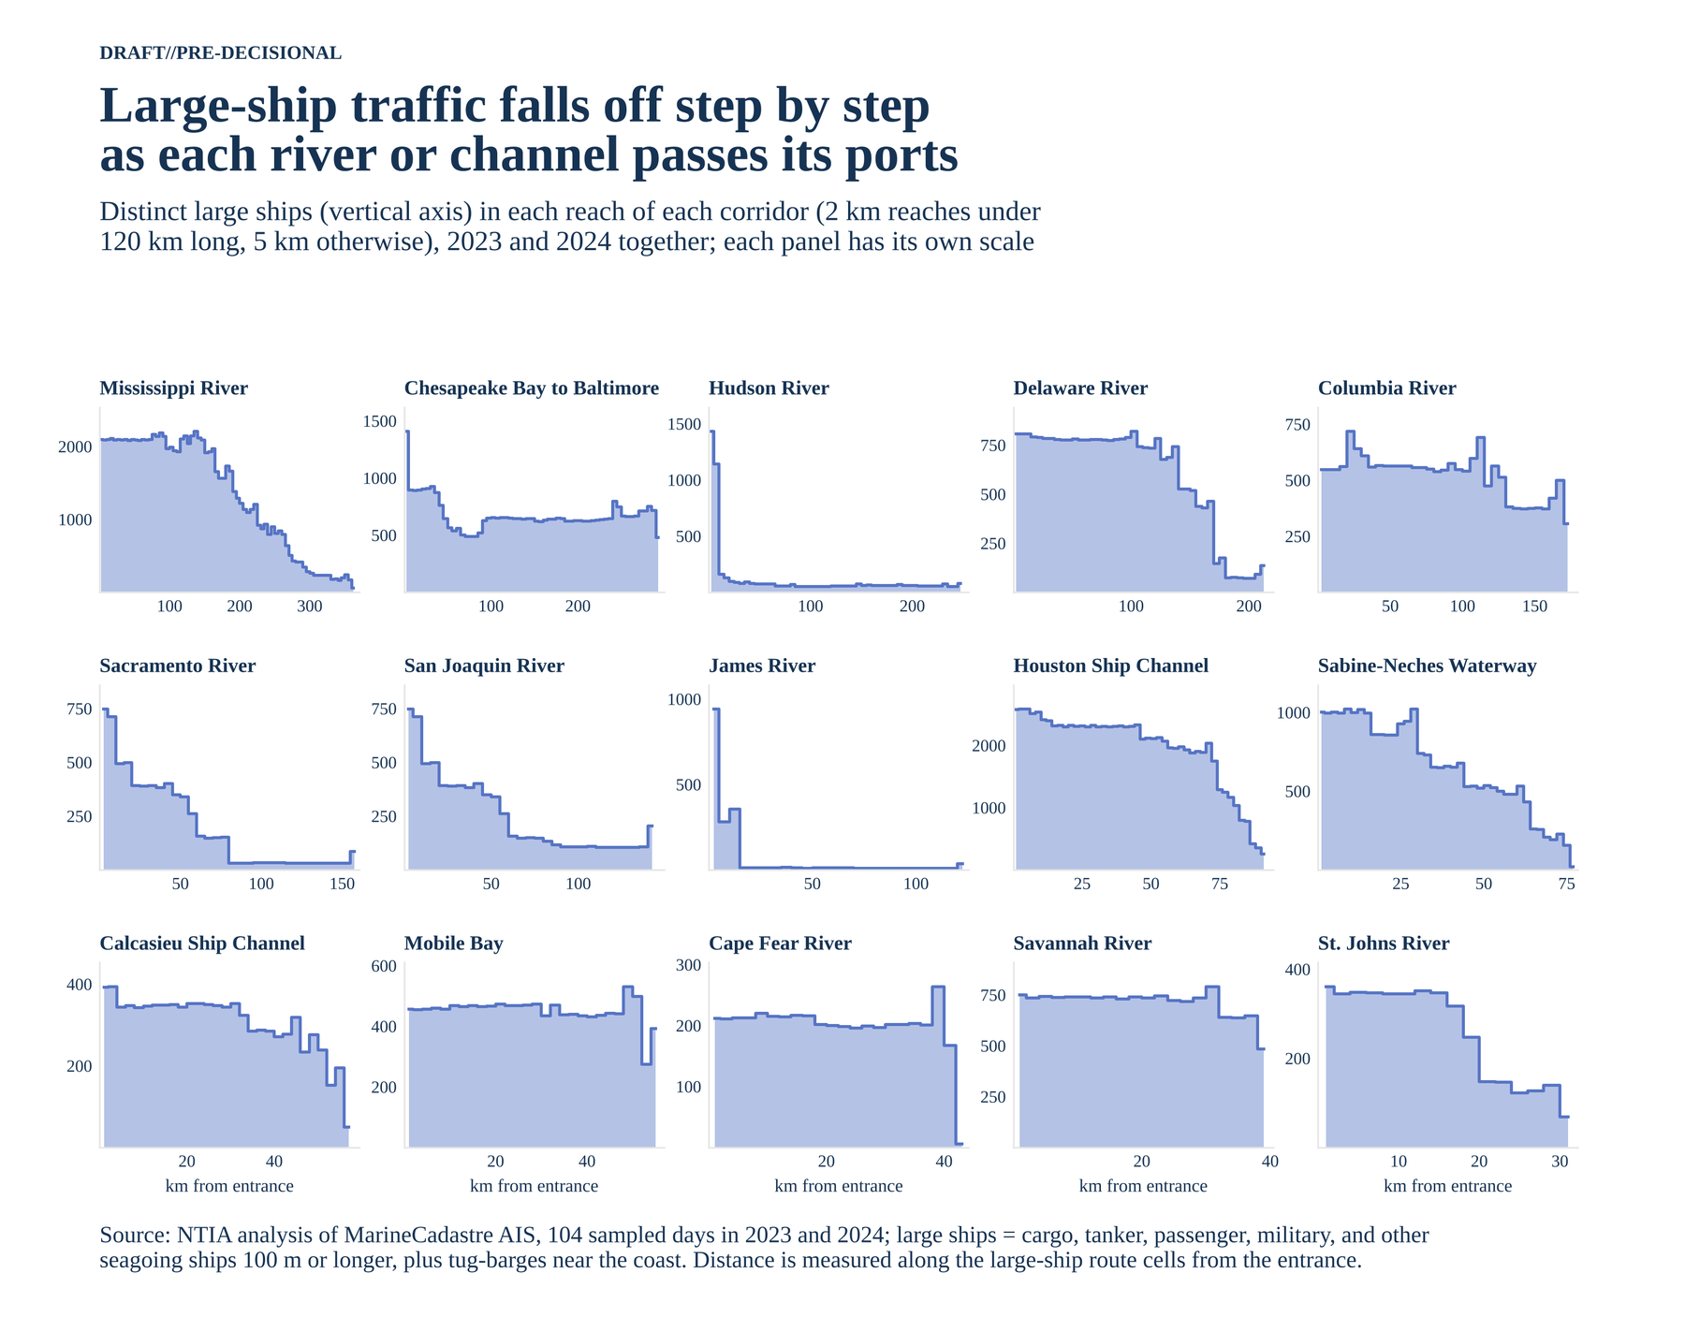
Figure A-19. Distinct large ships in each reach of each corridor.

A.19 Corridor maps and profiles
Each figure pairs a map of the corridor's route cells, shaded by distinct large ships, with the profile of ships against distance from the entrance. Dashed lines mark the ports along the way. Gray cells on the maps are other large-ship routes outside the corridor.
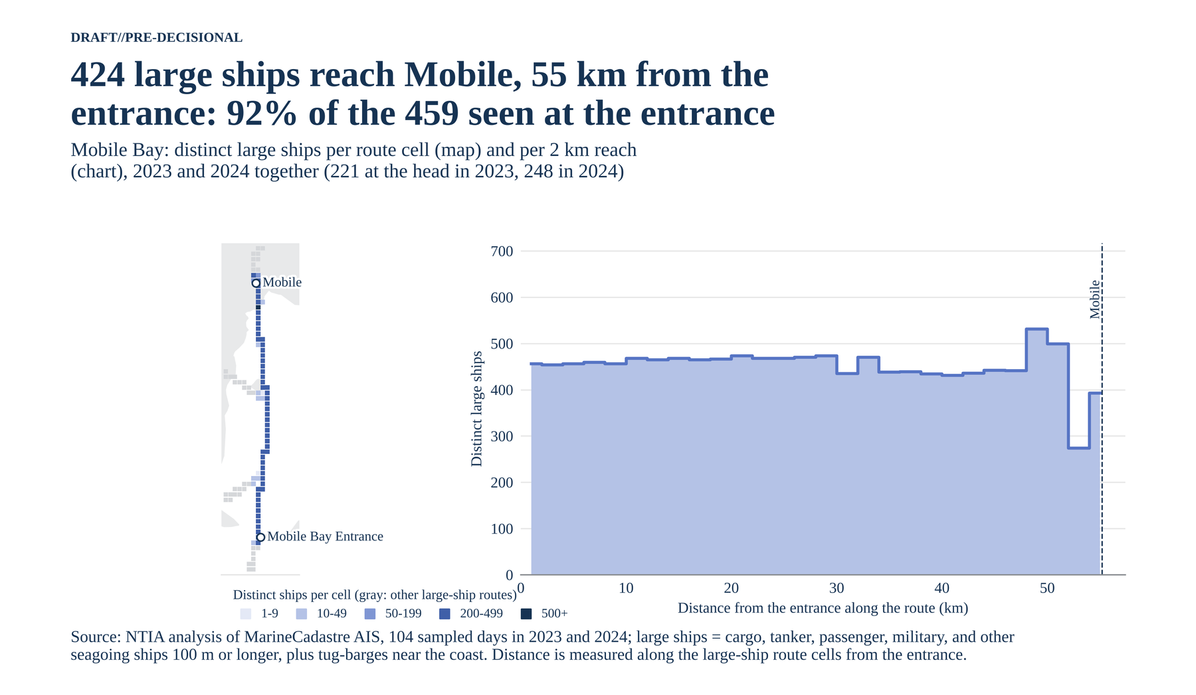
Figure A-20. Mobile Bay.
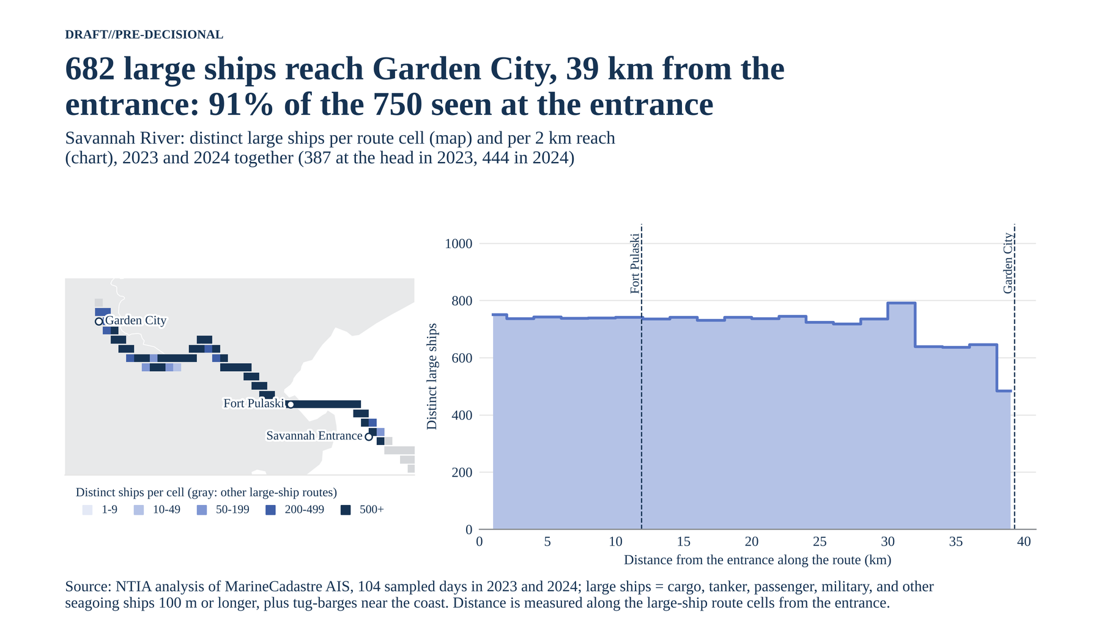
Figure A-21. Savannah River.
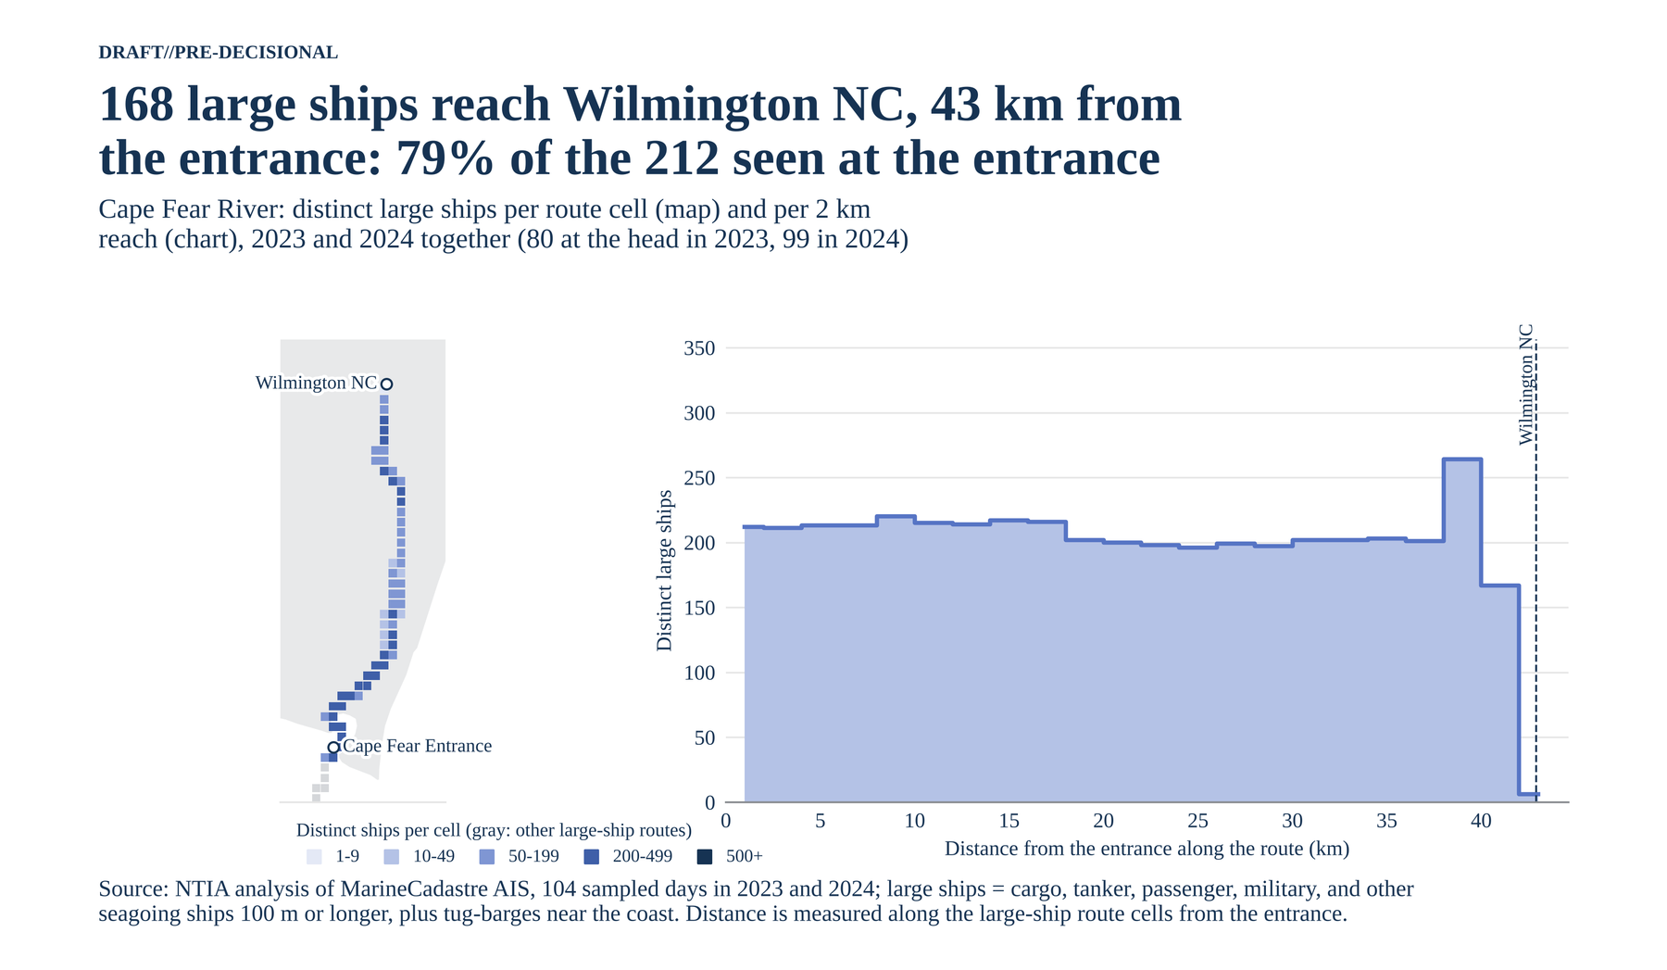
Figure A-22. Cape Fear River.
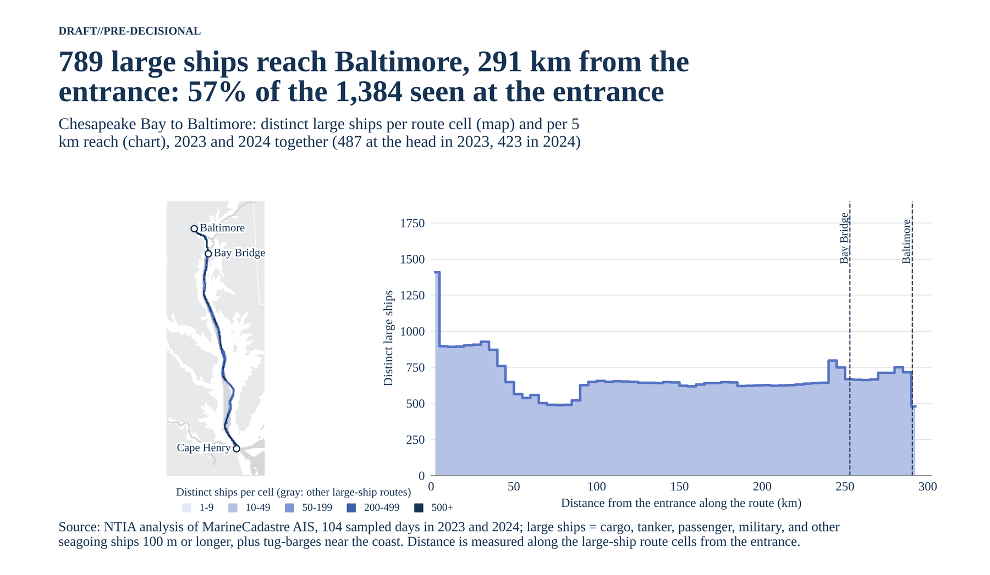
Figure A-23. Chesapeake Bay to Baltimore.
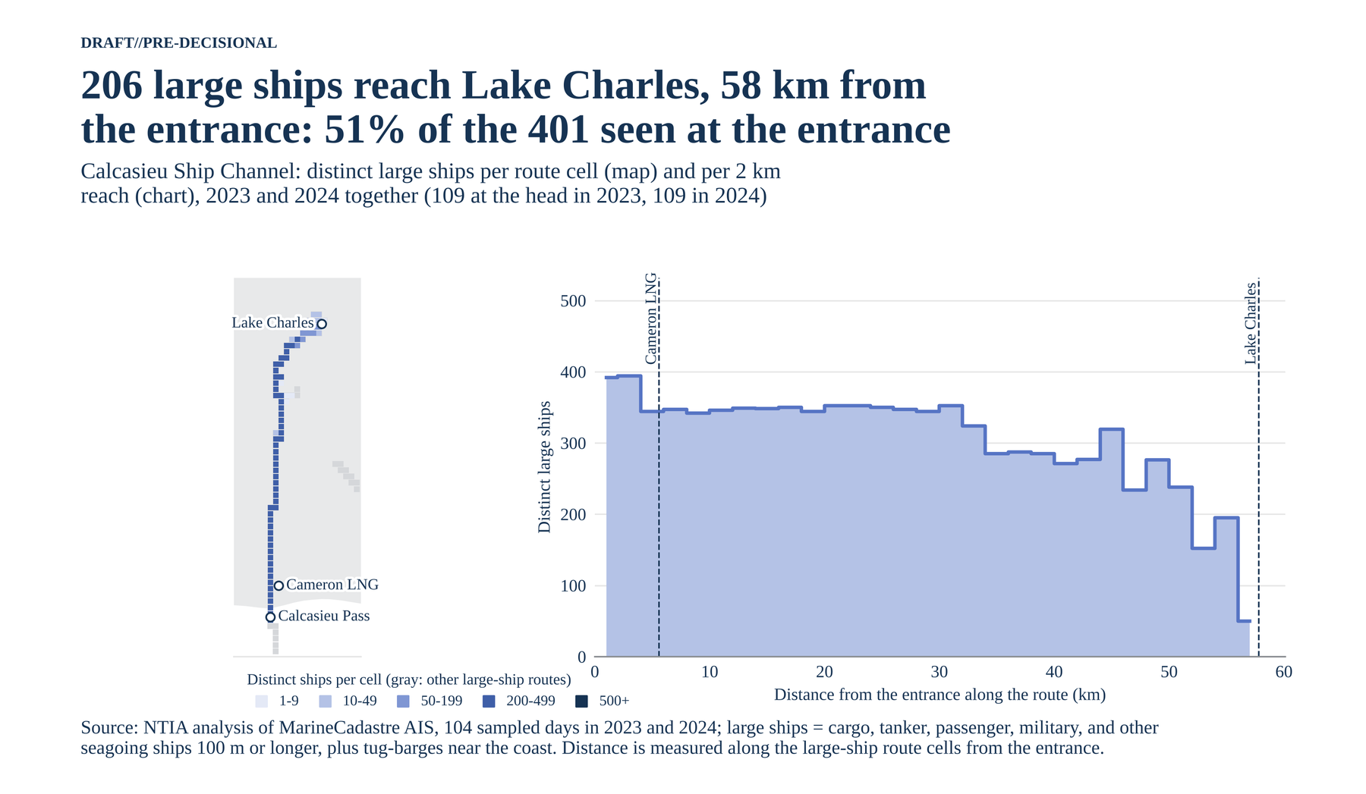
Figure A-24. Calcasieu Ship Channel.
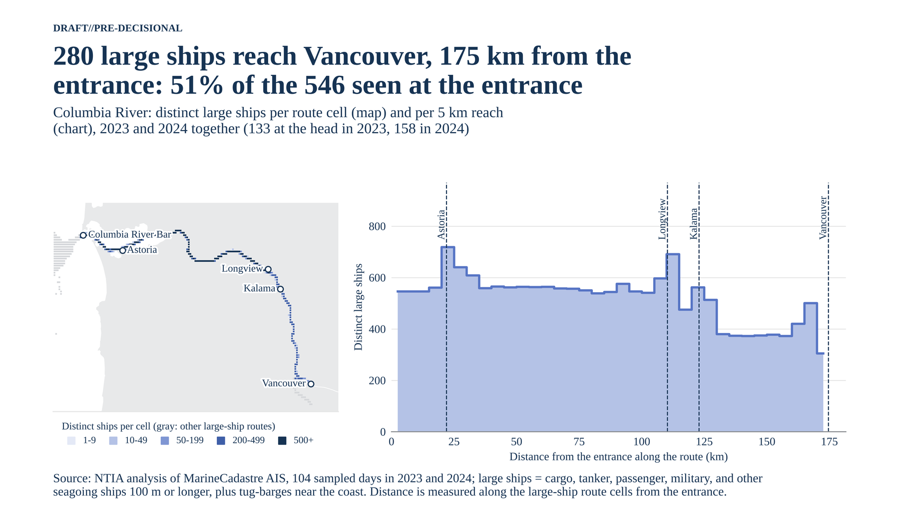
Figure A-25. Columbia River.
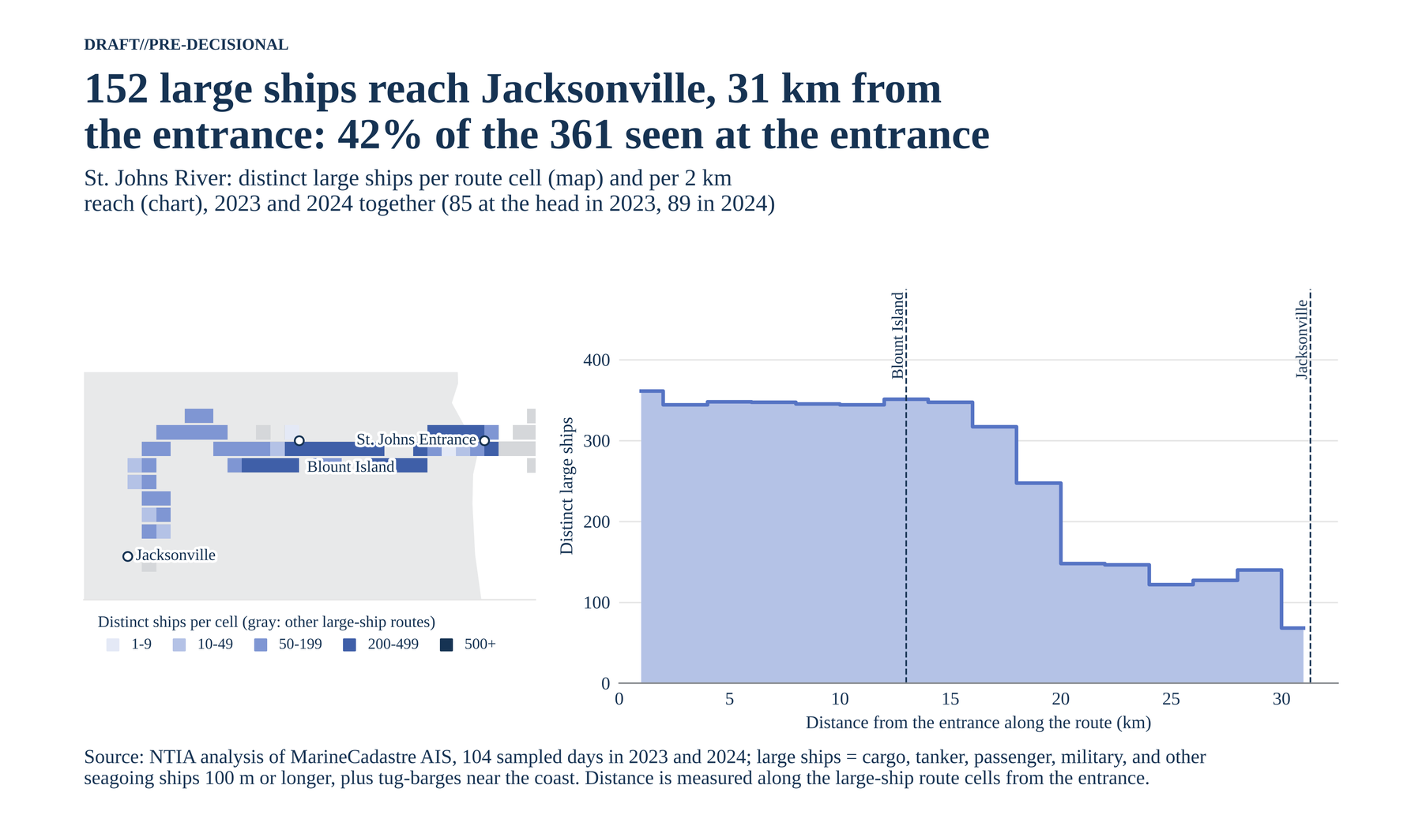
Figure A-26. St. Johns River.
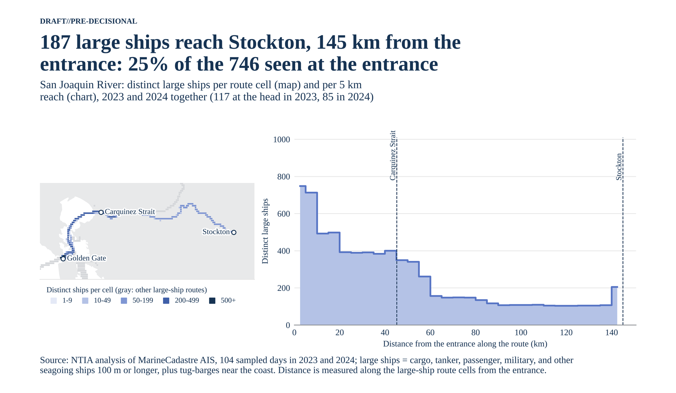
Figure A-27. San Joaquin River to Stockton.
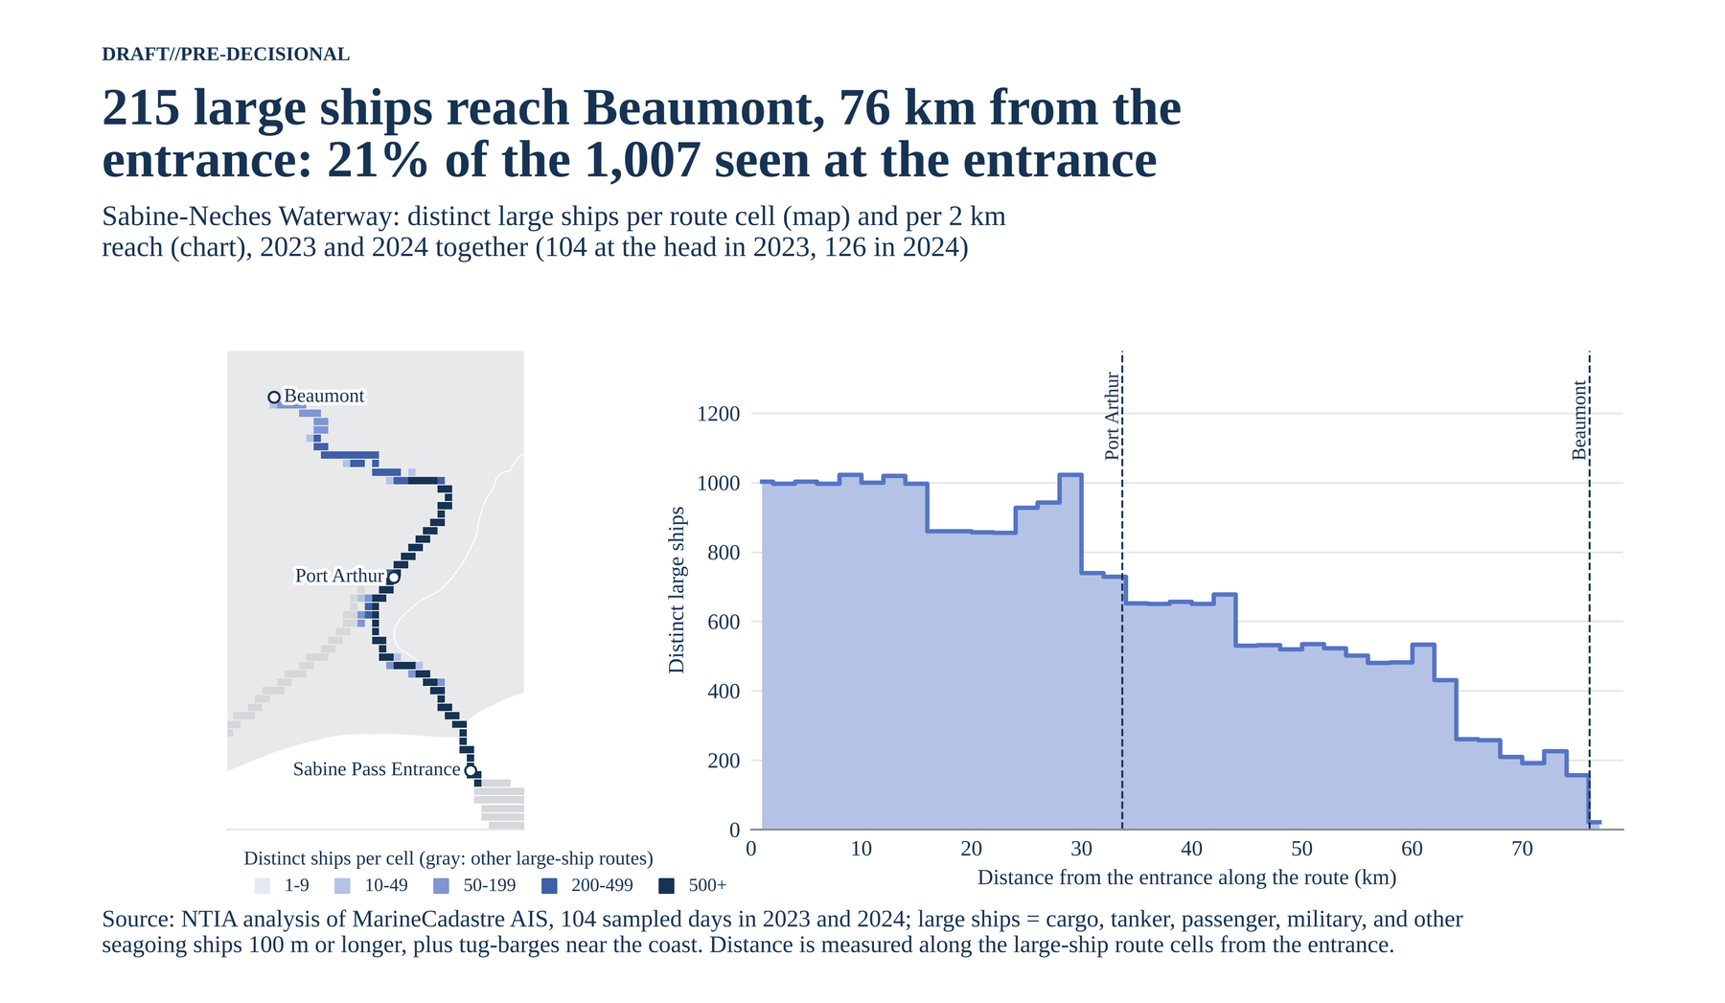
Figure A-28. Sabine-Neches Waterway.
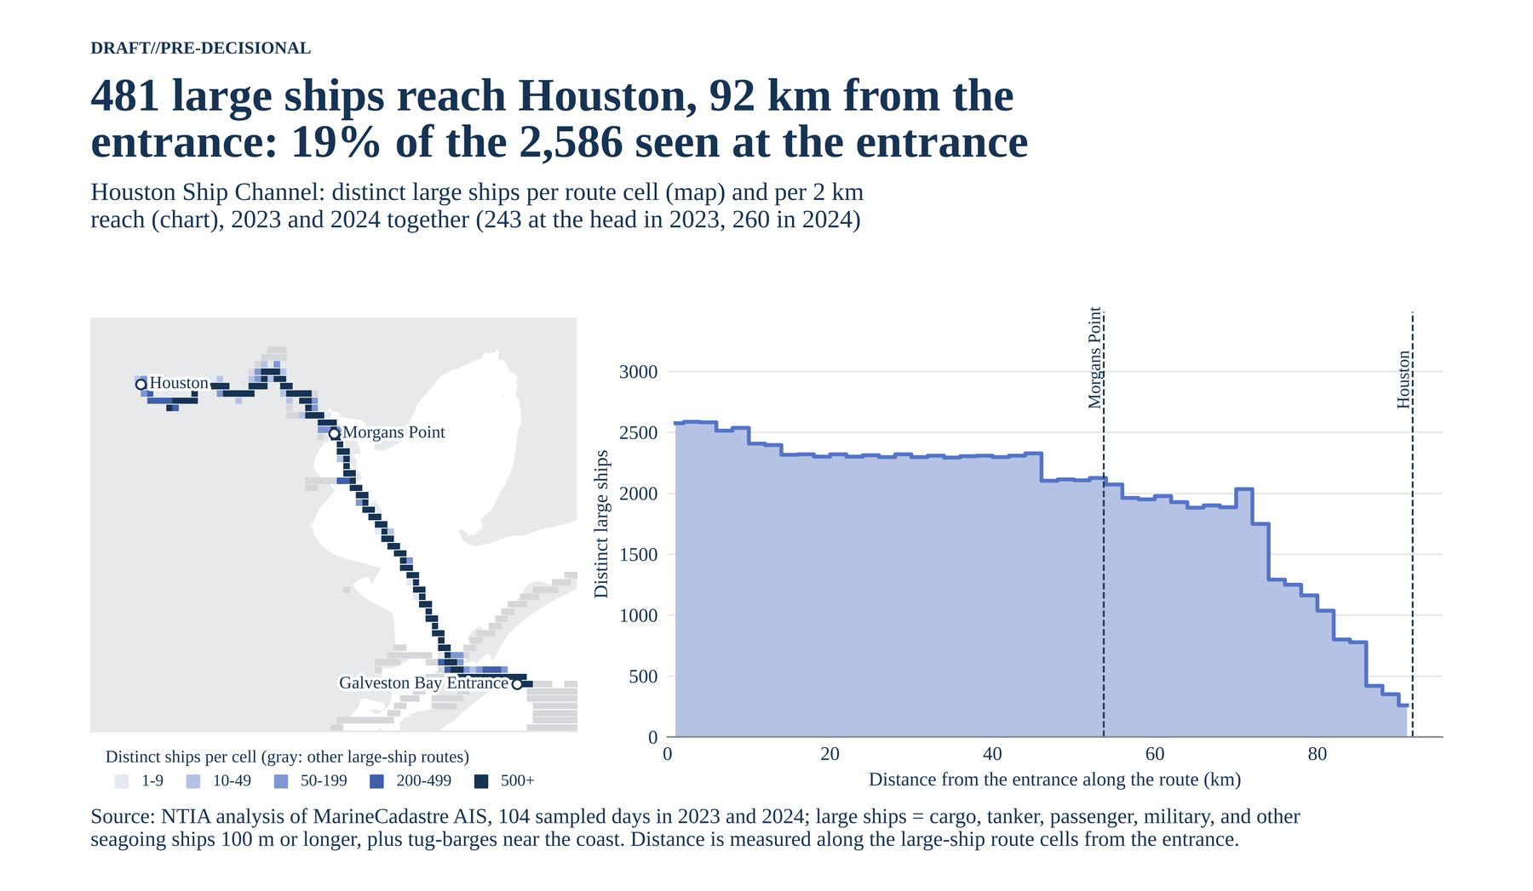
Figure A-29. Houston Ship Channel.
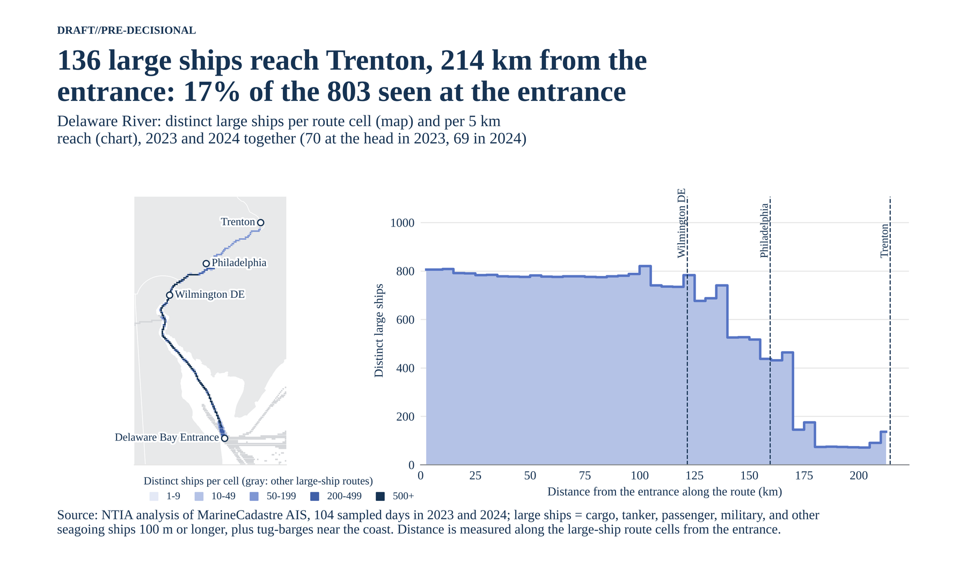
Figure A-30. Delaware River.
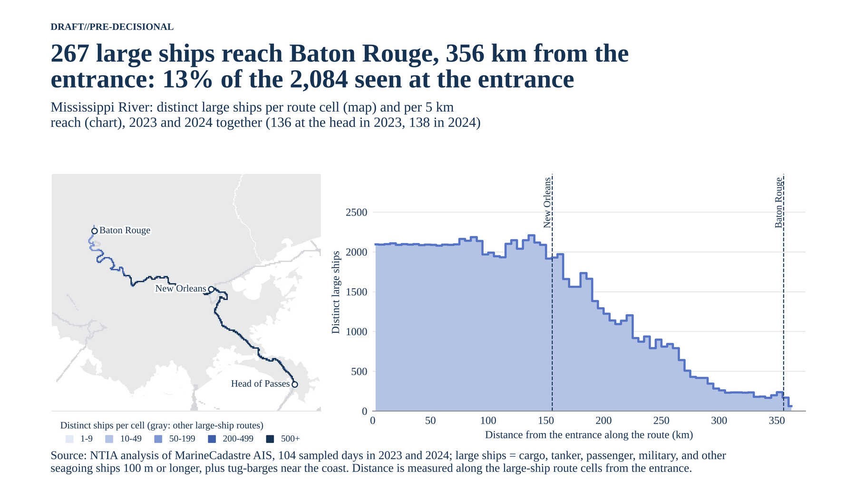
Figure A-31. Mississippi River to Baton Rouge.
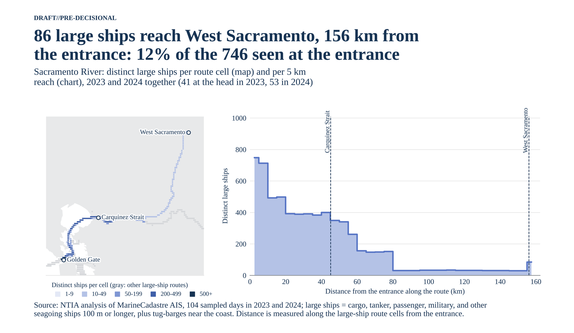
Figure A-32. Sacramento River.
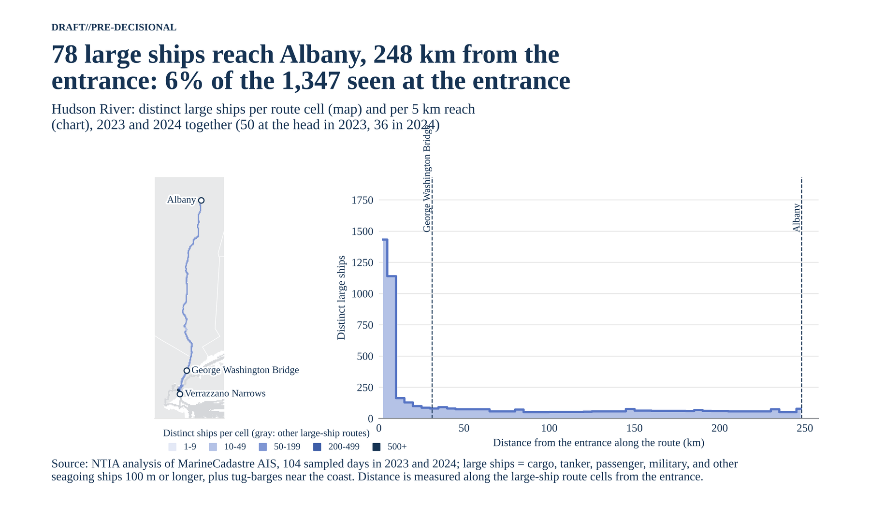
Figure A-33. Hudson River.
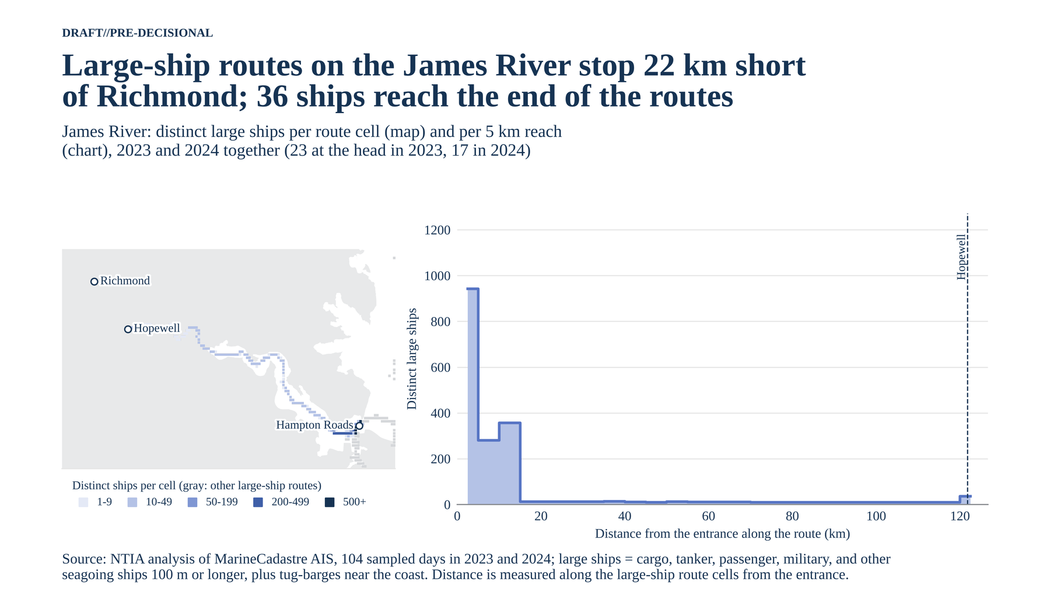
Figure A-34. James River.

A.20 How large-ship port visits split among the ports
Thirteen of the 73 deep-draft ports take half of all large-ship port visits, and Gulf ports take 48%. These ten figures show the same split in different forms. A port visit is one distinct large ship seen within 10 km of a deep-draft port over the 104 sampled days. Unlike Table 5, each 1 km cell counts toward its nearest port only, so neighbors such as Los Angeles and Long Beach split the water they share and the visits add to a total (38,537). A ship that calls at two ports counts once at each. Ports on a coastwise lane, such as Galveston at the Bolivar Roads entrance and Oxnard (Port Hueneme), also count ships passing within 10 km.
Treemap. Each rectangle is one port, sized by its share of visits and grouped by coast. Galveston (7.4%), New Orleans (6.3%), and Plaquemines (5.6%) are the largest.
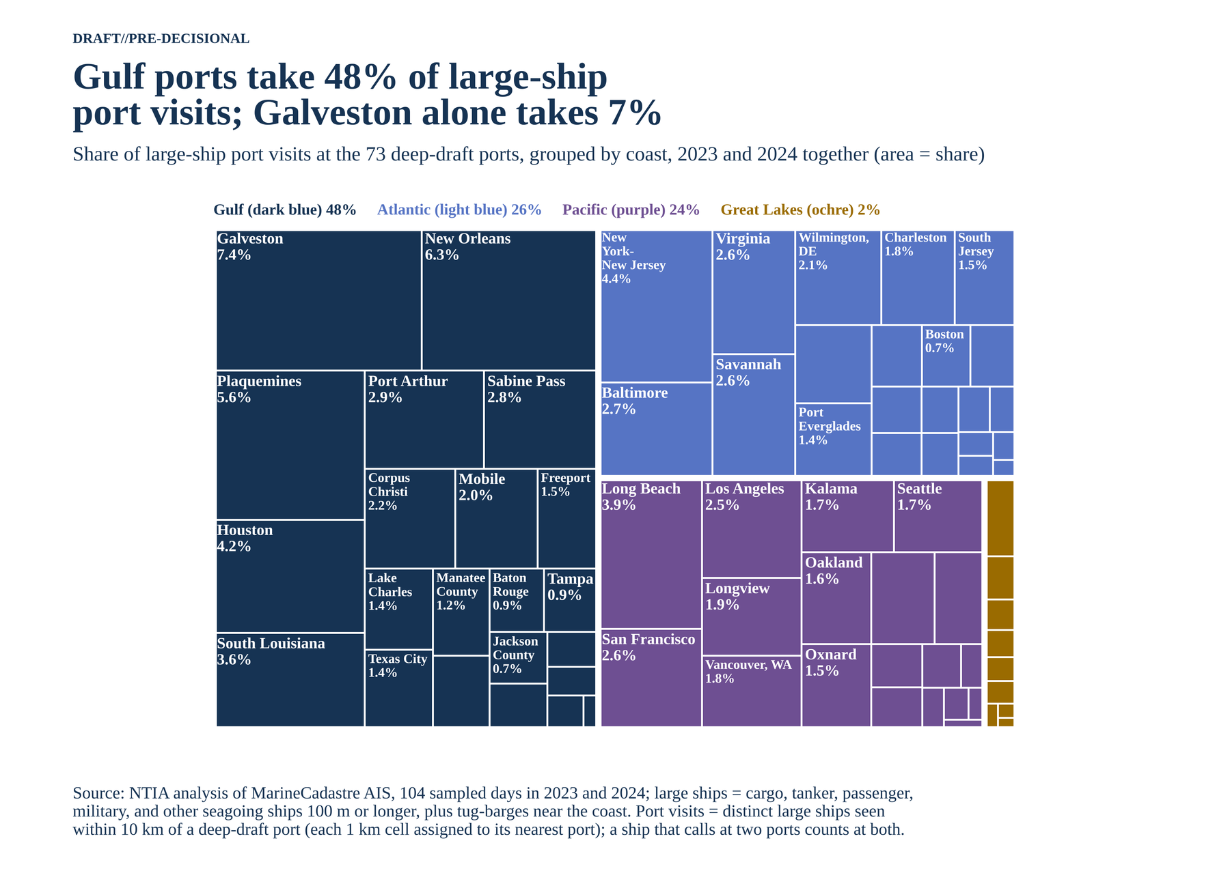
Figure A-35. Share of large-ship port visits by port and coast (treemap).
Circle packing. The same shares as circles, which makes the long tail of small ports easy to see: the 10 busiest take 44% of visits.
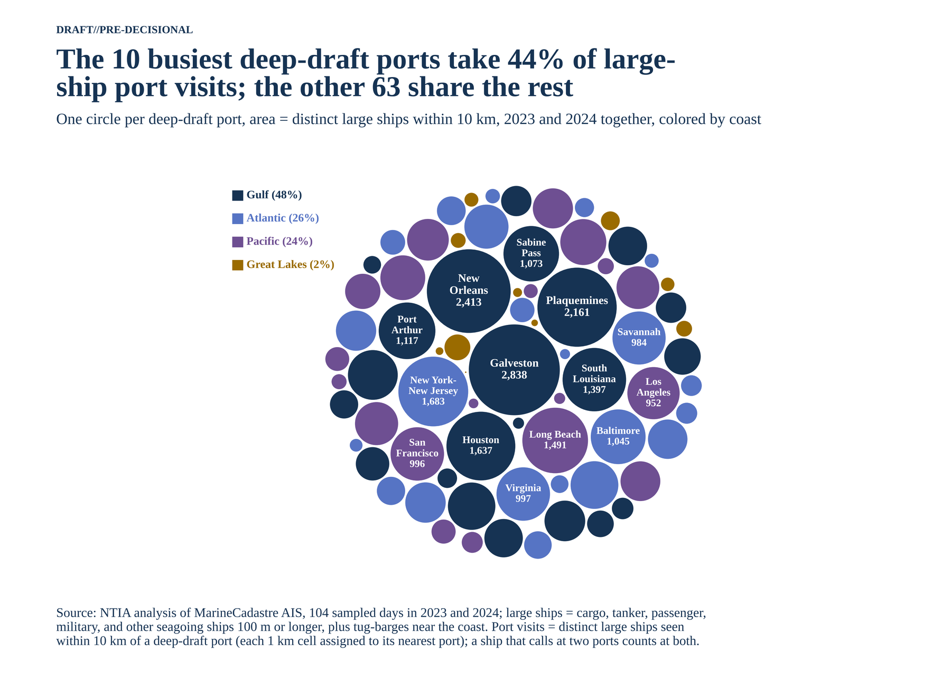
Figure A-36. Large-ship port visits, one circle per port.
Ranked bars. The 25 busiest ports with a running total; the total passes half at Savannah, the 13th port.
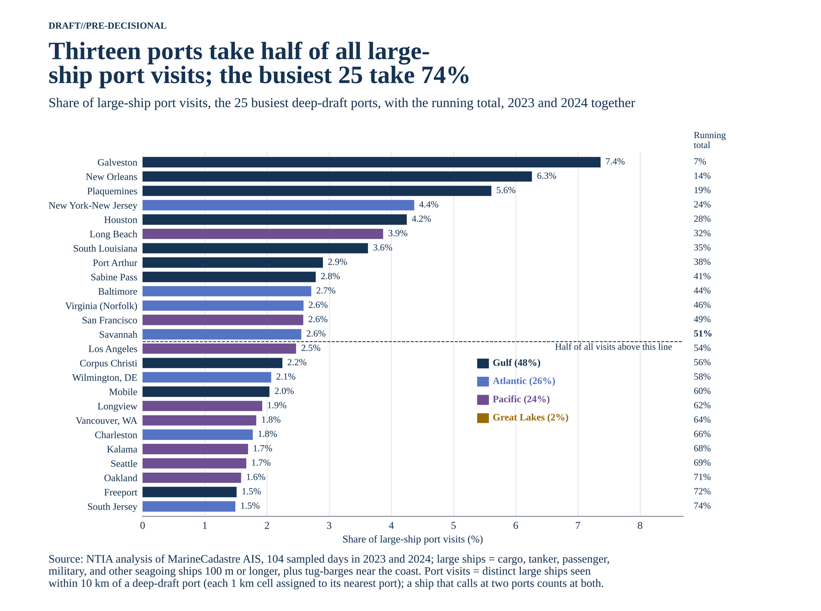
Figure A-37. The 25 busiest ports by share of visits, with the running total.
Concentration curve. The cumulative share against the number of ports: 13 ports take half and 30 take four-fifths, far above an even split.
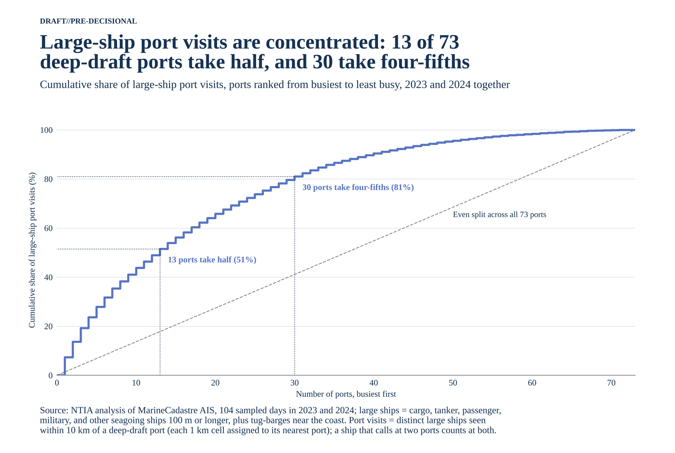
Figure A-38. Cumulative share of large-ship port visits, busiest ports first.
Waffle. One hundred squares grouped by port complex: eight complexes take 63%, led by the lower Mississippi (16%) and Houston-Galveston (13%).
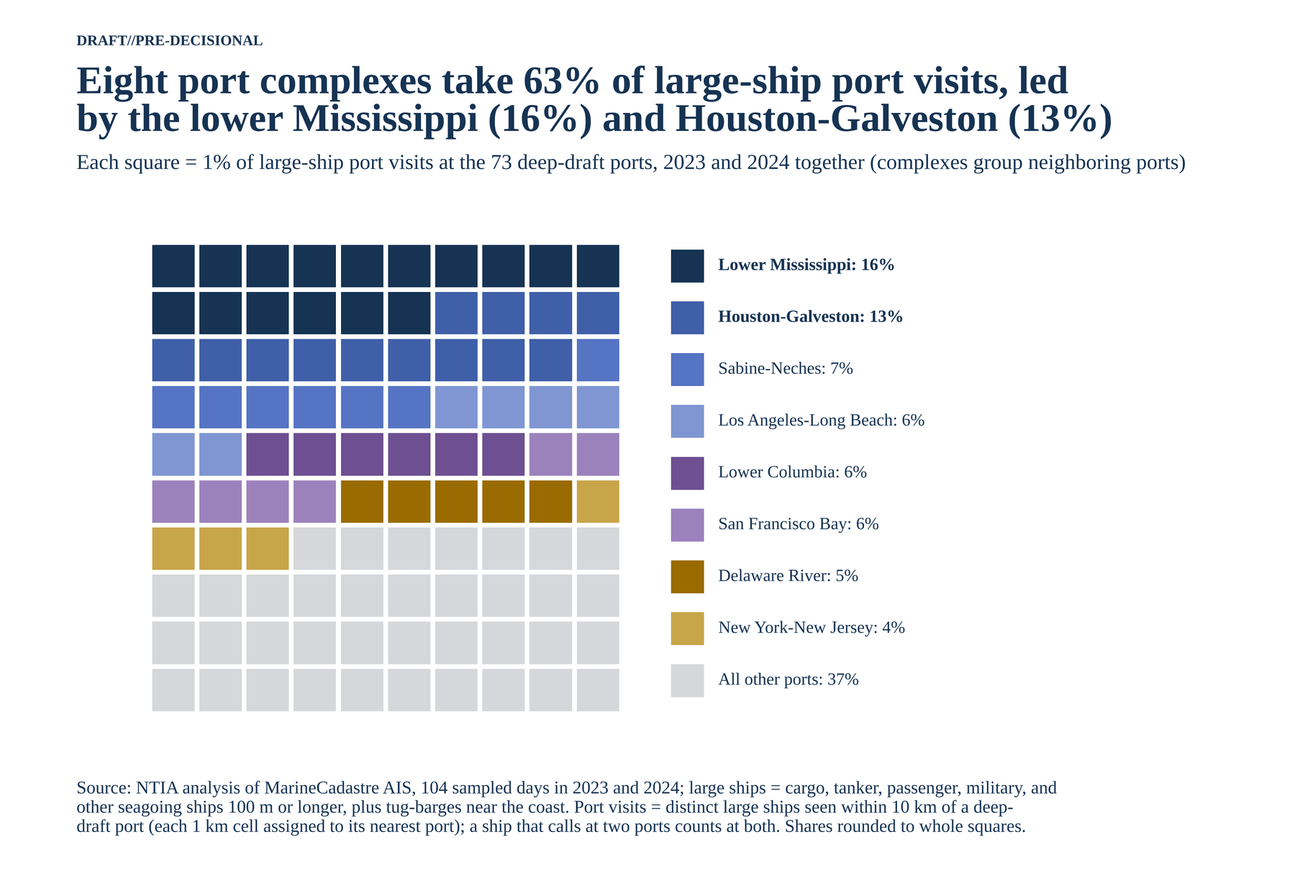
Figure A-39. Share of visits by port complex, each square 1%.
Marimekko. Column width is a complex's share of visits and column height its ship-type mix. Tankers make up 72% of visits at Sabine-Neches and 58% at Houston-Galveston; cargo and container ships lead at every other complex.
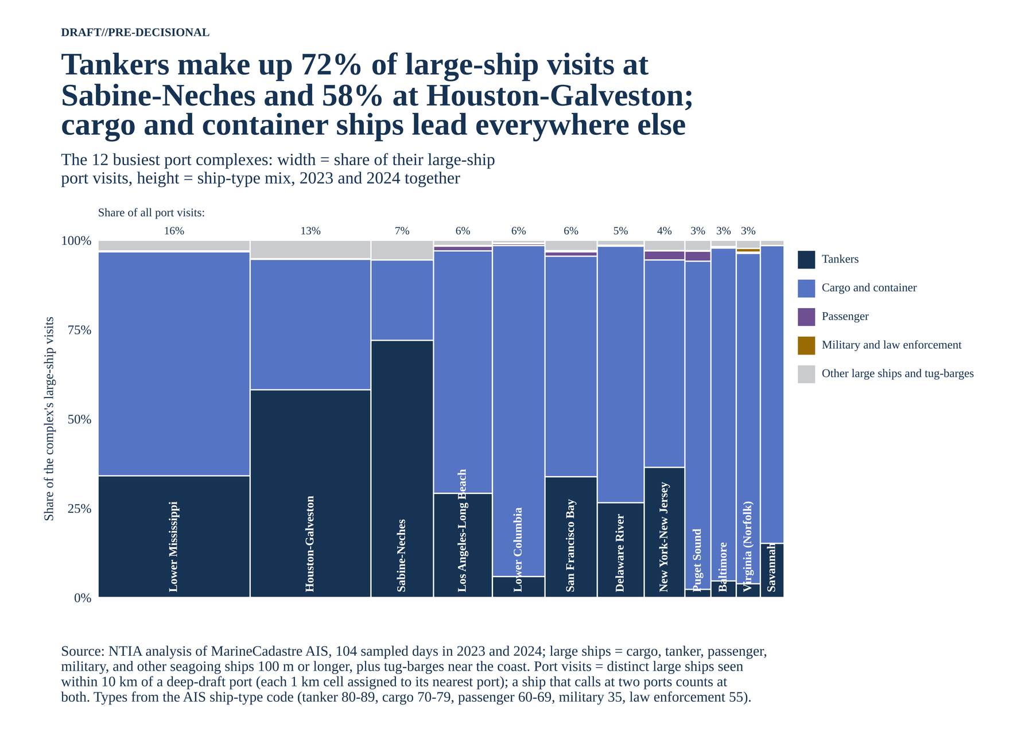
Figure A-40. Ship-type mix of the 12 busiest port complexes.
Sunburst. Rings for coast, port complex, and port. A third of the Gulf's visits are on the lower Mississippi.
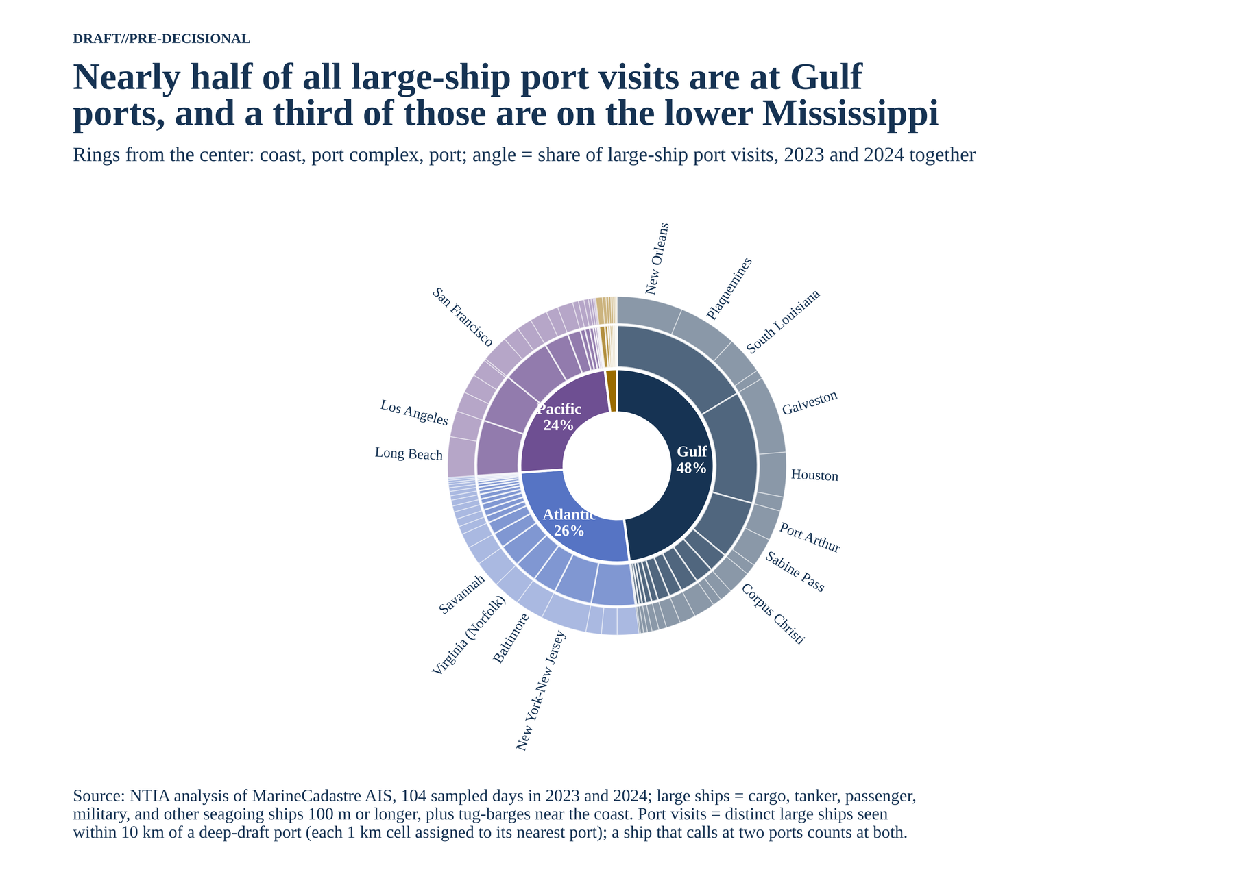
Figure A-41. Share of visits by coast, complex, and port.
Dorling map. One circle per port at its location, nudged apart so none overlap. The Texas and Louisiana ports form the largest cluster.
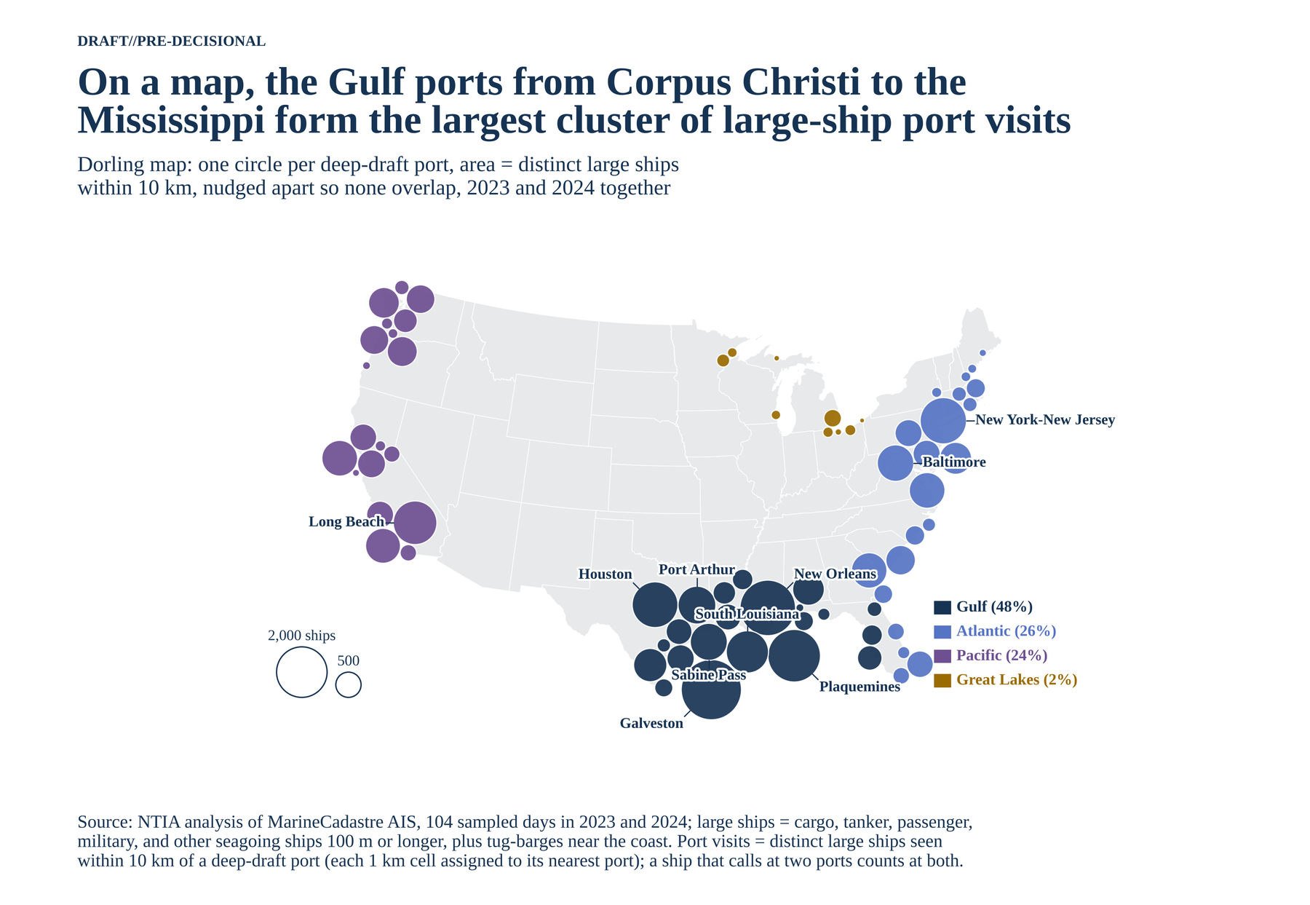
Figure A-42. Large-ship port visits on a map.
Shares within each coast. No port takes more than a sixth of any ocean coast's visits; New York-New Jersey leads the Atlantic with 17%.
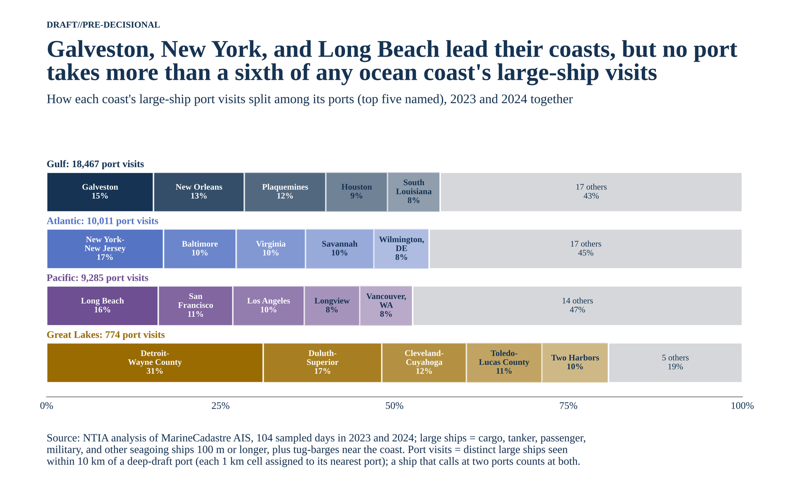
Figure A-43. How each coast's visits split among its ports.
2023 against 2024. Shares barely moved. The largest shift among the top 15 is Baltimore, down 0.7 points in 2024, the year the Key Bridge collapse closed the Fort McHenry channel to deep-draft ships for about 11 weeks.
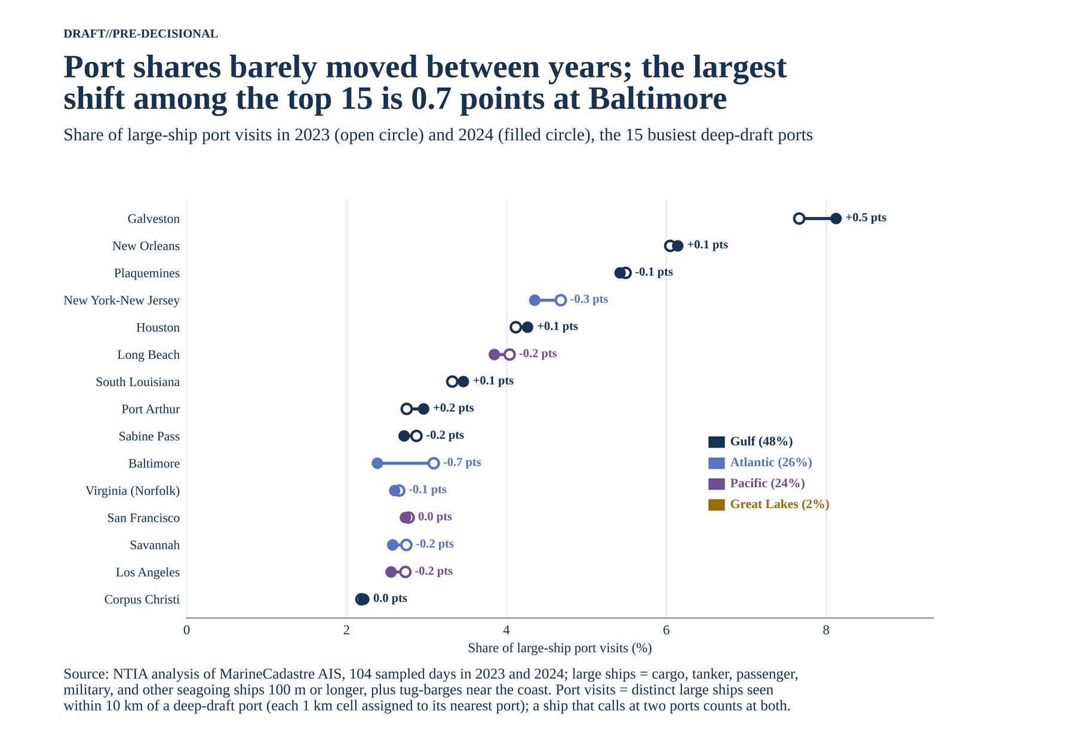
Figure A-44. Share of visits in 2023 and 2024, the 15 busiest ports.

A.21 Data sources
- Ship positions: Bureau of Ocean Energy Management and NOAA Office for Coastal Management, MarineCadastre.gov AIS data, daily files for 2023 (AISDataHandler) and 2024 (csv2024).
- Shipping fairways and traffic separation schemes: NOAA Office of Coast Survey, ENC Direct, Marine Transportation layer.
- Racons: NOAA Office of Coast Survey, ENC Direct general, coastal, and approach chart layers.
- States: U.S. Census Bureau, cartographic boundary file, states, 1:500,000, 2023.
- Coastline: U.S. Census Bureau, TIGER/Line coastline, 2023.
- Ports: U.S. Army Corps of Engineers Principal Ports, as published in the DOE NETL Energy Transition Atlas.
- Gross tonnage: Wikidata ship records (IMO number, gross tonnage, length).
- Key Bridge channel closure dates: U.S. Army Corps of Engineers, Fort McHenry Federal Channel restored.
- Radar carriage: 33 CFR 164.35; SOLAS Chapter V, Regulation 19.
- Code and figures: matlab_shipping_gis (MATLAB R2025b and Python).

