Methodology report: mutual antenna gain between scanning radars
Revision 4, draft of November 5, 2026. Source: repository nicklasorte/mutual_antenna_gain, branch feature/all-wsr88d-vcps, commit d367a9047512c436434538e1d61f153c38c2c4a4 (VCP tables and sweep) and commit 99d3000fe59a62234992e34e36a25a9913d5161a (other code references). This report comes from the code, its comments, and runs of the code in MATLAB.
Changes from revision 3:
- Adds a worked example between a NOAA WSR-88D (NEXRAD) weather radar and an FAA ASR-11 airport surveillance radar (Section 7). It uses the operational NEXRAD volume coverage patterns (VCPs), published antenna patterns for both radars, and the rotation rate of the ASR-11 with its variance.
- Compares main beam to main beam coupling with the statistical mutual antenna gain (MAG), and adds a bound that holds for any mix of NEXRAD scan modes (Sections 7.11 and 7.12).
- Records the concerns raised at the 2.7 GHz Retuning LOE meeting of November 4, 2026, and how this revision addresses each one (Section 8).
- Corrects Case 1 of the example script. Revision 3 called it “Radar B, 34 dBi, 90 degrees per second.” In Rec. ITU-R M.1464-2 Table 1, Radar B is 33.5 dBi at 75 degrees per second, so Case 1 now uses Radar D (32.8 dBi, 90 degrees per second).
- Adds the offaxis_table antenna type, per-scan maxima with the gains that make each peak, main-beam and sidelobe reference levels, a hand check of the per-scan plateaus, confidence intervals for every percentile, and a 72-hour time series.
- Walks through the WSR-88D and ASR-11 example in 11 numbered steps, each with the numbers it produces (Section 7).
- Covers every WSR-88D VCP in operational data from 2024 to 2026 (12, 31, 32, 34, 35, 112, 212, and 215), found by a survey of all WSR-88D sites on six dates. The clear-air VCPs 31, 32, and 34 are new; they don’t change the worst case (Section 7.6).

Summary of the WSR-88D and ASR-11 example
- Main beam to main beam is 79.5 dBi with both peak gains (45.5 dBi and 34 dBi). On a horizontal path it is 76.0 dBi, because the lowest NEXRAD elevation (0.5°) puts the path 0.5° off the NEXRAD beam axis.
- The statistical MAG is far below main beam to main beam. For the worst NEXRAD scan mode, the 99.9% MAG is 43.3 dBi, 36 dB below the peak-gain value. The 99.999% MAG is 66.9 dBi, 13 dB below.
- The share of time that the NEXRAD spends at 0.5° drives the result. The worst mode is VCP 212 with three SAILS rescans, which spends 44% of each volume at 0.5°.
- The unknown mix of NEXRAD modes doesn’t change the bound. For any mix of the 25 modes studied, which cover every WSR-88D VCP in operational data from 2024 to 2026, the 99.9% MAG is at most 43.3 dBi.
- The paper baseline is more conservative in the far tail. The model of the 2.7 GHz link budget working paper (F.1245 patterns, NEXRAD at 3 rpm on the horizon) gives 62.7 dBi at 99.99%, against 45.5 dBi for the worst VCP.
- High peaks are rare but real. Over 72 hours of the worst mode, the largest MAG in an ASR-11 revolution reached 45.5 dBi or more about 71 times per hour, 60 dBi or more about 2.5 times per hour, and came within 0.2 dB of main beam to main beam about once every 3.6 hours (Section 7.9).
- 5,000,000 samples are enough through the 99.99% MAG. The 99.999% MAG has a 95% confidence interval about 4 dB wide at that sample size (Section 7.13).

1. Purpose and method
The model estimates the mutual antenna gain (antenna coupling) between two radars whose antennas scan. It adds the transmit gain of one radar toward the other to the receive gain of the other radar toward the first. It repeats this calculation for many pointing states. The result is a distribution, a table of percentiles, and, in the time-series mode, statistics on how long and how often high coupling lasts.
The method follows Rec. ITU-R M.2069-0, Annex 1. Two example scripts apply it in the 2.7 GHz to 3.1 GHz band:
- example_radar_mutual_gain_rev1.m uses an air-traffic-control reflector radar as the victim (Radar A). The interferers are a second reflector radar (Radar D), a rotating active phased array, and a four-face staring array. The script then compares an unsynchronized ASR-9 pair with a synchronized ASR-9 pair.
- example_nexrad_asr11_rev1.m runs a WSR-88D against an ASR-11 for every operational NEXRAD scan mode and ranks the modes by worst-case MAG. Section 7 describes it.
The geometry does not depend on location. The two radars lie on a horizontal line of sight. Radar 2 is at 0° azimuth from radar 1, and radar 1 is at 180° azimuth from radar 2. Each antenna sweeps all azimuths. The bearing between the radars therefore changes only the rotation phase. It does not change the distribution. The path elevation at each end is an input, and the default is 0°.

2. Coupling calculation
For path 1 to 2 and path 2 to 1, the model calculates:
g12 = G_tx,1(toward radar 2) + G_rx,2(toward radar 1) (1)
g21 = G_tx,2(toward radar 1) + G_rx,1(toward radar 2) (2)
In these equations, each G is an antenna gain in dBi. The model finds it in the direction of the other radar, for the current pointing state of the antenna. The gains add in decibels, which is the same as a product of linear gains. If a radar uses one pattern for transmit and receive, g12 and g21 are equal. If a system defines separate tx and rx models, g12 and g21 can differ.

3. Antenna models
The model supports seven antenna types.
Type | Basis | Parameters
Statgain (default) | NTIA TM-13-489, Table 4-1 | Peak gain of 10 dBi or more
F.1245 | Rec. ITU-R F.1245 | Peak gain, D/λ
Rectangular aperture | Rec. ITU-R M.1851-2, Annex 1, Section 2.1. Azimuth and elevation cuts combine in dB (Equation 15). Optional cosecant-squared elevation. | Beamwidths, sidelobe levels, envelope
Parabolic | Rec. ITU-R M.1851-2, Section 4 (circular aperture) | Beamwidth, sidelobe level, envelope
Off-axis table | Measured or specified pencil-beam envelope, rotationally symmetric | Gain against off-axis angle, 0° to 180°
Measured | Digitized principal-plane cuts | Cuts relative to peak, floor
Planar array | Rec. ITU-R M.1851-2, Section 6.2, Equations 50 to 53 | Element count, spacing, taper
Statgain, F.1245, and the off-axis table depend only on the off-axis angle. This angle is between the beam axis and the direction of the target. The model finds it with the spherical law of cosines. The inputs are the azimuth offset, the target elevation, and the beam tilt. The off-axis table interpolates the gain linearly in dB. It checks that the table spans 0° to 180°, increases strictly, and peaks at 0 dB.
For Statgain, with a peak gain G from 22 dBi to 48 dBi and an off-axis angle θ in degrees, the model uses these equations:
- Main beam (θ up to θm): G − 4×10⁻⁴ · 10^(G/10) · θ²
- First sidelobe region (θ above θm, up to θr): 0.75G − 7
- Far sidelobes (θ above θr, up to 48°): 53 − G/2 − 25 log₁₀ θ
- Back region (θ above 48°): 11 − G/2
In these equations, θm = 50√(0.25G + 7)/10^(G/20) and θr = 250/10^(G/20). Other ranges of peak gain use other constants. For Radar A (33.5 dBi), θm is 4.14° and θr is 5.28°. The back-region level is −5.75 dBi. For Radar D (32.8 dBi), the back-region level is −5.4 dBi.
For the planar array, the model builds a square array that reaches the requested peak gain. It applies a Taylor taper on each axis (default sidelobe level −25 dB, nbar of 4). It calculates the array factor on a zero-padded FFT grid, and an interpolant reads this grid. The element spacing is half a wavelength at 2,900 MHz. The element gain is the gain of one unit cell, 10 log₁₀(4π·dx·dy/λ²), or 4.97 dBi. A request for 40 dBi gives a 63-by-63 array with a broadside gain of 40.09 dBi. The far-sidelobe floor and the front-to-back level default to the Statgain back level for the same peak gain.

4. Pointing states and sampling
The model has two modes.
Random mode is the default. It draws the pointing state of each radar independently. A mechanically rotating antenna gets a uniform azimuth from 0° to 360°. For a volume scan with several elevation steps, the model picks a step with a probability in proportion to its dwell time. A NEXRAD VCP is such a volume scan: each elevation cut is one step of one revolution at the cut’s rate and elevation. An array also gets a random steering azimuth and elevation within set limits. For a multi-face array, the model draws a beam azimuth and assigns it to the face with the nearest normal. The default is 5 million samples in chunks of 250,000. This matches the sample count of the M.2069-0 method. Each chunk uses its own substream of a mrg32k3a generator that starts from the user seed. Serial and parallel runs therefore give the same samples.
For two radars with equal rates, independent sampling averages over an unknown relative phase. The code comments call this the Mutual Antenna Coupling Distribution of the 2.7 GHz link budget working paper. The model gives a warning for equal rates. It also gives a warning for rates in a small-integer ratio. In that case, the pointing pair follows a closed path again and again. Random mode describes such a pair only if the rates drift apart.
Time-series mode turns each antenna at its own rate from a random start phase. Each trial draws a start offset in the scan cycle. If you set rate_jitter_deg_s, each trial also draws a rate offset, uniform between minus and plus that value. The default time step is one tenth of the shortest time that a beam needs to cross its own 3 dB width. The defaults are four trials of 3,600 s each. For each threshold, the model reports the number of events, the events per hour, the mean and maximum duration, and the percentage of time above the threshold. One event is a run of consecutive samples at or above the threshold. A run that a trial boundary cuts also counts as an event.
Synchronized rotation applies to two mechanical radars that have one equal rate. The model sweeps one revolution in steps. Radar 2 is at the azimuth of radar 1 plus a fixed offset. The step is 1/100 of the narrowest azimuth beamwidth. The result is the maximum coupling.

5. Output statistics
The model builds a cumulative table and an exceedance table on a 0.1 dB grid. It uses a histogram because an empirical CDF returns one row for each sample. Each percentile in the percentile table has a distribution-free 95% confidence interval from order statistics. It also returns the CDF as a plain numeric array, cdf_array12 and cdf_array21: column 1 is the percent of time from 0 to 100, and column 2 is the MAG in dBi that is not exceeded for that percent of time. The option cdf_pct sets the percent grid; the default is every 1% plus 99.5%, 99.9%, 99.95%, 99.99%, 99.995%, and 99.999%. The arrays for the cases in Figure 6 are in docs/figures/cdf_array_rev4.csv. It reports the 50th, 90th, 99th, 99.9th, 99.99th, and 99.999th percentiles. For each percentile, it also reports the number of samples above it. A count below 10 means that the tail has too few samples.
The WSR-88D and ASR-11 function adds four outputs:
- Maximum MAG per scan. A time series of both antennas gives the largest MAG in each ASR-11 revolution, each NEXRAD elevation cut, and each NEXRAD volume. At each revolution maximum, it records each radar’s gain and beam azimuth off the path, so every peak can be explained. Scans that a trial boundary cuts are flagged and left out of the statistics. Time-series percentiles come from a 0.01 dB histogram, so runs of many hours fit in memory.
- Plateau check. A hand count of how often each NEXRAD cut’s main beam crossing falls in an ASR-11 revolution, compared with the simulation.
- Reference levels. These are the MAG values for main beam to main beam and for each radar’s main beam into the other’s near sidelobe and back lobe, on the link path.
- Sensitivity table. This table lists each MAG choice with its difference from the peak-gain main beam to main beam value.
- Mode envelope. For each percentile, the envelope is the largest value over all scan modes. Section 7.12 shows that it bounds any mix of the modes.

6. Cases in the example script
Case | Interferer | Antenna | Scan
Victim (Radar A) | Not applicable | Statgain, 33.5 dBi | 75 degrees per second, 0° tilt
1 | Radar D | Statgain, 32.8 dBi | 90 degrees per second, 0° tilt
2 | Rotating AESA | Planar array, 40 dBi, 10° face tilt, transmit Taylor −17 dB | 60 degrees per second, random beam, elevation 0° to 30°, dwell 0.05 s
3 | Four-face array | Planar array, defaults (41 dBi), transmit Taylor −17 dB | Random beam over four faces, face 1 at 45°
Pair | ASR-9 pair | Statgain, then F.1245, 34 dBi | 12.5 rpm for both
All runs use seed 20261101 and 5 million random samples. Case 1 also has a time series of 3,600 s with 8 trials. Its thresholds are 20 dBi, 30 dBi, 40 dBi, and 50 dBi. The script marks the beam-axis tilt and the AESA face tilt as TODO. It takes other values from Rec. ITU-R M.1464-2, Tables 1 and 2.

7. WSR-88D and ASR-11 example
This example answers a question from the 2.7 GHz Retuning LOE: how does the MAG between a NOAA weather radar and an FAA ATC radar depend on the NEXRAD scan mode, and how does it compare with main beam to main beam? The function nexrad_asr11_mag_rev1 holds every input with a source key, and its citations table gives the URL of each source.
The example follows 11 steps. Each step names the code that does the work and the numbers it produces, so that a reader can check each number by hand or rerun it. Every figure and table comes from report_figures_rev4.m.

7.1 Inputs
Parameter | Value | Source
NEXRAD peak gain | 45.5 dBi at 2,850 MHz, including the radome | NOAA ROC, NEXRAD Technical Information (Rec. ITU-R M.1849-3 Radar 1: 45.0 dBi)
NEXRAD 3 dB beamwidth | 0.925° | NOAA ROC, NEXRAD Technical Information
NEXRAD sidelobes (default) | −35 dB to 2°, −48 dB at 6°, −55 dB at 20° and beyond | NSSL measurements of the KOUN antenna, 1998 report errata
NEXRAD sidelobes (alternative) | −29 dB beyond the main beam, −40 dB beyond 10° | NOAA ROC specification
NEXRAD scan | VCPs 12, 31, 32, 34, 35, 112, 212, and 215, with SAILS, MRLE, and AVSET options | Decoded from operational Level II data (Step 5)
ASR-11 peak gain | 34 dBi | Rec. ITU-R M.1464-2 Table 1, Radar C
ASR-11 beamwidths | 1.45° azimuth, 4.8° elevation | Rec. ITU-R M.1464-2 Table 1, Radar C
ASR-11 elevation pattern | Cosecant squared to +30°, Rec. ITU-R M.1851-2 Equations 25 to 27 | Rec. ITU-R M.1464-2 Table 1, Radar C
ASR-11 sidelobes | First +9.5 dBi (cosine taper), remote +3.5 dBi | Rec. ITU-R M.1464-2 Table 1, Radar C
ASR-11 tilt | 0° (beam nose on the horizon); allowed range −2.5° to +2.5° | Rec. ITU-R M.1464-2 Table 1, Radar C (TODO: site value)
ASR-11 rotation rate | 12.5 rpm (75 degrees per second, one revolution every 4.8 s) | Rec. ITU-R M.1464-2 Table 1, Radar C; Forecast International
ASR-11 rotation-rate variance | Uniform ±0.5 degrees per second, one offset per trial | Rec. ITU-R M.2069-0 Annex 1 drive accuracy (TODO: FAA Order JO 6310.30B value)
Path elevation | 0° at both ends | Location-agnostic assumption
Polarization mismatch | Not modeled | Study assumption
Radar C matches the ASR-11: a 25 kW solid-state transmitter with 1 µs and 89 µs pulses. The FAA standard and tolerance for the ASR-11 rotation rate are in FAA Order JO 6310.30B, which is available only on the FAA network. Until that value is available, the model uses the ±0.5 degrees per second drive accuracy of M.2069-0, and opts.asr_rate_jitter_deg_s changes it. Each radar uses one pattern to transmit and receive, so the MAG is the same in both directions (g12 = g21). The ASR-11 low beam is assumed for transmit and receive; the high beam is not modeled.

7.2 Step 1: Set the geometry
The NEXRAD is radar 1 and the ASR-11 is radar 2. The ASR-11 lies at 0° azimuth from the NEXRAD, and the NEXRAD lies at 180° azimuth from the ASR-11. The path is horizontal (0° elevation) at both ends. The distance between the radars does not enter the MAG; it enters the link budget through the basic transmission loss. Both antennas rotate through 360°, so the true bearing between the sites only shifts the rotation phase and does not change any result.

7.3 Step 2: Find the NEXRAD gain toward the ASR-11
The NEXRAD beam points at azimuth offset Δaz from the path and at the elevation (tilt) of the current cut. The angle γ between the beam axis and the path follows from the spherical law of cosines. With a path elevation of 0°, it reduces to:
cos γ = cos(tilt) · cos(Δaz) (3)
The NEXRAD gain is then G_N(γ) = 45.5 − 12(γ/0.925)² dBi in the main beam, until that curve meets the sidelobe envelope of Section 7.1. Beyond that point, the gain follows the envelope. Figure 1 shows the pattern.

Antenna patterns of the WSR-88D (off-axis angle) and the ASR-11 (azimuth and elevation cuts), each against the F.1245 pattern of the working paper.
Figure 1. The measured NEXRAD envelope falls below F.1245 beyond 1.5°, and the ASR-11 cosine taper is narrower than F.1245. Panel a: WSR-88D gain against off-axis angle. Panel b: ASR-11 azimuth cut. Panel c: ASR-11 elevation cut at 0° tilt. Source: NTIA analysis with report_figures_rev4.m (2026).
When the NEXRAD beam azimuth is on the path (Δaz = 0), γ equals the tilt. The table gives the NEXRAD gain toward the ASR-11 at that moment for each cut. For the 0.5° cut, for example: 45.5 − 12(0.5/0.925)² = 45.5 − 3.51 = 41.99 dBi. When the NEXRAD beam points away from the path (Δaz = 180°), its gain is the −55 dB floor: 45.5 − 55 = −9.5 dBi.
NEXRAD cut elevation | NEXRAD gain toward the ASR-11 with the beam azimuth on the path (dBi) | Region of the pattern
0.5° | 41.99 | Main beam
0.9° | 34.14 | Main beam
1.3° | 21.80 | Main beam
1.8° | 10.5 | First sidelobe (−35 dB)
2.4° | 9.2 | Sidelobe envelope
3.1° | 6.9 | Sidelobe envelope
4.0° | 4.0 | Sidelobe envelope
5.1° | 0.4 | Sidelobe envelope
6.4° | −2.7 | Sidelobe envelope
8.0° to 19.5° | −3.5 to −9.25 | Far sidelobes
The NEXRAD main beam reaches the ASR-11 strongly only on the 0.5°, 0.9°, and 1.3° cuts. Above 1.3°, a horizontal path is in the NEXRAD sidelobes even when the beam azimuth points at the ASR-11.

7.4 Step 3: Find the ASR-11 gain toward the NEXRAD
The ASR-11 beam points at azimuth offset Δaz_A from the path. Its tilt is 0°, so its elevation pattern adds 0 dB on a horizontal path, and the gain follows the azimuth cut of Figure 1b (Rec. ITU-R M.1851-2 cosine taper, 1.45° beamwidth):
ASR-11 beam azimuth off the path | ASR-11 gain toward the NEXRAD (dBi)
0° | 34.0 (peak)
0.725° (half the beamwidth) | 30.9
2.9° (two beamwidths, near sidelobe region) | 7.2
Far from the path, out to 180° | 3.5 (remote sidelobe floor)

7.5 Step 4: Add the two gains for one pointing state
The MAG for one pointing state is the sum of the two gains, Equation 2. Two pointing states from the time series in Step 7 show the arithmetic.
Pointing state | NEXRAD cut | NEXRAD beam off the path | γ, Equation 3 | NEXRAD gain (dBi) | ASR-11 beam off the path | ASR-11 gain (dBi) | MAG (dBi)
A, t = 1,353.35 s | 0.5° | 0.254° | 0.561° | 41.09 | 0.188° | 33.80 | 74.89
B, t = 3,205.81 s | 0.9° | 0.740° | 1.165° | 26.46 | 0.269° | 33.60 | 60.06
For state B: γ = arccos(cos 0.9° · cos 0.74°) = 1.165°, and 45.5 − 12(1.165/0.925)² = 45.5 − 19.04 = 26.46 dBi.
Four limiting combinations frame every result in this section.
Combination | NEXRAD gain (dBi) | ASR-11 gain (dBi) | MAG (dBi)
Main beam to main beam, peak gains | 45.5 | 34.0 | 79.5
Main beam to main beam on the path (NEXRAD at 0.5°) | 41.99 | 34.0 | 75.99
NEXRAD main beam at 0.5° + ASR-11 remote sidelobe | 41.99 | 3.5 | 45.49
ASR-11 main beam + NEXRAD back lobe | −9.5 | 34.0 | 24.5

7.6 Step 5: Turn a NEXRAD volume coverage pattern into time weights
The model covers every WSR-88D VCP found in operational data. To find them, we read the VCP number from the header of the Level II files of all WSR-88D sites (about 155) on six dates from January 2024 to January 2026, in winter, spring, summer, and fall. The survey found eight VCPs:
- Precipitation and convective VCPs: 12, 112, 212, and 215. The NOAA Radar Operations Center (ROC) VCP Info Sheet lists these.
- Clear-air VCPs: 31, 32, 34, and 35. ROC NEXRAD Technical Information lists 31, 34, and 35. VCP 32 is not in that table but appears in the 2024 archive.
The same archive holds VCPs 80 and 90, but only at sites whose names start with T. These are FAA Terminal Doppler Weather Radars, which operate in C band, so the model excludes them. The legacy VCPs 11, 21, 121, 211, and 221 didn’t appear on any survey date.
The cut tables in nexrad_vcp_rev1 come from the VCP messages in operational Level II files on the NOAA archive, decoded with MetPy. Each table names the file it came from in scan.source_file. Where a VCP was decoded at more than one site (KOAX, KHGX, and KLWX for VCP 212; KFTG for VCP 31; KVBX and KVTX for VCP 32; KAMA for VCP 34), the files give the same cuts and rates. VCPs 31 and 34 use the long pulse and the others the short pulse; pulse width changes the waveform, not the scan or the antenna pattern, so it doesn’t change the MAG. The one exception is the Doppler cut of the 0.5° to 1.3° split cuts, whose rate follows the site’s Doppler PRF (12.524, 14.458, 15.831, or 17.106 degrees per second); cd_rate_deg_s sets it for VCPs 12, 35, 212, and 215.
Each cut is one full revolution at the cut’s azimuth rate, so the cut lasts 360°/rate seconds. Summing the cuts gives the volume time. The share of the volume spent at each elevation is the weight that random sampling gives that elevation. Elevation transitions are not modeled; for VCP 112, the ROC gives 322 s for the 20-cut volume, against 320.1 s here.
VCP | Use | Cuts | Volume time (s) | Time at 0.5° (%) | Most SAILS rescans
35 | Clear air, 0.5° to 6.4° | 12 | 410.0 | 23.8 | 1
215 | Default precipitation | 18 | 344.5 | 15.7 | 1
212 | Rapidly evolving convection | 17 | 279.3 | 16.4 | 3
12 | Rapidly evolving convection | 17 | 236.4 | 13.3 | 3
112 | Large-scale, high-velocity systems | 20 | 320.1 | 19.4 | 1
31 | Clear air, long pulse, 0.5° to 4.5° | 8 | 569.5 | 25.0 | None
32 | Clear air, short pulse, 0.5° to 4.5° | 7 | 569.0 | 26.7 | None
34 | Clear air, long pulse, 0.5° to 4.5° | 10 | 524.4 | 21.7 | 1
The clear-air VCPs rotate slowly (4 to 8.5 degrees per second), so their volumes take 8.7 to 9.5 minutes. A slow rotation lengthens each cut but not its share of the volume, so time at 0.5° stays in the same range as for the precipitation VCPs.
SAILS adds rescans of the 0.5° cuts during the volume. MRLE rescans the lowest two to four elevations midway through the volume and cannot be used with SAILS. AVSET ends the volume at 6.4° or above when no significant echoes lie above that elevation. The worst mode in Step 9 is VCP 212 with three SAILS rescans. Its weights are:
Elevation | Cuts per volume | Azimuth rates (degrees per second) | Time per volume (s) | Share of volume (%)
0.5° | 8 | 21.149 (surveillance) and 12.524 (Doppler) | 183.07 | 43.94
0.9° | 2 | 21.149 and 12.524 | 45.77 | 10.99
1.3° | 2 | 23.027 and 12.524 | 44.38 | 10.65
1.8° to 6.4° (6 elevations) | 1 each | 26.389 to 28.224 | 12.76 to 13.64 each | 3.06 to 3.27 each
8.0° to 19.5° (5 elevations) | 1 each | 28.411 to 28.740 | 12.53 to 12.67 each | 3.01 to 3.04 each
Total | 19 |  | 416.61 | 100
For example, one 0.5° surveillance cut lasts 360/21.149 = 17.02 s and one 0.5° Doppler cut lasts 360/12.524 = 28.74 s. Four of each give 4 × (17.02 + 28.74) = 183.07 s, which is 183.07/416.61 = 43.94% of the volume. Figure 2 shows the schedule.
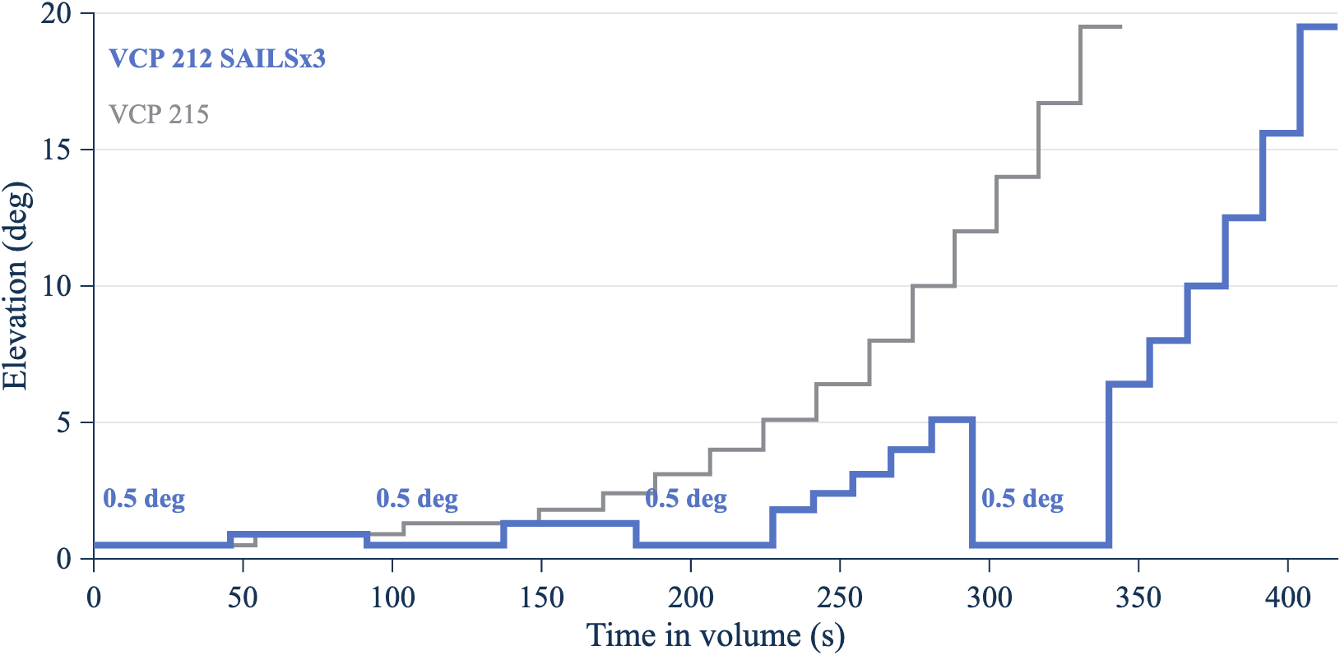
Elevation against time in one volume for VCP 215 and for VCP 212 with three SAILS rescans.
Figure 2. SAILS×3 returns the NEXRAD beam to 0.5° four times per volume. Source: cut tables in nexrad_vcp_rev1.m, decoded from NOAA Level II data (2026).

7.7 Step 6: Sample pointing states and build the CDF
Random mode draws 5,000,000 independent pointing states. For each draw, the model does the following:
- Picks a NEXRAD cut with probability equal to its share of the volume (Step 5).
- Draws the NEXRAD beam azimuth uniformly from 0° to 360°.
- Draws the ASR-11 beam azimuth uniformly from 0° to 360°.
- Computes the NEXRAD gain (Step 2), the ASR-11 gain (Step 3), and their sum (Step 4).
Independent draws are valid because the two radars rotate at unrelated rates: 75 degrees per second for the ASR-11, against 12.5 to 28.7 degrees per second for the NEXRAD, with the rate changing every cut. The time series in Step 7 confirms this: its 99th percentile matches the random-mode value within 0.5 dB, the tolerance of the repository test.
The model then sorts the 5,000,000 MAG values. The p-th percentile is the MAG that is not exceeded for p percent of the time. The CDF array cdf_array21 lists these percentiles from 0% to 100%, and the percentile table adds a 95% confidence interval for each value (Step 11).

7.8 Step 7: Run the time series and find the maximum MAG per scan
Random mode gives the share of time at each MAG, but not how the high values group in time. The time series runs both antennas forward from random start phases. Each trial lasts 3,600 s, and the run uses 72 trials (72 hours, 53,955 complete ASR-11 revolutions). Each trial draws a new ASR-11 rate within 75 ± 0.5 degrees per second, a new NEXRAD start azimuth, and a new start point in the NEXRAD volume.
The time step is 0.002 s. In that time the ASR-11 beam moves 0.15°, about one tenth of its 1.45° beamwidth, so a sampled peak falls at most about 0.2 dB below the true peak. For each ASR-11 revolution (4.8 s), the model keeps the largest MAG and records, at that sample, each radar’s gain and beam offset from the path.

7.9 Step 8: Read the maximum MAG per ASR-11 revolution
Figure 5 shows the maximum MAG in each revolution for the first hour of the run.
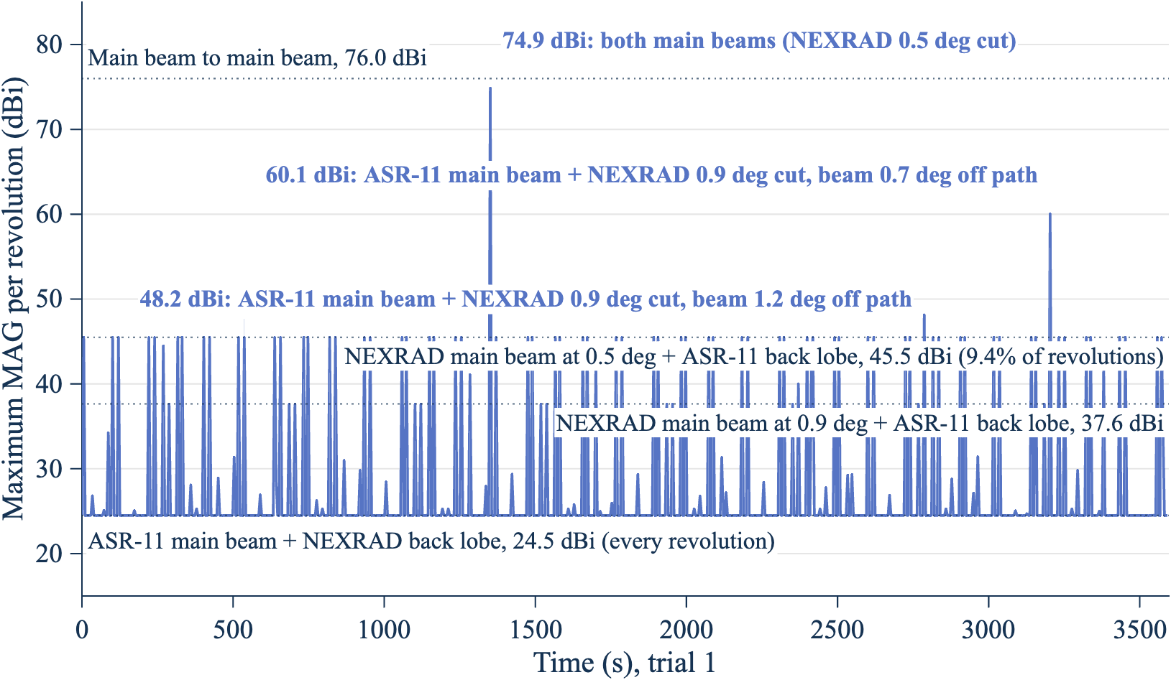
Line chart of the maximum MAG in each ASR-11 revolution over one hour, with four reference levels and the three peaks between 45.5 dBi and main beam to main beam labeled.
Figure 5. Most ASR-11 revolutions peak at 24.5 dBi; higher peaks need the NEXRAD beam on one of its three lowest cuts. The figure shows trial 1 of the worst mode (VCP 212 SAILS×3). Source: nexrad_asr11_mag_rev1 time series (2026).
The figure has three kinds of features.
The floor at 24.5 dBi. Every revolution sweeps the ASR-11 main beam across the NEXRAD once, so every revolution reaches at least the ASR-11 peak gain plus the lowest NEXRAD gain: 34.0 + (−9.5) = 24.5 dBi.
Plateaus at 45.5 dBi and 37.6 dBi. Each NEXRAD cut is one revolution, so the NEXRAD main beam crosses the ASR-11 once per cut. During that crossing, the ASR-11 beam usually points elsewhere and contributes its +3.5 dBi floor. The MAG then reaches the NEXRAD gain on the path at that cut’s tilt plus 3.5 dBi: 41.99 + 3.5 = 45.49 dBi on the 0.5° cuts and 34.14 + 3.5 = 37.64 dBi on the 0.9° cuts. The share of ASR-11 revolutions that contain such a crossing can be counted by hand. VCP 212 SAILS×3 has 8 cuts at 0.5° per 416.61 s volume, and each crossing falls in one 4.8 s ASR-11 revolution, so about 8 × 4.8/416.61 = 9.2% of revolutions reach 45.49 dBi.
NEXRAD cut | Plateau level (dBi) | Cuts per volume reaching the level | Hand count of revolutions (%) | Simulated revolutions (%)
0.5° | 45.49 | 8 | 9.2 | 9.4
0.9° | 37.64 | 10 (0.5° and 0.9°) | 11.5 | 12.2
1.3° | 25.30 | 12 (0.5°, 0.9°, and 1.3°) | 13.8 | 17.1
The hand count matches the simulation at 45.49 dBi and 37.64 dBi. At 25.30 dBi it is a lower bound, because the ASR-11 main beam on a NEXRAD sidelobe also reaches that level.
Peaks between 45.5 dBi and main beam to main beam. A peak above the 45.5 dBi plateau needs the ASR-11 main beam to cross the NEXRAD while the NEXRAD beam is also near the path on one of its three lowest cuts. The three such peaks in trial 1 are labeled in Figure 5, and Figure 6 shows the two largest as they happen.
Peak in Figure 5 | NEXRAD cut | NEXRAD gain (dBi), beam off the path | ASR-11 gain (dBi), beam off the path | What happened
74.9 dBi at 1,353 s | 0.5° | 41.09, 0.25° | 33.80, 0.19° | Both main beams on the path at the same time
60.1 dBi at 3,206 s | 0.9° | 26.46, 0.74° | 33.60, 0.27° | ASR-11 main beam crossed while the NEXRAD beam was still 0.74° from the path
48.2 dBi at 2,789 s | 0.9° | 15.38, 1.16° | 32.78, 0.46° | ASR-11 main beam crossed on the edge of the NEXRAD main beam
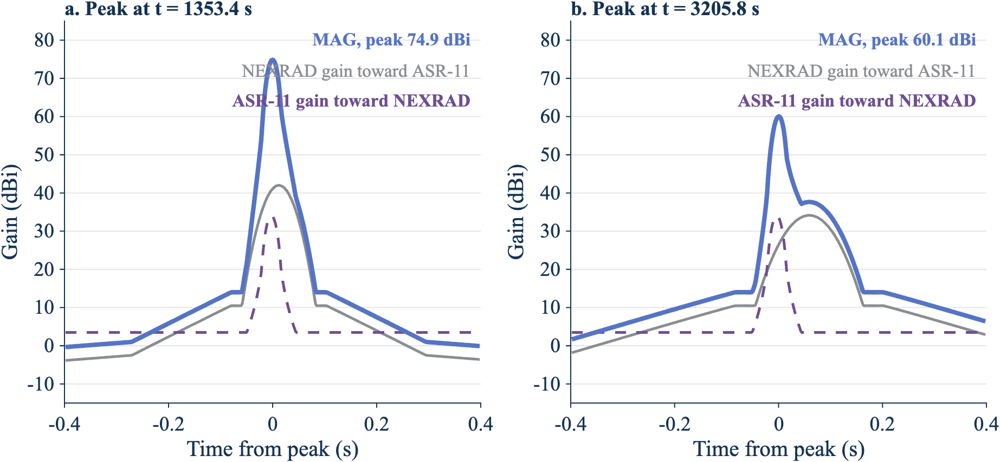
Two panels showing the NEXRAD gain, the ASR-11 gain, and the MAG during 0.8 s around the 74.9 dBi and 60.1 dBi peaks.
Figure 6. A peak needs the brief ASR-11 main beam to land inside the NEXRAD main beam. In panel a, both beams cross the path together. In panel b, the ASR-11 main beam (dashed) passes 0.06 s before the NEXRAD beam reaches the path, so the MAG peaks at 60.1 dBi rather than 76.0 dBi. Source: nexrad_asr11_mag_rev1 time series, trial 1 (2026).
The ASR-11 main beam crosses the NEXRAD in about 0.02 s, while the NEXRAD main beam takes about 0.04 s to 0.07 s to cross the ASR-11. The two crossings rarely overlap, so the MAG between 45.5 dBi and 76.0 dBi is rare and its exact value depends on how much they overlap. Over the full 72 hours:
Maximum MAG in a revolution | Revolutions in 72 h | Share of revolutions (%) | Per hour
24.5 dBi or more | 53,955 | 100 | 749
45.5 dBi or more | 5,080 | 9.42 | 70.6
50 dBi or more | 269 | 0.50 | 3.7
60 dBi or more | 182 | 0.34 | 2.5
70 dBi or more | 91 | 0.17 | 1.3
Within 0.2 dB of main beam to main beam on the path (75.8 dBi or more) | 20 | 0.037 | 0.28
All 291 revolutions with a peak more than 1 dB above the 45.5 dBi plateau occurred on the 0.5° cuts (212), the 0.9° cuts (42), or the 1.3° cuts (37). The full list, with each radar’s gain and beam offset at the peak, is in docs/figures/peaks_above_plateau_72h_rev4.csv.
For the NEXRAD, interference on its lowest cuts matters most, because the composite products draw on them. The per-cut maximum by elevation for the worst mode, over 32 complete volumes in the four-trial sweep, is:
NEXRAD elevation | Complete cuts | Median of cut maxima (dBi) | Largest cut maximum (dBi)
0.5° | 275 | 45.5 | 76.0
0.9° | 68 | 37.6 | 60.1
1.3° | 66 | 25.3 | 55.8
1.8° | 34 | 26.0 | 42.8
2.4° | 34 | 24.5 | 43.2
3.1° to 19.5° | 34 to 36 each | 24.5 | 24.7 to 34.3

7.10 Step 9: Repeat for every scan mode
example_nexrad_asr11_rev1 repeats Steps 5 to 8 for 25 VCP modes and the paper baseline, with seed 20261105, 5,000,000 random samples, and a time series of 4 trials of 3,600 s each. The table shows the time-weighted MAG on the path from the ASR-11 to the NEXRAD.
Mode | Time at 0.5° (%) | 99% (dBi) | 99.9% (dBi) | 99.99% (dBi)
VCP 212 SAILS×3 | 43.9 | 18.8 | 43.3 | 45.5
VCP 12 SAILS×3, Doppler cut at 12.524 degrees per second | 43.9 | 18.8 | 43.3 | 45.5
VCP 35 SAILS×1, Doppler cut at 12.524 degrees per second | 38.7 | 19.6 | 42.7 | 45.5
VCP 35 SAILS×1 | 38.4 | 19.5 | 42.7 | 45.5
VCP 12 SAILS×3 | 38.0 | 17.6 | 42.6 | 45.5
VCP 34 SAILS×1 | 35.7 | 18.9 | 42.2 | 45.5
VCP 112 SAILS×1 | 32.5 | 18.0 | 41.6 | 45.5
VCP 215 SAILS×1 | 27.2 | 16.3 | 40.0 | 45.5
VCP 32 | 26.7 | 14.4 | 39.8 | 45.5
VCP 31 | 25.0 | 14.0 | 39.0 | 45.5
VCP 35 | 23.8 | 18.3 | 38.8 | 45.5
VCP 34 | 21.7 | 17.6 | 37.7 | 45.5
VCP 112 | 19.4 | 16.3 | 37.5 | 45.4
VCP 212 | 16.4 | 15.3 | 36.8 | 45.4
VCP 215 | 15.7 | 14.4 | 36.4 | 45.4
VCP 12 | 13.3 | 14.0 | 35.2 | 45.4
Paper baseline (F.1245, 3 rpm, horizon) | Not applicable (0° tilt) | 22.5 | 42.4 | 62.7
The full table, including the MRLE and AVSET variants, is in docs/figures/vcp_sweep_rev4.csv. VCP 212 has a default Doppler-cut rate of 12.524 degrees per second, so its “Doppler cut at 12.524” variant repeats VCP 212 SAILS×3. VCPs 31 and 32 allow no SAILS, MRLE, or AVSET, and VCP 34 allows SAILS×1 only, so the sweep has fewer variants of them.
The clear-air VCPs don’t change the worst case. Their 99.9% MAG follows the same trend with time at 0.5° as the other modes. Their 99% MAG is lower, because VCPs 31 and 32 have no cuts at 0.9° and 1.3°: the next elevation above 0.5° is 1.5°, which puts the NEXRAD path gain further down its pattern. Figure 3 shows what drives the ranking.
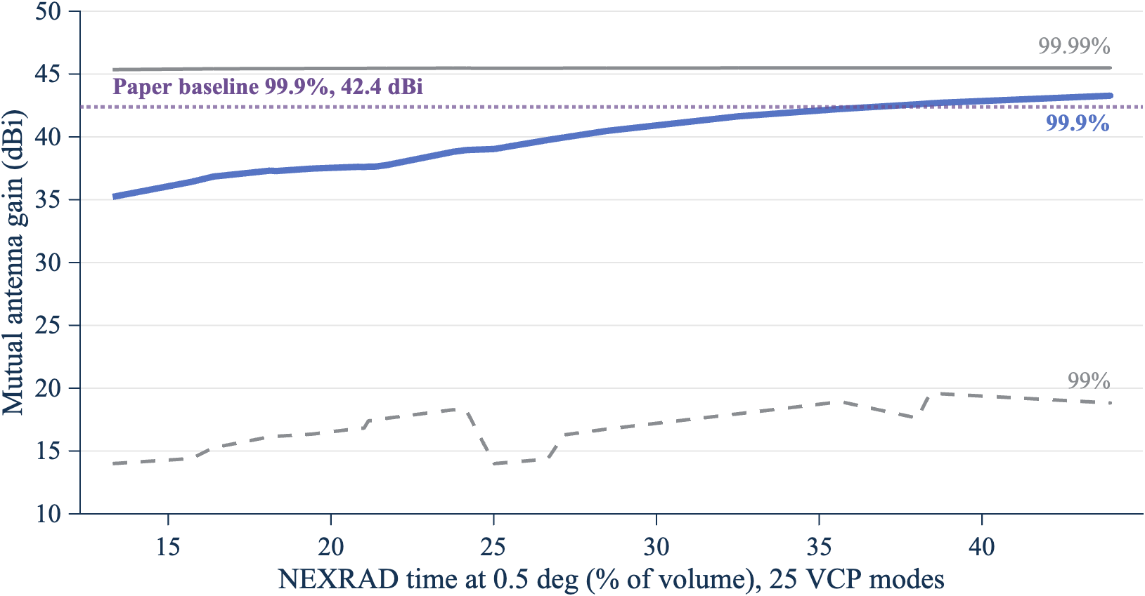
Line chart of the 99%, 99.9%, and 99.99% MAG against the percentage of volume time at 0.5° for 25 VCP modes, with the paper baseline 99.9% MAG as a reference line.
Figure 3. The more time the NEXRAD spends at 0.5°, the higher the 99.9% coupling. The lines join the 25 VCP modes in order of time at 0.5°. Source: docs/figures/vcp_sweep_rev4.csv (2026).
The 99.99% MAG is near 45.5 dBi for every VCP mode, because that percentile falls on the 45.49 dBi plateau of Step 8: the NEXRAD main beam at 0.5° plus the ASR-11 remote sidelobe floor. The M.1464-2 remote sidelobe level of the ASR-11 therefore sets this percentile.
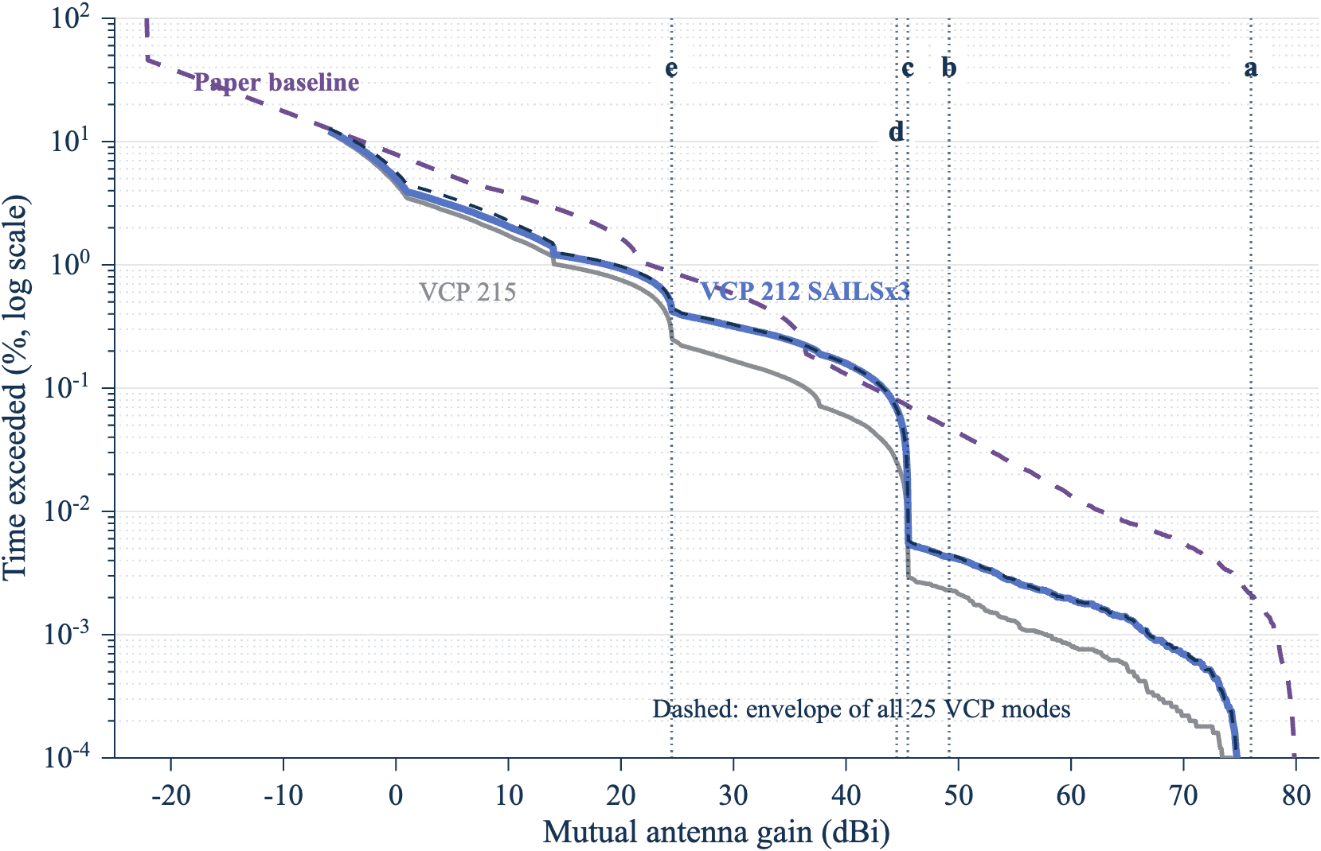
Exceedance curves of the MAG for the worst VCP mode, VCP 215, the paper baseline, and the envelope of all modes, with the main-beam and sidelobe reference levels.
Figure 4. Below 0.01% of the time, the worst VCP mode couples far less than the paper baseline. The dashed dark line is the envelope of all 25 VCP modes. The dotted lines are reference levels: a, main beam to main beam on the path (76.0 dBi); b, NEXRAD main beam and ASR-11 near sidelobe (49.2 dBi); c, NEXRAD main beam and ASR-11 back lobe (45.5 dBi); d, ASR-11 main beam and NEXRAD near sidelobe (44.5 dBi); e, ASR-11 main beam and NEXRAD back lobe (24.5 dBi). Source: docs/figures/ref_levels_rev4.csv (2026).

7.11 Step 10: Compare main beam to main beam with the statistical MAG
At the November 4, 2026 meeting, participants described main beam to main beam coupling as current FAA practice, and asked for a main beam to main beam case for every weather radar as a sensitivity analysis. Figure 7 and the table compare the two approaches. A negative difference is the relief, in dB, that a MAG choice takes relative to the peak-gain main beam to main beam value. The same number of decibels applies one for one to the required basic transmission loss.
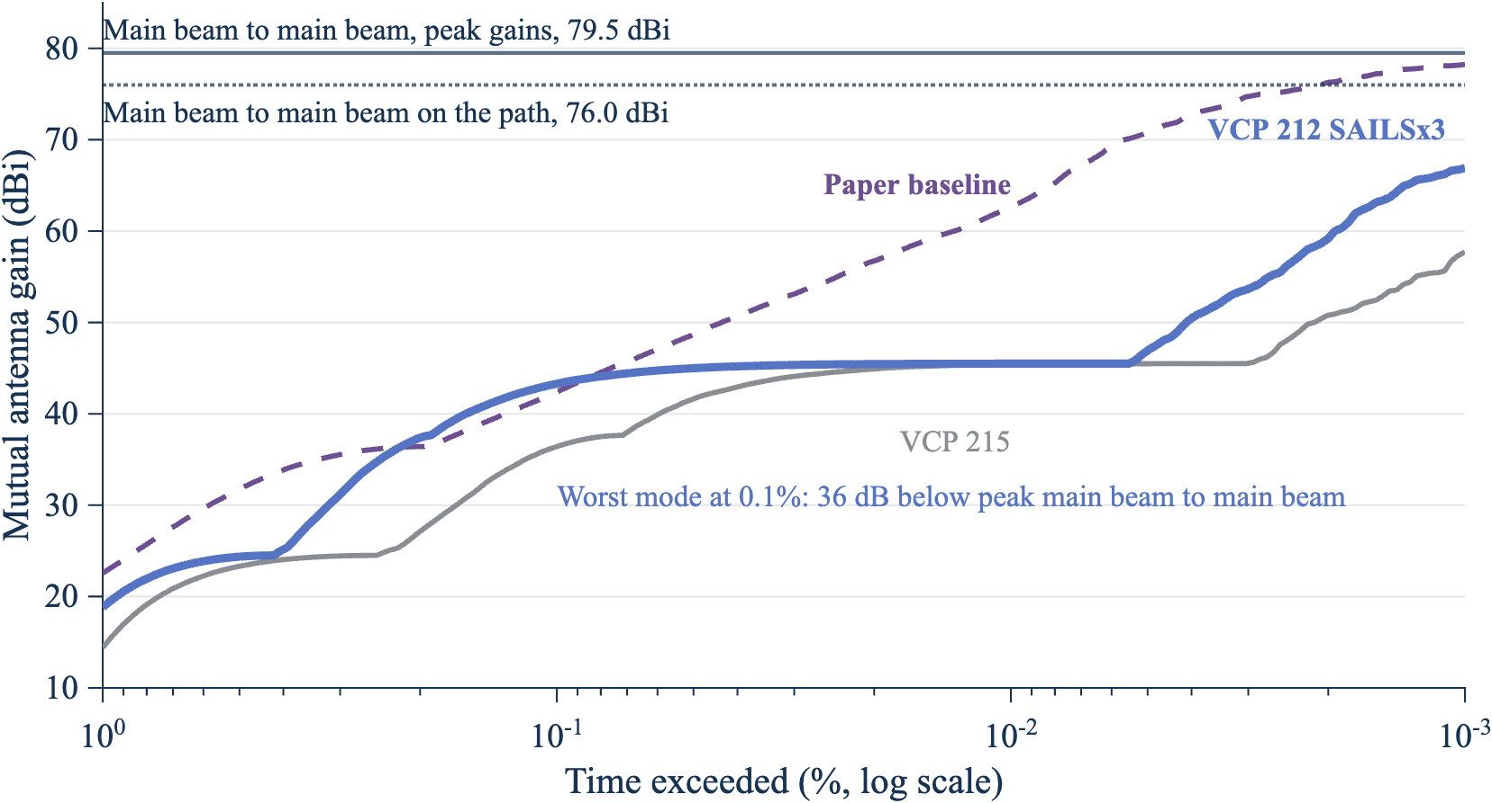
Line chart of the MAG against percent of time exceeded, from 1% to 0.001%, for the worst VCP mode, VCP 215, and the paper baseline, with peak-gain and on-path main beam to main beam as horizontal lines.
Figure 7. Even at 0.001% of the time, the statistical MAG of every VCP mode stays at least 12 dB below peak-gain main beam to main beam. The lines are the time-weighted MAG from 99% to 99.999%; the horizontal lines are main beam to main beam with peak gains (79.5 dBi) and on the path (76.0 dBi). Source: docs/figures/cdf_array_rev4.csv and docs/figures/mbmb_vs_statistical_rev4.csv (2026).
MAG choice | Worst mode (dBi) | Difference from peak-gain main beam to main beam (dB) | VCP 215 (dBi) | Paper baseline (dBi)
Main beam to main beam, peak gains | 79.5 | 0 | 79.5 | 80.0
Main beam to main beam, on the path | 76.0 | −3.5 | 76.0 | 80.0
Largest MAG in the time series | 76.0 | −3.5 | 75.7 | 80.0
99.999% MAG | 66.9 | −12.6 | 57.7 | 78.2
99.99% MAG | 45.5 | −34.0 | 45.4 | 62.7
99.9% MAG | 43.3 | −36.2 | 36.4 | 42.4
99% MAG | 18.8 | −60.7 | 14.4 | 22.5
The paper baseline uses F.1245 patterns of 46 dBi and 34 dBi, so its main beam to main beam value is 80.0 dBi. Its NEXRAD beam always points at the horizon, so main beam to main beam on the path equals the peak-gain value.
The time-weighted MAG and the per-revolution maximum answer different questions. The 99.9% time-weighted MAG (43.3 dBi) is exceeded 0.1% of the time. The maximum MAG in a revolution exceeds 45.5 dBi in 9.4% of ASR-11 revolutions, because each revolution contains many samples and the peak is taken over all of them. A link budget that compares a time percentage of interference with an I/N criterion uses the time-weighted MAG. A criterion stated per scan, such as missed detections, uses the per-revolution maximum.

7.12 Step 11: Bound the MAG for any mix of scan modes
Participants at the meeting noted that VCP choice depends on the weather, the site, and the operator, and that usable statistics of mode use may not exist. The mode envelope removes the need for them.
Let mode i have weight wᵢ ≥ 0, with the weights summing to 1. The exceedance of the mixture is P_mix(G > x) = Σ wᵢ Pᵢ(G > x), which is at most the largest Pᵢ(G > x). At x equal to the largest p-percentile over the modes, every Pᵢ(G > x) is at most 1 − p/100. The p-percentile of the mixture is therefore at most the largest p-percentile over the modes.
Percentile | Envelope over 25 VCP modes (dBi) | Worst mode
99% | 19.6 | VCP 35 SAILS×1, Doppler cut at 12.524 degrees per second
99.9% | 43.3 | VCP 212 SAILS×3
99.99% | 45.5 | VCP 212 SAILS×3
99.999% | 67.0 | VCP 12 SAILS×3, Doppler cut at 12.524 degrees per second
The bound covers only the modes in the envelope. The 25 modes include every WSR-88D VCP in the 2024 to 2026 survey (Step 5), so the bound holds for any mix of current operations. A future NEXRAD mode, or a Radar Next scan strategy, needs its own run, and the envelope then takes the larger value. All operational VCPs rotate a full 360°, so pointing a scan toward the ATC radar does not change the result. A sector scan centered on the ATC radar would need a separate model.

7.13 Sample size
Both parts of the method use samples, so both have sampling error.
Random mode. The 95% confidence interval of each percentile comes from order statistics: the p-quantile lies between the sorted samples at ranks n·p ∓ 1.96·√(n·p·(1 − p)). The table gives the interval for the worst mode at three sample sizes.
Samples | 99% (dBi), 95% interval | 99.9% (dBi), 95% interval | 99.99% (dBi), 95% interval | 99.999% (dBi), 95% interval
500,000 | 18.3 (17.8 to 18.9) | 43.1 (42.7 to 43.6) | 45.49 (45.48 to 45.49) | 65.6 (62.7 to 74.5)
5,000,000 | 18.8 (18.7 to 19.0) | 43.3 (43.2 to 43.4) | 45.49 (45.49 to 45.49) | 66.9 (65.5 to 69.7)
20,000,000 | 18.8 (18.7 to 18.9) | 43.3 (43.3 to 43.4) | 45.49 (45.49 to 45.49) | 67.1 (65.9 to 68.1)
With 5,000,000 samples, the 99%, 99.9%, and 99.99% values are known to within 0.2 dB, so more samples do not change them. The 99.999% value has only 50 samples above it, and its interval spans 4 dB. A link budget that uses the 99.999% MAG needs 20,000,000 samples or more, or should quote the interval.
Time series. The per-revolution statistics depend on rare events, so they need a long run. Four hours (3,000 revolutions) gave a 99.9th percentile of the per-revolution maximum of 68.6 dBi; 72 hours (53,955 revolutions) gave 74.0 dBi. Four hours contained one revolution within 0.2 dB of main beam to main beam; 72 hours contained 20. Per-scan results in this report therefore use the 72-hour run.

8. Concerns from the November 4, 2026 Retuning LOE meeting
The meeting reviewed agency comments on revision 2 of the 2.7 GHz link budget working paper. The table lists the concerns that bear on the MAG and how this revision addresses each one. The “Raised by” column records who spoke at the meeting, from the transcript; it does not state a coordinated agency position.
Concern | Raised by | How this revision addresses it
Main beam to main beam is current FAA practice; a histogram of pointing states is not a probability unless the pointing is random | FAA | Section 7.11 compares the two. Step 6 explains why independent sampling is valid for these unequal rates, and the time series confirms it.
A main beam to main beam case is required for every weather radar, with a sensitivity section | NOAA | Section 7.11 and the sensitivity output give the peak-gain and on-path main beam to main beam values beside each percentile.
NEXRAD modes vary with weather, site, and operator, and mode statistics may not exist | NOAA | Section 7.12 gives a bound that holds for any mix of the modes studied.
Run one NEXRAD volume scan toward an ATC radar, then add modes | Meeting participant (agreed approach) | Steps 5 to 9 (Sections 7.6 to 7.10) run one volume in detail and then every operational VCP and option.
Radars with the same scan rate can drift into synchronization and couple main beam to main beam for long periods | Meeting participant | Open item. NEXRAD rates change with every cut, and the volume time is not a multiple of the 4.8 s ASR-11 period. Consecutive-scan statistics and a multi-day run are planned.
A long simulation might miss some antenna interactions | Meeting participant | Section 7.9 reports a 72-hour run: 20 revolutions came within 0.2 dB of main beam to main beam, and every peak above 46.5 dBi is listed with the gains that made it.
The MAG percentile, the I/N exceedance time, and the ITM reliability must be consistent | Meeting participant | The sensitivity output gives the time exceeded for each MAG choice, and Section 7.11 separates time-weighted from per-scan results. Combining them with the propagation statistics belongs in the link budget working paper.
Interference in low NEXRAD elevations persists into the composite products | FAA | Section 7.9 reports the per-cut maximum by elevation.
The MAG calculation should be three-dimensional | Working paper author | The model uses the NEXRAD tilt of each cut and the ASR-11 cosecant-squared elevation pattern.
ATC radars also detect precipitation, not only point targets | FAA | Noted. The per-revolution maximum applies to both uses. The scan-rate analysis of the working paper assumes a point target.
Synchronization applies only between FAA radars, not to other agencies’ ATC radars | NOAA | Noted. This example does not use synchronization.
Radar Next may scan differently from the WSR-88D | FAA | Rerun with its scan strategy when NOAA defines it.
The meeting also raised items outside the MAG model, for the link budget working paper: placeholder I/N thresholds, per-link ITM reliability and confidence, ground permittivity, climate settings for each path, aggregate interference, coherent and non-coherent classification, the ASR-11 frequency-pair separation (possibly 60 MHz, not 30 MHz), and ducting.

9. Checks done in this review
These checks test the implementation. They do not validate the model.
- The repository tests ran in MATLAB R2025b: 79 tests in test_radar_mutual_gain_cdf_rev1.m and 32 tests in test_nexrad_asr11_rev1.m. None failed. The code targets R2024b; the one call newer than R2024b (theme, in report_figures_rev4.m) runs only on R2025a or later.
- The VCP tables reproduce the decoded Level II sequences. VCP 212 with SAILS×1 matches the cut order and volume time of the KLOT, KOAX, and KHGX files within 0.01 s.
- The mode envelope test draws mixtures of two modes with five weights and checks that each mixture percentile is at or below the envelope.
- At every per-revolution maximum, the MAG equals the recorded NEXRAD gain plus the recorded ASR-11 gain, and the two worked pointing states of Step 4 reproduce by hand to 0.01 dB.
- The hand count of the 45.49 dBi and 37.64 dBi plateaus matches the simulated share of revolutions within 0.7 percentage points (Section 7.9).
- A rerun of Case 1 (random mode, seed 20261101, 5 million samples) with Radar D gave the percentiles in the table below. The 50th percentile (−11.15 dBi) equals the sum of the two back-region levels (−5.75 dBi and −5.4 dBi).
Percentile | Mutual gain, path 2 to 1 (dBi) | Samples above
50 | −11.15 | 2,500,000
90 | 8.06 | 500,000
99 | 27.98 | 50,000
99.9 | 46.23 | 5,000
99.99 | 62.81 | 500
99.999 | 65.99 | 50

10. Open items
- ASR-11 rotation-rate tolerance. The FAA value in Order JO 6310.30B replaces the ±0.5 degrees per second placeholder.
- ASR-11 tilt and beams. The beam tilt of each site and the high-beam pattern are needed. A 0° tilt puts the beam nose on the horizon, which is the worst case.
- ASR-11 remote sidelobes. The +3.5 dBi level from M.1464-2 sets the 99.99% MAG for every VCP. A measured value would change it directly.
- NEXRAD back lobe. No measured back-lobe data was found; the model holds −55 dB to 180°.
- Persistence. Add statistics of consecutive ASR-11 revolutions above a threshold (Section 8). The 72-hour run gives the rate of single high revolutions but not how they cluster.
- Path elevation. The path is horizontal. Takeoff angles from the propagation model would change the NEXRAD gain on the path at each cut.
- Scope. The model has no propagation, pathloss, clutter, noise, or interference-to-noise calculation. It gives antenna coupling only. It does not model polarization mismatch.
- Input limits. Statgain needs a peak gain of 10 dBi or more. F.1245 needs a peak gain above G1.

Appendix A. Code traceability
Report claim | Implementation | Evidence level
Coupling is the sum of transmit and receive gains | radar_mutual_gain_cdf_rev1.m, coupling | Static inspection, tests pass
VCP cut tables and options | nexrad_vcp_rev1.m, vcp_table and insert_groups | Tests against decoded Level II files
NEXRAD and ASR-11 inputs and sources | nexrad_asr11_mag_rev1.m, assumptions and citations | Static inspection, citation test
Maximum MAG per scan and the gains at each peak | nexrad_asr11_mag_rev1.m, scan_maxima | Tests of physical bounds, consistency, and decomposition
Plateau hand check | nexrad_asr11_mag_rev1.m, plateau_check | Test against the simulation
Percentile confidence intervals | radar_mutual_gain_cdf_rev1.m, pct_table | Test
Sensitivity table | nexrad_asr11_mag_rev1.m, sensitivity_table | Test
Mode envelope bound | mag_mode_envelope_rev1.m | Mixture test
CDF arrays | radar_mutual_gain_cdf_rev1.m, cdf_array | Test
Figures and tables | report_figures_rev4.m; every figure in this report comes from this script | Run
Files in scope:
- example_radar_mutual_gain_rev1.m and example_nexrad_asr11_rev1.m: entry points.
- radar_mutual_gain_cdf_rev1.m: sampling, coupling, statistics.
- nexrad_asr11_mag_rev1.m: WSR-88D and ASR-11 inputs, per-scan maxima, reference levels, sensitivity.
- nexrad_vcp_rev1.m: NEXRAD VCP cut tables.
- mag_mode_envelope_rev1.m: envelope over scan modes.
- antenna_prepare_rev1.m and antenna_gain_rev1.m: antenna patterns.
- m1851_rect_field_rev1.m: field of a cosine-taper aperture.
- report_figures_rev4.m: figures and CSV tables for this report.
- test_radar_mutual_gain_cdf_rev1.m, test_nexrad_asr11_rev1.m, and crosscheck_csharp_rev1.m: test code.
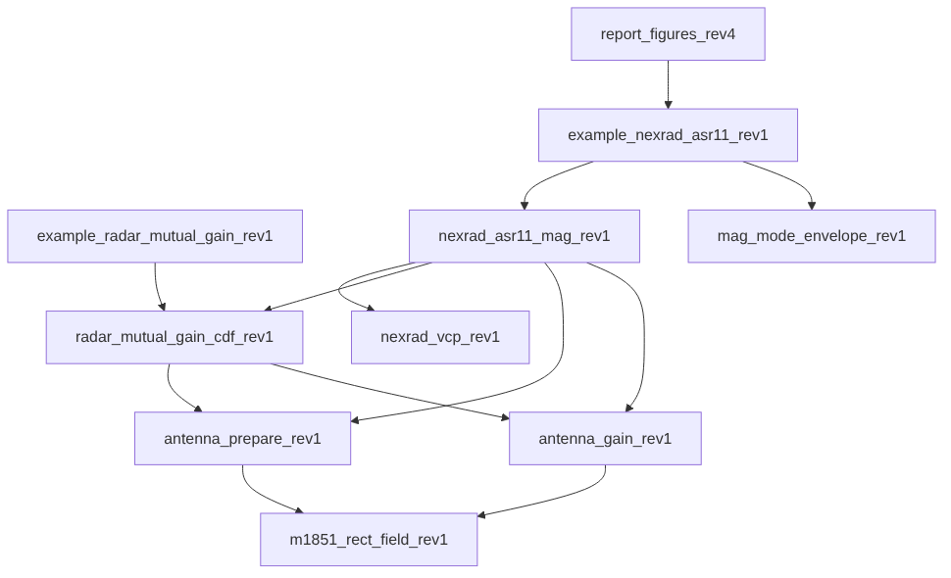
Call tree of the MATLAB functions behind this report.
Figure A-1. Call tree of the MATLAB functions behind this report.

Appendix B. Numbers ledger
Quantity | Exact value | Source | Form used
Peak-gain main beam to main beam | 79.5 dBi | 45.5 + 34 | 79.5 dBi
Main beam to main beam on the path | 75.994 dBi | ref_levels_rev4.csv | 76.0 dBi
Worst-mode 99.9% MAG | 43.279 dBi | sensitivity_rev4.csv | 43.3 dBi, 36 dB below
Worst-mode 99.999% MAG | 66.885 dBi | sensitivity_rev4.csv | 66.9 dBi, 13 dB below
Envelope 99.9% MAG | 43.279 dBi | mode_envelope_rev4.csv | 43.3 dBi
Paper baseline 99.99% MAG | 62.700 dBi | vcp_sweep_rev4.csv | 62.7 dBi
Worst-mode time at 0.5° | 43.94% | vcp_sweep_rev4.csv | 44%
ASR-11 revolutions at 45.5 dBi or more, 72 h | 9.415% | plateaus_rev4.csv | 9.4%
Revolutions per hour within 0.2 dB of main beam to main beam, 72 h | 0.278 | rev_exceedance_72h_rev4.csv | 0.28 per hour
Worst-mode 99.999% MAG, 95% interval at 5,000,000 samples | 65.55 to 69.66 dBi | convergence_rev4.csv | 65.5 to 69.7 dBi

Appendix C. References
- NOAA Radar Operations Center, NEXRAD Technical Information.
- NOAA Radar Operations Center, Convective VCP Decision Matrix (VCP Info Sheet), February 2026.
- NOAA Radar Operations Center, Theory and Concept of Operations for VCP 112, March 19, 2019.
- NOAA Radar Operations Center, New VCP Paradigm, October 2015.
- NOAA NCEI, Next Generation Weather Radar (NEXRAD) Level II data.
- Unidata, MetPy.
- NSSL, Errata and supplement to the 1998 WSR-88D polarimetric upgrade report.
- Recommendation ITU-R M.1849-3, February 2023.
- Recommendation ITU-R M.1464-2, February 2015.
- Recommendation ITU-R M.1851.
- Recommendation ITU-R M.2069.
- Forecast International, ASR-11 (DASR), August 2014.
- M. E. Weber, FAA Surveillance Radar Data as a Complement to the WSR-88D Network, MIT Lincoln Laboratory ATC-266, 1999.
- FAA, Airport Surveillance Radar (ASR-11).
- FAA, Order JO 6310.30B, Maintenance Handbook for Airport Surveillance Radar, ASR-11 Facilities, July 20, 2015.
- 2.7 GHz Retuning LOE, link budget analysis working paper comment adjudication meeting, transcript, November 4, 2026 (not public).

radar_mutual_gain_cdf_rev1.m, lines 2 to 19 | https://github.com/nicklasorte/mutual_antenna_gain/blob/99d3000fe59a62234992e34e36a25a9913d5161a/radar_mutual_gain_cdf_rev1.m#L2-L19
example_radar_mutual_gain_rev1.m, lines 1 to 12 | https://github.com/nicklasorte/mutual_antenna_gain/blob/99d3000fe59a62234992e34e36a25a9913d5161a/example_radar_mutual_gain_rev1.m#L1-L12
example_nexrad_asr11_rev1.m, lines 1 to 14 | https://github.com/nicklasorte/mutual_antenna_gain/blob/d367a9047512c436434538e1d61f153c38c2c4a4/example_nexrad_asr11_rev1.m#L1-L14
radar_mutual_gain_cdf_rev1.m, lines 38 to 44 | https://github.com/nicklasorte/mutual_antenna_gain/blob/99d3000fe59a62234992e34e36a25a9913d5161a/radar_mutual_gain_cdf_rev1.m#L38-L44
radar_mutual_gain_cdf_rev1.m, lines 243 to 250 | https://github.com/nicklasorte/mutual_antenna_gain/blob/99d3000fe59a62234992e34e36a25a9913d5161a/radar_mutual_gain_cdf_rev1.m#L243-L250
antenna_gain_rev1.m, off_axis_deg | https://github.com/nicklasorte/mutual_antenna_gain/blob/99d3000fe59a62234992e34e36a25a9913d5161a/antenna_gain_rev1.m
antenna_prepare_rev1.m, line 168 and make_offaxis_interp | https://github.com/nicklasorte/mutual_antenna_gain/blob/99d3000fe59a62234992e34e36a25a9913d5161a/antenna_prepare_rev1.m#L168
antenna_gain_rev1.m, statgain_dBi | https://github.com/nicklasorte/mutual_antenna_gain/blob/99d3000fe59a62234992e34e36a25a9913d5161a/antenna_gain_rev1.m
antenna_prepare_rev1.m, prep_array | https://github.com/nicklasorte/mutual_antenna_gain/blob/99d3000fe59a62234992e34e36a25a9913d5161a/antenna_prepare_rev1.m
radar_mutual_gain_cdf_rev1.m, draw_state_random | https://github.com/nicklasorte/mutual_antenna_gain/blob/99d3000fe59a62234992e34e36a25a9913d5161a/radar_mutual_gain_cdf_rev1.m
radar_mutual_gain_cdf_rev1.m, random_chunk and fill_opts | https://github.com/nicklasorte/mutual_antenna_gain/blob/99d3000fe59a62234992e34e36a25a9913d5161a/radar_mutual_gain_cdf_rev1.m
radar_mutual_gain_cdf_rev1.m, check_random_mode_valid | https://github.com/nicklasorte/mutual_antenna_gain/blob/99d3000fe59a62234992e34e36a25a9913d5161a/radar_mutual_gain_cdf_rev1.m
radar_mutual_gain_cdf_rev1.m, run_time_series | https://github.com/nicklasorte/mutual_antenna_gain/blob/99d3000fe59a62234992e34e36a25a9913d5161a/radar_mutual_gain_cdf_rev1.m
radar_mutual_gain_cdf_rev1.m, event_stats | https://github.com/nicklasorte/mutual_antenna_gain/blob/99d3000fe59a62234992e34e36a25a9913d5161a/radar_mutual_gain_cdf_rev1.m
radar_mutual_gain_cdf_rev1.m, sync_sweep | https://github.com/nicklasorte/mutual_antenna_gain/blob/99d3000fe59a62234992e34e36a25a9913d5161a/radar_mutual_gain_cdf_rev1.m
radar_mutual_gain_cdf_rev1.m, lines 452 to 474 (cdf_array and pct_table) | https://github.com/nicklasorte/mutual_antenna_gain/blob/99d3000fe59a62234992e34e36a25a9913d5161a/radar_mutual_gain_cdf_rev1.m#L452-L474
radar_mutual_gain_cdf_rev1.m, cdf_table and pct_table | https://github.com/nicklasorte/mutual_antenna_gain/blob/99d3000fe59a62234992e34e36a25a9913d5161a/radar_mutual_gain_cdf_rev1.m
nexrad_asr11_mag_rev1.m, lines 404 to 533 (scan_maxima) | https://github.com/nicklasorte/mutual_antenna_gain/blob/99d3000fe59a62234992e34e36a25a9913d5161a/nexrad_asr11_mag_rev1.m#L404-L533
nexrad_asr11_mag_rev1.m, lines 536 to 576 (plateau_check) | https://github.com/nicklasorte/mutual_antenna_gain/blob/99d3000fe59a62234992e34e36a25a9913d5161a/nexrad_asr11_mag_rev1.m#L536-L576
nexrad_asr11_mag_rev1.m, lines 157 to 191 (ref_levels) | https://github.com/nicklasorte/mutual_antenna_gain/blob/99d3000fe59a62234992e34e36a25a9913d5161a/nexrad_asr11_mag_rev1.m#L157-L191
nexrad_asr11_mag_rev1.m, lines 194 to 212 (sensitivity_table) | https://github.com/nicklasorte/mutual_antenna_gain/blob/99d3000fe59a62234992e34e36a25a9913d5161a/nexrad_asr11_mag_rev1.m#L194-L212
mag_mode_envelope_rev1.m, lines 1 to 64 | https://github.com/nicklasorte/mutual_antenna_gain/blob/99d3000fe59a62234992e34e36a25a9913d5161a/mag_mode_envelope_rev1.m#L1-L64
example_radar_mutual_gain_rev1.m, lines 21 to 107 | https://github.com/nicklasorte/mutual_antenna_gain/blob/99d3000fe59a62234992e34e36a25a9913d5161a/example_radar_mutual_gain_rev1.m#L21-L107
nexrad_asr11_mag_rev1.m, lines 234 to 344 (assumptions and citations) | https://github.com/nicklasorte/mutual_antenna_gain/blob/99d3000fe59a62234992e34e36a25a9913d5161a/nexrad_asr11_mag_rev1.m#L234-L344
nexrad_asr11_mag_rev1.m, lines 268 to 272 and 440 to 456 | https://github.com/nicklasorte/mutual_antenna_gain/blob/99d3000fe59a62234992e34e36a25a9913d5161a/nexrad_asr11_mag_rev1.m#L268-L272
radar_mutual_gain_cdf_rev1.m, lines 38 to 44 | https://github.com/nicklasorte/mutual_antenna_gain/blob/99d3000fe59a62234992e34e36a25a9913d5161a/radar_mutual_gain_cdf_rev1.m#L38-L44
nexrad_asr11_mag_rev1.m, lines 389 to 401 (pencil_table) | https://github.com/nicklasorte/mutual_antenna_gain/blob/99d3000fe59a62234992e34e36a25a9913d5161a/nexrad_asr11_mag_rev1.m#L389-L401
nexrad_asr11_mag_rev1.m, lines 157 to 191 (ref_levels) | https://github.com/nicklasorte/mutual_antenna_gain/blob/99d3000fe59a62234992e34e36a25a9913d5161a/nexrad_asr11_mag_rev1.m#L157-L191
nexrad_vcp_rev1.m, lines 1 to 122 (help, references and survey) | https://github.com/nicklasorte/mutual_antenna_gain/blob/d367a9047512c436434538e1d61f153c38c2c4a4/nexrad_vcp_rev1.m#L1-L122
nexrad_vcp_rev1.m, lines 124 to 291 | https://github.com/nicklasorte/mutual_antenna_gain/blob/d367a9047512c436434538e1d61f153c38c2c4a4/nexrad_vcp_rev1.m#L124-L291
radar_mutual_gain_cdf_rev1.m, draw_state_random | https://github.com/nicklasorte/mutual_antenna_gain/blob/99d3000fe59a62234992e34e36a25a9913d5161a/radar_mutual_gain_cdf_rev1.m
radar_mutual_gain_cdf_rev1.m, lines 452 to 474 (cdf_array and pct_table) | https://github.com/nicklasorte/mutual_antenna_gain/blob/99d3000fe59a62234992e34e36a25a9913d5161a/radar_mutual_gain_cdf_rev1.m#L452-L474
nexrad_asr11_mag_rev1.m, lines 404 to 533 (scan_maxima) | https://github.com/nicklasorte/mutual_antenna_gain/blob/99d3000fe59a62234992e34e36a25a9913d5161a/nexrad_asr11_mag_rev1.m#L404-L533
nexrad_asr11_mag_rev1.m, lines 536 to 576 (plateau_check) | https://github.com/nicklasorte/mutual_antenna_gain/blob/99d3000fe59a62234992e34e36a25a9913d5161a/nexrad_asr11_mag_rev1.m#L536-L576
example_nexrad_asr11_rev1.m, lines 16 to 104 | https://github.com/nicklasorte/mutual_antenna_gain/blob/d367a9047512c436434538e1d61f153c38c2c4a4/example_nexrad_asr11_rev1.m#L16-L104
nexrad_asr11_mag_rev1.m, lines 194 to 212 (sensitivity_table) | https://github.com/nicklasorte/mutual_antenna_gain/blob/99d3000fe59a62234992e34e36a25a9913d5161a/nexrad_asr11_mag_rev1.m#L194-L212
mag_mode_envelope_rev1.m, lines 1 to 64 | https://github.com/nicklasorte/mutual_antenna_gain/blob/99d3000fe59a62234992e34e36a25a9913d5161a/mag_mode_envelope_rev1.m#L1-L64
radar_mutual_gain_cdf_rev1.m, lines 452 to 474 (cdf_array and pct_table) | https://github.com/nicklasorte/mutual_antenna_gain/blob/99d3000fe59a62234992e34e36a25a9913d5161a/radar_mutual_gain_cdf_rev1.m#L452-L474

