**Analysis 1**

**Question** - Relationship between NYS Median Income and Heart Disease Mortality Rate

**Data Provenance:**

1. Dataset 1:
   1. Name - NYSERDA Low- to Moderate-Income New York State Census Population Analysis Dataset: Average for 2013-2015
   2. Collected from – catalog.data.gov
   3. Type of file – comma separated values
   4. Publisher - data.ny.gov
   5. Maintainer – NY Open data
   6. Maintainer email - [openny@nyserda.ny.gov](mailto:openny@nyserda.ny.gov)
   7. Unique Identifier - <https://data.ny.gov/api/views/bui8-bb6g>
   8. Metadata updated date – Nov 21, 2019
   9. Metadata created date – March 28, 2018
2. Dataset 2:
   1. Name - Heart Disease Mortality Data Among US Adults (35+) by State/Territory and County
   2. Collected from – catalog.data.gov
   3. Type of file – comma separated values
   4. Publisher - Centers for Disease Control and Prevention
   5. Maintainer – DHDSP Requests
   6. Maintainer email - [dhdsprequests@cdc.gov](mailto:dhdsprequests@cdc.gov)
   7. Unique Identifier - https://data.cdc.gov/api/views/i2vk-mgdh
   8. Metadata updated date – June 11, 2019
   9. Metadata created date – September 2, 2019

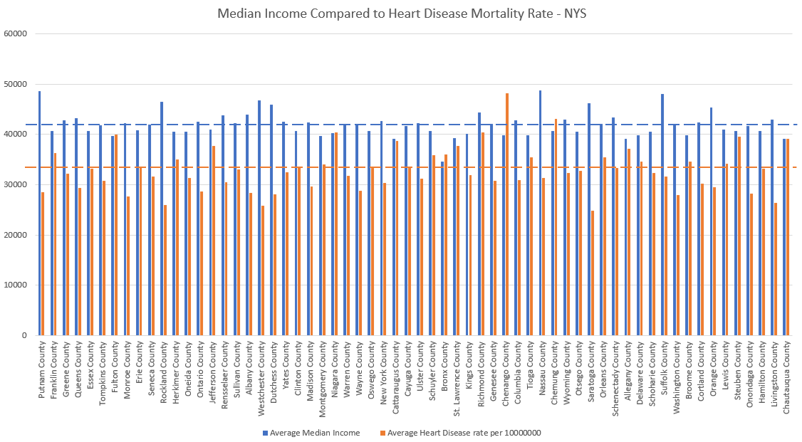

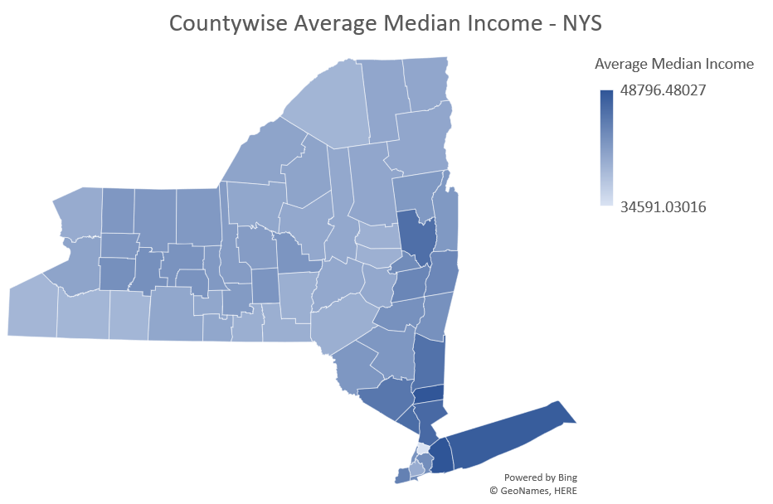

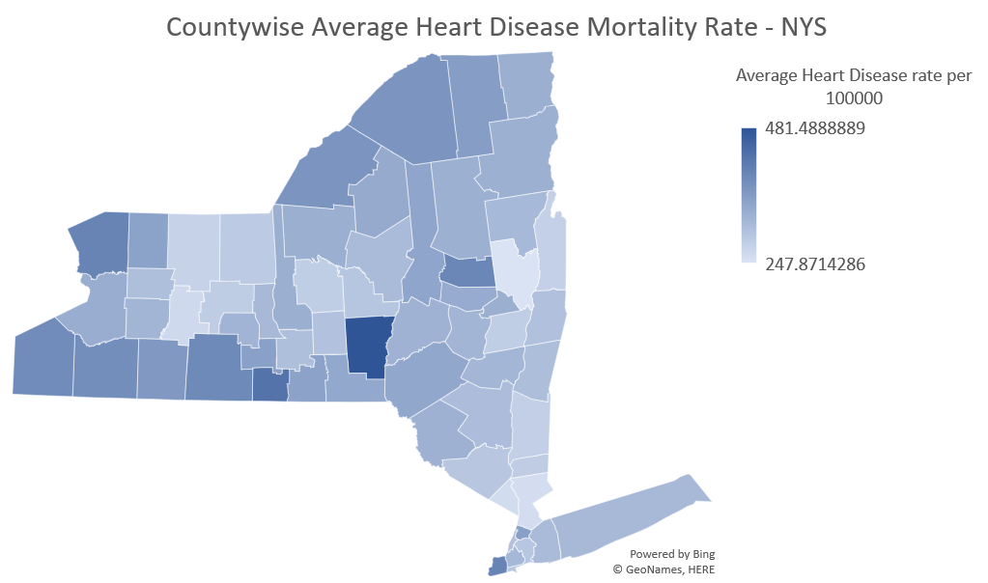

**Analysis 2**

**Question** - Relationship between Social Vulnerability Index and Heart Disease Mortality Rate

**Data Provenance:**

1. Dataset 1:
   1. Name – Social Vulnerability Index 2012 - 2014
   2. Collected from – svi.cdc.gov
   3. Type of file – comma separated values
   4. Publisher - cdc.gov
   5. Maintainer – Centers for Disease Control and Prevention
   6. Maintainer email - [dhdsprequests@cdc.gov](mailto:dhdsprequests@cdc.gov)
2. Dataset 2:
   1. Name - Heart Disease Mortality Data Among US Adults (35+) by State/Territory and County
   2. Collected from – catalog.data.gov
   3. Type of file – comma separated values
   4. Publisher - Centers for Disease Control and Prevention
   5. Maintainer – DHDSP Requests
   6. Maintainer email - [dhdsprequests@cdc.gov](mailto:dhdsprequests@cdc.gov)
   7. Unique Identifier - https://data.cdc.gov/api/views/i2vk-mgdh
   8. Metadata updated date – June 11, 2019
   9. Metadata created date – September 2, 2019