STOP THE 13-UNIT APARTMENT COMPLEX
26 Titus Avenue (at Calef Road) • Case #ZBA2026-063
PUBLIC HEARING — THURSDAY, SEPTEMBER 10, 2026 — 6:00 PM — CITY HALL, 3RD FLOOR

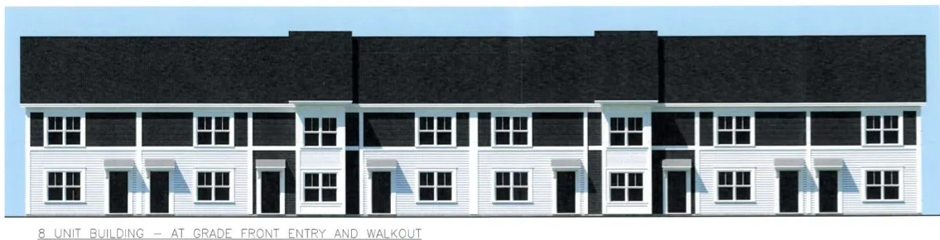
The developer's own rendering: the 8-unit building, as proposed
CONTRARY TO THE PUBLIC INTEREST  No safety, traffic, parking, or light study | 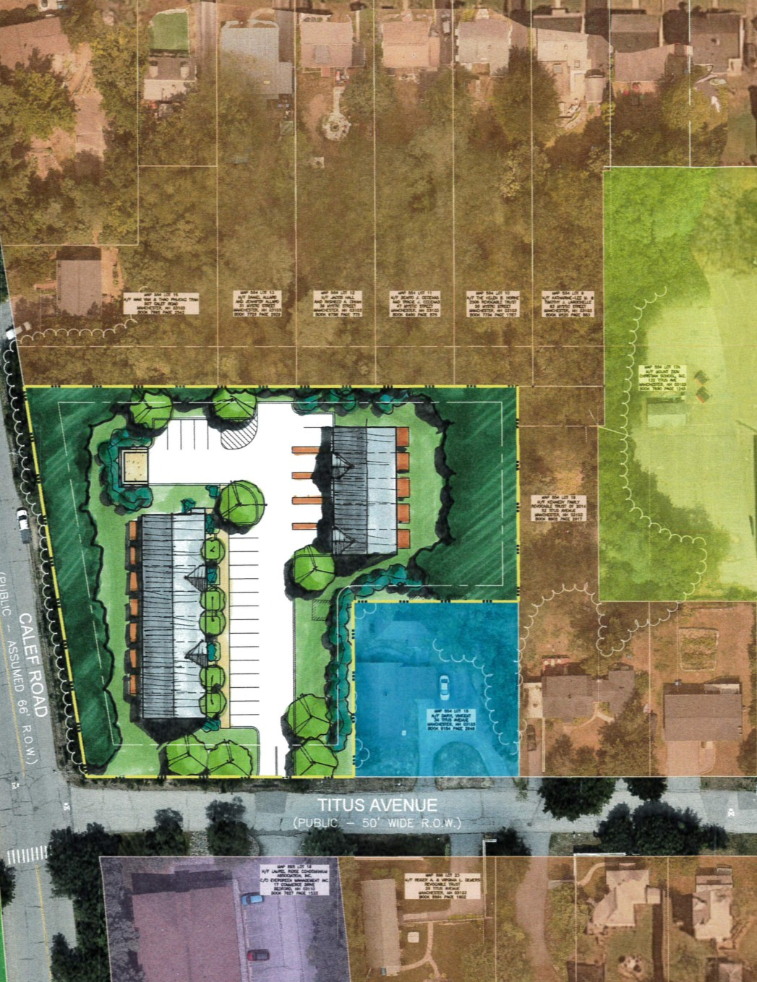  This complex vs. every surrounding single-family lot
ORDINANCE NOT OBSERVED
6 variances sought
VALUES OF SURROUNDING PROPERTIES AFFECTED
Only 20 parking spaces for potentially 40+ residents
NO HARDSHIP TO THE OWNER
Their own submission shows 5 buildable lots

The lot is 49,484 sq ft — zoning requires 78,000 sq ft for this many units. They're building on about 60% of the land the rules require.
- Townhouses are not permitted in this district — the City's own zoning review says so directly, and denied the permit on that basis.
- Underparked — 20 spots for 26 bedrooms means overflow parking on Titus Ave, Calef Road, and Mystic Street.
- Exceeds maximum height restrictions — 38 feet proposed where 35 feet is the max allowed.

GET INVOLVED NOW!
CONTACT YOUR ALDERMEN
Jim Burkush  Ward 9 Alderman  (603) 714-0283  jburkush@manchesternh.gov | June Trisciani  Alderman At-Large  (603) 502-7800  jtrisciani@manchesternh.gov | Dan O'Neil  Alderman At-Large  (603) 668-9814  doneil@manchesternh.gov

SHOW UP SEPTEMBER 10 — OR EMAIL pcd@manchesternh.gov CITING CASE #ZBA2026-063
QUESTIONS? NEIGHBORHOOD CONTACTS: Nick Levasseur — (603) 361-3828 | Jen Allard — (603) 661-2555
Full file: manchesternh.gov → Planning and Comm Dev → Zoning Board → Project Applications

