

Analyzing Vivino Wine Ratings
IST 652
Nicholas Lichtsinn

Nicholas Lichtsinn
Professor Landowski
IST 652

Introduction
I decided to analyze wine ratings on the Vivino app/website for the four different types of wine that are classified. Vivino is the world's largest online wine marketplace and most downloaded wine app, powered by a community of millions. Vivino’s unique wine shopping experience uses community data to suggest personalized wine recommendations, making wine discovery and purchase fun, accessible, and effortless for wine drinkers of every level.

Data and Pre-Processing
For this project I used the Wine Rating & Price dataset (available on Kaggle at https://www.kaggle.com/budnyak/wine-rating-and-price) which was originally scraped from the Vivino app/website, that consisted of 5 CSV files containing rating information on each type of wine for Red, Rose, White and Sparkling wines. The objective is to answer these research questions:

- What country has the most expensive and least expensive wines on average?
- How does country determine rating vs winery?
- Is year a better predictor of rating than price?
- Are more recent or older wines getting better ratings? Are the higher rated wines priced higher?

The data did not need a lot of pre-processing to be able to analyze as it was already pretty clean but I still had to make some adjustments. I loaded the data into Python, concatenated the data from each file into one dataframe after creating an additional column to record the wine type, giving me the ability to filter by type in the concatenated dataframe. I then removed the region filter as it was not needed for my analysis. All together this dataframe consisted of 8 columns and almost 14,000 rows.

This is how my dataset looks after cleansing:
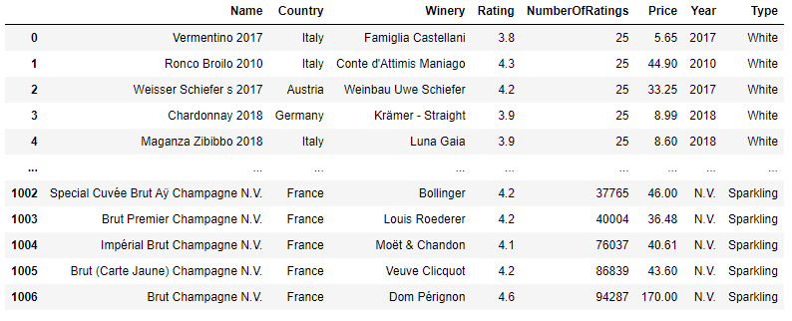

Analysis

For my analysis I used the Pandas, NumPy, Matplotlib, and Tweepy python libraries to create my summary statistics, plots and new dataframes. I used the ‘groupby’ function to do a lot of my comparison analysis.

I will include my summary, output and visualizations in this report but will keep my python code in the Jupyter Notebook file for you to reference as needed.

Question 1: What country has the most expensive and least expensive wines on average?
To answer each question I start with some summary statistics of the Price value and then group them by Country. Here are some summary statistics of the Price of the wines.
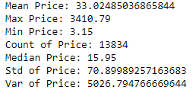

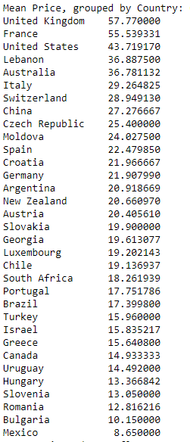
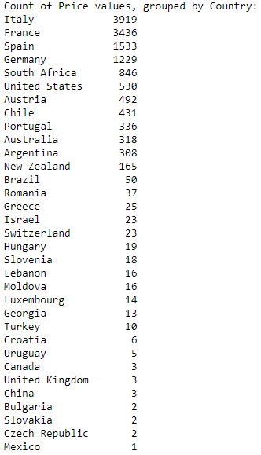
And I show the mean Price of wine, grouped by Country and the number of wines from each Country in the dataset:

As we can see there is a very large range in Price and the average price is pretty low with a large std deviation. The UK ($57.77) has the most expensive wine on average and Mexico ($8.65) has the cheapest wine on average. However if we take sample size into account and only look at countries with more than 100 wines then France has the highest average price and Portugal has the cheapest wines on average (with a price of $55.54 and $17.75 respectively).

Visualizations of average Price per Country and wine count per Country:

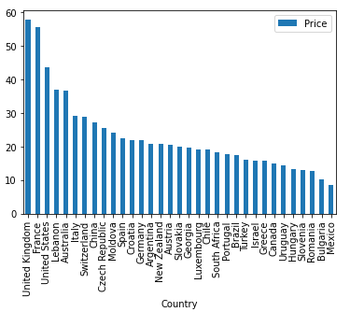
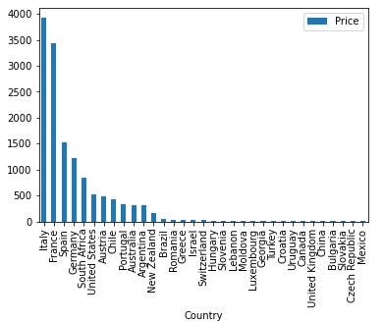

Question 2: How does country determine rating vs winery?
Again I calculate some summary statistics for the Rating value.
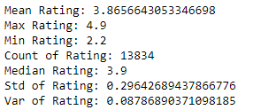

For this question I had to group the Rating value by Country and by Winery to see how each value impacted the Rating. Here I show the average Rating by Country and the top and bottom 10 of the Winery average Rating because there were 3505 wineries and could not show them all. I also include the winery count so we can see how many wines are from each winery there is a wide range from 1-73.

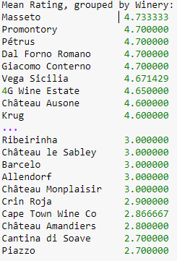
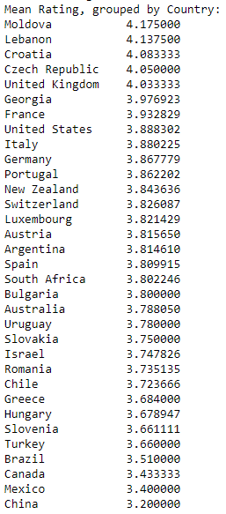

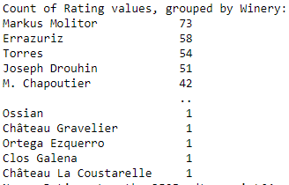

Graphs:
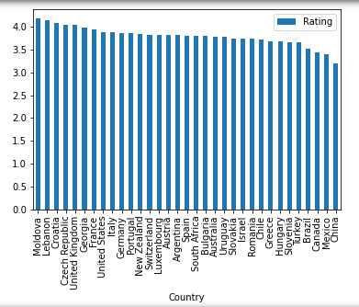
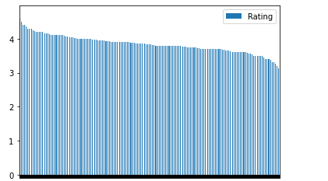

Winery is a much better factor at determining rating than country because for each winery we have a smaller sample size, and the average rating varies more by winery than it does by country. All of the countries are within the 4.18 to 3.2 range and quite a few of the wineries go above and below that range giving us more information and a better idea of which wines are good or bad.

Question 3: Is year a better predictor of rating than price?
This data ranges from 1989 to 2020 so we have a good look at multiple years to see if Price or the Year has is a better predictor of Rating.
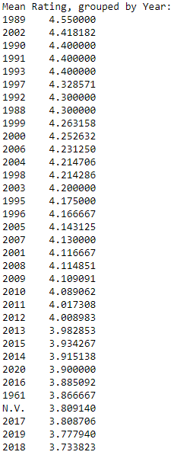
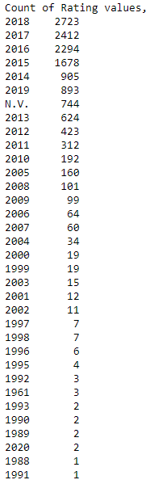

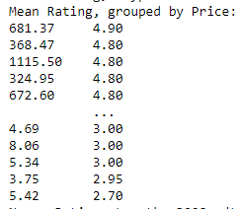
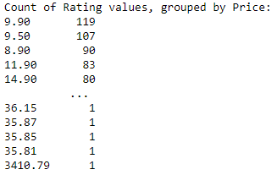

Price has a higher standard deviation and varies more than the years and also has a larger range so we can get more specific ratings and they seem to go down with price but each year has more of an impact on rating as they are not a single curve and each year shifts the rating more than the price.

Here are the graphs for ratings per year and ratings per price.

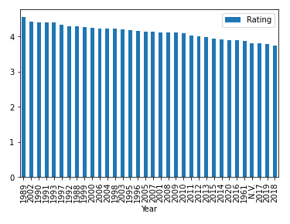
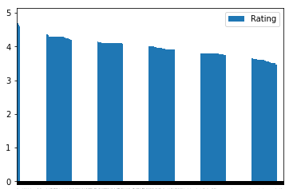

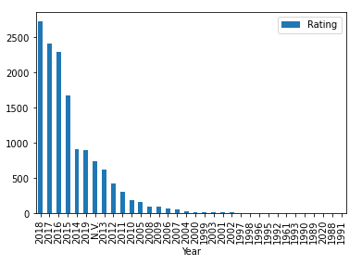

Question 4: Are more recent or older wines getting better ratings? Are the higher rated wines priced higher?
I showed the output for the Year vs Price calculation above. We cannot see definitively that the older wines are getting better ratings, on average the older wines have a better rating but it shows us that certain years have better ratings than others, notably 2002 and 1997 had better years than you would expect if we say that older wines are better.

We can see that the higher priced wines are rated better and the ratings decline with price so we can conclude that in this dataset the higher rated wines are priced higher.

Tweepy:
I did use Tweepy to pull tweets from the Vivino account and tweets with the #Vivino however the api was only letting me pull tweets from the last 2 weeks and there was only one #Vivino tweet in the last two weeks so I couldn’t really do much analysis with that but it is included in my Jupyter Notebook file. I included a sample of the recent tweets from the Vivino official twitter account.
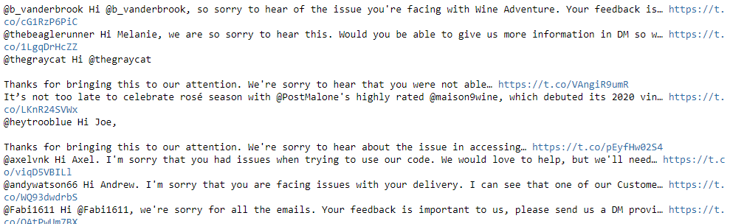

Conclusions

Overall this program will allow someone to pull in csv files, clean them and have the information in rows and columns in a pandas dataframe so they can run some statistics on the data in the csv files, create visualizations and answer some research questions from the data presented.

From the analysis that I have done we see that winery, year and price are probably the most influential variables to determine the rating of a wine. This matches up for me what I would usually take into account when thinking about the quality of wine. I had a ton of fun working with this dataset and hope to be able to take this a step further to analyze price vs rating to be able to measure a wines value per price and include that automatically in the app so people can have a better idea of what to purchase if they don’t know much about wine. Unfortunately I did not get the Tweepy interface to work as I hoped but I wanted to include that in here as well.

