Nicholas Lichtsinn

IST659 Lab 10

6/18/2021

1. UserLogin subform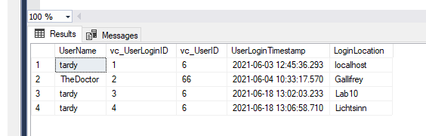
   1. The software knew what to use for LoginID and Timestamp because we used a surrogate PK for the loginID that assigns the next number in the sequence and we used GetDateTime() for the timestamp so it would use whatever time you logged in.
   2. Because we made the FK it knew to attach it to the User record where the UserID field matched.
   3. Pros would be adding a GUI to your database so people don’t have to code in SQL to get information and giving us more options to display the information in our database. Cons are the potential to create dirty records and security can be an issue for some databases.
2. Rstudio SQLResult

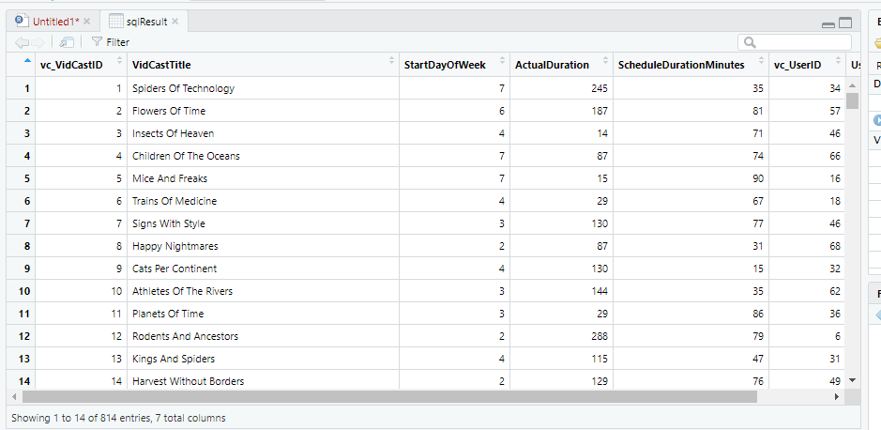

1. VidCast Hist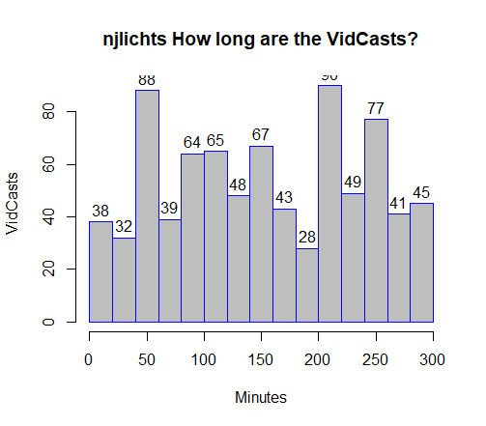
2. VidCast Count

