Week 2 Lab Assignment

Nicholas Lichtsinn

Part 1 - Conceptual Modeling Case Studies

Case Study 1 - Obligatory College Classes Modeling

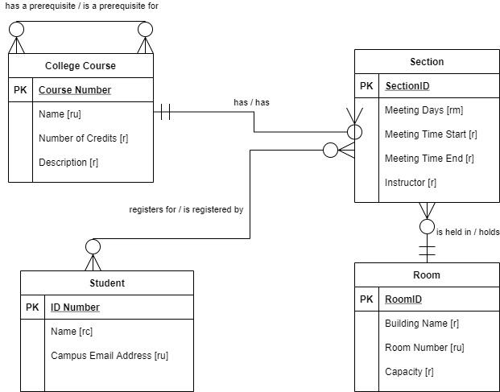

Case Study 2 - Project Management

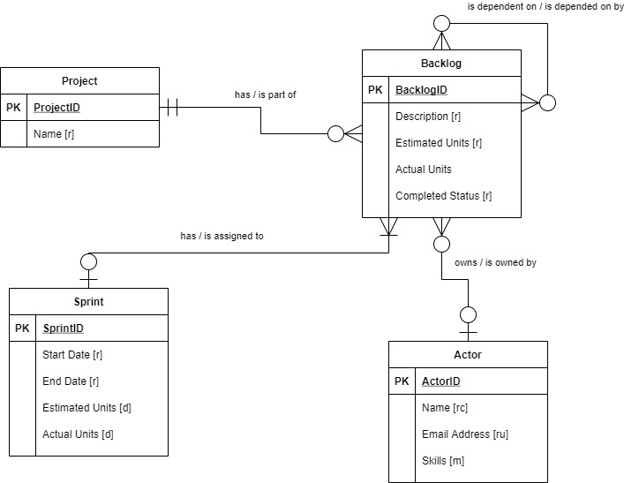

Case Study 3 - Book Publishing Database

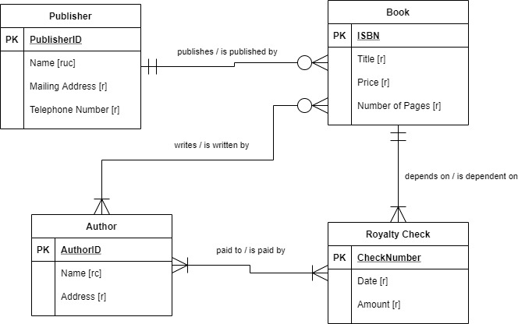

Part 2: VidCast Conceptual Model

