Nicholas Lichtsinn
IST 664
NLP Homework 2
Sentiment Analysis: Exploratory Analysis
Intro
To continue on with the homework I have done my analysis on the same two texts, The Bible, and Lord of the Rings: The Fellowship of the Ring. I started by importing nltk to do the cleanup and analysis on the texts and importing the files, then separated the text into sentences and split them using the word tokenizer.
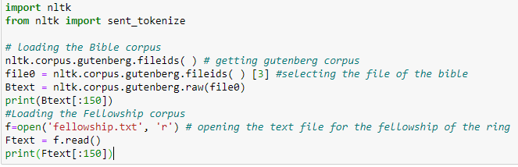

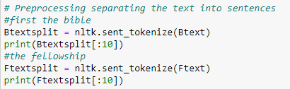

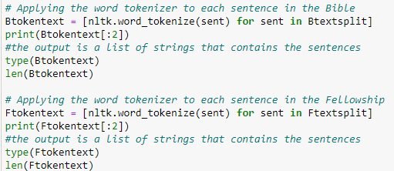

Then using the pos_tag command labeled both texts so we can identify the adjectives and adverbs in the texts.
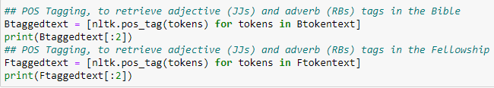

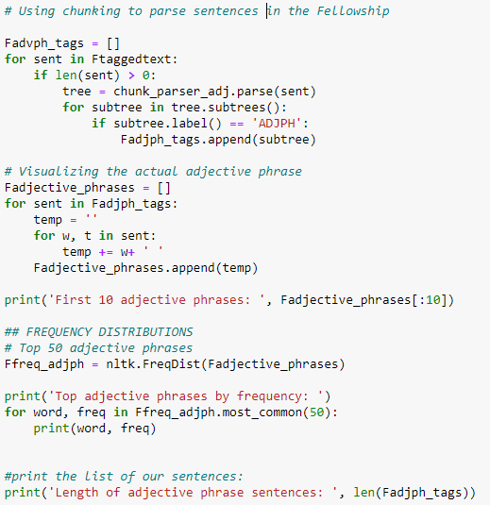
I used chunking and frequency tags to parse the sentences and look for adjective phrases that have adverbs and adjectives using the penn treebank POS tags for both texts.
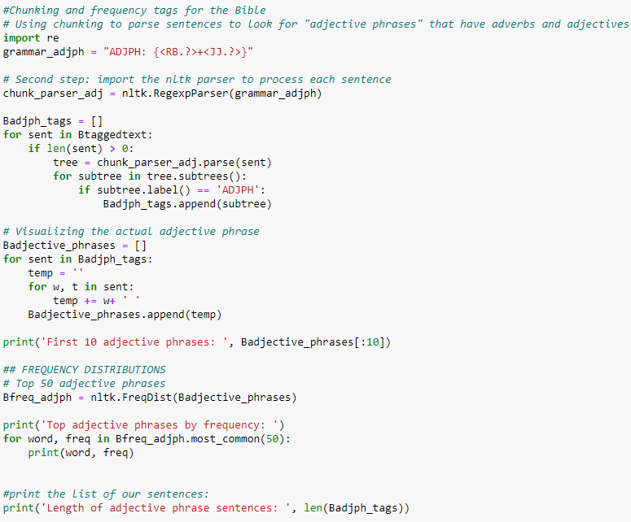

Here I use the .plot() function to graph the top 50 adjective and adverb phrases in the Bible and the Fellowship, showing us that the bible has a higher frequency but they have a similar slope.
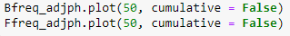
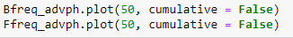

Bible Fellowship

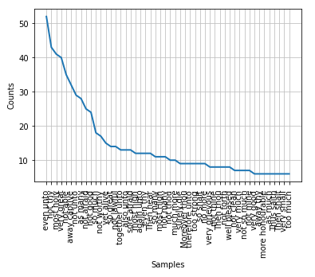
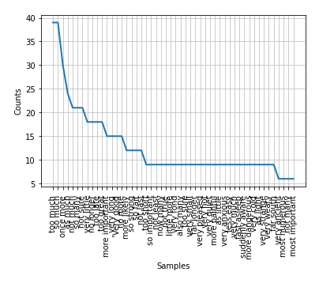

Adverb phrase frequency in both texts with the bible having a large outlier in “now therefore” with over 100 counts of the phrase, and both looking fairly similar without this outlier.

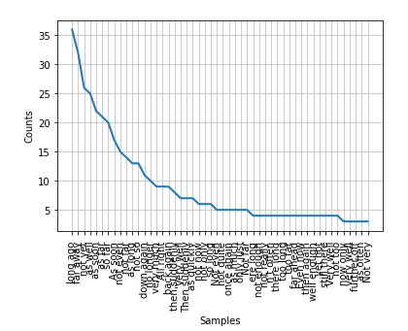
Bible Fellowship
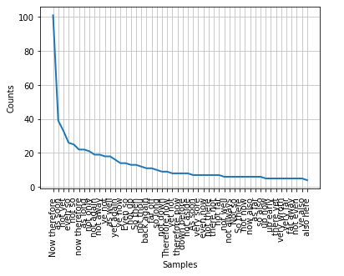

Here we have the top 50 counts of the adverbs showing us that both texts use the adverb ‘not’ way more than any other word, and the Bible having a much larger count overall due to the length of the text.

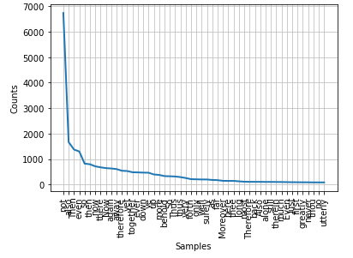
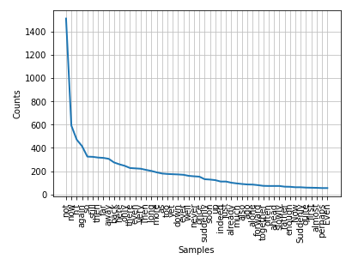
Bible Fellowship

The top 50 Nouns and Verbs follow, showing the code for each.
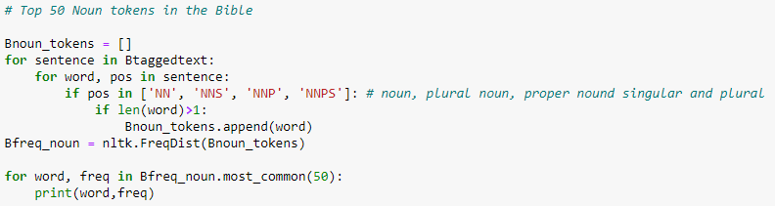

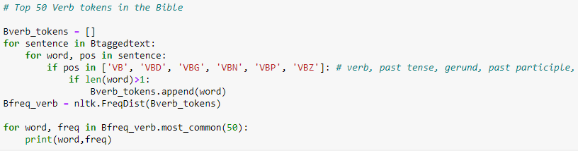

I used the same strategy to graph the top 50 Nouns and Verbs from each text shown below. The Fellowship has many more verbs than nouns and the bible is pretty equal for both.

Bible Nouns Fellowship Nouns
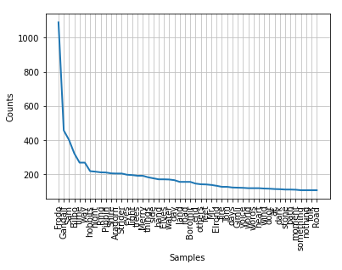
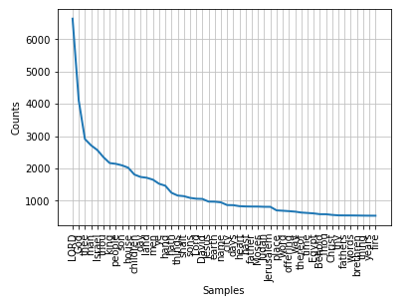

Bible Verbs Fellowship Verbs
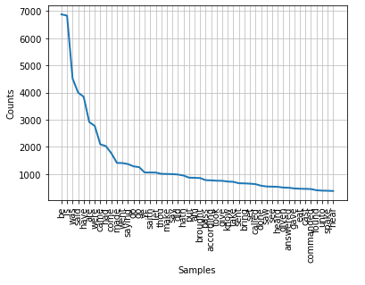
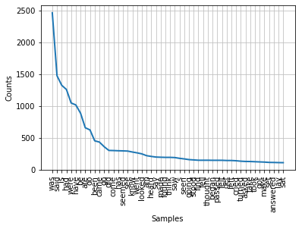

I then ran some statistics on the sentences that I created earlier for both texts code here:
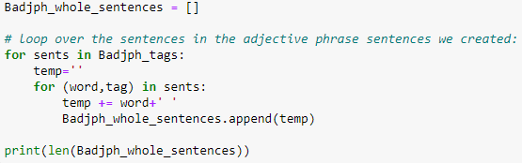

After running this the number of adjective sentences in the Bible was 4393 and the Fellowship was 5060, showing us that the Fellowship is using many more adjectives when compared to the length of the text and the style of writing can be shown as the author is telling a story and the Bible has a more passive tone.

Next I looked at the number of Adverb sentences in each with the same code and we get 2816 for the Bible and 2567 for the Fellowship again giving us some insight into the style of the writing as the fellowship is having more actions by characters than the Bible.

When we combine the lists together to get a total number of both the Bible has 4940 adjective and adverb sentences and the Fellowship has 5790.

Next I calculated the average sentence length in each text with this code:

For this the average sentence length in the bible was 143.44 characters and the Fellowship had an average length of 73.88 characters after rounding. This is important and makes sense in the context of the two texts as longer sentences are slower, and often are featured in formal texts whereas shorter sentences are used to create tension, haste and urgency which can be important when telling a fantasy story with a lot of action.

Lastly I calculated the length of each adjective and adverb phrases for each text with the code below.

For our averages the Bible had an average length of 8.61 characters and the Fellowship a length of 9.20 characters. As adjective sentences tend to be shorter in length in general as discussed above which is why the Fellowship will show shorter sentences on average as the work as more adjective sentences as a percentage of the total work.

Moving forward I would conduct sentiment analysis to see the tone of the text as well as the style that we have discussed here. With the tone we will be able to look deeper into what the text is saying and the overall theme of each work. This combined with the stylistic analysis I have done here will give a better picture of each text.

