Nicholas Lichtsinn
IST 664
NLP Homework 3
Sentiment Analysis
In this homework I explored the sentiment polarity of COVID-19 tweets by training my classifier on airline services tweets, to show sentences as positive, negative, or neutral in sentiment polarity. To do this I pulled both datasets into Python, and used pandas to turn them into dataframes.

Here are the first two rows of my training dataframe:
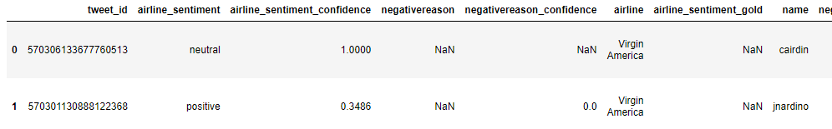

I then cleaned the data by removing the ‘@’ and ‘#’ symbols from the tweets using regular expressions in a function that I passed the dataframe through giving me this output:
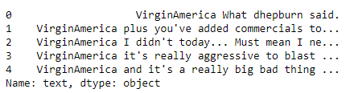

The next step in the process was to tokenize the datset using regular expressions.
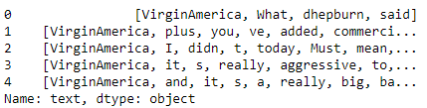

Once this is done I had to perform exploratory analysis on the dataset to see if it was balanced and to extract labels from the sentiment column to separate them into groups.
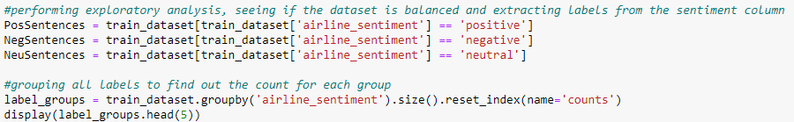

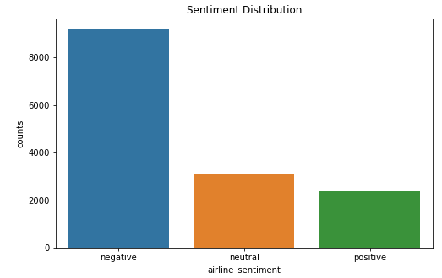
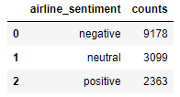

We can see that this data is imbalanced with the negative sentences making up the majority of the dataset. Imbalanced data can cause our model accuracy to be off, we can have very high accuracy by predicting the majority class but with this, we fail to capture the minority class as well so we will be right most of the time by only predicting one class due to our training data being skewed.

I then randomized our data and defined a set of words to be used for features, I found the 2000 most common words and used them as a feature of the whole corpus.
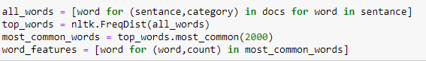

I defined a function to go over each sentence and see if the 2000 words I chose were present and applied that to the dataset. Then used a Naive Bayes classifier with 5-fold cross validation for training on sentiments using unigrams.

This calculated an accuracy score of 0.767. I also calculated a classifier using bigrams but this had an accuracy score of only, .679 so I decided to use the unigram classifier for this project.
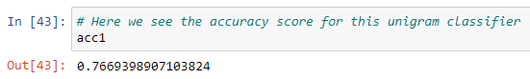
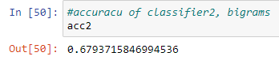

Now I started to use the test set of COVID-19 tweets to pass through the unigram classifier that I created. I tokenized the positive, negative, and neutral sentences lists and tagged them with parts of speech tags.

I then extracted the adjective, adverb, noun, and verb phrases from the positive, negative and neutral sentence lists and ranked them by frequency.

Here are the top 20 adjective phrases for the positive, negative and neutral sentence lists:
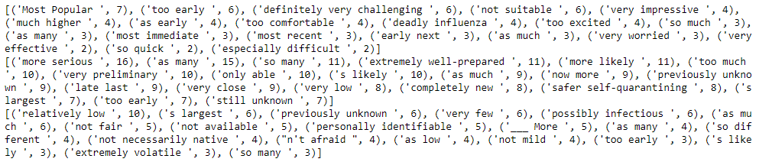

Here are the top 20 adverb phrases for the positive, negative and neutral sentence lists:
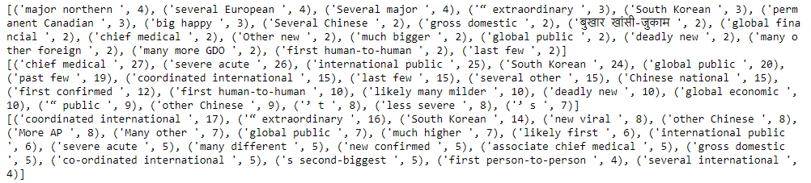

Here are the top 20 noun phrases for the positive, negative and neutral sentence lists:
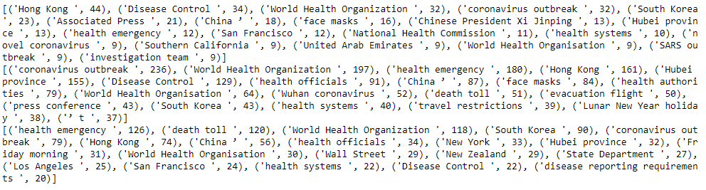

Here are the top 20 verb phrases for the positive, negative and neutral sentence lists:
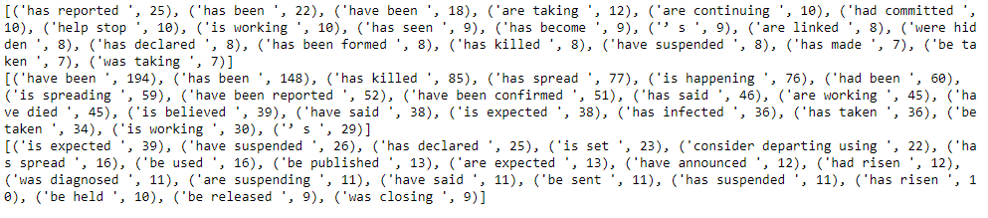

We can see that the adjectives and adverb phrases have a much lower frequency with the highest occurrence being 7 and 4 respectively, whereas nouns are the highest with 44 and verbs somewhere in between with 25 as the highest occurrence for the positive sentences. The negative sentences are similar but the gap is inflated, for the negative sentences the high was in the noun category again but was 236 this time with verbs being at 194 showing us that there were many more negative sentences but also that nouns and verbs are used at a higher rate in the negative sentences than the positive ones. The neutral sentences were similar to the positive ones with the exception that nouns had a higher number compared to the rest of them.

After looking at the sentence frequency I created a dataframe from the output and exported it into a CSV file that I will upload with my assignment submission. Here is an example of the dataframe with the output of the top 3 positive, negative and neutral sentences.

Example of dataframe:
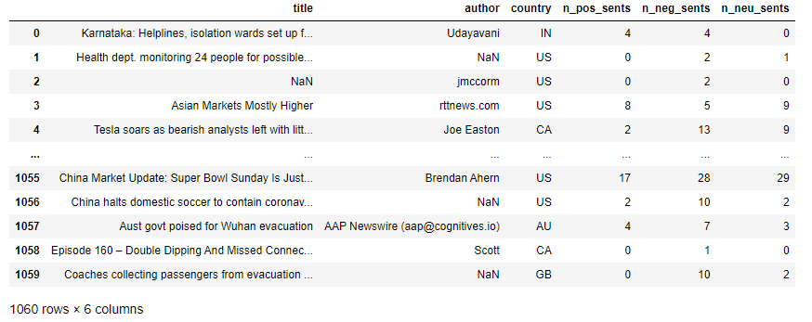

First 3 positive sentences:

First 3 negative sentences:
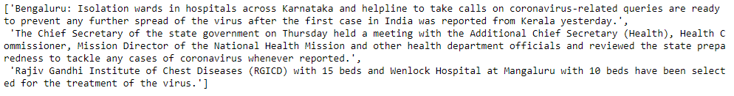

First 3 neutral sentences:
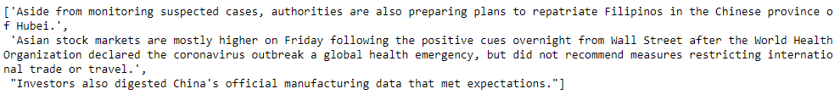

Based on our analysis we can see the overall sentiment of the text and since we exported it to a csv file we can filter by column and make it easier for other people to use without coding in Python.

