SCM 651

Homework 1

Group 4

Emmanuel Gola, Joshua Granville, Nicholas Lichtsinn,

Andrew Morcos, Jermaine Whitehead

| **Average of Price** | **Brick** |  |  |
| --- | --- | --- | --- |
| **Location** | **No** | **Yes** | **Average** |
| East | $117,750.00 | $135,468.42 | $125,231.11 |
| North | $108,583.78 | $118,457.14 | $110,154.55 |
| West | $148,230.43 | $175,200.00 | $159,294.87 |
| **Average** | **$121,958.14** | **$147,769.05** | **$130,427.34** |

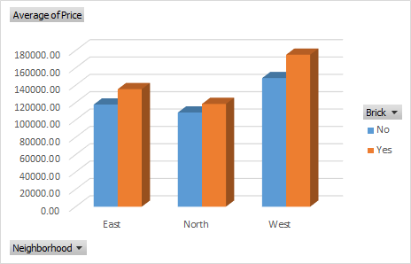

We see prices change mainly due to location with prices in the West being the highest followed by the East and prices in the North being the lowest. The average price of Brick homes were greater than non-brick homes in each location.

The brick and non-brick homes for sale in the West were more expensive than all the other houses for sale. In the West and the East Brick homes are about $20,000 more than non-brick homes but in the North Brick homes are only about $10,000 more than non-brick homes.

| **Average of SqFt** | **Brick** |  |  |
| --- | --- | --- | --- |
| **Location** | **No** | **Yes** | **Average** |
| East | 2,001.54 | 2,031.05 | 2,014.00 |
| North | 1,928.11 | 1,857.14 | 1,916.82 |
| West | 2,073.48 | 2,091.25 | 2,080.77 |
| **Average** | **1,989.19** | **2,025** | **2,000.94** |

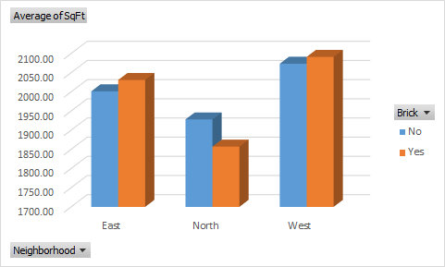

Homes located in the East and West Neighborhoods that are made of brick on average are larger than their counterparts. In the North neighborhood we see the opposite. The differences among the data are negligible with the current sample size, therefore brick is not a strong predictor for square footage.

This Sq. Ft data is intuitive as we have the largest and most expensive homes in the West, the second largest and second most expensive houses in the East and the smallest and least expensive houses in the North. Seeing that the non-brick homes in the North have more Sq Ft could be a reason that the brick houses were only $10,000 more on average in the North compared to $20,000 in the other two locations.

|  | Price | SqFt | Bedrooms | Bathrooms | Offers |
| --- | --- | --- | --- | --- | --- |
| Price | 1 |  |  |  |  |
| SqFt | 0.552982243 | 1 |  |  |  |
| Bedrooms | 0.525926058 | 0.483807112 | 1 |  |  |
| Bathrooms | 0.523257758 | 0.522745301 | 0.414555956 | 1 |  |
| Offers | -0.313635883 | 0.336923352 | 0.11427061 | 0.143793404 | 1 |

Sq. Ft and Price have the largest magnitude correlation of 0.55 and Bedrooms and Offers have the smallest magnitude correlation of 0.11. If we were to perform a regression analysis this would imply that a change in Sq Ft will cause a similar change in Price. Since they are positively correlated if one increases or decreases the other will increase or decrease in the same direction.

We have one negative correlation between Price and Offers, telling us that Price will increase as the numbers of Offers decrease and vice versa. This is intuitive because if a house is a lower price there will be more people who can afford to make an offer on the house, and less people that can afford to make an offer on more expensive houses. The rest of the correlations also seem intuitive as Bedrooms and Bathrooms do not have much of an impact on the number of Offers but a larger impact on the Price and Sq. Ft.

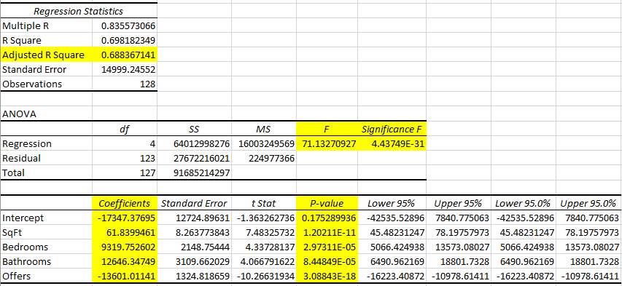

The significance of F is low, therefore the probability of our model being correct is high and the null hypothesis is rejected. Our adjusted R squared is high (close to .7) showing a high correlation, we use adjusted R square since we have multiple predictors. The model can be accepted as correct due to the P-value being under our acceptable 5% threshold.

The coefficients detail the likelihood of how price is being affected by bedrooms and bathrooms. The average increase in price per bathroom is $12,646, while the average increase in price per bedroom is $9,319.The coefficient of square feet has the most impact on our equation when the $61 price per sq ft is multiplied by the range of 1450 to 2590 sq ft homes in these areas.   
  
As a house flipper If you are choosing between adding a bedroom or a bathroom before listing a home the data is telling us that the list price has a stronger correlation to adding a bathroom. As more bathrooms are added the list price grows, but at some point there is a diminishing return to factor in.

We developed the formula below based on our regression model and used 3 bathrooms to be our constant in model. We also developed the output price to service the higher end of the range of prices of the homes in the market.   
  
The predicted price is equal to the intercept + coefficient A * input A+ coefficient B * Input B + coefficient C * input C + coefficient D * input D  
 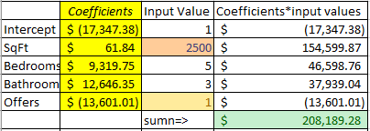

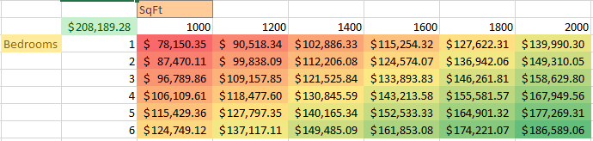

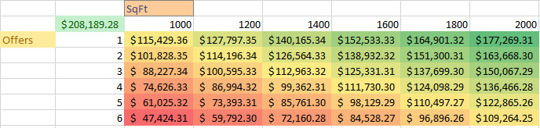

We used a two-way analysis to determine how Sq. Ft. and number of bedrooms would impact our price as a seller. Presented in a red to green conditional formatting chart we notice that as bedrooms increase the total size of the home must also increase to reach our optimal price. That’s an understandable assumption because if square footage remains the same and bedrooms increase we are selling the buyer a house with smaller rooms.

Using a two-way sensitivity analysis for S. Ft and Offers we can see the expected price of a home between 1000 and 2000 Sq. Ft when it has 1 to 6 Offers on the house. We used conditional formatting to highlight our results showing a range in price from $47,424 to $177,269 based on the number of Offers and the Sq. Ft of the house. This predictive model is understandable as you would expect a larger home to cost more and a house with more offers to be at a lower price point as stated previously.

This technique would be very helpful for a real estate agent or someone trying to sell their home to decide on their price as well as the need to increase Sq. Ft or get less Offers on a home to be at their optimal price in the market.

One reason for non-intuitive results in our regression could be fabricated data, our calculations could be off because this data is not realistic for the current housing market as it changes constantly. Another reason could be location, housing prices and variables change drastically from state to state and in rural vs urban communities as well. Another factor of non-intuitive results could be our high P-value for our intercept, with a P-value of 0.175 this should not be considered statistically significant and we cannot be sure this model is accurate.