Joshua Granville, Nicholas Lichtsinn,

Andrew Marcos, Jermaine Whitehead

SCM 651

11/15/21

Homework 2 Team 4

**Question 1: What were the time frames for each marketing campaign? How much was spent on each campaign? What was the effectiveness of previous campaigns?**

Whitman.syr.edu

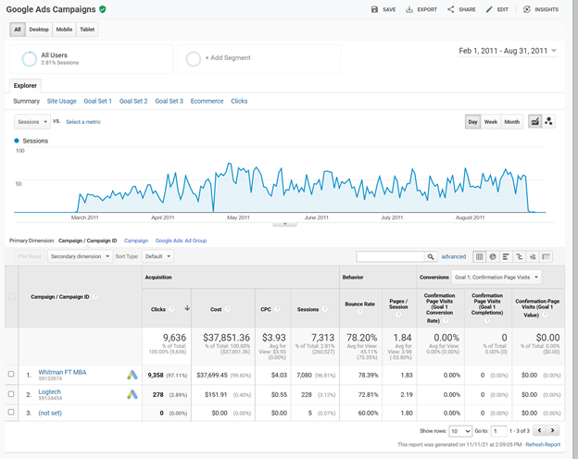

1. Whitman.syr.edu
   1. Feb 27,2011 - Aug 21, 2011
   2. Cost: $37,851
   3. Cost Per Click: $3.93
   4. Bounce Rate: 78.20%
   5. Effectiveness: Of the four campaigns this one seemed to be the most beneficial producing 9,636 clicks at about 25% per dollar spent and has the second highest pages per session (1.84) and second lowest bounce rate.

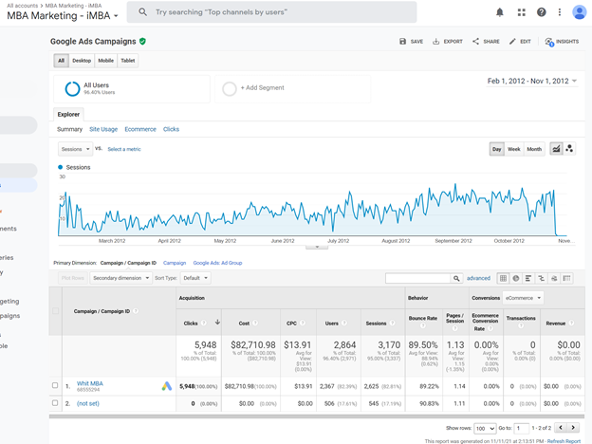

B. MBA Marketing - iMBA

i. February 1, 2012 - November 1, 2012

ii. Cost: $82,710.98

iii. Cost Per Click: $13.91

iv. Bounce Rate: 89%

V. Effectiveness: Increased cost and produced a lower amount of clicks at 5,948, at about 7% per dollar spent. This campaign was not as successful with a higher bounce rate, lower clicks, lower pages per session and a higher cost per click.

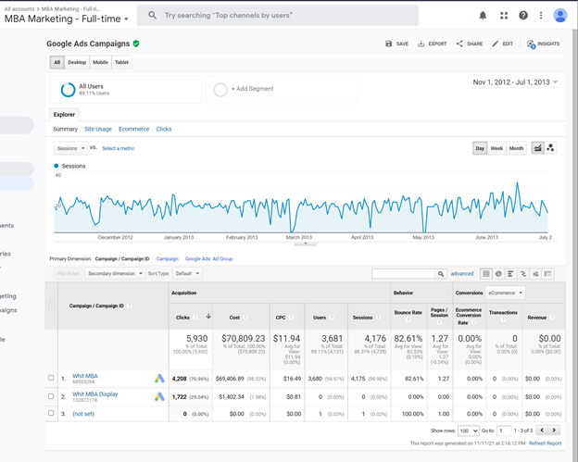

C. MBA Marketing - Full Time

1. Nov 1, 2012- Jul 1,2013
2. Cost: $70, 809.23
3. Cost Per Click: $11.94
4. Bounce Rate: 82.61%
5. Effectiveness: Similar to the iMBA campaign this campaign had increased cost 5,930 clicks and only produced 8% of clicks per dollar spent. With a low pages per session and high cost per click and bounce rate this campaign was a little more successful than the iMBA but not as successful as the whitman.syr.edu campaign.

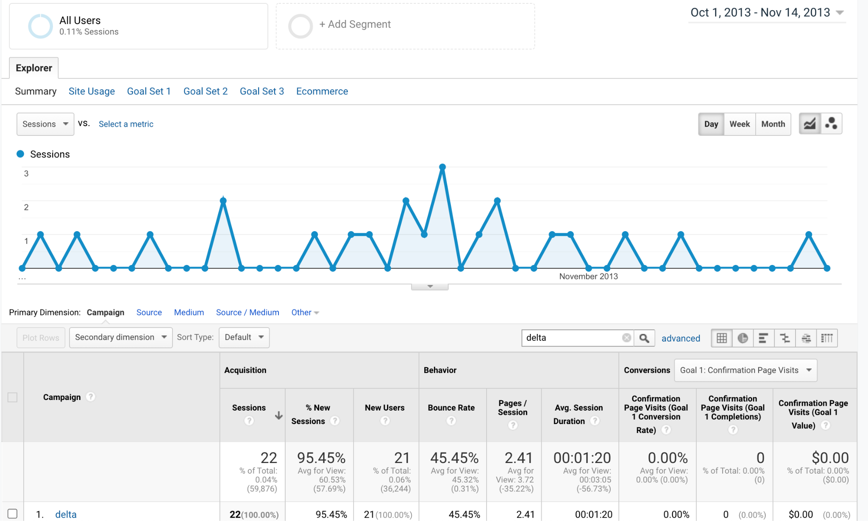

D. Delta

1. October 1, 2013 - November 14, 2013
2. Cost: $10,000
3. Bounce Rate: 45.45%
4. Effectiveness: This campaign resulted in fewer users overall with 95% of users being new. This campaign also had a very low bounce rate of 45% and a high pages per session of 2.41, but only attracted 22 users so was effective but with a high cost per user.

**Question 2: Create a prediction of cost per click and a prediction of advertising cost per student for Google Ads for next year. Use either the prediction technique or Excel’s forecast option. Do not include Delta. If using the forecast option, assume the years below. Number of students recruited from the advertisements is listed below.**

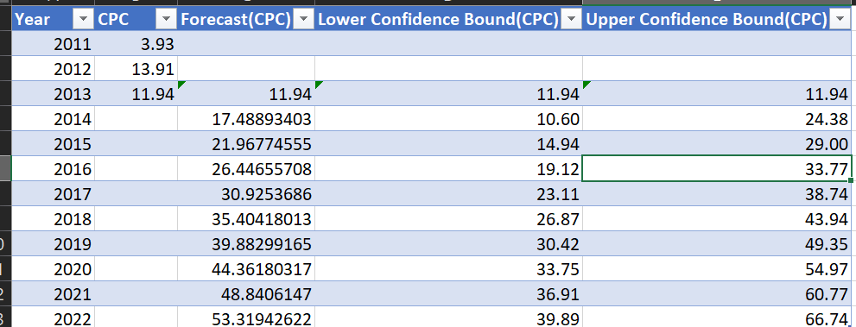

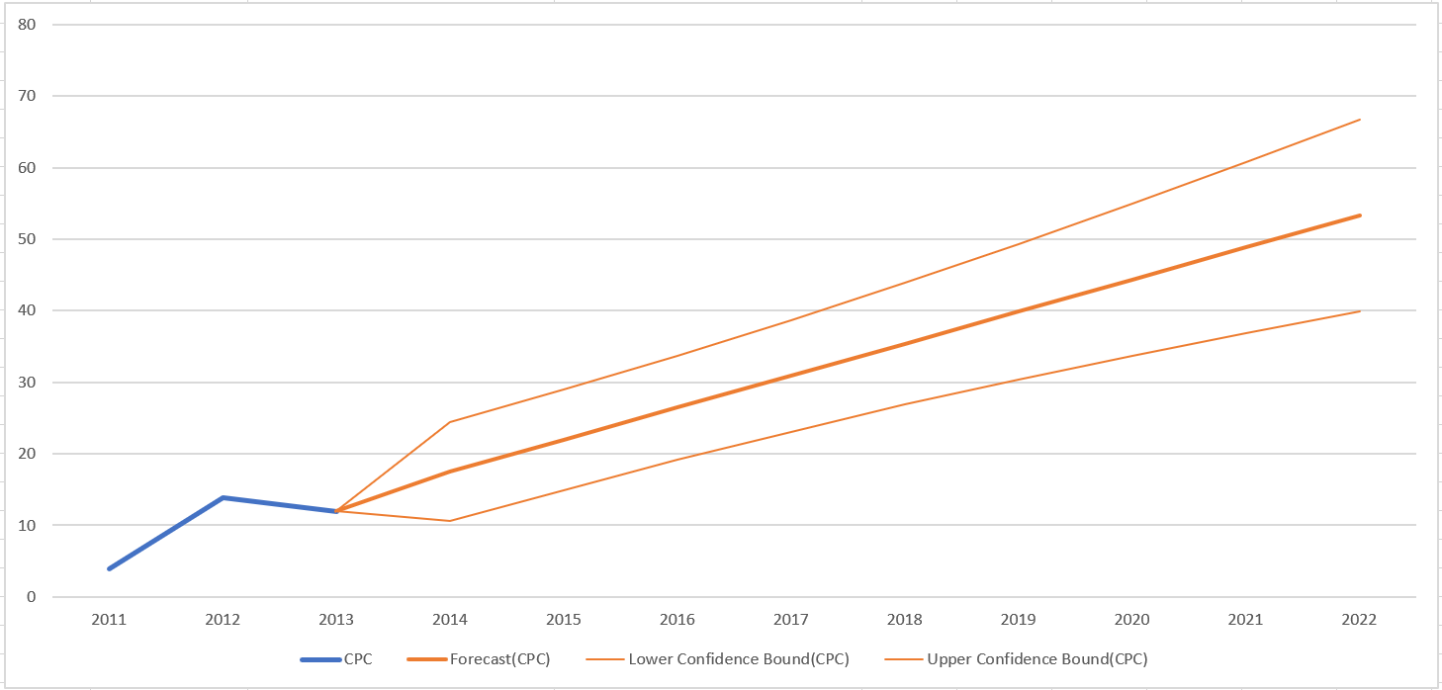

1. Advertising Cost per Click
   1. In the year 2022 it is forecasted to cost $53.31 with lower bounds of $39.89 and upper bounds of $66.74
   2. Advertising increases each year and the number of clicks do not accurately correlate. One would think the more advertising dollars spent the clicks would increase, but the clicks are staying similar with the cost increasing.

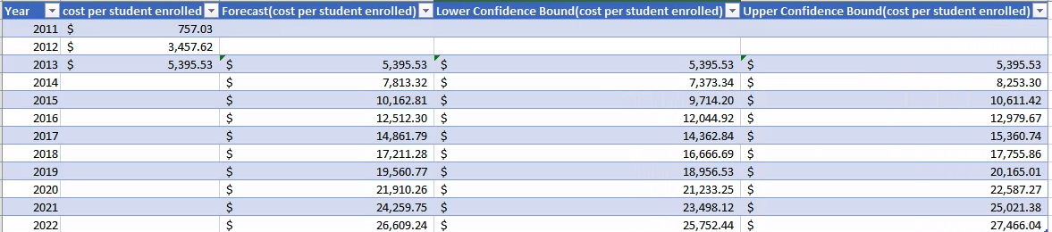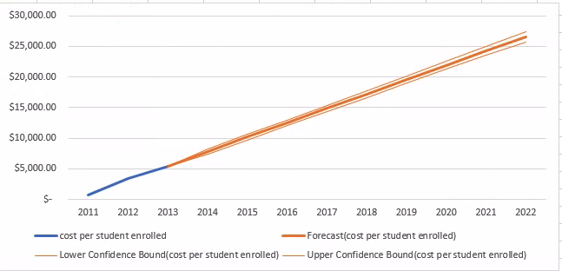

1. Advertising Cost per Student enrolled
   1. In 2011, 50 students enrolled costing $757.03 per student
   2. In 2012, 24 students enrolled costing $3,457.62 per student
   3. In 2013, 15 students enrolled costing $5,395.53per student
   4. The advertising budget is not effectively recruiting students to enroll. And by 2022 we forecasted a cost of $26,609 per student enrolled.

**Question 3: Identify the key aspects of a United States campaign for next year.**

1. In which geographic region, states, or cities would you advertise? Why?
   1. Most clicks are coming from New York, California, Texas, New Jersey and Massachusetts. We would keep advertising in these states. Syracuse specifically gets many clicks (53%), New York city had 16% of all users, I would continue to advertise there. Rochester had a significantly lower session count by great bounce rate at 37%.

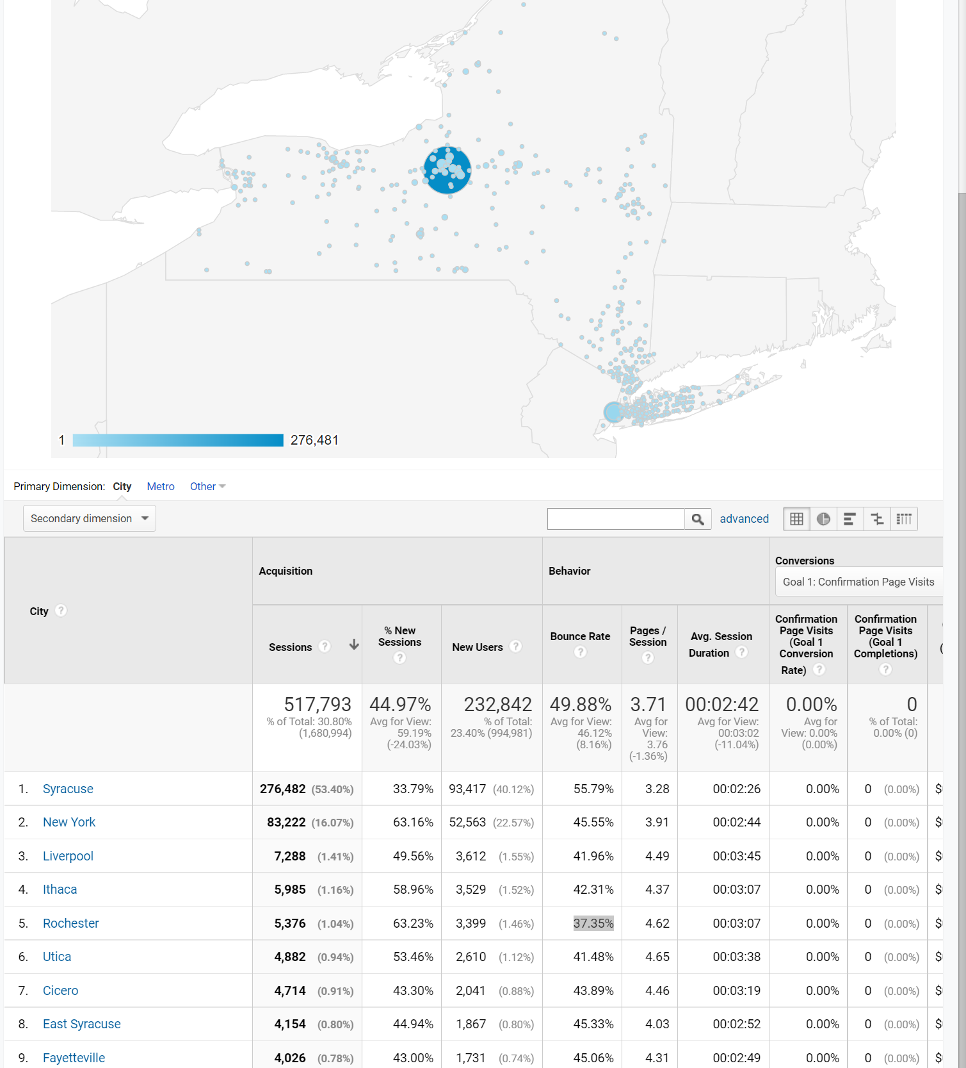

1. What keywords would you use? Why?
   1. Online MBA had 60% of all clicks in Whitman (exclude SU), MBA had 19% the remaining keywords. The rest of the keywords had MBA specific terms and accounted for < 20% of the clicks combined. Specific keywords with Syracuse in them would not be recommended as users are specifically seeking out the university. Our data set is a bit older, but I would imagine Data Science would be another strong keyword in 2021.
2. Which days of the week and what time of day would you advertise? Why?
   1. Most users were visiting the site on Sunday 17.25%, Tuesday 15.43%, Saturday 15.95%, Monday 14.94%. I would recommend advertising these days of the week. Wednesday and Thursday were 13.43% and 12.71% respectively and Friday had the lowest % of sessions at 10.30%
   2. The best time of day was 5:00pm, the data jumps from 164 sessions to 792 and stays active hitting 808 sessions at 9:00pm until it starts to fall again at 11:00pm (678).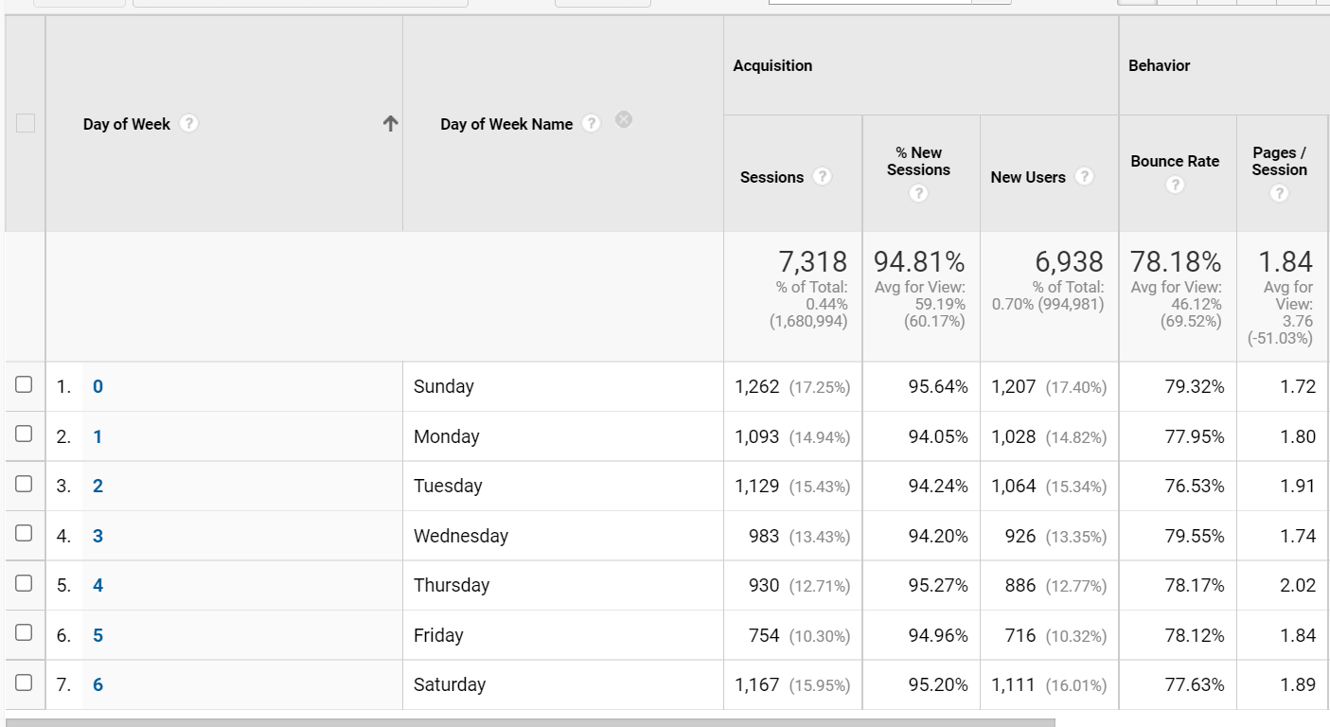

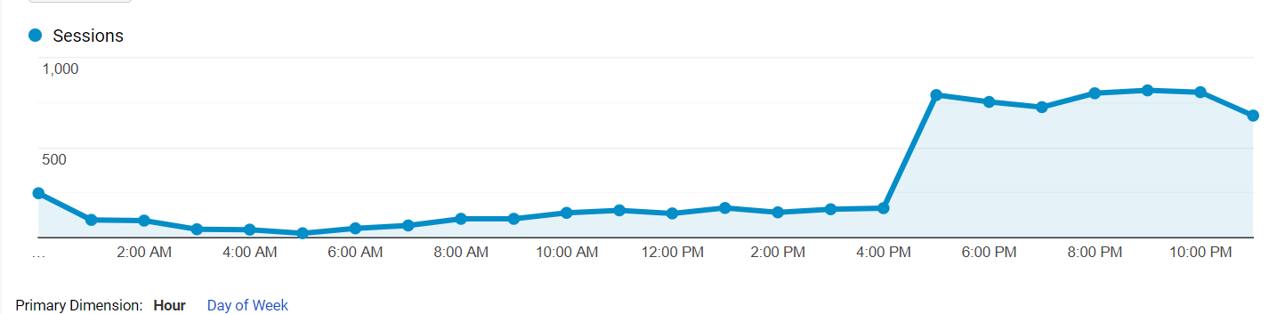

**Question 4: How would you measure performance of your decisions after implementation?**

1. After implementing new campaigns for specific keywords on specific days/times, we would then review new sessions compared to prior campaigns. Looking specifically at the bounce rates, a rate of 70 or above is poorly performing, 20-40 is excellent, and a rate from 50-70 is higher than average. The bounce rate tells us specifically what percent of people are exiting the website immediately after arrival. This along with the amount of users and cost per click will be the main measures of performance after implementation. With these three metrics we will be able to see how many people our campaigns are attracting, how much it costs to get them to our site, and how engaged they are once they arrive.

**Question 5: What other factors or considerations are important? What other data would help in developing an Internet advertising strategy, if you could collect it?**

1. Some additional factors that could be important are Location, keywords vs price of keyword, audience, and time of day. Combining data from the admissions department, specifically around location and date of application would help validate campaigns effectiveness. Also the GMAT scores by city and region to allocate targeted marketing.

**Use Google analytics to analyze the data to identify patterns and opportunities. Your goal is to recruit the best United States students, measured by GMAT scores, but you are limited to a budget of $100,000. The budget must cover advertising costs, but no Whitman administration costs. The campaign starts one year from today.**

1. To recruit the best US students measured by GMAT scores, we would target our recruiting in New York, California, Texas, New Jersey and Massachusetts as these states have the highest click rates. We would schedule the majority of our ads for the 5:00pm to 9:00pm timeframe as this is when most users are active and schedule the majority of the ads for Sunday, Tuesday and Saturday as these days have the highest activity rate. With an estimated enrollment cost of $26,000 per enrolled student, we can expect to have 3-4 enrollments from our $100,000 invested in ad campaigns.