­Homework03

Nick Ling

5/4/2015

Tutorial: How to created a ASP.NET Web Application using Master Pages.

1) Create a new ASP.NET website project called “Homework03.”

2) Create a new Master Page with navigation buttons on the top of the page.

3) Create a new Home.aspx Content page.

4) Create a **new** LoginRequest.aspx Content page.

5) Create a new AboutUs.aspx Content page.

We are going to make a website that has 3 pages. The final result will look like this:

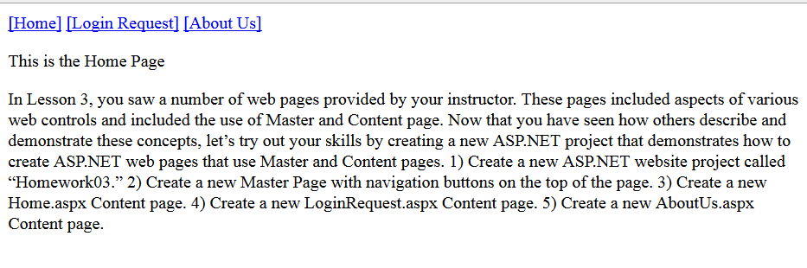

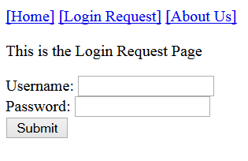

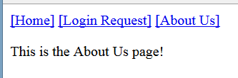

**Step 1** Create a new ASP.NET website project called “Homework03.”

Open Visual Studio 2013 and create a new Empty C# ASP.NET Web Application.

File 🡪 New 🡪 Project 🡪 Visual C# 🡪 ASP.NET Web Application

Name: Homework03

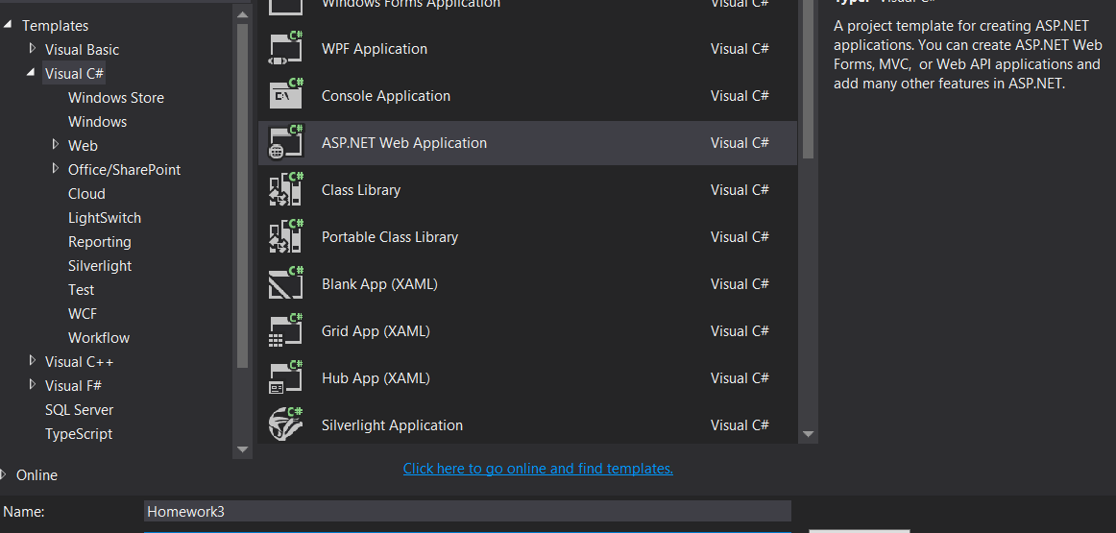

Select the option to create an empty ASP.NET application.

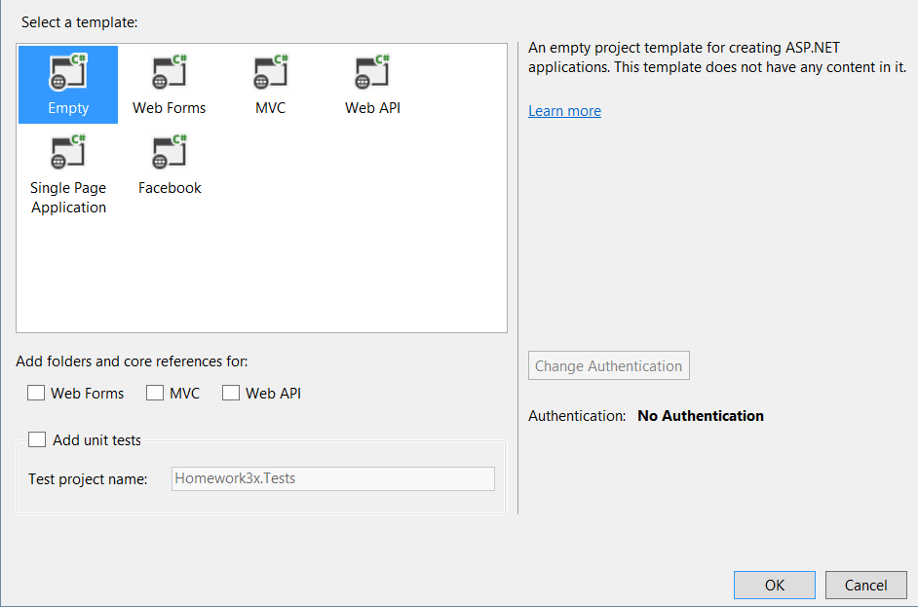

Result:

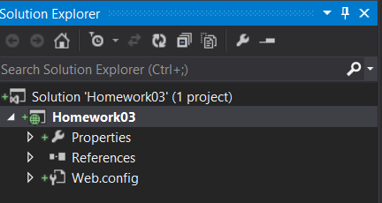

**Step 2 Create a new Master Page with navigation buttons on the top of the page.**

In the solution explorer, right-click on Homework03 and click Add 🡪 New Item 🡪 Web 🡪 Web Forms Master Page. Name it "Site.Master"

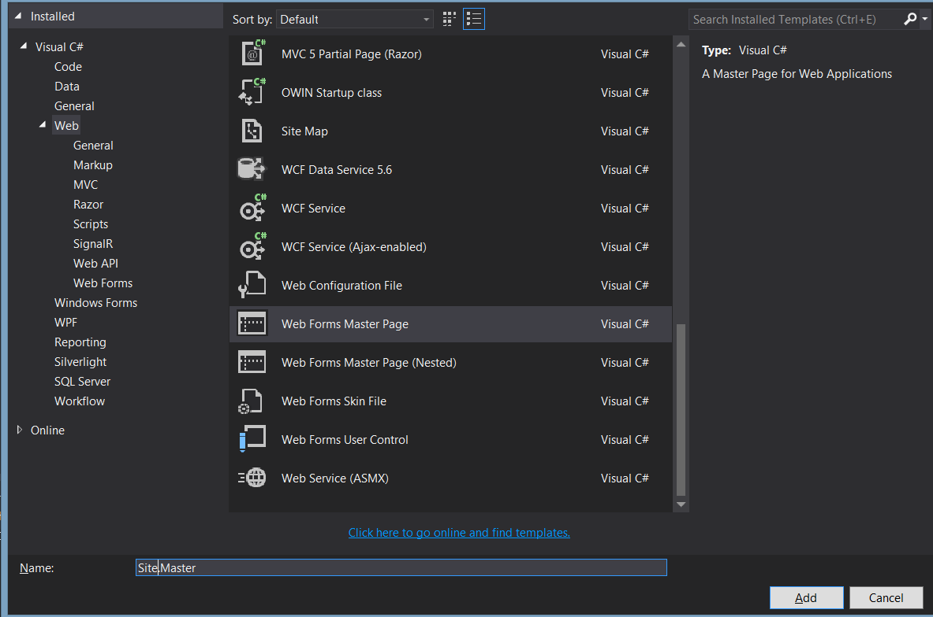

You have just created a Master Page. What this allows you to do is to place common elements and layout on the master template. You can then create pages that use this template to create new pages. One such example in using this page is to put your navigation buttons. You want your navigation buttons to be consistent, right?

This is what the Site.Master looks like right now. It is empty.

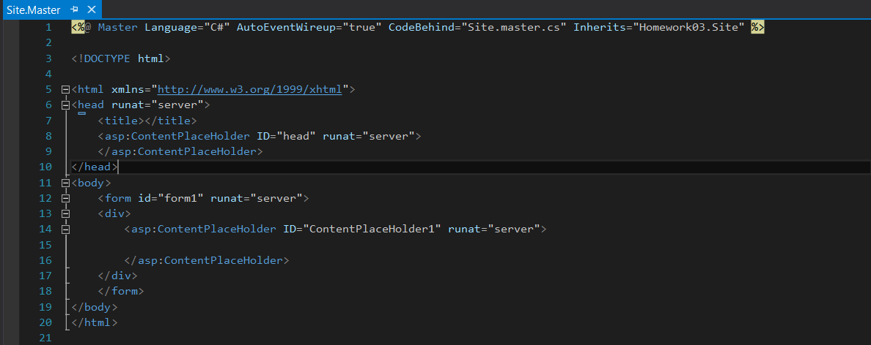

Now we can add some navigation buttons to this page.

Go to the Toolbox and select a LinkButton. Drag over three of them into the section above

Take these three LinkButtons, and nest them into <nav> tags.

Change the names of these Buttons to Home, Login Request, and About.

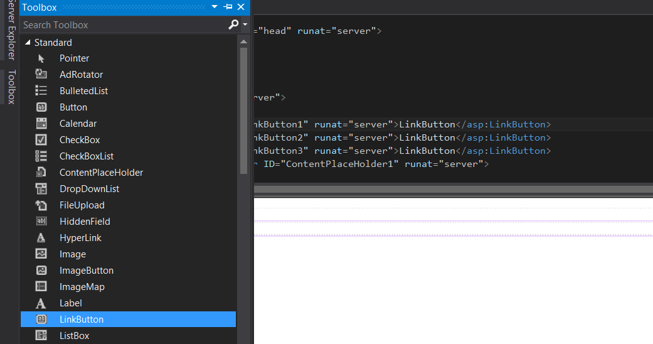

<form id="form1" runat="server">

<nav runat="server">

<asp:LinkButton ID="LinkButton1" runat="server" PostBackUrl="~/Home.aspx">[Home]</asp:LinkButton>

<asp:LinkButton ID="LinkButton2" runat="server" PostBackUrl="~/LoginRequest.aspx">[Login Request]</asp:LinkButton>

<asp:LinkButton ID="LinkButton3" runat="server" PostBackUrl="~/About.aspx">[About]</asp:LinkButton>

</nav>

<div>

<asp:ContentPlaceHolder ID="ContentPlaceHolder1" runat="server">

</asp:ContentPlaceHolder>

</div>

Here, we added 3 LinkButtons. We added the PostBackUrl attribute with the page that we want that link to go to when clicked. These need to be placed within the <form> tag otherwise it will cause a compilation error.

Step 3: Create a new Home.aspx Content page.

Now that you have completed your master page, you can now create a page with this "template".

Right click anywhere in the master page, and select "Add Content Page". This will generate a new Web form page. Rename this to Home.aspx. You can add any text on the home page.

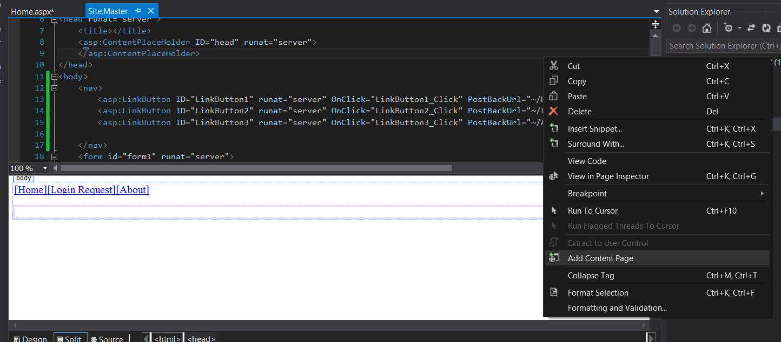

It should look like this:

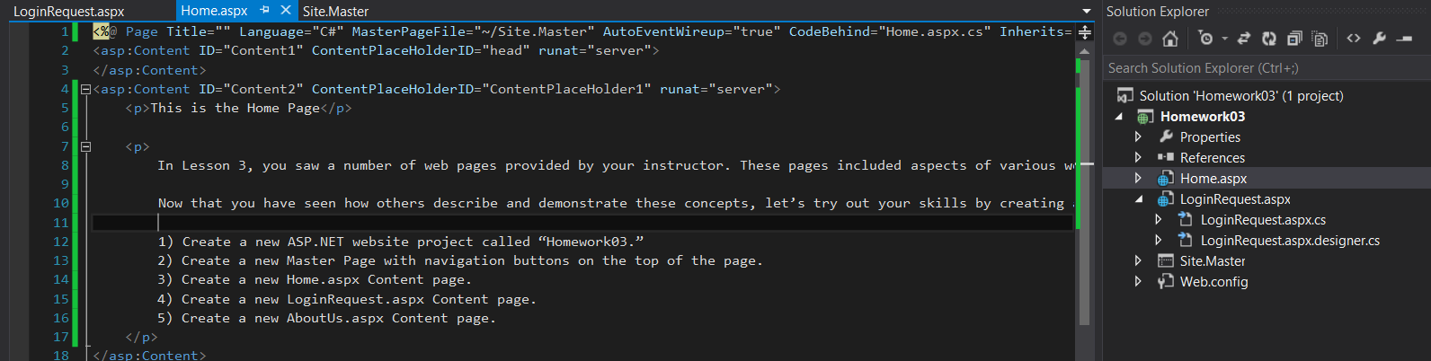

Step 4: Create a **new** LoginRequest.aspx Content page.

This will be similar to the previous step, except in this one, you will need to add labels, textboxes, and a submit button.

Add a new content page and name it LoginRequest.aspx

From the toolbar, drag in two labels, two textboxes, and a button.

<%@ Page Title="" Language="C#" MasterPageFile="~/Site.Master" AutoEventWireup="true" CodeBehind="LoginRequest.aspx.cs" Inherits="Homework03.WebForm2" %>

<asp:Content ID="Content1" ContentPlaceHolderID="head" runat="server">

</asp:Content>

<asp:Content ID="Content2" ContentPlaceHolderID="ContentPlaceHolder1" runat="server">

<p>This is the Login Request Page</p>

<asp:Label ID="LblLogin" runat="server" Text="Login:"></asp:Label>

<asp:TextBox ID="TbLogin" runat="server"></asp:TextBox>

<br />

<asp:Label ID="LblPassword" runat="server" Text="Password:"></asp:Label>

<asp:TextBox ID="TBPassword" runat="server"></asp:TextBox>

<br />

<asp:Button ID="Button1" runat="server" Text="Submit" />

</asp:Content>

In this example, grouped the username labels together and the password labels together. They will situate next to each other. I've placed a <br/> break tag to send the next label/textbox pair to the next line.

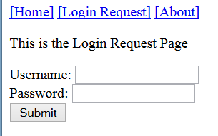

Step 5: Create a new AboutUs.aspx Content page.

This step is nearly identical to the 3rd step. Create a new web form from the master page and name it AboutUs.aspx

You may have noticed, but it appears we've made a typo on the About Us navigation button.



All we need to do is go to the master page, and change [About] to [About Us]

This change will be reflected on all of the pages!

From this:

<asp:LinkButton ID="LinkButton3" runat="server" PostBackUrl="~/AboutUs.aspx">[About]</asp:LinkButton>

To this:

<asp:LinkButton ID="LinkButton3" runat="server" PostBackUrl="~/AboutUs.aspx">[About Us]</asp:LinkButton>

